The Impact of Virtual Learning Environment (VLE)-Moodle on student’s learning experience at UWTSD London campus.
Student Name: Fiona Tesfazghi
ID: 1914615

Abstract
A virtual learning environment is a new platform for maintaining the courses of learning for one or two decades. The virtual learning environment made easy the way of learning, here all kinds of materials are available on this platform. Different kinds of modules provide here for the students and also record student details information in this Moodle. Here also available multiple materials for the same topics. VLE Moodle vastly impacts learning and teaching methods whereby it is a new technical way of learning. Learning experiences of students due to VLE increases day by day and bring great benefits in a school project for their learning system (Gong, Chiu, and Zou, 2016). Thus, it is clear that it widens our learning methods by providing different materials and instruction. This survey tries to explain about virtual learning environment experience for the learning experience of the students. For primary data, we collect responses from 10 students and try to show the results of their experience whether virtual learning helpful or not, and make some recommendations.

Contents
Abstract 2
Introduction 4
The rationale of the study. 5
Aims and objectives 5
Literature Review 5
Methodology 6
Analysis and findings 7
Discussion and recommendations 15
Conclusion 16
REFERENCES 17
APPENDIX 18

Introduction
The virtual learning environment is the digital aspect of the study which is a web-based educational platform. It is the better way of interactions between course structure and learner. Here, easily provided materials and tasks by the teacher, and also students can easily adopt these and respond particularly. It is the best way for long-distance and part-time learners. Thus, it is clear that it widens our learning methods by providing different materials and instruction. This survey tries to explain about virtual learning environment experience for the learning experience of the students. For primary data, we collect responses from 10 students and try to show the results of their experience whether virtual learning helpful or not, and make some recommendations for the effectiveness of the virtual learning environment at the University of Wales Trinity Saint David London Campus (Hasebrook and Maurer, 2004).

The rationale of the study
In this IT era, it is one kind trend that taking the facility of a virtual learning environment for learning different courses online. The maximum educational institute provides these facilities, as well as UWTSD, also provides web-based facilities like a virtual learning environment for the teachers and students. Here try to survey the effectiveness of a virtual learning environment that how much effective for the students this learning way. This is the main reason for our survey. Also for knowing the feeling of students about virtual learning, how they get benefits, and how many services they get from virtual learning, can be effective in the future? etc. we take this survey. Suggestion to continue this way or not (Hollowell, 2011).

Aims and objectives
The main reason for this report is knowing about the effectiveness of the virtual learning environment for learning courses of the students of UWTSD. Especially, specific main objectives are-
- For knowing what kinds of impact on their study methods due to virtual learning Moodle
- For giving information about the feelings of students of UWTSD about their VLE Moodle
- For knowing negative review about VLE Moodle if available
- Find out the problem and makes some recommendations

Literature Review
There are several literatures published which are related to this topic. Scardamalia and Bereiter studied and find out the positive aspects of the VLE platform for the learning of students. Here, showed that VLE used for online learning by both teacher and students. This study expressed that most of the students use this platform for developing their vocabulary skills, language skills, and depth measurement about a topic. Here, students express that they can easily access their required courses like computers, mathematical, etc. through the technological aspect. They easily complete the tasks and submit them from anywhere. Several tests also they can provide in this way.
According to the Mirandanet, VLE Moodle vastly impacts learning and teaching methods whereby it is a new technical way for learning. Learning experiences of students due to VLE increases day by day and bring great benefits to a school project for their learning system. In this, their literature found that if the higher educational institute does not provide the VLE platform facility then cannot sustain more in this era. Besides this literature report published that the VLE platform be popular day by day by their facilities like assignment submission, related materials available, etc. VLE is a great platform providing courses in a different way like documents, videos, etc. and it is added to the new way for interacting between teachers and students. Thus, it is clear that it widens our learning methods by providing different materials and instruction (Mirandanet 2014).
According to the study of Emerson, the VLE platform is the center stage of taking courses in higher learning institutes in the UK. Providing assignments, submission facility, and providing feedback through VLE are a great opportunity that’s told by the teachers and students that published in this literature. Supportive learning materials, flexible time, and outcomes bring great positive reviews in the learning of students. Thus, it is clear that it widens our learning methods by providing different materials and instruction. Proper planning about an academic year about learning is decorated in this Moodle. Thus, every institute should provide this facility told in this literature.
Ethink published literature and explained that the VLE platform vastly improved the learning experience of students in their learning process. Here, some reasons express Ethink that why students are taking advantage of the VLE platform for their learning. Such as, Moodle provides organized learning materials, easily integrates with the current learning system, several information collects from the same platform and it is also providing flexible timing and location flexibility the study process. Those are the main reasons for choosing the VLE platform which was explained in this literature. Different tests, assignments provided here and provide feedback also that is a great opportunity taken by students and teachers (Ethink 2019).

Methodology
UWTSD London campus for researching on the impact of VLE Moodle on the learning experience of their students follow different methods for collecting data. Here, primary and secondary data collected for this research. After observation of this Moodle has decided for collecting data about the effectiveness of VLE Moodle. Here, primary data collected by questionnaire method and secondary collect from the different articles about this topic and previous research about this topic. The different website also helps for making this research.
Here, I use 8 questions and collect responses from the students about their experience. But face some problem for collecting response in offline due to current pandemic Covid-19. For that, I collect responses online.
Secondary data analysed based on my understanding by reading the article.

Analysis and findings
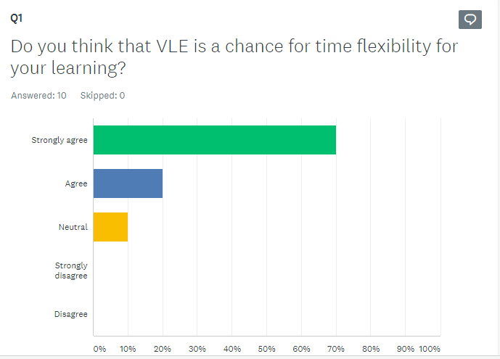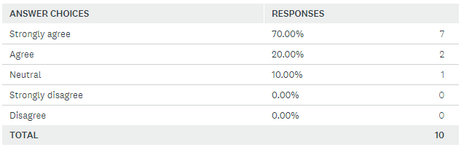
Here, we can find that maximum students strongly agree about the time flexibility of the Virtual learning environment Moodle which is provided by the UWTSD. From these respondents, two students express that they agree about this time flexibility by using VLE Moodle for their learning, and here one student out of ten expresses his neutral position about the time flexibility of VLE Moodle.
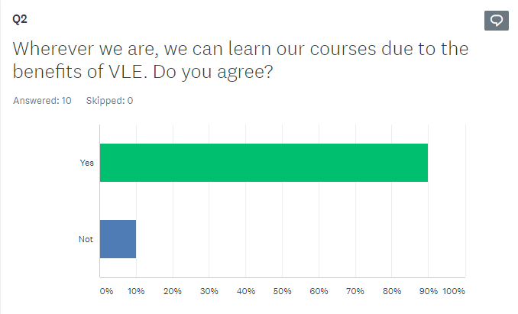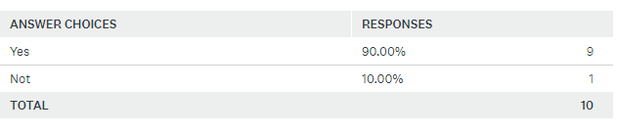
As seen here almost all students agree with the statement that wherever we are, we can learn from VLE Moodle. That means here it is cleared that a student where he lives doesn’t matter, he can get benefits from the learning module from the VLE platform. Assignment submission and getting feedback about it also a student can get from anywhere he/she live. In a word, students can location facility from the VLE Moodle whereby in the traditional system every student needed to go campus for their class and other tasks.
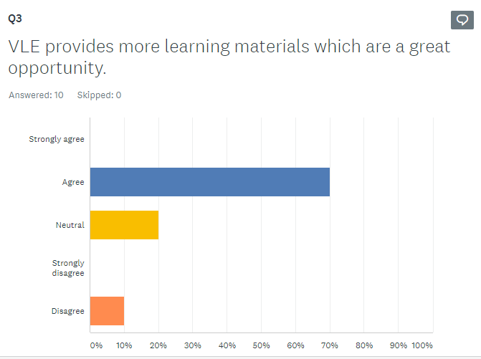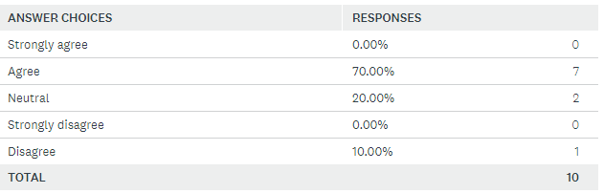
When a student learns about a topic then he/she needs different materials for understanding the concept but in the traditional system had not got sufficient materials. But for the opportunity of the VLE platform, they get different materials like different articles, journals, videos, etc. In this survey, it is also cleared that 70% of students agree with the statement that they get enough learning materials for the benefit of VLE Moodle although some of the students keep silent about this opinion.
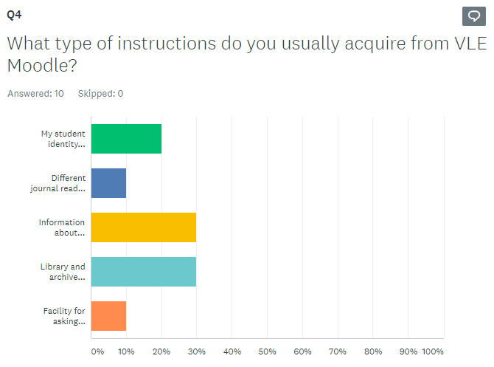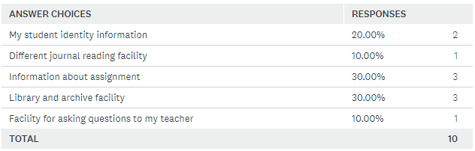
In this question we wanted to know what kinds of instructions are followed by the students from the VLE Moodle for their learning experience and as seen here that maximum instructions followed by equally. Here, some students told that they maximum time used VLE for learning about assignments, some students treat it as knowing their student information, and comparatively majority students use it as library and archive facility at UWTSDs’ VLE platform.
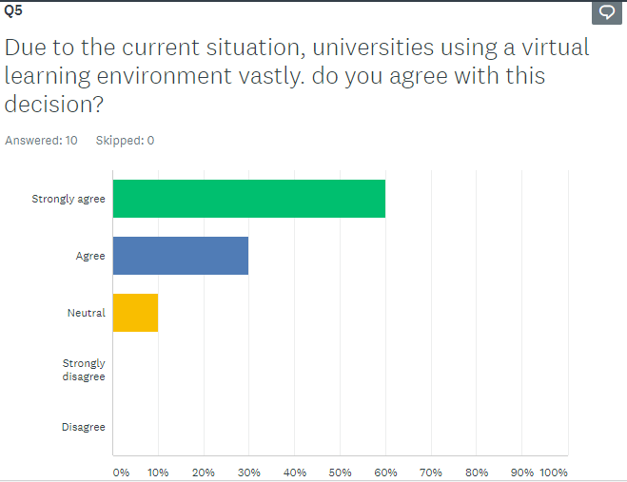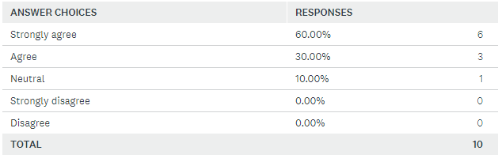
Here, we found that maximum students strongly agree to take learning facilities by using the VLE platform due to the current pandemic situation. Some students agree about the service of virtual learning whereby go outside is risky for them. They feel that it is the best solution to continue their courses due to the service of VLE Moodle. But one student among the ten respondents feels that no need to commenting on the VLE Moodle, may he/she can apathy about these services.
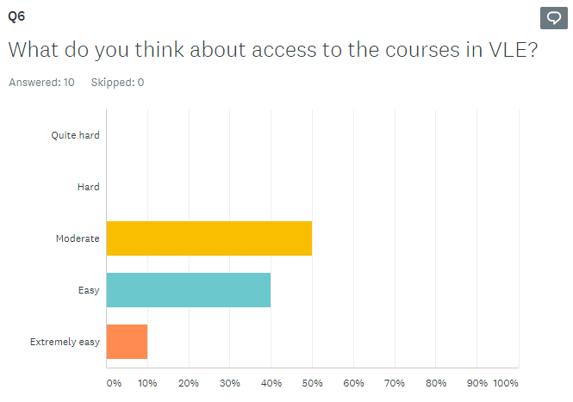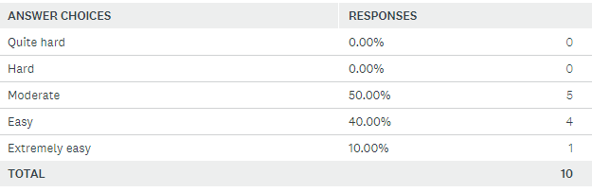
By this question, we wanted to know that how difficult or easy to access the service of VLE Moodle then here we found that majority respondents feel that it is lies at a moderate level and some students feel that it is easy for accessing and learning from the VLE Moodle. From the above respondents, one student feels that the VLE platform is extremely easy for operating for the students.
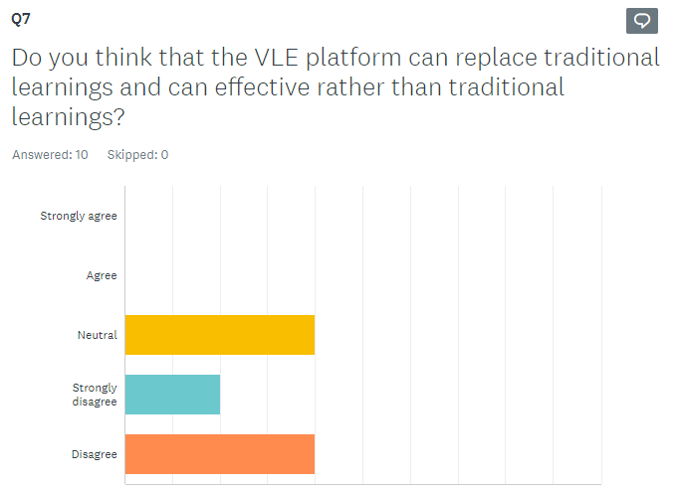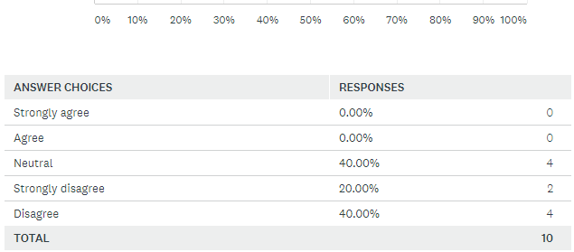
When we conducting this survey then here one question had about known the feeling of students that can VLE platform replaced in traditional learning or can be more effective it than traditional then we found that almost equal parties we were found that some disagree about this statement, some strongly disagree and some of them keep neutral position about this question. So it is cleared that the VLE learning experience can be effective but replaced in traditional learning.
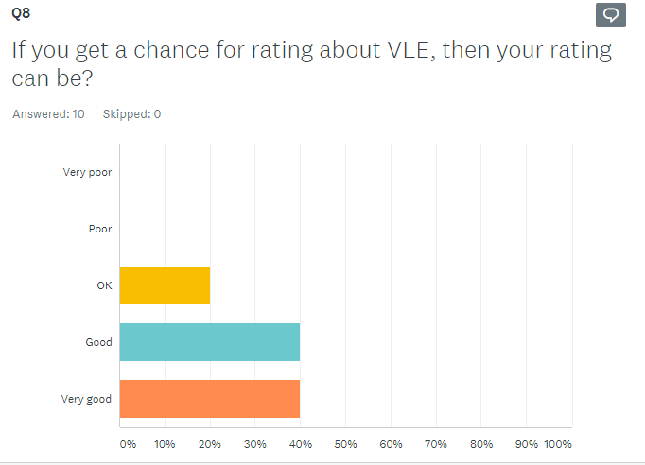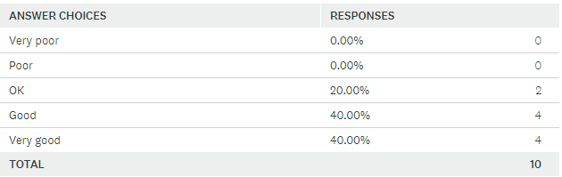
In this stage, we wanted to know that the service quality of VLE Moodle which is offered by the UWTSD at the London campus then we found that they rate about VLE is positive. Some feel that it is very good for them, some told that it is good for their learning experience and some of them accept it is ok for their assistant for their learning. Thus it is clear that it widens our learning methods by providing different materials and instruction.

Discussion and recommendations
There are several arguments explained in the above based on primary data about the learning experience of the students by using VLE Moodle. Here showed that many students enhanced their learning capacity through VLE Moodle. Some students accept it as a location facility, some students consider it for time flexibility and some students think that it was enough effective for their learning. Most of the respondents consider VLE Moodle that is a big platform for collecting multiple materials and keep their information about student identity. Thus, it is clear that it widens our learning methods by providing different materials and instruction (Ethink 2019).
Secondary data different literature which explained in above denotes that the VLE platform is a well-organized way for learning materials and learning different terms with multiple sources of article or archive.
Though UWTSD provides enough facilities through their VLE Moodle I think that they need some improve and for that, I recommend some recommendations. Such as-
- Need to easier for operating VLE Moodle for learning at UWTSD
- Need to increase the materials and information for their students
- To prompt two-way communication for better interaction between teachers and students
- Some control of study design needs to provide to the students' control if keep any chance.

Conclusion
The virtual learning environment made easy the way of learning, here all kinds of materials are available on this platform. Different kinds of modules provide here for the students and also record student details information in this Moodle. Here also available multiple materials for the same topics. It is the better way of interactions between course structure and learner. Here, easily provided materials and tasks by the teacher, and also the student can easily adopt these and respond particularly (Hollowell, 2011). VLE Moodle vastly impacts learning and teaching methods whereby it is a new technical way of learning. Learning experiences of students due to VLE increases day by day and bring great benefits to a school project for their learning system. Different tests, assignments provided here and provide feedback also that is a great opportunity taken by students and teachers. Thus, it is clear that it widens our learning methods by providing different materials and instruction. Every institute needs to adopt this Moodle and some institute need solution who face problem in existing VLE Moodle.

REFERENCES
Gong, Z., Chiu, D. and Zou, D., 2016. Current Developments In Web Based Learning. Cham: Springer.
Graser, A., 2014. Learning QGIS - Second Edition. Packt Publishing.
Hasebrook, J. and Maurer, H., 2004. Learning Support Systems For Organizational Learning. Singapore: World Scientific Publishing Company.
Hollowell, J., 2011. Moodle As A Curriculum And Information Management System. Birmingham, U.K.: Packt Pub.
Ravenscroft, A., 2012. 21St Century Learning For 21St Century Skills. Berlin: Springer.
Repetto, M. and Trentin, G., 2011. Faculty Training For Web Enhanced Learning. New York: Nova Science Publishers.
Secker, J., 2004. Electronic Resources In The Virtual Learning Environment. Oxford: Chandos Pub.
Spaniol, M., 2009. Advances In Web Based Learning - ICWL 2009. Berlin: Springer.
Thomas, M., 2012. Design, Implementation, And Evaluation Of Virtual Learning Environments. Hershey, PA: Information Science Reference.
Tsang, P., Kwan, R. and Fox, R., 2007. Enhancing Learning Through Technology. Hackensack, NJ: World Scientific.
Wolpers, M., Kirschner, P., Scheffel, M., Lindstaedt, S. and Dimitrova, V., n.d. Sustaining TEL: From Innovation To Learning And Practice.

APPENDIX

Questionnaire: (Source- https://www.surveymonkey.com/results/SM-DTTYXTQB7/)


