

Programme: MBA – Master of Business Administration
Module: MARKETING MANAGEMENT – ASSESSMENT 2
Module code: LCMB7001

ENVIRONMENTAL ANALYSIS FOR MARKETING 0F SAINSBURY’S

Student Name: MOHAMMED ABDUL THAKIE
Student ID: 2241639
Word Count: 2000
Lecturer: TUSHARA BALENDRAN

Date: 29/8/2023
Table of Contents
Introduction 3
External Environmental Analysis 3
Internal Environmental Analysis 7
Role of marketing in the organization 8
Recommendations for a better future 9
Conclusion 10
Reference List 11

Introduction
The UK-based supermarket Sainsbury’s has been focused on the evaluation which analyses the external and internal environments of the organization in order to identify the improvements that can be made in its marketing. The analysis of the environmental impacts helps to understand the opportunities or threats that lie in the external world as well as the capabilities that can be utilised to address them. Certain recommendations have also been provided keeping the environmental analysis and its outcomes for Sainsbury’s in focus which structures the marketing approach of the company for future times.

External Environmental Analysis
The PESTLE analysis has been further provided to understand the external environmental impacts of the UK-based multinational supermarket chain Sainsbury’s.
Factors | Description
Political | - The political instability due to the international war, pandemic and other factors can have a crucial impact on UK retailers and in 2023 some retailers will find opportunities to reshape their goals and some will make difficult choices (Deloitte.com, 2023).  - The impact of Brexit is a political factor which has significant consequences for the UK business environment  - Between December 2019 and March 2023, food prices increased significantly and all British households paid an extra £6.95bn which in the absence of Brexit could have been 30% less (Inman, 2023).
Economic | - In April, the inflation for food and non-alcoholic drinks rose to 19.1% which can be a strikingly concerning situation for business in the UK (Partington, 2023).  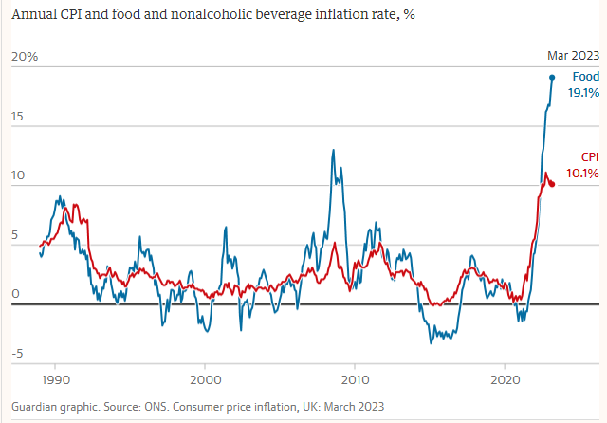  Figure 1: Food and non-alcoholic beverage inflation  (Source: Partington, 2023)  - The trade barriers in the UK consistently hamper imports and increase the bills by an average of £250 and the cost of food since 2019 has increased by 25% which could have also been avoided if post-Brexit restrictions were absent (Inman, 2023).  - Two of the UK's biggest supermarkets, ASDA and Morrisons, are limiting the sale of tomatoes, cucumbers, peppers and lettuce to customers since the supply of fresh fruit and vegetables is crunched by a farming crisis and underwhelming foreign harvests (Price, 2023). Sainsbury’s, however, avoided putting any such limitation on customer purchases irrespective of the shortened supply.
Social | - Online shopping is a key factor of the UK societal environment and according to a survey among 2,598 consumers it is seen that Sainsbury’s is the fourth largest in terms of customer preference for online grocery and beverage shopping with 21% (Statista, 2023).  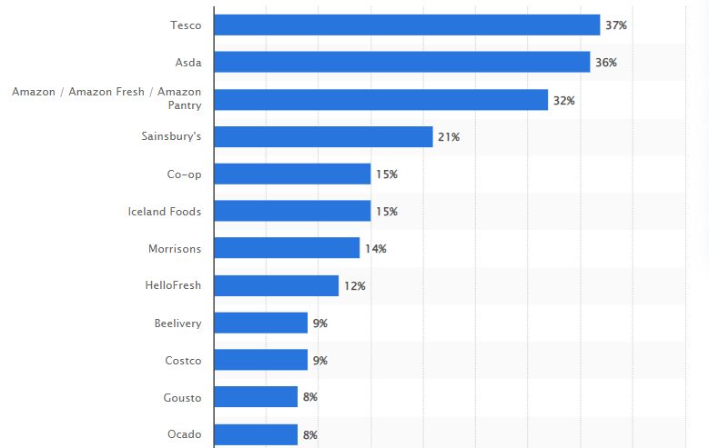  Figure 2: Online grocery and beverage shopping in the UK  (Source: Statista, 2023)  - Even though cost-of-living and inflation is an issue for consumers, in May a steady increase of 12.3% sales at supermarkets has been observed as shoppers have been steadily enhancing their spending (Grocerygazette.co.uk, 2023).  - Due to the week of Coronation, the shoppers purchased extra items causing supermarkets to garner more sales across all channels where online mediums experienced the highest sales growth since 2021 with a rise of 5.2% (Grocerygazette.co.uk, 2023).  - The shoppers have also been observed to be inclined to the own-label products of supermarkets which reflected a strong performance in terms of value sales with a growth rate of 14.1% (Grocerygazette.co.uk, 2023).
Technological | - Despite the economic crisis and constraints of costs, the UK food and drink segment observed transformative and innovative steps towards sustainability, healthy eating and plant-based food which cannot be possible without technological contributions (Grocerygazette.co.uk, 2022).  - Technology is an integral resource for the UK retail and supermarket industry as it has major contributions in not only manufacturing own labels but also innovation, distribution, sustainability, customer service and security.  - For example, in an attempt to deter thieves from leveraging the self-scan technology incorporated by several UK supermarkets, an AI technology company, Supermarket innovated a system that can measure the weight of an entire trolley (Grocerygazette.co.uk, 2022).
Legal | - UK legislation and governmental policies are expected to make impacts in the UK food and drink segment by beginning ERP, re-evaluating business rates, national increase in living wage, utilising land use framework and Scotland DRS among other initiatives (Thegrocer.co.uk, 2023).  - It is important for organizations to abide by governmental obligations and legal requirements to ensure a market presence that is competitive, productive and effective.
Environmental | - The extreme weather in the UK is impacting harvests along with the UK's largest-ever bird flu outbreak that combined with the price gouging approach of supermarkets made the situation worse (Partington, 2023).  - Irrespective of the economic downturns the environmental concerns in the UK are striking and supermarkets are active in implementing measures to contribute to its management.  - Strategies for plastic reduction, waste reduction, emission control, and climate management among others are key environmental concerns of the UK.
Table 1: PESTLE Analysis
(Source: Grocerygazette.co.uk, 2022; Statista, 2023; Deloitte.com, 2023)

Internal Environmental Analysis
The VRIO analysis for the evaluation of Sainsbury’s internal environment has been provided.
Capabilities | Value | Rarity | Inimitability | Organization | Competence
Market presence | Yes | Yes | Yes | Yes | Core Competence
Brand portfolio | Yes | Yes | Yes | Yes | Core competence
Human resources | Yes | No | Yes | Yes | Strong Competence
Financial resources | Yes | Yes | Yes | Yes | Core competence
E-commerce | Yes | No | No | Yes | Strong Competence
Technology | Yes | Yes | Yes | Yes | Core competence
Table 2: VRIO Analysis of Sainsbury’s, UK
(Source: Sainsburys.co.uk, 2023)
Discussion: The VRIO analysis for the UK-based supermarket Sainsbury’s has been provided which identifies its capabilities in terms of its value, rarity, inimitability and organization. The capabilities include market presence, brand portfolio, human resources, financial resources, e-commerce and technology.
- Market presence:
The market presence of Sainsbury's is a core competence that is defined by its competitive pricing, delicious and high-quality food, and convenient shopping across all mediums (Sainsburys.co.uk, 2023). Sainsbury's has over 600 supermarkets, and 800 convenience stores and is also the 3rd most visited retail website in the UK contributing significantly to its market presence (Sainsburys.co.uk, 2023).
- Brand portfolio:
Sainsbury’s has a diverse portfolio of brands that include Argos, Habitat, Nectar, Tu and Sainsbury's Bank (Sainsburys.co.uk, 2023). The range of brands along with the diverse categories of products like groceries, air fresheners, cleaning products, household essentials, and laundry among others which Sainsbury's offers contribute to its core competence.
- Human resources:
Sainsbury's has around 171,000 employees working collaboratively towards common goals and organizational success effectively delivering a strong competence (Sainsburys.co.uk, 2023). The supermarket celebrates individuality, values the uniqueness of each colleague and ensures diversity which significantly helps the organization to build a workforce that is motivated, engaged and capable.
- Financial resources:
The financial strength of Sainsbury's is a core competence that helps the company fund operations, develop technological innovations, ensure resource allocation and deliver customer and employee satisfaction. The revenues collected by Sainsbury's in 2022 amounted to $40.831 billion indicating a 7.44% increase from 2021 (Macrotrends.net, 2023). Further, taking the financial year ending as March of 2023 the supermarket collected a profit of 327 million British pounds before tax whereas 207 million British pounds after tax (Statista, 2023). This also contributed to a significant improvement from 2021 and heavily enabled the core competence of financial resources to be intensified.
- E-commerce:
Sainsbury’s has a significant presence over digital mediums which not only forms a strong competence for the company but also enhances its performance potential. The ongoing cost-of-living crisis in the UK even though the online sales of Sainsbury's experienced a downturn, the influence of the company's website and online sales over its competitiveness cannot be overlooked.
- Technology:
Technology is of high priority to Sainsbury's and also forms one of its core competencies. This can be observed from the supermarket being eagerness to support small businesses that pioneer sustainable technologies that minimise carbon and water use (Sainsburys.co.uk, 2023). Sainsbury's extensive investment in acquiring Net Zero of its operations by 2035 by reducing operational emissions also indicates its inclination to technologies in not only ensuring operational strengths but also sustainable outcomes.

Role of marketing in the organization
Marketing plays a key role in ensuring effective performance, customer awareness and brand recognition for any company which for a highly established and prominent organization like Sainsbury’s is also not different. Being one of the big four supermarkets, Sainsbury's relies greatly on spreading the awareness of its brands and products to the customers which ensures to attract and retain them effectively. The shops of Sainsbury's are usually located in the densely populated, high-street locations of the UK where high-income customers are available (Xia, 2023). This helps Sainsbury's to reach capable consumers more easily and build brand reputation and presence more strategically. This can be considered a marketing approach which is also supported by other benefactors like more spaces at such high-street stores that enable displaying more shelves of products and reach a wider customer base (Xia, 2023). Acquiring other stores like Argos is also a marketing approach of Sainsbury’s that contributed to their portfolio diversification. Apart from these physical approaches to marketing, Sainsbury's also relied heavily on digital platforms and online shopping that uplifted organizational marketing and customer satisfaction. A well-governed system of delivery, social media presence, and collection of data to make services more customer-oriented are some of the marketing strategies of Sainsbury's that are highly effective and beneficial. It can be said that the organization understands the value of reaching out to the customers and, therefore, to ensure the same the organization ensures to tap into every crucial domain of customer satisfaction and service which shapes its overall marketing strategy and performance.

Recommendations for a better future
Recommendations to Sainsbury's have been provided in terms of its marketing and environmental analysis for improved future performance.
Empowered workforce:
The workforce of Sainsbury’s is valued, collaborated, diverse and individualistic which greatly contributes to its operational capabilities. However, it is observed that the economic conditions are adverse, the cost of living is high and uncertainties are rapid. In such a context, it is important for Sainsbury's to have a workforce that remains motivated and does not get intimidated by organisational underperformance. Sainsbury's is, therefore, recommended to ensure employee empowerment through discussions, meetings, communication and rewards that keep them engaged and driven by the objectives of improving performance.
Strategic decision-making that focuses on resilience:
Having resilience in the current volatile market is highly essential without which a customer-oriented supermarket like Sainsbury’s will not be able to deliver performance, recovery and competitiveness. Sainsbury's is, therefore, recommended to keep the focus on external impacts as well as internal capabilities to ensure strategic decision-making. Maintaining a fund for risk management needs to be intensified and cost-intensive innovations need to be strategically determined. Ensuring a customer-oriented marketing approach will also contribute to the strategic and resilient business approach which is highly recommended as well.
Maintaining the customer-oriented operational approach:
Customers play a pivotal role in making Sainsbury's the success that it is, as much as the employees because customer satisfaction and engagement a defining factor for organisational performance. Therefore, it is crucial for Sainsbury's to deliver customer satisfaction and focus amidst the high cost-of-living crisis in the UK which is also highly recommended. The prices are increasing and the customers have diminished spending which can be a critical issue for Sainsbury’s performance standards. Therefore, reducing prices, making products more preference-oriented, and enhancing online distribution channels can be significant recommendations for Sainsbury's better performance.

Conclusion
The overall analysis focused on one of the biggest supermarkets in the UK, Sainsbury’s which focuses heavily on customer satisfaction and quality. The external environmental analysis of the company has been done through the PESTLE analysis and the internal environmental analysis has been done through the VRIO analysis which collectively reflected the impacts on the company and the abilities of the company to address the impacts. It is seen that the external conditions are severe where the cost-of-living crisis is prominent and customers are spending moderately. The internal environment reflects key strengths of Sainsbury's like market presence, brand portfolio, and human and financial resources among others that have the potential to cater to those severities effectively. The marketing approach of the company has been observed to be customer-oriented where focus on both physical and digital mediums are equally delegated. Further certain recommendations to Sainsbury’s have also been provided based on the analysis and organizational understanding which will contribute to shaping its future performance approaches.

Reference List
Deloitte.com, 2023. Retail Trends 2023 | Deloitte UK. [online] [Available at: https://www2.deloitte.com/uk/en/pages/consumer-business/articles/retail-trends.html] [Accessed 26 Aug. 2023].
Grocerygazette.co.uk, 2022. Looking forward: What to expect from the grocery sector in 2023. [online] [Available at: https://www.grocerygazette.co.uk/2022/12/30/grocery-2023-trends-prediction/] [Accessed 26 Aug. 2023].
Grocerygazette.co.uk, 2022. The digital age: How tech innovations are hitting supermarkets. [online] [Available at: https://www.grocerygazette.co.uk/2022/08/05/technologys-newest-innovations/#:~:text=Advanced%20self%2Dservice%20technology,can%20weigh%20an%20entire%20trolley.] [Accessed 26 Aug. 2023].
Grocerygazette.co.uk, 2023. UK supermarkets experience 12.3% rise in sales as shoppers increase spending - Grocery Gazette - Latest Grocery Industry News. [online] [Available at: https://www.grocerygazette.co.uk/2023/05/31/uk-supermarkets-sales-rise/] [Accessed 26 Aug. 2023].
Inman, P., 2023. Brexit food trade barriers have cost UK households £7bn, report finds. [online] the Guardian. [Available at: https://www.theguardian.com/politics/2023/may/24/brexit-food-trade-barriers-have-cost-uk-households-7bn-report-finds#:~:text=Adding%20up%20the%20impact%20on,lower%2C%E2%80%9D%20the%20report%20found.] [Accessed 26 Aug. 2023].
Macrotrends.net, 2023. J Sainsbury Revenue 2010-2023 | JSAIY. [online] [Available at: https://www.macrotrends.net/stocks/charts/JSAIY/j-sainsbury/revenue#:~:text=J%20Sainsbury%20annual%20revenue%20for,a%207.44%25%20increase%20from%202021.] [Accessed 26 Aug. 2023].
Partington, R., 2023. Food for thought: why isn’t the UK government focusing on soaring grocery prices? [online] the Guardian. [Available at: https://www.theguardian.com/business/2023/apr/23/food-for-thought-why-isnt-the-uk-government-focusing-on-soaring-grocery-prices] [Accessed 26 Aug. 2023].
Price, B., 2023. Supermarkets begin rationing fruit and vegetables. [online] The Telegraph. [Available at: https://www.telegraph.co.uk/business/2023/02/21/ftse-100-markets-public-sector-finances-data-ons-live-news-uk/] [Accessed 26 Aug. 2023].
Sainsburys.co.uk, 2023. About us. [online] [Available at: https://about.sainsburys.co.uk/about-us] [Accessed 26 Aug. 2023].
Sainsburys.co.uk, 2023. Sainsbury’s gives green light to sustainable start-ups with £5 million investment. [online] [Available at: https://www.about.sainsburys.co.uk/news/latest-news/2022/26-07-2022-sainsburys-helps-sustainable-start-ups-with-investment] [Accessed 26 Aug. 2023].
Statista, 2023. Online grocery & beverage shopping by store brand in the UK 2023 | Statista. [online] [Available at: https://www.statista.com/forecasts/997903/online-grocery-and-beverage-shopping-by-store-brand-in-the-uk] [Accessed 26 Aug. 2023].
Statista, 2023. Sainsbury’s profits 2014-2023 | Statista. [online] [Available at: https://www.statista.com/statistics/386446/sainsburys-profits-united-kingdom-uk/] [Accessed 26 Aug. 2023].
Thegrocer.co.uk, 2023. Nine things food, drink and supermarkets can expect in 2023. [online] The Grocer. [Available at: https://www.thegrocer.co.uk/supermarkets/nine-things-food-drink-and-supermarkets-can-expect-in-2023/674934.article] [Accessed 26 Aug. 2023].
Xia, Y., 2023. The 4Ps of Marketing and Applications in Various Brands. Journal of Education, Humanities and Social Sciences, 16, pp.165-170. [Available at: https://drpress.org/ojs/index.php/EHSS/article/view/9601/9350

