David Sheppard (2306723)
2306723@student.uwtsd.ac.uk
Abstract
This report will outline the steps undertaken to create a Database Management System (DBMS) that will allow a seamless user experience and effectively manage data
ACCA4023: Introduction to Web and Database Concepts
Developing an MS Access Database for Coastal Tourism Management

Table of contents

Introduction 2
Section A 3
User requirements 4
Q1: Types of users that may access the database. 4
Q2: Departments within coastal getaways that might require access. 5
Database Design and Implementation 6
Q3: Coastal Tourism Management System Entity Relationship Diagram (ERD). 6
Q4: Relational database schema. 8
Application of Database Management System 9
Q5: Create a DBMS using Microsoft Access. 9
Reports Design 12
Q6a: Produce a report that calculates total revenue during a time period. 12
Q6b: Design a report that compiles guest feedback. 13
Forms Design, User Interface and Menus 15
Q7a: Create a reservation form for tourists to book a coastal vacation package. 15
Q7b: Create a form that allows event owners to update information about their events. 17
Q8a: Design a user-friendly menu. 19
Q8b: Menu that displays options immediately after opening the database. 20
Section B 21
Q9: Importance of developing MS Access database for Coastal Tourism Management 22
Q10: Potential challenges and benefits of transitioning from manual data 23
Conclusion 24
Bibliography 25

Introduction

A database is a collection of related data, and a Database Management System (DBMS) is the software that manages and controls access to the database. [1, p. 52]

The purpose of a database is to provide users with a view of the data without showing irrelevant details of how the data is stored or manipulated. The initial design of a database is produced with this in mind, whilst considering all information requirements of the organization that needs to be represented in a database, including storage. [1, p. 83]

To manage a database effectively, a DBMS is needed. Most DBMSs available today are based on the Three-Level ANSI-SPARC Architecture. The three levels in the ANSI-SPARC architecture relate to the:
- External level – the view for end users.
- Internal level – where the data is stored.
- Conceptual level – where mapping between the external and internal levels occurs.
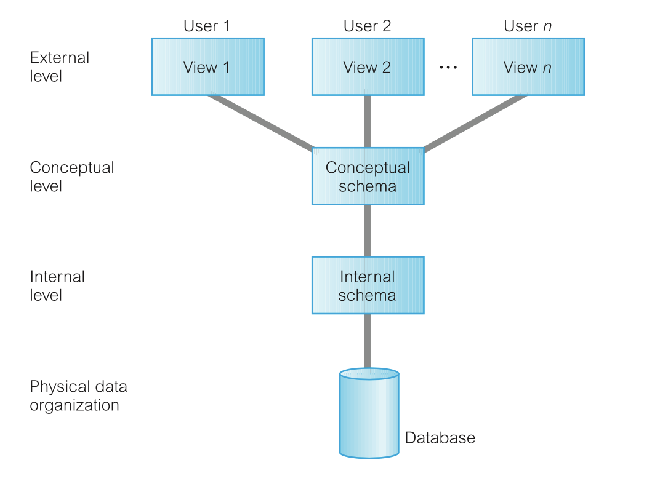
Fig 1. Three-Level ANSI-SPARC Architecture [1, p. 85]

The external level should provide the facility for users to access the same data, with the ability to modify the data without affecting other users [1, p. 84].

Section A

User requirements

Q1: Types of users that may access the database.

In the Coastal Getaways organization, there are several different users that will require a view of the data in the Coastal Tourism Management System (CTMS) and this view must not be compromised by other views for other users. Users of the CTMS for Costal Getaways include:

Type of user | Roles and responsibilities
Tourists | - Use the data on cost, facilities, availability to make an informed decision.  - Registration and reservation.  - Provide feedback.
Local businesses | - Promoting facilities.  - Provide cost and availability of facilities.
Database administrators | - Management of the data resource – database planning, development, creation of procedures and policies.  - Ensure database is maintained, accurate and reliable.  - Make changes to external level view.
Coastal Getaways organization | - Offer a range of coastal vacation packages.  - Provide costing, itineraries, and availability.  - Responsible for managing the database.  - Use feedback from tourists to improve or make changes if needed.  - Manage staff and resources.

Q2: Departments within coastal getaways that might require access.

Departments within Coastal Getaways that would need access to the CTMS:

Department | Needs and responsibilities in managing coastal tourism
Sales department | - Maintain details of clients, registrations, reservations, facilitate secure online bookings.  - Responsible for capturing client details and placing orders.
After Sales | - Collect feedback.  - Deal with problems, inquiries and requests.  - Responsible for collating feedback and using this feedback to make improvements as necessary.
Contracts | - Maintain details of local businesses, list of products on offer, availability, location.  - Regularly engaging with local businesses to set up contracts and maintain a list of businesses.
Human Resources | - List of Coastal Getaways staff and branches.  - Responsible for registering and maintaining a list of current staff across the organization.

Knowledge of these users and departments will help enhance the build of an effective DBMS, which will offer a seamless experience.

Database Design and Implementation

Q3: Coastal Tourism Management System Entity Relationship Diagram (ERD).

Following the initial investigation, the next step when planning a DBMS is to create an Entity Relationship Diagram (ERD). The ERD is used to show the entities (tables), attributes (fields within the tables) and relationships between these entities. It is an important step in the process as it allows you to map out your initial ideas on paper before investing time and energy into building the physical database. This can be considered the planning phase. Figure 2 shows my ERD for Coastal Getaways.

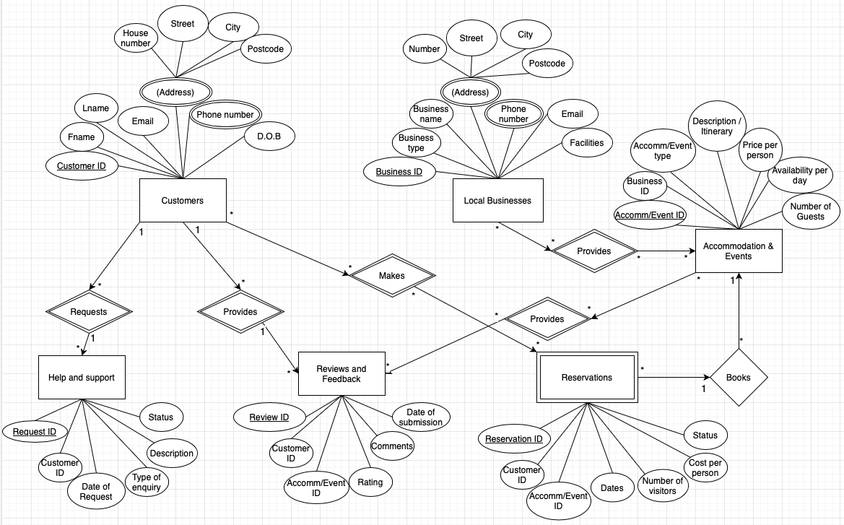
Fig 2. Coastal Getaways Entity Relationship Diagram

Following the user review in question 2, my design is based around a database that will be managed internally by Coastal Getaways staff and departments to manage new customer and business registrations, allowing staff to make bookings and log help, support and reviews.
My “Customers” table will have a relationship to 3 tables:
- to the “Help and Support” table on a one-to-many multiplicity as 1 customer can make several requests for support.
- to the “Reviews and Feedback” table on one-to-many multiplicity as 1 customer can provide several reviews.
- to the “Reservations” table on a many-to-many relationship as many customers can make many different reservations.
Further relationships exist between:
- “Local businesses” table and “Accommodation and Events” on a many-to-many relationship, where many businesses can provide many different events.
- “Accommodation and Events” table and “Reservations” on a one-to-many relationship as one event can be booked with many different reservations.
- “Accommodation and Events” table and “Reviews and feedback” on a many-to-many relationship as many events can provide many different reviews.
The attributes that have been selected have been limited due to the requirement to keep the database simple at this early stage, with further queries planned to be undertaken within the DBMS, for example total costs and revenue calculations.
Furthermore, user access will be developed in future updates, with consideration given to password protecting certain areas of the database and providing user log ins for the different departments within Coastal Getaways.

Q4: Relational database schema.

Now that I have decided on my ERD, I can look in more detail at the separate tables, identifying the Primary Keys and Foreign keys that will be critical to the efficiency of relationships in the database.
The Primary Key is a unique reference number that identifies a record, such as an ID number, like an invoice number of NHS number. A Foreign Key is a Primary Key from another table that can be used to link the two tables together. [2]
Customers Entity:
Attributes: CustomerID (Primary Key), Fname, Lname, Email, Address (House number, Street), City, Postcode, Phone Number, D.O.B

Accommodation & Events Entity:
Attributes: Accom/EventID (Primary Key), BusinessID (Foreign Key referencing Local Businesses), Accomm/Event Type, Description/Itinerary, Price per person, Availability per day, NumberOfGuests

Reservations Entity:
Attributes: ReservationID (Primary Key), CustomerID (Foreign Key referencing Customers), Accom/EventID (Foreign Key referencing Accommodation & Events), Costperperson, Dates, NumberOfVisitors, Status

ReviewsAndFeedback Entity:
Attributes: ReviewID (Primary Key), CustomerID (Foreign Key referencing Customers), Accom/EventID (Foreign Key referencing Accommodation & Events), Rating, Comments, DateOfSubmission

HelpAndSupport Entity:
Attributes: RequestID (Primary Key), CustomerID (Foreign Key referencing Customers), DateOfRequest, TypeOfenquiry, Description, Status

Local Businesses Entity:
Attributes: BusinessID (Primary Key), Business type, BusinessName, Address (House number, Street), City, Country, Postcode, Phone Number, Email, Facilities

If I was to expand my database in the future, I would consider adding more entities into the design, allowing for more control over the running of the organization and management of all aspect, such as staff records, HR information, pay details, branch details.

Application of Database Management System

Q5: Create a DBMS using Microsoft Access.

My DBMS using Microsoft Access has been created using the ERD from question 4 as a guide. Fig. 3 shows the relationships between the tables in my database, and further figures show the components of the various tables within the database.
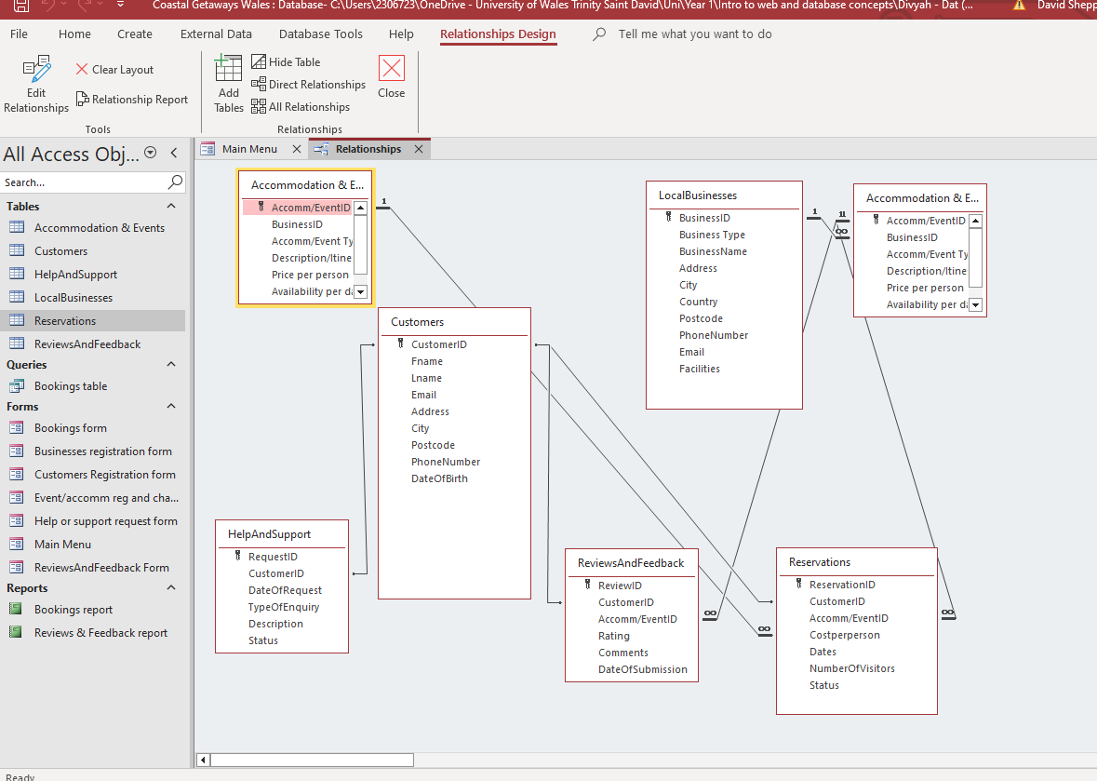
Fig 3. DBMS relationships screen
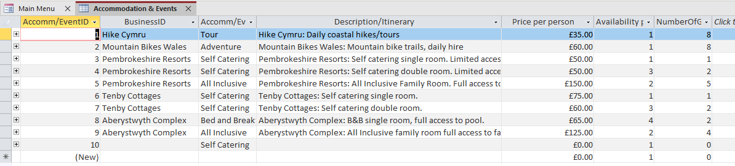
Fig 4. Accommodation and Events table
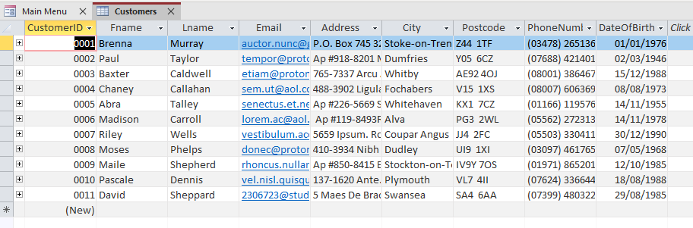
Fig 5. Customers table
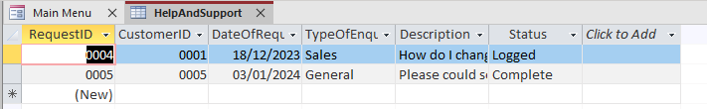
Fig 6. Help and Support table
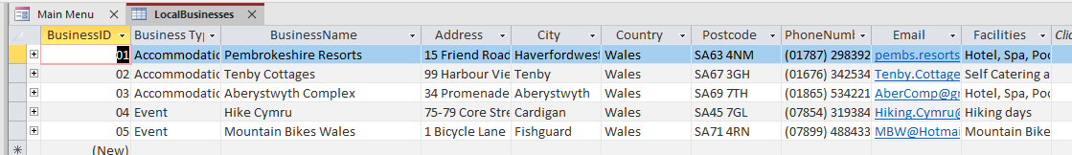
Fig 7. Local Businesses table
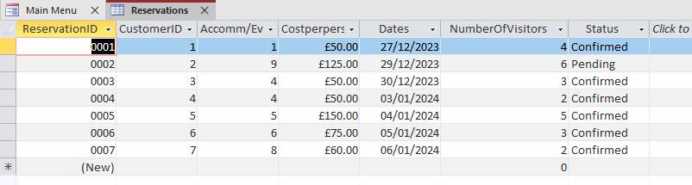
Fig 8. Reservations table
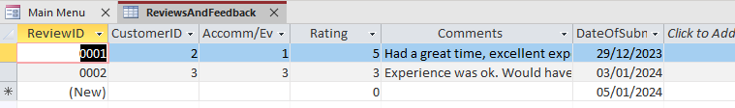
Fig 9. Reviews and Feedback table
Each table in figures 4 to 9 is supported by a form that allows users to input relevant information and update the data. For example, using the “Customer registration form”, users can register new customers to the system using a simple form, and search through existing records.

Reports Design

Q6a: Produce a report that calculates total revenue during a time period.

Included in my DBMS is a report that calculates total revenue in a time period (shown in figure 10) and is generated from a query between the “reservations”, “accommodations and events”, and “customers” table. The query allows me to create an appropriate reservations form, which in turn feeds into a report summarizing all sales during a time period.
Between 27th December 2023 and the 6th January 2024, a total of £2,245 has been generated, from a total of 25 visitors using the system.
For any successful business it is imperative that you can run reports to monitor financial information such as this.
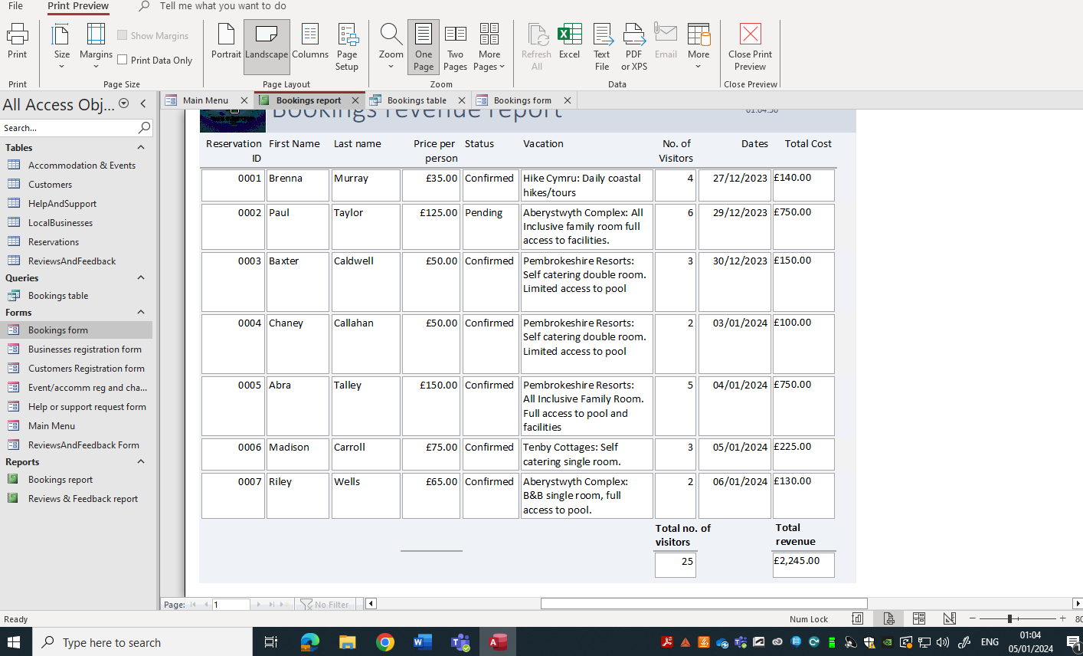
Fig 10. Revenue report from booked events

Q6b: Design a report that compiles guest feedback.

Guest feedback and reviews are also very important elements of any business in this industry. The report that I have generated in this DBMS collates the reviews together and provides an average rating as a summary of overall satisfaction. Ratings of 0 to 5 only can be chosen, and are RAG rated to show Red for reviews rated 0 or 1, Amber for 2 or 3 and Green for anything 4 or over.
Figure 11 shows a summary of the 2 reviews that have been received, one of which provided 5 stars review while the other was 3 stars, giving an average rating of 4 over the 2 records.
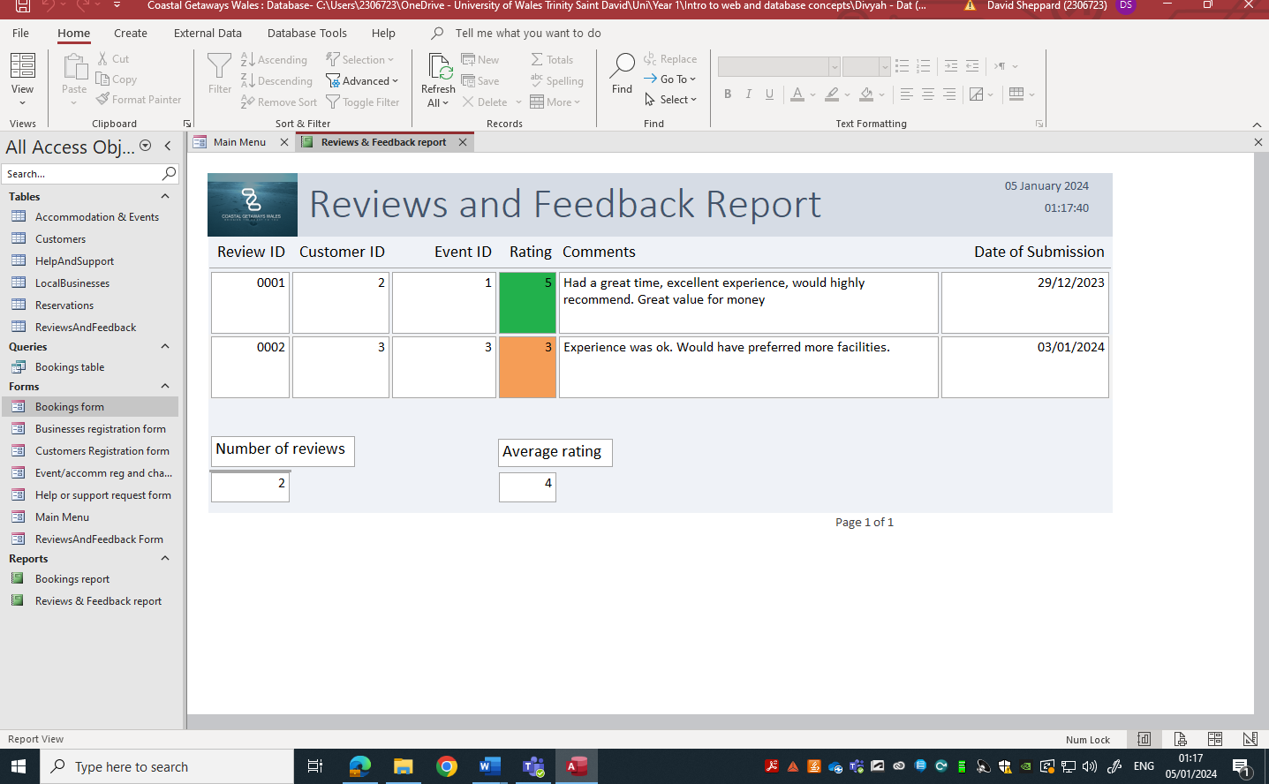
Fig 11. Reviews and Feedback report.
In order to populate this report, a form has been created to capture user reviews as seen in figure 12 and customers can also log help and support requests in figure 13.
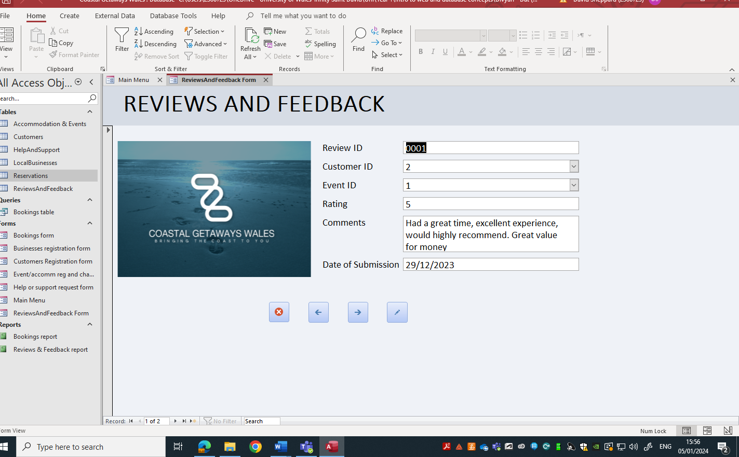
Fig 12. Reviews and feedback form
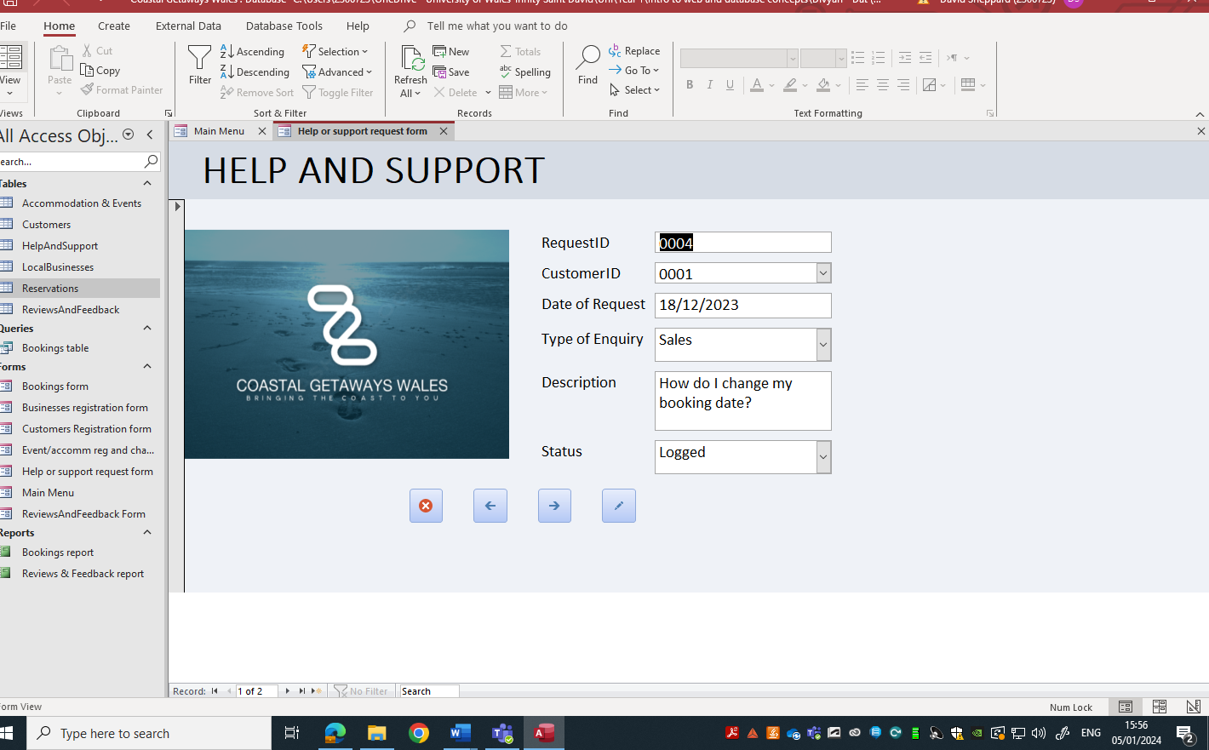
Fig 13. Help and support request form

Forms Design, User Interface and Menus

Q7a: Create a reservation form for tourists to book a coastal vacation package.

In order to produce a functional customer reservation form, I first had to create a query between the “reservations”, “accommodations and events”, and the “customers” table. I named this query “Bookings table”. From this “Bookings table”, I created a Bookings Form, as seen in figure 14.
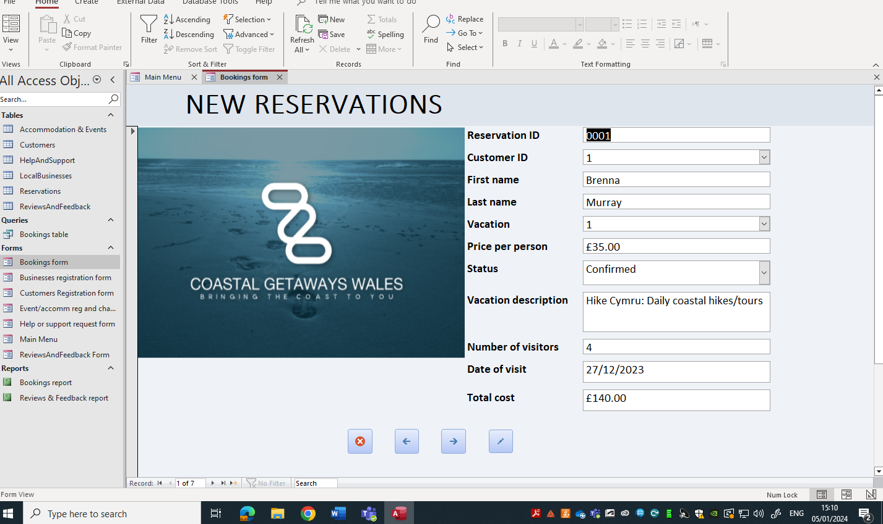
Fig 14. Bookings form
In this bookings form, I included the following controls and validation rules:
- A calculated text box named Total cost (=[Price per person]*[NumberOfVisitors]). This field automatically calculated the cost of the package based on the event cost per person and the number of visitors.
- The form includes navigation buttons to close the form, navigate to previous or next record, or add a new record.
- Once a Customer ID is selected, the customer’s name is displayed. Once a Vacation is selected, the vacation description and price per person is displayed.
- Data from this form feeds into the Bookings Report and Reservations table.
Figure 15 shows the customer registration form that allows new customers to register to the DBMS or make changes to existing customer details, further supporting this process. Only customers that are registered can be selected.
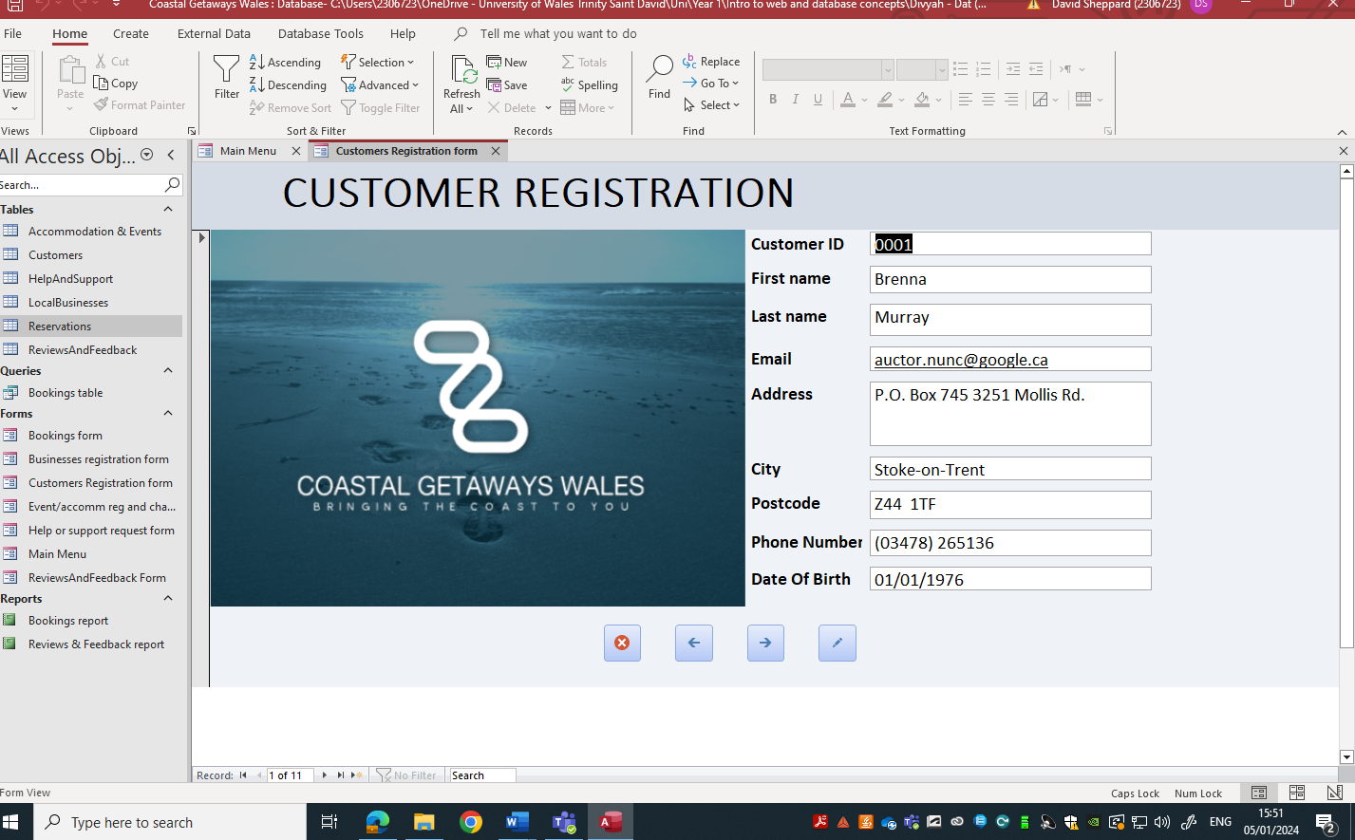
Fig 15. Customer registration form

Q7b: Create a form that allows event owners to update information about their events.

The form allowing event owners to update information about events and add new events is generated directly from the “Accommodation and Events” table. Any additions or changes made via this form update the corresponding entry in the table. Figure 16 shows the form that can be used to make these changes.
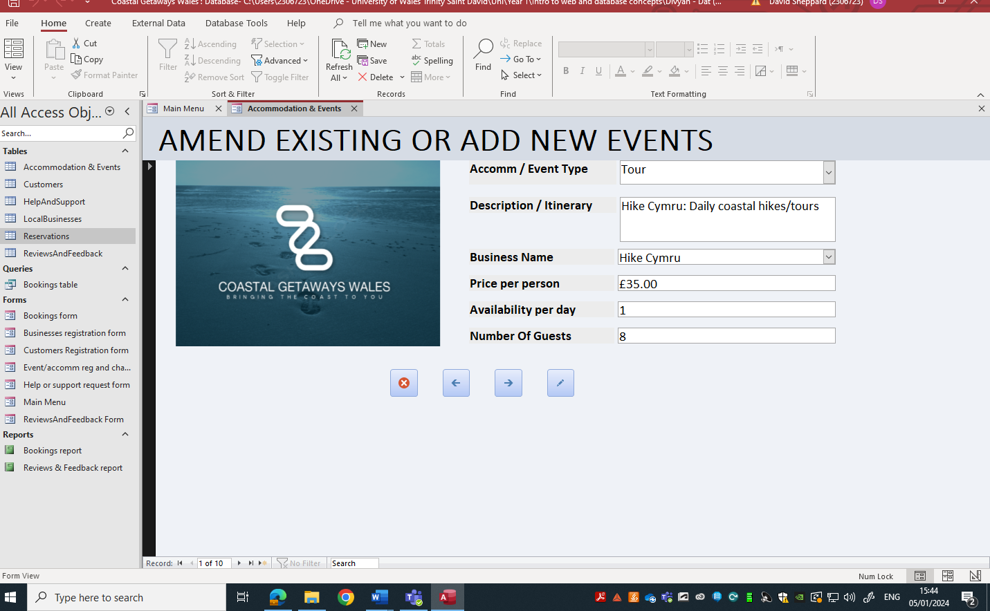
Fig 16. Amend or add new events form
Businesses can select the type of event, the itinerary and their business name. Businesses can change the cost per person and other details here. Easy navigation buttons are included within the form.
To assist with this, a separate form is provided for new businesses to register to the DBMS as shown in figure 17. Here current businesses can update their details or new businesses can register their services. Only registered businesses can have an event.
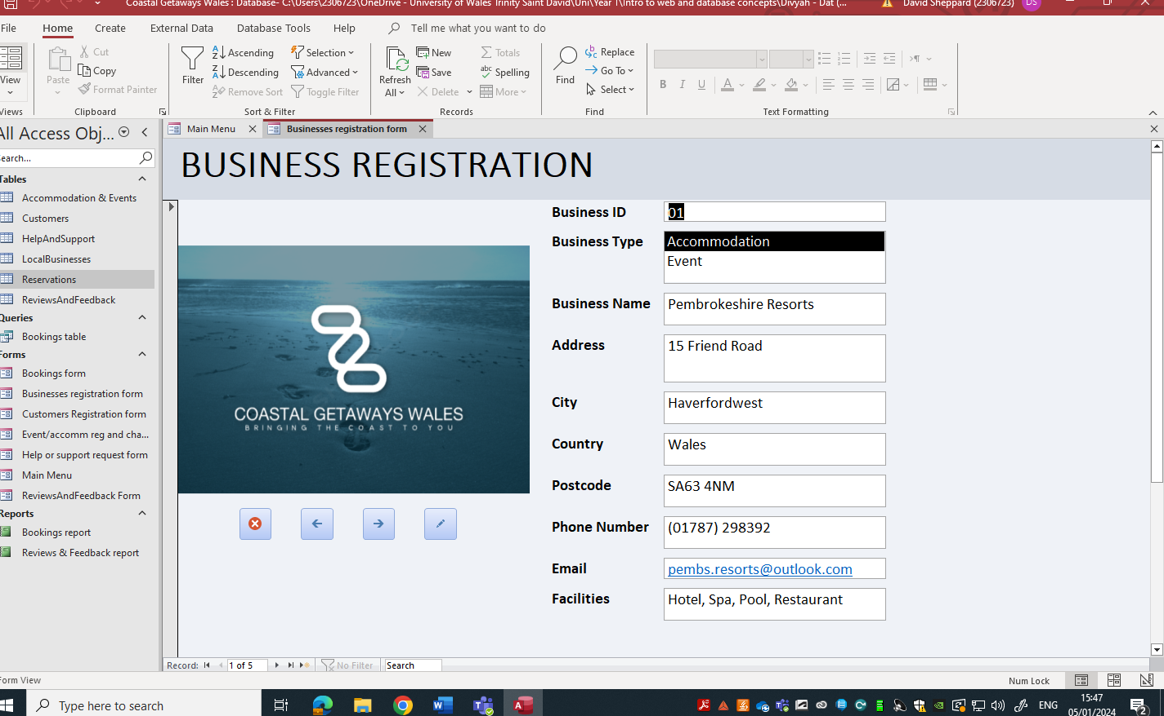
Fig 17. New business registration form

Q8a: Design a user-friendly menu.

I have created a simple main menu system seen in figure 18, from which users can navigate to the forms they want to see and view reports. Buttons have been added to the main menu to allow easy navigation, with clear names for forms and reports.
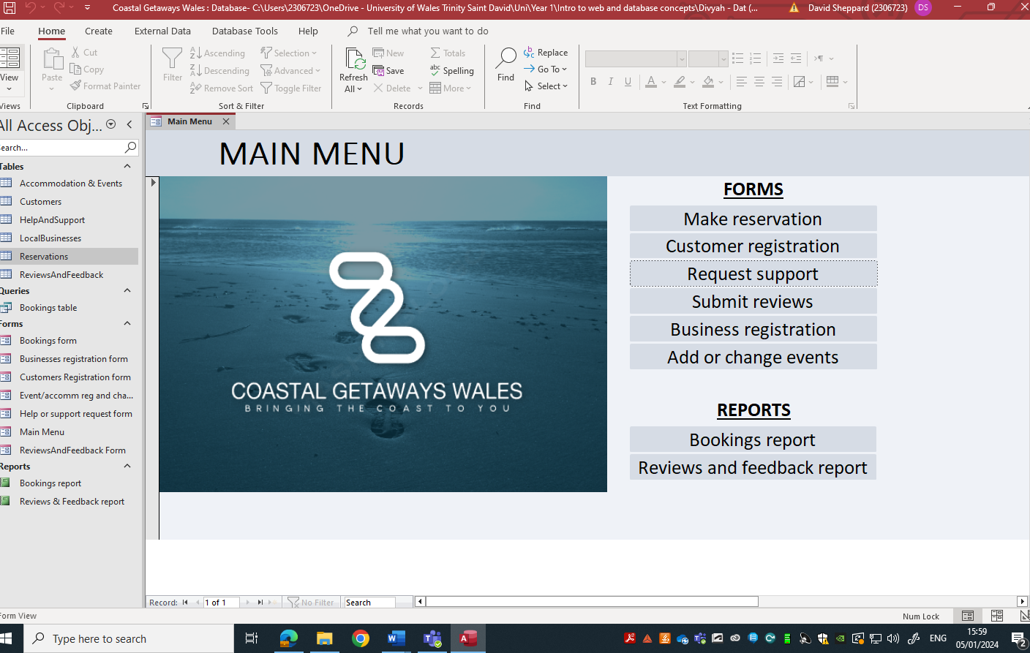
Fig 18. Main menu

Q8b: Menu that displays options immediately after opening the database.

I have set the database to open on the Main Menu screen from the settings as shown in figure 19. This allows users to have a user-friendly experience by being prompted to select the area they want to look at.

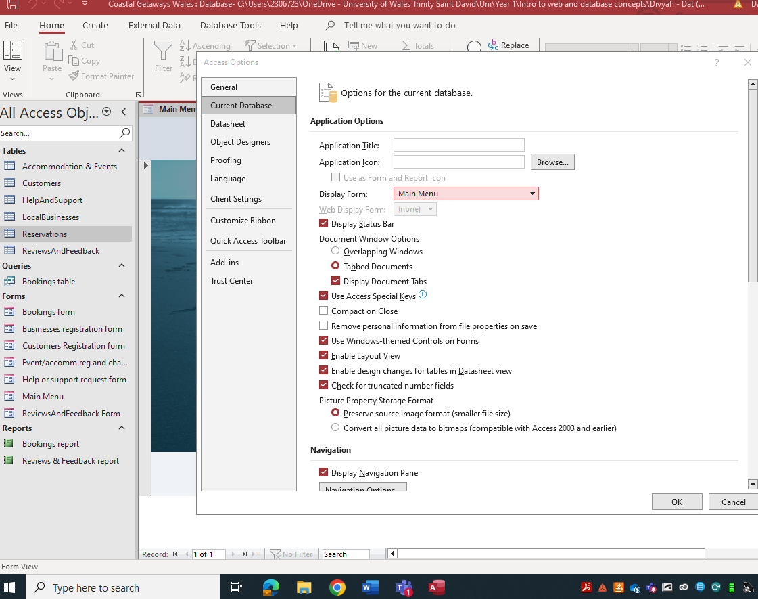
Fig 19. Main Menu display options

Section B

Q9: Importance of developing MS Access database for Coastal Tourism Management

“Humans can process a limited amount of data” is a verified fact, as managers within an organization simply cannot handle or memorize vast quantities of data that can be help in a business. Therefore, a digital solution such as a DBMS is required, where computers can analyze vast quantities of data simply and effectively. This frees up managers to focus only on the data that matters to learn and build knowledge. This in turn helps a business grow. [3]
A company such as Coastal Getaways Wales is a very complex organization. As identified in questions 1 and 2, there are several different users, with data captured for several different local businesses, a growing number of customers and a wide range of ever-changing holiday packages. Add to this the number of staff that it would take to run this organization and you are left with lots and lots of data.
The alternative to a DBMS is a paper system, where manual records are kept monitoring data on customers, businesses, staff and reservations. Paper systems can be very good in smaller organizations where there is less complexity, which can be managed more efficiently. However, when you get to managing different entities across different sites, it becomes harder to manage. Additionally, using a DBMS allows you to create relationships in data and allows you to run queries such as quick and easy calculations of revenue.
If you consider the calculation of revenue addressed in question 6a. In the MS Access database, all data was contained in separate tables. This data is all held centrally. A query was then run to merge data from these tables so that the cost of an event could be multiplied by the number of guests booked onto the reservation. This then got totaled into a simple report that can be run at any time and can have results available live.
Considering the alternative, paper-based solution, there may be data held about events in files in one department, and records about customers in a separate department. Those 2 departments would need to communicate with each other when registering a new customer for an event. Following this, if a report on revenue was requested, somebody would have to try and manually gather information from different paper forms and bring it all together, taking a lot more time and increasing the margin for error. Additionally, this only works for a set point in time, so if another report was requested, the whole long-winded process would have to be run again.
In summary, a database will exponentially improve efficiency in the organization.

Q10: Potential challenges and benefits of transitioning from manual data

As outlined in Q9, manual data collection can be difficult to track due to the volume of paper records. This can lead do logistical challenges with moving records onto a computerized system. For example, records can go missing or can be incomplete and can take a long time to process. This leads to increased costs.
Additionally, some users are very reluctant to embrace change and will push back against implementation of a computerized system. This is a problem often encountered in my line of work, the NHS, where such a high volume of users are used to a manual method of taking certain records and are reluctant to change.
However, benefits can be wide-ranging, from more efficient reporting, reduced storages costs, upskilled employees and improved data integrity (assurance that data is accurate and consistent throughout its life cycle) [3]. A DBMS addresses these challenges by offering a sustainable reliable service for the future.

Conclusion

Creating this DBMS has made me appreciate the thought and work that goes into managing data. I realize how it can improve the efficiency of data storage and retrieval and offer solutions for businesses that have expanding portfolios that would like to move away from a paper-based system.
I found Microsoft Access to be quite challenging at times, but it is very rewarding when you make it work as planned. I feel like I can take away some of the tools learnt during this assignment and use them in my current job role.

Bibliography

[1] | T. M. Connolly and C. E. Begg, Database Systems: A Practical Approach to Design, Implementation, and Management Sixth Edition, University of the west of Scotland: Pearson Education Limited, 2015.
[2] | BBC Bitesize, "Introducing Databases: Primary and Foreign keys," 5 January 2024. [Online]. Available: https://www.bbc.co.uk/bitesize/guides/zc93tv4/revision/5.
[3] | S. Zygiaris, Database Management Systems : A Business-Oriented Approach Using ORACLE, MySQL and MS Access, Emerald Publishing Limited, 2018.

