

Programme: Master of Business Administration

Module Code: LCMB7034
Module Name: International Business Concepts

Student Name: Dharmikkumar Govindbhai Rabari

Student ID: 2510581

Assignment Title: Report

Lecturer Name: Gladius Kulothungan

Words: 4600

Table of Contents
1. Organisational Classification and Global Strategy 4
1.1 Strategic Categorisation 4
1.2 Global Configuration 4
2. Macro-Environmental Appraisal and Market Attractiveness 5
2.1 Political Environment 5
2.2 Economic Environment 6
2.3 Legal Environment 8
2.4 Cultural Environment 9
2.5 Market Entry Analysis Using Dunning's Eclectic (OLI) Framework 10
3. Entry Mode Strategy and Strategic Synthesis 13
3.1 Historical Pattern Recognition 13
3.2 Strategic Fit and Justification 14
3.3 Conclusion and Recommendations 15
4. Reflective Account 16
4.1 Description 16
4.2 Feelings 17
4.3 Evaluation 17
4.4 Analysis 18
4.5 Conclusion 18
4.6 Action Plan 19
References 20

1. Organisational Classification and Global Strategy

1.1 Strategic Categorisation
Reiss is a British high-end fashion retailer which has grown from a store in London to become a high-end fashion brand on an international scale. The company now has company-owned outlets, franchise agreements, wholesale deals, concessions and ecommerce outlets throughout the United Kingdom, Europe, North America and Australia (Reiss, 2026a). The information available in public records suggests that Indonesia is currently not a part of Reiss's major business operations, as there was no evidence of any Reiss-owned stores or set up subsidiaries in Indonesia (Reiss, 2026d). As such, Reiss offers a valid case to examine which is that of an established multinational company expanding into an overseas market.
The two approaches that Bartlett and Ghoshal (1989) have used to categorise multinational enterprises (MNE) are based on the degree of global integration and the degree of local responsiveness. It can be concluded that Reiss can be best classified as a transnational approach as it strives to establish a global brand while at the same time adapting the approach to the local market (Bartlett and Ghoshal, 1989). The company's strategic operations, such as product development, brand management and sourcing, continue to be driven from the United Kingdom, ensuring an international premium brand image (Reiss, 2026b).
But the activities that the company offers to customers are carried out in a number of different market-specific arrangements, such as franchise operations, concessions and wholesale partnerships, which allow the company to cater for the varying preferences and regulations of customers. The strategic dimension of central control with operational autonomy at the local level is believed to be the way multinational companies achieve a balance that helps them gain international competitiveness and remain coherent at the organisational level (Dasí et al., 2024).

1.2 Global Configuration
The geographic reach of Reiss' business is impressive and shows a diversified business model that works both online and offline, with strategic partnerships. Instead of using only totally owned subsidiaries, the company grows by several ownership models that enable the company to expand internationally but keep the financial risk and operational exposure to a minimum (Reiss, 2026c). This configuration allows Reiss to obtain economies of scale in the development, branding and management of the supply chains; at the same time, it offers flexibility in terms of adapting to other market characteristics. This is especially relevant in the luxury fashion sector, where maintaining consistency and integrity of the brand's image and the experience of its customers is a source of competitive advantage (Global Fashion Agenda, 2024).
The firm's global configuration also helps to create value in the long term by utilising intangible assets in geographically dispersed markets. Its high brand value, design ability and its own retail channels offer it competitive edge which can be exported to other markets without having to copy each of its activities. Modern studies suggest that MNCs are able to generate more strategic value if the coordination of their operations across countries is done in a way that ensures protection of their core capabilities and adequate market responsiveness (Kapeller et al., 2024). Reiss's transnational approach and international diversification, thus, give a solid strategic ground to assess their future expansion in Indonesia where maintaining a global brand while adapting to the local market will be key to sustainable competitive advantage (Donnelly et al., 2024).

2. Macro-Environmental Appraisal and Market Attractiveness

2.1 Political Environment
Indonesia has a relatively stable political environment that welcomes foreign investments for the long-term and is an attractive place for Reiss to invest as a multinational retailer. The economic reform, investment liberalisation and digitisation have been a focus of successive governments to make Indonesia more competitive in the Southeast Asian region. The implementation of such measures has enhanced the trust of investors in the country, made investment much easier and created a more transparent regulatory framework for foreign investment (UNCTAD, 2024). The World Bank also acknowledges that Indonesia has been able to stay economically resilient in the face of global uncertainty, a testament to the Government's efforts to ensure that the economy and the country's institutions remain stable (World Bank, 2026a).
In spite of these good signs, Reiss needs to acknowledge that the political landscape in Indonesia is quite institutionalised. The decentralized system of government gives the regions extensive flexibility in regard to the implementation of national policies, which inevitably leads to variations in the licensing process, commercial approvals and local administrative procedures. More institutional variation makes market entry more complex and necessitates multinational companies to have flexible governance structures that are able to adapt to regional regulatory differences. Research has shown that the institutional distance between home and host countries is positively associated with market entry uncertainty, and local knowledge and adaptive management skills are crucial factors for international market entry success (Donnelly et al., 2024).
Political changes also have an increasing impact on the digital business world. Indonesia is continuing efforts to enhance consumer protection and digital governance by introducing more regulations for online platforms and digital services. In particular, the government has been keen to step in the digital world with the objectives of public policy come into play, as with recent proposals to limit social media access for children (Reuters, 2026). Even though these don't directly affect foreign retailers, they signal the need for Reiss to keep up with changing digital regulations and adjust their online marketing strategy to meet local policy needs. Overall, the political environment in Indonesia is favourable to market entry, as long as Reiss has a coordinated strategy with international partners and is able to help mitigate the complexity of institutions and legislative changes in Indonesia (Aguzzoli et al., 2024).

2.2 Economic Environment
The large consumer market, high economic growth and growing middle class in Indonesia make it an extremely promising economic market for Reiss. Despite the ongoing global economic uncertainties, the International Monetary Fund (IMF) projects a growth of around 5% for the economy in 2025 and 2026. Stable economic performance will help increase household consumption and provide good conditions for international premium retailers to find long term market opportunities. In the future, disposable income is likely to be growing, leading to a rise in demand for foreign brands of lifestyle and fashion products, especially for urban middle- and high-income consumers (World Bank, 2026a).
The other economic benefit is the growth of the digital economy in Indonesia. With internet penetration over 80%, Reiss has instant access to a large digitally connected consumer base with DataReportal estimating around 230 million internet users. APJII's recent report also echoes these findings, revealing that digital connectivity has become a key aspect of Indonesian consumers' lives, driving the growth of online retail and omnichannel commerce. In addition to expanding its brick-and-mortar footprint, Reiss can use its existing e-commerce platform to grow brand recognition, while minimizing the risk of an initial investment.
Indonesia's economic appeal is not only its size, but also from an international business point of view. Modern studies on location attractiveness contend that alongside the traditional economic factors (GDP growth, labour costs etc.), digital infrastructure and institutional quality and technological readiness have become equally crucial factors in the location choice of foreign investors (Andy et al., 2024). Likewise, recent studies based on Dunning's Eclectic Paradigm highlight that companies are increasingly looking at the digital readiness and market accessibility as part of their considerations in the choice of location for international expansion (Li and Eriksson, 2026). As a result, Indonesia's continued economic growth, digitalization and increasing consumer purchasing power provide good economic conditions, which are very compatible with Reiss's premium omnichannel retail approach.
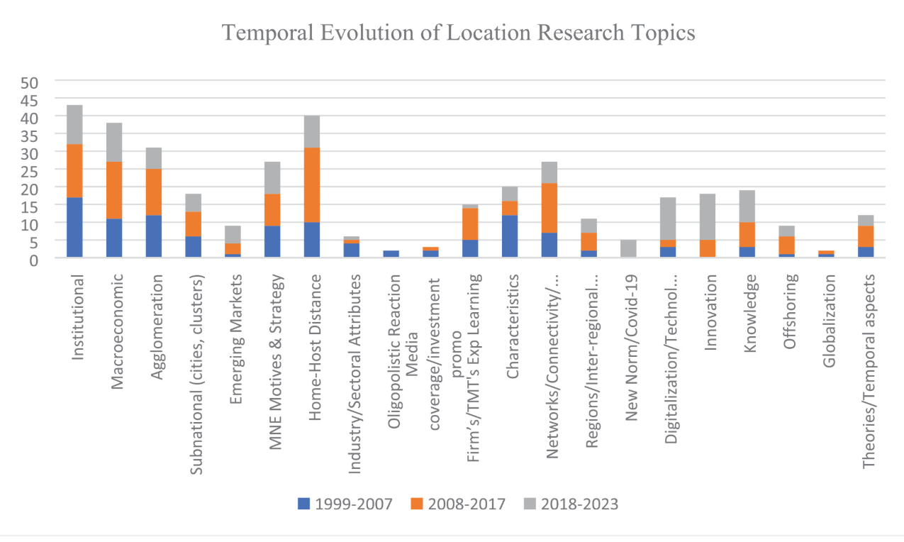
Figure 1: Temporal evolution of location research topics
Source: (Andy et al., 2024).

2.3 Legal Environment
Indonesia has opportunities and challenges for Reiss's planned market entry. While the government still promotes foreign investment with a series of regulatory changes, international retailers must meet a number of import laws, certification requirements and commercial standards to open a business here. The U.S. Department of Commerce indicates that Indonesia has an open trading climate while a number of product categories linked to the fashion industry still have import duties, customs procedures and product-specific requirements and regulations (U.S. Department of Commerce, 2025a). Such compliance requirements make it more expensive and complex to come into the market in Indonesia.
While tariffs may be just one of the legal requirements, product standards, intellectual property protection, customs documentation and local regulatory approvals are also part of the equation. Local-content requirements, testing procedures, and ongoing intellectual property issues are among the important challenges that can impact foreign companies doing business in Indonesia (U.S. Department of Commerce, 2025b). The protection of brand reputation, the authenticity of products and the integrity of their design is of paramount importance for a high-quality fashion brand like Reiss. Uncontrolled and poorly managed legal risk could damage consumer trust and add to operation costs for meeting regulatory requirements.
The legal environment also affects the decision of the market entry strategy. An international business study indicates that companies that enter into legally complex markets may be better served by forming a partnership with a local partner experienced at operating in the country to understand the local regulations and administrative requirements (Brouthers et al., 2022). In addition, the research on multinational governance shows that multinationals perform better when they have a centralized strategic control and local operational expertise (Dasí et al., 2024). As a result, the Indonesian legal landscape does not bar Reiss from entering the market but reinforces the need to carefully choose an entry mode, which is a balance of compliance with the law, flexibility of operations and effective protection of the company's brand assets.

2.4 Cultural Environment
Consumer preferences play a crucial role in determining purchasing behaviour in the premium fashion industry, and cultural compatibility is a key factor that can contribute to Reiss's success in Indonesia. Indonesia is the world's largest Muslim-majority nation and is known for its modest fashion that is well supported by government policies and industry organisations that advocate for the competitiveness of the fashion industry in the international market (IAEI, 2025). Instead of being a limitation, it creates an opportunity for Reiss to offer specific product lines, such as tailored dresses, occasion wear and top-quality workwear, in the expanding modest-luxury market, without compromising the brand's premium British reputation (Kemenperin, 2025).
The cultural alignment of Reiss and the Indonesian market is also enhanced by urbanisation and altered lifestyles of consumers. As consumers in the middle and upper tier of income levels get more sophisticated, they are looking for brands that not only offer quality, exclusivity and modern fashion, but also provide them with easy-to-use multi-touchpoint shopping experiences. Reiss' current focus on high-end design, digital retailing and customer experience dovetails nicely with this new, changing consumer outlook.
Instead of relying on mass-market pricing, the company can differentiate itself in terms of the quality of its products, craftsmanship and brand heritage, which are still very important in the minds of the more affluent urban consumers. Previous studies in international luxury fashion retailing have shown that the best performing premium brands are those that maintain their key brand values and make some changes to local preferences (Bai et al., 2021).
But cultural adaptation should be selective and not extensive. Too much of a good thing can prove to be a bad thing and could water down Reiss's premium image and lose its sense of separation from home-grown brands. Recent studies suggest that the sustainable competitive advantage for multinational fashion companies lies in their ability to maintain a global image while also adapting the product and marketing strategies to a certain degree to meet local cultural expectations (Bai et al., 2024).
Hence, Reiss must maintain the quality of its British collection and add culturally relevant collections, localization marketing campaigns and digital communication strategies that are relevant to the Indonesian consumers. This would help to reinforce the customers' acceptance of the product, while maintaining the international brand equity on which the company's international competitive advantage is based.

2.5 Market Entry Analysis Using Dunning's Eclectic (OLI) Framework
For Reiss, the Indonesian market is suitable to be evaluated based on the Eclectic Paradigm of John Dunning. The OLI framework states that there are three complementary advantages that need to be considered to achieve international expansion: ownership advantages, location advantages and internalisation advantages. This framework is not about these things separately, but rather, it brings together the capabilities of the firm and the characteristics of the host country to answer the question of whether foreign market entry will lead to sustainable competitive advantage (Li and Eriksson, 2026). Based on the above political, economic, legal and cultural analyses, Indonesia has a lot of potential for Reiss, but the attractiveness of market entry relies on the strength of reinforcement of the three OLI dimensions.
Ownership advantages (O) are the firm specific resources and capabilities which allow the company to be successful in a foreign market against domestic companies. Reiss has a number of unique ownership benefits, such as a trusted brand in the UK, a reputation for good design, a multichannel retailing strategy, and experience in growing internationally in various ownership configurations (Reiss, 2026a). The company has also gained experience in managing product development, merchandising and customer experience across the geographically dispersed markets, while also ensuring consistent brand positioning (Reiss, 2026b).
The intangible assets are hard to copy by competitors and give Reiss a basis to enter into Indonesia. Studies on multinational enterprises have indicated that companies with valuable intangible assets like brand equity and design skills are likely to gain sustainable competitive advantage in international markets because these assets can be transferred from one market to another without significant extra investments (Kapeller et al., 2024).
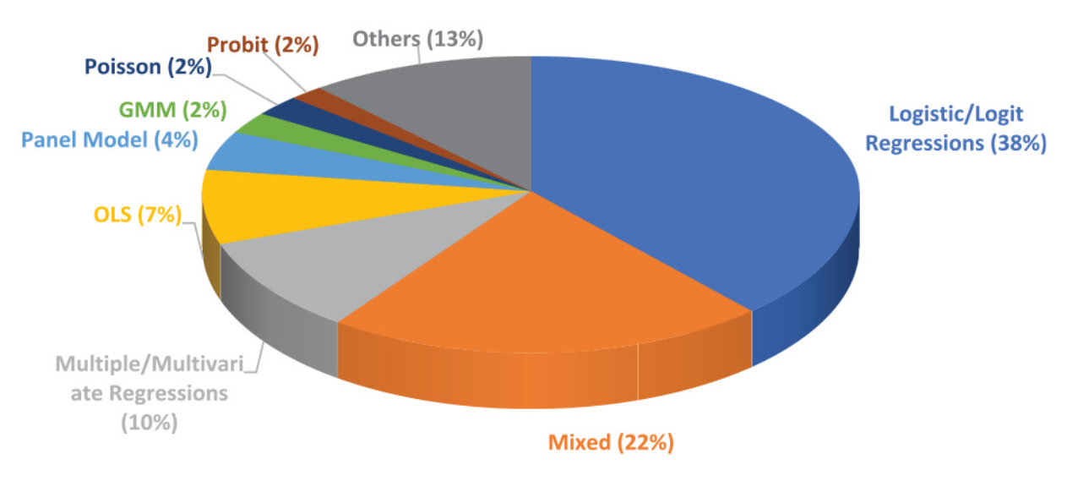
Figure 2: Types of analysis
Source: (Andy et al., 2024)
Location advantages (L) is a factor that makes Indonesia an attractive place for expansion by other countries. Politically, the country presents a relatively stable investment climate with continuous economic reforms, and the government's drive towards digital transformation (UNCTAD, 2024). From an economic perspective, a high growth in GDP, rising disposable incomes and one of the largest digitally connected consumer populations in the world offer promising circumstances for premium retail growth (IMF, 2026). Regulatory complexity and import requirements are potential compliance issues, but these can be overcome by suitable market entry strategies and local partnerships, legally (U.S. Department of Commerce, 2025b).
Culturally, the rising premium fashion market and the well-known modest fashion industry in Indonesia offers Reiss the chance to customise some collections while maintaining its worldwide brand identity (IAEI, 2025). Overall, these location-specific benefits indicate that Indonesia has the institutions, commercial and consumer attributes to support Reiss's long-term growth plan.
Internalisation advantages (I) are the benefits that accrue to Reiss if they have direct control over the strategic activities or if they use external market mechanisms. Although the potential of the Indonesian market is very large, the legal and institutional issues discussed previously suggest that the use of wholly owned subsidiary may be risky for the company in the early phases of the expansion. Rather, Reiss should take on roles that are directly tied to brand value creation functions – such as product design, merchandising strategy, digital customer experience and brand management – and partner with skilled local resources for store management, regulatory compliance, and market development (Reiss, 2026c).
Institutionally complex markets are associated with better performance of hybrid governance arrangements, where strategic control is paired with local knowledge and flexibility of operations, as shown by research on non-traditional entry modes (Brouthers et al., 2022). Likewise, the research on multinational governance suggests that having central strategic control with local operational capabilities will aid companies in achieving better performance and mitigate risk of foreign market entry (Dasí et al., 2024).
The overall result of the OLI framework in Indonesia suggests that it is a strategic opportunity that is attractive for Reiss, as all three dimensions support each other. The company's ownership advantages are good, the location advantages of Indonesia are good, and the internalisation strategy is selectively implemented, so that Reiss can safeguard its brand while minimizing the risk of entering the market. Therefore, by using the OLI analysis, it is possible to enter into the Indonesian market by a gradual and step-by-step process with a combination of control and strategic assets from the central level and operation from the local level. This synthesis is the strategic context for the analysis of the most suitable entry mode that follows, in which the opportunities and disadvantages of the various types of market entry are discussed, taking into account the risk, the commitment of resources and the potential for long-term competitive advantage.

3. Entry Mode Strategy and Strategic Synthesis

3.1 Historical Pattern Recognition
Reiss has a flexible approach to international expansion as opposed to a one-size-fits-all strategy in each market. Its growth has been mostly through company owned stores, franchise agreements, wholesale arrangements, concession and e-commerce, depending on the market characteristics and strategic goals (Reiss, 2026c). This multi-faceted strategy allows the company to expand its business overseas and to meet the conflicting demands of investment and control and responsiveness to markets. In developed and strategic markets, Reiss has retained more control and ownership of the customer experience, while in other markets, franchise and wholesale models have been implemented because of the strategic value that local market knowledge and less capital commitment offer (Reiss, 2026a).
This historical trend is typical of a transnational multinational company which wants to remain consistent on a global level but flexible in terms of market entry. Modern studies indicate that strategic alliances and hybrids are becoming more common among companies aiming to capitalize on niche fashion retail segments as it enables organisations to safeguard their strategic assets while leveraging local market expertise and agility (Bai et al., 2024). Likewise, in the field of multinational governance, other scholars have proposed that a mix of two capacities – strategic control and the ability to operate locally in the country – has a positive impact on international performance because it helps to lower uncertainty in foreign market entry (Dasí et al., 2024). Thus, Reiss's internationalisation policy over the years has been one of a mixture of control and flexibility, not a policy of 100% investment or 100% outsourcing in all markets.

3.2 Strategic Fit and Justification
The strategy of franchise and partnership-based expansion would still be the best option for entering Indonesia as it has been the historical strategy of Reiss. The Indonesian market has promising growth prospects, but the political, legal and institutional analysis suggests that the company should not enter the market in a totally foreign ownership format, but rather by establishing a joint venture format in the first stage of market entry, thus avoiding unnecessary financial and operational risks. In addition, uncertainty about consumer demand and institutional complexity, as well as import regulations and compliance, add to the cost of direct investment (U.S. Department of Commerce, 2025b). A combination of a master franchise and strategic retail partnership with direct e-commerce is thus the most appropriate fit for the resources, control and flexibility in the market (Brouthers et al., 2022).
This allows Reiss to maintain its direct control over activities that are essential to competitive advantage, such as brand management, product design, merchandising strategy, digital customer experience and marketing communications, and at the same time gives experienced local partners control over the activities directly related to store operations, regulatory compliance and domestic distribution (Reiss, 2026c). As per Dunning's OLI framework, Reiss's brand and design capabilities are well-controlled in the center, which is a protection for its ownership advantage, and Indonesia's market size as well as its digital maturity and growing premium consumer base are a strong source of location advantages (Li and Eriksson, 2026). The idea of internalisation should therefore be to protect strategic assets, not to be spread-out over-all activities.
A step-by-step approach would limit risk and enable Reiss to assess how the market does before committing substantial capital investment. The first step to the Indonesian market is to start through the internet and digital marketing strategy in Indonesian language, followed by the establishment of premium concessions or pop-up stores in the main metropolitan retail centres. Permanent standalone stores should only be considered once there is evidence of ongoing commercial viability from performance indicators. Digital conversion rates, AOV, CAO, repeat purchase rates, and gross profit after import duty and retail productivity should be key evaluation metrics, allowing for evidence-based decisions on expansion, alongside retaining flexibility (World Bank, 2026a). This is in line with the current international business research, which has found that mixed forms of governance often work better than 100% foreign direct investment in institutionally complex markets, due to the strategic control and the local expertise they bring together (Brouthers et al., 2022).

3.3 Conclusion and Recommendations
It can be observed that the analysis reveals that Indonesia is a better opportunity for long-term growth for Reiss rather than a market which calls for heavy investments. The stable political environment of the country along with the growth in economy, growing population of digital consumers, and increased need for fashion apparel products provides a good environment for expansion. However, the complexities involved in the market and uncertainties call for a careful approach towards the same (Donnelly et al., 2024).
All things considered, Reiss should use a phased master franchise or strategic retail relationship coupled with e-commerce and some retailing. This strategy would match the company's past strategy regarding internationalization, allowing the firm to retain control over its premium brand properties and lower the associated political, financial, and operational risks at the beginning of market entry (Reiss, 2026c). With this combination of global strategic control and local operational knowledge, the firm can increase its competitive advantages over time while still maintaining enough flexibility to scale up, adjust, or restrict their investment in the future, based on the performance of the market. Thus, such an entry strategy is a perfect match between the company's internationalization and the market potential of Indonesia (Brouthers et al., 2022).

4. Reflective Account
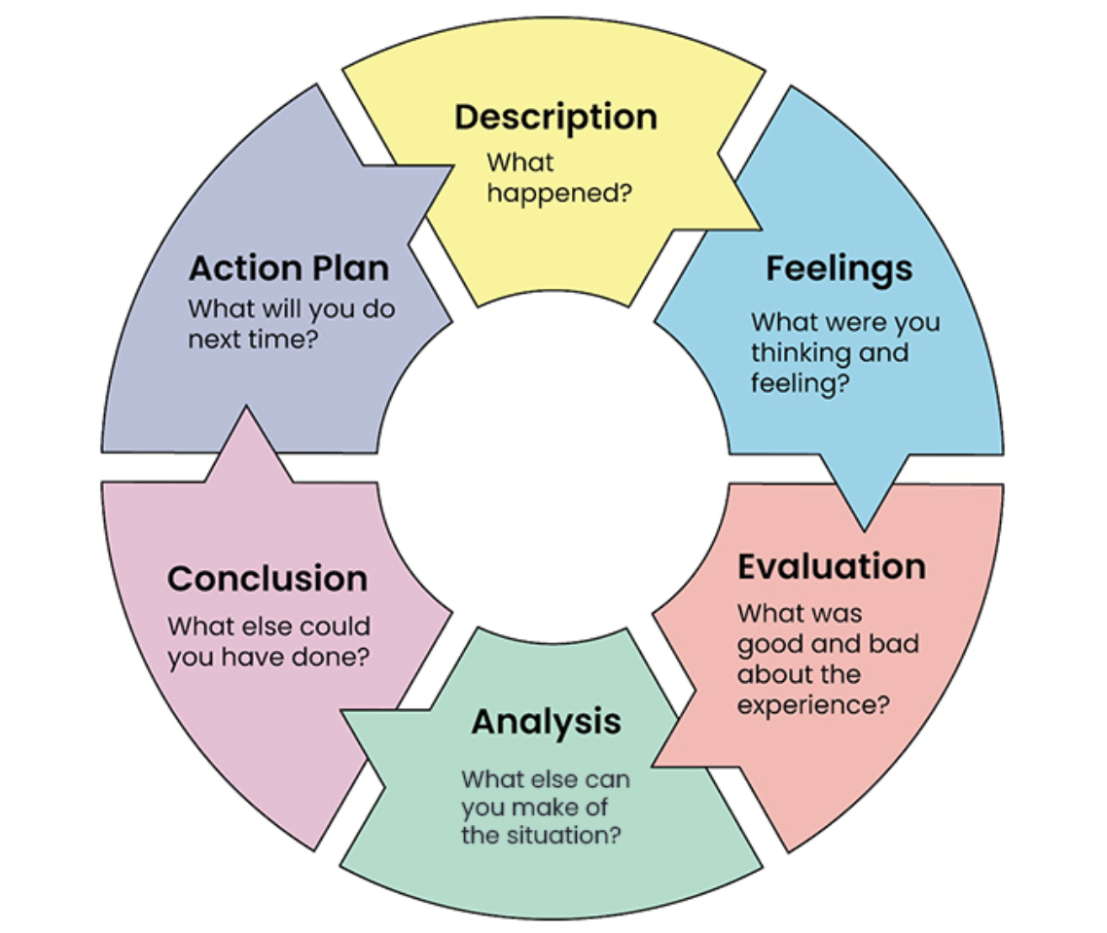
Figure 3: Gibbs’ Reflective Cycle.
Source: (OpenLearn, 2026)

4.1 Description
The preparation of this assessment started by carefully considering the assignment brief, determining the learning outcomes, assessment criteria and the structure of the report. I mapped out the process of research prior to starting the report to the requirements of the assignment. This method kept the report analytical and not descriptive, and all sections helped to answer the main research question, which was about Reiss's international expansion to Indonesia (UWTSD, 2026).
The information in the report was gathered from several sources, such as Reiss's official publications, peer-reviewed journal articles, and government reports and international organisations like the World Bank and the IMF. Information about the company was used to gain insight into Reiss's international activities, and literature from the academic field was used for theoretical support in analysing the internationalisation strategies and market entry decisions. The academic evidence coupled with industry evidence enabled recommendations to be based on up-to-date and reliable information and not on personal opinion (Li and Eriksson, 2026).

4.2 Feelings
Initially, I thought that analysing Indonesia would be relatively easy due to its large population and the economy was growing. But I quickly found out that it was going to be more difficult than I thought as there was little to no information about Reiss's expansion into Indonesia that was available publicly. This raised questions as to what can be done to develop realistic recommendations without making assumptions.
The lectures and suggested readings helped me to stick to existing and accepted international business models and not make guesses. As I continued the research, I grew more confident as I realised that the literature available supported the development of strategic recommendations and they could be substantiated through an analysis of company information as well as other more general economic, institutional and academic evidence. This experience gave me confidence in conducting independent research and gave me a better ability to critically examine the international business opportunities in terms of not just company disclosures, but also critically (OpenLearn, 2026).

4.3 Evaluation
The use of several credible sources to examine the same issue from various points of view was one of my best research experiences. Reports from companies were used to gain insight into how Reiss's business model works, and academic journals were used to explain the importance of the choice of internationalisation strategies for companies. Up-to-date evidence on the economic performance of Indonesia, investment climate and digital development were provided by government publications and international organisations. By comparing the different sources, I was able to develop well-rounded arguments and make the recommendations in the report more credible (World Bank, 2026a).
I also had a great impact on the approach to the assignment from the module lectures. I didn't learn theories, but I learned that frameworks should be used in real business problems. Therefore, the model used in this study was adapted from Bartlett and Ghoshal's model for classification of Reiss's international strategy and the OLI model was used to explain the opportunities and challenges of international expansion in Indonesia. The use of these theories directly to the case study enhanced the analytical quality of the report and provided a support to the recommendations based on the recognized international business theories (Brouthers et al., 2022).

4.4 Analysis
I have been able to gain a lot more knowledge about international business strategy after completing this assessment. Prior to the report, I had primarily thought of successful international expansion in terms of size of the market and economic growth. The lectures, readings and case examples across the module, however, showed that there is a need to balance ownership advantages, institutional conditions, regulatory complexity, cultural differences, and organisational capabilities, in order to achieve successful internationalisation. This wider knowledge allowed me to look at Indonesia more objectively and to make a good case for a phased partnership approach rather than a whole of ownership approach to growth (Donnelly et al., 2024).
In the process of conducting this research I also developed my skills at critically assessing evidence. I didn't take any information from individual sources; I did a comparison of findings in academic literature, company reports and government publications and made conclusions. This method enhanced the quality of the report as a whole as the recommendations were made from the converging evidence, not just one person's opinion. It also illustrated the practical application of the knowledge acquired through the module in real decisions in international business, thus making the final report more practical and strategic (Aguzzoli et al., 2024).

4.5 Conclusion
In general, this assignment helped me to improve my research skills and my knowledge of making decisions in international business. The lectures, academic readings and discussions of cases presented in class helped me to understand that one needs to be analysis driven and utilize the right theoretical lenses for successful international expansion, and not just discussion.

4.6 Action Plan
In subsequent assignments I will start researching literature earlier, conduct more extensive competitor benchmarking and create a matrix with a structure to facilitate a more efficient comparison of sources. I will also continue to use Gibbs' Reflective Cycle as it gives me a systematic approach to assess the research process and my learning as I go, which allows me to improve my learning in the future, as I will be using it in other academic and professional projects (Ocampo et al., 2025).

References
Aguzzoli, R., Lengler, J., Miller, S.R. and Chidlow, A., 2024. Paradigms in Qualitative IB Research: Trends, Analysis and Recommendations. Management International Review, 64, pp.165–198. Available at: https://doi.org/10.1007/s11575-024-00529-5 [Accessed: 1 August 2026].
Andy, A., Idris, A. and Ayavoo, R., 2024. Location attractiveness in the new norm: A systematic review. Available at: https://journals.sagepub.com/doi/abs/10.1177/21582440241281036 [Accessed: 1 August 2026].
APJII., 2025. APJII catat tingkat penetrasi internet Indonesia capai 80,66 persen. Available at: https://www.antaranews.com/berita/5019229/apjii-catat-tingkat-penetrasi-internet-indonesia-capai-8066-persen [Accessed: 1 August 2026].
Bai, H., He, W., Shi, J., McColl, J. and Moore, C., 2021. Internationalization strategies of emerging market multinationals in luxury fashion retailing—Case study of Shandong Ruyi Group. Thunderbird International Business Review, 63(3), pp.319–327. Available at: https://onlinelibrary.wiley.com/doi/10.1002/tie.22181 [Accessed: 1 August 2026].
Bai, H., Shi, J., Song, P., McColl, J., Moore, C. and Fillis, I., 2024. Localised multiple channel distribution strategies of luxury fashion retailers – evidence from China. Journal of Fashion Marketing and Management: An International Journal, 28(6), pp.1151–1169. Available at: https://doi.org/10.1108/JFMM-10-2023-0259 [Accessed: 1 August 2026].
Bartlett, C.A. and Ghoshal, S., 1989. Managing across borders: The transnational solution. Available at: https://openlibrary.org/works/OL1910376W/Managing_across_borders [Accessed: 1 August 2026].
Brouthers, K.D., Chen, L., Li, S. and Shaheer, N., 2022. Charting new courses to enter foreign markets: Conceptualization, theoretical framework, and research directions on non-traditional entry modes. Journal of International Business Studies, 53, pp.2088–2115. Available at: https://doi.org/10.1057/s41267-022-00521-x [Accessed: 1 August 2026].
Dasí, À., Pedersen, T. and Pla-Barber, J., 2024. MNCs’ intermediate units and their choice of control mechanisms. Management International Review, 64, pp.59–88. Available at: https://doi.org/10.1007/s11575-023-00527-z [Accessed: 1 August 2026].
DataReportal., 2026. Digital 2026: Indonesia. Available at: https://datareportal.com/reports/digital-2026-indonesia [Accessed: 1 August 2026].
Donnelly, R., Purkayastha, S., Manolova, T.S. and Edelman, L.F., 2024. Institutional distance, slack resources, and foreign market entry. Journal of International Business Studies, 55, pp.194–211. Available at: https://link.springer.com/article/10.1057/s41267-023-00647-6 [Accessed: 1 August 2026].
Global Fashion Agenda., 2024. The GFA Monitor 2024 Update. Available at: https://globalfashionagenda.org/resource/the-gfa-monitor-2024-update/ [Accessed: 1 August 2026].
IAEI., 2025. Indonesia excels in modest fashion global SGIE report 2024/2025. Available at: https://iaei.or.id/en/news-and-articles/news/indonesia-excels-in-modest-fashion-global-sgie-report-20242025 [Accessed: 1 August 2026].
IMF., 2026. IMF Executive Board Concludes 2025 Article IV Consultation with Indonesia. Available at: https://www.imf.org/en/news/articles/2026/01/21/pr-26010-indnonesia-imf-executive-board-concludes-2025-article-iv-consultation [Accessed: 1 August 2026].
Kapeller, J., Gräbner-Radkowitsch, C. and Hornykewycz, A., 2024. Corporate power and global value chains: Current approaches for conceptualizing the power of multinationals. Review of Evolutionary Political Economy, 5, pp.371–397. Available at: https://link.springer.com/article/10.1007/s43253-024-00121-5 [Accessed: 1 August 2026].
Kemenperin., 2025. Potensi industri fashion muslim lokal didorong masuk ke pasar internasional. Available at: https://ikm.kemenperin.go.id/kemenperin-potensi-industri-fashion-muslim-lokal-didorong-masuk-ke-pasar-internasional [Accessed: 1 August 2026].
Komdigi., 2025. IMDI 2025 naik ke 44,53, Indonesia makin cakap digital. Available at: https://portal.komdigi.go.id/kanal-publik/berita-kini/9673 [Accessed: 1 August 2026].
Li, H. and Eriksson, D., 2026. Unveiling the eclectic paradigm in manufacturing location decisions: Applications, limitations and practical guidance. Review of International Business and Strategy, 36(4), pp.541–573. Available at: https://doi.org/10.1108/RIBS-08-2025-0122 [Accessed: 1 August 2026].
Ocampo, F.A., McIntyre, B.G., Massey, D. and Saunders, R., 2025. Nursing student reflections on a research internship: A reflective discussion following the Gibbs' reflective cycle. Nurse Education Today, 145, 106481. Available at: https://researchportal.scu.edu.au/esploro/outputs/journalArticle/Nursing-student-reflections-on-a-research/991013231513402368 [Accessed: 1 August 2026].
OpenLearn., 2026. Developing your own reflective skills. Available at: https://www.open.edu/openlearn/health-sports-psychology/social-care-social-work/an-introduction-social-work/content-section-2.4.4 [Accessed: 1 August 2026].
OpenLearn., 2026. Developing your own reflective skills. The Open University. Available at: https://www.open.edu/openlearn/mod/oucontent/view.php?id=166863&section=_unit3.7.1 [Accessed: 1 August 2026].
Reiss., 2026a. Our story. Available at: https://www.reiss.com/it/en/our-story [Accessed: 1 August 2026].
Reiss., 2026b. Sustainability. Available at: https://www.reiss.com/fr/en/sustainability [Accessed: 1 August 2026].
Reiss., 2026c. Franchise opportunities. Available at: https://www.reiss.com/nl/en/franchise-opportunities [Accessed: 1 August 2026].
Reiss., 2026d. Store locator. Available at: https://www.reiss.com/at/en/store-locator [Accessed: 1 August 2026].
Reuters., 2026. Indonesia to restrict social media access for children under 16, minister says. Available at: https://www.reuters.com/sustainability/society-equity/indonesia-restrict-social-media-access-children-under-16-minister-says-2026-03-06/ [Accessed: 1 August 2026].
U.S. Department of Commerce., 2025a. Indonesia – Import tariffs. Available at: https://www.trade.gov/country-commercial-guides/indonesia-import-tariffs [Accessed: 1 August 2026].
U.S. Department of Commerce., 2025b. Indonesia – Market challenges. Available at: https://www.trade.gov/country-commercial-guides/indonesia-market-challenges [Accessed: 1 August 2026].
UNCTAD., 2024. World Investment Report 2024: Investment facilitation and digital government. Available at: https://unctad.org/publication/world-investment-report-2024 [Accessed: 1 August 2026].
UWTSD., 2026. LCMB7034 International Business Concepts assessment specification. University of Wales Trinity Saint David module document.
World Bank., 2026a. Indonesia's economy maintains resilience amid global uncertainty. Available at: https://www.worldbank.org/en/news/press-release/2025/12/16/indonesia-s-economy-maintains-resilience-amid-global-uncertainty [Accessed: 1 August 2026].

