Health, Wellbeing and Sustainable Development- Written Report

Student name: GABRIELA ROXANA UNGUREANU
Student number: 2118379
Module number: BMHP6021BIRM
Lecture’s name: Chloe Harries

Table of Contents
Introduction 3
Introduction to Concepts 3
Health 3
Wellbeing 4
Sustainable Development 5
Sustainable Development Goals (SDGs) 6
Goal A: SDG 1: No Poverty 7
Definition of Goal 7
UK Strategies/Programmes 8
Critical Review of Strategies 9
Progress Evaluation 10
Implementation Challenges 11
Recommendations 11
Goal B: SDG 2: No Hunger 12
Definition of Goal 12
UK Strategies/Programmes 13
Critical Review of Strategies 13
Progress Evaluation 15
Implementation Challenges 15
Recommendations 16
Conclusion 18
References 19

Introduction
The United Nations Sustainable Development Goals (SDGs) can be described as a set of targets adopted globally with the aim of solving some of the most crucial issues of people in the contemporary world some of which include poverty, hunger, health and sustainability. These 17 goals were adopted back in 2015 and are expected to be achieved by the year 2030, making the world a better place to live. This report focuses on two specific goals: SDG 1 (No Poverty) and SDG 2 (Zero Hunger) with reference to health and wellbeing in the United Kingdom.
Health and wellbeing should always be prioritized as they are main components that will lead to the development of any society. It then becomes apparent that they are mutually interconnected with development and prosperity of countries. According to the World Health Organization (WHO), health is not merely a condition that is free from disease and infirmity but is a positive concept involving the physical, mental, and social well-being of the individual. Wellbeing as opposed to this can be defined as a state of togetherness in respect to the emotional, social and economic well-being of a person. However, the health and well-being of populations remain essential to sustainable development for the world’s people.
As with other countries, poverty and hunger remain a major problem of the United Kingdom. However, income inequality and unequal distribution of resources are evident in this country though it is among the richest countries globally. The COVID-19 pandemic has made these issues even more pronounced, especially in revealing the weaknesses of the existing organizational structures. These issues can therefore only be managed through multi-sectorial and multisystemic approaches that promote health and economic reforms.
The objective of this report is to assess the UK’s progress towards the achievements of the SDG 1 and SDG2. It will also determine the approaches adopted in establishing strategies and programmes, assess the outcomes achieved, and define the issues which arose in the process. In addtion, the report will supply the improved guide on the way how the UK can bring the existing approaches closer to these significant goals. It is with this idea in mind that this paper will attempt to deepen the discussion on sustainable development and the need to support health promotion initiatives through the use of empirically-informed strategies.

Introduction to Concepts

Health
Health is a complex phenomenon that encompasses more than the medical model would suggest. WHO defines health as a state of physical, mental and social well-being of an individual (Levine et al. , 2021). This broad definition thereby emphasizes the integration of different aspects of a person’s life affirming that health is not only the physical but also the mental and social.
Each of the concepts and the theoretical framework that underpins them are best understood when viewed in the context of the Biopsychosocial Model. This framework was established by George Engel in 1977 with the belief that health and illness result from a number of biological psychological and social aspects. The biological factor refers to genetics, body and physical well-being; the psychological factor ranges from feelings, perceptions, actions, and mood, and mental state; and the social factor involves interactions and relations within the culture and the environment. This model has played a critical role in current approaches to delivering care by extending the analytical process beyond disease symptoms to embrace other set factors about the patient (Lugg , 2022).
The necessity of health can be considered to be the most crucial concern in each society. Health on the other hand dictates productivity which enhances employment, accomplishes goals and duties and gives back to society. This lowers the strain on health care facilities and puts more years on life. Secondly, health is a basic human need, as well as for peace, and security to be respected. Health is an essential aspect of any economy since healthy people tend to work harder, be productive, and support economic growth.

Wellbeing
Subjective wellbeing pertains to one dimension of the human life and is an important, yet partial aspect of wellbeing. It means all rounded, healthy, secure, and happy condition that people may wish to be in. Compared to health, which emphasizes the lack of illness, wellbeing includes a range of positive states, or a continuum of experience and states that affect a given individual.
Wellbeing can be physiological, psychological, and socio-economic. Physical health is exercising, good food, and sleep. It also encompasses developmental care, preventive healthcare, and care of chronic illnesses. Mental health, commonly known as emotional health, pertains to psychological condition and well-being, stress and mental disorders. This may be particularly important for dealing with hardships in life and staying optimistically focused. Social well-being is the capacity to maintain healthy relationships, social cohesiveness, and a feeling of integration into any group (Gothe et al., 2020). It is important in offering comfort and minimizing feelings of loneliness that are so common amongst elderly patients.
First, there is the aspect of wellbeing because this is a determining factor of whether or not one can lead a normal life. Optimal levels of wellbeing enhance the quality of life and resultant physical health and interpersonal relationships. It also increases the robustness that allows individuals to manage pressure and difficulties in their lives. In the global perspective, ‘development’ and ‘sustainability’ are associated with the health of the society, economic status, cohesion and general welfare of the community. Wellbeing is the process of building those packages that enhance human health, positive thinkings and healthy relations.

Sustainable Development
Sustainable development refers to improvement of the quality of human life in the present without adversely affecting the earth’s ability to support such quality in future. Sustainable development, which was brought to light by the Brundtland Commission in 1987, is an approach that focuses on the three equally important pillars: Economic, Environmental and Social (Bonnedahl et al. 2022).
The principles of sustainability involve:
Intergenerational Equity: Making sure that whatever is done currently should not negatively impact the generations of tomorrow.
Integrated Decision-Making: Applying the principles of economic and ecological sustainability, and social responsibility in all policy formulations and decisions.
Precautionary Principle: Preparing in advance for action when there is doubt on how best to proceed in order to prevent significant or irreversible damage to the environment.
Participation and Inclusivity: Ensuring decision-making encompasses all players including the minority and the vulnerable ones.
Continuous Improvement: Commitment to the constant improvement of sustainability initiatives and results.
Sustainable development is important as its goal is to build a better world and to restore balance. It helps reduce issues of poverty, inequalities, climate change, environmental issues, and peace and justice around the world (Robertson, 2021). Sustainable development provides prospects for advancing long-term economic progress, preserving resources, and improving the well-being of the inhabitants of societies.

Sustainable Development Goals (SDGs)

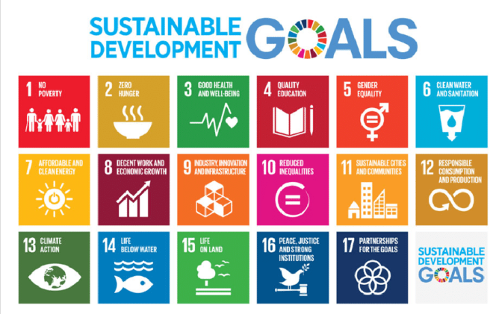

Figure: SDGs

Source: ResearchGate (2017)
The SDGs are in fact 17 integrated global goals aimed at framing the future development agenda in terms of sustainable development for all. It was embraced and signed by all United Nations Member States in 2015 as part of the 2030 sustainable development agenda (Weiland et al. , 2021). The SDGs involve all the social economic and environmental related development concerns such as poverty, hunger, health, education, gender equality, water and sanitation, energy, economic growth and decent work, industries infrastructure innovations, inequality, sustainable cities communities, consumption production climate change, life below water and life on land peace justice and institutions partnerships and cooperation for development (ElAlfy et al. , 2020).
It is, therefore, impossible to overemphasize the importance of the SDGs both at the international and the national level. Internationally, the SDGs therefore allow for a shared approach to solving challenges that humanity’s continues to face. They foster and encourage international cooperation and strategic alliances, common endeavors, and responsibilities between different nations, groups, and persons. The SDGs also promote sustainability to be incorporated in policies and systems to help towards achieving a sustainable development.
Globally, the SDGs act as the roadmap used by the national and sub-national governments to formulate strategies and policies that reflect their commitment to the global goals. For instance in the UK the government has ensured that the SDG goal was incorporated in the national planning and policy system. Local governments and citizens are also urged to intervene in order to achieve the SDG targets due to the fact that local interventions can go a long way to contribute to the global goals and objectives.
The SDGs are meaningful due to the fact that are concrete and offer a tangible course of action for attaining sustainable development. It focuses on the integration of social, economic, and environmental aspects of the development and calls for a systemic and participatory approach to solving the problems (Saiu and Blečić 2022). When countries strive to realize the targets of the SDGs, they will be assured development that will encompass all people, the environment and in the process foster for world peace and prosperity.

Goal A: SDG 1: No Poverty

Definition of Goal
The first of the United Nations’ Sustainable Development Goals (SDG 1) is to eradicate extreme poverty for all the people worldwide by 2030. It is particularly important to note that poverty is viewed not only in terms of inadequate income, but also in terms of deficiencies in basic services, including education, healthcare, and access to clean water and sanitation facilities. Targets of the SDG 1 are elimination of poverty in all forms, particularly extreme poverty for everyone earning $1. 25 a day, at the very least, reducing the poverty rate of men, women, and children of all ages by at least one-half as defined in each country, and establishing nationally appropriate social protection systems and measures for everyone (Babu and Srivastava, 2024). The goal focuses on the promotion of equal rights to economic resources, basic services, ownership, and control of land and other forms of property, succession, natural resources, as well as to access to appropriate technologies and financial services, especially microcredit.
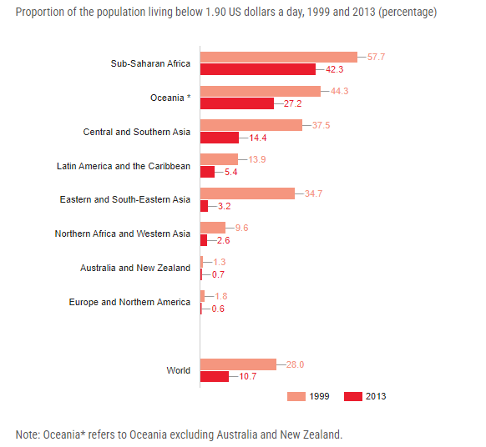
Source: Nations (2024)

UK Strategies/Programmes
Universal Credit
Universal Credit is a major welfare reform in the UK and an attempt to alleviate poverty through simplifying the benefits plan. It subsumes six of the means-tested benefits and tax credits with a single amount. The principle aim is to design a less complex programme that promotes working and eradicating poverty traps, whereby earnings result in decreased benefits (Carey & Bell, 2020).
The Child Poverty Action Group (CPAG) Initiatives
CPAG is a British charitable organization whose main goals are to fight against child poverty and to reduce its impact. Their activities range from undertaking advocacy such us policy advocacy, use of law courts, to assisting families. CPAG advocates for increased child benefits, free school meals and ensure that such families access the benefits that they are legally entitled to (Bennett et al. , 2022).

Critical Review of Strategies
Universal Credit
Universal Credit is again a strategy designed under the assumption to simplify the existing welfare system and ensure that work pays. However, the implementation of the model has been faced several criticisms and challenges. One major concern is that payment for the first time is usually made after four to five weeks which poses serious challenges and hardship in claiming those periods to be reimbursed. Even when there are advance payments made to the clients, such payments must be repaid and creates cycles of debts. Furthermore, there have been complaints of administrative inefficiency, delay and challenges accessing the online system noting that the burden arising there from has been immense financially on the claimants.
Moreover, the role which Universal Credit plays in encouraging employment is also questionable. It has been proposed that other features of the system such as work allowances as well as graduated reduction in benefits will help foster work. However, some argue that the strict criteria and penalties of the Universal Credit which include the requisite need to find a job can be stressful and lead to poor mental health among claimants. The below figure illustrates the diverse categories of the advantages of Universal Credit in the UK.
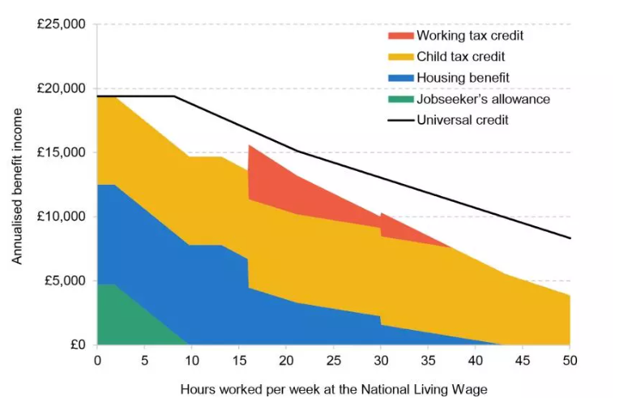
Figure: Annual benefit income due to Universal Credit
Source: Institute for Fiscal Studies, (2024)

The Child Poverty Action Group (CPAG) Initiatives
Due to the noble efforts of CPAG, children and families in poverty have had an advocate to stand for them. Due to their policy advocacy, there are improvements in awareness and policies of child poverty. For example, CPAG’s campaigns have helped shape policy changes such as expansion of free school meals and additional assistance for families in need during the COVID-19 crisis (Hayre & Pollock, 2022).
However, child poverty rates in the UK are still very high even when one considers the improvements in poverty measures. There is some restraint in the effects of lobbying by CPAG due to factors such as economic crises and policies that affect its spending, such as austerity and reduction of welfare. Furthermore, although CPAG helps families find support and information, there is a high number of families in need of those services, pointing to a lack of more profound systemic reforms. The figure shown below illustrates the number of children in poverty in the UK which says that it goes up to 4. 28 million in the financial year 2022 - 23 (Social, 2024).
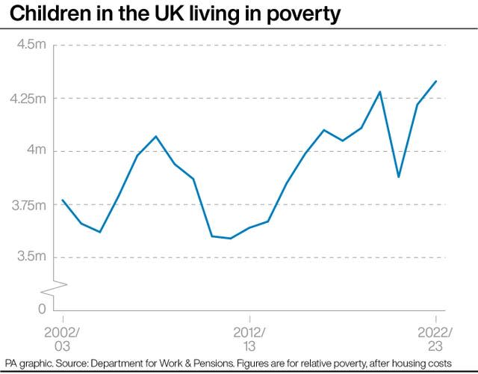
Source: (Social, 2024)

Progress Evaluation
A number of recent statistics in the UK can be used in order to assess the nation’s advancement on the path of achieving SDG 1. Based on the ONS data, around 22% of the UK population resides in relative poverty after adjusting the costs of housing, including roughly 4.3 million children (Ray-Chaudhuri et al. , 2023). Universal Credit has introduced a positive change by simplifying the benefits system, although, initial implementation and current problems have been a set-back. In this case, claimants of Universal Credit have suffered various difficulties because of delayed and a poor payment system (Wright and Dwyer, 2022). There is evidence that that the presence of CPAG has effected policies on provisions for children although child poverty rates remain high due to structural questions and the economic situations.

Implementation Challenges
Economic Barriers
The employee facing issues include low wages and job insecurity. Low-income families also experience poor employment conditions including zero hours contracts that results to low income and financial vulnerability.
Social Barriers
Discrimination, exclusion from education and training prolong poverty. Some groups, such as ethnic minorities or disabled persons, may experience further difficulty in the process of search and obtaining of opportunities potentially available.
Political Barriers
Government policies such as cuts to welfare expenditure and the implementation of austerity measures have affected poverty reduction. Less government expenditures on social services and welfare lead to more challenges for families with low incomes to move out of poverty (Power et al. , 2023).

Recommendations
Reduce the Waiting Period for Universal Credit: Lessen the first waiting period and offer non-repayable grants to avoid the instant deterioration of the person’s financial status.
Increase Benefit Levels: Reducing the benefit rates for aligning with inflation makes sure that customers can afford their essentials while keeping the increased rate of Universal Credit that has been implemented during the pandemic.
Strengthen Social Protection for Precarious Workers: Stronger social protection measures that can be taken for workers under zero-hour contracts are likely to develop more financial security and improve poverty impact (Leal Filho et al., 2021).
Expand Access to Education and Training: Increasing education literacy, for instance through vocational training among the marginalized groups, leads to better jobs and economic development.
Increase Investment in Social Services: Cutting back on austerity and investing in collective services such as housing, health services, and child care helps the low-income population in upgrading living conditions.
Enhance Collaboration with NGOs: Enhancing strategic collaborations with agencies such as CPAG enhances the fight against poverty. Funding and support help them increase the number of families they can assist.
Implement Inclusive Economic Policies: Living wage policies and job creation interventions that seek to enhance economic growth can help address income disparity and poverty levels (Soergel et al. , 2021).
In addressing these recommendations, the UK will be on the right track toward fulfilling this goals of SDG 1 and ensure the leaving behind of no one in the poverty fight.

Goal B: SDG 2: No Hunger

Definition of Goal
The second UN Sustainable Development goal focuses on the hunger prevention, Food security and reduced malnutrition as well as Sustainable agriculture by year 2030. It focuses on achieving undernutrition, adequate nutrition, and household food insecurity free from all nutrition related complications for every citizen always. SDG 2 also aims at increasing the productivity of small-scale food producers, especially women, indigenous people, families farmers, and fishers to double their incomes from agriculture. It focuses on conservation agriculture and functional agricultural practices for enhancing agricultural yield, production as well as Continued Conservation of ecosystems. it emerged that approximately 4.2 million people, or nearly 6 per cent of the population, were in food poverty in the UK in the year 2020 to 2021 (McRae and Westwater, 2023).
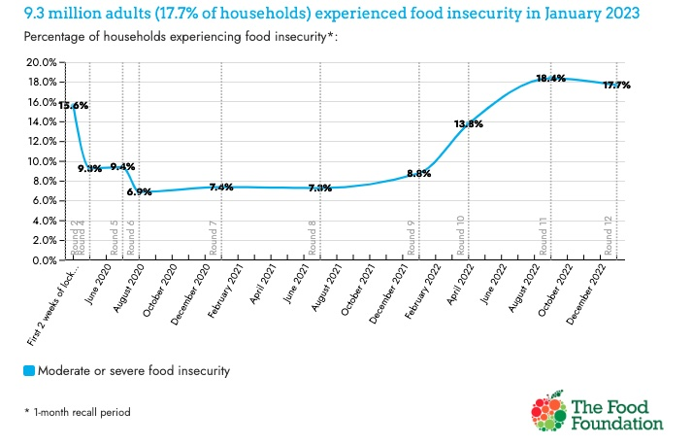
Figure: Hunger issues in the UK
Source: McRae and Westwater, (2023)

UK Strategies/Programmes
Food Banks and Emergency Food Aid
Food banks are essential in providing short term relief to food insecure households in the UK. The Trussell Trust alone has around 1200 food bank centres which dispense emergency food vouchers for the poor and needy (family) (Lambie-Mumford and Loopstra, 2020).
Healthy Start Scheme
The Healthy Start scheme is aimed at giving nutritious foods to Women and families on low income during pregnancy and early stages of babies. The scheme provides food vouchers and free vitamins to ensure that those considered vulnerable have proper nutritional intake (Parnham et al. , 2020).

Critical Review of Strategies
Food Banks and Emergency Food Aid
The role of food banks and emergency food aid is vital when helping to alleviate food insecurity in the short-term. It has been observed that they have received an increased demand and especially during the current COVID19 outbreak. Trussell Trust has shown that the number of emergency food parcels and packages it gave out in the 2020/2021 financial year was 33% more than that of the financial year before. This speaks to the increasing demand for such services (Pautz and Dempsey, 2022).
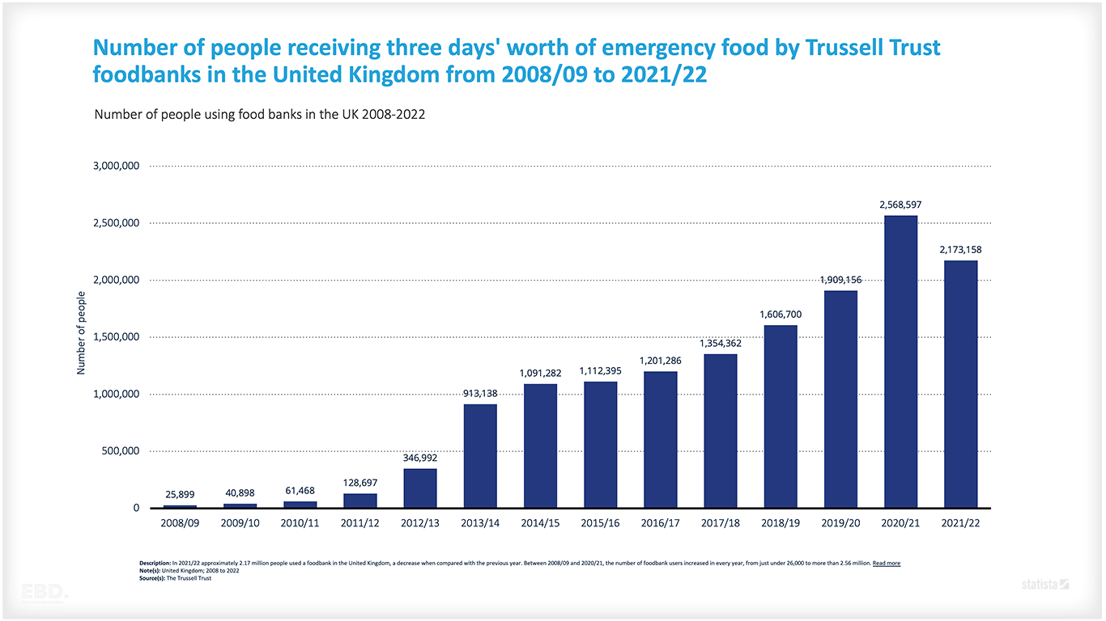
Source: Economics By Design, (2024)

But, depending on the food banks as a means of solving the problem in the long run is an issue. They are an insistent solution that does not actually deal with the causes of hunger but with the effects. The growth of food banks has taken its root from broader problems like the prevalence of poverty, unemployment, and lack of social protection. However, the food banks mostly operate on donations, and volunteers, which may be inconsistent in terms of supply, and capacity, respectively. Employees of these facilities may also suffer from reduced dignity and self-reliance since they might be subjected to prejudices and have a limited selection of meals.
Healthy Start Scheme
The Healthy Start scheme aims at supplementing state benefits of low income families with initial supplies of small packet foods for young children and supplementary vitamins for pregnant women. Results of the implementation of the scheme demonstrate the extent to which nutritional and health needs of beneficiaries have been met. For instance, a cross-sectional study done in the Journal of Public Health confirmed that the scheme positively affected food consumption patterns and used nutrient densities among households earning low wages.
However, the Healthy Start scheme has some challenges as highlighted below. Not all families who are qualified for the scheme are participating in it because most are not even aware of it. Challenges include low consciousness levels, and intricacies of the application process, and concerns with the stigma of applying for benefits (Long et al. , 2021). Furthermore, due to poor management, the value of the vouchers has not increased proportionally to the general inflationary trend hence there purchasing power has eroded over time. There is also the need to ensure that the retailers who are participating in the scheme offer fresh quality healthy foods.
Nutritional Indicator | Participants in Healthy Start Scheme | Non-Participants
Average Daily Fruit Intake (servings) | 3.5 | 1.8
Average Daily Vegetable Intake (servings) | 4.2 | 2.0
Incidence of Vitamin D Deficiency (%) | 12% | 25%
Average Weekly Consumption of Sugary Snacks (times/week) | 4.0 | 7.2
Proportion Meeting Daily Protein Requirements (%) | 85% | 60%
Average Body Mass Index (BMI) of Children | 18.2 | 19.5
Prevalence of Iron Deficiency Anemia (%) | 8% | 15%
Average Weekly Milk Consumption (liters) | 2.5 | 1.2
Table: Comparing nutritional outcomes of families participating in the Healthy Start Scheme with others
Source: Parnham et al., (2021), Author’s Work
This table compares the nutritional result of families on Healthy Start scheme and families not on the scheme thus showing the positive effects that the scheme has on nutrition and health of the families.

Progress Evaluation
Latest figures indicate substantial food insecurity in the UK. The Food Foundation estimates that about 4.7 million adults and 2.5 million children were food insecure in the year 2020 (Thomas et al., 2022). The COVID-19 pandemic has further aggravated this scenario, revealing numerous challenges in food systems. Food banks were present to help those in need; however, the root problems remained unaddressed. The Healthy Start scheme has brought change and improvements for the better but requires more changes to be implemented and maximize its full potential.

Implementation Challenges
Economic Barriers
Hunger is caused by factors such as low income, high unemployment levels, and high costs of living. COVID-19 has weakened the economic status of households and subsequently escalated food insecurity risk.
Social Barriers
Lack of understanding and stigma weaken the efficiency of support programs. However, cultural beliefs and personal dietary requirements can also pose a great challenge achieving these interventions.
Political Barriers
Cuts to welfare services combined with austerity measures have made the food insecurity problem even worse. To tackle these issues adequately, political commitment is crucial (Lowe, 2021).

Recommendations
Increase Funding for Food Banks: Strengthen the distribution networks for food banks to provide regular and healthy food collections without overemphasizing sustainable food recovery.
Enhance the Healthy Start Scheme: Encourage the public, make it easy to apply for the vouchers, and increase the voucher value due to inflation. Make sure participating retailers sell a range of healthier foods.
Implement Comprehensive Food Security Policies: Address root causes of food insecurity by implementing policies, such as raising the minimum wage, strengthening social protection programs, and effective job training.
Promote Sustainable Agricultural Practices: Promote sustainable agriculture, help the small farmers and market gardeners, adopt measures such as crop rotational and soil protection.
Strengthen Social Safety Nets: Increase spending on basic necessities, such as transportation, housing, health care, and child care to ease pressure on poor households.
Increase Collaboration with NGOs: Overcome challenges by expanding collaborations with organizations such as the Trussell Trust and CPAG to extend the coverage of the campaign.
Raise Awareness and Reduce Stigma: This involves informing the public on the opportunities for help out there to help reduce on the stigma that is often attributed to attending sessions like the Healthy Start (Barker and Russell, 2020).
Adopting these measures, the United Kingdom can significantly contribute toward attaining the goal set by SDG 2, mention of food sufficiency and adequate nutrition for all consumers. This implies a multifaceted strategy which deals with economic, social & political factors that hinder food access and stability & support sustainable land management for farming.

Conclusion
It is crucial to understand that the attainment of Sustainable Development Goals (SDGs) is actually necessary for global change. This report explored a limited scope of the UK health and wellbeing sector by focusing on SDG 1 (No Poverty) and SDG 2 (Zero Hunger); the executed strategies and programmes, an assessment of their effectiveness, the challenges faced, and suggestions for enhancement were included.
In relation to SDG 1, policy reform and practice through analysing Universal Credit and other efforts by the Child Poverty Action Group (CPAG) have been discussed. Although the implementation of Universal Credit has committed to remove the complexity of the benefits system and eradicate poverty traps, it has experienced various issues like delays and administrative issues, and many claimants have been financially struggled. There have been policy changes that are as a result of the support offered by CPAG, however, there exist limitations that stem from larger economic and policy issues. The evaluation also brought out more of the issue of child poverty and the need to look at the systems that take care of children with an aim of finding long term solutions.
More so, when it comes to SDG 2, it is imperative to recognize food banks and the Healthy Start scheme as valuable measures against hunger. While food banks have helped greatly with assistance during the COVID-19 crises, aid in such form signifies that there are bigger problems within society. The Healthy Start scheme has actually increased the nutritional standard of low income families, however the awareness must increase and vouchers made accessible and the value should also be enhanced. According to the progress evaluation, food insecurity is too high in the UK and affected by the pandemic; thus, it requires proper and far-reaching policies based on the causes.
The challenges are based on economic factors such as low income and unemployment, social factors including stigma and lack of knowledge, and political factors including policy of austerity and cuts in welfare benefits. Overcoming these challenges requires an integrated solution including the reinforcement of funding, development of social protection programs and regulation of agriculture, cooperation with NGOs.
If the UK follows these recommendations, the country will be well along the path to meeting the goal of SDG 1 and SDG 2, to eliminate poverty and hunger for people in the UK and around the world. It will also result in effective and sustainable promotion of the health and wellbeing of people in society.

References
Babu, S. and Srivastava, N., (2024) ‘Sustainable Development Goal 1: Ending poverty’, In Handbook on Public Policy and Food Security (pp. 80-89). Edward Elgar Publishing. https://doi.org/10.4337/9781839105449.00013
Barker, M. and Russell, J., 2020. Feeding the food insecure in Britain: learning from the 2020 COVID-19 crisis. Food security, 12(4), pp.865-870. https://doi.org/10.1007/s12571-020-01080-5
Bennett, D., et al. (2022) ‘Child poverty and children entering care in England, 2015–20: a longitudinal ecological study at the local area level’, The Lancet Public Health, 7(6), pp.e496-e503. https://doi.org/10.1016/S2468-2667(22)00065-2
Bonnedahl, K., et al. (2022) ‘Strongly sustainable development goals: Overcoming distances constraining responsible action’, Environmental Science & Policy, 129, pp.150-158. https://doi.org/10.1016/j.envsci.2022.01.004
Carey, M. and Bell, S., (2020) ‘Universal Credit, lone mothers and poverty: some context and challenges for social work with children and families’, Critical and Radical Social Work, 8(2), pp.189-203. https://doi.org/10.1332/204986020X15945756252756
Economics By Design (2024) How many children live in poverty in the UK? ‘For the 3.9 million children in the UK living in poverty, the soaring cost of living will have a devastating effect’ Action for Children 2022. [online] Linkedin.com. Available at: https://www.linkedin.com/pulse/cost-child-poverty-uk-economics-by-design-biune [Accessed 11 Jul. 2024].
ElAlfy, A., et al. (2020) ‘Scoping the evolution of corporate social responsibility (CSR) research in the sustainable development goals (SDGs) era’, Sustainability, 12(14), p.5544. https://doi.org/10.3390/su12145544
Gothe, N., et al. (2020) ‘Physical activity, sleep and quality of life in older adults: influence of physical, mental and social well-being’, Behavioral sleep medicine, 18(6), pp.797-808. https://doi.org/10.1080/15402002.2019.1690493
Hayre, J. and Pollock, A., (2022) ‘Children in poverty: Time for action to address rising inequalities in the United Kingdom’, Poverty & Public Policy, 14(4), pp.423-436. https://doi.org/10.1002/pop4.353
Institute for Fiscal Studies. (2024) Universal credit: incomes, incentives and the remaining roll-out | Institute for Fiscal Studies. [online] Available at: https://ifs.org.uk/publications/universal-credit-incomes-incentives-and-remaining-roll-out [Accessed 11 Jul. 2024].
Lambie-Mumford, H. and Loopstra, R., (2020) ‘Food banks and the UK welfare state’, In The rise of food charity in Europe (pp. 191-218). Policy Press. https://doi.org/10.51952/9781447347576.ch007
Leal Filho, W., et al. (2021) ‘Poverty: A central barrier to the implementation of the UN Sustainable Development Goals’, Environmental Science & Policy, 125, pp.96-104. https://doi.org/10.1016/j.envsci.2021.08.020
Levine, G., et al. (2021) ‘Psychological health, well-being, and the mind-heart-body connection: a scientific statement from the American Heart Association’, Circulation, 143(10), pp.e763-e783. https://doi.org/10.1161/CIR.0000000000000947
Long, M., et al. (2021) Holiday hunger in the UK: Local responses to childhood food insecurity. Routledge. https://www.taylorfrancis.com/books/mono/10.4324/9781003029977/holiday-hunger-uk-michael-long-margaret-anne-defeyter-paul-stretesky
Lowe, N., (2021) ‘The global challenge of hidden hunger: perspectives from the field’, Proceedings of the Nutrition Society, 80(3), pp.283-289. https://doi.org/10.1017/S0029665121000902
Lugg, W., (2022) ‘The biopsychosocial model–history, controversy and Engel’, Australasian Psychiatry, 30(1), pp.55-59. https://doi.org/10.1177/10398562211037333
McRae, I. and Westwater, H. (2023) Food poverty in the UK: The causes, figures and solutions. [online] Big Issue. Available at: https://www.bigissue.com/news/social-justice/food-poverty-in-the-uk-the-causes-figures-and-solutions/ [Accessed 11 Jul. 2024].
Nations, U. (2024) Goal 1: End poverty in all its forms everywhere — SDG Indicators. [online] Un.org. Available at: https://unstats.un.org/sdgs/report/2017/goal-01/ [Accessed 11 Jul. 2024].
Parnham, J., et al. (2021) ‘Is the healthy start scheme associated with increased food expenditure in low-income families with young children in the United Kingdom?’, BMC Public Health, 21, pp.1-11. https://doi.org/10.1186/s12889-021-12222-5
Parnham, J., et al. (2020) ‘Half of children entitled to free school meals did not have access to the scheme during COVID-19 lockdown in the UK’, Public health, 187, pp.161-164. https://doi.org/10.1016/j.puhe.2020.08.019
Pautz, H. and Dempsey, D., (2022) ‘Covid-19 and the crisis of food insecurity in the UK’, Contemporary Social Science, 17(5), pp.434-449. https://doi.org/10.1080/21582041.2022.2044069
Power, M., et al. (2023) ‘How COVID-19 has exposed inequalities in the UK food system: The case of UK food and poverty’, Emerald Open Research, 1(10). https://doi.org/10.1108/EOR-10-2023-0003
Ray-Chaudhuri, S., et al. (2023) Living standards, poverty and inequality in the UK: 2023 (No. R265). IFS Report. https://www.econstor.eu/bitstream/10419/282944/1/185353739X.pdf
ResearchGate. (2017) Fig. 1 UN Graphical Illustration of the 17 SDGs. [online] Available at: https://www.researchgate.net/figure/UN-Graphical-Illustration-of-the-17-SDGs_fig1_320685121 [Accessed 11 Jul. 2024].
Robertson, M., (2021) Sustainability principles and practice. Routledge. https://www.taylorfrancis.com/books/mono/10.4324/9780429346668/sustainability-principles-practice-margaret-robertson
Saiu, V. and Blečić, I., (2022) ‘SDGs Implementation in Italy: A Comparative Assessment of Subnational Strategies for Sustainable Development’, In International Conference on Computational Science and Its Applications (pp. 627-638). Cham: Springer International Publishing. https://doi.org/10.1007/978-3-031-10545-6_42
Social, P. (2024) Record number of children in poverty branded ‘an outrage’. [online] Yahoo Finance. Available at: https://uk.finance.yahoo.com/news/record-number-children-poverty-branded-105311032.html?guccounter=1&guce_referrer=aHR0cHM6Ly93d3cuZ29vZ2xlLmNvbS8&guce_referrer_sig=AQAAAArknpoQVstz6OwYmEOh8zH_pjDujEZ-RihOLtFWwxaKVRRbTc6ctOX1I-Tw5AQa65SnDW8y7kA48t9toJGisE2nCv8UqAxiPtoL3GsGJUUH89H8QaV9shNwCwfJdQ1xPP-2sPc-_CkpsSixvoLfC1lifdf_LiXmvWdD9GL7k2q3 [Accessed 11 Jul. 2024].
Soergel, B., et al. (2021) ‘Combining ambitious climate policies with efforts to eradicate poverty’, Nature Communications, 12(1), p.2342. https://doi.org/10.1038/s41467-021-22315-9
Thomas, M., et al. (2022) ‘The Impact of the COVID-19 Pandemic on the Food Security of UK Adults Aged 20–65 Years (COVID-19 Food Security and Dietary Assessment Study)’, Nutrients, 14(23), p.5078. https://doi.org/10.3390/nu14235078
Weiland, S., et al. (2021) ‘The 2030 agenda for sustainable development: transformative change through the sustainable development goals?’, Politics and Governance, 9(1), pp.90-95. https://doi.org/10.17645/pag.v9i1.4191
Wright, S. and Dwyer, P., (2022) ‘In-work Universal Credit: claimant experiences of conditionality mismatches and counterproductive benefit sanctions’, Journal of Social Policy, 51(1), pp.20-38. https://doi.org/10.1017/S0047279420000562

