DS 1 Template

My Screenshots/Photos
- Please add 4–6 screenshots or photos of your digital life.
- You can use your phone or laptop.
- For each screenshot, write one or two sentences explaining what it shows.

Screenshot/Photo 1
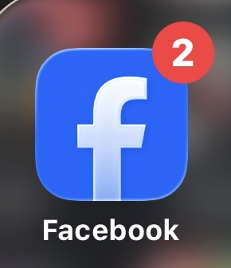
I use this app to keep up to date with news and announcements. I also use it to search for items for sale in the marketplace.

Screenshot/Photo
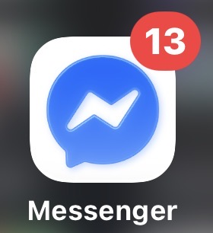
I use this app to socialise and communicate with my friends and family.

Screenshot/Photo 4
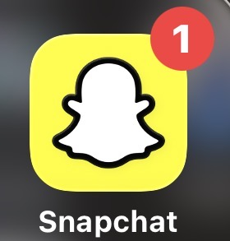
I use this app to create and post memories. Also to communicate with friends and colleagues.

Screenshot/Photo 5
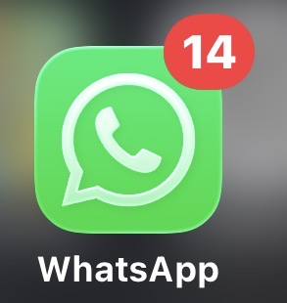

I use this app mainly for work and professional communication.

Screenshot/Photo 6

I use this app for leisure and browsing. Mainly to listen to podcasts.

My Short Reflection
- Write 5–8 simple sentences about your digital life.
- You can use the sentence starters below if helpful.
I use digital tools partly to communicate and share information. And also to brows and be up to date with news.
I feel confident when I manage to use the right digital tool correctly.
I want to improve in using digital platforms such as word, excel and PowerPoint.
I often use these tools for work and personal reasons.
I sometimes feel nervous about showing my digital work to my colleagues or managers.
I hope this module will help me to understand and enhance my digital skills.

Sentence starters
- I use digital tools to …
- I feel confident when I …
- I want to improve …
- I often use these tools: …
- I sometimes feel nervous about …
- I hope this module will help me …
- Digital skills are important for me because …
You can write more if you want.

Submission Checklist
Before you submit, please check:
​​​ ☐ I added 4–6 screenshots
☐ I wrote short sentences for each screenshot
☐ I wrote my short reflection
☐ My work is my own
☐ My file opens correctly
​​☐ My file opens correctly

