Author: | Charles Gill | Student Number: | 0250767
Module: | Network Operating Systems and Services | Programme: | BSc (Hons) Software Engineering
Reference: | ACCA5023 - Worksheet 3 | Lecturer: | Nitheesh Murugan Kaliyamurthy
Date: | 11/04/21

Network Operating Systems and Services

A Report on How to Manage and Maintain Network Resources Using Network Policy and Security Practices.

Contents
Contents 2
Section 1. Overview 3
1.1 General 3
1.2 Purpose 3
Section 2. NTFS and Share Permissions 4
2.1 NTFS (local permissions) 4
2.1.1 Create Folder and File for Sharing 4
2.1.2 Remove existing permissions 6
2.1.3 Create users with permissions 8
2.1.4 Test the accounts’ access rights 11
2.2 Share Permissions 17
2.2.1 Create Share Drive 17
2.2.2 Set User’s Share Permissions 21
2.2.3 Access Network Share 26
Section 3. Group Policy 29
3.1 Create OU and User 29
3.2 Group Policy Management Console 30
3.2.1 Control Panel Access 30
3.2.2 Command Prompt Access 34
3.2.3 Access to removable drives 36
3.2.4 Restrict Software Installs 37
3.2.5 Password Policy 40
Section 4. Observational Tasks (Q3) 43
3.a) Explain differences between local permissions and file shares. 43
3.b) Describe the role of Group Policy Management in the network environment, you can use example policies in your answer. 44
3.c) Give some examples of sound ‘password’ principles in modern network environments 45
References 49

Overview

General
This task involves creating local drive/file and folder (NTFS) permissions and understanding the use of (Sharing permissions) for network deployed access control to these resources. To demonstrate this, basic local file access control will be demonstrated before then investigating the major difference to deploying these files for shared network access. Furthermore, the ability to manage network environment settings and security policies via Group Policy Objects is investigated, utilising the Group Policy Management Console.
This report details the outcomes of implementing the permissions via NTFS and the use of sharing permissions for network deployed access and also provides examples of setting network environment settings and use of Group Policy Objects.

Purpose
Use the following resources:
- NTFS, Sharing Permissions and Group Policy Management Console.
The tasks mentioned above comprise of Practical work and Observational tasks.
This document is laid out with the following structure:
- Section 1: is this overview.
- Section 2: Covers utilising NTFS and Sharing permissions to control access.
- Section 3: Setting network environment settings using Group Policy Management Console.
- Section 4: Observational Tasks

NTFS and Share Permissions
All NTFS permissions take effect at the local OS level, which means they are bound to the local operating system and its user. The sections below describe setting up a folder and files and then permitting access to these files and folders, a) through NTFS permissions and b) utilising Network based share permissions.

NTFS (local permissions)
This section deals with providing access via NTFS local permissions by creating a folder and a file and then setting the necessary NTFS permissions.

Create Folder and File for Sharing
Sign in as Administrator (Requires Server 1 to be running)
Navigate to ‘This PC’.
Create folder in the Root directory named ‘Dept_Important_Docs’:
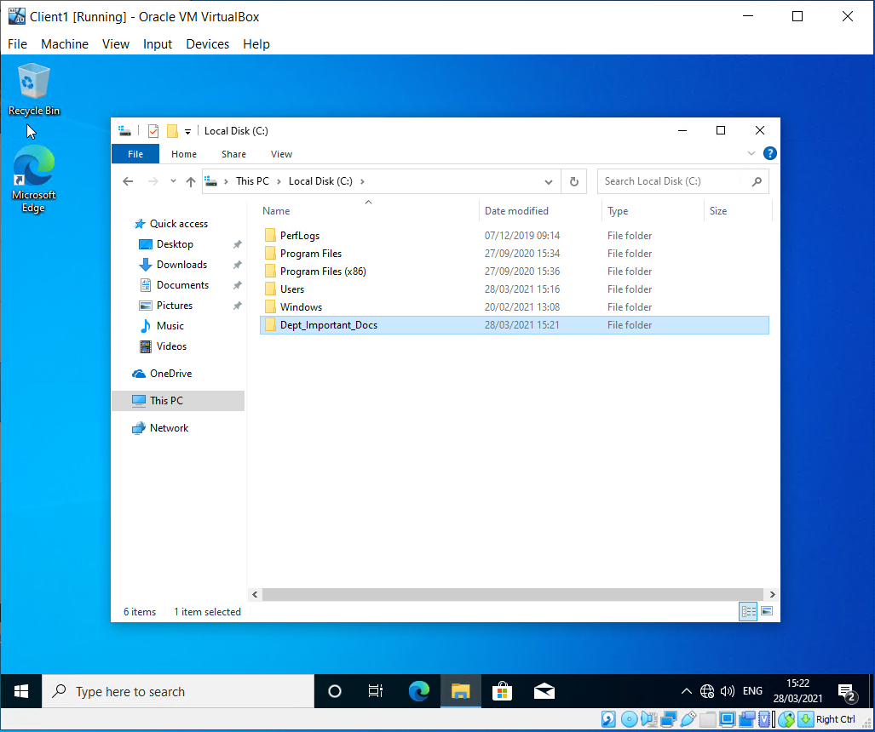

Create ‘Important_file.txt’ within that directory:
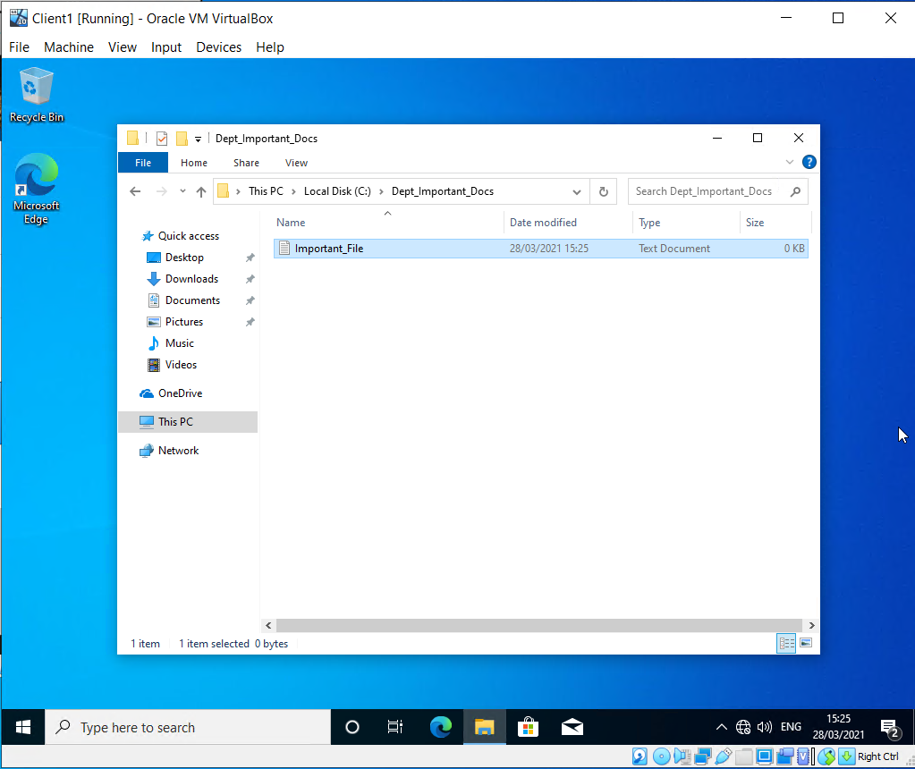

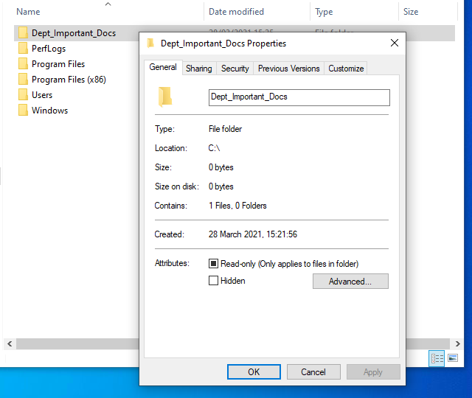

Choose Properties

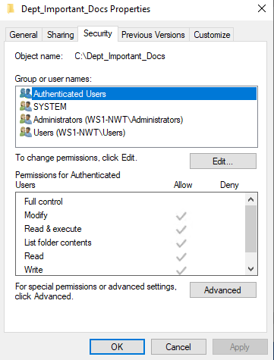

Select Security Tab:

Remove existing permissions
Click Edit and then remove Authenticated Users:
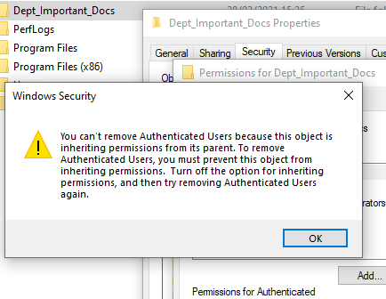
Displays error that Authenticated users cannot be removed as this folder is inheriting it permissions from its parent. Click OK and return to Properties screen, select Advanced:
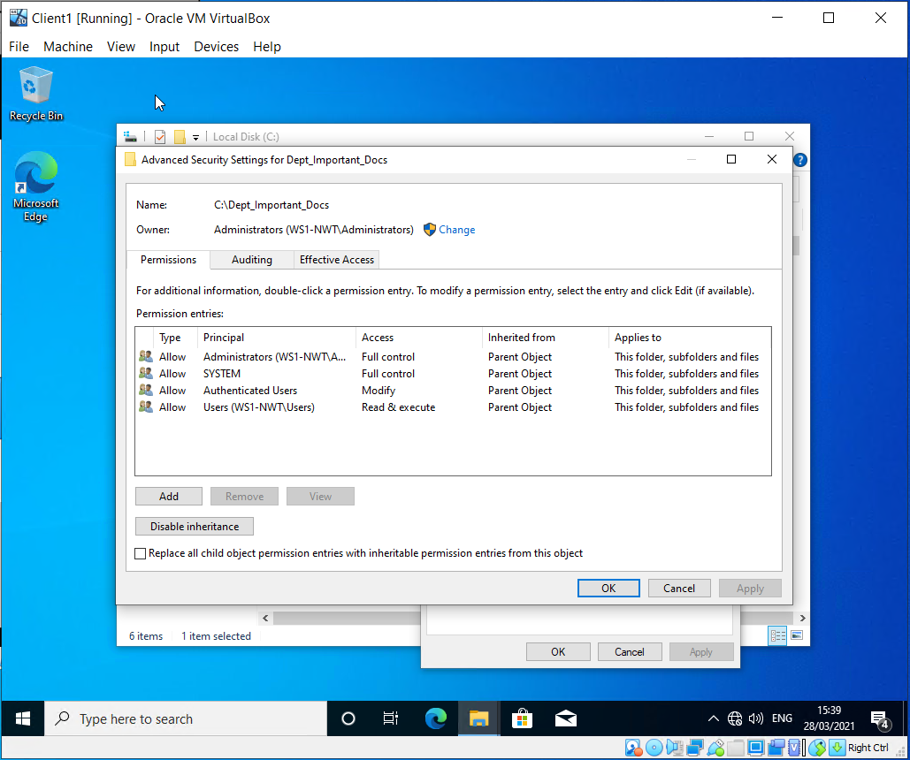
Select ‘Disable inheritance’ and then ‘Remove all inherited permissions from this object’:
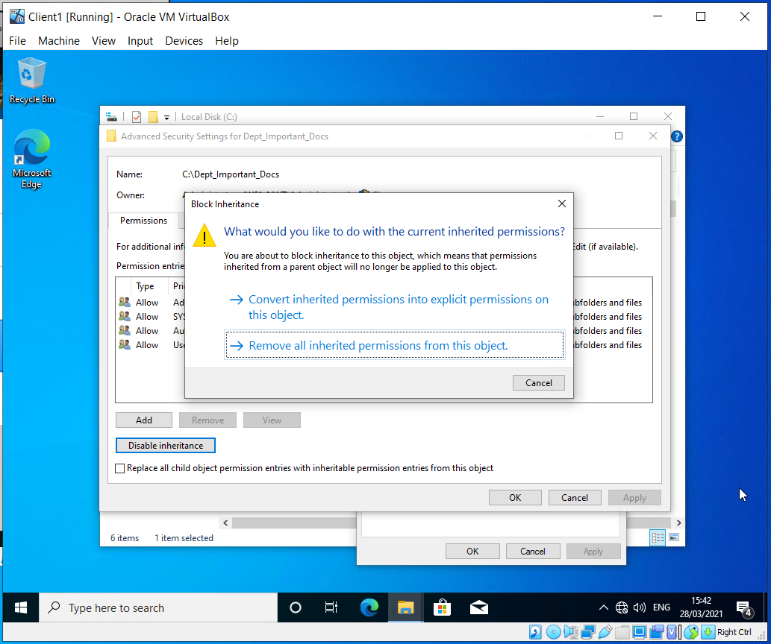
Confirm:
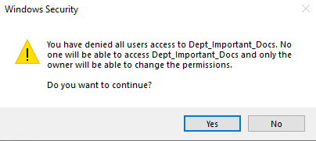
Providing a property page as below:
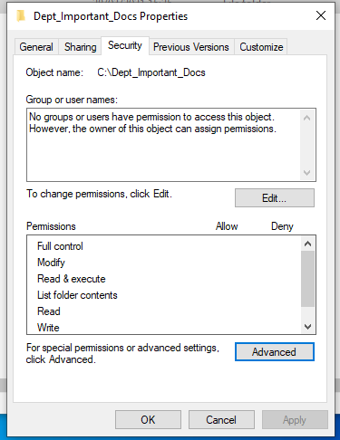

Create users with permissions
Now that the folder has no groups or users set, assign users with varying degrees of access as below:

Click Edit and ‘Enter current user into the object names to select..’, type Administrator and click ‘Check Names’:
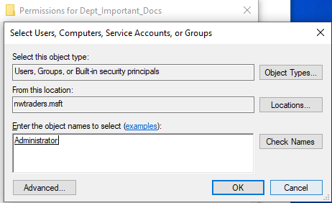

Check the Full control option for Administrator:
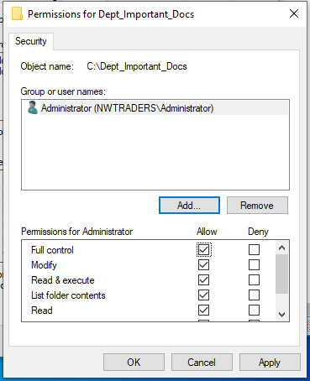

Click apply and exit the properties of the folder.

Navigate to the Important file within the folder and view the properties:
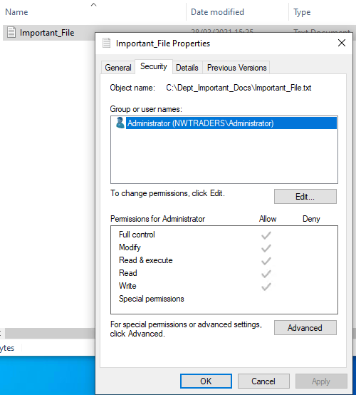
It can be seen that the file has the same permissions as the parent folder.
Return to the Folder permissions and add another user to the permissions list.
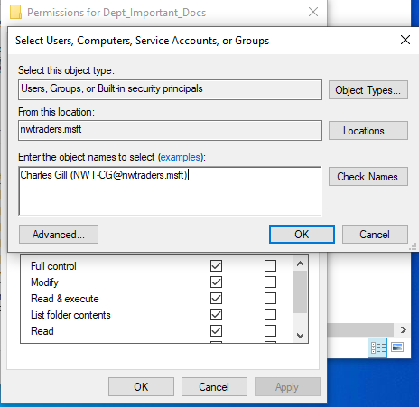
+
Click OK and set all permissions underneath ‘Read & Execute’ as below:
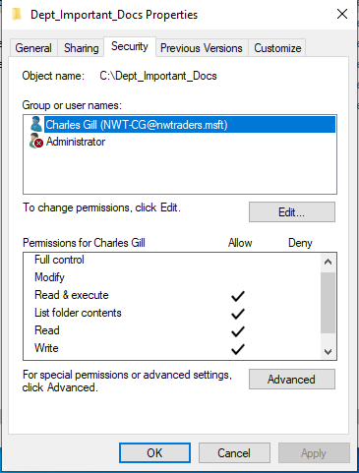

Test the accounts’ access rights
Open the ‘Important_File’ and edit it within the Administrator account. And Save.
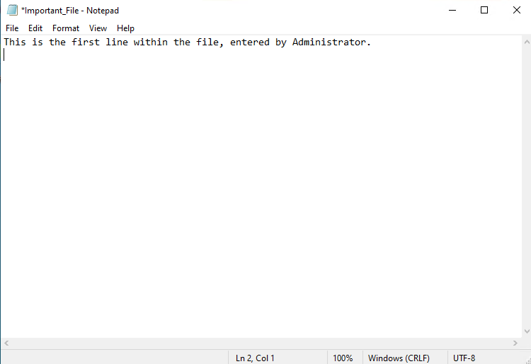
This completes successfully.
Logout and sign back in as Charles Gill (a user that is a domain admin).
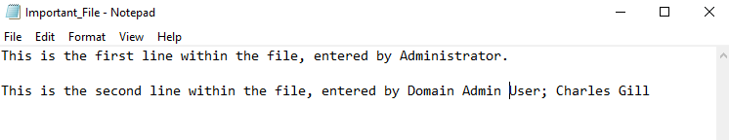
The file can still be edited. However, this account is also a domain admin, and rights were assigned to the domain admin group, this account would have the permissions set at that level.
Therefore, the exercise was repeated with the restricted user – Joe Bloggs.
Logging back in with the Administrator account, removing Charles Gill and adding Joe Bloggs account (Joe Bloggs is a restricted user), tests for the limited user’s ability to edit the file. Joe Blogg’s account is time restricted and so I have had to sign back in to the server as an administrator and set access for the weekend to continue this exercise.
Joe Blogg’s permissions set as described in the worksheets.
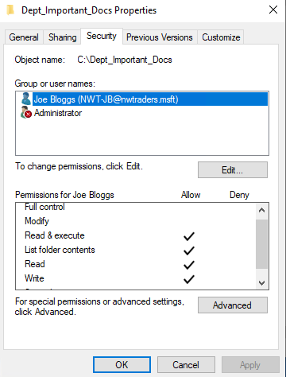

Editing this file with the Joe Bloggs account also allowed the file to be altered.

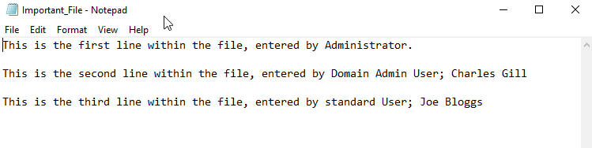
This is likely to be because the worksheets instructed to set all permissions under Read & Execute, which includes ‘Write’. This places the restricted user in the position where writing to files is allowed but the modification permission is specifically removed.
Hence:
The user Joe Bloggs is able to create files and folders, but cannot name them:
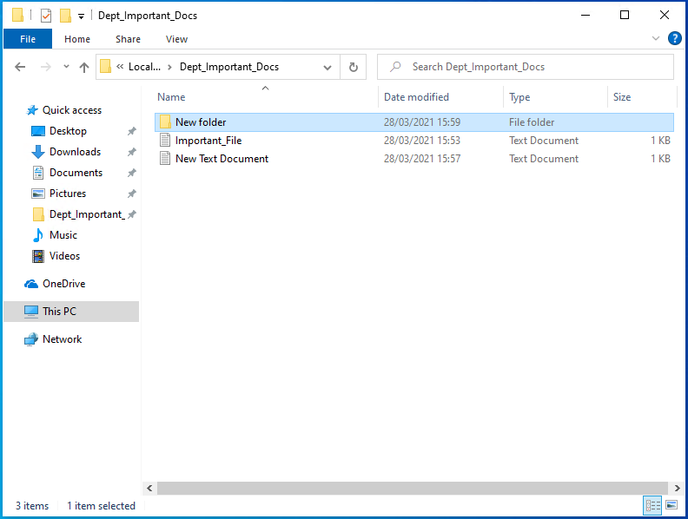
The text file can be edited and saved…
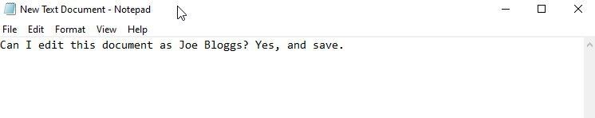
Selecting ‘Save As’ prompts the following error…
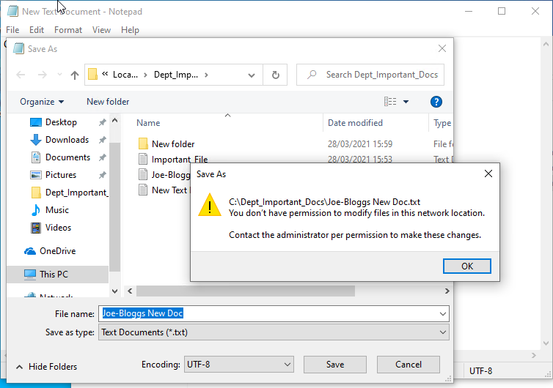
Yet new files can be created and existing files edited. If the administrator username and password are used, the filename can also be changed. As below:
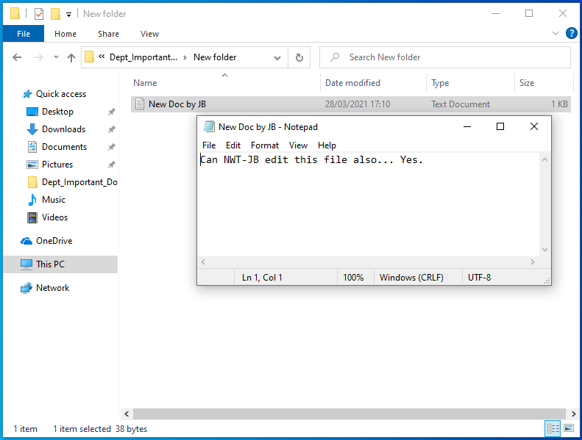

Therefore, the Joe Bloggs user was re-visited and permissions altered to remove write access.
Remove the write permission for the restricted user – Joe Bloggs:
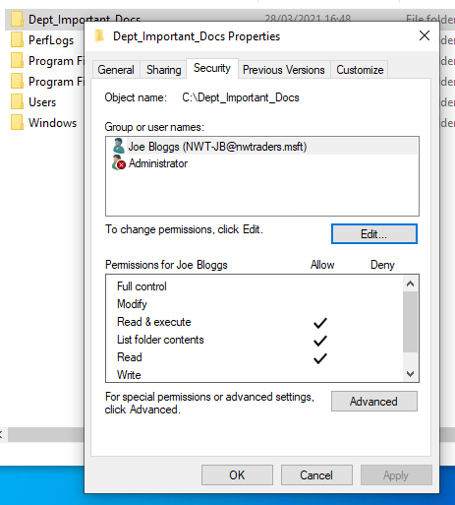

Check ability to write to files within folder:
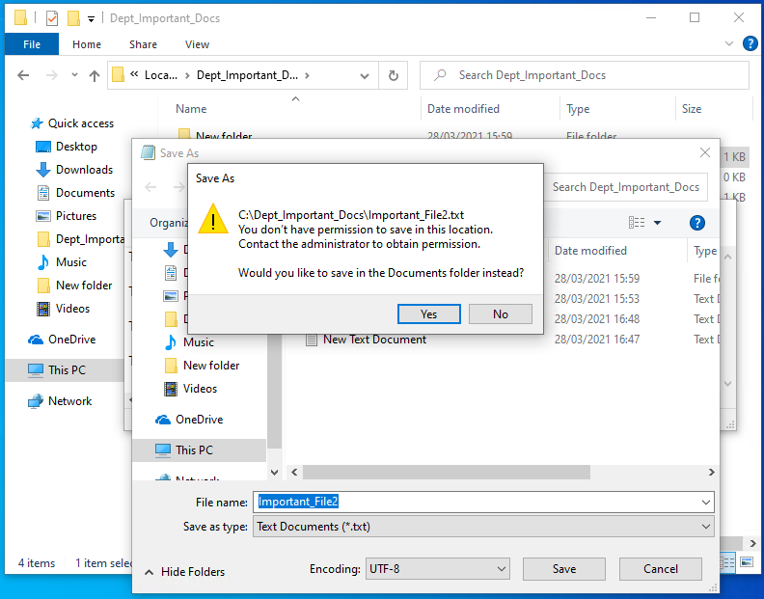
The save option is disallowed and changes to ‘Save As..’, renaming the file to save in the same folder provides the warning displayed above. That the user does not have permission to save in this location. Contact administrator to obtain permission. However, the option to save to the local user folder is provided.
The other files created by the user Joe Bloggs also cannot be edited and saved to the files/folders created earlier. Permission to write revoked and stops this user from altering files/folders within the Dept_Important_Docs folder.

Share Permissions

This time, the access rights for users will be set against a share drive, created within the network environment. The share is created on the server and access rights granted from within Server Manager.

Create Share Drive
Open Server Manager and select ‘File and Storage Services’
Select ‘Shares’ – ‘Tasks’ and ‘New Share’ as below:
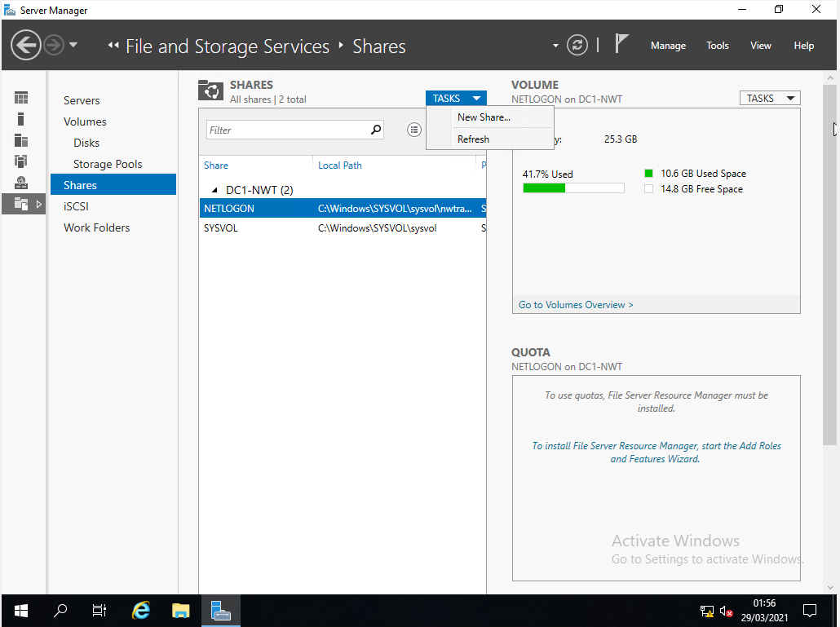
Providing the window below:
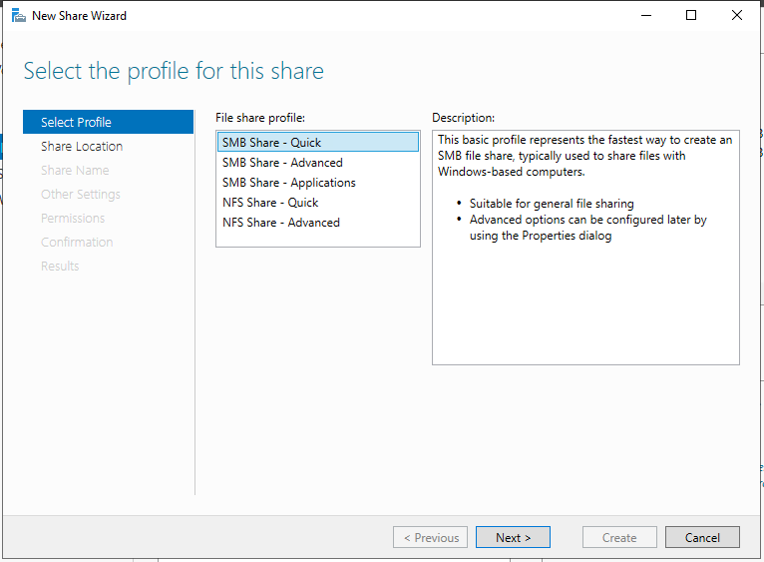
Although the option ‘SMB Share – Quick’ is the one suitable for this exercise, descriptions of the others are shown below:
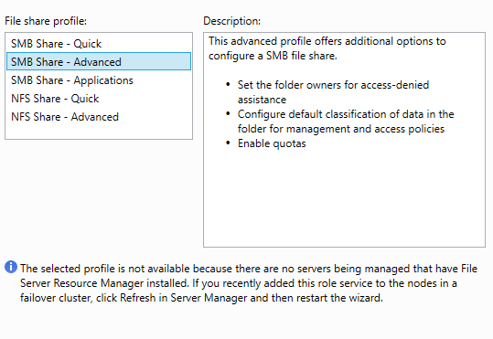
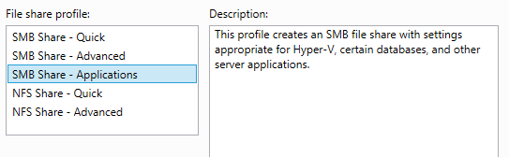

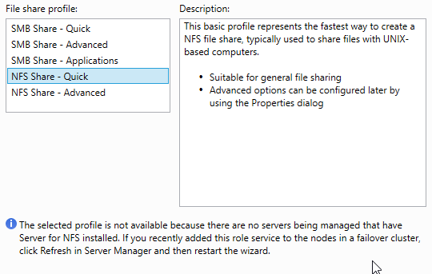
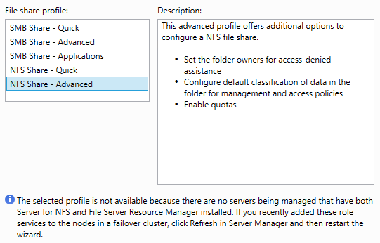
Select by volume option on share server and path options:
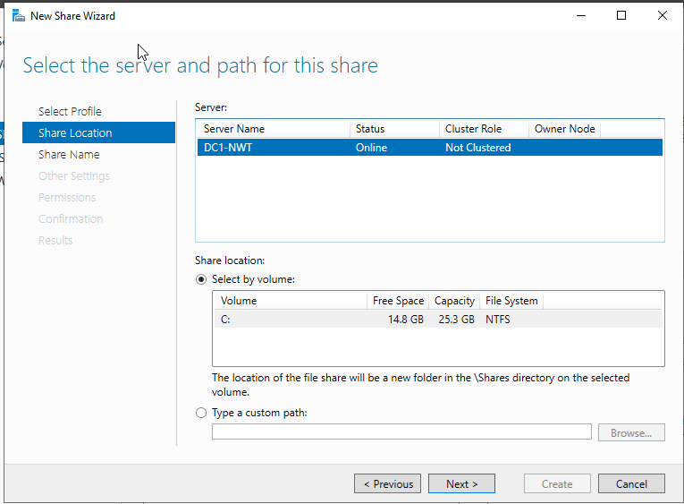
Name the Share ‘DeptNetShare$’ and record local path to share and remote path to share:
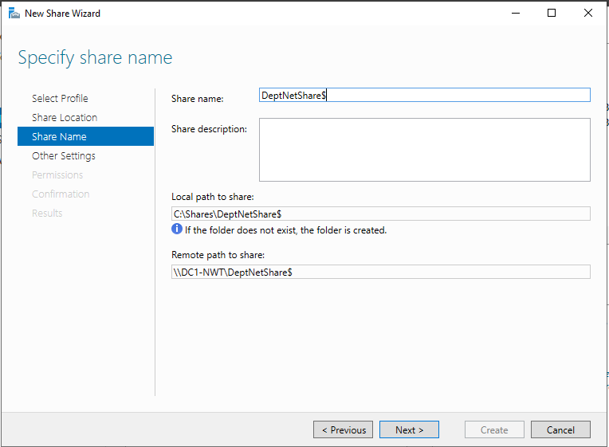
Enable access-based enumeration and caching of share:
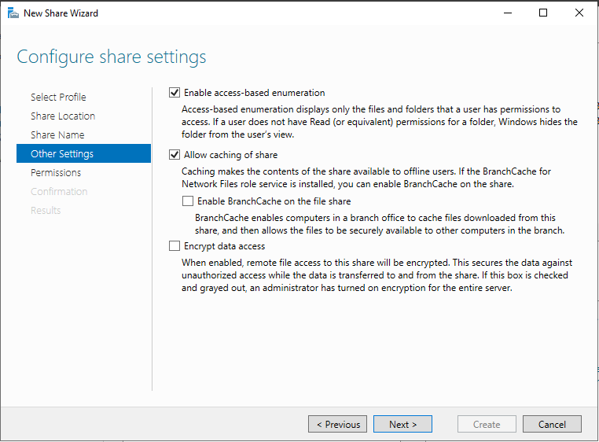

Set User’s Share Permissions
The next screen is used for setting the User’s share permissions:
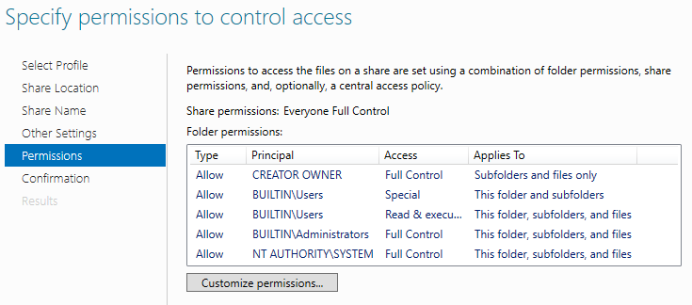
Selecting Customize permissions provides the following Advanced Security Settings page:
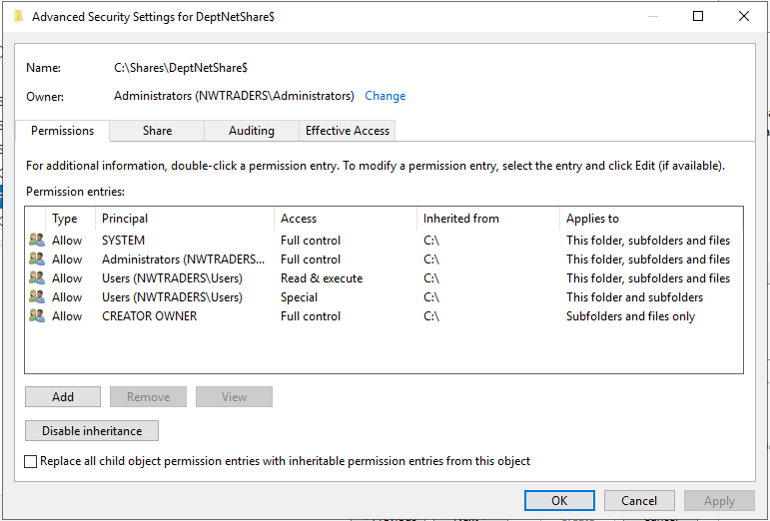
Selecting Add displays the following:
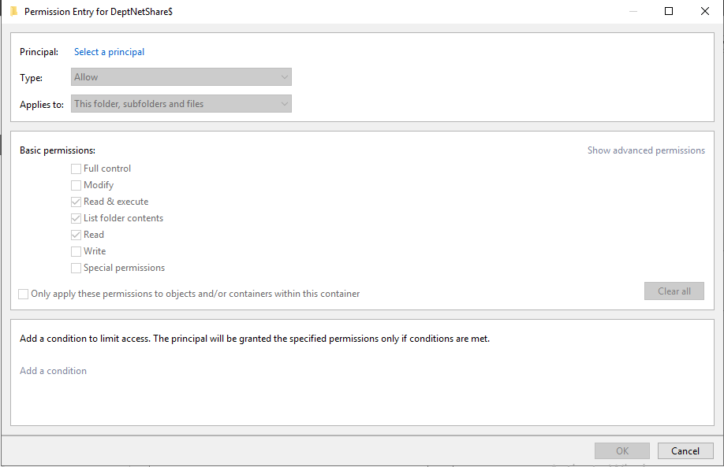

Find the principal’s account (Joe Bloggs in example below),
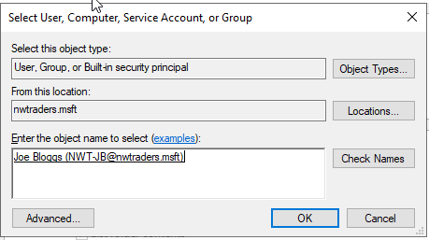
and set read only permissions:

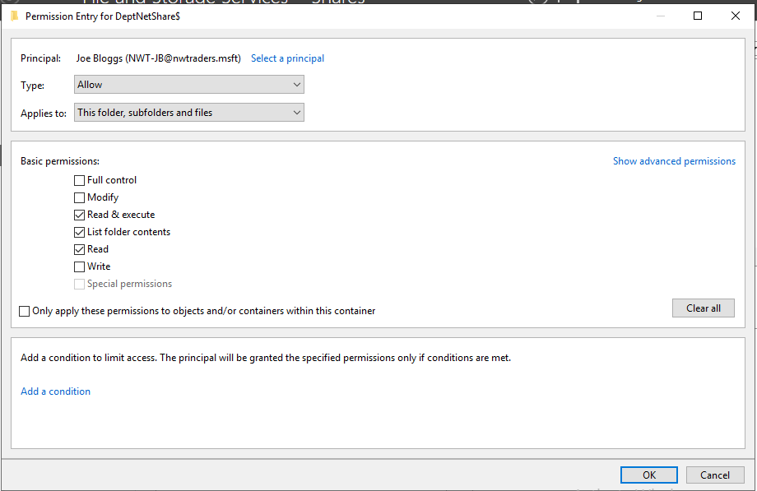

Performing this for standard user Joe Bloggs and Administrator User Charles Gill, displays the following set of user permissions:
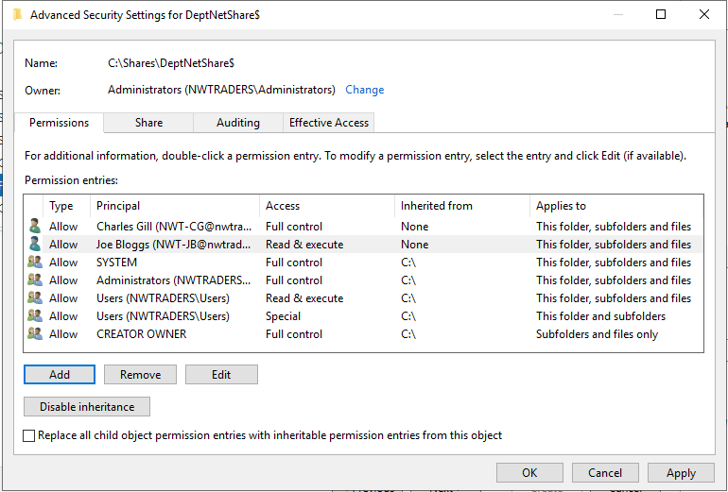
Currently these are the only two users setup on the Domain.
Click apply and confirm the settings for the Share and select Create:
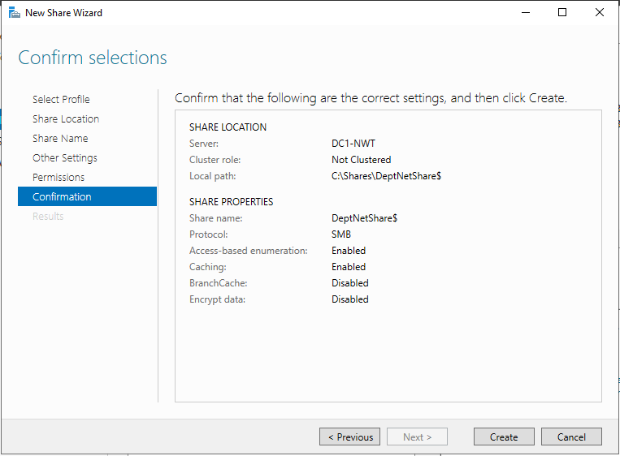

Confirmation screen for the Share being created:
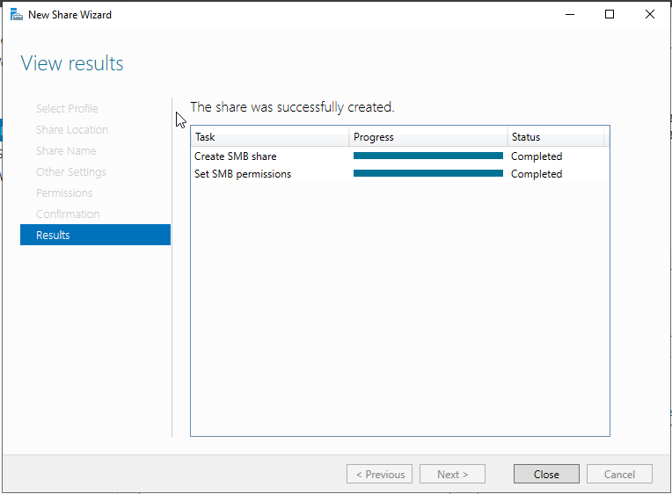
And the share listed in the File and Storage Services Shares section:
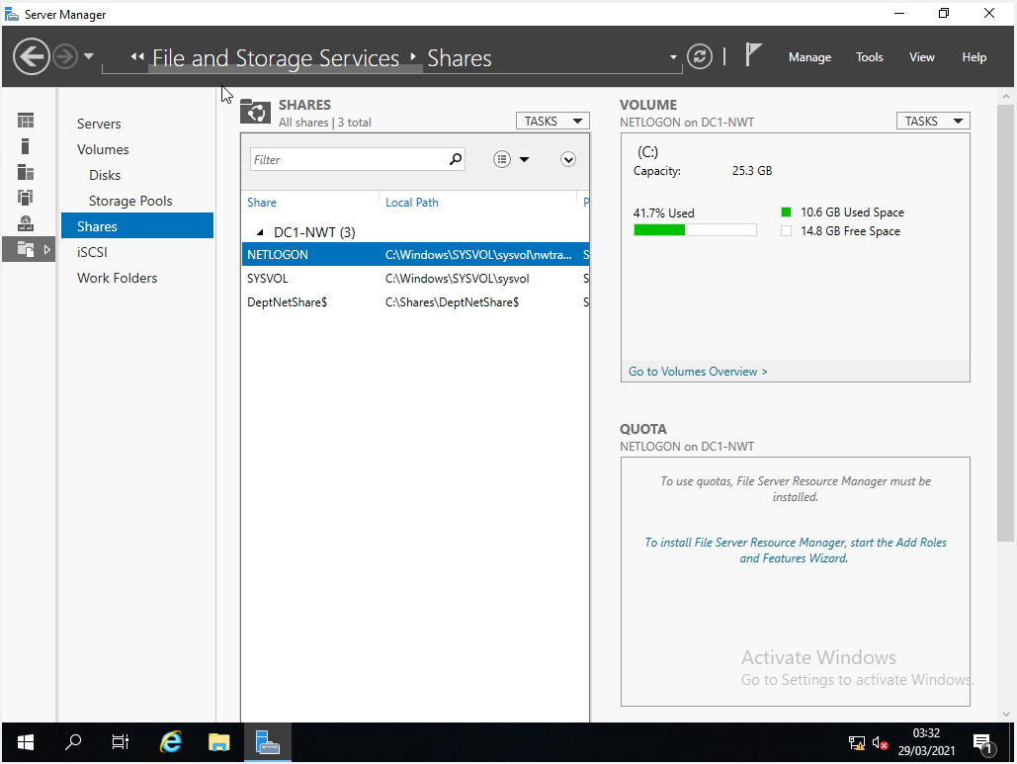
Viewing the server system drive through Explorer also shows the share folder in the location listed above:
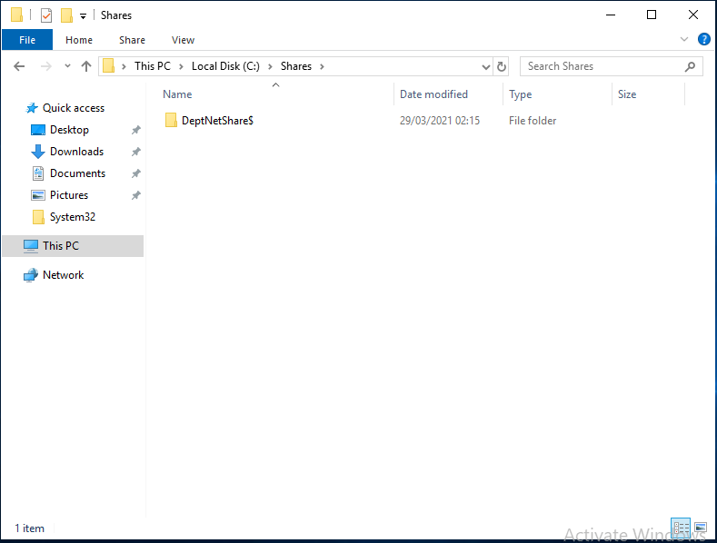

Access Network Share
Accessing the Network share form the client:
Right click on This PC and select Map Network Drive:
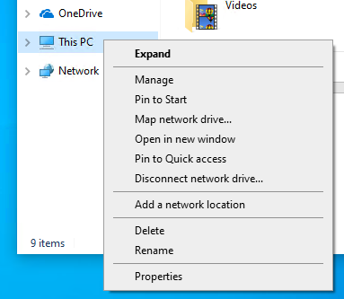
Enter the network share folder name and click finish:
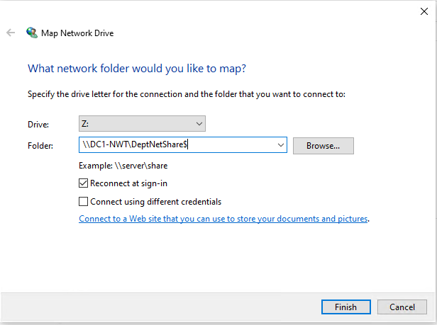

Looking back at the server, the properties for the DeptNetShare$ folder show the network path of \\DC1-NWT\DeptNetShare$ which matches the Remote path to share shown in the screenshot earlier. The properties of the server folder are shown below:
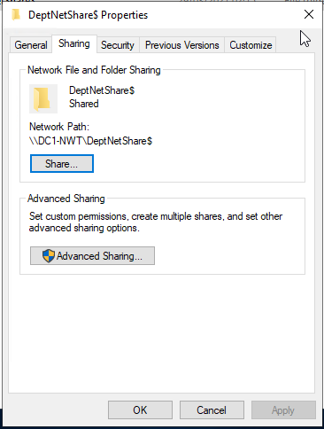

As can be seen within explorer, the new mapped drive is now available as Drive Z:
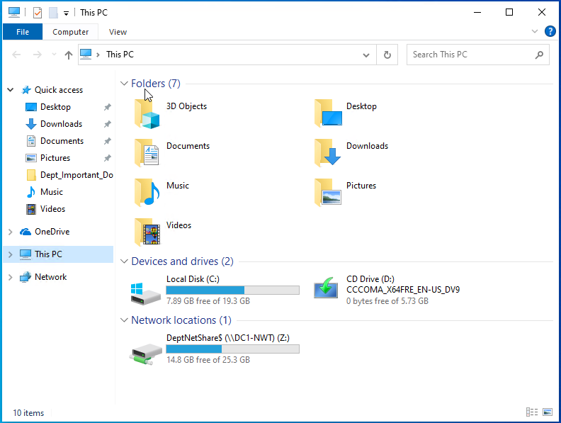
Access is allowed for supervisors and files can be created:
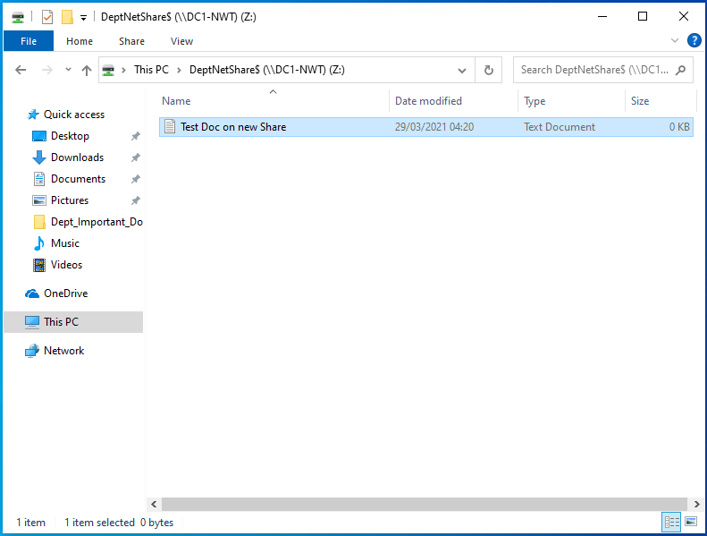

Group Policy
Utilising Active Directory Users and Computers, New Users, Organisational Units (OUs) and Group Policy Objects (GPOs) will be created to set the capabilities of users to alter their systems or access certain parts of their systems.

Create OU and User
Start Active Directory Users and Computers, right click on ‘nwtraders.msft’ and create new organisational group named ‘Non Admin Users’:
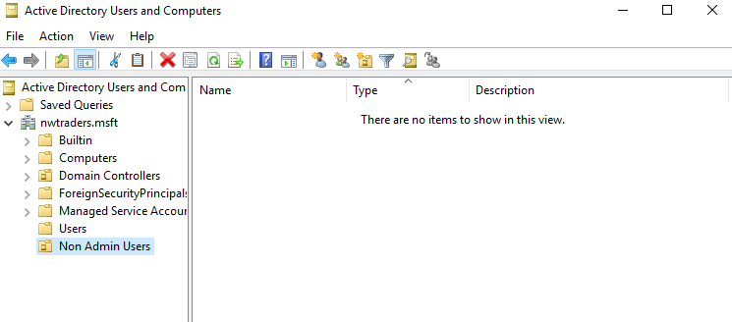

Right click on the Non Admin Users OU and add new User:
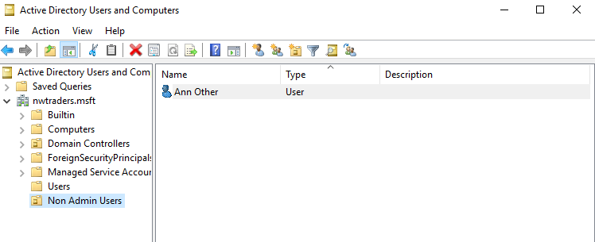

User created is Ann Other with password of !leT”mE£iN

Group Policy Management Console

Within this application the user Ann Other and Client 1 PC have various rights restricted within their systems. They are described in the sections below.

Control Panel Access
This section describes the steps taken to remove access to control panel for users within the Non Admin Users Group (ie Ann Other).
Open Group Policy Management console and expand the ‘nwtraders.msft’ domain:
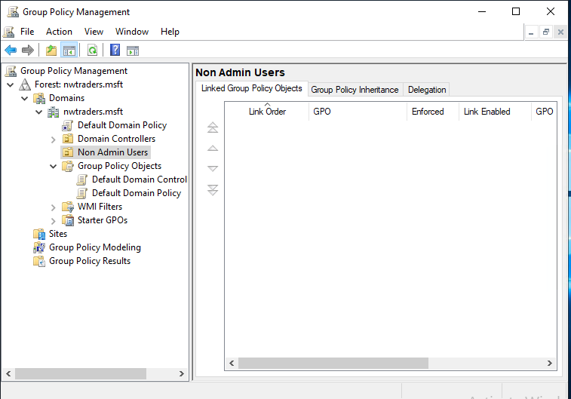

Right clicking the ‘Non Admin Users’ OU does not provide the user with the option to create a ‘New Group Policy Object’ as per the worksheet, see below:
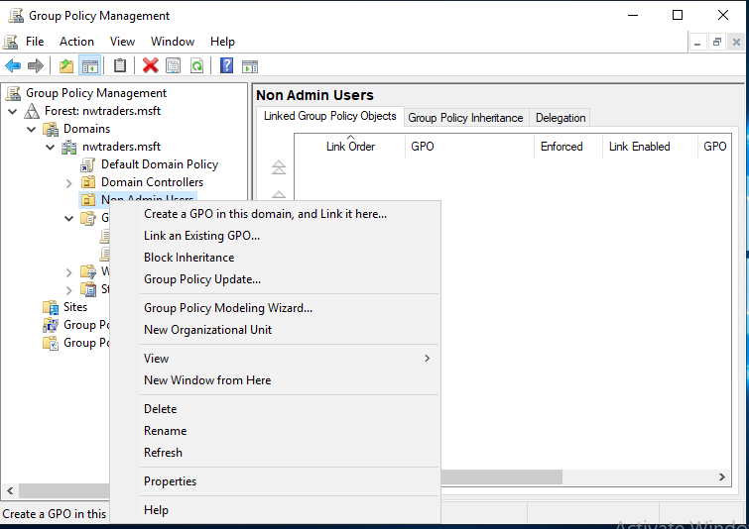
Presumably, it is the ‘Group Policy Objects’ folder that allows an admin to create a ‘New Group Policy Object’, select this and create the object here:
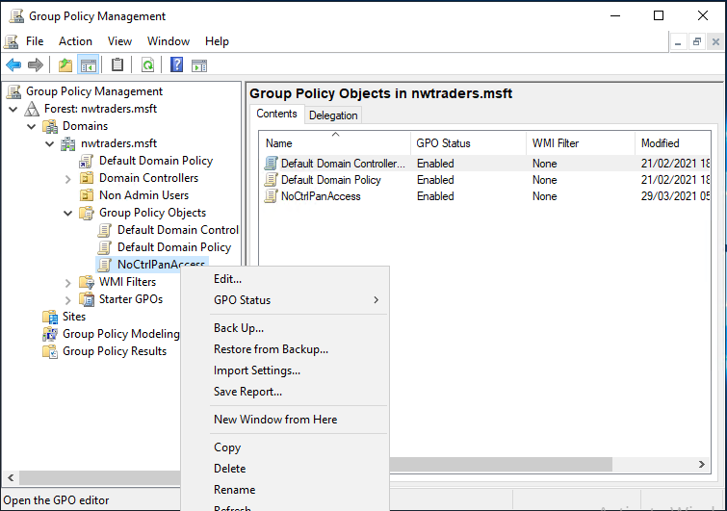
The above is incorrect, and the GPO has to be created within Non Admin Users using the ‘Create a GPO in this Domain, and link it here’ option:
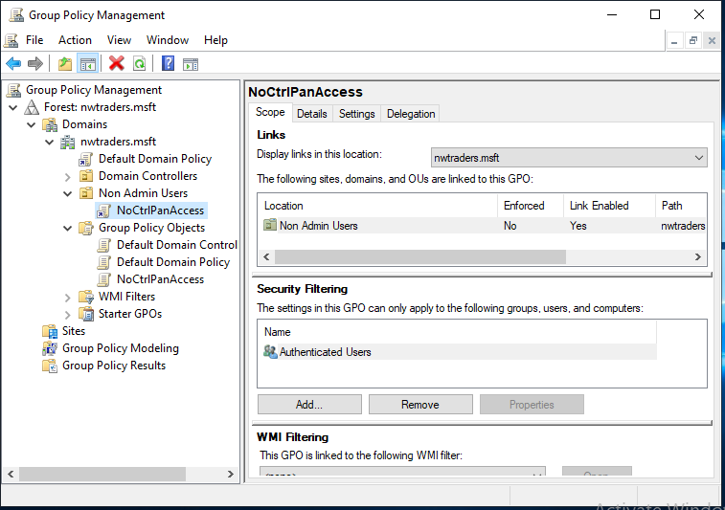
Once created right click and edit, starting the Group Policy Management Editor application:
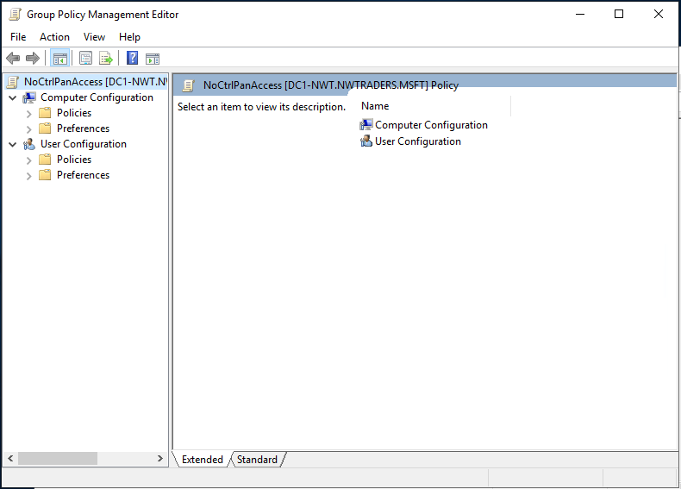
Navigate to User Configuration – Policies – Administrative Templates – Control Panel and select ‘Prohibit Access to Control Panel and PC settings’:
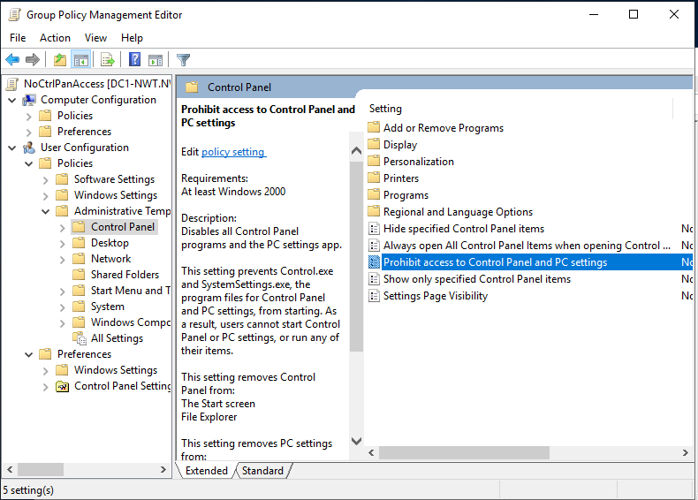
Double click and select enable and Apply:
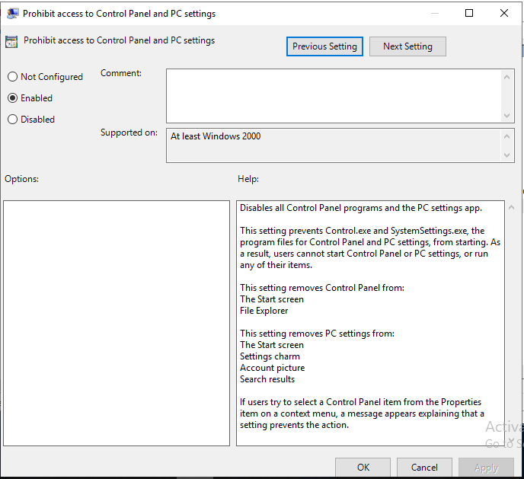
Once this Policy has been created and exists as an object, the group policy needs to be updated across the network.
Use command prompt to run the gpupdate /force command to set the new policies in place:
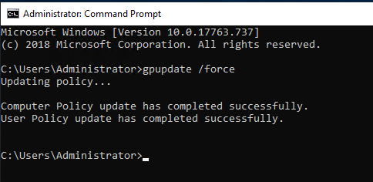

Login on client machine as Ann Other and check that control panel is not available:
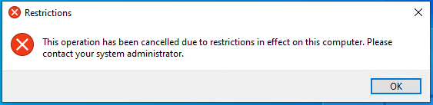

Command Prompt Access

Create another GPO for No Command Prompt Access named ‘NoCmdPrmptAccess’. Simlilar to above procedure, right click create and then edit as below:
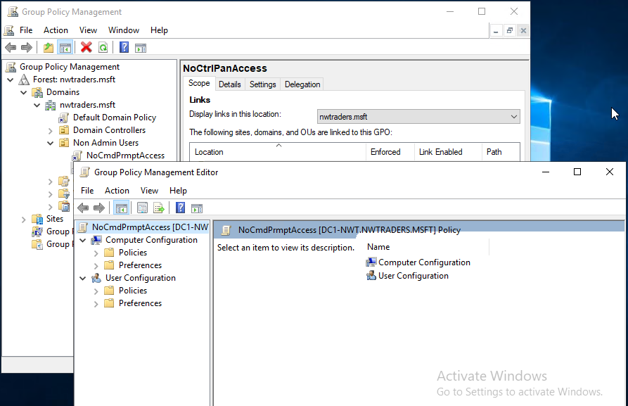
Navigate to ‘User-Configuration – Policies – Administrative Templates – System’ and select ‘Prevent access to the command prompt’.
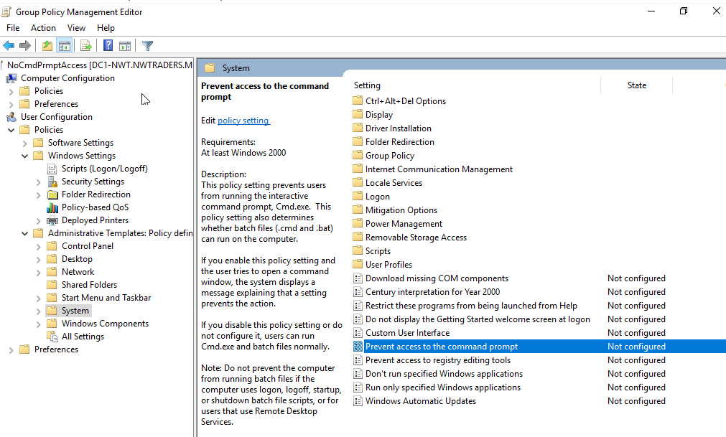
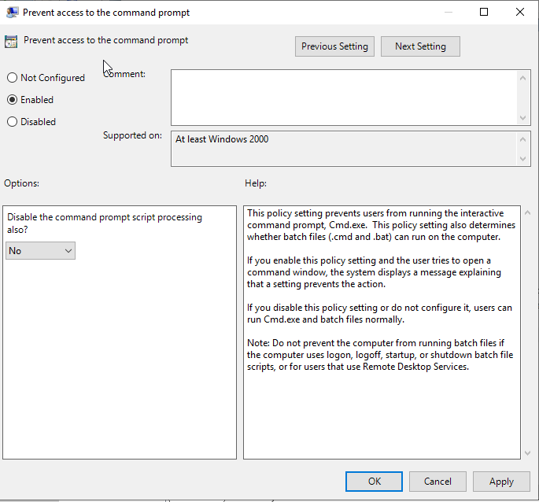

Enable the script:

Run gpupdate /force as previously, reports back as successful. Sign into Client1 with the Ann Other account and Run ‘cmd’ and the resulting report appears as below:
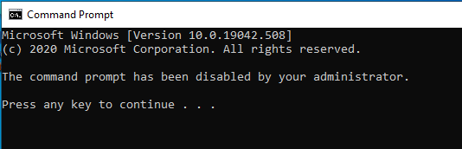

Access to removable drives
Remove access to removable drives:
Start Group Policy Management Editor:
Navigate to ‘User-Configuration – Policies – Administrative Templates – System – Removable Storage Access’ and select ‘All Removable Storage classes: Deny all access’.
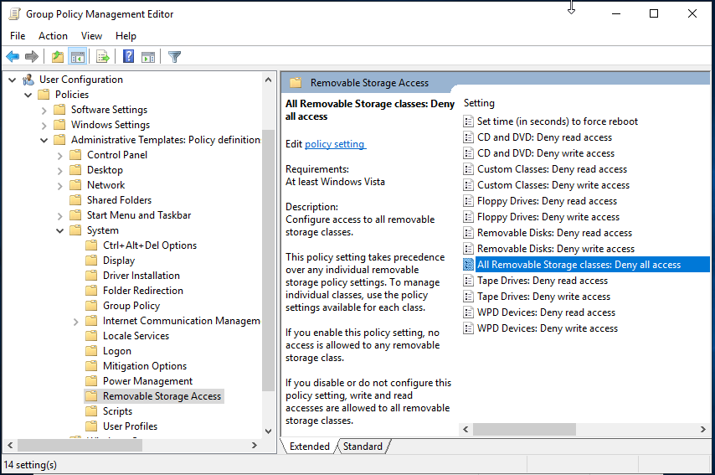
As before, select Enable, click Apply and OK. Run gpupdate /force to set the policy.
Sign in to Client1 VM with Ann Other account and check for access to removable drive:
Attempted access to the Optical drive and the resulting message is displayed:
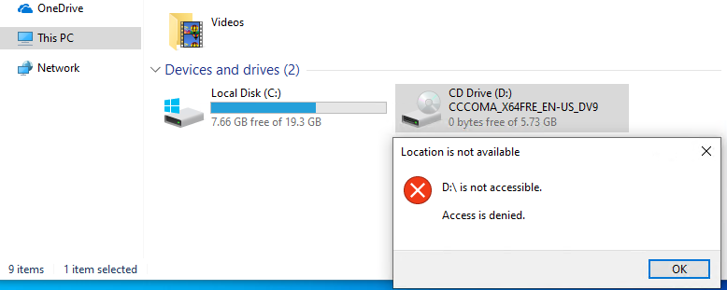

Restrict Software Installs
This Policy acts upon the computer system and therefore, an organisational unit is created for computer objects to be added.
Create new OU named ‘NWClient Computers’
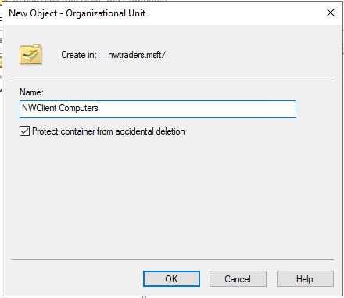
Move workstation1 ‘WS1-NWT’ from OU ‘Computers’ to the new OU ‘NWClient Computers’:
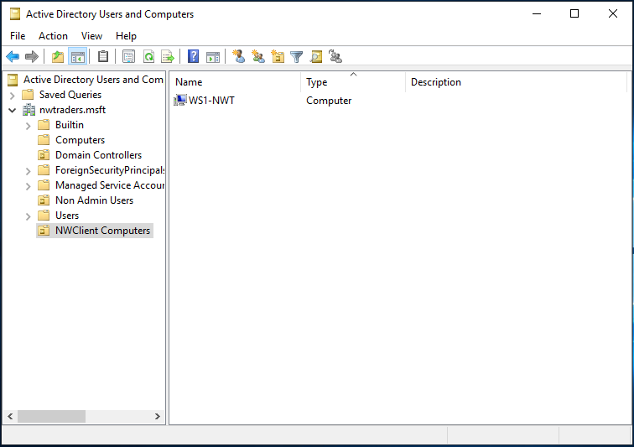

Now start Group Policy and expand the ‘nwtraders.msft’ domain revealing the newly created OU NWClient Computers’. Right click on the OU and choose ‘Create a GPO in this domain…’ named ‘NoUnauthSoftInstalls’:
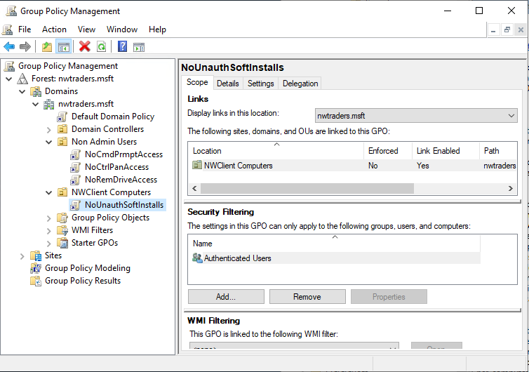

Right click on the ‘NoUnauthSoftInstalls’ GPO and navigate to ‘Computer Configuration – Administrative Templates – Windows Components – Windows Installer’ and select ‘Prohibit User Installs’:

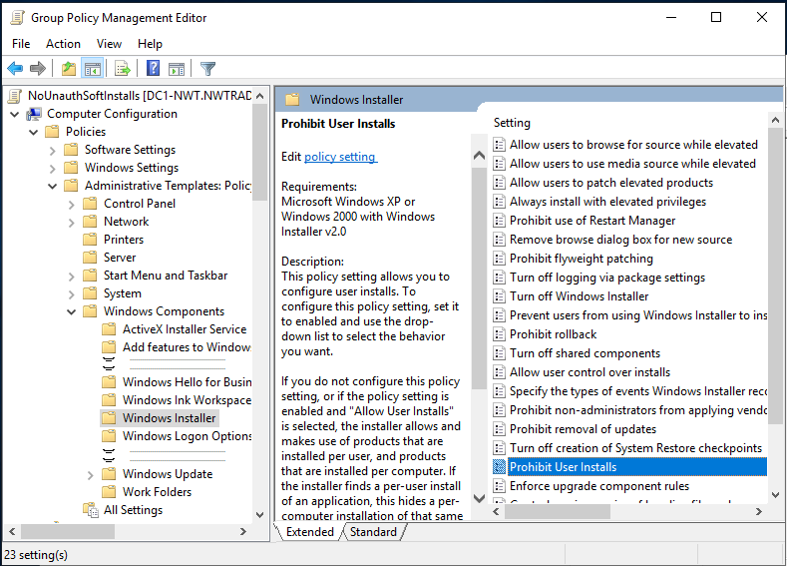

Double click and Enable:
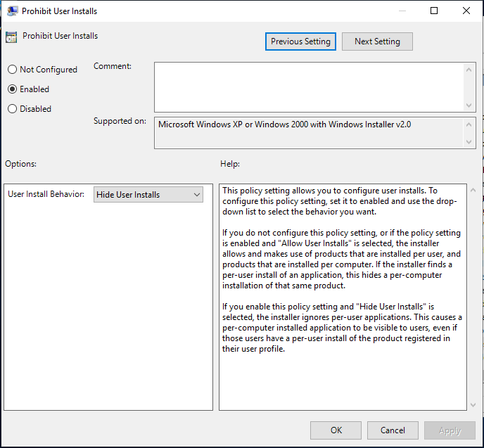
Click Apply and OK then use command line to run gpupdate /force to implement the policy. Applies successfully as before.

Check that the rights to install software have been revoked.

Log in to Client1 VM and sign in as Ann Other.
In the meantime, I had enabled shared folders on the VM using ‘VirtualBox Guest Additions’ so I could copy an installer to the root of the C drive on Client1 VM. Otherwise, I would not be able to find a piece of software to install. Possibly I could have used the Guest Additions CD for this, however, I was not sure whether it was tailored to the VirtualBox environment. Therefore, I copied the installer for OBS Studio (used for screen recording) to a folder named ‘AppInstallFolder’.
Double clicking this installer prompted the following response:
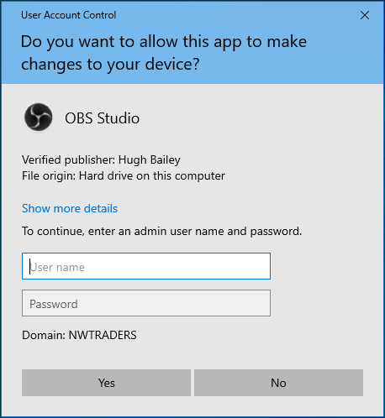
Clicking Yes does nothing unless an administrator account is signed into at that point.
If the administrator account is signed into, the installer starts, demonstrating that the admin account can overcome the OU ‘NWClient Computers’Group Policy.

Password Policy
Open Group Policy manager, expand the ‘nwtraders.msft’ domain, right click on the ‘Default Domain Policy GPO – Edit’.
Expand ‘Computer Configuration – Policies – Windows Settings – Security Settings’.
Click on ‘Account Policies – Password Policy’

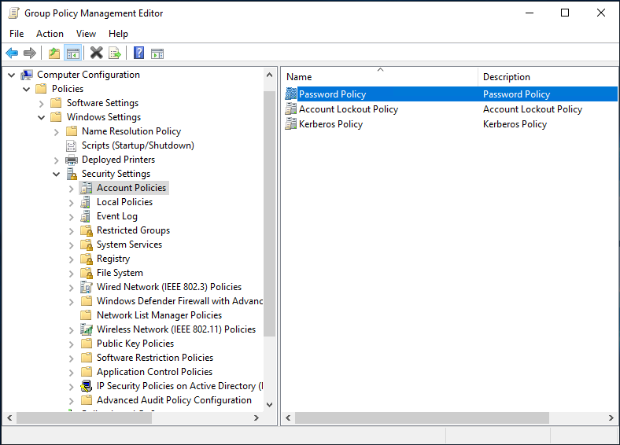

Six settings are available within this Policy:
Set according to the worksheet:
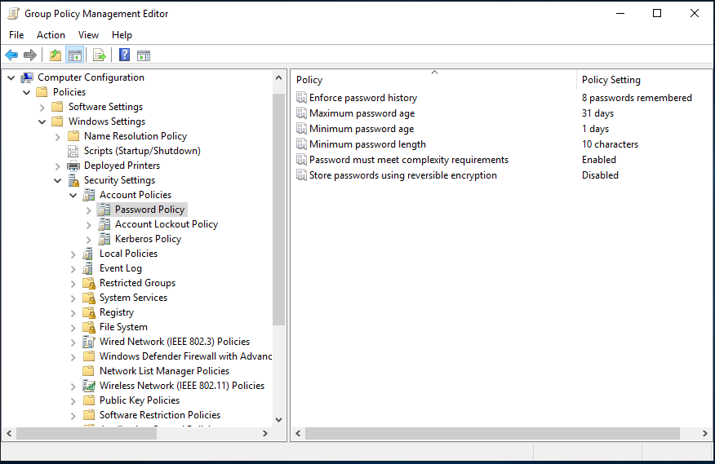
Click Apply and OK, close Group Policy Management.
Run gpupdate /force to apply policy. Check it completes successfully.
Create new user using ‘Active Directory Users and Computers’
User created named ‘John Smith’ with User logon name of NWT-JS (@nwtraders.msft)
and use a password that does not comply with the rules:
Setup with password ‘P@ssw0rd’ as used previously…
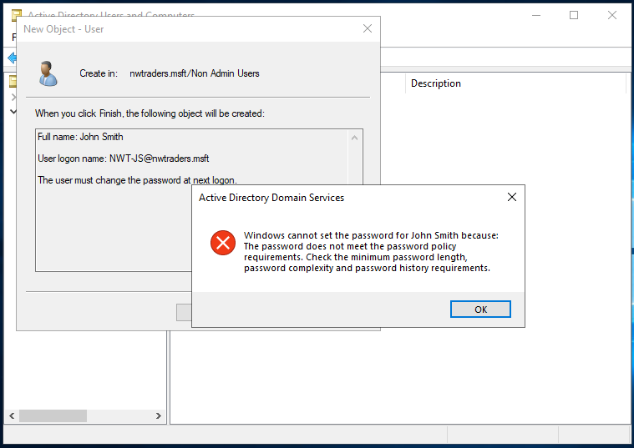
The AD Domain Services reports that the password cannot be set for the new user ‘John Smith’ as the password does not meet the password policy set.
Use an easy to remember three-word passphrase: Get the tea interspersed with 123 and a punctuation mark. !Get2The3Tea
User created successfully.

Observational Tasks (Q3)

3.a) Explain differences between local permissions and file shares.
Local permissions are set on files and folders that are contained within an NTFS volume. The permissions allowed by NTFS permissions are listed by ‘dnsstuff.com’ as follows:
- Full Control: With this setting turned on, this means users can add, change, move, and delete files and directories. This also applies to any associated properties of the files or directories. Furthermore, users can change the permissions for the files and directories, which means they can give others full control or take permissions away.
- Modify: This is not as powerful as full control, but users can still view and modify files and their properties. They can add or delete files from a directory or add or delete properties from a file.
- Read and Execute: This means users can read files and run executable files including scripts. They cannot modify files and their properties.
- Read: Users can only read or view files, their properties, and directories.
- Write: Users are only able to write to a file or add files to a directory. [1]
Conversely Share folder permissions are only listed as having three permissions as detailed below and are set against a folder:
- Read: This is much like the NTFS permission above. Users can only view file names, read the data in those files, and run some programs.
- Change: Users have all the permissions included with read, but can also change data within files, add new files or folders, and delete files or folders. This permission is never assigned by default and must be assigned on purpose.
- Full Control: This is the same as the NTFS permission—users can do all of the things included in the read and change groups but can also change the permissions for files and folders. All administrators are granted full control permissions by default. [1]
Share permissions are used for managing access to folders shared over a network. A local login will not gain access to that folder. Share permissions can be set against NTFS, FAT and FAT32 file-systems. But only with the three options above, Read, Change or Full Control.
Therefore, NTFS permissions allow finer controls on the access granted to files and folders but the share method is easier to manage and apply and within advanced settings further controls are available, for example to set the number of connections allowed to a file or folder, which is not provided by NTFS permissions.
These permissions can both be set, and if they are confusion can arise as there maybe conflicting settings set at different levels, however, as stated by etutorials “the most restrictive permission is the effective permission.” [2]

3.b) Describe the role of Group Policy Management in the network environment, you can use example policies in your answer.
Group Policy is described by Microsoft as:
Group Policy is an infrastructure that allows you to specify managed configurations for users and computers through Group Policy settings and Group Policy Preferences. To configure Group Policy settings that affect only a local computer or user, you can use the Local Group Policy Editor. You can manage Group Policy settings and Group Policy Preferences in an Active Directory Domain Services (AD DS) environment through the Group Policy Management Console (GPMC). Group Policy management tools also are included in the Remote Server Administration Tools pack to provide a way for you to administer Group Policy settings from your desktop. [3]
It is used to set rules against the users or computer objects that sit within an Active Directory domain/forest. Each Organisational Unit (OU) can have its own group policy set against it. Therefore, when assigning the abilities of users or their machines on a network it can be easy to control or manage as the administrator only has to move that object into the necessary OU and the settings are automatically assigned or inherited. Sometimes tighter controls are necessary and to this end Group Policy Objects (GPO) can be set against objects when required. However, this must be done in an organised fashion to make sure that conflicts do not occur between permissions and groups that an object belongs to. As mentioned by Microsoft below:
“Within each GPO, you can create multiple preference items with each preference extension. Targeting options give you with more precise control over how Windows applies preference settings. By using item-level targeting, you can configure each GPO to be appropriate to more users and computers.” [4]
Examples of the policies available are given below:
- In the worksheet above we saw:
  - Prohibit access to Control Panel and PC settings
  - Prevent Access to the Command Prompt
  - All removable storage classes: Deny all accesses
  - Prohibit User Install
  - Enforce Password Policy
- Other examples include:
  - Disable Forced System Restarts
  - Disable Guest Account [5]
  - Desktop settings – including corporate backgrounds
  - Disabling automatic driver updates on your system [6]
Some of these settings are network security based, some are to help users enjoy a stable system and some are corporate image based. It would go without saying that the above are in order of importance.

3.c) Give some examples of sound ‘password’ principles in modern network environments
As seen in the first worksheet, passwords were created during that exercise. Creating a password of !leT”mE£iN utilised the rule of using three simple words to make it memorable but the complexity is increased by interspersing the words with punctuation instead of spaces. The punctuation is 1,2,3 with shift, which helps with memorising. However, it must be realised that different keyboard layouts may not have !”£ as shift +123. Also, sometimes numbers are required but they can be used instead of the punctuation. A further layer of complexity is that the words have the capital letter at the end of the word. Dictionary attacks often use rules such as putting capitals at the start of words, using <space> or _ between words and placing numbers at the start or end of the string. By using the above format, a recall friendly password can be created that is relatively secure. Obviously a completely random set of characters is preferable but memorising these type of passwords is not easy or required during the purpose of this exercise.
The cartoon below demonstrates well how passwords have mutated over the years:
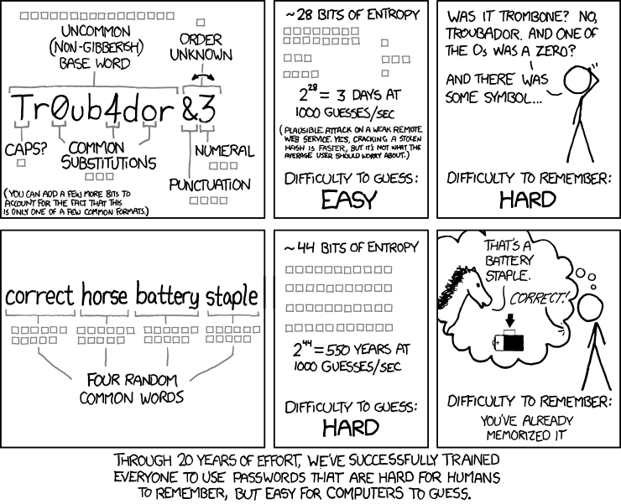 [7]
The above is also recommended by the NCSC (National Cyber Security Centre) as can be seen in the text below:

‘Using complexity requirements (that is, where staff can only use passwords that are suitably complex) is a poor defence against guessing attacks. It places an extra burden on users, many of whom will use predictable patterns (such as replacing the letter ‘o’ with a zero) to meet the required 'complexity' criteria. Attackers are familiar with these strategies and use this knowledge to optimise their attacks. Additionally, complexity requirements provide no defence against common attack types such as social engineering or insecure storage of passwords.
For the above reasons, the NCSC do not recommend the use of complexity requirements when implementing user generated passwords.’ [8]
Leading on to the following advice:
‘Adopting the 'three random words' technique can help users to use suitably complex passphrases that they can actually remember.’ [8]
The site does mention using machine generated passwords but accepts the difficulty in remembering these. Once patterns are introduced, their efficacy diminishes especially if the attackers learn the pattern.
They summarise as:
- Be aware of the pros and cons of different password generation methods.
- If password managers are used, encourage the use of the built-in password generator.
- Complexity requirements provide no defence against common attacks and should not be used.
- Prevent users setting passwords that are too short.
- Don't impose artificial capping on password length. [8]
Microsoft’s minimal complexity requirements use characters from three of the following categories:
- Uppercase letters of European languages
- Lowercase letters of European languages
- Base 10 digits (0 through 9)
- Non-alphanumeric characters (special characters): (~!@#$%^&*_-+=`|\(){}[]:;"'<>,.?/)
- Any Unicode character that's categorized as an alphabetic character but isn't uppercase or lowercase. This group includes Unicode characters from Asian languages.
Set Passwords must meet complexity requirements to Enabled. This policy setting, combined with a minimum password length of 8, ensures that there are at least 218,340,105,584,896 different possibilities for a single password. This setting makes a brute force attack difficult, but still not impossible. [9]

References

[1] | dnsstuff, “NTFS vs. Share Permissions,” dsnstuff.com, 3 4 2020. [Online]. Available: https://www.dnsstuff.com/ntfs-vs-share-permissions. [Accessed 8 04 2021].
[2] | etutorials.com, “Lesson 3: Combining Shared Folder Permissions and NTFS Permissions,” etutorials.com, [Online]. Available: http://etutorials.org/Microsoft+Products/microsoft+windows+xp+professional+training+kit/Chapter+9+-+Administering+Shared+Folders/Lesson+3nbspCombining+Shared+Folder+Permissions+and+NTFS+Permissions/. [Accessed 08 04 2021].
[3] | Microsoft, “Group Policy Overview,” Microsoft, 31 08 2016. [Online]. Available: https://docs.microsoft.com/en-us/previous-versions/windows/it-pro/windows-server-2012-r2-and-2012/hh831791(v=ws.11). [Accessed 08 04 2021].
[4] | Microsoft, “Overview of Preferences,” Microsoft, 22 2 2013. [Online]. Available: https://docs.microsoft.com/en-us/previous-versions/windows/it-pro/windows-server-2008-R2-and-2008/cc732027(v=ws.11)?redirectedfrom=MSDN. [Accessed 08 04 2021].
[5] | D. Murphy, “Top 10 Most Important Group Policy Settings for Preventing Security Breaches,” lepide.com, 25 03 2021. [Online]. Available: https://www.lepide.com/blog/top-10-most-important-group-policy-settings-for-preventing-security-breaches/. [Accessed 08 04 2021].
[6] | netwrix.com, “Group Policy Best Practices,” netwrix.com, 2021. [Online]. Available: https://www.netwrix.com/group_policy_best_practices.html. [Accessed 08 04 2021].
[7] | R. Monroe, “Password Strength,” XKCD.com, 10 Aug 2011. [Online]. Available: https://xkcd.com/936/. [Accessed 10 Mar 2021].
[8] | National Cyber Security Council, “Password administration for system owners,” GOV.UK, 19 Nov 2018. [Online]. Available: https://www.ncsc.gov.uk/collection/passwords/updating-your-approach#tip5-password-collection. [Accessed 10 Mar 2021].
[9] | Microsoft, “Password must meet complexity requirements,” Microsoft, 22 Jan 2021. [Online]. Available: https://docs.microsoft.com/en-us/windows/security/threat-protection/security-policy-settings/password-must-meet-complexity-requirements. [Accessed 10 Mar 2021].

