COMPONENT 1 REPORT EFFECTIVE TEAMWORKING FOR
TEAM SUCCESS

SOCORRO ALAM

2029042@student.uwtsd.ac.uk

MODULE EFFECTIVE TEAM WORKING AND COMMUNICATION

MODULE CODE= BMSW4002

LECTURER= JOANNE DAVIES

ABSTRACT

This report is written for Green Fields Care Home. They have an urgent issue that needs attention, as it gives bad reputation in their organisation. There’s no effective teamwork in the organisation and has poor leadership.

CONTENTS

TITLE PAGE= COMPONENT 1 REPORT EFFECTIVE
TEAMWORKING FOR TEAM SUCCESS page 1
ABSTRACT page 2
CONTENTS PAGE page 3
INTRODUCTION page 4
MODELS OF TEAM DEVELOPMENT page 8
TEAM ROLES page 12
DISCUSSION page 13
CONCLUSION page 15
REFERENCE page 16

INTRODUCTION
OVERVIEW OF TEAM WORKING
MODELS OF TEAM DEVELOPMENT
TEAM ROLES
DISCUSSION
CONCLUSION AND RECOMMENDATION
REFERENCE LIST

INTRODUCTION

In this report the main purpose is to create an effective teamwork. Establish barriers that may have cause in Green Fields Care Home and the impact that may had cause. Different models of team development were introduced in creating an effective teamwork.

OVERVIEW

Green Fields Care Home is a bed 56 residential care facility, which cater for older people in different ethnicities and religions. And some of the staff are not tolerant of diverse beliefs and customs. Which lead to residence and relatives making complaints. And the care team are not working together, which lead to negative impact on the quality of care given. There are also some staff issues, some of the staffs are resigning. And if this carry-on there will be not enough staffs to keep the home running.
How can management of Green Fields Care home can develop an effective team? These is an urgent matter that needs to be discuss and make solution. Management team needs to be address. Some of the staffs has lack of commitment, care teams are not working together. Most of the staffs are giving their resignation letters, there will no more staffs left to keep the home running and will impact on productivity losses.
Green Fields Care home needs to recruit more staffs and start creating an effective teamwork. Individuals who work as a team and cooperate with other members has more chances of solving shared problems and personal needs. (Qin.Z., Johnson. D., Johnson. R. (1995).
Richard Branson says, “If they look after their employees, they will look after their business.”

Diagram 1.1 Common problem in a team (Griffith & Durham (2015)
- LACK OF COMMITMENT= Staffs in Green Fields Care Home has shown no commitment in their work, and they’re not tolerant of diverse beliefs.
- PRODUCTIVITY LOSSES= Attracting new residence is at risk.
- POOR COMMUNICATION= They don’t communicate properly to their job role.
- INTERPERSONAL CONFLICT= Conflict among workers.
- POOR LEADERSHIP= Team leader don’t handle well their team, that’s why conflict begun.

CREATING EFFECTIVE TEAM: 4 KEY COMPONENTS OF EFFECTIVE TEAMS
THE KEY COMPONENTS MAKING EFFECTIVE TEAMS HAS 4 GENERAL CATEGORIES:

- WORK DESIGN ----------------------
*AUTONOMY
* SKILLS VARIETY
* TASK IDENTITY
2. COMPOSITION
* ABILITY TEAM EFFECTIVENESS
* PERSONALITY
* ROLES AND DIVERSITY
* SIZE
* FLEXIBILITY
T * PREFERENCE FOR A TEAMWORK
3. CONTEXT
* ADEQUATE RESOURCES
* LEADERSHIP
* CLIMATE OF TRUST
* PERFORMANCE EVALUATION AND REWARDS
4. PROCESS
* COMMON PROCESS
* SPECIFIC GOALS
* TEAMS EFFICACY
* CONFLICTS
* SOCIAL LOAFING ----------------|
IEdunote.com

MODELS OF TEAM DEVELOPMENT
Green Fields Care Home has been receiving complaints from residents and relatives. Staff morale has been affected which gives negative impact on the quality of care in their organisation. On this part team development should be considered to develop effective teams. Groups go through different stages. (Arrow et al., 2004).
Tuckman’s theory is to be considered in this stage. It focuses on teams from their behaviour towards the task and start building trust with each other. The stages of Tuckman’s team development consist of the following and has been the most cited in models of team development.
- FORMING STAGE= Getting to know each other. Teams is assembling and task is allocated.
- STORMING= Team starts to suggest ideas. Different ideas may compete if not handle well.
- NORMING= Team moves out of storming. Teams begin to trust themselves.
- Performing= Teams has been identified, decision making with respect in communication between team members.
- ADJOUNING= Final phase added by Tuckman in later date. To cover end of the project. Team dissolving after completion.

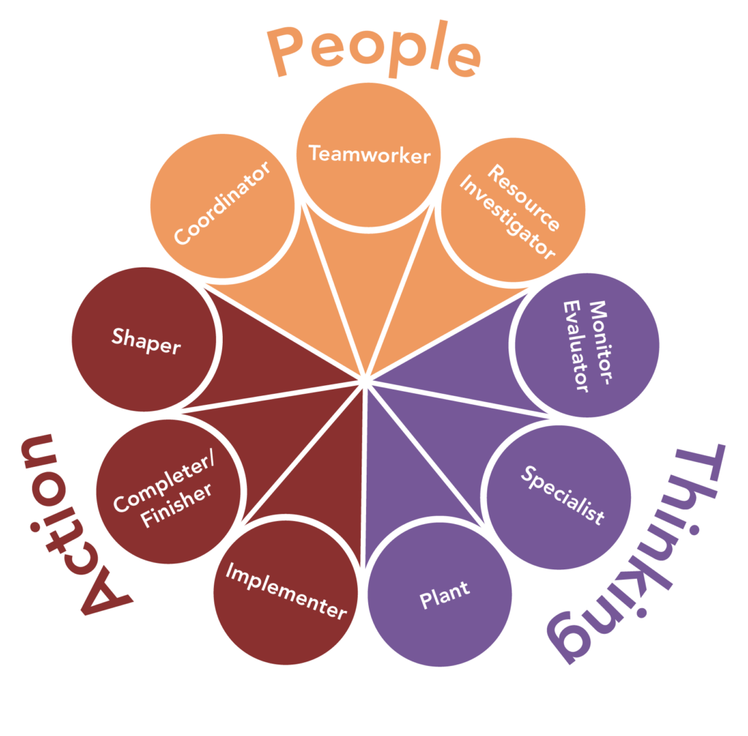
This Photo by Unknown Author is licensed under CC BY

Belbin. M. (1981) is another to be considered as it allows you to discover strength and weakness of everyone to develop and resolve conflict. Belbin Book “Management teams was named as the one of the top fifty management books of all time. And has been used in a university setting for over 30 yrs.

9 TEAM ROLE, STRENGTH, AND WEAKNESS EXPLAIN:
TEAM ROLE. STRENGTHS. WEAKNESS (ALLOWABLE)
COORDINATOR MATURE, CONFIDENT CAN BE SEEN AS MANIPULATIVE
IDENTIFY TALENT OFFLOADS OWN SHARE OF WORK

IMPLEMENTER PRACTICAL, RELIABLE & SOMEWHAT INFLEXIBLE SLOW TO
EFFICIENT. TURNS IDEAS RESPONSE TO NEW POSSIBILITY
INTO ACTION & ORGANISE
WORK THAT NEEDS TO BE
DONE.

SHAPER CHALLENGING, DYNAMICS PRONE TO PROVOCATION.
THRIVES ON PRESSURE. HAS OFFENDS PEOPLE FEELINGS.
THE COURAGE & DRIVE TO
OVERCOME OBSTACLES.
TEAM ROLE STRENGTHS WEAKNESS ( ALLOWABLE)

COMPLETE PAINSTAKING, CONSCIENTIOUS INCLINE TO WORRY UNDULY
FINISHER ANXIOUS, SEARCH FOR ERROR RELUCTANT TO DELEGATE
POUSIL & PERFECT

RESOURCE OUTGOING, ENTHUSIASTIC OVER OPTIMISTIC, LOSES
INVESTIGATOR COMMUNICATIVE. EXPLORE INTEREST ONCE INITIAL
OPPORTUNITY & DEVELOP ENTHUSIASM HAS PASSED.
CONTACTS.

SPECIALIST SINGLE MINDED, SELF STARTING, CONTIBUTE ONLY ON
PROVIDE KNOWLEDGE AND NARROW FRONT DWELLS
SKILLS IN RARE SUPPLY ON TECHNICALITIES.

MONITOR STRATEGIC & DISERNING LACK DRIVE & ABILITY TO
SEES ALL OPTIONS & JUDGE INSPIRE OTHERS CAN BE
ACCURATELY. OVERLY CRITICAL.

PLANT CREATIVE, IMAGINATIVE, FREE IGNORE INCIDENTIALS
THINKING. GENERATES IDEAS TOO PREOCCUPIED TO
& SOLVE DIFFICULT PROBLEMS. COMMUNICATE.

TEAM WORKER COOPERATIVE, PERCEPTIVE, INDECISIVE IN CRUNCH
DIPLOMATIC, LISTENS & SITUATION. AVOID
AVERTS FRICTION CONFRONTATION.

Other model of team development in effective teamwork:

The Culture Code by Coyle (2018). Coyle identify the secret of successful groups and how this develops into effective teams.
Skill 1- Build safety
a). Over communicate listening: use body language and eye contact to show that you are attending to what they are saying.

Skill 2- Share vulnerability
a). Tell the truth to your team.
b). Any negative feedback should be done face to face.
C). Good listening.

Skill 3- Establish a purpose
a). Name and rank your priority
b). Be ten times as clearer about priories.

Wheelan (2016) is about size + diversity equals team composition. Size matters. In a small group everyone has a chance to give their ideas and a chance to speak. While a bigger size of group some member has no chance in speaking for themselves and they end up just listening to the group. Diversity of the teams bring s impact in the group.

BEING A GOOD TEAM MEMBER:
Wheelan (2014) outlines key advice for members of groups.
DON’T BLAME OTHERS FOR GROUP PROBLEMS:
- GIVES EVERYONE THE BENEFIT OF THE DOUBT FOR THE SAKE OF THE GROUP.
- BLAME STARTS A CYCLE OF REVENGE AND RETALIATION.
- INSTEAD FINDOTHER FACTORS THAT MIGHT BE BLOCKING PROGRESS AND FIX THEM.
ENCOURAGE CLARIFICATION:
- IF YOU DON’T KNOW WHAT IS HAPPENING OR UNDERSTAND WHY SOMETHING IS HAPPENING ASK QUESTION.
LISTEN TO OTHERS INPUT AND BE HEARD.
BALANCE TASK COMMUNICATIONS AND SUPPORTIVE COMMUNICATIONS.
TEAM ROLE
In this stage, Green Fields Care Home should have been considering recruiting more staffs. And Belbin’s team role should be considered to get an effective workforce. Belbin team roles model has identified nine (9) roles which has been categories into three (3) different groups: Action oriented, thinking oriented and people oriented. According to Mind tools (2013) “These roles are drawn from observed behaviour and interpersonal styles. Management teams should know each team members skills and abilities.

Diagram 2.2
Belbin nine (9) team roles

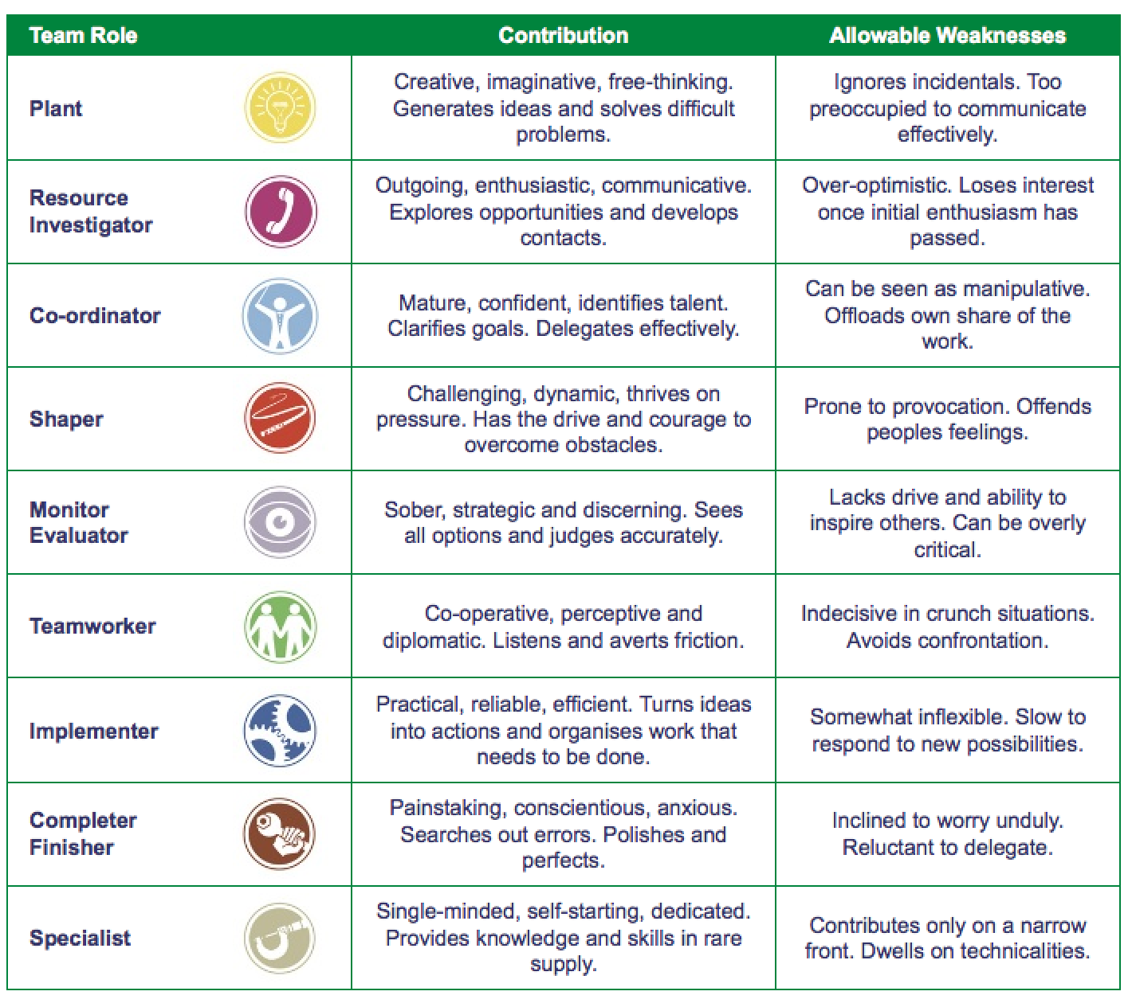
This Photo by Unknown Author is licensed under CC BY-SA-NC

DISCUSSION:
“Effective teamwork for health care professional’s is critical for patients’ safety and the quality of care”. O’Connor. P., et al (2016).
Green Fields Care home reputation is on the line because of poor team workforce, and it gives a bad impact on the organisation. Attracting new resident would be at risk. They need to build a strategy for effective teamwork. (Amos. M., Hu. J., Herrick. 2005).
Recruiting more staffs and give them proper training and understanding of their role. Rewarding is a bonus for everyone who deserve it.
Let me share to you an experience I have encounter at work. I work as a care assistance For Avery Care home base in Moulton, Northampton. I do two (2) nights a week. One night, I was allocated to work with new staff and a senior care assistant. We have thirty-one (31) residence. And one of the residences is on end- of life and is on half an hourly observation. After giving them their suffer and assisted with their personal care, most of the residence are in bed and settled. There are some residences who can’t sleep. Some will get -up and may need assistance in going to use the toilet. I also had to teach the new staff the routine. That night our focus is one of the residences is on end -of life whose breathing at the time was shallow. And that night she died. After informing the nurse and the senior carer, the nurse must check the pulse and was declared dead. The senior care assistant is busy making calls to the relative to let them know what has happen. She has also had to arrange for the funeral director to collect the body. The new staff I was working was very scared at that time. We had to wash the body and dress. But the new staff is scared. I give her reassurance and there’s nothing to fear. All I need is to help reposition the body and I will wash the body. When the funeral director arrives to collect body, more paperwork needs to be done, and some of the residence has started to get up. Personal care needs to be assisted. We have decided between us that me and the new staff will start the residence personal while the senior care assistant finish the daily notes. It was a busy night; I don’t remember having break but at the end of the shift we deliver a good quality care for being effective team.

IMPACT OF INEFFECTIVE OR POOR TEAM WORKING

- POOR LEADERSHIP FAILS TO LEAD OR DEMONSTRATE APPROPRIATE
LACK OF PATIENT FOCUS STANDARDS OF CLINICAL CARE

- LACK OF COORDINATION FAILS TO WORK EFFECTIVELY AS A TEAM AND
THEY DON’T FEEL COMPETENT. COORDINATE TO PRIORITIZE A PATIENT NEEDS.

- LACK OF SHARED MENTAL TEAM MEMBERS DO NOT HAVE A COMMON
MODELS. UNDERSTANDING OF TASK & PATIENT CARE.

- POOR COMMUNICATION LACK OF CLEAR & OPEN COMMUNICATION
BETWEEN TEAMS

O’CONNOR. P. et al. (2016).

CONCLUSION AND RECOMMENDATION

To give quality of care must have a good teamwork in care settings. With right understanding of each role and commitment, with good environment, it reduces any conflict in the organisation. A good teamwork encourages them with their potentials. Good teamwork creates good environment and gives residence something to look forward. Rewarding for their work done well, gives team members motivation in their work. Good relationship with the teams, doesn’t matter what position they might have brings harmony to all. If the residence is happy, everyone is grateful.
In care settings, we need to be focus on our job role because we are dealing with human lives. If you are committed, with good understanding of job role, plus effective teamwork is one good recipe in delivering quality of care. Effective teamwork is very important, it increase productivity. Team members who help produce good results will feel valued, supported and committed with each other. Stronger relationship between team members-built trust with each other and communication becomes natural and open. That’s conclude 1st task.

I would strongly recommend Belbin’s (1981)., and Tuckman’s (1965) theory. Belbin’s methods allow to discover strength and weakness of everyone to develop and resolve conflict. Belbin identify nine (9) roles model which was categorise in three (3) groups. These roles are drawn from observed behaviour and interpersonal styles. And in Belbin team role is a set of characteristics, strength and weakness. Belbin team role has been using in university settings for over 30 yrs. And Belbin’s book “Management teams is one of the top fifty management books of all time. A successful team lies upon excellent teamwork, where roles and responsibility are clearly defined. The nine (90 Team roles are, coordinator, implementer, shaper, complete finisher, resource investigator, specialist, monitor evaluator, plant and team worker. And they. are all categorizing in three groups. Action oriented, thinking oriented and peoples oriented.

While Tuckman’s (1965). theory focusses on building trust with each other through completing task. Tuckman identify the stages of team development. Forming, storming, norming, performing and later added adjourning. Tuckman is the most cited in effective teamwork. That’s conclude my recommendation.

REFERENCE

Amos. M., Hu. J., Herrick (2005). The impact of Team building on communication and job satisfaction of nursing staff. Journal.Iww.com

Arrow et al., (2004). Journal of economic perspective

Belbin. M. (1981). Management teams Heiman

Coyle.D.(2016). The Culture Code

Griffith & Durham (2015)

Guyas. H. (2014) Effective communication and teamwork promote patient safety. Nursing standard.

Mind tool (2013)

O’Connor et al (2016)

Qin. Z., Johnson. D., Johnson. R. (1995) Cooperative versus competitive efforts and problem solving.

www. IEdunote.com

