Jakob Lewis (1901440)
ACBA4027 Skills For Professional Practice
report of City ground football stadium

Introduction
The City Ground is a 30,745-seater football stadium situated on the banks of the river Trent in Nottingham. The stadium has been home to Nottingham Forest football club since its construction was completed on the 3rd of September 1898. Wollaston, S. (2020). This structure is significant as it’s the home of the world’s second oldest football league club and has gone through various stages of redevelopment since its construction 126 years ago. The purpose of this report is to document the development of this structure and identify engineering and architectural features used during this period of redevelopment.
Description
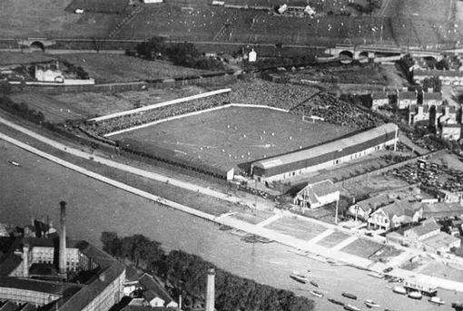
The city ground was originally built in 1898, and consisted of 3 timber framed brick stands, the original structure had no seating unlike modern sports stadiums and constated of timber framed terraces which only allowed standing room for fans. The original construction was undertaken by a local company JW Bardill. The stadium was named the City Ground to celebrate Nottingham’s new city status in 1897. The stadium and land it were built upon was originally owned by the Nottingham corporation but in 1935 the stadium was bought by Nottingham Forest Football Club LTD for the sum of £7000, however the land it was built on still remains under the ownership of the Nottingham corporation (now Nottinghamshire County Council). Wollaston, S. (2020).
Figure 1 showing the city ground in 1920

Construction process
As stated previously, the City Ground has gone various stages of redevelopment in its 126-year history. the first stage of this redevelopment was the construction of the main stand in 1957, this development was a 2500 seat wooden framed 2 terraced stand designed by Husband & Co architects and building work was undertaken by Taylor Woodrow contractors. This stand stood for 11 years but due to its timber construction it was destroyed by a fire on the 24th august 1968. This left the stadium unusable for a number of months until rectification work could be carried out. Wollaston, S. (2020).
The next period of redevelopment was completed in 1980 when the 10,000-seater Brian Clough stand was constructed. This redevelopment was required due to the football club’s successes in domestic and European football competitions leading to a much larger fan base and a need for more capacity to house these fans and came at a cost of £2 million. This stand was named after the football clubs’ manager at the time Brian Clough as a celebration to the newfound success he brought to the club.
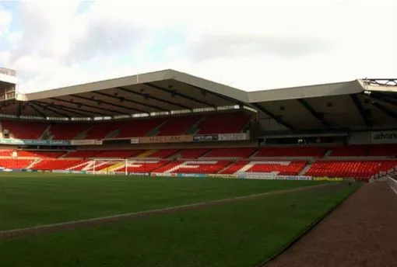
It was 12 years later in 1992 when the next period of redevelopment was completed, this was to increase the capacity and modernise the aging Bridgford stand, this development increased the capacity of the stand to 7710 seats. A major obstacle in the design of this stand was the effect it would have on neighbouring residential properties, in order to pass planning restrictions an unusual, shaped roof (see fig 2) had to be designed and constructed to allow sunlight to reach nearby houses on the adjected Colwick Road. Club, N.F.F. (20220
Figure 2 showing the odd shaped roof on the bridgford stand

In 1996 the Trent end stand was reconstructed to a capacity of 7500 seats, this development came from the city ground being used to host the 1996 European Football championships which required the stadium to have a total capacity of at least 30,000 seats. The reconstruction of the Trent end took the total capacity of the stadium to 30,445. This new development was carefully designed to incorporate the existing stands which in turn meant that the stadium as a whole resembled the designs of more traditional English football stadiums whilst also encapsulating aspects of more modern European ‘bowl’ style stadiums. Around The Grounds. (2020).
The next period of redevelopment wasn’t completed until 2020, this long gap in development of the stadium was due to a number of financial difficulties endured by the football club at his time, with this being cause by a period of unsuccessfulness in football competitions and the club going through a number of different owners. In 2020 the new owner, Evangelos Marinakis a Greek shipping magnet, set to modernise the ageing stadium and began with the redevelopment of the main stand. This development houses the Club shop museum and executive hospitality boxes which has lead to increased revenue options of the club as a whole. During this time the Main stand was renamed The Peter Taylor stand in commemoration of an ex assistant manager.
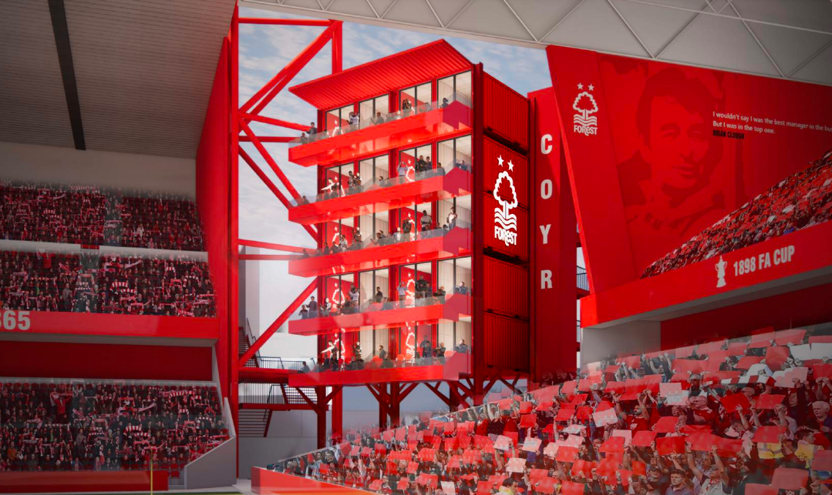
The most recent expansion has been in the corners of the Trent end, in which 20 private hospitality pods have been constructed out of shipping containers stacked upon each other. These were designed by Nottinghamshire based architect BENOY, shipping containers were used in an ode to the clubs’ owners Evangelos Marinakis’s links to international maritime shipping and to demonstrate sustainable and ethical construction processes. This expansion came after Nottingham forests promotion to the premier league which required the club to comply with the premier league’s standards for hospitality and media facilities. This project also allows for further expansion projects such as the demolition and reconstruction of the Peter Taylor stand as proposed in the wider city ground redevelopment project. Hartley, J. (2024).
Figure 3 showing shipping container hospitality suites
Conclusion
In conclusion The City Ground is an important structure in the history of English sport and has gone through a vast period of redevelopment in the last 126 years starting from 3 small timber framed stands and now being a 30,000 plus seater sporting stadium that’s used for a variety of events such as concerts and various sporting events and continues to be developed to allow future generations to enjoy.

References
Figure 1and 2
- Russell, D. and Cooper, B. (2019). How Nottingham Forest’s City Ground has changed in the past 121 years. [online] NottinghamshireLive. Available at: https://www.nottinghampost.com/news/history/how-nottingham-forests-city-ground-2588711.

Figure 3
- Metcalf, S. (2023). Forest unveil ‘hospitality pod’ plans as owner writes off £11m club owes him | TheBusinessDesk.com. [online] East Midlands. Available at: https://www.thebusinessdesk.com/eastmidlands/news/2080233-forest-owner-writes-off-11m-club-owes-him [Accessed 12 Dec. 2024].
Club, N.F.F. (2022). History of The City Ground. [online] Nottingham Forest Football Club. Available at: https://www.nottinghamforest.co.uk/club-information/history/history-of-the-city-ground/. Accessed on 11/12/24
Wollaston, S. (2020). See how the City Ground has changed over the years. [online] Nottinghamshire Live. Available at: https://www.nottinghampost.com/sport/football/football-news/nottingham-forest-city-ground-news-197477 [Accessed 12 Dec. 2024].
Around The Grounds. (2020). City Ground the home of Nottingham Forest | Around The Grounds. [online] Available at: https://www.aroundthegrounds.org/grounds-hub/premier-league/city-ground/ [Accessed 12 Dec. 2024].
Hartley, J. (2024). City Ground changes underway to meet ‘incredible demand’. [online] Nottinghamshire Live. Available at: https://www.nottinghampost.com/news/nottingham-news/nottingham-forest-city-ground-changes-9530623 [Accessed 12 Dec. 2024].

‌

‌

‌

‌

