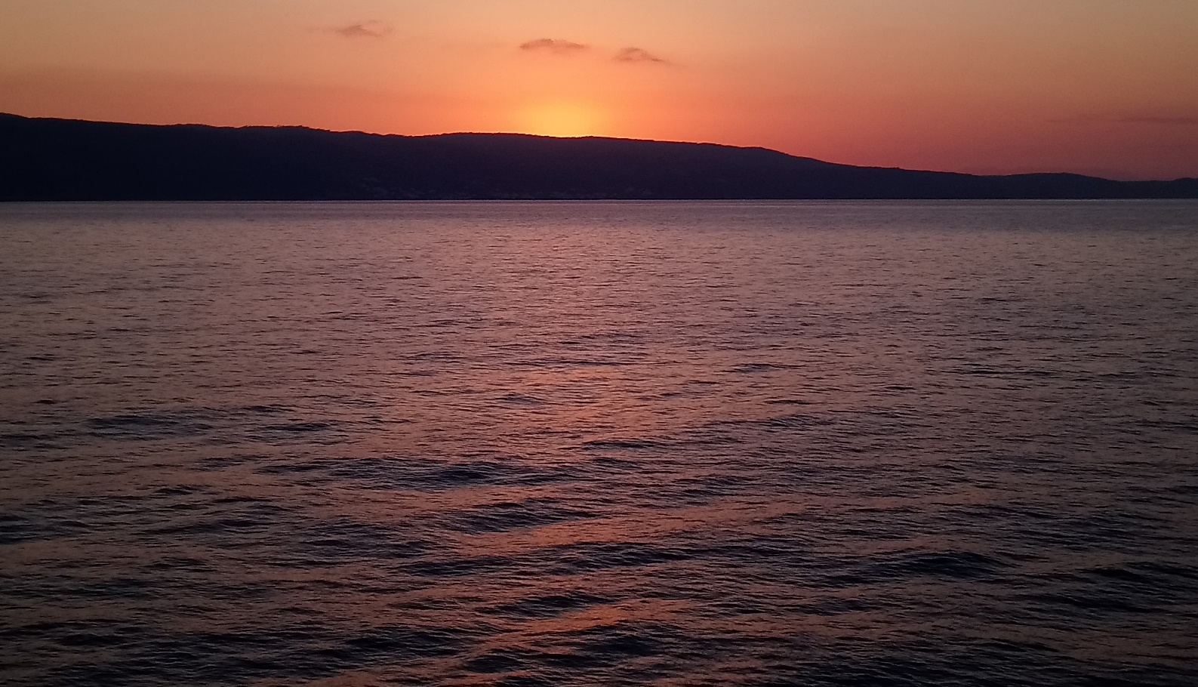

Decoding by Coding the Hidden World of Submerged Archaeology:
2D Legacy or Digital Film to Immersive Cinematic 3D or Virtual Reality

Victoria Maria Genn
Dissertation submitted in partial fulfilment
of a B.A. (Hons.) in Nautical Archaeology
University of Wales Trinity Saint David
May 2018



DECLARATION

This work has not previously been accepted in substance for any degree and is not being
concurrently submitted for candidature for any degree

Signed………Victoria Maria Genn………………. (candidate)

Date…………23rd May 2018………………………………….

STATEMENT

This thesis is the
result of my own investigation, except where otherwise stated.

Other sources are acknowledged by explicit references

and a

Reference List is appended.

Signed…Victoria Maria Genn.. (candidate)

Date……23rd May 2018.………………….

Table of Contents

Abstract iv
Acknowledgements v
Glossary & Abbreviations vi
List of Illustrations viii
Introduction 1
Chapter One ~ A Short Introduction to the Use of 3D in Maritime Archaeology 2
Chapter Two ~ The Benefits of Virtual Reality 10
Chapter Three ~ From Old to New 15
Chapter Four ~ 2D Legacy Footage to Virtual Reality, 3D & Methodology 18
Conclusion 32
References 34
Appendix One – System Information & Software System Requirements 43

Abstract

The vast amount of submerged archaeology that has been discovered and is yet to be discovered can provide historians and scientists with immense resources for research. Unfortunately for the public, many of the sites that have already been discovered are inaccessible. The oceans and seas for those that do not dive, swim or have the resources to travel are a mystery. This results in a lack of awareness which impacts the regard given to submerged cultural heritage. It is possible that the unseen nature of the submerged landscape not only places underwater cultural heritage at risk, but additionally influences the respect given to the oceanic environment which covers approximately seventy percent of the worlds’ surface. Presenting submerged cultural heritage in such a way that it can raise awareness, instil appreciation, and enthuse all people to value the largest area of the planet while igniting the imaginations of future historians and researchers is sorely needed. Much research is being carried out regarding the recording of newly found sites in immersive virtual reality or 3D environments, albeit not always for dissemination to the general public. There are many incredible submerged shipwrecks and cities that have been surveyed in the past and photographed or filmed, but these images and film are just stored away and never published and awareness is limited to the few. It is perhaps a result of the perceived costs and expertise associated with graphical work that is acting as a barrier to archaeologists releasing this information in the types of formats that can inform and galvanise appreciation for the sunken world. This research seeks to find a cost and time effective way of creating immersive environments of submerged cultural heritage sites that have been previously filmed in such a way that VR or 3D was not considered. Additionally, the research seeks to use easily accessible software and inexpensive hardware.

Acknowledgements

First and foremost, I would like to thank my wonderful Baby Boy, Alexander Oscar Ross Genn who always believed that his Mom could do anything ~ regardless of the obstacles in the way. You make me believe in myself almost as much as I believe in you. Your love, support and friendship are everything to me. I am so proud of the man you have become.
Also, my Dad, Oscar Ephraim Genn, your pride in me drives me further. I know it is late ~ but I got there in the end!
To my Uncle, Ross Wallace who instilled in me my love of the ocean, its life, cities and shipwrecks! I hope that somehow you are smiling wherever you are in the cosmos.
I really could not have done it without any of you.
The two doctors in my life, Dr Claudine Young & Dr Joanne Page both of who have enabled me to chase my dreams in different ways. Without your support, I would never have made it.
Special thanks, are likewise owed to Prof. Nigel Nayling and Dr Louise Steel. The encouragement and advice received from you both throughout my time here in Lampeter has been invaluable. The soon to be Dr ~ Mr Doshin Beñat Eguiluz Miranda, thank you so much for the film starring yourself and the abovementioned Prof. Nayling and the long discussions about all things nautical!
I would also like to thank Kathie Flood, CEO and Managing Director of Cascade Game Foundry who provided wonderful insights into how her company manages to support worthy oceanographic causes while also raising awareness of the many risks faced by our oceans and seas through the sale and use of serious (but fun) games and VR. Also, Claire Fleming for her advice and knowledge from within the movie industry. I am extremely grateful to both Fabio Bruno, Associate Professor at the Department of Mechanical, Energetics and Management Engineering (DIMEG), University of Calabria (UNICAL) and Milan Doležal from the Department of Computer Science at Masaryk University who are both involved in the iMare-Culture Project for being so helpful providing new academic works that I otherwise would not have been able to access.
And to everyone that has been a part of this journey with me for the last three years. I have had the time of my life! Thank you all for living through the triumphs and tears with me!
Whatever the future holds and wherever I land, I will never forget any of you!

In Memoria
Jocette Maria Francesca Elnora Genn (nee Eaton) ~ My Mom
William Arthur Ross Wallace ~ Uncle, Brother & one of the Best Friends I ever had all rolled into one
Morné Steyn ~ My Nephew
All of you were gone far too soon ~ I miss you all so much

Glossary & Abbreviations

2D Image Two-dimensional image which is perceived as flat
3D Image Three-dimensional image which is perceived with depth
360° Cameras A type of camera that takes images using multiple cameras mounted in such a way that they take simultaneous images in all directions
ADS Archaeological Data Service
AR Augmented reality
AVI Audio Video Interleaved file format
Algorithm a process or set of rules to be followed in calculations or other problem-solving operations, especially by a computer
Ambisonics Spherical surround sound
Anaglyph An 3D image created by using the same image twice. Each image is slightly offset with elements of different colours, usually red and green then superimposed producing a stereo effect when viewed with appropriate filters over each eye.
BBC British Broadcasting Corporation
CG Computer graphics
CPU Central processing unit
CGI Computer generated imagery
CT Computed tomography
Codec A code that acts as a translator between input and output of data
FPS Frames per second
Geovisualization Short for Geographic Visualization, refers to a set of tools and techniques supporting the analysis of geospatial data through interactive visualization
GPU Graphics processing unit
HD High Definition
HMD Head mounted display – VR headset
Haptic Sensory – haptic devices are two-way communication between user and computerized technology
In situ Artefact that is in the place that it was originally deposited
JPG or JPEG Joint Photographic Experts Group – photographic digital file type
Monoscopic A format for VR and 360° video that requires a viewer with only one lens
MPEG or MP4 Moving picture file type
Photogrammetry the use of photography in surveying and mapping to ascertain measurements between objects and create 3D images
PNG Portable Network Graphics - photographic digital file type
RAM Random access memory
ROV Remote operated vehicle
Serious Games Games developed to teach a specific skill or impart real world information
STEM Science, technology, engineering and maths
Script or scripting A list of commands that runs through a certain piece of software and acts a specific set of commands that need to be followed by the software
VFX Visual Effects
VR Virtual reality – a type of media that is usually viewed with an HMD in 3D and is spherical in nature allowing the user to interact with everything around them through the use of haptic devices
VRML Virtual Reality Mark-up Language

List of Illustrations

Figure 1 - Processed Stills on ACE Parameter 3 (Miranda, 2015) 26
Figure 2 - Processed Stills on ACE Parameter 5 (Miranda, 2015) 27
Figure 3 - Processed Stills on ACE Parameter 4 (Miranda, 2015) 27
Figure 4 - After Cursory Colour Correction in Adobe Premier Pro (Miranda, 2015) 28
Figure 5 - Original Colouring of the Video (Miranda, 2015) 28
Figure 6 - 3DCombine processing ACE Cardboard (Genn, 2018)) 30

Introduction

Much of the research into legacy 3D reconstruction within the discipline of archaeology had been done using photographs or drawings (Wilson et al., 2016). However, to date there has been very little academic research conducted and published on the conversion of legacy 2D film footage into 3D or immersive media. What has been produced cinematically has been processed with anaglyph (Zhou, Desai and Poullis, 2017) imagery for 3D film but this impacts colour. As far as VR and 360° environments are concerned, most of these have been processed using “built” features and are intensively manipulated and the artefacts or site have been specifically recorded to be processed in this manner, for example, the recording of the Thistlegorm in The Red Sea (The Thistlegorm Project, 2017).
The goal of this research is to see if previously recorded 2D film footage of submerged cultural heritage can be converted into either VR or 3D immersive environments. This dissertation is organized as follows: Each chapter includes a short introduction to the topics then covered in detail. The first chapter will give an overview of the history and development of some of the 3D technologies utilized in maritime archaeology from the earliest computer models to the latest ongoing research. In chapter two the benefits of immersive technologies will be highlighted regarding its many uses in training for the highly skilled. Chapter three is an overview of developments that have been made taking 2D to 3D which will be presented and assessed. In the final chapter, ideal hardware and software is discussed followed by a methodology which can convert legacy footage to immersive media.

Chapter One ~ A Short Introduction to the Use of 3D in Maritime Archaeology

Access to computers today is easy; they have become entrenched in life as has the World Wide Web. Gone are the days of trawling through libraries for information, finding out that your own library does not have the information that you need and having to wait patiently until that information can be obtained; now access to information is as simple as typing your enquiry into a search engine like Google or Bing and thousands of results are returned that can be explored. Specialist information sometimes requires a wait but is usually forthcoming. If a computer is not available then this access to information is still possible through even the most modest mobile phones. Email and messaging makes communication instant. These developments have in many ways made life in general so much easier, yet as seems to be humankind’s nature, we are always reaching for something more. In the past, the recording and dissemination of information has been achieved by oral traditions and then by pictures and words on rock, papyrus, wax, clay, skin and paper; in fact, anything that can be marked. Humans are a species of recorders.
Such has been the way with archaeology, starting at its earliest inceptions with simple lists of information and evolving into longer descriptions accompanied with illustrations and or photographs (Reilly, 1991). We have sketches and multiple notes, drawings and photographs from Howard Carter’s discovery and excavation of King Tutankhamun’s tomb (The Griffith Institute, 2018) and the earliest excavations at Pompeii and Herculaneum (Hale, 2006). Yet, with the inception of computers, the move towards using this new technology and using 3D models within archaeological recording has been explored in a multitude of ways since the personal computer entered the mass market. This has further developed now that the very real possibility of using virtual reality technology has become a tangible prospect. At first, the simplicity of what was recorded was modelled on what may have been reproduced on paper, mainly because all that could be achieved at this time was two-dimensional representations (Reilly, 1991). However, computer technology has now moved forward to a time where three-dimensional representations are possible, which is certainly a game changer. Various computerized 3D technologies now exist that can portray archaeological records in differing ways. From a simple anaglyph image to a 3D printed model; what can be achieved will depend entirely on the equipment you have access to. Much in the same way the ability to finely carve a piece of wood without the appropriate chisels is difficult to impossible, the same holds true with computerized 3D reconstruction. The results will depend on the tools that are available.
The revolution of “virtual archaeology” was well underway by 1989 with a collaboration between York and Southampton when they built a system called SYASS (Southampton York Archaeology Simulation System). This program was essentially a simulator for students and while it did not aim to simulate the actual digging of a trench, it aimed to allow them insight into the types of decisions that were available to them when on a variety of digs (Reilly, 1991 & O’Flaherty, 1988). Developments moved forward with the use of WINSOM (WINchester SOlid Modelling system) which was not created for archaeology but was used to reconstruct the Saxon minster of Winchester which was destroyed in the eleventh century using archival, archaeological and analogous data (Burridge et al., 1989). However, these models were static and could not show the different layers of information, and the move to make dynamic models that could show the various phases became the next goal. This was achieved using the Grafland solid model animation which, while still a solid model, has animation added so that as it runs through the animation, the user can see the various layers and details such as post holes, pits and so forth (Reilly and Rahtz, 2011, p. 102).
It is fair to say that submerged archaeology recording also underwent an evolution of sorts. In 1900, the wreck of the Antikythera was discovered and salvage operations began the following year. There is very little record of what the sponge divers saw on the seabed and this may have been because they could only spend up to ten minutes at the depth of the wreck and these precious minutes were utilized for salvage operations (Return to Antikythera, 2018). It was not until the late 50s and 60s that visual recording of underwater archaeological sites became practice. The warship Vasa was one of the first shipwrecks to be visually recorded in some way before it was raised from the depths. This was not done in a way that is now considered to be acceptable by marine archaeologists (Cederlund and Hocker, 2006, p. 180). This was due, in part, to the abysmally bad visibility where the wreck was located, but also in part to the fact that it was navy divers and engineers that were working on the project. While much recording was done the depictions are oddly perfect line drawings. Yet one of the things that was decided by the governing body was to use underwater cameras to record as much as they could. This was a fortuitous decision as there was a carving that was of paramount importance to identify the ship that was lost in the salvage effort (Cederlund and Hocker, 2006, p. 182). Admittedly, the clarity of the images is not ideal due to the water conditions. However, it is situations like this that reiterate the need for good in situ recording of submerged archaeology.
Peter Throckmorten was a photo journalist who was recording shipwrecks on the coast of Turkey in 1960. He was of the firm belief that shipwrecks when excavated should be done with the same care with which terrestrial sites were excavated. By this time, archaeologists excavating terrestrial sites had established a good methodological approach which never seemed to apply to submerged sites. Submerged sites were treated more as salvage opportunities, sometimes by government departments that wanted to fill their museums and study artefacts, but also by private entities. There was no understanding of the in situ context which resulted in studying only half of the wider picture.
As George Bass said ~
“Once excavated a site is destroyed forever. All that remains, besides a collection of artefacts, are the plans and records that allow the archaeologist to publish his evidence so that others can judge his interpretations and conclusions. Only then can the results become a new paragraph or page in the history books” (Bass, 2012, loc..511-512)
Throckmorten decided to write to Dr Rodney Young at the University of Pennsylvania Museum to see if they would sponsor the excavation of a shipwreck. Young proceeded to approach George Bass who was a terrestrial archaeologist with a special interest in the Bronze Age Mediterranean and while not a diver, he had experienced a fascination with diving for much of his life. Consequently, Bass agreed to learn how to dive and travelled to meet Throckmorten. This decision forever changed the way that submerged archaeology is investigated, recorded and excavated. The Cape Gelidonya shipwreck was the first shipwreck to ever be excavated to terrestrial standards and methodologies by a diving archaeologist (Bass, 2005, p. 14). The practice of nautical archaeology has since followed and utilized the methods and technologies that land archaeologists use and in some cases, has developed new technologies for use in underwater sites with input from many different disciplines.
However, it is the advent of virtual reality (VR) technology that may have the biggest implications for the in situ recording of submerged archaeology. It means that excavation is no longer destruction if a record of the unexcavated site and the process of excavation is recorded in VR. VR technology is yet another type of 3D visual representation. In the simplest terms, VR is a moving, interactive, and immersive type of video. Virtual Reality Mark-up Language (VRML) is a computer language that allows code containing images, video, objects and text to be represented as three-dimensional space (Forte, Siliotti and Renfrew, 1997, p. 13). While the language that is capable of achieving this has been accessible since 1995 when it was announced at a conference (Forte, Siliotti and Renfrew, 1997, p. 13), it has not been until recently that this technology has been available to the mass market. The implications of this technology being so accessible not only allows archaeologists to record sites in a different way but will if utilized, have many benefits for the public and their access to archaeological sites for educational and tourism purposes.
The first major exploration of the benefits of using this type of technology to record submerged archaeology came from the VENUS (Virtual ExploratioN of Underwater Sites) project. It was recognized by the participants that submerged archaeology offers unique opportunities to study the past. This is due to factors such as dark, low temperature, anaerobic environments which facilitate better preservation of artefacts Chapman et al., 2006). Nonetheless, they also recognized that many underwater sites are cut off from researchers and the public alike and face dangers such as deep trawling which could result in damage and even destruction (Chapman et al., 2006). The idea behind the project was that the participants would try methods of acquiring data using remote operated vehicles (ROVs) while surveying multiple shipwrecks at various depths. The goal was to acquire comprehensive 3D records in order to develop VR and Augmented Reality (AR) tools in order to explore shipwrecks (Chapman et al., 2006). The merits of this project were recognized by the European Commission, which gave over two million Euros in funding to the project which ran from 2006 to 2009 (CORDIS, 2009). Some of the records of the project have been made available as open access on the Archaeological Data Service (ADS) (Drap, 2009). The venture seemingly continued after this time with two further stages (Sanders, 2012) and it was reported on many news outlets such as the BBC (Mitchell, 2008) and Sky News (Sky News, 2018) in 2008 and 2009 that virtual dives would be available to the public online. Ten years later, much of the resulting virtual reality data is hard to locate and what was being presented to the public as a glimpse into the world of underwater archaeology through an immersive experience that had been developed by an international team of archaeologists and computer scientists is no longer available. Furthermore, the official website of the project, www.venus-project.eu is no longer in operation. The project was an ideal opportunity and while paving the way for projects that have come after, the virtual reality aspect being sold to the public for the purposes of raising awareness and accessibility was perhaps both ahead of its time and naïve due to the cost of the equipment required at the time.
Currently, there is a new group of scholars that have taken up the gauntlet of raising awareness and accessibility to the public while developing new ways of recording submerged sites utilizing virtual reality. The project’s name is i-MareCulture which stands for “Advanced VR, iMmersive serious games and Augmented REality as tools to raise awareness and access to European underwater CULTURal heritage” (i-MareCulture, 2018). The cost of the project will be over two and half million Euros, much of which has been provided by the European Commission’s Horizon 2020 initiative through the collective funding of various institutions. At the heart of their mission is the purpose of: “raising the European identity awareness using maritime and underwater cultural interaction and exchange in the Mediterranean Sea” (i-MareCulture, 2018).
The project has been running since 2016 with an expected end in 2019 (CORDIS, 2018). True to their ethos, i-MareCulture have already developed and freely released an image enhancement tool which can be used to correct images taken underwater that suffer from clarity issues or what they term as “hazing”. Additionally, they regularly provide updates and developments on their website (i-MareCulture, 2018), Facebook (Facebook, 2018) page and Twitter (Twitter, 2018) platform, all of which are aimed at specialist scholars and the public alike. The algorithmic image clarification tool has been designed specifically to address the problems associated with underwater environments such as the murky, dynamic conditions and it is run through the scripting software Java. Java was first developed as a platform in 1995 by Sun Microsystems and is freely available from their parent company’s Oracle website (Java, 2018). The image clarification tool is also freely available as a download from the i-MareCulture website (i-MareCulture, 2018).
The team have also developed what they term as an interactive digital story (Faculty of Electrical Engineering - University of Sarajevo, 2017) using the Kyrenia shipwreck’s archaeological evidence in addition to historical and archaeological evidence of the period. It is debateable that this is in fact interactive. The webpage features it as an “interactive digital story,” and on i-MareCulture’s published information, it is sometimes referred to as an “hyper-storytelling pilot application”, although arguably in its current form there is hardly any interaction except to click on the next video. In reality, it is a webpage with links to videos which give information about the various aspects of the Kyrenia and life on board. While engaging, the story is not interactive in the way the word is understood within current technology. According to the link on the page, it has been developed for the Thalassa Municipal Museum in Agia Napa but it does not currently feature on their website. Presently, the only way to access the interactive digital story is through the University of Sarajevo website (Faculty of Electrical Engineering - University of Sarajevo, 2017). Still, it seems that this is a project that is still under development and that further modifications will be forthcoming (Rizvic, 2018). As Rizvic (2018) states; “Based on user evaluation of this pilot story, the hyper storytelling method will be adjusted and implemented in other output applications of i-MareCulture” (Rizvic, 2018).
Some of the applications being referred to include two games that are currently in development called Seafarers (Philbin-Briscoe et al., 2017) and U-excavation. Seafarers has been developed using the historical and archaeological data available and allows players to undertake various trade missions with a small fleet of three of the types of ships available in the classical era, namely the Merchant Galley, Olkas (round ship), and Trireme (Philbin-Briscoe et al., 2017). The ports available to players are also ports that thrived during the classical era. The goods being traded within the game are commodities that were traded in the classical era such as cedar, copper, marble, olive oil and slaves amongst others. The objective is that players will learn about the trade routes, risks at sea due to weather and tides, ancient ports and the relationships between different states and the goods traded between them. The U-excavation game will be aimed at novice archaeologists and will enable them to learn how to excavate underwater particularly with the use of a dredge which it is thought is one of the most difficult techniques to master (Kouril and Liarokapis, 2018). Random sites will be generated in such a way that it enforces the different types of conditions that may be encountered, thereby enabling the archaeologist to perceive the different difficulties that they may face on a variety of sites.
The design and manufacture of an Augmented Reality (AR) tablet is also being undertaken. This will enable divers to visit the sites that have been encompassed in the project equipped with an AR enabled tablet which will give them extended information regarding aspects of the site (Bruno et al., 2017). Should the divers then wish to study the site further, they will be able to do so from the comfort of their own homes using VR (Bruno et al., 2017).
The i-MareCulture project seems to be trying to use every innovative digital tool currently available to create a narrative and instil a genuine interest for submerged cultural heritage but perhaps the one that may have the biggest implications is the research they are carrying out into VR. The simulation is seemingly based on a multiplayer cooperative game and is still in the testing phase. The developers have used thirty volunteers who have been able to share the same virtual space concurrently. The participants can communicate within the virtual space and at this time the goal is to be able to learn about submerged archaeological sites with the aid of geovisualization (Doležal, Chmelik and Liarokapis, 2017). The sites that are being used as examples are the Mazotos shipwreck, Baiae archaeological site and Xlendi shipwreck (i-MareCulture, 2018).
There seems to be no doubt due to the plethora of work being carried out within “virtual heritage” that the idea of VR, AR and Serious Games are visualized by many as being the way forward for the preservation of cultural heritage and while this sort of work has been carried out extensively with terrestrial sites and artefacts, the technology to achieve these methods’ full potential on in situ submerged sites can only now be realized. The advent of reliable “off the shelf” waterproof casings for good quality cameras, 360° cameras and video cameras (Ikelite, 2017) has brought the idea as a standard much closer. That said, one of the problems that remains is that the computing power, coding knowledge and equipment costs to achieve this type of recording as standard is out of reach for most archaeology faculties or students. Additionally, there are many sites that have previously been recorded in an archaeological manner but which now no longer exist, both on land and submerged. The research outlined in chapter four was undertaken to determine if there was a way in which the data from previously recorded sites can be converted into immersive content in such a way as to overcome problems such as a lack of advanced coding knowledge and expensive equipment.

Chapter Two ~ The Benefits of Virtual Reality

The use of VR up until now within the sphere of archaeology has been scant. While many other disciplines have embraced all that VR can offer, archaeological disciplines have been slower on the uptake of what this technology can provide us with as researchers. Conversely, the heritage industry seems to have embraced the technology of VR and AR with institutions such as the National Museum of Singapore, Singapore, Smithsonian National Museum of Natural History, Washington, D.C., Kennedy Space Center, Florida, Jinsha Site Museum, Chengdu, China and England’s Historic Cities, England which gives AR information about twelve of England’s historic cities through a smartphone app that can be used while travelling around the cities (Billock, 2017). In this chapter, the focus will be on the cognitive applications, training, and fundraising awareness. Also, the benefits of the preservation of cultural heritage will be examined in a format that will ensure that future generations will be able to enjoy, study and research sites and artefacts.
Archaeologists arguably use technology from multiple disciplines within an archaeological context if it will answer the questions posed. Examples include the use of satellite imagery to identify new sites or the looting of new un-surveyed sites (Parcak, 2017) and medical computed tomography (CT) scans as a non-destructive way to examine mummies (Cox, 2015). X-ray techniques followed by a type of CT scan from the industrial sector that are used to detect fractures in large metal items such as turbines were used in three separate studies to see below the concretion of the Antikythera Mechanism found on the Antikythera wreck site in 1901. These tests were carried out to investigate the inscriptions and the inner workings of the mechanism (Freeth and Jones, 2018). Archaeologists have a history of “borrowing” technology that can help solve the riddles of the past and in some cases have helped to develop and perfect techniques such as radio carbon 14 half-life measurements to make the absolute dating of organic substances prior to 1950 possible (Ramsey et al., 2006). Yet, the benefits of using VR have not been explored to their full potential and this is perhaps due to the cost associated with VR upon its inception, and possibly a mistrust of the technology itself.
Numerous studies have been carried out regarding the use of VR in teaching platforms. Virtual reality in some shape or form has been used for decades but the cost has been prohibitive until recently with the emergence of commercially available headsets.
NASA has been making use of this type of technology since 1990, but it was not until 1993 when the Hubble telescope required complex repairs that VR became a standard tool at NASA Johnson Space Centre. The use of virtual reality allowed the astronauts to train not only in a weightless environment but also to perform complex operations and movements that would enable the repairs to take place (Carson, 2015). NASA now has a dedicated VR laboratory at the Johnson Space Centre that allows crew members to train together in areas such as space walks; zero-g mass handling teaches astronauts how to use robotic arms to deliver payloads in in zero gravity. Additionally, the technology allows NASA to train crew members in the use of thruster backpacks in case they are separated from the shuttle or ISS (International Space Station) and must make their way back. Presently, NASA does not use the standard commercially available headsets and the graphics engine is bespoke. When Scott Kelly spent a year in space, NASA had to find a way to keep his cognitive functions sharp and in true NASA ad hoc style did this by creating a virtual reality headset for him by hanging a laptop upside down in front of his face and using a webcam to create a VR HMD (Carson, 2015).
Nevertheless, NASA is reportedly looking at VR as a way to keep astronauts entertained on Mars missions or long periods in space using commercially available HMDs.
The medical establishment is another area where VR has become a part of students training regimes in medical schools that can afford the initial outlay required to integrate the technology required. Many studies have been carried out looking at the validity of using VR as training tools. The evidence overwhelmingly supports the theory that those students that use VR in their training not only score higher in any examinations but also obtain better surgical techniques (Stefanidis et al., 2006 & Kockro et al., 2015). VR is now also being used as a treatment tool for patients. Treatments for patients with the use of VR have been effective for traumatic pain (Teeley et al., 2012) and equally, mental health professionals are also making use of VR to treat disorders such as phobias in adults and children (Bouchard, 2011 & Plancher et al., 2012) and post-traumatic stress disorder (Maples-Keller et al., 2017). The use of VR has also been found to have positive effects in dementia and Alzheimer’s as well as being a tool for diagnosis and research into conditions that affect memory (White and Moussavi, 2016).
The use of VR and games as a serious training tool in various spheres is well established, but VR has a much broader appeal to the public that has been demonstrated by the development of VR games. Steam is one of the major global gaming platforms where players can buy and own a digital library of games (Steam, 2017). These games can be as simple as archery target shooters or more complex games like Skyrim or Subnautica, all of which have VR versions (Steam, 2017). Many of the games that people now own have automatic updates to include a VR mode should the player have an HMD. While these games are purely built for fun there are other VR experiences developed for the Steam platform that fall under the genre of “serious games”. This terminology was developed in the 1970s by Abt (Abt, 1987) and essentially means a game through which you learn. One company sells archaeological recreations of sites such as the Acropolis in Athens or the ancient Roman theatre of Paphos in Cyprus among many others. These games have been developed by a company called Lithodomos VR of which the founding members are archaeologists and they often work in conjunction with universities to create the most accurate recreations possible (Lithodomos VR, 2017). These games or experiences are built and not cinematic in nature as they have recreated sites to their former glory according to evidence from the archaeological record. Serious games are becoming more popular because some players are not content to aimlessly sit at a computer playing a game which is pure fiction and fantasy. Players are becoming more discerning and big gaming companies are now employing historians and researchers such as has happened with the new offering from Ubisoft in Assassin’s Creed Origins. While this game does not have a VR version, it does have a “historical mode” in which you can explore Ptolemaic Egypt. Dr Peter Der Manuelian, an Egyptologist from Harvard University has stated his impression that the game is a fairly accurate representation of the period according to current knowledge (Gault, 2018). The by-product of this is that players are learning about a period and culture that perhaps they would never have had any interest in otherwise. The format of a game is now becoming an accepted way of learning. Games can and are used as a way to raise awareness of history, ecology, STEM principles and so forth. However, there are also games available that utilize archaeology such as the Tomb Raider franchise which are fun but not very accurate. But accuracy within a submerged archaeological game is exactly what the i-MareCulture project is addressing, although it remains to be seen if this game will be released onto the mass market or if it will just be available to educational institutions and museums.
Cascade Game Foundry have developed two games called Infinite Scuba and Dive with Sylvia VR, both of which are diving games aimed at raising awareness surrounding the ocean and the environmental threats that it faces. Both games have been developed with renowned oceanographer Dr Sylvia Earle and are modelled on real places. A percentage of the proceeds from Infinite Scuba and all the proceeds from Dive with Sylvia are donated to Mission Blue / The Sylvia Earle Alliance which is Dr Earle’s united global coalition aimed at inspiring an “upwelling of public awareness, access and support for a worldwide network of marine protected areas” (Mission Blue, 2017). Kathie Flood is the CEO and Managing Director of the Cascade Game Foundry which is a social purpose corporation. Both games Infinite Scuba and Dive with Sylvia cost millions to develop yet due to the donation of time and expertise by the team at Cascade Game Foundry the company can support the causes they feel passionately about (Flood, n.d.), such as preserving the marine environment.
There are many factors that can place submerged cultural heritage at risk both natural and as a direct and indirect consequence of the actions of humans. For example, the remains of the Stirling Castle shipwreck that are situated in the Goodwin Sands are being exposed to multiple shifts in tides resulting in many of the sandbanks changing position (Dunkley, 2008 & Maritime Archaeology Trust, 2016). A report from the UK Hydrographic Office infers that this may have been due dredging operations that were carried out to the north of the area (UK Hydrographic Office, 2018). The ramifications for the wreck are that it has been suffering the damage caused by shifting sands which are constantly exposing and then covering parts of the ship. This has caused deep scouring on some areas which will in turn have weakened the structure (Dunkley, 2008). If these trends continue, it may be that the only options for the preservation of the Stirling Castle is either excavation or perhaps the preservation in a digital format such as that of VR.
Pavlopetri is a 5000-year-old submerged city off the coast of Greece that suffers from the indirect threats caused by the exploits of industry and progress. Observations over a two-week period in August 2017 showed heavy shipping traffic in Vatika Bay. While the immediate surrounding area of Pavlopetri is designated a Hope Spot under the Mission Blue initiative which is protected, the nearby shipping routes and the multiple ferries that pass over the site between Elafonisos and the Mainland increase the pollution and turbidity. While an environmental report produced by the Hellenic Centre for Marine Research revealed some direct environmental concerns for the site, the biggest dangers presently posed are from indirect sources such as shipping accidents (Sakellariou, n.d.). There has been extensive research carried out on the site and it is one of the submerged sites that has benefited from multidisciplinary recording and reconstruction in a 3 D manner through the work undertaken by Dr Jon Henderson from the University of Nottingham and Nicholas Fleming in partnership with Dr Oscar Pizarro from Australian Centre for Field Robotics, University of Sydney and Simon Clarke from Prime Focus Broadcast VFX (University of Nottingham, 2011). This is a site that has truly benefitted from a multidisciplinary approach regarding the surveying, recording and reconstruction has the project utilized maritime archaeologists, historians, marine robotic engineers and special effects experts from the television and film industry.

Chapter Three ~ From Old to New

The emergence of computers and the possibility of vast amounts of virtual space in which to store documents is appealing. The requirements for vast archives that require constant maintenance and care have been reduced. Of course, we keep original artefacts, whether they are documents or physical objects, but the advent of the cloud allows many to access images, video, documents and other data online or via some other digital storage media. This reduces the footfall walking through archives but also makes the research materials accessible to multiple parties globally. Still, perhaps the main strength of a digital archive is in the backup of original information that may either be destroyed or damaged over time. However, it should be pointed out that online archiving poses some additional risks in itself and multiple copies should be kept not only online but on hard drives in addition to hard copy. This is because there are some instances in which cloud and server data can be destroyed as has previously happened with Google servers in 2015 after lightning struck a Belgian power grid four times which affected one of Google’s data centres resulting in the permanent loss of data from its servers (BBC News, 2015). Nevertheless, hard copy is also faced with the same risks such as the loss of all data from the Flag Fen site during a fire. Twenty years’ worth of data and samples were destroyed in the fire resulting in the managing bodies requesting old pictures from the public in order to try and create a kind of ad hoc data archive (Venables, 2000).
The recent Windrush scandal in the UK where the original landing documents of all the Commonwealth citizens who came to the country to help rebuild after World War II were destroyed, leaving many who had indefinite leave to remain in the UK and their descendants who were British facing deportation and being refused medical care and housing. This has highlighted the need for the digitization and retention. The decision to destroy the documents was due to a lack of archival space (Walters, 2018). These documents were necessary for legal processes in this country yet they were also a part of our historical record but were destroyed due to a lack of space within government buildings. These documents not only proved the right to remain for many people and their descendants in this country but would also have been very useful for genealogical research after the required holding period by government had passed (Walters, 2018).
It is not a new idea to try and take old records and convert them into a new format. This has been done in a variety of ways. The simple black and white photograph has been colourized, sometimes with great success and sometimes less so. The technique has been applied in various contexts and has even enabled some art historians to ascertain damage that may have been done to fine works of art over time thorough the development of an algorithm that can colourize the photograph accurately via the evaluation of the depth of grayscale and then enable the comparison of old photographs to the current state of the paintings (Tsaftaris et al., 2013).
Within the archaeological sphere, there have been various attempts to take archived records of photographs either of buildings or landscapes and convert them into 3D models using photogrammetry. In 2016, a group of computer scientists from Bangor and Aberystwyth Universities worked together to use stored imagery from archives to create 3D representations. The subjects of the images were varied but were chosen by way of assessing which subjects had the most coverage therefore making them more suitable to the ideal outcome (Wilson et al., 2016). However, as is the case when using old technology, the images available to work with were most suitable for the technology that they were initially captured for. It could be argued that researchers do not spend enough time thinking ahead to what may be possible in the future.
In order for the experiment to proceed, the photographs were first scanned into a computer so that they were available in a digital format. Then they were “restored” using Adobe Photoshop before finally being processed into a 3D format using software package called Agisoft Photoscan (Wilson et al., 2016).
While many of the results from this research were adequate and in some cases were very good, there were instances where after conversion the 3D model was arguably far worse than the original image. This result was particularly highlighted in the reconstruction of The Beaumaris Castle ticket office which has undergone alterations since being photographed in 1954 (Wilson et al., 2016). The photographs available through the archive for this building were from various stages of construction meaning that some elements were missing from some of the photographs. For example, the roof in some of the images had not yet been constructed. For this reason, these photographs were not used in the experiment. Additionally, there was a certain amount of reflection from one of the windows which interfered with the creation of the model within the software being used.
Digitizing data is a vast undertaking which many institutions are now undertaking, yet it seems to be the method that most archives are striving to achieve. Yet for some sites and artefacts it is too late. In an archaeological context there is the example of the long-standing Flag Fen investigations. Twenty years of documents and artefacts were destroyed in a fire along with their back-up copies that were being stored at the same site when fire broke out. A general call out to the public for any photographs or documents they may have has been issued (Venables, 2000) as this will be the only way to try and reconstruct all the missing data. Digitization for this reason is an invaluable tool as it creates an extra backup. It is however debateable as to whether digitization will ever be able to replace the original data, sites or artefacts.
Much of the previous research has been carried out using photographs, yet not much research has been carried out to turn legacy film footage into 3D immersive film. The research that has been carried out has been mainly to find out if there is a way to turn film into a format that can be viewed on a 3D TV. This revolution seemed to be driven by the advent of new cinema releases in 3D. However, as will the idea of taking archival photographs and turning them into 3D models has evolved in addition to the drive of now recording sites in such a way that archaeologists and the general public will be able to view them in immersive VR environments, the question has to be asked if old legacy 2D flat film footage of wreck sites or submerged cities could in fact be converted to 3D immersive environments.

Chapter Four ~ 2D Legacy Footage to Virtual Reality, 3D & Methodology

Part of the purpose of this dissertation is to understand if IT literate archaeologists would be able to undertake the creation of cinematic VR recreations or 3D immersive experiences with commercially available or free open source tools and software and readily available hardware.
The process is very different to taking a new recording specifically filmed for this purpose and processing it as a VR immersive environment. The first question that should and must be asked is if it is worth the investment of time. The initial findings using “off the rack” software resulted in many of the problems that were faced by the team using photographs from the archives to create photogrammetric 3D models insofar that to create a 3D model of an image or a 3D film, there needs to be a certain amount of coverage and overlap of images. Overlap for video is not always an issue, yet the filming from various angles is a problem as unless the video was filmed for creating a 3D immersive environment, it is unlikely that the angles required will have been covered to make a truly 3D immersive experience. Added to this was the problem of image clarity which poses problems for much of the software that is currently available. The image clarification tool developed by i-MareCulture is a great first step in the de-hazing of underwater imagery but in its current format is only able to process single images. Therefore, to use this tool which has specifically been developed for underwater images, a film would have to be separated image by image and processed separately before being put back together, which can easily be done using Adobe After Effects. Greater detail is to be found in the methodology section of this chapter.
Most of the work that has so far been carried out in the academic sphere to find a way to take 2D flat video and convert it into 3D has been undertaken using a convolutional/cellular neural network (CNN or ConvNet) equations. In basic language, these equations act as separate synthetic cells of a brain and can perform cognitive functions. Like a natural brain made up of cells, the overall effect is that each cell has the ability to learn. Sophisticated CNNs are the elements that drive the creation of artificial intelligence by mimicking the actions of a biological brain. In the case of CNNs, this is based on mathematical models of cells that will perform one computational phase and pass the result onto the next layer of CNN cells so that the next computational phase can commence (Techopedia, 2018). In the case of image analyzation, each of the cells are programmed to complete a stage of the computation required to analyse the depth of objects in the flat image, thereby mimicking the same function of perception between the eyes and the brain. Many of these equations were developed when 3D televisions entered the mass market, supposedly so that people would be able to convert previously recorded movies to play in 3D. Results have been mixed and many of the equations found in academic papers are becoming more intricate. The lack of advanced mathematical knowledge for many archaeologists makes the development of bespoke CNNs for a specific environment out of reach.
For some underwater archaeological sites that have previously been filmed, this process may be completely unnecessary. Nevertheless, with the threat that expected degradation, climate change, natural and industrial disasters pose, the possibility of losing cultural heritage of great importance is a very real probability. As discussed, the undertaking of an excavation to save sites from threats is not always feasible for a plethora of reasons but that mainly come down to the funding, infrastructure and expertise an enterprise of this nature requires. Even so, these sites have value insofar that they can teach us many things about the past and they are all part of a larger picture of our evolution; each site is a piece in a very large jigsaw puzzle. Of course, some sites are more informative than others, yet this perception may have more to do with dissemination of information and how much press and public relations coverage a site gets. The reasoning aside, this is a labour-intensive task and in some cases may not be viable. Additionally, the majority of these conversions have made using the 3D format that uses anaglyph images and requiring the viewer to use the glasses that have two different coloured lenses. One lens would have to be red and the other either green or blue. One of the problems with this format and why other formats for archaeology are preferable is that there is a tendency for the colours to be distorted.
As VR is relatively new on the mass market, there are computers available that can easily experience VR with the use of an HMD. There are multiple headsets available on the market and new types constantly under development. The main HMDs available for the gaming market now are the Oculus Rift at £ 399.00 (Oculus, 2018) and the HTC Vive at £ 499.00 (Vive, 2018). There are however, alternatives to these sets which are much more cost effective. These headsets are made to be used with smartphones and use the screen of the smartphone as the image projector. The headset used in the following experiment was the DESTEK V4 VR which cost £ 32.99 from Amazon (Amazon, 2018). These HMDs all work differently and use various video formats. Successful 3D perception when viewing the various formats such as stereoscopic, interlaced, side by side anaglyph and the multitude of other formats can only be ensured if the compatibility between the HMD or glasses and the video format has been established.
The hardware required can all be easily obtained on the open market and many systems owned by avid gamers are capable of processing work like this albeit slowly. However, it needs to be assessed if it can be done on a standard machine that is a few years old that was not bought for this purpose.
If setting up an ideal computer system for the purpose of creating VR experiences there are options to consider. The need for a dedicated machine that can cope with the graphic content and processing power essential by some of the software is crucial. Trying to process this type of work without good hardware will result in failure for some aspects of the processing, as was tested during the research for this dissertation. Ideally, if investing in a system for this purpose, a machine that has room to grow is the ultimate goal. This is because VR as a technology is still growing quickly (Chang and Chen, 2017 & Cho, Yoon and Jung, 2018) and it is likely that the demands for processing power will grow as it develops and games and experiences become more intricate. It is true that many developers are trying to restrict the requirements needed to run VR games or experiences (Jones, 2016), but, the graphical work required to create them is far more resource heavy. Processing on the lower end is possible but will take much longer. The higher specification than what is needed, would allow expediency and would also ensure that the investment would be long term rather than being unfit for purpose in two years.
There are many steps in creating a VR experience from legacy footage, therefore the possibility to run multiple graphical processes is preferable. Additionally, the requirements needed by software can change with each upgrade. While the Adobe Creative Cloud software is resource heavy, most new mass produced higher end systems are more than capable of dealing with the demands of the software, yet when software like Agisoft Photoscan is considered for projects that include photogrammetry, the system resources required are higher. In instances where there is a requirement to run both pieces of software concurrently for expediency, then the hardware requirements are much increased.
Therefore, in an ideal world a one off bespoke system that can be built using mass produced components. The following specifications are the higher and lower end of what is needed now to create VR efficiently. The higher specification will create a computing environment where processing times are greatly reduced, but can cost in excess of £ 30,000.00, while the lower specification will cost in the region of £ 5,000.00 but still has the ability to be upgraded if necessary and should be able to handle quite intensive graphical work albeit at a slower pace and multiple processes may not be possible.
- Intel Xeon Platinum 8164 Processor or Intel i9 7980XE Extreme Edition 18 Core Unlocked Processor
- NVIDIA Quadro GP100 graphics card or NVIDIA 1080ti graphics card
- 96 GB DDR4 RAM or 64 GB DDR4 RAM (random access memory)
- 2 x 4TB SSD (solid state drive) – as more space needed this could be incorporated into a RAID (redundant array of independent disks) system
- Liquid cooling system
The motherboard would be dependent on processor type used as each of the processors above can accommodate different amounts of RAM and the motherboard would be selected dependent on the specification chosen. It is also worth mentioning some of the new technologies regarding immersive environments that are emerging as it would also be wise to keep these in mind if purchasing a new computer.
"Seeing's believing, but feeling's the truth." - Thomas Fuller (Open.conted.ox.ac.uk, 2018)
In the not too distant future, the use of haptic interfaces will greatly enhance the experience of VR or 3D experiences. Haptic interfaces are anything that allow humans to interact and receive feedback with computerized technology (Technopedia, 2018). For example, a game controller from a games console. In the case of haptic devices such as a game controller of which many vibrate when contact is made with something in a game; the haptic device is a two-way street of information. The player by using the controls can perform functions in the game but can also feel through vibration when the actions in the game bring the player into contact with something. This of course requires additional programming within the platform so that feedback to the haptic device connected can be received.
Mulsemedia incorporates the olfactory and gastronomy senses with the visual, auditory, and tactile technologies already widely available in the digital world. All of this is achieved using electrical impulses which in turn sends signals to the sensory and olfactory cortex in the brain (Ghinea et al., 2014) which then converge in the orbitofrontal cortex (Rolls, 2004) of the brain which allows for the processing of cognitive information therefore informing decisions (Rolls, Everitt and Roberts, 1996). There are currently developments for haptic interfaces in the form of wearable suits and gloves that will enhance the immersive experience of VR (Teslasuit, 2018 & HaptX, 2018) and 3D video and cinematic environments (Ablart, Velasco and Obrist, 2017). The full body suit designed and manufactured by Teslasuit and due to be released for general sale this year works on integrated systems that can provide haptic feedback to the user and will enable the user to feel tactile sensations of pressure, pain, tickling and pleasure to name a few. Full body motion tracking can be achieved and the suit also has its own climate control so that the users’ temperature is manipulated to that of the digital world the participant is occupying (Foxx, 2018). Further haptic interfaces are being developed for media which would not require the wearing of any external devices and is termed mid-air haptics (Ablart, Velasco and Obrist, 2017). However, systems such as these in the current economic climate may not be feasible. Therefore, an economical method that does not take the sort of computing power that requires a huge budget needs to be sought.
If the legacy footage is on celluloid film it would first need to be transferred to a digital format. Many people have old family movies and have wanted to transfer celluloid to digital media and files which has resulted in a plethora of scanners, that can process celluloid of various sizes being developed and available on the open market. A reference table for the FPS should be checked as they will differ depending on the size of the film. Scanners for film, like any technology, can be expensive. Moreover, if there is any audio, this too may be on a legacy format that would need to be transferred. It is worth remembering that there are still directors such as Steven Speilberg and Christopher Nolan who film in celluloid (Dean 2011 & Curtis, 2017). Celluloid is far from a forgotten analogue technology and is easily transferred to digital media given the right equipment and the film being in a viable condition.
For the purposes of this dissertation, the computer available to use is a five-year-old Lenovo Ideapad (Touchscreen), Intel i5 at 2.6 Ghz with 4 GB of RAM and an intel HD4000 internal graphics card running Windows 10 as an operating platform (Full information in appendix 1). The software needed to try and transform legacy footage to cinematic VR is different to what would be needed if creating a cinematic VR experience from scratch, as the film footage needs to be transformed from one type of footage to another. Claire Fleming kindly provided expert advice regarding software for creating cinematic VR (Fleming, n.d.). Ms Fleming is a Producer, Director and Art Director within the film industry and was the Art Director for Tomb Raider and Ready Player One (IMDb, 2018) both of which were released here in the UK in March 2018. Other credits include Exodus, Gods and Kings in 2014, Star Wars, The Force Awakens in 2015 and the new Terminator reboot which is currently in pre-production (IMDb, 2018). She has extensive experience in cinematic processes and special effects.
In this case, the software chosen was Adobe Creative Cloud; specifically, Premier Pro, After Effects, Photoshop and Media Encoder. Also used was the image enhancement tool downloaded from the i-MareCulture website and a conversion software called 3D Combine. The first step would be to choose the footage and in this case, it was footage obtained from Mr Doshin Beñat Eguiluz Miranda, who filmed it and is a member of the ForSEAdiscovery Project. The footage features the wreck site of the Ribadeo shipwreck in Galicia, Spain.
Much of how successful a project like this will be depends on the quality of the initial film footage that is available to work with. To create a truly immersive virtual environment from legacy footage which can be fully explored by moving about and zooming in on features, extensive filming needs to have taken place from every angle and at multiple distances. As the filming would not have taken place for this purpose, this is a very unlikely scenario. Next it is important to consider the purpose of the finished project. If the answer is for research and re-examination of a site that no longer exists in the same condition, then what can be achieved with integrity will be a different product than if the product is for displaying in a museum where absolute accuracy may not be the greatest desire. Before embarking it needs to be ascertained how much editing is acceptable and if any, what sort of editing? The decision to enhance the footage to create the illusion of better visibility may seem simple enough until the consideration that the colours will change is realized. Bigger questions then arise in that if the footage was filmed while divers were working on the wreck; should they be edited out? Then decisions need to be arrived at as to what should be done with the “holes” in the footage that will be in the end product if an area has not been filmed from the angle required. In VR, there is always the option to create “built” elements, but these elements may not have the desired integrity. Yet for a museum product or serious game, the “built” elements would be a necessity. It is only once these questions are considered and answered that the process can commence.
It is for precisely the reason regarding the amount of interference and manipulation of the raw footage that would be required through editing within the constraints of current technology that it is unlikely that a true cinematic immersive VR experience would be achievable. However, this does not mean that a 3D immersive experience cannot be accomplished.
The following is just one methodology to create a cinematic 3D immersive experience from 2D digital footage. The goal of this experiment was not complete accuracy but to prove that the conversion of 2D legacy film footage to cinematic 3D immersive is possible with limited access to expensive hardware and software. The previously discussed clip selected was an MP4 format with a duration of 2 minutes and 31 seconds filmed at a rate of 23.98 frames per second.
As mentioned before, the i-MareCulture image clarification tool will only process separate images. Therefore, the first step was to separate the video sequence into individual still photographs for processing. When separating the video sequence for this purpose the audio will be lost. The audio can be retained as a separate file and then added back to the clip when reassembled. For the purposes of this experiment and since the computer being used has low graphical and memory specifications, the clip was separated into a sequence of JPG images. However, if these considerations are not necessary, the PNG format would be a better option as the quality is higher, but the individual file sizes of the images are much larger. The separation of the video into still images was achieved using Adobe After Effects and resulted in 3638 high quality JPG images.
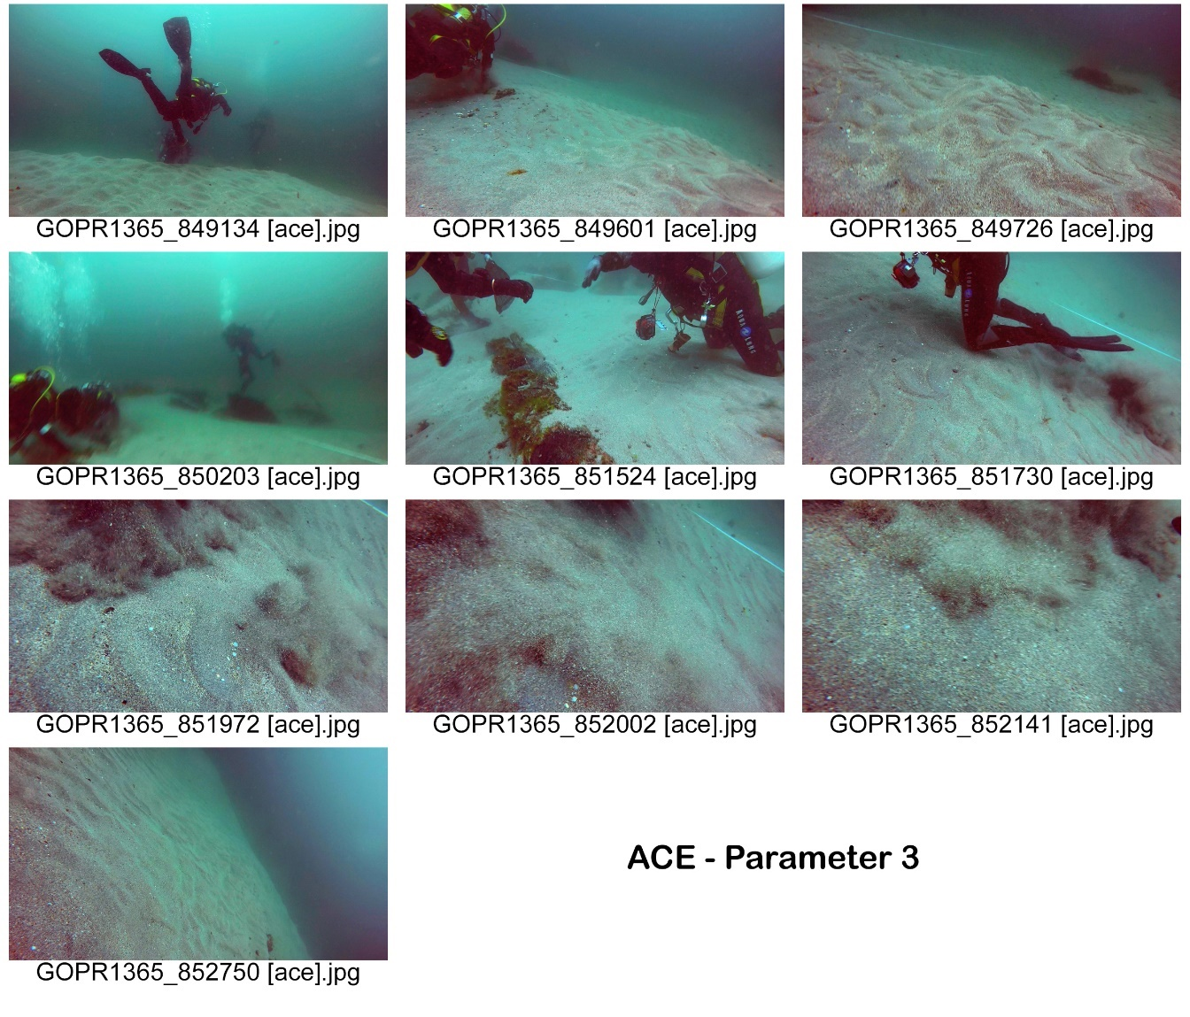
The next step was to run the images through the i-MareCulture clarification tool. Testing to find the right settings for the ACE algorithm was carried out using different parameters and the optimum value of 4 was chosen. The full process was initiated eight times and on each occasion the program froze. The windows 10 and Java platform were fully up to date as were all the relevant intel graphics drivers. A successful run of over a thousand images had been completed before the latest automatic Windows 10 update. Speculatively, it seems possible that the update created a conflict either with the Intel integrated graphics or Java platform. Due to the freezing of the program, it was impossible to automatically process the images. Instead, the process had to be monitored and manually restarted each time it failed. Processing the 3638 images through the ACE algorithm took over twelve hours and the laptop was unable to perform any other functions during this time. The resulting pictures were mixed in quality with colour inconsistencies. To ensure that this was not an issue with the hardware resources available to the laptop, a batch of the images were run on a much more powerful gaming machine as a test. The results were the same. This tool is extremely good for individual images but is not viable for use with separated video in its current format for the novice user. This is most probably because the light levels change across the sequence of the video therefore resulting in differing outcomes across the separate frames of the video. Even if each image was processed through the tool individually for the best results, when stitching the images back together into film there would be inconsistencies in colour, saturation, exposure and clarity. Due to these results, the decision to run the images through the i-MareCulture non-local de-hazing (NLD) algorithm was abandoned.
Figure 1 - Processed Stills on ACE Parameter 3 (Miranda, 2015)
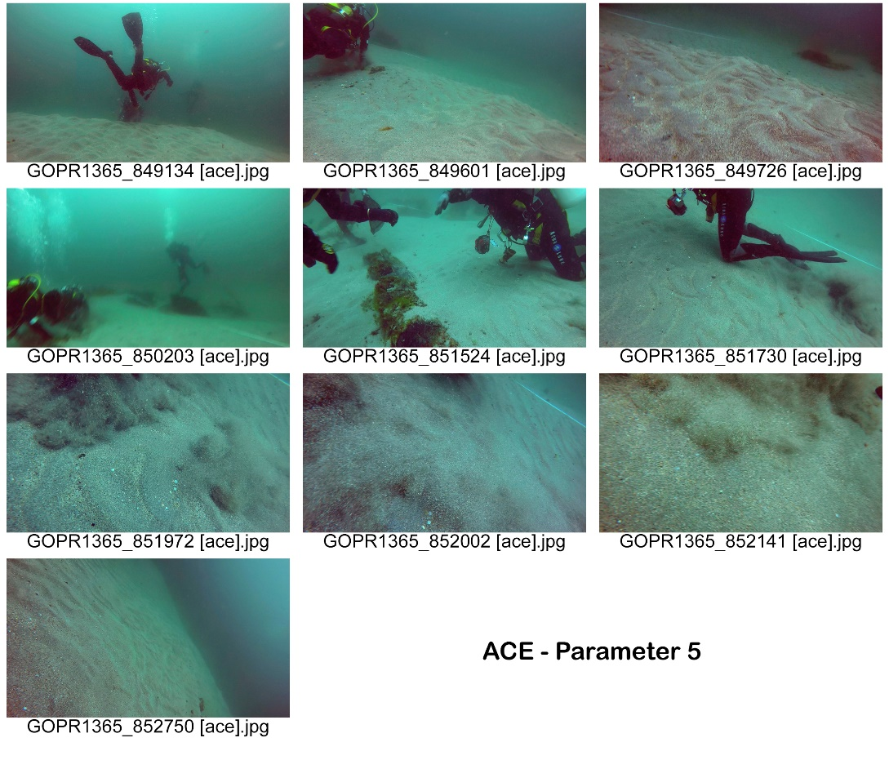
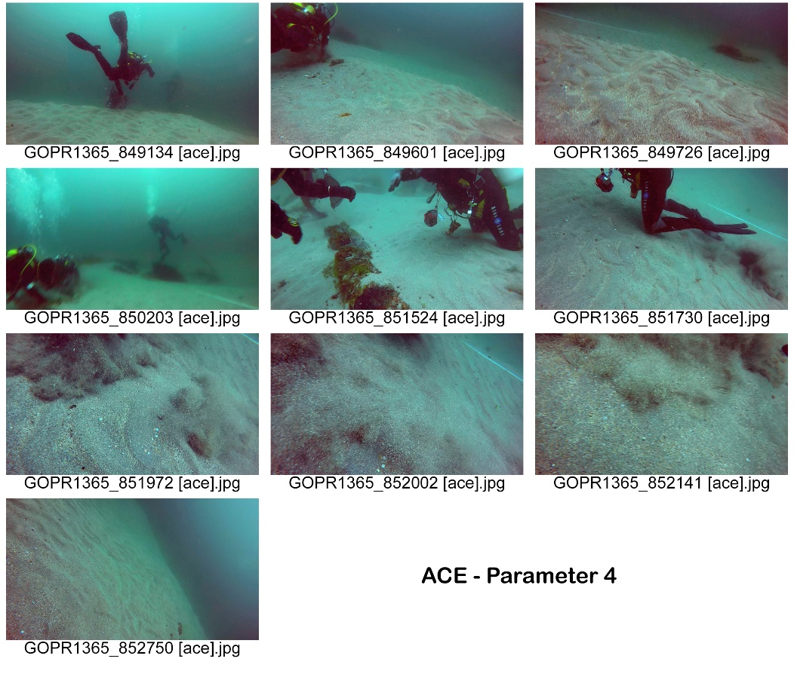

Figure 2 - Processed Stills on ACE Parameter 5 (Miranda, 2015)
Figure 3 - Processed Stills on ACE Parameter 4 (Miranda, 2015)
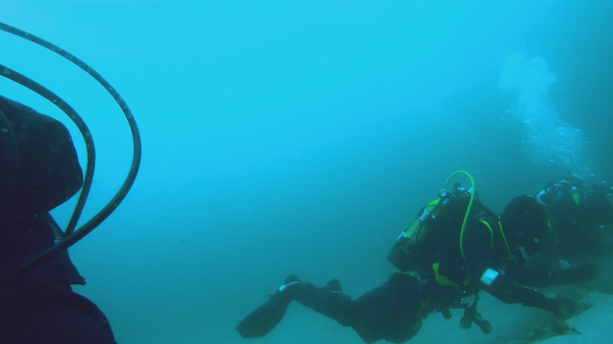
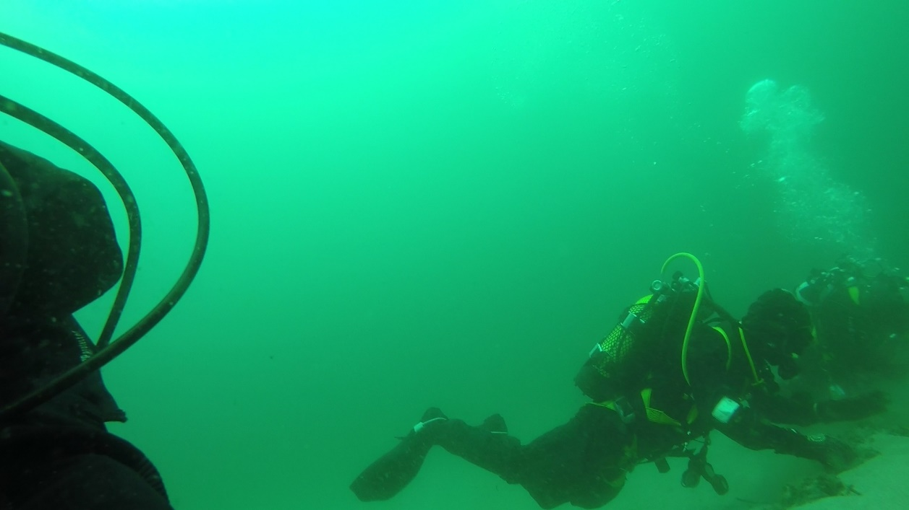
Cursory colour correction was performed in Adobe After Effects on the original video and the results were even, making this type of colour correction for video more suitable at present. Further corrections regarding contrast, saturation, sharpening can also be achieved through Adobe Premier Pro and After Effects, but as the purpose of this experiment was to show that 2D can be converted to 3D, these stages were not carried out as they were not essential at this time.
Figure 4 - After Cursory Colour Correction in Adobe Premier Pro (Miranda, 2015)
Figure 5 - Original Colouring of the Video (Miranda, 2015)
The video was then encoded in Adobe Media Encoder with the H.264 codec which allows for high definition digital video in the MP4 format. The H.264 codec is also the desired codec for VR. It was clear that the footage available would not be enough to result in a VR spherical environment. However, coding as a VR Monoscopic (one image) Ambisonics (directional spherical audio) was carried out, but due to the lack of coverage the footage was distorted and not viable as suspected and therefore discarded. The video was then encoded again with the H.264 codec as an HD 1080p resolution 2D video. The decision to encode this way was to obtain the highest quality video that would require the least amount of memory.
However, immersive 3D was still a viability. There are various ways to achieve 3D video from 2D video. The method chosen would depend entirely on how the finished product is going to be viewed. In this case, because testing was carried out on a Sony Xperia XA1 smartphone and an HMD that runs with the Google Cardboard format, the following two methods are available.
Manual conversion is currently the most accurate available option within the limited resources available. This would require the separating of the frames into still images and creating depth maps for each image. This can be done in Photoshop by creating a new layer over the image and using black to white gradients. When creating the gradient, all the objects or areas that are furthest away in the image are black to dark grey while everything that is closer is white to mid grey. The gradients must be created in such a way that the furthest objects are darkest and the closest objects are white. This process would have to be applied to all the images making it very labour intensive.
It must be noted that there are software packages available at great cost that would automate this process. One example of this type of software and the one that seems best suited to the job at the time of writing is a package called YUVsoft 3D Video. Much like the Adobe software that has been used in this methodology, it is the type of software that is utilized in the movie industry for the most part especially when taking 2D and converting it to 3D. The software promises to make depth mapping for video a fully automated process (YUVsoft, 2018). Unfortunately, no demonstration or trial licence is available and the company will not sell to individuals and only entertains requests for licencing from corporate entities requiring multiple licences. The company goes as far as to warn that if contact is made via a Gmail or Hotmail email account, it is most likely that these emails will not be answered (YUVsoft, 2018). Some of the features belonging to this software are available as Adobe After Effect plugins, but again, only corporate requests are considered and in all cases, they warn that a non-disclosure agreement would have to be signed (YUVsoft, 2018).
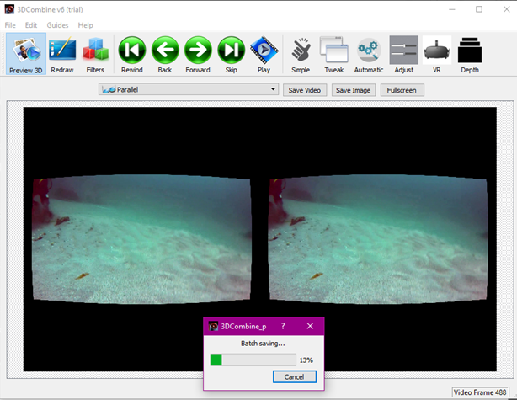
In this case, a software package called 3DCombine was chosen to create the 3D footage. The version used was a free trial but the software is relatively inexpensive at $ 45.00 which at the time of writing is approximately £ 33.50. The software can convert to multiple different types of 3D formats and can be used on both still images and video. The software uses relatively low amounts of computer resources and therefore was ideal for the computer being used. There are many options to choose from with regard to format but in this case parallel was chosen and saved as an AVI file due to the testing HMD using the Google Cardboard format. The video or image is opened on the left of the screen and the software creates a stereo image for each frame, which if you were to overlay one image directly on top of the other, you would find the new set of images are slightly offset to the right. This is what creates the depth and mimics the depth mapping of black to white gradients discussed earlier. Due to testing taking place on a HMD that uses the Google Cardboard format the parallel AVI file was then run through a filter to make it appropriate for viewing (See Figure 1). Should there be any issues with misalignment, there are options that allow for correction of the alignment and depth. It should be noted that the way a Google Cardboard HMD works is by clipping a smartphone into the front of the unit with the screen facing the user. There are separate lenses for each eye and due to the way they are angled, allow the side by side images to converge and be perceived as one image but with depth due to the slight offset.
Figure 6 - 3DCombine processing ACE Cardboard (Genn, 2018))
Should the reader wish to view the original video clip and the two 3D (Google Cardboard format) clips (one processed with the i-MareCulture ACE algorithm but no sound and the other clip in which the sound was preserved and colour corrected in Adobe After Effects) please use the following link. An HMD that uses the Google Cardboard format will be required.
https://drive.google.com/drive/folders/1PD6pzXLuEIU4siLxo_wfZMv3zy9PF_Kw?usp=sharing

Conclusion

In the Oxford Handbook of Maritime Archaeology, Sanders (2012) has a chapter on the use of virtual archaeology and states that the technology is not yet developed enough to attain the fictitious depictions of Star Trek’s Holodeck, but with the development of the haptic technologies and 3D immersive technologies, this ideal is much closer to being realized.
The methodology described in chapter four is perhaps rudimentary but proves that 2D film can be converted into 3D. The equipment used to process the 3D video clip did not meet the minimum system requirements needed by the software used (see appendix one for details). Each project that is processed would result in different issues to overcome. Even slightly better equipment than used in the experiment would produce cleaner sharper results in an acceptable timeframe. If plentiful amounts of footage and good multi directional shots were available for a site, it is entirely possible that 360° video or a spherical VR environment can be produced without too much distortion.
Due to widespread internet coverage around the world (ITU, 2018), the possibility of a team of researchers based in various countries is viable for collaborative research projects insofar that travel is not always necessary. The immersive technologies discussed in this dissertation further increase the viability of multi-disciplinary research on submerged archaeological sites. A team of researchers who are in different locations would be able to access immersive and highly visual data. If made available on databases such as ADS, nautical archaeologists would have immediate access. The same applies to students of archaeology and history insofar that diving on a site that had been recorded or revisiting a site virtually in the digital world that perhaps no longer existed materially would be entirely possible.
Moreover, with the threats facing maritime cultural heritage and our oceanic environment, academics can no longer keep data unpublished. It is of paramount importance that the public are presented with the wonders of the sea in a way that they can appreciate. People need to feel affinity with these sites to care about their preservation.
While generally, archaeologists will borrow any technology they can to reveal answers to the past, it was strange to find during this research that on balance the expertise and technologies to be found in the gaming and movie industries has not been embraced by the discipline. It has become clear during the course of this piece of research that these two areas of expertise need to be explored further within cultural heritage. Further, it is ideally suited to submerged heritage and archaeology due to the image manipulation that would be required without losing integrity.
Just as the spaces of the oceans and seas connected our ancestors’ worlds, the information highway can temporally connect archaeologists to the pasts of our ancestors.

References

Ablart, D., Velasco, C. and Obrist, M. (2017). Integrating Mid-Air Haptics into Movie Experiences. In: ACM International Conference on Interactive Experiences for TV and Online Video. New York: ACM, pp.77-84.
Abt, C. (1987). Serious games. Lanham, MD: University Press of America.
After Effects. (2018). Adobe.
Amazon. (2018). DESTEK V4 VR. [online] Available at: https://www.amazon.co.uk/gp/product/B074SF9TMW/ref=oh_aui_detailpage_o00_s00?ie=UTF8&psc=1 [Accessed 18 Apr. 2018].
Bass, G. (2005). Beneath the seven seas. New York: Thames & Hudson, p.14.
Bass, G. (2012). Archaeology Beneath the Sea. Istanbul: Boyut, pp.loc. 511-512.
BBC News. (2015). Lightning strikes wipe Google data. [online] Available at: http://www.bbc.co.uk/news/technology-33989384 [Accessed 6 Jan. 2018].
Bergin, M., Tripathi, S., Jai Devi, J., Gupta, T., Mckenzie, M., Rana, K., Shafer, M., Villalobos, A. and Schauer, J. (2014). The Discoloration of the Taj Mahal due to Particulate Carbon and Dust Deposition. Environmental Science & Technology, 49(2), pp.808-812.
Billock, J. (2017). Five Augmented Reality Experiences That Bring Museum Exhibits to Life. [online] Smithsonian. Available at: https://www.smithsonianmag.com/travel/expanding-exhibits-augmented-reality-180963810/ [Accessed 6 Feb. 2018].
Bouchard, S. (2011). Could virtual reality be effective in treating children with phobias?. Expert Review of Neurotherapeutics, 11(2), pp.207-213.
Bristol Cameras. (2018). Ikelite Underwater Housing For Canon EOS 650D | 700D. [online] Available at: https://www.bristolcameras.co.uk/p-ikelite-underwater-housing-for-canon-eos-650d-700d-6871-65-.htm [Accessed 10 Apr. 2018].
Bruno, F., Lagudi, A., Ritacco, G., Agrafiotis, P., Skarlatos, D., Čejka, J., Kouřil, P., Liarokapis, F., Philpin-Briscoe, O., Poullis, C., Mudur, S. and Simon, B. (2017). Development and integration of digital technologies addressed to raise awareness and access to European underwater cultural heritage. An overview of the H2020 i-MARECULTURE project. In: Oceans 17. Aberdeen: The Marine Technology Society (MTS) and the IEEE Oceanic Engineering Society (OES).
Burridge, J., Collins, B., Galton, B., Halbert, A., Heywood, T., Latham, W., Phippen, R., Quarendon, P., Reilly, P., Ricketts, M., Simmons, J., Todd, S., Walter, A. and Woodwark, J. (1989). The WINSOM solid modeller and its application to data visualization. IBM Systems Journal, 28(4), pp.548-568.
Canon. (2018). Canon 700 D. [online] Available at: https://store.canon.co.uk/search/700+d/?_requestid=2793161 [Accessed 10 Apr. 2018].
Carson, E. (2015). How NASA uses virtual reality to train astronauts. [online] TechRepublic. Available at: https://www.techrepublic.com/article/how-nasa-uses-virtual-reality-to-train-astronauts/ [Accessed 5 Apr. 2018].
Castro, F. (2018). Treasure Hunters. [online] Nautarch.tamu.edu. Available at: http://nautarch.tamu.edu/shiplab/treasurehunters_04faqs.htm [Accessed 10 Apr. 2018].
Catsambis, A., Ford, B. and Hamilton, D. (2012). The Oxford Handbook of Maritime Archaeology. New York: Oxford University Press.
Cederlund, C., Hocker, F., Hafström, G., Tanner, R. and McManamon, J. (2006). Vasa 1. Stockholm: Statens maritima museer.
Chang, S. and Chen, W. (2017). Does visualize industries matter? A technology foresight of global Virtual Reality and Augmented Reality Industry. 2017 International Conference on Applied System Innovation (ICASI).
Chapman, P., Conte, G., Drap, P., Gambogi, P., Gauch, F., Hanke, K., Long, L., Loureiro, V., Papini, O., Pascoal, A., Richards, J. and Roussel, D. (2006). VENUS, Virtual ExploratioN of Underwater Sites 2006. The 7th International Symposium on Virtual Reality and Cultural Heritage.
Cho, I., Yoon, Y. and Jung, M. (2018). A Study on Entertainment Video Game Content Industry using Virtual Reality Technology. Journal of the Korea Entertainment Industry Association, 12(2), pp.1-13.
Clairefleming.com. (2018). art directing | Claire Fleming. [online] Available at: http://www.clairefleming.com/art_directing.html [Accessed 6 Jan. 2018].
CORDIS. (2009). European Commission : CORDIS : Projects and Results : Virtual ExploratioN of Underwater Sites. [online] Available at: https://cordis.europa.eu/project/rcn/80194_en.html [Accessed 13 Nov. 2017].
CORDIS. (2018). European Commission : CORDIS : Projects and Results : Advanced VR, iMmersive serious games and Augmented REality as tools to raise awareness and access to European underwater CULTURal heritagE.. [online] Available at: https://cordis.europa.eu/project/rcn/205696_en.html [Accessed 18 Mar. 2018].
Cox, S. (2015). A Critical Look at Mummy CT Scanning. The Anatomical Record, 298(6), pp.1099-1110.
Curtis, D. (2017). Can celluloid lovers like Christopher Nolan stop a digital-only future for film?. [online] NewStatesman. Available at: https://www.newstatesman.com/culture/film/2017/08/can-celluloid-lovers-christopher-nolan-stop-digital-only-future-film [Accessed 16 Feb. 2018].
Dean, T. (2011). Steven Spielberg & Martin Scorsese: the joy of celluloid. [online] The Guardian. Available at: https://www.theguardian.com/artanddesign/2011/oct/10/steven-spielberg-martin-scorsese-celluloid [Accessed 16 Feb. 2018].
Dolezal, M., Chmelik, J. and Liarokapis, F. (2017). An immersive virtual environment for collaborative geovisualization. In: VS-Games 2017 9th International Conference on Virtual Worlds and Games for Serious Applications. The IEEE Computer Society.
Drap, P. (2009). VENUS: Virtual ExploratioN of Underwater Sites: Port-Miou C wreck, Marseille. [online] Archaeology Data Service. Available at: http://archaeologydataservice.ac.uk/archives/view/venus_eu_2009/downloads.cfm [Accessed 22 Nov. 2017].
Dunkley, M. (2008). Stirling Castle: Conservation Statement & Management Plan. [online] Portsmouth: English Heritage. Available at: https://content.historicengland.org.uk/content/docs/listing/mgmtplan-stirlingcastlevfinal.pdf [Accessed 8 Feb. 2018].
Facebook. (2018). iMARECULTURE. [online] Available at: https://www.facebook.com/iMareCulture/ [Accessed 24 Jan. 2018].
Faculty of Electrical Engineering - University of Sarajevo. (2017). Kyrenia. [online] Available at: http://h.etf.unsa.ba/kyrenia/#!/main [Accessed 9 Dec. 2017].
Fleming, C. (n.d.). Legacy Footage and VR Environment - Explanation of Needs. [email].
Flood, K. (n.d.). Help with Dissertation Research. [email].
Forte, M., Siliotti, A. and Renfrew, C. (1997). Virtual archaeology. New York: Thames and Hudson & H.N. Abrams.
Foxx, C. (2018). Electric VR suit shocks gamers. [online] BBC News. Available at: http://www.bbc.co.uk/news/av/technology-42577476/ces-2018-electric-virtual-reality-suit-shocks-gamers [Accessed 4 May 2018].
Francioni, F. and Lenzerini, F. (2003). The Destruction of the Buddhas of Bamiyan and International Law. European Journal of International Law, 14(4), pp.619-651.
Freeth, T. and Jones, A. (2018). Tony Freeth and Alexander Jones. "The Cosmos in the Antikythera Mechanism." ISAW Papers 4 (February, 2012). [online] Dlib.nyu.edu. Available at: http://dlib.nyu.edu/awdl/isaw/isaw-papers/4/ [Accessed 13 Apr. 2018].
Gault, M. (2018). A Harvard Egyptologist Explains the Historical Accuracy of 'Assassin's Creed: Origins'. [online] Motherboard. Available at: https://motherboard.vice.com/en_us/article/59kwea/a-harvard-egyptologist-explain-the-historical-accuracy-of-assassins-creed-origins [Accessed 14 Apr. 2018].
Genn, V. (n.d.). Help with Dissertation Research. [email].
Ghinea, G., Timmerer, C., Lin, W. and Gulliver, S. (2014). Mulsemedia. ACM Transactions on Multimedia Computing, Communications, and Applications, 11(1s), pp.1-23.
González Zarandona, J., Albarrán-Torres, C. and Isakhan, B. (2017). Digitally Mediated Iconoclasm: the Islamic State and the war on cultural heritage. International Journal of Heritage Studies, 24(6), pp.649-671.
Hale, J. (2006). Classical archaeology of ancient Greece and Rome. Chantilly, VA: Teaching Co., p.4.
HaptX. (2018). Technology | HaptX. [online] Available at: https://haptx.com/technology/ [Accessed 20 Mar. 2018].
Ikelite. (2017). Ikelite. [online] Available at: https://www.ikelite.com/ [Accessed 5 Nov. 2017].
i-MareCulture. (2018). i-MareCulture. [online] Available at: http://imareculture.weebly.com/ [Accessed 30 Jun. 2017].
i-MareCulture. (2018). Project. [online] Available at: http://imareculture.weebly.com/project.html [Accessed 5 Apr. 2018].
i-MareCulture. (2018). Project Tools. [online] Available at: http://imareculture.weebly.com/project-tools.html [Accessed 2 Jan. 2018].
IMDb. (2018). Claire Fleming. [online] Available at: http://www.imdb.com/name/nm2690982/ [Accessed 11 Dec. 2017].
Institute of Nautical Archaeology. (2018). Cape Gelidonya Late Bronze Age Shipwreck Excavation Site Report. [online] Available at: https://nauticalarch.org/cape-gelidonya-late-bronze-age-shipwreck-excavation-site-report/ [Accessed 10 Apr. 2018].
ITU. (2018). Statistics. [online] Available at: https://www.itu.int/en/ITU-D/Statistics/Pages/stat/default.aspx [Accessed 20 Apr. 2018].
Jacques Cousteau Odyssey Diving For Roman Plunder. (1978). [video] Available at: https://www.youtube.com/watch?v=rph2sJqsFyI&t=941s&list=PLkEvNWj3q-AEBa5SEb3kMFKArsN0qngz9&index=6 [Accessed 1 Apr. 2017].
Java. (2018). What is Java and why do I need it?. [online] Available at: https://java.com/en/download/faq/whatis_java.xml [Accessed 3 May 2018].
Jones, B. (2016). Valve has plans to lower VR system requirements. [online] Digital Trends. Available at: https://www.digitaltrends.com/computing/valve-lower-vr-system-requirements/ [Accessed 14 Jan. 2018].
Keen, D., Rahtz, S. and Ucko, P. (1992). Visualization and analysis of the antiquarian record in archaeology. Bulletin of the John Rylands Library, 74(3), pp.121-138.
Kockro, R., Amaxopoulou, C., Killeen, T., Wagner, W., Reisch, R., Schwandt, E., Gutenberg, A., Giese, A., Stofft, E. and Stadie, A. (2015). Stereoscopic neuroanatomy lectures using a three-dimensional virtual reality environment. Annals of Anatomy - Anatomischer Anzeiger, 201, pp.91-98.
Kouril, P. and Liarokapis, F. (2018). Simulation of Underwater Excavation Using Dredging Procedures. IEEE Computer Graphics and Applications, 38(2), pp.103-111.
Lithodomos VR. (2017). About Us - Get to know us better | Lithodomos VR. [online] Available at: https://lithodomosvr.com/about-us/ [Accessed 12 Nov. 2017].
Lithodomos VR. (2017). VR Tour Case Studies | Lithodomos VR. [online] Available at: https://lithodomosvr.com/case-studies/ [Accessed 22 Oct. 2017].
Lockyear, K. and Rahtz, S. (1991). Computer applications and quantitative methods in archaeology. Oxford (England): Tempus Reparatum.
Machkovech, S. (2016). Ars tests NASA’s first Vive VR experiments: ISS, lunar rover simulators. [online] Ars Technica. Available at: https://arstechnica.com/gaming/2016/03/ars-tests-nasas-first-vive-vr-experiments-iss-lunar-rover-simulators/ [Accessed 13 Apr. 2018].
Maples-Keller, J., Yasinski, C., Manjin, N. and Rothbaum, B. (2017). Virtual Reality-Enhanced Extinction of Phobias and Post-Traumatic Stress. Neurotherapeutics, 14(3), pp.554-563.
Maritime Archaeology Trust. (2016). Stirling Castle. [online] Available at: http://www.maritimearchaeologytrust.org/stirlingcastle [Accessed 7 Feb. 2016].
Media Encoder. (2018). Adobe.
Miranda, B. (n.d.). The Galleon of Ribadeo Wrecksite. [images].
Mission Blue. (2017). About Mission Blue - Mission Blue. [online] Available at: https://mission-blue.org/about/ [Accessed 5 Feb. 2018].
Mitchell, E. (2008). BBC NEWS | Science/Nature | Seabed archaeology goes virtual. [online] BBC News. Available at: http://news.bbc.co.uk/1/hi/sci/tech/7605718.stm [Accessed 30 Feb. 2018].
O’Flaherty, B. (1988). The Southampton-York Archaeological Simulation System. In: S. Rahtz, ed., Computer and Quantitative Methods in Archaeology. Oxford: BAR International Series 446, pp.491-498.
Oculus. (2018). Oculus Rift | Oculus. [online] Available at: https://www.oculus.com/rift/?utm_campaign=[campaign]&utm_source=google&utm_medium=cpc&gclid=CjwKCAjw2dvWBRBvEiwADllhnwsWejI5zA7Ezu1ycv_QDQvkCKMlV4uN1X0sbhzOj8O-_XT6v_S9uhoC0wEQAvD_BwE&gclsrc=aw.ds#oui-csl-rift-games=star-trek [Accessed 18 Apr. 2018].
Open.conted.ox.ac.uk. (2018). Thomas Fuller - Sayings | open.conted.ox.ac.uk (beta). [online] Available at: https://open.conted.ox.ac.uk/resources/documents/thomas-fuller-sayings [Accessed 20 Mar. 2018].
Parcak, S. (2017). Moving from Space-Based to Ground-Based Solutions in Remote Sensing for Archaeological Heritage: A Case Study from Egypt. Remote Sensing, 9(12).
Philbin-Briscoe, O., Simon, B., Mudur, S., Poullis, C., Rizvic, S., Boskovic, D., Liarokapis, F., Katsouri, I., Demesticha, S. and Skarlatos, D. (2017). A Serious Game for Understanding Ancient Seafaring in the Mediterranean Sea. In: 9th International Conference on Virtual Worlds and Games for Serious Applications (VS-Games) (2017). [online] Athens, Greece. Available at: http://poullis.org/pubs/POULLIS_VS-GAMES2017.pdf [Accessed 9 Jan. 2018].
Photoshop. (2018). Adobe.
Plancher, G., Tirard, A., Gyselinck, V., Nicolas, S. and Piolino, P. (2012). Using virtual reality to characterize episodic memory profiles in amnestic mild cognitive impairment and Alzheimer's disease: Influence of active and passive encoding. Neuropsychologia, 50(5), pp.592-602.
Premier Pro. (2018). Adobe.
Ramsey, C., Buck, C., Manning, S., Reimer, P. and Plicht, H. (2006). Developments in radiocarbon calibration for archaeology. Antiquity, 80(310), pp.783-798.
Reilly, P. (1991). Towards a Virtual Archaeology. In: S. Rahtz and K. Lockyear, ed., Computer Applications and Quantitative Methods in Archaeology. Oxford: Tempus Reparatum, pp.132-139.
Reilly, P. and Rahtz, S. (2011). Archaeology and the Information Age. London: Routledge.
Renfrew, C. (1997). Virtual Archaeology. London: Thames and Hudson.
Return to Antikythera. (2018). 1900 – 1901: The Discovery. [online] Available at: http://antikythera.org.gr/history/1900-1901/ [Accessed 18 Feb. 2016].
Rizvic, S. (2018). Kyrenia interactive digital story - trailer. [video] Available at: https://www.youtube.com/watch?v=i7w2UJdzv_E [Accessed 29 Mar. 2018].
Rolls, E. (2004). The functions of the orbitofrontal cortex. Brain and Cognition, 55(1), pp.11-29.
Rolls, E., Everitt, B. and Roberts, A. (1996). The Orbitofrontal Cortex [and Discussion]. Philosophical Transactions of the Royal Society B: Biological Sciences, 351(1346), pp.1433-1444.
Sakellariou, D. (n.d.). Possible assistance with student undertaking research on tourism pressures at Pavlopetri. [email].
Sanders, D. (2012). Virtual Reconstruction of Maritime Sites and Artefacts. In: A. Catsambis, B. Ford and D. Hamilton, ed., The Oxford Handbook of Maritime Archaeology. New York: Oxford University Press, pp.305-326.
Scullion, R. (2018). 3DCombine. US: RPS Software.
Sky News (2018). Swipe | The electric Teslasuit & McLaren's new VR tool. [video] Available at: http://Swipe | The electric Teslasuit & McLaren's new VR tool [Accessed 13 Apr. 2018].
Sky News (2018). VENUS Project on Sky News. [video] Available at: https://vimeo.com/102111391 [Accessed 21 Apr. 2018].
Smith, C., Burke, H., de Leiuen, C. and Jackson, G. (2015). The Islamic State’s symbolic war: Da'esh's socially mediated terrorism as a threat to cultural heritage. Journal of Social Archaeology, 16(2), pp.164-188.
Steam. (2017). Welcome to Steam. [online] Available at: https://store.steampowered.com/ [Accessed 6 Aug. 2017].
Stefanidis, D., Haluck, R., Pham, T., Dunne, J., Reinke, T., Markley, S., Korndorffer, J., Arellano, P., Jones, D. and Scott, D. (2006). Construct and face validity and task workload for laparoscopic camera navigation: virtual reality versus videotrainer systems at the SAGES Learning Center. Surgical Endoscopy, 21(7), pp.1158-1164.
Techopedia. (2018). What is a Convolutional Neural Network (CNN)? - Definition from Techopedia. [online] Available at: https://www.techopedia.com/definition/32731/convolutional-neural-network-cnn [Accessed 9 Mar. 2018].
Techopedia. (2018). What is a Haptic Interface? - Definition from Techopedia. [online] Available at: https://www.techopedia.com/definition/3638/haptic-interface [Accessed 20 Apr. 2018].
Teeley, A., Soltani, M., Wiechman, S., Jensen, M., Sharar, S. and Patterson, D. (2012). Virtual Reality Hypnosis Pain Control in the Treatment of Multiple Fractures: A Case Series1. American Journal of Clinical Hypnosis, 54(3), pp.184-194.
Teslasuit. (2018). Teslasuit - full body haptic suit. [online] Available at: https://teslasuit.io/ [Accessed 20 Feb. 2018].
The Griffith Institute. (2018). Tutankhamun: Anatomy of an Excavation | The Griffith Institute. [online] Available at: http://www.griffith.ox.ac.uk/discoveringTut/ [Accessed 16 Feb. 2018].
The Thistlegorm Project. (2017). Thistlegorm 3D Tour | Presence in the Past. [online] Available at: http://thethistlegormproject.com/thistlegorm-2017/index.html [Accessed 23 Mar. 2018].
Tsaftaris, S., Casadio, F., Andral, J. and Katsaggelos, A. (2013). A novel visualization tool for art history and conservation: Automated colorization of black and white archival photographs of works of art. Studies in Conservation, 59(3), pp.125-135.
Turner Classic Movies. (2018). The Jacques Cousteau Odyssey: Diving for Roman Plunder. [online] Available at: http://www.tcm.com/this-month/article/309185%7C309197/The-Jacques-Cousteau-Odyssey-Diving-for-Roman-Plunder.html [Accessed 10 Apr. 2018].
Twitter. (2018). iMARECULTURE Project (@imareculture) | Twitter. [online] Available at: https://twitter.com/imareculture [Accessed 22 Dec. 2017].
UK Hydrographic Office (2018). ENGLAND – GOODWIN SANDS SOUTH SAND HEAD-ASSESSMENT ON THE ANALYSIS OF ROUTINE RESURVEY AREA GS1 FROM THE 2015 SURVEY. [online] Taunton: UK Hydrographic Office's. Available at: https://assets.publishing.service.gov.uk/government/uploads/system/uploads/attachment_data/file/577403/2015_GS1_South_Sand_Head.pdf [Accessed 8 Feb. 2018].
Unesco. (2018). Conventions. [online] Available at: http://www.unesco.org/eri/la/convention.asp?KO=13520&language=E&order=alpha#1 [Accessed 10 Apr. 2018].
University of Nottingham. (2011). BBC documentary brings the world's oldest underwater city back to life - The University of Nottingham. [online] Available at: https://www.nottingham.ac.uk/news/pressreleases/2011/october/bbc-documentary-brings-underwater-city-back-to-life-.aspx [Accessed 8 May 2018].
University of Nottingham. (2017). Pavlopetri archaeology project team - The University of Nottingham. [online] Available at: https://www.nottingham.ac.uk/pavlopetri/pavlopetriarchaeologyprojectteam.aspx [Accessed 8 Jun. 2017].
Venables, J. (2000). BBC News | SCI/TECH | Fire destroys Bronze Age records. [online] BBC News. Available at: http://news.bbc.co.uk/1/hi/sci/tech/604067.stm [Accessed 7 Feb. 2017].
Vive. (2018). VIVE™ | Discover Virtual Reality Beyond Imagination. [online] Available at: https://www.vive.com/uk/ [Accessed 18 Apr. 2018].
Walters, G. (2018). Windrush is just the start: records are being shredded and history deleted | The Spectator. [online] The Spectator. Available at: https://www.spectator.co.uk/2018/04/windrush-is-just-the-start-records-are-being-shredded-and-history-deleted/ [Accessed 29 Apr. 2018].
Wei, O., Chin, C., Majid, Z. and Setan, H. (2010). 3D DOCUMENTATION AND PRESERVATION OF HISTORICAL MONUMENT USING TERRESTRIAL LASER SCANNING. Geoinformation Science Journal, 10(1), pp.73-90.
White, P. and Moussavi, Z. (2016). Neurocognitive Treatment for a Patient with Alzheimer's Disease Using a Virtual Reality Navigational Environment. Journal of Experimental Neuroscience, 10, p.JEN.S40827.
WHOi (2018). RMS Titanic. [image] Available at: https://www.whoi.edu/page.do?pid=83577&tid=7842&cid=76634 [Accessed 10 Apr. 2018].
Wilson, A., Miles, H., Labrosse, F., Tiddeman, B. and Roberts, J. (2016). Historical records, archives and photogrammetry. The Historic Environment: Policy & Practice, 7(1), pp.25-42.
YUVsoft. (2018). Contact us. [online] Available at: http://www.yuvsoft.com/contacts/ [Accessed 3 May 2018].
YUVsoft. (2018). Depth Editing Technologies. [online] Available at: http://www.yuvsoft.com/stereo-3d-technologies/depth-editing-technologies/ [Accessed 3 May 2018].
Zhou, X., Desai, B. and Poullis, C. (2017). Automatic 2D to stereoscopic video conversion for 3D TVS. 2017 3DTV Conference: The True Vision - Capture, Transmission and Display of 3D Video (3DTV-CON).

Appendix One – System Information & Software System Requirements

Lenovo Ideapad Z500 Touch
Microsoft Windows 10 Home, version 10.0.16299 Build 16299
Intel(R) Core(TM) i5-3230M CPU @ 2.60GHz, 2601 Mhz, 2 Core(s), 4 Logical Processor(s) x64-based PC
4 GB RAM
266 GB free after installation of all the software space
Intel(R) HD Graphics 4000 - Display 1366 x 768 x 59 hertz (Best Settings Available)
Wi-Fi internet connection available

The following system requirement statements have been directly quoted from the Adobe website

“System requirements | April 2018 (15.1) release of After Effects CC
Windows
Multicore Intel processor with 64-bit support
Microsoft® Windows® 7 with Service Pack 1 (64 bit), Windows 8.1 (64 bit), or Windows 10 (64 bit)
8GB of RAM (16GB recommended)
5GB of available hard-disk space; additional free space required during installation (cannot install on removable flash storage devices)
Additional disk space for disk cache (10GB recommended)
1280 x 1080 display
Optional: Adobe-certified GPU card for GPU-accelerated ray-traced 3D renderer
Internet connection and registration are necessary for required software activation, validation of subscriptions, and access to online services.*”
(Adobe,2018)

“System requirements | April 2018 (12.1) release of Premiere Pro CC
Windows
Multicore processor with 64-bit support
Microsoft Windows 7 with Service Pack 1 (64 bit) or Windows 8.1 (64 bit), or Windows 10 (64 bit). However Windows 10 is recommended
Supporting Windows 10 Creator Edition & Dial
8 GB of RAM (16 GB or more recommended)
8 GB of available hard-disk space for installation; additional free space required during installation (cannot install on removable flash storage devices)
1280 x 800 display (1920x1080 or larger recommended)
Sound card compatible with ASIO protocol or Microsoft Windows Driver Model
Optional: Adobe-recommended GPU card for GPU-accelerated performance
Internet connection and registration are necessary for required software activation, validation of subscriptions, and access to online services.*”
(Adobe, 2018)

“System requirements | April 2018 (12.1) release of Media Encoder CC
Windows
Multicore processor with 64-bit support required
Microsoft Windows 7 with Service Pack 1 (64 bit) or Windows 8.1 (64 bit), or Windows 10 (64 bit)
Supports Windows 10 Creator Edition
4 GB of available hard-disk space; additional free space required during installation (cannot install on removable flash storage devices)
1024 x 768 display (1280 x 800 recommended)
Optional: Adobe-recommended GPU card for GPU-accelerated performance
Internet connection and registration are necessary for required software activation, validation of subscriptions, and access to online services.*”
(Adobe, 2018)

“System requirements | January 2018 and October 2017 (19.x) releases of Photoshop CC
Windows
Intel® Core 2 or AMD Athlon® 64 processor; 2 GHz or faster processor
Microsoft Windows 7 with Service Pack 1, Windows 8.1, or Windows 10 (version 1607 or later)
The 19.0 and 19.0.1 releases of Photoshop CC support Windows 10 1511 and later versions, but not versions 1507 and earlier.
Photoshop CC release 19.1 (and later) supports Windows 10 1607 and later versions, but not versions 1511 or earlier.
2 GB or more of RAM (8 GB recommended)
2.6 GB or more of available hard-disk space for 32-bit installation; 3.1 GB or more of available hard-disk space for 64-bit installation; additional free space required during installation (cannot install on a volume that uses a case-sensitive file system)
1024 x 768 display (1280 x 800 recommended) with 16-bit colour and 512 MB or more of dedicated VRAM; 2 GB is recommended*
OpenGL 2.0-capable system
Internet connection and registration are necessary for required software activation, validation of subscriptions, and access to online services.**”
(Adobe, 2018)

