
University of Wales Trinity Saint David School of Engineering
Assignment Title: Plant Flow Diagrams – Pipe and Instrument Diagrams
Plant Performance and Operations
ACMA4002
Luke Read-Jenkins
2318055
Submission Deadline: 21.07.2024
Word Count: 1935

2024

This report will focus on the nitrogen system used on the converter in Tata Steel Port Talbot, a Piping and Instrumentation Diagram (P&ID) has been created to illustrate the overall engineering process. P&ID’s are schematic drawings that give a detailed graphical representation of a process’ system installation. They are considered ‘the gold standard’ tool for designing, maintaining and operating plants in the engineering industry (Toghraei, 2014). These drawings show the piping and related components of a plants process such as; valves, sensors, piping routes, alarms, gauges, vent, and more. This makes P&IDs foundational to the maintenance, modification process, and emergency scenario.
At TATA Steel, Port Talbot there are two Basic Oxygen Converters (BOCs) that are a type of furnace, which are used in the steelmaking process. They convert molten iron from the blast furnaces into steel, by reducing the carbon content, and removing any impurities within the iron. The common gasses used in the Basic Oxygen Converters are Nitrogen, Oxygen, and Argon. While Oxygen the primarily used gas in the basic oxygen process, Nitrogen plays a significant role in several areas which will be discussed in this report. Low pressure (LP) Nitrogen can be utilised for a variety of purging applications (Elsevier, 2013) such as, pressure maintenance of the basic oxygen steelmaking (BOS), gas recovery main, purging of the flux addition system, and emergency dilution at the oxygen gas system hood. The nitrogen systems continuously feed from the BOS and site ring main, with the valve positions shown on the associated P&ID. The low-pressure system of the BOS process cannot begin until the nitrogen supply is operational. This provides an inert atmosphere within the converter during the heating and cooling process. As oxygen blasting is used in the converter, it creates oxidation and chemical reactions like CO2, CO, and other impurities, which makes nitrogen a key gas to neutralize the atmosphere, creating a clean environment. This reduces the number of unwanted reactions and improves the grade of steel.
Figure 1. P&ID Diagram of the Nitrogen System used at TATA Steel, Port Talbot
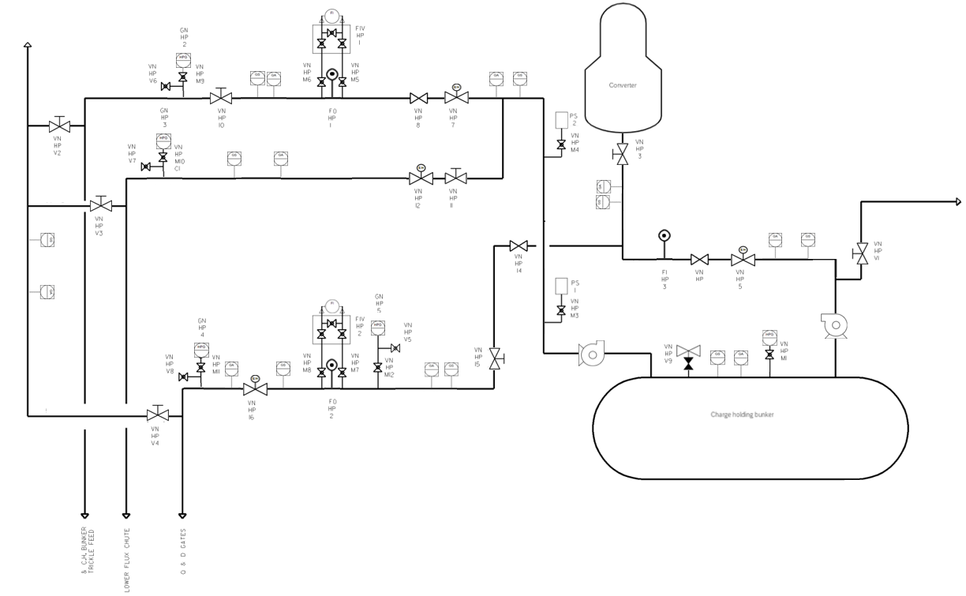
The figure is broken down into four coloured boxes to simplify the P&ID component description: green, red, blue, and yellow.
In the red box, the cylinder with hemispherical ends is the charge holding bunker. That is where the nitrogen stores and charges for the system. In the bunker there is an integrated block and bleed valve. This feature is to enhance safety and to shut off the system at the source, as this allows the entire system to close, allowing maintenance procedures to commence. To the right is a ball valve and a high-pressure gauge. The ball valve uses a rotary ball to control the flow of nitrogen (gas) passing through the high-pressure gauge. The gauge is to measure the pressure in the bunker. To the right side of the bunker is a gas blower which flows the nitrogen (gas) through the system at a set rate. Further up the system on the right is a manual gate valve. This restricts the flow of nitrogen (open or closed) through to the vent. This can shut off the flow of nitrogen to the vent for any maintenance required. To the left is an electro-hydraulic gate valve which can connect / isolate the medium within the system. These give a medium rather than adjusting flow, which means it can produce a range of pressure flow. Following that is a gate valve used to stop the system entirely if required. To measure the flow rate, an orifice plate is required for the discharge line as it can generate backpressure. It can reduce pressure or restrict flow. This line removes the heat by cooling the vapours and ensures the transfer of the load to the vent.
Next to the cylinder labelled ‘converter’, is a manual gate valve, this is there to restrict the flow of nitrogen (open or closed) through to the converter and is a way of closing the system in case the electro-hydraulic gate valve fails. This is another barrier for shutting the system down for any maintenance, like the converter refractory lining. On the left of the bunker is another gas blower going up to push switch one. A ball valve before the switch acts on the signal of the switch, so when the switch activates it opens and, when activated, again will close. The same system is required for push switch two.
In the green box, on the lower flux chute and bunker trickle feed, is an electro-hydraulic gate valve which can connect / isolate the medium within the system. These give a medium rather than adjusting flow, which means it can produce a range of pressure flow. Following off that is a gate valve used to stop the system entirely if required. In the yellow box is a differential pressure transmitter with an orifice plate. This allows a pressure drop in the pipe and then off the orifice plate measurement can distribute the pressure measurement on either side of the system to provide the required rate of flow. This can be used in various applications, such as, flow measurement, monitoring levels in the system, and filtering the system. This goes onto a manual gate valve; this is there to restrict the flow of nitrogen (open or closed) through to the ball valve vent line. If the ball valve vent line is closed, the nitrogen flow continues to another ball valve with a high-pressure gauge. This is where the system can measure the amount of nitrogen pressure coming through the system down to the bunker trickle feed.
The lower flux chute coming off the bunker trickle feed line has a manual gate valve followed by an electro-hydraulic gate valve. The manual gate valve is there to restrict the flow of nitrogen (open or closed) and is a way of closing the system in case the electro-hydraulic gate valve fails. Further down the system is a ball valve and connected is a high-pressure gauge, this is to measure the pressure of nitrogen (gas) flowing through the lower flux chute. Connected to the lower flux chute is a ball valve end vent, this is an accurate pressure release not to overload the pipeline. This pipeline then continues to the lower flux chute.
Continuing from the converter pipeline in the blue box is a gate valve used to stop the system entirely if required and further down the system is a manual gate valve which is a manual way of shutting off the system if the gate valve fails or requires maintenance. The pipeline then flows down to the same system as in the green box with the ball valve and high-pressure gauge to measure the pressure of the flow and have the capability to release any excess pressure through the ball valve end vent. In the yellow box is another differential pressure transmitter, with an orifice plate system. After the differential pressure transmitter, is an electro-hydraulic gate valve which can connect / isolate the medium within the system. Again, the same system as in the green box with the ball valve and high-pressure gauge to measure the pressure of the flow and have the capability to release any excess pressure through the ball valve end vent is required. This pipeline then continues to the quadrant and dampener gates, and breaks off to a manual valve gate which leads to a vent system. On each lower flux chute and bunker trickle feed pipeline are connected to the vent system via a manual gate valve, this allows each of the pipelines to be completely shut off for any maintenance or in case of an emergency.
In all green, red, and blue boxes are gas sensors and gas alarms, there are there for health and safety as they provide a reading part of the system has been leaking.
P&ID’s have various roles and responsibilities, one of the crucial roles it provides is ensuring the health and safety of personnel and the plant equipment. This is done by a clear render of the design, operation, and location of critical elements along with, component specifications, maintenance and modifications, operating schemes, and startup and shutdown procedures.
Health and safety precautions identified using Control of Substances Hazardous to Health (COSHH, Health And Safety Executive, 2013) and Health and safety precautions identified using Control of Major Accident Hazards (COMAH, Great Britain. Health And Safety Executive, 2015). Risk assessment: In the P&ID system the use of high-pressure nitrogen around plant could potentially breakout due to a flaw in the system, such as a leak. Identification: As Nitrogen is a hazardous substance due to it causing asphyxiation.
Assessment: Evaluating storing nitrogen and handling in the converter should be considered due to over-pressurisation in the system preventing explosions. To eliminate this the use of a block and bleed value is in place. If the system fails having an Major Accident Prevention Policy (MAPP), which outlines the companies safety management systems and what the measure in place are to control major hazards.
Control measures: In the P&ID system the protocol in place is the ventilation system as this can cause system can cause a buildup and reduce the asphyxiation hazard as these controls are there to minimise the amount of nitrogen exposure. Another control in place are high-pressure gauges. In the nitrogen system the use of electro-hydraulic and manual gate valves allows the system to be completely shut off during maintenance or a breakout. The manual gates can serve as a method of closing the system off if the electro-hydraulic system fails. Controlling emergency situations with planned actions is vital for keeping personnel safe when around nitrogen. Creating an on site and off site emergency plan of what to do and where to go for emergency green zones etc. Its vital that TATA conduct regular drills to ensure that the on site TATA emergency services response and procedures are effective and in line with local authorities.
Continuous monitoring: Nitrogen can be dangerous due to its capabilities to cause asphyxiation and an explosive gas. In the P&ID system there are gas sensors and alarms throughout the system which continuously monitor the nitrogen pressure, ensuring data is transmitted to control systems for real-time monitoring and response.
Storage and handling: Ensuring proper installation and maintenance is kept on the charge holding bunker as this is a preventative measure to reduce the exposure to leakage. Along with the maintenance of the piping, valve, gauges, transmitters, and vents. Each amendment should keep a detailed record of the findings of the inspections, incidents involving nitrogen, and the maintenance carried out.
Training and procedures: Its vital to conduct regular emergency drills to ensure all personnel know the correct procedures in place for a nitrogen leak such as, where the system has failed, where to go to stop flow going through the system, process of closing the valves etc. It is important to have detailed documentation of all risk assessments, control measures and incident reports, ensuring continuous improvement and compliance.
Continuous monitoring can lead into safety reports. Working with Nitrogen it is important to report on if the quantity of nitrogen exceeds the threshold levels specified in the COMAH regulations. According the HSE the percentage threshold is 15.7% (www.hse.gov.uk, n.d.). These safety reports should dive into the potential hazards and the hazards occurred, along with a detailed assessment on the measures in place to prevent these incidents from happening again.
To conclude, this report conducted a P&ID of the nitrogen system of the basic oxygen convertor, reference was made to the different components of the system and health ans safety features were identified and discussed.

References:
Great Britain. Health And Safety Executive (2015). The control of major accident hazards regulations 2015 : guidance on regulations. Merseyside, Liverpool: Hse Books.
Health And Safety Executive (2013). Control of substances hazardous to health : the Control of Substances Hazardous to Health Regulations 2002 (as amended) : approved code of practice and guidance. Sudbury? Health And Safety Executive.
Toghraei, M. 2014, "Principles of P&ID Development", Chemical Engineering, vol. 121, no. 4, pp. 62-71.
Treatise on Process Metallurgy, Volume 3: Industrial Processes 2013, Elsevier, San Diego. Available from: ProQuest Ebook Central. [7 July 2024].
www.hse.gov.uk. (n.d.). HSE Explosives - Ammonium nitrate and COMAH. [online] Available at: https://www.hse.gov.uk/explosives/ammonium/comah.htm.

