University of Wales Trinity Saint David
Wales Institute of Science and Art


Discrete Event Simulation

Manufacturing Systems & Simulation
ACMA6002

Jordan Hessey
2315713
21/09/2026
Contents
Table of Tables 2
Table of Figures 2
1 Introduction 3
1.1 Aims 3
1.2 Objectives 3
2 Process Selection 4
2.1 Machine layout and station identification 4
2.2 Machine processing sequence 4
3 Current state model development 5
3.1 Model creation steps 5
3.2 Model verification and validation 8
4 Simulation Analysis 9
4.1 Overall performance and resource utilisation 9
4.2 Waste identification 10
4.3 Value-added versus non-value-added analysis 11
4.4 Opportunity Identification (Lean evaluation) 12
5 Conclusion 13
6 References 14
7 Appendices 15
7.1 Arena symbol breakdown 15
7.2 Machine data collection 16
7.3 Arena variables 17
7.4 Model Outputs 19

Table of Tables
Table 1 - Summary of ten-replication current-state results 9
Table 2 - Arena symbol breakdown 15
Table 3 - Model output for 10 replication runs 19
Table 4 - Utilisation results over 10 replications converted to % 20
Table 5 - Queue waiting time results over 10 replications 20

Table of Figures
Figure 1 - Festo Cyber-Physical Laboratory production system (UWTSD 2026) 3
Figure 2 - Festo CP Lab layout (UWTSD 2026) 4
Figure 3 – Completed Arena model of Festo CP Lab 5
Figure 4 - Create function for parts entering model 6
Figure 5 - Station 6 Output module labelled 6
Figure 6 - Average resource utilisation across ten replications 9
Figure 7 - Average Drilling HOLD queue waiting time across ten replications 10
Figure 8 - Remaining average queue waiting times across ten replications 11
Figure 9 - Data collection for machine parameters (UWTSD 2026) 16
Figure 10 - Data definition, Entity setup 17
Figure 11 - Data definition, variable setup 17
Figure 12 – Discrete Processing, create parts IN 17
Figure 13 - Discrete Processing, Process’ setup 17
Figure 14 – Decisions, Hold setup 17
Figure 15 - Decisions, Decide setup 17
Figure 16 - Discrete Processing, Delay setup 17
Figure 17 – Input/Output, Interarrival setup 18

Introduction
Discrete event simulation (DES) represents a system as a chronological sequence of events, where each event changes the state of an entity, queue or resource (Banks et al. 2010; Law 2015). This makes it suitable for manufacturing systems in which parts compete for limited equipment and experience variable processing and waiting times. Unlike a static process map, DES can reproduce interactions between arrivals, routing rules, batch conditions and resource availability over time (Karnon et al. 2012; Law 2015). It therefore provides a controlled environment in which process behaviour can be examined without disrupting production. Recent research also positions DES as a practical link between conventional process improvement and increasingly connected, data-driven manufacturing systems (Turner and Garn 2022).
This report applies DES to a Festo Cyber-Physical Laboratory (CP Lab) production system. The current-state model represents the movement of a manufactured part through optical inspection, drilling, top-cap dispensing, hydraulic pressing, label printing and the output station. The purpose is to understand material flow, quantify current performance and identify where waste restricts throughput. The report combines Arena output data with lean analysis so that improvement opportunities are based on system-level evidence rather than observation alone.
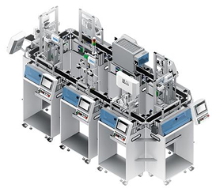
Figure 1 - Festo Cyber-Physical Laboratory production system (UWTSD 2026)

Aims
The aim of this work is to develop and evaluate a current-state DES model of the Festo CP Lab process and use its outputs to identify waste, customer value and evidence-based opportunities to make the process leaner.

Objectives
- Define the process boundary, entities, queues, resources and routing logic
- Document the data and assumptions used to construct the model
- Verify the implemented logic and assess whether the model is sufficiently representative for its intended purpose
- Evaluate throughput, cycle-time components, work in progress (WIP), waiting and resource utilisation
- Identify non-value-adding activity and the principal capacity constraint
- Recommend practical improvement opportunities for subsequent modelling or physical investigation.

Process Selection
The Festo CP Lab process was selected because it is an event-driven manufacturing system containing sequential operations, alternative drilling routes, batching and hold conditions. These features create dependencies that are difficult to evaluate using isolated cycle-time calculations.

Machine layout and station identification
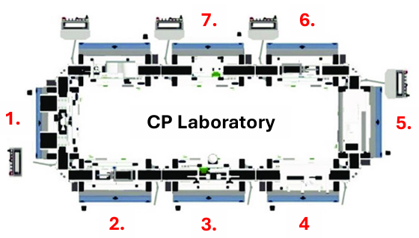
Figure 2 - Festo CP Lab layout (UWTSD 2026)
- Parts in from the Robot assembly
- Automated optical Inspection
- Drilling (2 or 4 holes drilled)
- Top cap dispensing (Refilled after 10 components by operator)
- Hydraulic press
- Label printing and application
- Output Station (Max 4 assemblies)

Machine processing sequence
The CP Lab operates as a sequential production system in which parts are transported between seven capacity-constrained resources using a pallet conveyor. Each resource can process only one part at a time. As shown in Figure 2, the process begins when a component is loaded onto a pallet and transferred to the automated optical inspection station. The component then moves to the drilling station, where the required operation is determined by customer demand: 60% of components require two drilled holes, while the remaining 40% require four.
Following drilling, each component is transported to the top-cap dispensing station. The dispenser magazine holds ten caps and must therefore be replenished after every ten components. The component then proceeds to the hydraulic press before being labelled with the required product information. Finally, the completed components enter the output station, where they are accumulated into batches of four before removal. One operator supports the production system and is responsible for both replenishing the cap dispenser and removing completed batches from the output station.

Current state model development
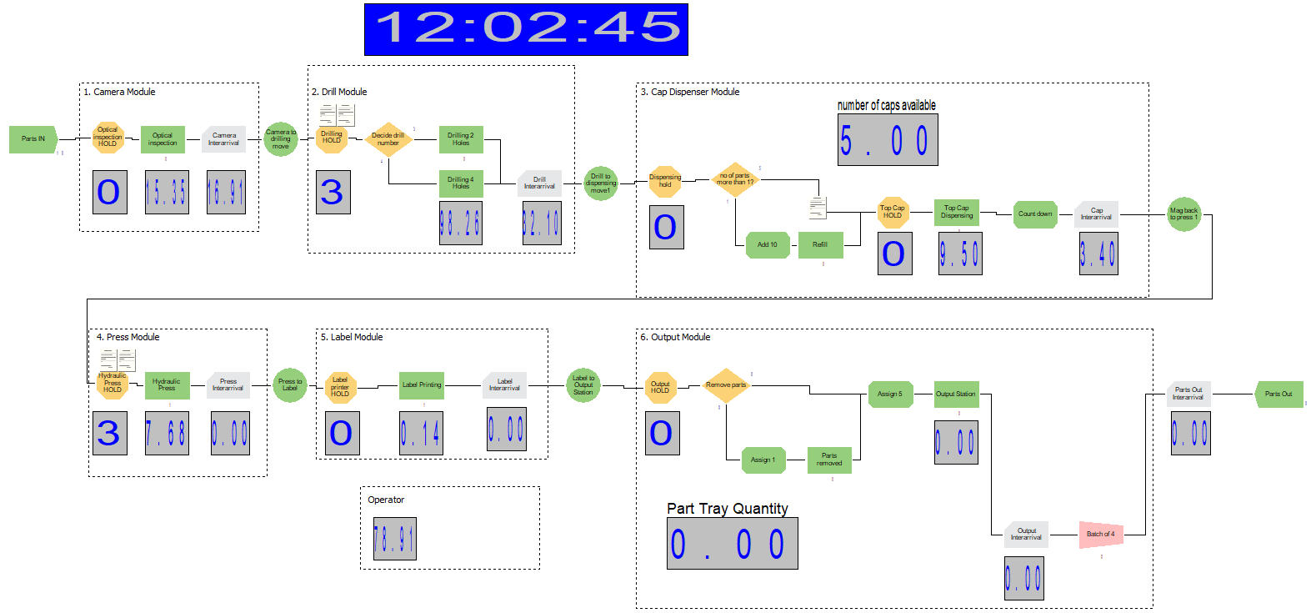
Figure 3 shows the finished Arena model running following the machine flow, running from left to right, starting at Parts IN and ending at Parts Out. To achieve this, several steps were taken to ensure the model represented the real-world machine.

Figure 3 – Completed Arena model of Festo CP Lab
To get the conceptual model translated into Arena, the first step was data collection and breaking down the machine into discrete state changes. Figure 9 presents the part-creation, movement and processing times for Stations 1–7, including the minimum, most-likely and maximum values. It also defines the product mix, with 60% of parts requiring two holes and 40% requiring four holes.
The final model was constructed using entities, Process modules, HOLD modules, resources and decision logic. To help with understanding what each symbol represents and its brief functionality, breakdown of these functions can be seen in Table 2 - Arena symbol breakdown.

Model creation steps
First, parts are created within the model using a Create module. Parts enter one at a time as Entity 1 under a triangular distribution to achieve the data collected values of minimum, most-likely and maximum (15, 18 and 21 seconds), Shown in Figure 4 - Create function for parts entering model. Triangular distributions were selected because minimum, most-likely and maximum values were available for each operation, providing a practical representation where extensive historical data were unavailable (Law 2015).
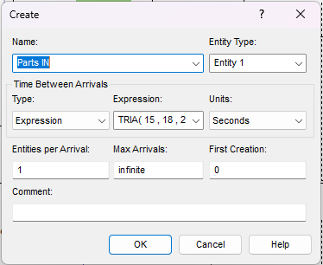
Figure 4 - Create function for parts entering model
Each station was configured to reproduce the sequence and operating logic of the corresponding physical CP Lab station. Although the stations use a broadly similar top-level structure, their lower-level configuration differs according to the operation being represented. This includes station-specific module names, processing-time distributions, resource assignments, queue names, HOLD conditions and variables. For example, the drilling station applies the customer-request variable to direct components towards either two-hole or four-hole processing, whereas the output station uses the part tray variable to control the accumulation and removal of completed components.
Station 6, shown in Figure 5, contains examples of the principal Arena function blocks used throughout the model. It demonstrates how entities are transported, held, assessed against logical conditions, processed, recorded and grouped. The numbered functions are described below. For all station variables, see Appendix 7.3 Arena variables.

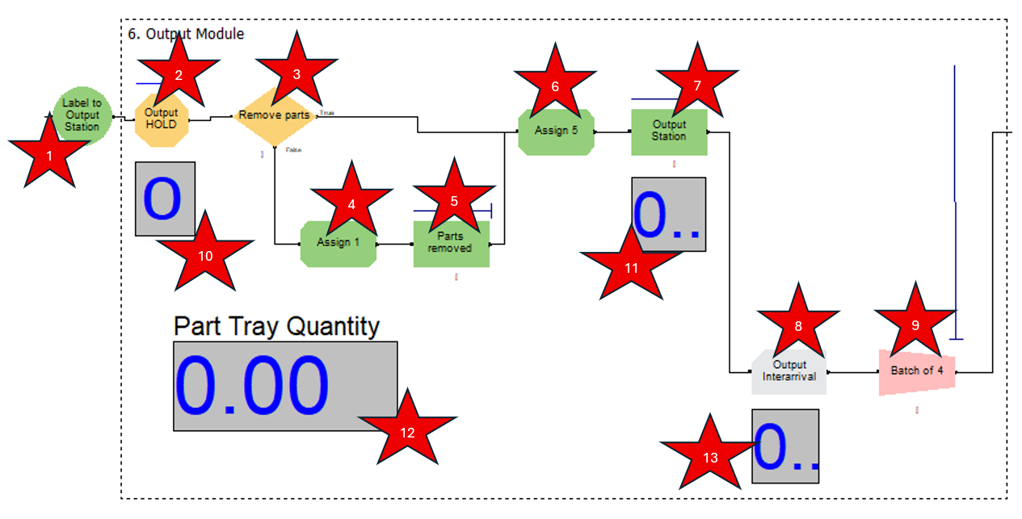
Figure 5 - Station 6 Output module labelled

1. Label to Output Station - Delay module
This module represents the fixed conveyor movement between the label-printing station and the output station. A non-value-adding delay of 8.2 seconds is applied because the component is being transported rather than physically transformed. Equivalent Delay modules are used between the other stations, but their names and delay values are changed to match the corresponding conveyor movement.
2. Output HOLD - Hold module
The Output HOLD module prevents a component from entering the output area until the required conditions are satisfied. It scans the model conditions and retains the entity in the associated virtual queue when the output station or parts-removal operation is unavailable. In Station 6, the condition refers specifically to the WIP at the output and parts-removal processes. Other stations use the same type of HOLD logic but reference different queue names, resources and station-specific conditions.
3. Remove Parts - Decide module
This Decide module evaluates whether the output tray has reached its permitted quantity. The decision is controlled by the part tray variable and directs the entity along one of two routes. If additional tray capacity is available, the component continues to the output process. When the removal condition is reached, the entity follows the alternative route containing the parts-removal operation. Decide modules elsewhere in the model use different variables and conditions, such as the customer requirement for two or four drilled holes and the number of caps remaining in the dispenser.
4. Assign 1 - Assign module
The Assign 1 module updates the variable associated with the output tray when the parts-removal route is activated. This allows Arena to represent the change in tray quantity after completed components have been removed by the operator. Assign modules do not create a physical delay; instead, they change stored information such as counters, attributes or system variables. Their names and expressions are therefore configured differently at each station.
5. Parts Removed - Process module
This Process module represents the physical removal of completed components from the output station. It seizes the shared Operator resource, applies the specified triangular processing time and releases the operator when the task has been completed. The data defines this activity as 20, 26 and 32 seconds. The same operator is also responsible for replenishing the cap dispenser, meaning that only one of these manual activities can be performed at a time.
6. Assign 5 - Assign module
Assign 5 updates the part tray quantity as components enter the output station. The updated value is used by the Remove Parts decision to determine when the output tray has reached its defined capacity. Although similar Assign modules appear elsewhere in the model, they reference different variables, such as the number of caps available or the component’s drilling requirement.
7. Output Station - Process module
The Output Station Process module represents the time required for a completed component to enter and be handled by the output station. The processing time is modelled using the triangular distribution 3.6, 4.1 and 5.1 seconds. The module is classified as non-value-adding because it controls the final handling of the component without changing its form, fit or function.
8. Output Interarrival - Record module
The Output Interarrival Record module collects the time between consecutive entities reaching the output stage. This provides a measure of the consistency of flow from the preceding operations and supports comparison between throughput and upstream congestion. The Record module does not delay the entity. Equivalent Record modules are used at other stations, but each uses a station-specific name, such as Camera Interarrival, Drill Interarrival, Cap Interarrival or Press Interarrival.
9. Batch of 4 - Batch module
The Batch module groups completed components into batches of four, reflecting the physical capacity and removal rule of the output station. Entities are retained until the required batch size is available, after which they are released as a grouped batch for completion of the model. This allows Arena to represent the real-world requirement for the operator to remove four completed assemblies together.
10–13. Variable and system-status displays
The displays numbered 10–13 provide real-time visual monitoring of the output section during the simulation. They show the status of the Output HOLD area, the WIP at the Output Station, the current part tray quantity and the number of entities progressing towards the final batch. These displays help identify congestion and provide visual confirmation that the HOLD, Assign, Decide and Batch modules are operating as intended. They are used only for monitoring and model verification and do not directly influence entity flow or the underlying simulation logic.

Model verification and validation
Model verification was completed by running the simulation at reduced speed and visually tracing entities through each station. The two-hole and four-hole routing, cap replenishment, output-tray counter, HOLD conditions, shared Operator resource and four-part batching logic were checked individually. Input and output counts were also compared to confirm that entities were moving through the model as intended. Verification establishes that the model was implemented as intended, while validation considers whether it represents the physical system sufficiently accurately for its intended purpose (Sargent 2013).
The findings remain dependent on the model assumptions. Processing times were represented by triangular distributions, while equipment failures, operator breaks and maintenance were excluded. The model also started with an empty system to represent the beginning of an eight-hour shift. If production normally begins with existing WIP, different initial conditions would be required. Physical throughput data were unavailable for full validation, therefore, the results represent the defined CP Lab inputs and operating rules.

Simulation Analysis
The model simulated one eight-hour production shift across ten replications. This accounted for variation in the triangular processing-time distributions and the routing of parts between the two-hole and four-hole drilling operations. Using the mean of multiple replications provides a more reliable estimate of expected performance than a single simulation run (Law 2015).

Overall performance and resource utilisation
The overall results are presented in Appendix 7.4 Model Outputs. Table 1 summarises the principal throughput, congestion and efficiency KPIs. Output Station throughput averaged 1,190.5 parts per shift, equivalent to 148.8 parts per hour. The throughput half-width of 6.99 parts represents only 0.59% of the mean, while the drilling-wait half-width of 113.21 seconds represents 3.14%. These relatively small values indicate that the principal throughput and bottleneck findings were consistent across the ten replications. System.NumberOut averaged 297.6 four-part batches, equivalent to approximately 1,190.4 individual parts and closely supporting the Output Station result (Law 2015).
Table 1 - Summary of ten-replication current-state results
KPI | Mean | 95% half-width | Replication range
Output Station Number Out (parts/shift) | 1,190.50 | 6.99 | 1,176-1,204
System.NumberOut (batch of 4/shift) | 297.6 | 1.76 | 294-301
Entity 1 WIP (parts) | 209.75 | 5.29 | 198.39-224.81
Drilling HOLD wait (s) | 3,610.08 | 113.21 | 3,348.9-3,935.8
Drilling HOLD queue (parts) | 200.87 | 5.75 | 187.95-216.81
Entity 1 VA time (s) | 157.6 | 0.64 | 156.49-159.02
Entity 1 NVA time (s) | 136.78 | 0.12 | 136.61-137.11

The resource-utilisation results provide strong evidence of an imbalance within the production line as shown in Figure 6.

Figure 6 - Average resource utilisation across ten replications

This demonstrates that the Drill is operating at virtually full capacity throughout the simulated shift. This result is consistent with the model inputs. Components enter the system at a most-likely interval of 18 seconds, while the weighted most-likely drilling time is 24 seconds.
$\left(0.6×18\right)+\left(0.4×33\right)=24 second$s
Based on this, the theoretical maximum drilling capacity is approximately 1,200 parts per eight-hour shift. The simulated output of 1,190.5 parts was close to this limit, providing an additional verification check and confirming that drilling controlled system throughput. The drilling station therefore receives work faster than it can process it. The large difference between drill utilisation and the utilisation of the downstream resources also indicates that additional capacity at the Camera, Dispenser, Press, Labeller or Output Station would be unlikely to increase throughput while drilling remains constrained.
The Operator recorded the second-highest utilisation at 83%. This is because the same operator replenishes the cap magazine after ten components and removes completed parts in groups of four. Although the Operator is not the principal current-state bottleneck, it could become a secondary constraint if drilling capacity were increased. This demonstrates the importance of evaluating proposed improvements across the complete production system rather than considering an individual station in isolation. DES research similarly uses resource utilisation, WIP, throughput and buffer behaviour together when identifying manufacturing bottlenecks (Velumani and Tang 2017).

Waste identification
Waiting and excess WIP were the principal wastes identified in the current-state model. Average WIP was 209.75 parts, while the difference between input and completed-part throughput indicated that components accumulated throughout the shift. Most congestion occurred before drilling, where the HOLD queue averaged 200.87 entities and a waiting time of 3,610.08 seconds, or 60.2 minutes.

Figure 7 - Average Drilling HOLD queue waiting time across ten replications
Figure 7 shows that drilling delay was substantially greater than every other queue. Its 95% confidence interval of 3,496.87–3,723.29 seconds also demonstrates that this delay occurred consistently across the ten replications. Combined with 99.99% drill utilisation, these results confirm that components enter the drilling queue faster than they can be processed, creating the lean wastes of waiting and excess inventory (Hines and Rich 1997).

Figure 8 - Remaining average queue waiting times across ten replications
Figure 8 separates the smaller queue delays to improve readability. Although considerably lower than the drilling delay, these remain non-value-adding activities.

Value-added versus non-value-added analysis
Across ten replications, Entity 1 (parts) recorded an average value-added time of 157.60 seconds and non-value-added processing time of 136.78 seconds. Value-added activities include drilling, cap dispensing, pressing and labelling because they transform the component to meet customer requirements. Inspection, movement, replenishment, batching, removal and waiting are classified as necessary or avoidable non-value-added activities (Hines and Rich 1997).
The model reported an average waiting time of 14,893.8 seconds, which included the accumulated waiting time of the four components grouped within each output batch. Dividing this figure by the batch size produced an average waiting time of 3,723.45 seconds per part:
$\frac{14,893.8}{4}=3,723.45 second$s
The adjusted total time was calculated by combining the value-added, non-value-added and waiting times:
$157.60+136.78+3,723.45=4,017.83 second$s
This produced a value-added ratio of:
$$\frac{157.60}{4017.83}×100=3.92\%$$
The value-added proportion was therefore approximately 4%, showing that most of the time experienced by each part consisted of waiting or non-value-added activity. Simulated value-stream mapping supports the use of simulation results to identify non-value-added time and evaluate process improvements before changes are implemented physically (Poswa et al. 2022).

Opportunity Identification (Lean evaluation)
The principal improvement options are parallel drilling capacity, reduced drilling cycle time, separate two-hole and four-hole routes, revised product sequencing and removal of avoidable drilling downtime. DES enables these alternatives to be compared using throughput, WIP, queue length and resource utilisation (Velumani and Tang 2017).
Parallel drilling is expected to provide the greatest capacity increase. Reducing the weighted drilling cycle from 24 to 18 seconds, or introducing a second drill, would theoretically allow throughput to approach the arrival rate of 1,600 parts per shift. Compared with current throughput of 1,190.5 parts, this represents a potential increase of 34.4%. However, scaling the current 83.08% Operator utilisation against throughput indicates that the Operator could reach full utilisation at approximately 1,433 parts per shift. Improving drilling alone may therefore provide an increase of approximately 20% before cap replenishment and output removal become the next constraints.
Reducing drilling cycle time through improved tooling, optimised parameters or reduced unnecessary movement may achieve a similar balancing effect without purchasing another machine. Reduced cycle time and non-value-added activity can improve productivity and process flow (Poswa et al. 2022).
Separating drilling routes or controlling part release may reduce variation, WIP and waiting but would not increase physical drilling capacity to the same extent. Future-state simulations should therefore evaluate drilling and Operator capacity together, using multiple KPIs to identify whether the constraint transfers elsewhere (Rocha and Lopes 2022). Testing these alternatives offline would allow their system-wide effects to be assessed before physical implementation (Shou et al. 2021).

Conclusion
A current-state Arena model was developed to evaluate the Festo CP Lab over ten simulated eight-hour shifts. The model produced an average of 1,190.5 completed parts per shift, equivalent to approximately 148.8 parts per hour. This was supported by System.NumberOut, which recorded an average of 297.6 four-part batch events.
The results identified drilling as the dominant bottleneck. The Drill operated at 99.99% utilisation, while its HOLD queue averaged 200.87 entities and 3,610.08 seconds of waiting. Average WIP was 209.75 parts, while the difference between the input and completed-part throughput indicated that components accumulated throughout the shift. In contrast, downstream resources operated with considerably lower utilisation, showing that additional capacity at these stations would be unlikely to improve throughput while drilling remains constrained.
The strongest improvement opportunities are therefore to reduce drilling cycle time, separate the two-hole and four-hole routes, introduce parallel drilling capacity or control the release of components into the drilling queue. Operator workload should also be monitored because cap replenishment and output removal share the same resource.
Before future-state scenarios are evaluated, the model should be validated against observations from the physical CP Lab. The value analysis calculated that approximately 4% of the total time experienced by each part was value-adding, with the remaining time primarily associated with waiting before the drilling operation. Subject to these limitations, reducing or controlling flow into drilling offers the greatest opportunity to decrease WIP, waiting and overall lead time.

References
Banks, J., Carson, J.S., Nelson, B.L. and Nicol, D.M. 2010. Discrete-Event System Simulation. 5th ed. Harlow: Pearson.
Hines, P. and Rich, N. 1997. The seven value stream mapping tools. International Journal of Operations & Production Management 17(1), pp. 46–64. Available at: https://doi.org/10.1108/01443579710157989.
Karnon, J., Stahl, J., Brennan, A., Caro, J.J., Mar, J. and Möller, J. 2012. Modeling Using Discrete Event Simulation: A Report of the ISPOR-SMDM Modeling Good Research Practices Task Force-4. Medical Decision Making 32(5), pp. 701–711. Available at: https://doi.org/10.1177/0272989X12455462.
Law, A.M. 2015. Simulation Modeling and Analysis. 5th ed. New York: McGraw-Hill Education.
Poswa, F., Adenuga, O.T. and Mpofu, K. 2022. Productivity improvement using simulated value stream mapping: A case study of the truck manufacturing industry. Processes 10(9), p. 1884. Available at: https://doi.org/10.3390/pr10091884.
Rocha, E.M. and Lopes, M.J. 2022. Bottleneck prediction and data-driven discrete-event simulation for a balanced manufacturing line. Procedia Computer Science 200, pp. 1145–1154. Available at: https://doi.org/10.1016/j.procs.2022.01.314.
Sargent, R.G. 2013. Verification and validation of simulation models. Journal of Simulation 7(1), pp. 12–24. Available at: https://doi.org/10.1057/jos.2012.20.
Shou, W., Wang, J. and Wu, P. 2021. The application of simulation in lean production research: A critical review and future directions. Engineering, Construction and Architectural Management 28(8), pp. 2119–2154. Available at: https://doi.org/10.1108/ECAM-10-2020-0853.
Turner, C.J. and Garn, W. 2022. Next generation DES simulation: A research agenda for human centric manufacturing systems. Journal of Industrial Information Integration 28, p. 100354. Available at: https://doi.org/10.1016/j.jii.2022.100354.
UWTSD. 2026. Discrete Event Simulation – Festo CP Laboratory. Swansea: University of Wales Trinity Saint David.
Velumani, S. and Tang, H. 2017. Operations status and bottleneck analysis and improvement of a batch process manufacturing line using discrete event simulation. Procedia Manufacturing 10, pp. 100–111. Available at: https://doi.org/10.1016/j.promfg.2017.07.033.

Appendices

Arena symbol breakdown
Table 2 - Arena symbol breakdown
Arena symbol | Function | Number within Figure 5 | Reason used
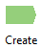 | Discrete Processing | Shown in Figure 3 | Create 1 entity (part) into the model
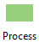 | Discrete Processing | 5 & 7 | Simulate each of the processes on the machine. Seize – delay - release
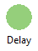 | Discrete Processing | 1 | Simulate the part moving along the conveyor system
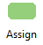 | Discrete Processing | 4 | Used for counting parts through a particular part of the machine
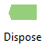 | Discrete Processing | Shown in Figure 3 | Remove parts from the model once completed
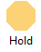 | Decisions | 2 | Holding parts in a virtual queue if the next operation has a part working in progress.
 | Decisions | 3 | Decide which path to take depending on condition
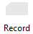 | Input/Output | 8 | Used for recording the interarrival time between stations
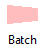 | Grouping | 9 | Moving parts into a batch of 4 at the end of the process for output station
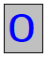 | Variable | 10, 11, 12 & 13 | Used to monitor specific variables within the model

Machine data collection
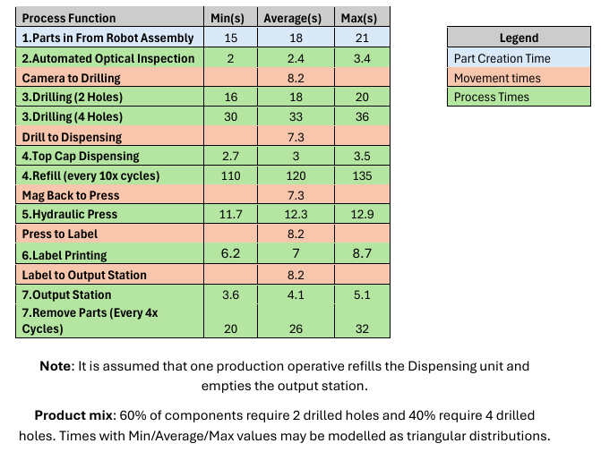
Figure 9 - Data collection for machine parameters (UWTSD 2026)

Arena variables
Figure 10 - Data definition, Entity setup
Figure 11 - Data definition, variable setup
Figure 12 – Discrete Processing, create parts IN
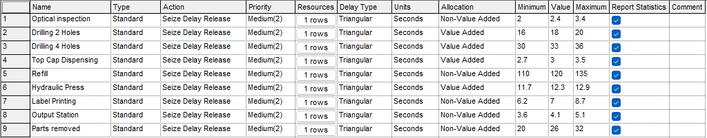
Figure 13 - Discrete Processing, Process’ setup
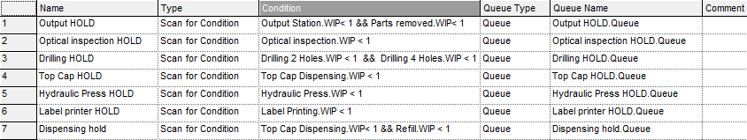
Figure 14 – Decisions, Hold setup
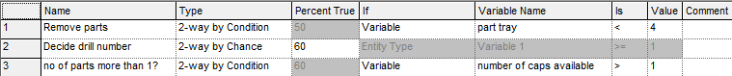
Figure 15 - Decisions, Decide setup
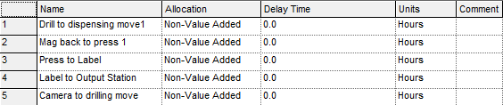
Figure 16 - Discrete Processing, Delay setup
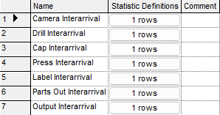
Figure 17 – Input/Output, Interarrival setup

Model Outputs
Table 3 - Model output for 10 replication runs
Identifier | Average | Half-width | Minimum | Maximum | # Replications
Parts removed Number Out | 296.7 | 1.721 | 293 | 300 | 10
Top Cap Dispensing Accum VA Time | 3665.8 | 24.543 | 3615.9 | 3700.8 | 10
Hydraulic Press Accum Wait Time | 0 | 0 | 0 | 0 | 10
Hydraulic Press Accum VA Time | 14683 | 89.699 | 14486 | 14836 | 10
Parts removed Accum Wait Time | 11327 | 360.97 | 10403 | 11940 | 10
Label Printing Number In | 1193.9 | 7.3525 | 1178 | 1206 | 10
Label Printing Number Out | 1193.6 | 7.2962 | 1178 | 1206 | 10
Drilling 4 Holes Accum VA Time | 15919 | 298.9 | 15320 | 16569 | 10
Refill Accum NVA Time | 16193 | 136.33 | 15868 | 16437 | 10
Drilling 2 Holes Number Out | 715.3 | 17.041 | 677 | 750 | 10
Optical inspection Accum Wait Time | 0 | 0 | 0 | 0 | 10
Refill Number Out | 133 | 1.0116 | 131 | 135 | 10
Top Cap Dispensing Accum Wait Time | 0 | 0 | 0 | 0 | 10
Drilling 2 Holes Number In | 715.9 | 16.962 | 677 | 750 | 10
Refill Number In | 133.5 | 0.69515 | 132 | 135 | 10
Hydraulic Press Number Out | 1193.9 | 7.3525 | 1178 | 1206 | 10
Parts removed Accum NVA Time | 7703 | 50.462 | 7583.7 | 7837.1 | 10
Drilling 2 Holes Accum VA Time | 12868 | 299.6 | 12203 | 13471 | 10
Hydraulic Press Number In | 1194.6 | 7.4275 | 1179 | 1207 | 10
Top Cap Dispensing Number Out | 1196 | 8.2665 | 1179 | 1209 | 10
Drilling 4 Holes Accum Wait Time | 0 | 0 | 0 | 0 | 10
Optical inspection Accum NVA Time | 4171 | 8.7403 | 4153 | 4184.7 | 10
Optical inspection Number In | 1601.4 | 2.0005 | 1597 | 1606 | 10
Label Printing Accum NVA Time | 8710.2 | 56.006 | 8595.5 | 8812.1 | 10
Refill Accum Wait Time | 980.21 | 70.912 | 800.45 | 1119.6 | 10
Top Cap Dispensing Number In | 1196.1 | 8.3585 | 1179 | 1210 | 10
Output Station Accum NVA Time | 5076.1 | 29.497 | 5021.7 | 5136.3 | 10
Optical inspection Number Out | 1601.3 | 2.0246 | 1597 | 1606 | 10
Output Station Accum Wait Time | 0 | 0 | 0 | 0 | 10
Drilling 2 Holes Accum Wait Time | 0 | 0 | 0 | 0 | 10
Drilling 4 Holes Number In | 483.1 | 9.0508 | 465 | 504 | 10
Output Station Number Out | 1190.5 | 6.9862 | 1176 | 1204 | 10
Output Station Number In | 1190.6 | 6.9449 | 1176 | 1204 | 10
Drilling 4 Holes Number Out | 482.7 | 9.1296 | 464 | 503 | 10
Label Printing Accum Wait Time | 0 | 0 | 0 | 0 | 10
Parts removed Number In | 297.5 | 1.6605 | 294 | 300 | 10
Entity 1.NumberIn | 1899 | 2.7185 | 1893 | 1907 | 10
Entity 1.NumberOut | 1488 | 8.793 | 1470 | 1505 | 10
Operator.NumberSeized | 430.6 | 2.6162 | 425 | 435 | 10
Operator.ScheduledUtilization | 0.83077 | 0.00593 | 0.81723 | 0.8413 | 10
Press.NumberSeized | 1194.6 | 7.4275 | 1179 | 1207 | 10
Press.ScheduledUtilization | 0.51 | 0.00309 | 0.5033 | 0.51538 | 10
Drill.NumberSeized | 1199 | 7.9724 | 1181 | 1215 | 10
Drill.ScheduledUtilization | 0.9999 | 1.0556E-5 .99988 | 0.99993 | 10
Output.NumberSeized | 1190.6 | 6.9449 | 1176 | 1204 | 10
Output.ScheduledUtilization | 0.17626 | 0.00102 | 0.17437 | 0.17835 | 10
Labeller.NumberSeized | 1193.9 | 7.3525 | 1178 | 1206 | 10
Labeller.ScheduledUtilization | 0.30248 | 0.00195 | 0.29846 | 0.30598 | 10
Camera.NumberSeized | 1601.4 | 2.0005 | 1597 | 1606 | 10
Camera.ScheduledUtilization | 0.14483 | 3.0225E-4 .14420 | 0.1453 | 10
Dispenser.NumberSeized | 1196.1 | 8.3585 | 1179 | 1210 | 10
Dispenser.ScheduledUtilization | 0.12729 | 8.5301E-4 .12555 | 0.12851 | 10
System.NumberOut | 297.6 | 1.7586 | 294 | 301 | 10

Table 4 - Utilisation results over 10 replications converted to %
Identifier | Average
Dispenser | 12.73%
Camera | 14.48%
Output | 17.63%
Labeller | 30.25%
Press | 51.00%
Operator | 83.08%
Drill | 99.99%

Table 5 - Queue waiting time results over 10 replications
Replication | Drilling HOLD | Output HOLD | Parts removed | Dispensing hold | Hydraulic Press HOLD | Batch of 4
1 | 3,465.10 | 50.296 | 39.227 | 39.151 | 29.47 | 10.11
2 | 3,562.00 | 55.925 | 37.74 | 37.114 | 29.401 | 11.04
3 | 3,348.90 | 85.122 | 39.948 | 38.955 | 30.072 | 9.852
4 | 3,592.40 | 45.462 | 37.411 | 36.896 | 28.77 | 11.76
5 | 3,628.30 | 54.011 | 39.801 | 38.675 | 29.646 | 10.29
6 | 3,669.50 | 37.829 | 37.389 | 37.288 | 29.07 | 11.14
7 | 3,743.00 | 32.337 | 37.17 | 36.828 | 28.756 | 11.18
8 | 3,935.80 | 31.319 | 35.507 | 37.99 | 29.213 | 12.46
9 | 3,621.90 | 53.764 | 39.759 | 39.974 | 29.846 | 10.47
10 | 3,533.90 | 58.875 | 37.935 | 39.862 | 30.189 | 10.96
Mean | 3,610.08 | 50.49 | 38.19 | 38.27 | 29.44 | 10.93
95% half-width | 113.215 | 11.197 | 1.039 | 0.866 | 0.36 | 0.563

