DEVELOPING RELATIONSHIPS AND WORKPLACE ACHIEVEMENT
Mohammad Wasimuzzaman
Student ID: 1708859
Module Code: BMSK5002
Lecturer: Domnan Freeman Miri

Executive summary
This report will analyse the development of relationships in the workplace. This report consists of three tasks. In the first task report will analyse the three-development vehicle that will help employees to increase productivity of employees. Second task will analyse the benefits of development of relationship in place of work that will and effects in productivity due to this. For the analysis of second task Marks & Spencer will be taken and third task will set a development plan using the vehicles of development that will help the workers to increase the productivity of employees of Marks & Spencer. This report will also include a detailed introduction and conclusion of the report.

Table of Contents

Introduction 4
Task 1 4
Performance Management 4
Feedback and Reward 6
Training 7
Critical evaluation of the development vehicles 8
Task 2 9
Potential Benefits of the Employees 9
Potential Benefits of the Organisation 10
Task 3 13
Conclusion 15
Reference List 17
Appendices 19
Appendix 1: Systematic training model 19
Appendix 2: Expectancy theory 20
Appendix 3: PDCA Cycle 21
Appendix 4: Personal Development Plan (PDP) 22
Appendix 5: SMART OBJECTIVE 23

Introduction
The relationship in place of work is a relationship between colleagues. If the relationship in a place of work is good then that leaves an impact on the productivity of a worker. This assignment reflects on doing a report that critically evaluates three development vehicles that is available to an organization. This is also appropriate to the developmental needs of a worker of an organization. The second task critically analyses the benefits of these development vehicles in the organization and the third task is development of a plan using three examples that analyses the expectations and the developmental needs of an individual.

Task 1
Individual development of employees of an organisation is highly necessary for the growth and development of an organisation. This is basically because of the fact that employees are the most unique assets that a company can have. The intellect of an employee of a company cannot be imitated under any circumstances and therefore, individual development of an employee is highly essential from the perspective of a company. The major focus of all companies across the globe has been to help in the development of each employee of an organisation, in order to derive better performance from all employees. As stated by Armstrong (2009), a company can employ a large number of ways in order to cater to the individual development of an organisation. Each employee of an organisation has some unique skills which can be polished to achieve better results. Companies provide rigorous training and orientation classes in order to achieve better performance of each employee. In the viewpoints of Bee and Bee (1994), a company can use a large number of vehicles of development that can be employed by a company in order to enhance the performance of the employees of the company. The training that is to be provided by the management of a company should be strictly in accordance with the major drawbacks of an employee. The management should make efforts to polish the shortcomings of all employees and train them for betterment of self and of the company. As influenced by the ideas of Carr (1996), it can be stated that there is a need to make proper developmental plans, in order to promote maximum development of each and every employee within an organisation.

Performance Management
The creation of a development plan is the most fundamental vehicle of development and helps in analysing the various strengths and weaknesses of an individual employee. This can therefore, help the company in the areas where the employees are lacking performance and thus, training should be provided accordingly. The HRM department of a company shoulders the maximum responsibility of training and orientation of an employee of an organisation in order to enhance the performance level of the employees. Therefore, it is in the interest of the company that the HRM department sits with each individual employee within an organisation and discusses their career goals and personal and professional interests. As opined by Hargreaves (2004), this will help in the formation of an accurate performance development plan that will help in the overall development of the individual employee. The discussion regarding the various career goals and individual interests will also help the employee in analysing the various developmental activities that they are to take up in future. This will help in better development in the performance of an employee.
The needs and demands of each employee cannot be identical. Therefore, it is of high importance that the company analyses the aims and aspirations of all the employees and create a performance development plan for each individual employee likewise. There are employees who are unsure regarding their aims for the future. In the viewpoints of Harrison (2009), this can be a problem in the planning process. However, in such cases, the HRM plays a major role in assisting the employee with the path that is to be taken by the employee. The plan that is to be created for the development of each individual employee should contain a set of specific goals. The employee should make the necessary efforts to complete all the goals within the deadline that is set for each goal. In the opinions of Hutchinson & CIPD (2013), this will help in measuring the amount of progress that is being made by each employee, while achieving the goals. The entire planning process is to be done by the HRM department of an organisation and the plan is created in accordance with the social exchange theory. There is a large-scale interaction between each individual employee and management of an organisation and there is a cost and benefit involved throughout the entire interaction. The cost is the cost that the company incurred in the training of all employees and the benefit is the enhancement in the performance of each individual employee that helps in improving the performance of the company.
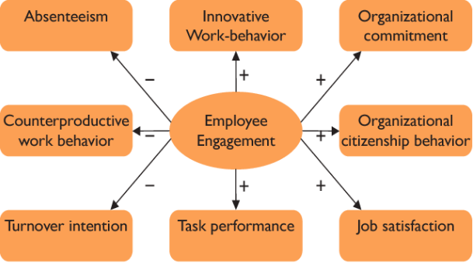
Figure 1: Social Exchange theory
(Source: As influenced by Carr, 1996)

Feedback and Reward
There is a high need of gathering and analysing required data about each individual employee to enhance their performance. In the opinions of Leatherbarrow and Fletcher (2014), work related data is to be gathered regarding all the employees and the approach to be taken for this should be highly sensitive. There are also a fixed set of things that are required to be remembered while gathering the required data. The major requirement throughout the entire activity is to maintain the dignity and self-esteem of each individual employee. There are also a large number of generalisations in the results that needs to be ignored. The management needs to collect data regarding the performance of an employee from the jobs that have been completed previously by the employees and appraisals issued in the name of the employee. In the words of Maund (2001), gathering of data regarding an employee helps the management to analyse the various shortcomings of the employee and analyse the issues that the employee needs to work upon. The analysis of the performance helps the management to know about the individual talents of the employees and reward them in accordance with it. The analysis will not only provide the management with better insights regarding the employee performance, but also give them the idea to draft plans in order to enhance their performance. The collected data are needed to be presented with the gap of skills within the employees accurately and should be helpful to analyse the performance of the employee. The management could then offer rewards to the employees who are more efficient at work. The employees performing in a less productive manner should be given feedbacks that would help them to see their mistakes and improve them accordingly.
On completion of collection of the necessary data, management needs to analyse the data that has been collected. This will provide the management with better insights about the situation and help in the drafting of better plans that will help in training the employees. The collected data should represent the gap of skills within the employees accurately and should help in proper analysis of the performance of the concerned employee. In the opinions of Megginson and Whitaker (2007), a company should be totally dedicated to the cause of identifying the various gaps as they are highly essential in enhancing the performance of an employee.
The expectancy theory helps in describing the entire process of gathering and analysing the collected data. This is because of the fact that the management expects the specific behaviour of a person is not subject to change, unless they are motivated to do so. This form the basis of the analysis of the gathered data and the selection of the process of training that is to be undertaken.
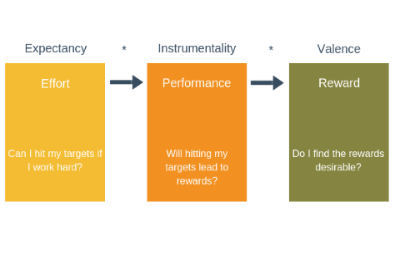
Figure 2: Expectancy theory
(Source: Influenced by Megginson and Whitaker, 2007)

Training
The overall enhancement in the performance of an employee is possible only on providing proper training to the employee. Therefore, the management of a company needs to plan the training process first in order to be able to set the metrics to review the performance of all the employees. According to Mullins & Christy (2013), the systematic training model is highly helpful in determining the entire process of training that is to be set for an employee. There are five phases of training according to the model, which is highly helpful in providing the appropriate training to the employees. There is a high need for the management of the company to set the training process according to this model, in order to derive the maximum benefit from the entire training process.
The next most important process is the setting of the metrics that will help an employee to analyse their current performance status and enhancement in performance after taking up the training. The metrics that are to be set should be quantifiable and should be realistically achievable for all the participants of the job.

Critical evaluation of the development vehicles
According to Reid et al. (2004), it is very important to use development vehicles in order to enhance the performance of employees of an organisation. Few of the many development vehicles are performance management of the employees, training and feedback and reward system. In the viewpoints of Rees and Porter (2015), all these vehicles help individuals to improve their performance at work and recreate their methods of doing jobs. The difference that can be concluded from the three vehicles is that all these vehicles are used in different periods of time. Performance management requires analysis of the employees; training includes proper drilling of the employees for growth; while the rewards and feedback are given to the employees after performance management.
The vehicles include the motivation, training and appraisal which help an individual to perform better in their field of work. According to Rees and Porter (2015), most organisations use training along with feedback and rewards. These vehicles help the companies to improve the performance of their employees and get better results in the end.
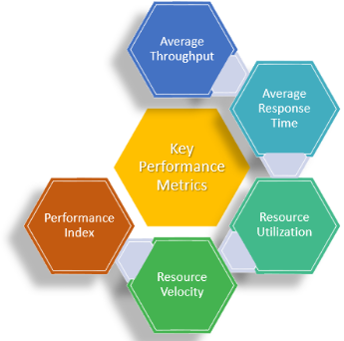
Figure 3: Key Performance Metrics
(Source: Influenced by Reid et al. 2004)

Task 2

Potential Benefits of the Employees
In this context Marks & Spencer has been taken for an analysis of developing relationship and achievement in a place of work. Every employee has a different set of skills. Therefore, there arises a gap between the skills of employees of Marks & Spencer. The management of the company should identify existing gaps of skills of the employees and the management also needs to gather and analyse data of that employee for a detailed analysis of skills of that employee (Armstrong, 2012). Then the management of the company should identify skills that the employee is lacking off and they should create an individual plan for the employee, such as they should arrange training program for the employees. According to Bee and Bee (2003) this can help the organization as well as an employee of the organization. This situation can result in an increase a level that deals with profit of the organization and also increase the productivity of the employee. That is an individual training program can be beneficial for both the employee and the organization. This training program also can also able to meet the demand for the development of the employees of the organization. Hence, training in certain skills can increase the productivity of the employee. Therefore the authority of the company should choose the correct plan of action for the employee that will help them to develop their set of skills. As the set of skills is different for different employee the authority should also choose different training program for different employees. That may have increased the cost of their organization in the short run but in the long run that will increase the level that deals with profit of the company.
The authority should also do detailed analysis of their motivation level, their performance level appreciation, self esteem and job satisfaction. This analysis of data gives knowledge about the abilities of employee. The organization should also follow some theories that will help them to increase the productivity of the employee.

Potential Benefits of the Organisation
In case of training Marks & Spencer should follow the systematic training model. According to the systematic training model the organization should gather data of the employee and then they should identify the needs of training of the employee. They should arrange training program for employee that will help them to increase productivity. In this case the authority of the company needs to choose the correct training program otherwise it will have no impact on the employee.
Third step is that they should choose an experienced trainer for the program of training. Marks & Spencer should do another evaluation of the employees to see whether the training has an impact on the employee or not that's the productivity of the employee has increased or not. The authority of the organization should follow the systematic training program that will help the employees to increase the productivity of the employee (Bee and Bee, 2004). If the productivity of the employee, that will also enhance the culture of work of the employees. As a result the production of the company will also increase and it will also result in an increase in the sales of the company. This in turn also helps them to increase the profit of the organization.
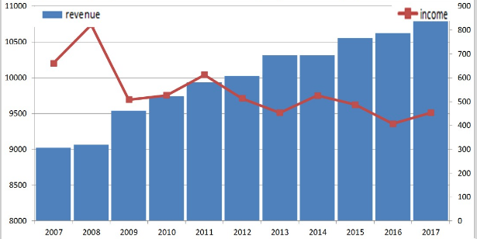
Figure 4: Revenue of Marks & Spencer
(Source: Marksandspencer.com, 2019)
In order to develop the relationship in the place of work the organization needs to follow the social exchange theory. According to the social exchange theory there is a two way relation between the employer and the employee. It can be stated that in order to develop the relationship in the place of work the employer or the owner of the company should keep good relations with the employees. This situation develops the relationship in the workplace. The owner of the company should discuss the new strategies with the employees of the organization. This will help the employer in many ways like the owner will be able to know some information about the competitors of the company. In this case the owner of the Marks & Spencer should keep a good relation with the workers of the company that will help to increase the productivity of employees. As a result of this the level that deals with profit of the company also increases.
In order to increase the achievement in place of work the organization should follow the theory of expectancy. According to this theory the performance of the employee depends upon the reward that is given by the organization (Maund, 2001). In order to increase the productivity of the employee the amount of reward should be increased by company. This increment in the reward of the company can increase productivity of the company as a result of this also increase a level that deals with profit of the company. In this case the Marks & Spencer should also increase the reward that will be given to the employee of the organization. This increment in the reward of the Marks & Spencer will increase the productivity of the company. This also increases the level that deals with profit of the company. The organization should give correct training to the employees and they should also evaluate the performance of employee after the program of training. Management of Marks & Spencer should also implement these strategies in order to increase the productivity of employees. This will also increase level that deals with profit of organization. Thus systematic training model can increase the productivity of the employee and it also help Marks & Spencer to increase the level that deals with profit of Marks & Spencer. Thus individual program of training, gathering of data and evaluation of the performance of the employee after training can be beneficial for both the employees of the organization and also organization. In this case that will be beneficial for employees of Marks & Spencer and for the company also.
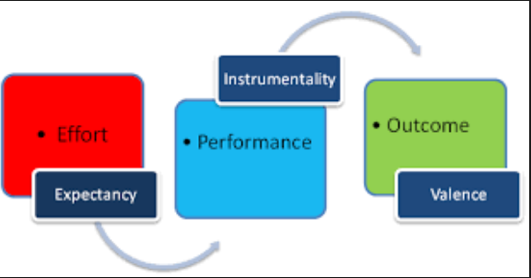
Figure 5: expectancy theory
(Source: influenced by Armstrong, 2012)

Task 3
While working in an organisation, an individual expects to improve personally and professionally. The driving forces that are described above can assist an individual to fulfil their expectation of improvement. The drivers mentioned above are development plan for an individual, analysis of collected data and analysing performance metrics. Marks and Spencer is an organisation who gives importance to their employees (Marksandspencer.com, 2019). According to Armstrong (2009), within an organisation where employees have space and can have proper training, are likely to grow more as an individual and perform well in the workplace. While having training from the company, the employees are able to gather the information necessary for the improvement of their performance. As influenced by the ideas of Armstrong (2012), it can be stated that every individual is given different responsibilities as per their posts in the organisation. Therefore, every individual employee has a different goal. On the other hand, in order to improve their personal development, it is evident that all the employees or individuals are required to follow the basic steps, that is, to develop a plan and act in accordance with it so that they have further improvement in their performance.
In order to maintain the growth within the employees, Marks and Spencer, allow its employees to have proper training. As per the company guidelines, the customers are important, however, the company also pays attention to its employees. The organisation offers rewards to those who excel in performing their responsibilities. According to Woodward (1996), company along with individual employees are able to work on the efficiency of the employees with the help of performance management. The management of performance of an individual not only develop their efficiency regarding workplace activities, but also affect the reward and pay system of the company. Providing motivation and giving feedback and recognition are effective vehicles for the development and management of performance.
As per the ideas of Williams and Johnson (2003), an organisation is able to manage the performance of its employees with the help of the following elements:
Agreement: At this step, Marks and Spencer carry outs contracts and agreements with its employees which are not based on commands or orders of the superiors. The agreements are made by allowing the employees to speak out about their thoughts. The company puts forward the roles that are required to be done by individual employees who are concluded as the objectives or goals set for them.
Measurement: In this situation, the individual or the company judges the performance of the employees based on the fulfilment of the objectives with the extent of expected performance. The outputs that have been used by the individuals are measured at this time.
Feedback: the company managers provide employees with feedback that are the ultimate outcome of their performance. The company provides rewards and punishment to the employees at this time. This part of the plan decides whether a person needs improvement or not and tasked with accordingly.
Positive reinforcement: This part of the planning is considered to motivate the employees working under the organisation. The positive and motivating talks help the employees to work with a fresh start. The meetings also help the employees to work individually on themselves which also plays a huge role for the development of the employees as a whole.
Dialogue: The officials of the company tell on the employees who are not progressive and help them improve their working performance by giving them individual goals to perform. This act in turn increase the efficiency of the employees as they are being equally paid attention to.
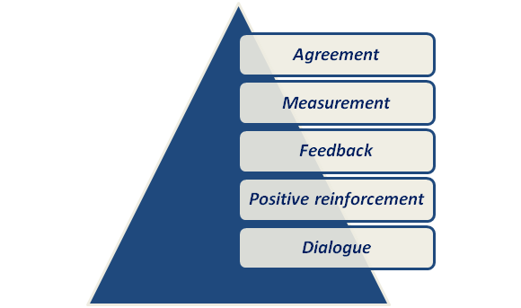
Figure 6: Characteristics of Performance Management
(Source: As influenced by Armstrong, 2012)
Performance management is an act that is flexible and goes on as a cycle. In the views of Sisson (1994), performance management will continue to come to the top as the act is done till the bottom. This means that all the elements of performance management will be repeated as soon as the last task is done which is providing the employees with dialogue. There are many theories that work as an effective tool while an individual wants to perform in an improved manner and give out a greater impact through their performance. Firstly, William Deming’s Plan-Do-Check-Act (PDCA) model is an effective model that can be used for the development of personal productivity [Refer to Appendix]. According to the ideas of Sadler-Smith (2005), it can be stated that in order to achieve goals and objectives, it is very important to figure out the objectives and then plan in accordance with it. The PDCA model can be explained in the following manner:
Plan: To identify the problem that has occurred, gather relevant information regarding it and ascertain the root cause of the problem.
Do: To work on a plan by measuring its effectiveness after the implementation.
Check: To study the outcomes and compare them to the previous data.
Act: To according to the outcome of the study and think of ideas to make improvements.
The individual development can also be done with the help of SMART objectives [Refer to Appendix 5].
Another example of checking on the development of an individual is the Personal Development Plan (PDP) [Refer to Appendix 4]. According to Rosenfeld, Giacalone and Riordan (1995), this method helps an individual to go through their desired objectives and act accordingly. The PDP can be presented in tabular form in order to set the objectives that are necessary to be paid attention to. Afterwards, the success criteria helps to make use of the performance management in which an individual is expected to analyze their performance level. Actions or decisions are to be made after the analysis and suitable solutions are found. Lastly, the methods for the solution are put under use in order to achieve success. The PDP, hence, is beneficial for the development of an individual as well as an organisation.
In the case of Marks and Spencer’s, the company will be able to analyse the performance of the employees and select the training procedure, which after implementation will improve the overall performance of the employees.

Conclusion
After the analysis of the entire report, it can be stated that in order to improve one’s performance working in an organisation, many methods can be used. The report includes the driving forces that help in the development of an organisation by improving the work efficiency of their employees. The company discussed here is the Marks and Spencer. With the help of individual development plan, analysis of gathered data and calculating the performance metrics, the organisations can largely benefit in the market. Lastly, the methods to develop performance planning are mentioned. SMART objectives, PDCA model and Performance Development Plan are the methods that have been used for the performance development.

Reference List
Armstrong, M. (2009) Armstrong’s handbook of human resource management practice, 9th edition London; Philadelphia: Kogan Page, 2009.
Armstrong, M. (2012) Armstrong’s handbook of human resource management practice, 12th edition. (Online) London, U.K; Philadelphia Pa.: Kogan Page. Available at: Available at: http://www.tsd.ac.uk/en/lrc/onlineresources/e-books/ [Accessed on: 20.07.2019]
Armstrong, M. (2012) Armstrong’s handbook of performance management: an evidence based guide to delivering high performance 4th edition. (Online) London, U.K. ; Philadelphia, Pa. : Kogan Page. Available at: http://www.tsd.ac.uk/en/lrc/onlineresources/e-books/ [Accessed on: 20.07.2019]
Bee, F. and Bee, R. (1994). Training Needs Analysis and Evaluation. London: Institute of Personnel Management.
Bee, F. and Bee, R. (2003). Learning Needs Analysis and Evaluation. 2nd ed. London: Chartered Institute of Personnel and Development.
Bee, F. and Bee, R. (2004). Learning Needs Analysis and Evaluation. 2nd ed. (Online) London: Chartered Institute of Personnel and Development. Available at: http://www.tsd.ac.uk/en/lrc/onlineresources/e-books/ [Accessed on: 20.07.2019]
Carr, C. (1996). Team Leader's Problem Solver. Englewood Cliffs, NJ: Prentice Hall.
Hargreaves, D.H. (2004) Learning for life : the foundations for lifelong learning, Bristol: Policy Press. Available at: http://www.tsd.ac.uk/en/lrc/onlineresources/e-books/ [Accessed on: 20.07.2019]
Harrison, R. (2009). Learning and Development. 5th ed. London: Chartered Institute of Personnel and Development.
Hutchinson, S., & CIPD. (2013). Performance Management. London: Chartered Institute of Personnel and Development.
Leatherbarrow, C. and Fletcher, J., (2014). Introduction to Human Resource Management: A Guide to HR in Practice. Kogan Page Publishers.
Marksandspencer.com (2019), About the company Available at: https://www.marksandspencer.com [Accessed on: 23.07.2019]
Maund, L. (2001). Introduction to Human Resource Management: Theory and Practice. Houndmills, Basingstoke, Hampshire: PALGRAVE.
Maund, L. (2001). Introduction to Human Resource Management: Theory and Practice. (Online) Houndmills, Basingstoke, Hampshire: Palgrave. Available at: http://www.tsd.ac.uk/en/lrc/onlineresources/e-books/ [Accessed on: 20.07.2019]
Megginson, D. and Whitaker, V., (2007). Continuing professional development. Kogan Page Publishers.
Mullins, L., & Christy, G. (2013). Management & organisational behaviour (Tenth ed.). (Online) Harlow: FT Publishing.
Rees, W.D. and Porter, C., (2015). Skills of management and leadership: Managing people in organisations. Macmillan International Higher Education.
Reid, M.A., Barrington, H.A. and Brown, M., (2004). Human resource development: beyond training interventions. CIPD Publishing.
Rosenfeld, P., Giacalone, R. A. and Riordan, C. A. (1995). Impression Management in Organizations: Theory, Measurement, Practice. London: Routledge
Sadler-Smith, E. (2005) Learning and development for managers: integrating individual and organizational learning. (Online) Oxford: Blackwell. Available at: http://www.tsd.ac.uk/en/lrc/onlineresources/e-books/ [Accessed on: 20.07.2019]
Sisson, K. (1994). Personnel Management: A Comprehensive Guide to Theory and Practice in Britain. 2nd ed. Oxford, UK: Blackwell Business.
Williams, K. and Johnson, B., (2003). Introducing management: A development guide. Routledge.
Woodward, I. (1996). Continuing Professional Development: Issues in Design and Delivery. London: Cassell.

Appendices

Appendix 1: Systematic training model

(Source: Influenced by Mullins & Christy, 2013)

Appendix 2: Expectancy theory

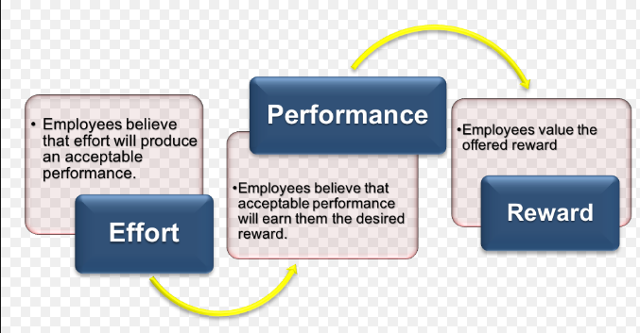

(Source: Influenced by Maund, 2001)

Appendix 3: PDCA Cycle
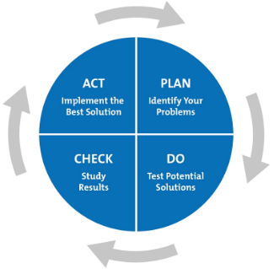
PDCA Cycle
(Source: As influenced by Sadler-Smith, 2005)

Appendix 4: Personal Development Plan (PDP)

Objectives | Success Criteria | Actions | Implementation
To increase the performance level of the employees employed in Marks and Spencer’s | Use of performance management in order to analyse the performance level of the employees | Identification of their potential and reward them with appraisal and on the other hand provide feedback as per the limitations of the employees | Use of trainings in order to improve employee performance

Personal Development Plan (PDP)
(Source: As influenced by Rosenfeld, Giacalone and Riordan, 1995)

Appendix 5: SMART OBJECTIVE
Specific | Measurable | Attainable | Relevant | Time-bound
To identify development expectations and needs of an employee in Marks and Spencers | The idea is measurable because the efficiency of the employee can develop | The act is attainable as the employees are willing to improve their performance in the workplace | The method is relevant as it will align the goal of the employees with the corporate goal | The time required for the implementation of the plan is 1 year
(Source: as influenced by Reid, Barrington and Brown, 2004)

