

A CRITICAL DATA ANALYTICS EVALUATION OF DELIVERY PERFORMANCE AND CUSTOMER RATINGS USING EXCEL AND IBM SPSS

DATA HANDLING AND BUSINESS INTELIGENCE
COMPONENT 2
LCBB5014
DUMITRU ADRIAN CIRJAN
2319495

TABLE OF CONTENTS
1.0 Introduction 3
2.0 Data Cleaning and Preparation 3
3.0 Descriptive Statistics and Summary 4
3.1 Descriptive Statistics Analysis for Numerical Fields 4
3.2 Descriptive Statistics Analysis for Distributions of Categorical Variables 5
4.0 Trend Analysis and Visualisation 6
4.1 Trend lines for delivery times 6
4.2 Trend lines for delivery ratings over time 7
4.3 Analysis of Weather, Traffic Density, and Delivery Time 8
5.0 Statistical Analysis using SPSS 9
5.1 Hypothesis Testing 9
5.2 Correlation Analysis 10
5.3 Regression Analysis 10
6.0 Insights and Recommendations 13
References 15

1.0 Introduction
The report evaluates operational efficiency and service quality, and environmental and logistical factors to assess their impact on performance through analysis of a structured food delivery dataset. The dataset contains 7,672 records, showing delivery personnel characteristics, the time of delivery, current weather conditions and traffic density, and service features, including vehicle type and order category. The analysis aims to achieve more than basic data presentation by showing distributional patterns, operational tendencies and important statistical relationships that affect delivery results and customer assessment.
The analysis contains four interconnected objectives that serve as its main framework. First, “data cleaning and preparation” work to establish analytical accuracy by eliminating all records that contain incomplete information, display inconsistent data and present logical flaws, especially in their time and location information. Second, “descriptive statistical” analysis evaluates “central tendency”, “dispersion”, and “distributional characteristics” to identify structural patterns and anomalies. Third, trend analysis investigates temporal dynamics in delivery volumes and ratings, alongside interaction effects between weather and traffic conditions. And finally, the “statistical testing process” uses “SPSS” to conduct hypothesis testing, correlation analysis and regression modelling, allowing for the precise evaluation of important variables that affect operational outcomes.

2.0 Data Cleaning and Preparation
The dataset required extensive preprocessing in Excel because multiple variables contained missing data, inconsistent data and invalid data entries. A complete-case data cleaning strategy was adopted, and all records containing NaN values were removed because incomplete observations needed to be eliminated to prevent analytical bias. The research used this approach because the dataset contained enough data points for them to conduct thorough statistical testing (Côté et al. 2024). The study location boundaries were altered because all erroneous entries, including zero values and logically invalid negative values in "Restaurant_latitude", "Restaurant_longitude", "Delivery_location_latitude" and "Delivery_location_longitude", needed to be removed from the analysis.
The research discovered major discrepancies in the measurement of time. Excel's "Text to Columns" feature processed the Order_Date field to create a single date format. The Time_Ordered and Time_Order_picked variables showed mixed data formats, including both decimal numbers (0.75) and invalid time entries (24:15:00). These items were deleted, which needed adjustment but proved impossible to fix.
The unnecessary column that showed "#NAME?" was removed because it did not provide any useful information. The changes made to the data brought about structural uniformity, better data accuracy and increased reliability for future analysis work using Excel and SPSS.

3.0 Descriptive Statistics and Summary
The descriptive statistics generated from both Microsoft Excel and IBM SPSS Statistics demonstrate a high level of consistency in central tendency and dispersion, while also revealing notable differences in distributional interpretation, particularly for the dependent variable.

3.1 Descriptive Statistics Analysis for Numerical Fields
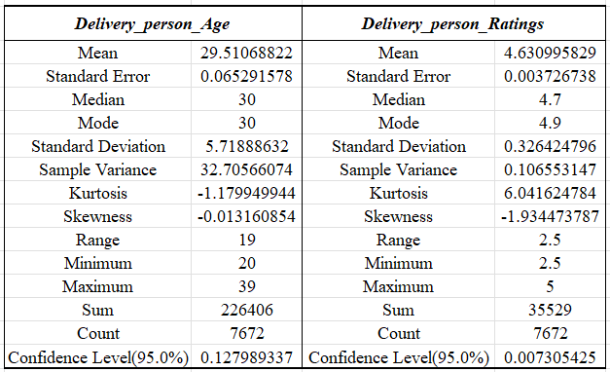
(Source: Excel)
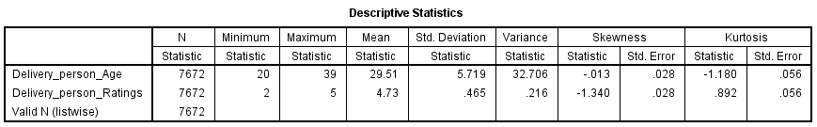
(Source: SPSS)
The statistical results show that Delivery_person_Age has an average value of 29.51 and a minimum age of 20 and a maximum age of 39, creating a workforce age range that operates within practical limits. The distribution shows a symmetric pattern because its skewness value reaches near zero at -0.013, showing no preference for any age group in the distribution of employees. The negative kurtosis value of -1.18 indicates that the distribution has a platykurtic pattern, resulting in a distribution that shows fewer extreme age values compared to a normal distribution. The delivery performance models become less affected by outliers because of this factor. The Delivery_person_Ratings variable in SPSS shows a higher average rating of 4.73, while Excel shows a lower average rating of 4.63, which stems from minor differences in their calculation methods. The two systems present different minimum values, showing that their data cleaning methods and data inclusion standards differ (Cooksey, 2020). The strong negative skewness (-1.34 in SPSS; -1.93 in Excel) confirms a clustering of ratings at the upper bound (maximum = 5), suggesting a ceiling effect and limited variability in customer feedback. Excel shows a high kurtosis value of 6.04, indicating a distribution that leads to extreme concentration of ratings towards high values, while SPSS shows a lower kurtosis of 0.892, meaning it has a mild peak. The different findings create doubts about the strength of the ratings-based inferential results.

3.2 Descriptive Statistics Analysis for Distributions of Categorical Variables
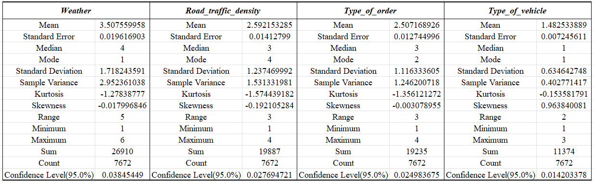
(Source: Excel)
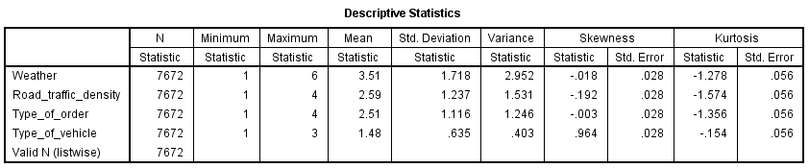
(Source: SPSS)
The two tools generate matching central measurements for numeric categorical variables, yet need careful evaluation to understand their results. Weather (mean 3.51; range 1-6) shows symmetrical distribution across its conditions because it has near-zero skewness, while its negative kurtosis value of -1.28 indicates that weather types exhibit uniform distribution instead of a clustered appearance. The distribution of road_traffic_density (mean 2.59; mode = 4) exhibits slight negative skewness, indicating that the data tends to group in higher traffic categories that cause delivery delays. The distribution of Type_of_order (mean 2.51) shows symmetrical patterns, creating equal distribution across different order categories. The distribution pattern of Type_of_vehicle (mean 1.48) shows strong positive skewness (0.964) because delivery operations depend on one specific vehicle type.

4.0 Trend Analysis and Visualisation

4.1 Trend lines for delivery times
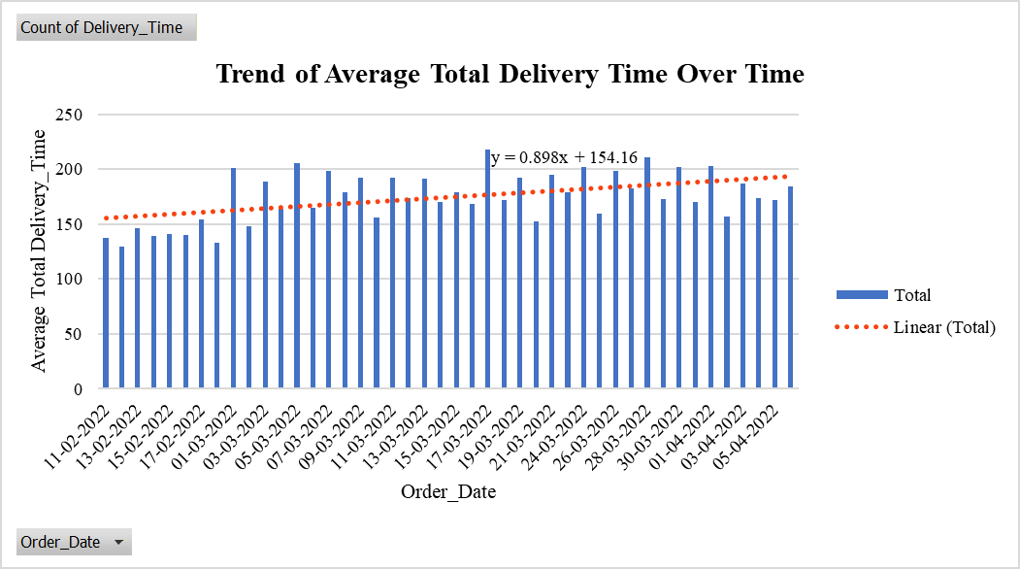
(Source: Excel)
The trend line equation (y = 0.898x + 154.16) shows an upward delivery time pattern that extends through the entire study period because delivery volume increased without any operational efficiency improvements. The early February data shows stable results between 129 and 154, although March displays a noticeable increase, with its highest points reaching 218 on 17-03-2022 and 211 on 28-03-2022. The upward trend indicates that operational demands are increasing, which may result from either higher order volumes or seasonal consumption patterns (Ren et al. 2020). The current situation shows no downward trend, indicating that both capacity expansion and logistical optimisation efforts have failed to keep pace with increasing demand. Operational volatility shows itself through daily fluctuations, ranging between 152 on 20-03-2022 and 195 on 21-03-2022, because external factors like traffic congestion and weather disruptions affect operations. The positive slope shows moderate strength because it represents total inefficiencies that need strategic handling to prevent future accumulation.

4.2 Trend lines for delivery ratings over time
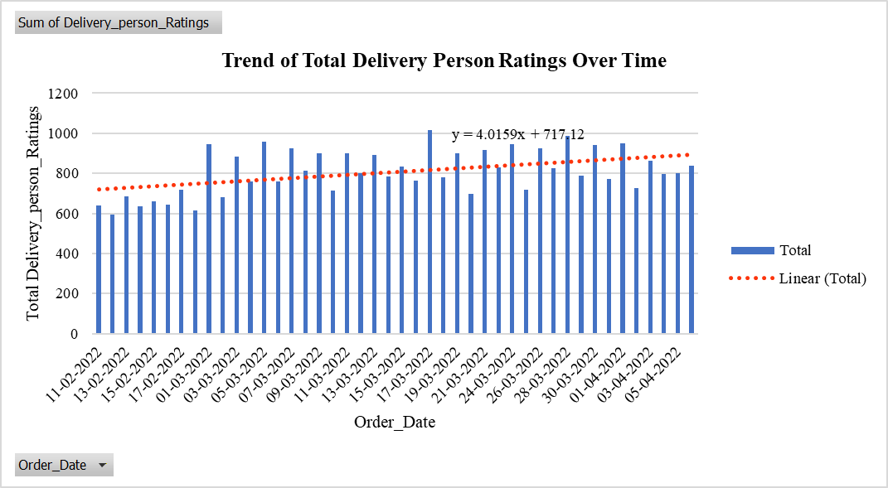
(Source: Excel)
Delivery ratings show an increasing pattern because their trend line (y = 4.0159x + 717.12) shows higher ratings as time progresses. The results must be evaluated through critical analysis because volume effects create different impact pathways that affect service quality improvements. March cumulative ratings (e.g., 1014.8 on 17-03-2022) show higher delivery counts, proving that transaction frequency drives the upward trend more than improved customer satisfaction. The average rating consistency shows a saturation effect because ratings stay near the upper limit even when operations become more demanding, according to previous descriptive statistics (Liu et al. 2022). The simultaneous growth of delivery numbers, together with unchanged rating patterns, demonstrates that service quality assessments remain stable because both factors combine to create this effect. The trend does not show a quality improvement because it only indicates that operations have expanded while service quality has remained constant.

4.3 Analysis of Weather, Traffic Density, and Delivery Time
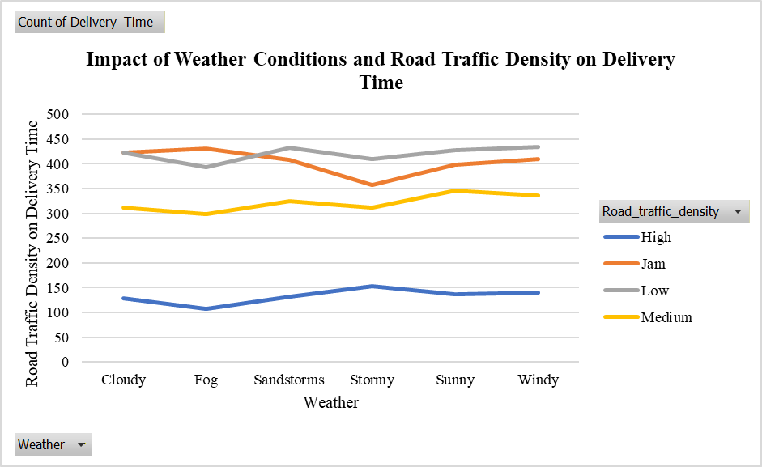
(Source: Excel)
The chart shows weather conditions along with road traffic density, establishing a strong connection that affects delivery time changes throughout the day. “Jam” traffic conditions account for the highest frequency (2426), creating a significant gap with “High” (798), because congestion acts as the primary constraint that affects operations. All weather conditions show that delivery counts reach their peak under “Jam” and “Low” traffic conditions because delivery demand stays constant throughout different environmental situations. The combination of Stormy and Fog adverse weather creates higher traffic counts under “High” conditions, reaching 153 and 108 for each weather condition, respectively. Sunny weather conditions show delivery performance results that stay constant throughout their operational range. The data shows no direct relationship between poor weather conditions and longer delivery times because it demonstrates that weather conditions make existing traffic congestion problems worse (Gössling et al. 2023). The analysis shows that delivery problems arise from multiple factors, including traffic density as the main cause and weather conditions as a secondary factor that increases the impact.

5.0 Statistical Analysis using SPSS

5.1 Hypothesis Testing
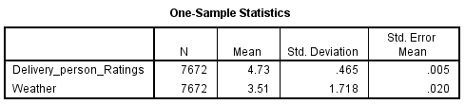
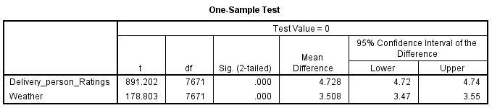
(Source: SPSS)
The one-sample t-test results indicate statistically significant mean values for both Delivery_person_Ratings (t = 891.202, p < 0.001) and Weather (t = 178.803, p < 0.001); however, this test specification is methodologically misaligned with the stated objective. A one-sample t-test evaluates whether a sample mean differs from a fixed benchmark (here, zero), rather than testing differences in ratings across weather categories. The significant p-values demonstrate that the observed means for ratings measured 4.73 and weather measured 3.51 exceed zero, yet this finding lacks meaningful value for interpretation. The research hypothesis needs testing through an independent samples test or an ANOVA-based test because it examines how weather conditions impact rating outcomes (Francis et al. 2023). The ratings show high stability across different conditions because the confidence interval from 4.72 to 4.74 provides a narrow range of customer evaluations, yet shows that weather conditions do not significantly affect their service quality perception.

5.2 Correlation Analysis
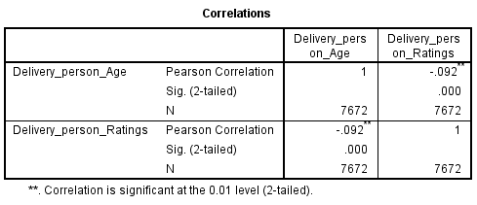
(Source: SPSS)
The Person correlation coefficient of -0092 has a p value below 001, establishes a statistically significant relationship between Delivery_person_Age and Delivery_person_Ratings, and shows only weak correlation. The statistical significance of the study results from its large sample size, which includes 7672 participants, but the coefficient size shows only a minor practical impact. The negative direction shows that older age leads to lower ratings, but the effect size remains too small to create any useful predictive or management analysis (Janse et al. 2021). The weak relationship shows that customer ratings depend more on operational factors than they do on age-related demographic information. The use of age as a performance modelling factor will create interpretive bias and will not provide any valuable explanatory benefits.

5.3 Regression Analysis
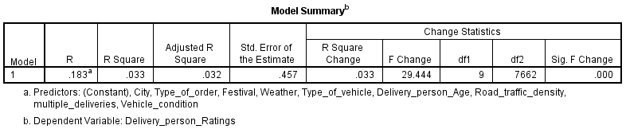
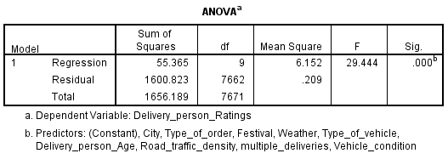
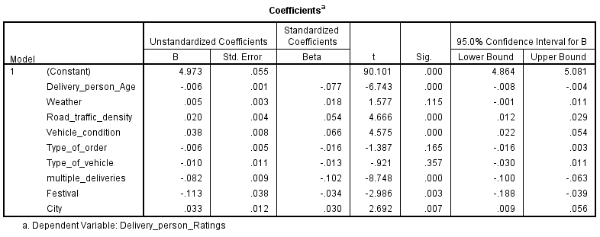
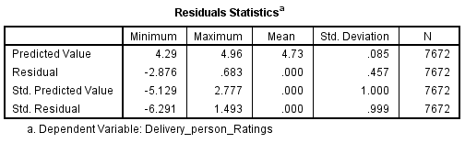
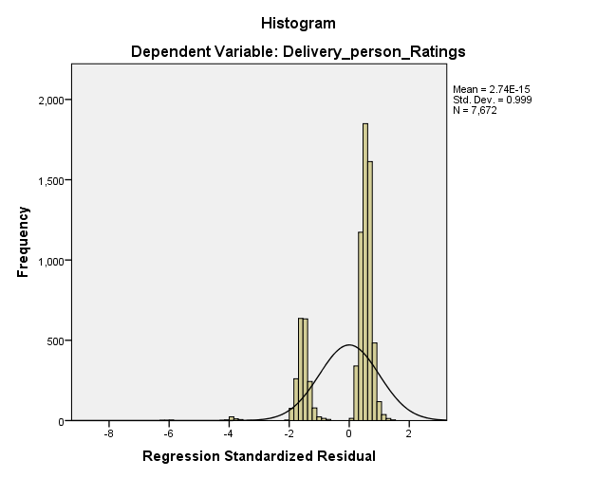
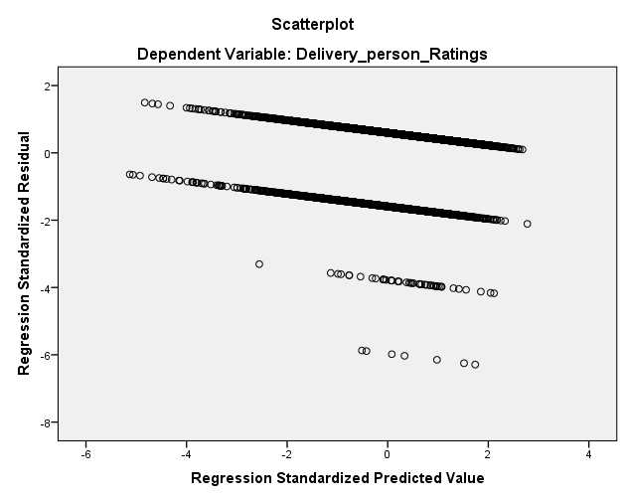
(Source: SPSS)
The regression model demonstrates statistical significance (F = 29.444, p < 0.001), confirming that the set of predictors collectively explains variation in Delivery_person_Ratings. The model maintains critical explanatory deficits because it can only account for 3.3 per cent of the total variance, which leads to diminished predictive accuracy. Multiple_deliveries (β = -0.102, p < 0.001) stands as the most powerful negative predictor because higher delivery volumes lead to diminished customer evaluation of service quality. The operational pressures of peak and complex conditions negatively affect ratings throughout the entire Delivery_person_Age (β = -0.077, p < 0.001) and Festival conditions (β = -0.034, p = 0.003) evaluation period. Vehicle_condition (β = 0.066, p < 0.001) and Road_traffic_density (β = 0.054, p < 0.001) both demonstrate positive relationships, yet the second variable seems to display artificial enhancement because of its programming framework. Weather (p = 0.115), Type_of_order (p = 0.165), and Type_of_vehicle (p = 0.357) show no statistical significance, supporting the previous finding about environmental factors and categorical factors not having a major impact on ratings (Montgomery et al. 2021). The residual spread further indicates potential model misspecification, suggesting that delivery time and customer expectations should be regarded as essential factors that determine customer satisfaction.

6.0 Insights and Recommendations
The study identifies essential elements that affect both operational efficiency and service delivery performance. Delivery times show a steadily increasing pattern, demonstrating rising operational demands that do not lead to equivalent efficiency improvements. At the same time, delivery ratings display a strong tendency to remain close to their highest possible value, creating a performance measurement limit that reduces the ability to detect actual performance changes. Traffic congestion stands as the main restriction because "Jam" conditions considerably affect delivery capacity, while weather conditions function as a factor that increases delays without causing operational problems. The regression results demonstrate that operational elements, especially multiple deliveries and vehicle condition, have a stronger impact on ratings than demographic or environmental factors, although the total explanatory strength remains inadequate.
The research results indicate that operational activities should first implement dynamic route allocation systems for handling high traffic situations. The system needs to prevent multiple deliveries during peak times to maintain service standards. The system should use vehicle condition assessment data to make scheduling decisions. The implementation of different routing methods during severe weather conditions will help decrease total delays.
The analysis faces limitations from its research methods and available data, including the incorrect application of one-sample t-tests and possible errors in data cleansing and deficient regression model results. Future research should use delivery time as its main variable while employing multivariate or panel data models and measuring customer expectations through their behaviour.

References:
- Cooksey, R.W., 2020. Descriptive statistics for summarising data. In Illustrating statistical procedures: Finding meaning in quantitative data (pp. 61-139). Singapore: Springer Singapore. https://pmc.ncbi.nlm.nih.gov/articles/PMC7221239/pdf/978-981-15-2537-7_Chapter_5.pdf
- Côté, P.O., Nikanjam, A., Ahmed, N., Humeniuk, D. and Khomh, F., 2024. Data cleaning and machine learning: a systematic literature review. Automated Software Engineering, 31(2), p.54. https://arxiv.org/pdf/2310.01765
- Francis, G. and Jakicic, V., 2023. Equivalent statistics for a one-sample t-test. Behavior Research Methods, 55(1), pp.77-84. https://link.springer.com/content/pdf/10.3758/s13428-021-01775-3.pdf
- Gössling, S., Neger, C., Steiger, R. and Bell, R., 2023. Weather, climate change, and transport: a review. Natural Hazards, 118(2), pp.1341-1360. https://link.springer.com/content/pdf/10.1007/s11069-023-06054-2.pdf
- Janse, R.J., Hoekstra, T., Jager, K.J., Zoccali, C., Tripepi, G., Dekker, F.W. and Van Diepen, M., 2021. Conducting correlation analysis: important limitations and pitfalls. Clinical kidney journal, 14(11), pp.2332-2337. https://academic.oup.com/ckj/article-pdf/14/11/2332/41100015/sfab085.pdf
- Liu, X.X. and Chen, Z.Y., 2022. Service quality evaluation and service improvement using online reviews: A framework combining deep learning with a hierarchical service quality model. Electronic Commerce Research and Applications, 54, p.101174. https://papers.ssrn.com/sol3/Delivery.cfm?abstractid=537532
- Montgomery, D.C., Peck, E.A. and Vining, G.G., 2021. Introduction to linear regression analysis. John Wiley & Sons. http://sutlib2.sut.ac.th/sut_contents/H133678.pdf
- Ren, S., Chan, H.L. and Siqin, T., 2020. Demand forecasting in retail operations for fashionable products: methods, practices, and real case study. Annals of Operations Research, 291(1), pp.761-777. https://www.academia.edu/download/90995702/s10479-019-03148-820220913-1-y12dyu.pdf

