Group Project



Level 6 Assignment
Submitted By
Gareth Davies, Tom Hall & Jay Popham
Contents Page

Table of Figures 4
Introduction 6
Aims and Objectives (GD) 7
Product Design Specification (PDS)(JP) 8
Project Gantt Chart (TH) 8
Literature Review (TH, JP) 10
Existing systems: 10
System Fundamentals (GD) 12
1. Microcontroller (MCU): 12
2. 3x4 Matrix Keypad: 12
3. Liquid Crystal Display (LCD): 12
4. Electrical Relays: 12
5. Printed Circuit Board (PCB): 12
Driver Circuits (TH) 13
Component Selection (JP) 14
Driver Circuit: 14
LCD Selection 15
15
Buzzer Selection 16
Keypad Selection 16
Indicator selection 17
Voltage Regulator 17
Connector Selection 18
Microcontroller Selection 20
Circuit Simulation (GD) 22
System Operational Flowchart (JP) 23
Easy-PC Component Design (TH) 24
PCB Schematic Design (TH) 26
Microcontroller Program Setup (GD) 29
Microcontroller Setup Test: 32
Keypad Interfacing (GD) 34
Keypad Interfacing – Rectification (GD) 35
Programming the Keypad: 35
Password Array (GD) 38
Circuit Control Routines (GD) 40
Correct Password Routine: 40
Incorrect Password Routine: 41
Program Simulation Testing (GD) 43
Final PCB Design (TH) 46
PCB Construction (TH) 49
Prototype Build (GD, TH, JP) 51
Programming the MCU: 51
Device Construction: 52
Prototype Testing (GD, TH, JP) 53
Fault Analysis: 54
Oscilloscope Timing Results: 54
Fault Conclusion: 54
Final Prototype Design (GD, TH, JP) 56
Project Costing (JP) 57
Future Work – Communication Methods (JP) 58
Serial Communication: 58
Parallel Communication: 58
CAN (Controller Area Network): 58
USB (Universal Serial Bus): 58
Ethernet: 58
Wireless Communication: 59
Project Conclusion (GD, TH, JP) 60
Bibliography 61

Table of Figures

Figure 1 - Project Gantt Chart 9
Figure 2 - Circuit breaker lockout [1] 11
Figure 3 – Proposed BTC College System [25] 11
Figure 4 - Relay driver circuit [4] 13
Figure 5 - 24V Relay [34] 14
Figure 6 - 24V Relay [33] 14
Figure 7 - NPN Transistor [5] 15
Figure 8 - LCD [35] 15
Figure 9 - Buzzer [4] 16
Figure 10 - 3x4 Keypad Matrix [37] 16
Figure 11 - Panel LEDs [38] [39] 17
Figure 12 - 7805 Voltage Regulator 17
Figure 13 - PIC18F4450 [15] 21
Figure 14 - Circuit Proteus Simulation 22
Figure 15 - System Operational Flowchart 23
Figure 16 - PIC18F4450 PCB Component Design 24
Figure 17 - LCD Component Design 25
Figure 18 - Keypad Component Design 25
Figure 19 - Voltage Regulator Schematic 26
Figure 20 - MCU Schematic 26
Figure 21 - Keypad Connector Schematic 27
Figure 22 - LCD Connector Schematic 27
Figure 23 - Relay and Buzzer Schematic 28
Figure 24 - Clock Frequency Definition 29
Figure 25 - Test Code Set-Up 29
Figure 26 – 3x4 Matrix Keypad Internal Connections [23] 30
Figure 27 – Port B Pull-Up Resistors 30
Figure 28 - LCD Pin Allocations 31
Figure 29 - Defining MCU Fuses 31
Figure 30 - Initial Test Program 32
Figure 31 - Test Code Simulation 33
Figure 32 - Keypad Driver File Pull-Up Definition 34
Figure 33 - Defining Keypad Pins 35
Figure 34 - Basic Keypad to LCD Routine 36
Figure 35 - Keypad to LCD Interfacing 37
Figure 36 - Keypad to LCD Routines for Columns 2 & 3 37
Figure 37 - Defining Password Arrays 38
Figure 38 - Password Array Integration to Switch Cases 38
Figure 39 - Password Array Routine 39
Figure 40 - Circuit 1 Password Control 40
Figure 41 - Password Control Circuits 2 & 3 41
Figure 42 - Incorrect Password Routine 42
Figure 43 – Simulation: Start-Up 43
Figure 44 – Simulation: Circuit 1 ON 43
Figure 45 – Simulation: All Circuits ON 44
Figure 46 – Simulation: Circuit 2 OFF 44
Figure 47 – Simulation: Incorrect Password 45
Figure 48 - PCB Design 46
Figure 49 - Back of PCB 47
Figure 50 - PCB Copper Pour 47
Figure 51 - 3D Render of PCB 48
Figure 52 - Bare PCB 49
Figure 53 - Soldered PCB 50
Figure 54 - Pick-It 3 51
Figure 55 - Preliminary Prototype 52
Figure 56 - Prototype Start-Up 53
Figure 57 - Final Prototype Design 56

Introduction

Within any engineering environment, there are countless systems, circuits and processes that can be dangerous, and even fatal, if operated by unauthorised personnel. To protect against this, employers will often secure these systems usings various security measures including access control circuits, identification badges and restricted area access. These safeguards not only ensure the safety of employees, but also protect sensitive information and company assets from theft or sabotage.
A fundamental yet effective method of securing these systems, is through the use of a password protected circuit controller. This project will show just how such a device can be designed, programmed, and built using a PIC microcontroller and basic electrical components.
This process will be conducted as a group project with Gareth Davies, Tomos Hall and Jay Popham working together. Throughout this report, individual contributions will be highlighted through the use of unique name initials within the subtitles of their work.

Aims and Objectives (GD)

Aim:

To design, simulate, code, and build a password-controlled system that can operate three independent circuits using a microcontroller, keypad, LCD display, and basic electrical components.

Objectives:

- Research and select an appropriate microcontroller, keypad, LCD display, and other electrical components for this project.

- Design and produce a schematic diagram for an access control system highlighting the three controlled circuits and their connections to interfacing components.

- Write the C code for the microcontroller that enables password verification and controls the activation and deactivation of the individual circuits.

- Simulate the operation of the access control system using Proteus software and the C code written to ensure correct functionality of the system.

- Build and functionally test a physical prototype of the access control system.

- To document the design and implementation process, including any challenges faced and lessons learned during the project.

Product Design Specification (PDS)(JP)

This system will be used to enhance safety in a practical setting when the user intends to energise higher voltage circuits from a ‘safe zone’. The system will also aid in stopping any unauthorised personnel from accessing the equipment.
In order to successfully complete this project, a PDS has been created as shown below.

- Ability to be used and adapted to client specifications, such as password configuration.

- Compact design with mounting capabilities.

- Voltage source must be compatible with the chosen microcontroller.

- Keypad for user input of password to access circuits.

- LCD screen and indication LEDs for user feedback on password input and circuit status.

- Driver circuit for relay control activated by the microcontroller.

- Buzzer for alerting the user of incorrect password entry.

Project Gantt Chart (TH)

To ensure the project was completed by the planned deadline, a Gannt chart was created as shown in figure 1. The Gantt chart displays all tasks required to complete the project, who the tasks are assigned to, and the progress of each task. As the project progressed, the Gantt chart was updated to reflect adjustments to the workload.

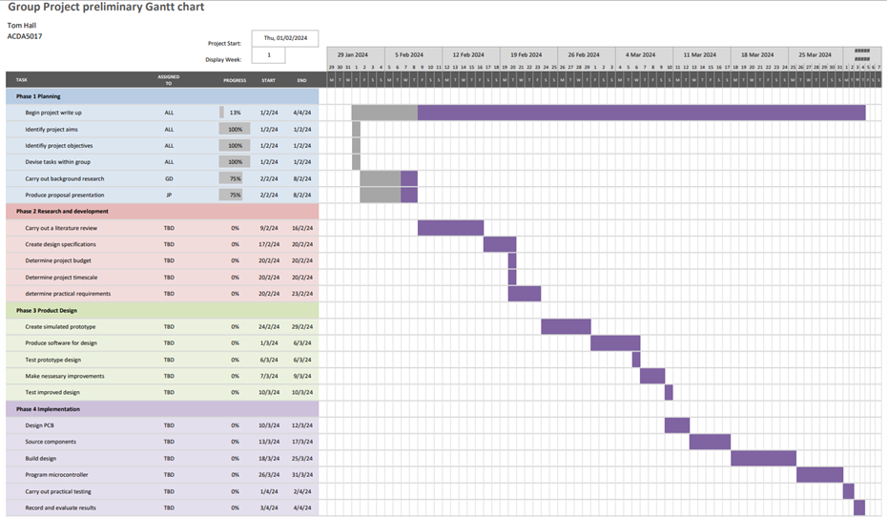
Figure 1 - Project Gantt Chart

Literature Review (TH, JP)

To ensure that electrical systems such as circuit breakers or control of outgoing circuits are safe for use by only authorised personnel, using a microcontroller and password authentication process with several measures can be implemented.
One approach is to integrate the microcontroller with a password authentication system that requires authorised personnel to input a unique password before accessing the electrical system or initiating different commands using password control. This can help prevent unauthorised individuals from operating the circuit breakers or outgoing circuits which could potentially be very dangerous if they are not trained to do so.
Additionally, the microcontroller can be programmed to monitor and log access attempts, providing a record of who has accessed the system and when. This can help track any unauthorised access and ensure accountability among authorised personnel.
Furthermore, another advantage could be using remote access capabilities through the microcontroller, this can allow authorised personnel to control the electrical system from a secure location, reducing the need for physical access and minimising potential risks.
By combining password authentication, access monitoring, and remote access capabilities within the design of the electrical system controlled by a microcontroller, it can be made safe for use by only authorised personnel.

Existing systems:

Currently in industry, to safeguard an electrical system the lockout procedure is implemented using a padlock and key as seen in figure 2 [1]. This type of system is most suited for maintenance.

Figure 2 - Circuit breaker lockout [1]
BTC college of engineering's department of electronics and communication has proposed a solution for improving security in operations. This wireless device generates a new passcode each time it is used, enhancing system security. The passcode is created by a microcontroller and sent to the engineer via text message. This solution offers increased security as the passcode is unique for every use of the system.
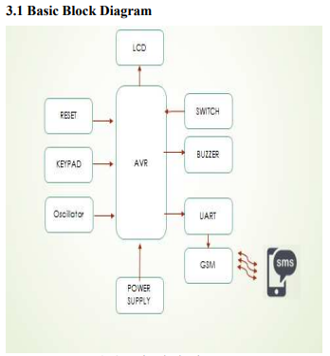
Figure 3 – Proposed BTC College System [25]

System Fundamentals (GD)

From the research conducted, five fundamental components have been identified for this project.

Microcontroller (MCU):

A microcontroller is a small integrated device that contains a processor core, memory, and programmable input/output peripherals. They are used to execute specific tasks within small electronic systems based on instruction stored within the memory.

3x4 Matrix Keypad:

A 3x4 matrix keypad uses a grid of twelve keys arranged into rows and columns. When a key is pressed, it creates a unique electrical connection between a row and a column pin, allowing a MCU to determine which key has been pressed.

Liquid Crystal Display (LCD):

A LCD is a flat panel display that uses liquid crystals to create images or text. It consists of a grid of small cells that can change their optical properties when an electric current is applied. This allows the display to show information by selectively blocking or allowing light to pass through each pixel.

Electrical Relays:

An electrical relay is a device that controls electricity in a circuit by opening or closing contacts in response to a signal. It consists of a coil that creates a magnetic field when energised, moving the contacts to open or close the circuit. Relays are often used to control high-power devices with low-power signals, like motors and lights.

Printed Circuit Board (PCB):

A PCB is a non-conductive board made of fiberglass that supports and connects electronic components with copper tracks etched onto it. It simplifies electrical circuits in electronic devices into a small, organised space.

Driver Circuits (TH)

A driver circuit is needed to power the relays for motor control. The MCU's low voltage output may not be strong enough to activate the relay, and higher voltage could harm the MCU. The driver circuit solves these issues. [2] [3] [4].
Relay driver circuitry uses a NPN transistor with the collector connected in series with the relay and the emitter connected to ground. The transistor base is energised by the MCU output, allowing current flow through the relay to ground, energising the coil. A diode is connected in parallel with the relay in figures 4, to prevent voltage spikes from damaging the transistor. A resistor on the transistor base is also necessary to limit current and prevent damage [3] [4].
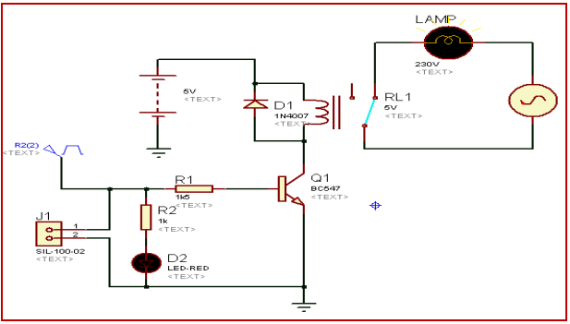
Figure 4 - Relay driver circuit [4]

Component Selection (JP)

Driver Circuit:

The components listed below have been selected to create a driver for both the relay and buzzer circuits. Included in the driver circuit is a diode, transistor, and a relay.
Figure 5 below shows the chosen relay for this project. A 24V relay was chosen to suit the required high voltage switching capacity.
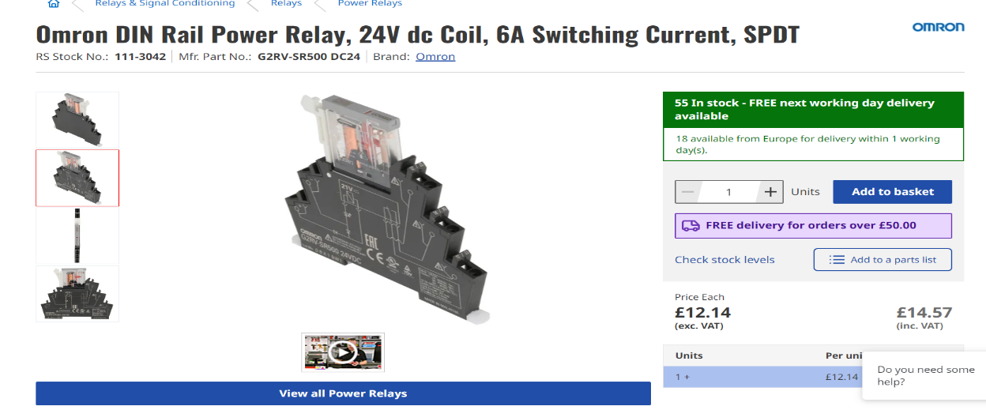
Figure 5 - 24V Relay [34]

The chosen diode was selected due to its capability of being conductive at 300mA which was compatible with the relay load current when cross referenced with the datasheet.
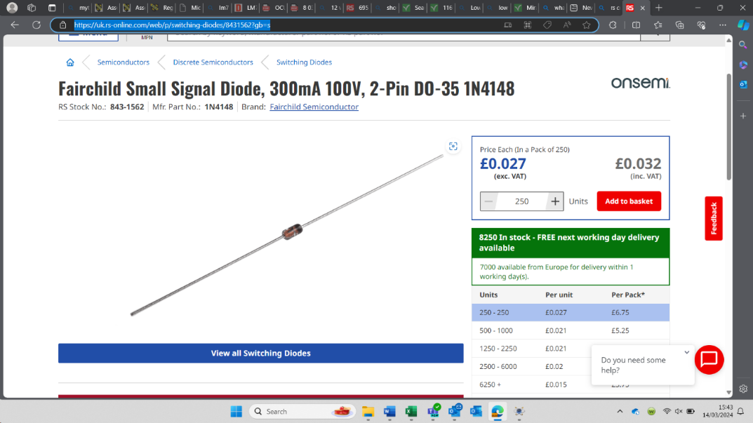

Figure 6 - 24V Relay [33]

For the required NPN transistor highlighted in the driver circuit research, a BC547B-ML model was selected due to its compatibility with the other components.

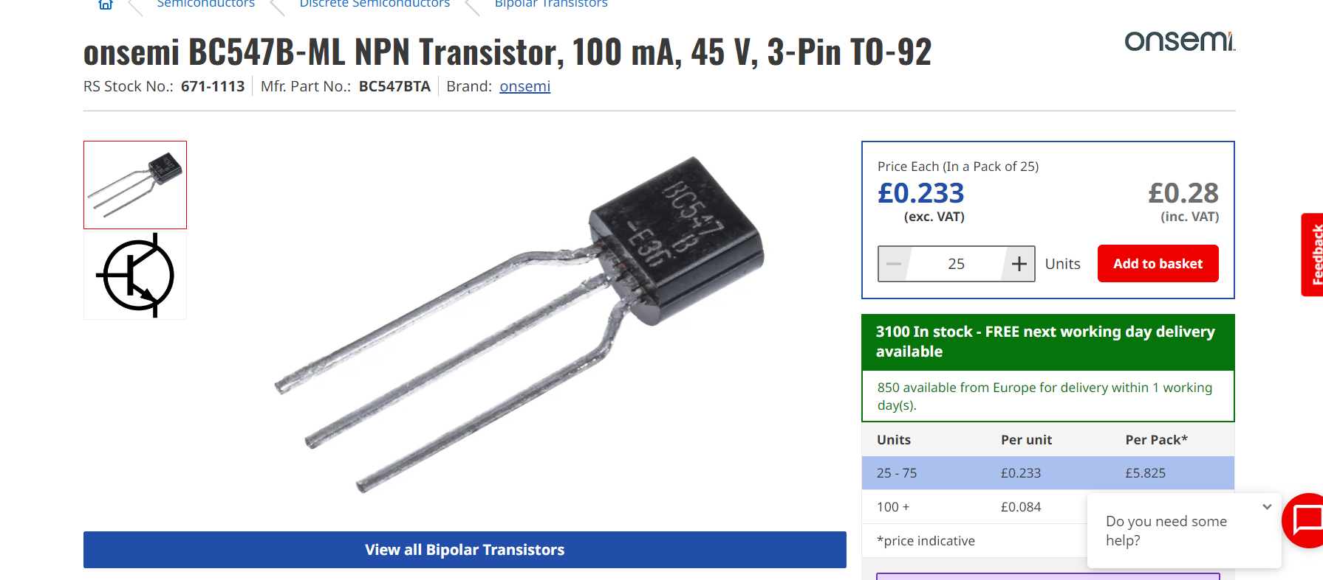
Figure 7 - NPN Transistor [5]

LCD Selection

This LCD screen was chosen due to its specification meeting the requirements the screen will need to display when the circuit has been put on and off, the screen will need to be able to illustrate statements such as “circuit 1 is on” or “wrong password”. The 16x2 LCD screen would meet the requirements needed.

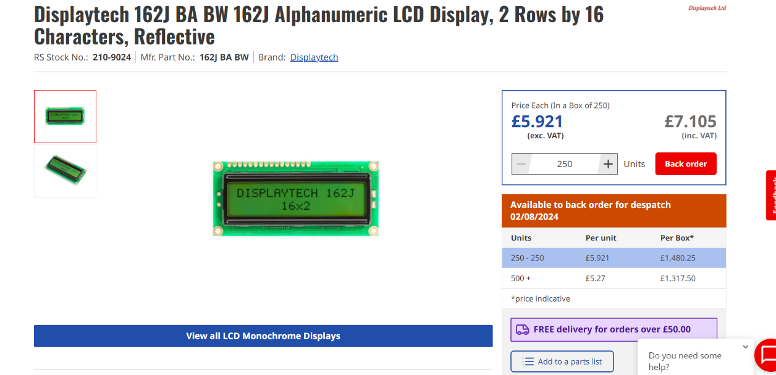

Figure 8 - LCD [35]

Buzzer Selection

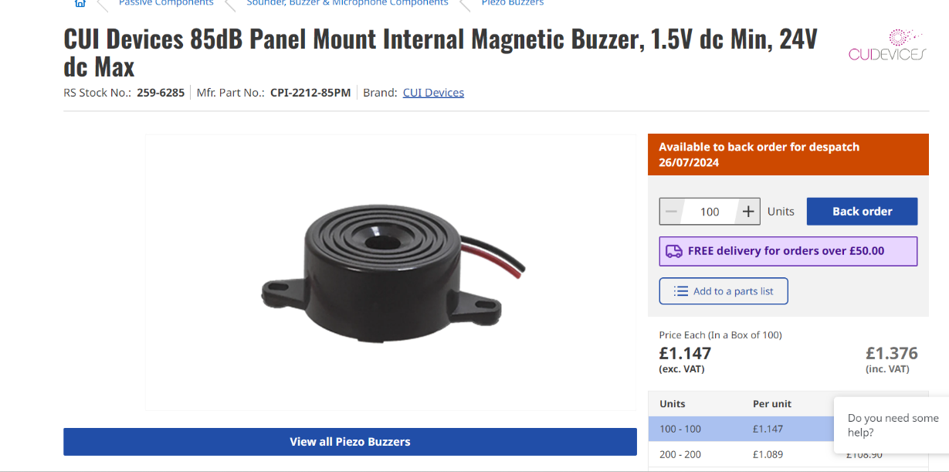
The buzzer presented below was picked since it can be controlled from the MCU via the driver circuit and is compatible with the voltage source. It will sound when the keypad is entered with a wrong password.
Figure 9 - Buzzer [4]

Keypad Selection

The keypad below was chosen due to the availability of numbers, this will aid in complex passwords being used to ensure a safer authentication process. The 3x4 keypad is also compatible with the MCU with no additional circuitry needed.
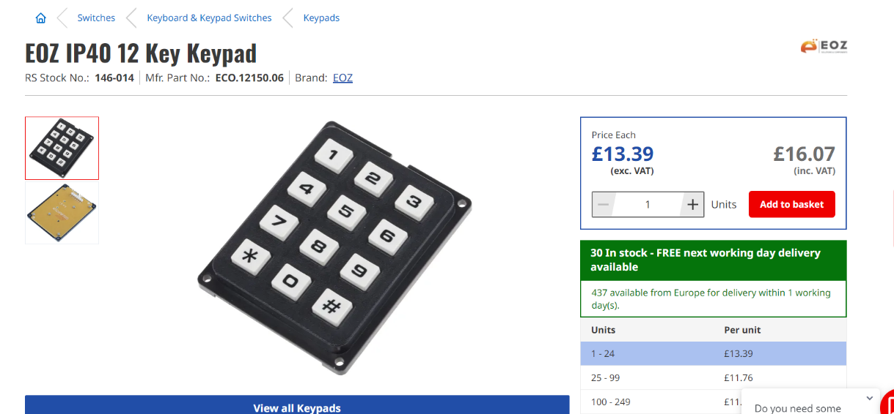
Figure 10 - 3x4 Keypad Matrix [37]

Indicator selection

These LEDs have been selected for their ability to be panel mounted and meet ingress protection (IP) standards. These will be installed at the front of the panel. They will indicate to the user when the relays have been activated and a circuit is operational.
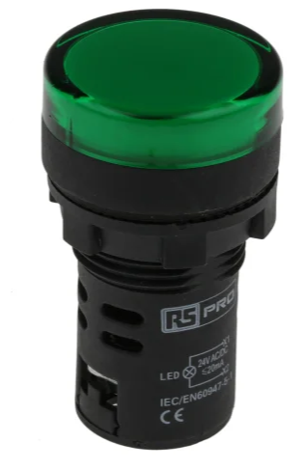
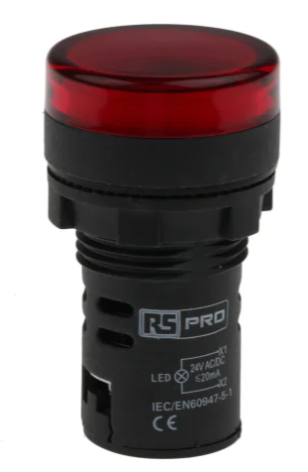
Figure 11 - Panel LEDs [38] [39]

Voltage Regulator

The 7805-voltage regulator shown in figure 12 was selected as it reduces the 24V supply voltage down to the required 5V for MCU operation.
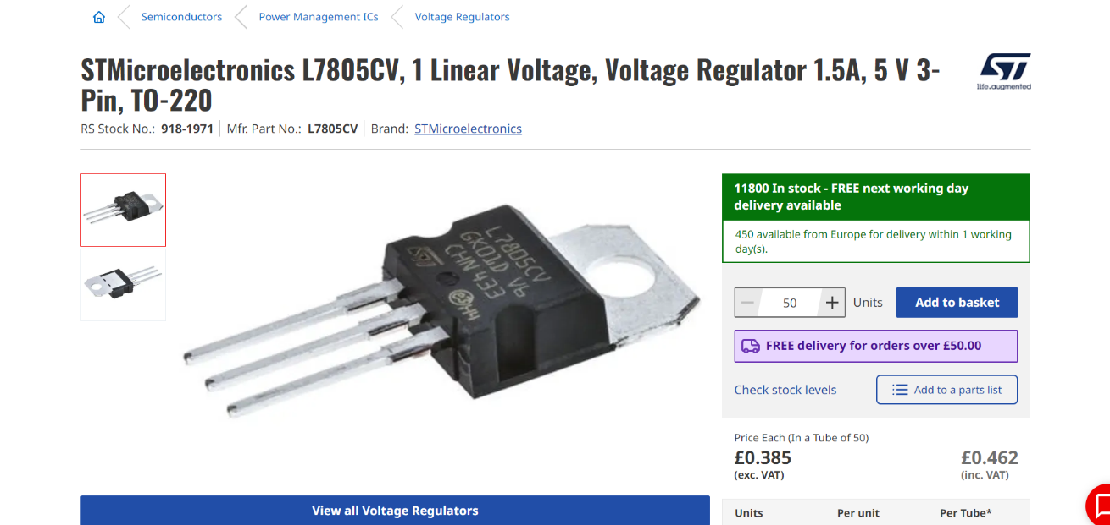
Figure 12 - 7805 Voltage Regulator

Connector Selection

All of the connectors selected are utilised for outgoing circuits, including the buzzer circuit, relay circuits, power supply for the MCU, keypad, and LCD screen.
Molex wire-to-board connectors are electrical connectors designed to establish a connection between a wire harness and a PCB. These connectors typically consist of a male header with pins on one end and a female receptacle with sockets on the other end. The male header is soldered onto the PCB, while the wire harness is crimped or soldered onto the female receptacle.
Molex wire-to-board connectors come in various configurations, including different numbers of pins or sockets. The specific connector chosen for this project are shown in table 1 below.

Molex Product | Connector | Component
22-05-7028  2 Pin Male Connector  [6] | Power | 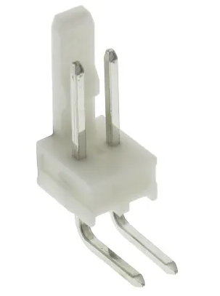
679-5363  2 Pin Female Housing  [7] | Power | 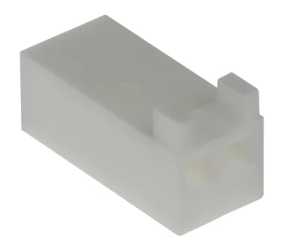
22-27-2031  3 Pin Male Connector  [8] | Relay Circuitry | 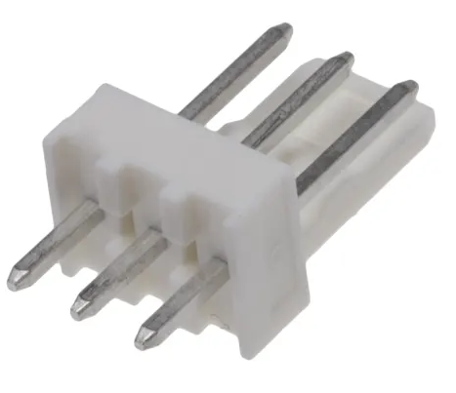
22-01-3037  3 Pin Female Housing  [9] | Relay Circuitry | 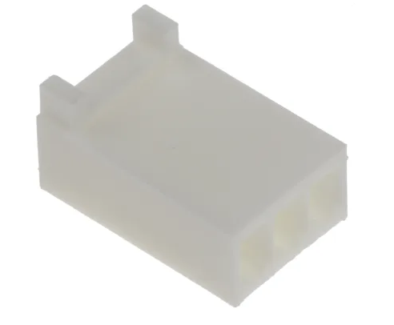
22-27-2071  7 Pin Male Connector  [10] | Matrix Keypad | 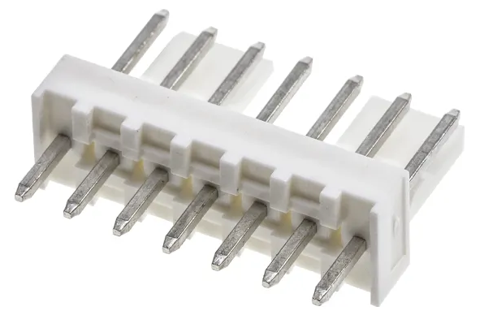
22-01-3077  7 Pin Female Housing  [11] | Matrix Keypad | 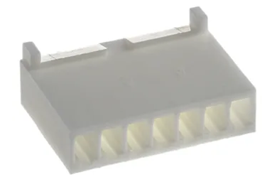
22-27-2141  Male Strip Pin Connector  [12] | LCD | 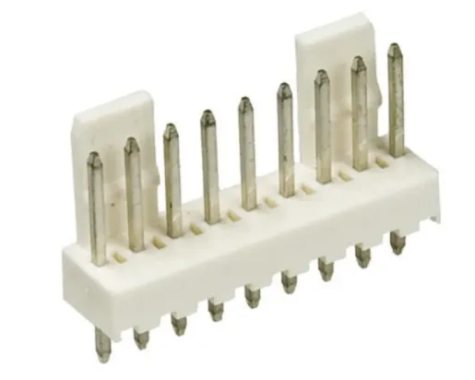
33-00-1335  Female Strip Pin Housing  [13] | LCD | 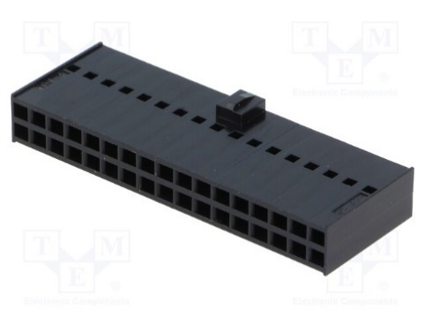
08-50-0032  Crimps Terminals  [14] | All Connectors | 

Table 1 - Molex Connector Selection

Microcontroller Selection

The below table provides a summary of the total number of pins that will be required by the MCU.

Component | No. Of Pins | No of Units | Pin Count
Driver Circuit | 1 | 4 | 4
Matrix Keypad | 7 | 1 | 7
LCD | 7 | 1 | 7
VCC | 1 | 1 | 1
GND | 1 | 1 | 1
 |  | Total Pin Count = | 20

Table 2 - Total MCU Pin Count

The chosen MCU will be required to contain the following specifications:

- Minimum of 20 pin count
- Internal Oscillator
- 4 Pins with available pull up resistors
- Operation Voltage to be max 5.5V
- C Compiler architecture
- 256 Byte RAM
- Communication methods available
- Bi-directional ability
- Ability for code to be rewritten for future upgrades or updates.
From these specifications, the PIC18F4450 [15] was selected for this project.

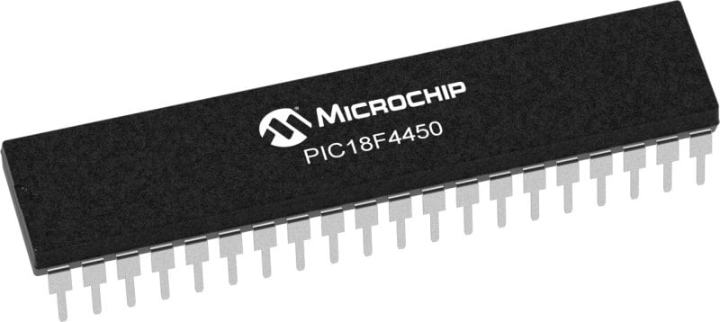
Figure 13 - PIC18F4450 [15]

Circuit Simulation (GD)

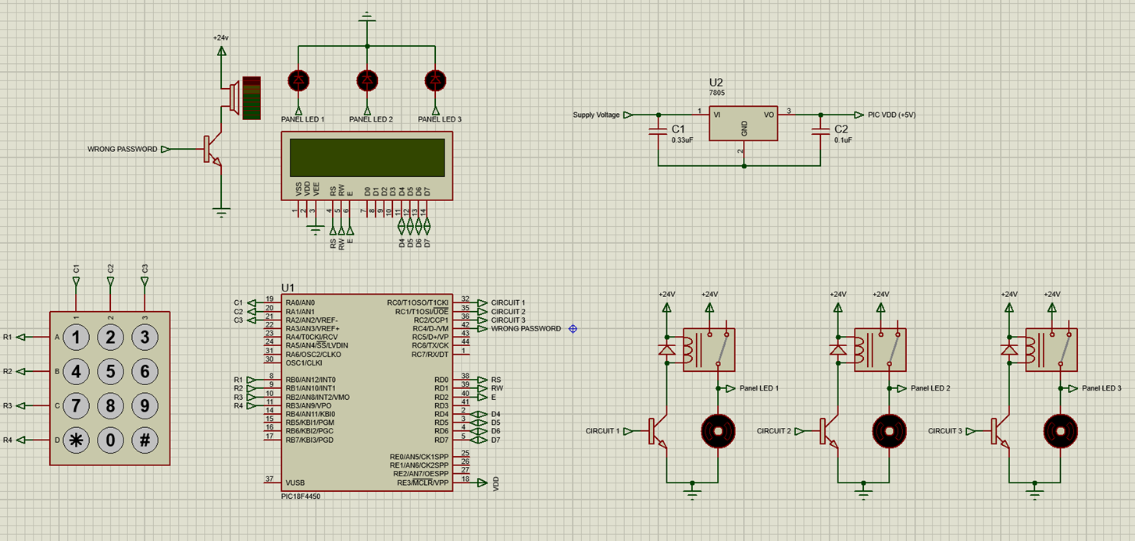
Using the components selected and research conducted for this project, the circuit simulation shown in figure 14 was created via Proteus software.
Figure 14 - Circuit Proteus Simulation

System Operational Flowchart (JP)
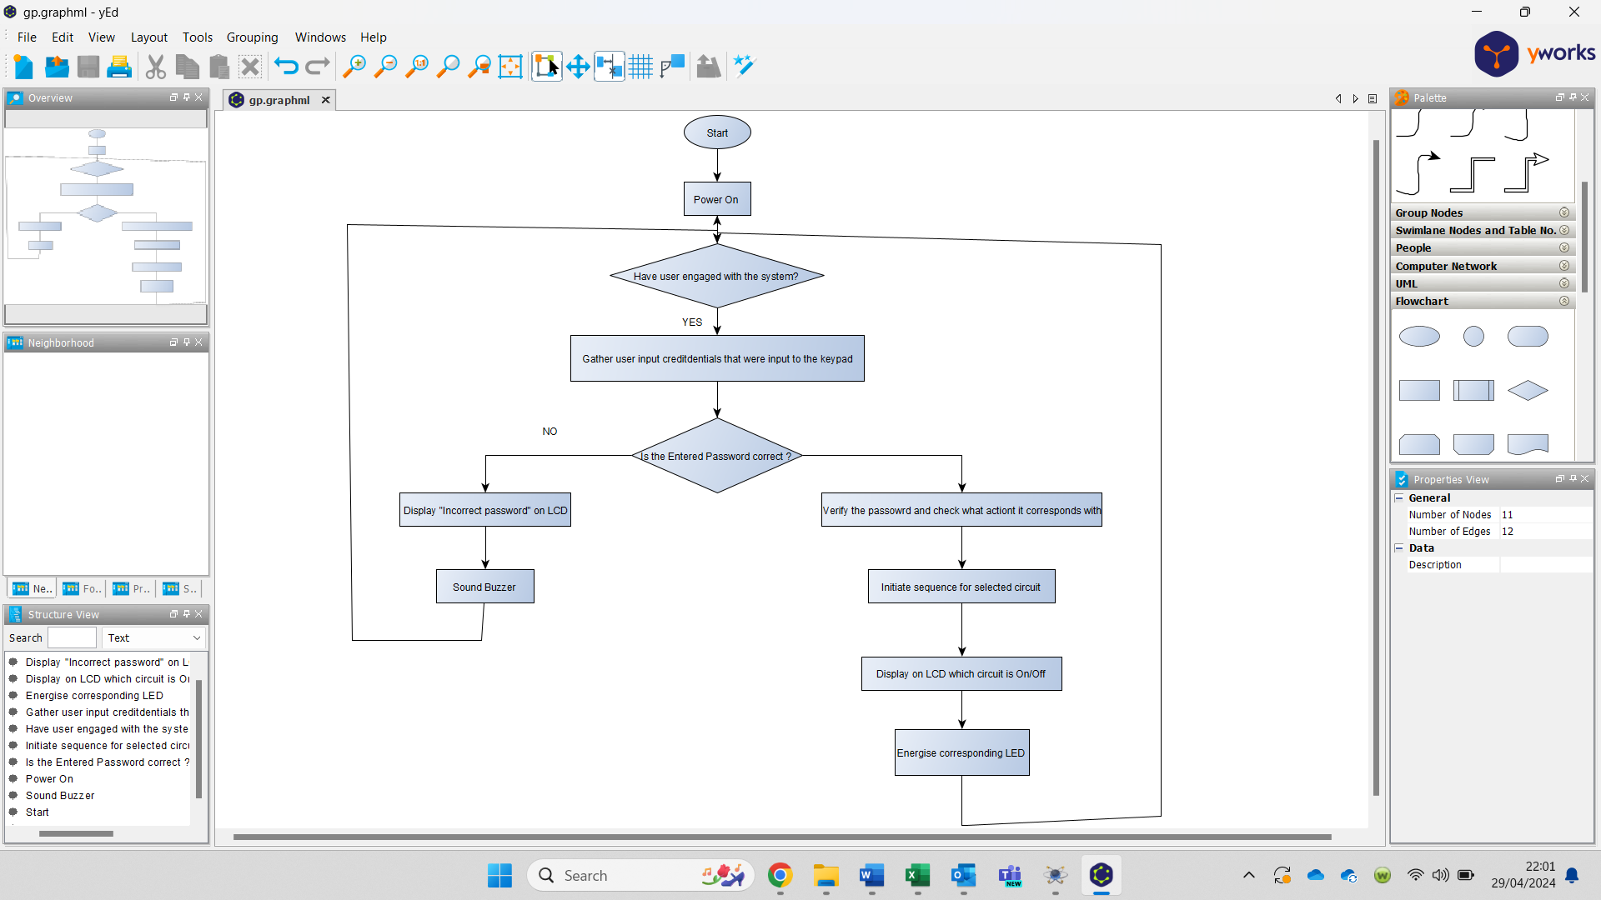
Figure 15 - System Operational Flowchart

Easy-PC Component Design (TH)

Following the initial circuit design by Gareth Davies, a PCB design was required. To create the schematic diagram, the required components had to be designed. The schematic symbol and PCB symbol for the MCU were designed to match the dimensions and pinouts found in the datasheet [16]. The component design for the PIC18F4450 can be seen in figure 16.
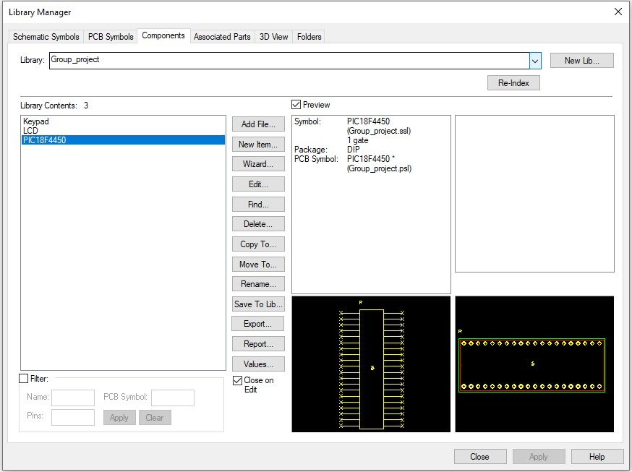
Figure 16 - PIC18F4450 PCB Component Design

Most of the standard components were already available in the Easy-PC library. Connectors were designed for the LCD and the keypad. The connectors were designed based on Molex KK connector spacing and pinouts were determined from the relevant data sheets [17] [18] [19]. Figures 17 and 18 show the keypad and LCD connector design.

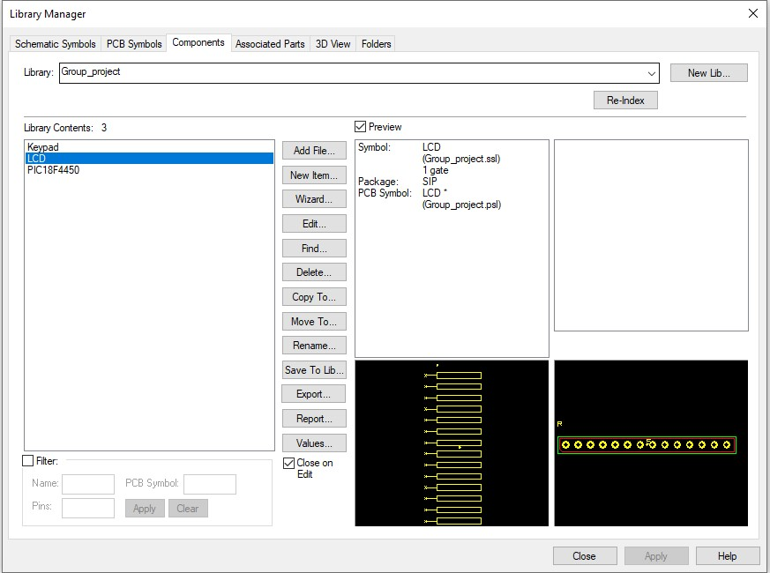
Figure 17 - LCD Component Design
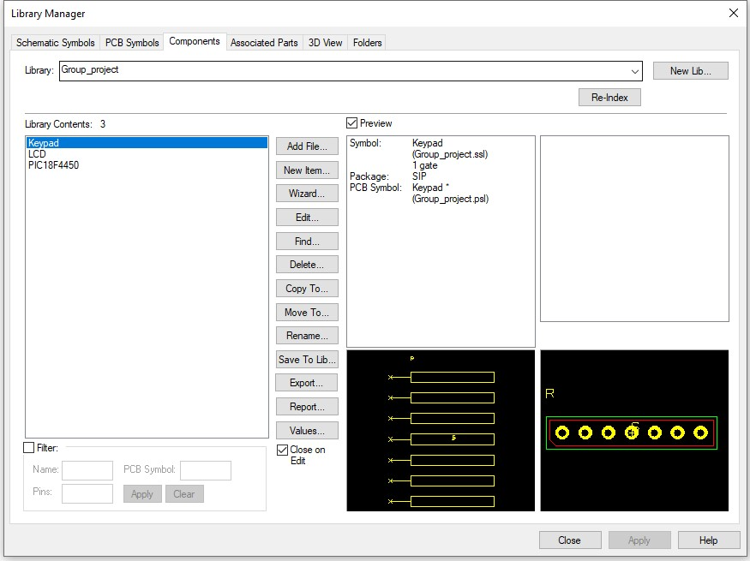
Figure 18 - Keypad Component Design

PCB Schematic Design (TH)

Once the components had been designed, the circuit schematic was created. Following the original circuit design, connections were made using nets linked utilising to and from pins. Figure 19 shows the schematic for the power supply. Capacitors were added to the voltage regulator as recommended in the datasheet [20]. The input supply is given by a two-pin connector.
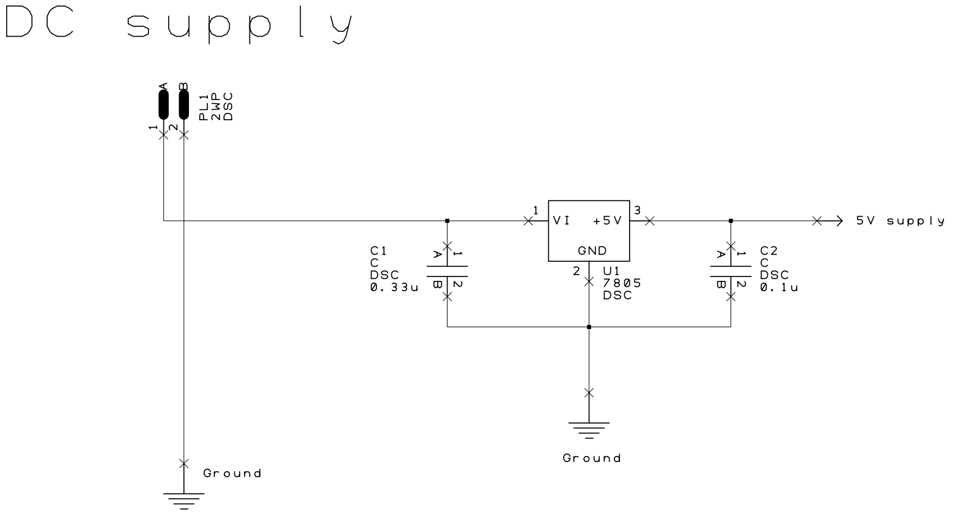
Figure 19 - Voltage Regulator Schematic

The MCU was connected as recommended in the datasheet, with inputs and outputs following the original circuit design. This can be seen in figure 20. The labeled outputs and inputs are connected to the connector as shown in figures 21 and 22.
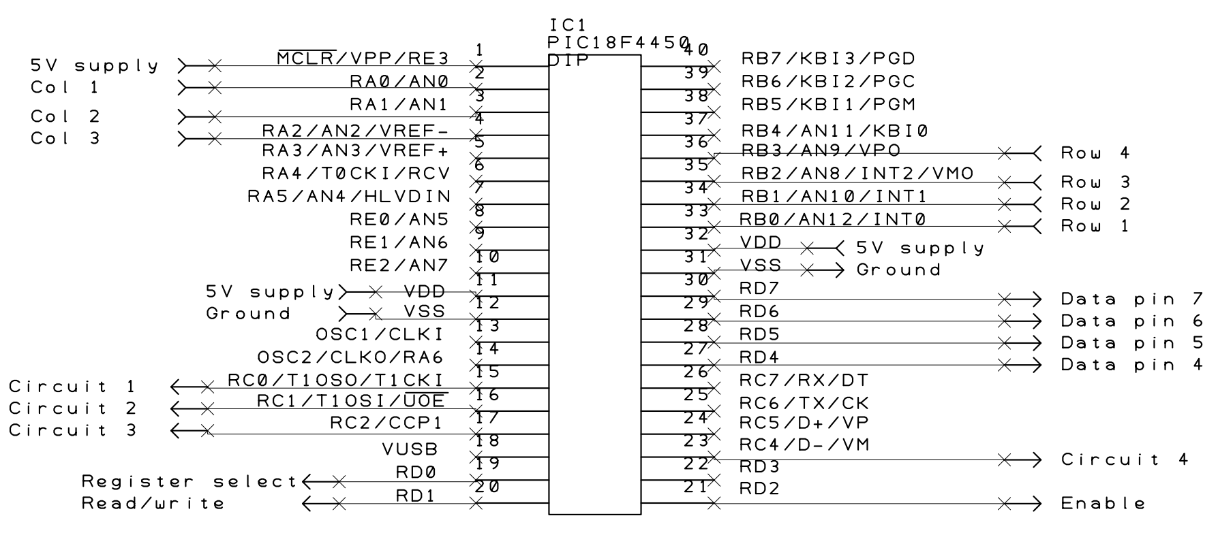
Figure 20 - MCU Schematic
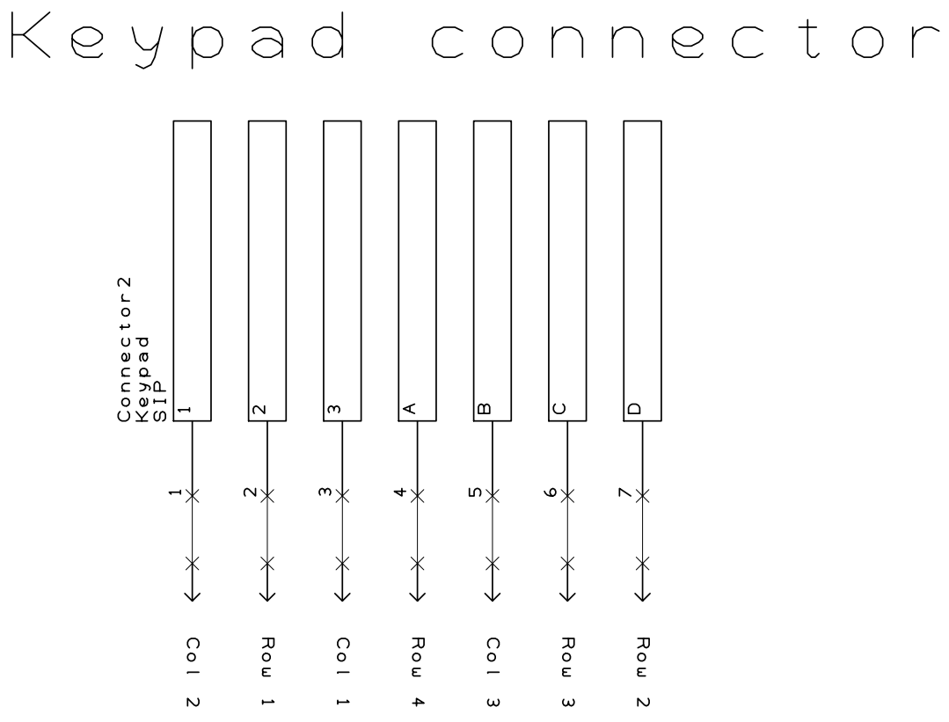
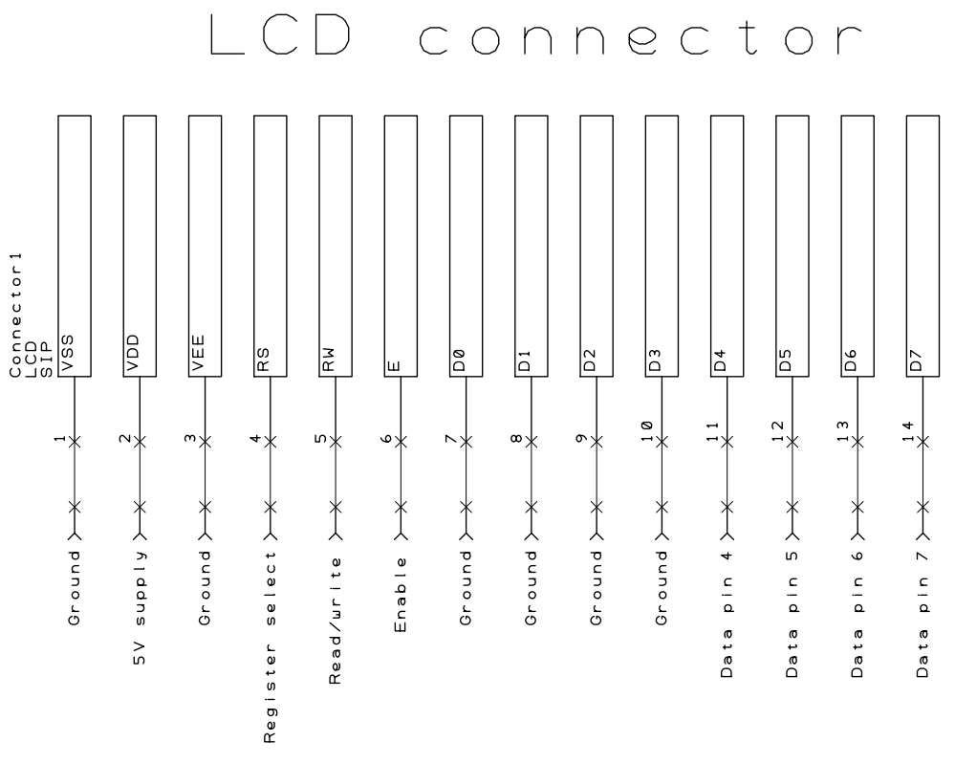
Figure 21 - Keypad Connector Schematic
Figure 22 - LCD Connector Schematic
The MCU outputs to the relay driver circuits as shown in figure 23. Each relay, together with the buzzer, is connected to a standard PCB connector.

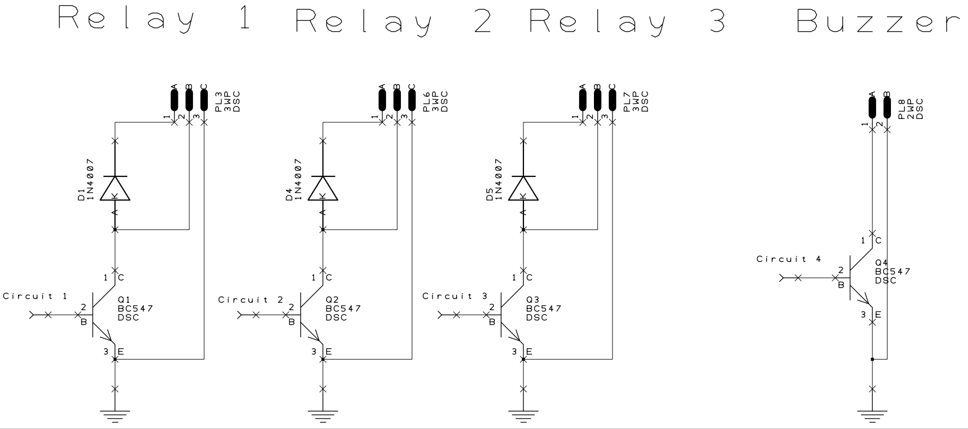
Figure 23 - Relay and Buzzer Schematic

Before finalising the PCB design, it was decided that the device program and simulation testing should first be completed. This will ensure the initial circuit deisgn opperates correctly and that no modifications to the PCB schematic are required.

Microcontroller Program Setup (GD)

With the PIC18F4450 selected as the required microcontroller, CCS complier can be used to set-up the program files for this project. Working through the Project Wizard tab of this software, the user is able to define several key aspects of the microcontroller such as clock frequency, PIN allocations and communication protocols.
For this project, the following features were selected:
- Clock Frequency:
A microcontroller's clock frequency determines its processing speed. Incorrect clock settings can cause timing errors, peripheral malfunctions, and system crashes. It's crucial to set the code at the right frequency for proper operation. Per the datasheet [15], the PIC18F4450's internal clock ranges from 4 to 40MHz. The clock was therefore set to an 8MHz internal oscillator as shown in figure 24.

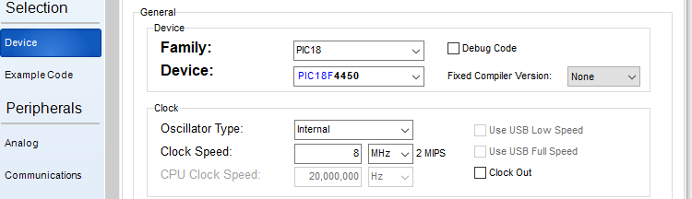
Figure 24 - Clock Frequency Definition

- Test Code:
When setting up a microcontroller, test code should be used to confirm correct configuration by blinking a defined LED pin at a specified rate, ensuring proper communication without timing issues.

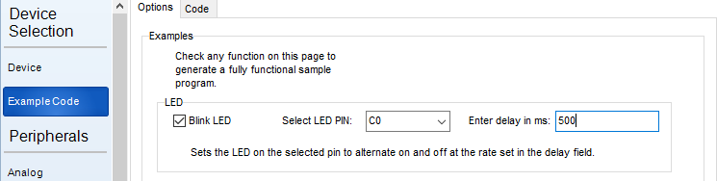
Figure 25 - Test Code Set-Up

- Pull-Up Resistors:
Pull-up resistors are needed for the 3x4 matrix keypad to set row pins to high. Column pins are sequentially set low in the code routine. Pressing a button sends low logic through the matrix, setting the corresponding row pin to low. By reading the two low logic pins, the microcontroller can identify the pressed button.
Figure 26 below highlights this operation when button 7 is pressed.
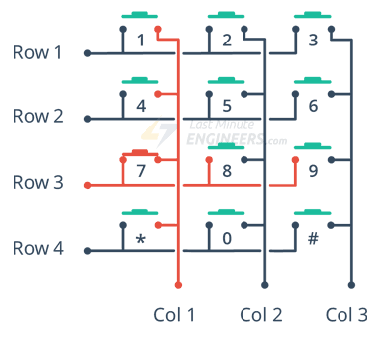

Figure 26 – 3x4 Matrix Keypad Internal Connections [23]

To reduce components and PCB size, microcontrollers can use internal pull-up resistors on specific ports. In this project, Port B will be forced high for the row output signals.

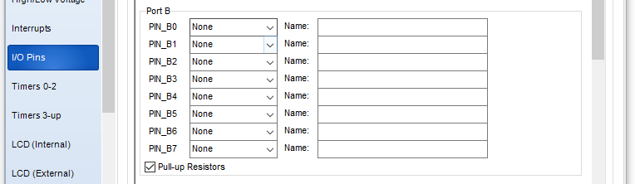
Figure 27 – Port B Pull-Up Resistors

- LCD PIN Allocations:
In the circuit simulation shown in figure 14, the LCD pins are connected to unique microcontroller pins. CCS compiler lets users define these connections during setup, generating a driver file for automating LCD operation in the program.
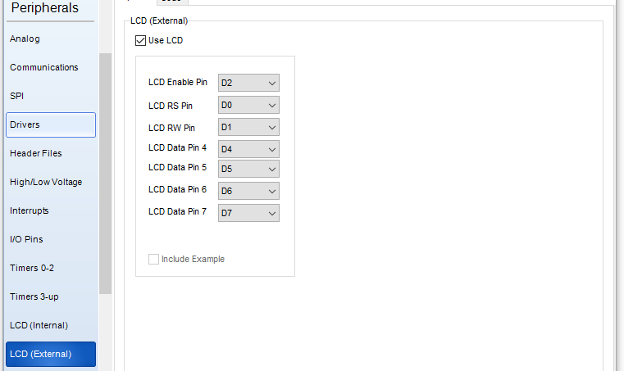
Figure 28 - LCD Pin Allocations

- Fuses:
Fuses are special memory registers that control various hardware configurations of the microcontroller. For this project, fuses were included to enable a power up timer and brownout reset. The Master Clear pin was also disabled reducing component requirement for the final design.

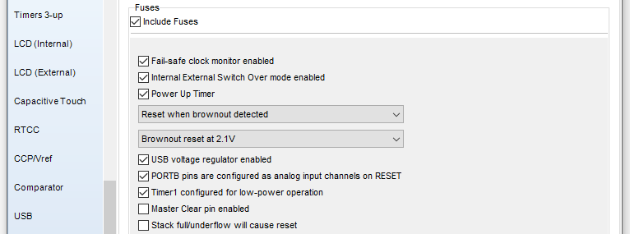
Figure 29 - Defining MCU Fuses

Microcontroller Setup Test:

After configuring the microcontroller, CCS creates a ‘main.c’ and ‘main.h’ file for the project.
‘Main.c’ houses the main function, acting as the program's entry point and coordinating its flow. ‘Main.h’ is a header file that declares functions, variables, and other information, organising and sharing common elements among source files [21].
These files are then inserted into the Proteus microcontroller files producing the basic program definition shown in figure 30.

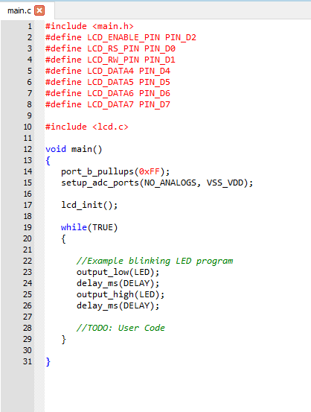
Figure 30 - Initial Test Program

This code was then used to run a Proteus simulation as shown in figure 28, confirming the microcontroller setup. Port B stayed high, validating pull-up resistor settings. Pin C0 flashed every 500ms without delay, indicating proper communication.

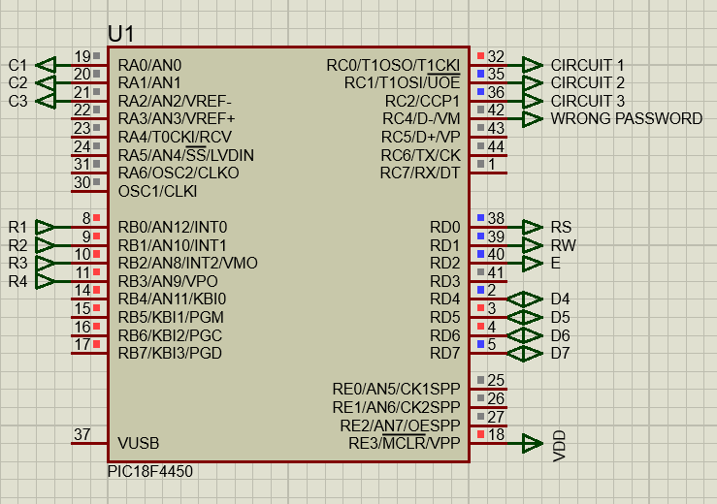
Figure 31 - Test Code Simulation

Keypad Interfacing (GD)

After setting up the microcontroller and LCD for programming, the final component to address was the keypad. Despite initially using a CCS driver file, various issues arose during testing.
Even after assigning all microcontroller pins to the keypad pins, the simulation could not detect buttons being pressed. Initially, it was suspected that the pull-up resistors on port B were interfering with the keypad driver. However, upon reviewing the driver file, it was noted that it requires row pins to be pulled high as depicted in the figure 32.

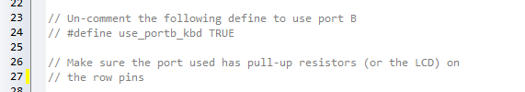
Figure 32 - Keypad Driver File Pull-Up Definition

During the next week, extensive research was conducted into interfacing a 3x4 keypad, testing various keypad drivers without success. After hours of consulting the CCS forums for solutions, the decision was made to seek help from university lecturers the following week.

Keypad Interfacing – Rectification (GD)

After consulting university lecturers, it was found that the keypad driver files may be outdated or not compatible with the chosen microcontroller and keypad. Two options were discussed:

- Redesign the circuit using a different microcontroller.
- Define the keypad operation manually in the program.

The group chose to manually define the keypad, as much progress had been made with the PIC18F4450.

Programming the Keypad:

To interface the keypad, the column and row pins were defined to their respective microcontroller pins using code shown in figure 33.

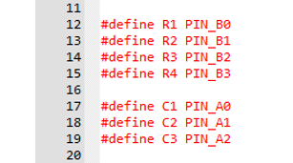
Figure 33 - Defining Keypad Pins

The keypad works by sequentially setting one column pin low at a time. When a button is pressed the corresponding row pin will also be set low allowing the specific button to be defined. This is then displayed on the LCD. The code shown in figure 34 accomplishes this.

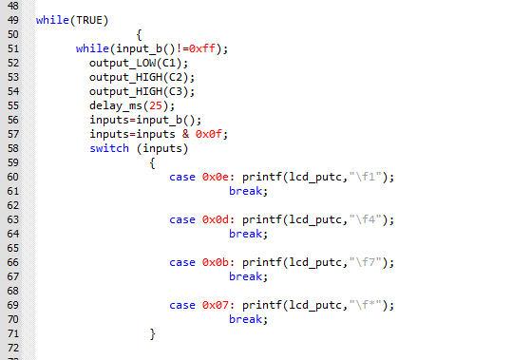
Figure 34 - Basic Keypad to LCD Routine

This code utilises hexadecimal switch cases to identify the pressed button using four bits. When a button is pressed, one of these bits will be set to low. Table 3 maps the button to the corresponding hexadecimal and binary value.

Button Press | Binary Value | Hexadecimal Value
1 | 1110 | 0x0e
4 | 1101 | 0x0d
7 | 1011 | 0x0b
* | 0111 | 0x07
Table 3 – Hexadecimal Case References

To eliminate unwanted signals, hexadecimal value 0x0f shall be used as a mask.
When a button is pressed, the routine for one of four cases will now be carried out. To test keypad operation, a simple ‘printf’ statement to the LCD is used. This result can be seen in figure 35 Showing successful interfacing of the keypad to LCD.

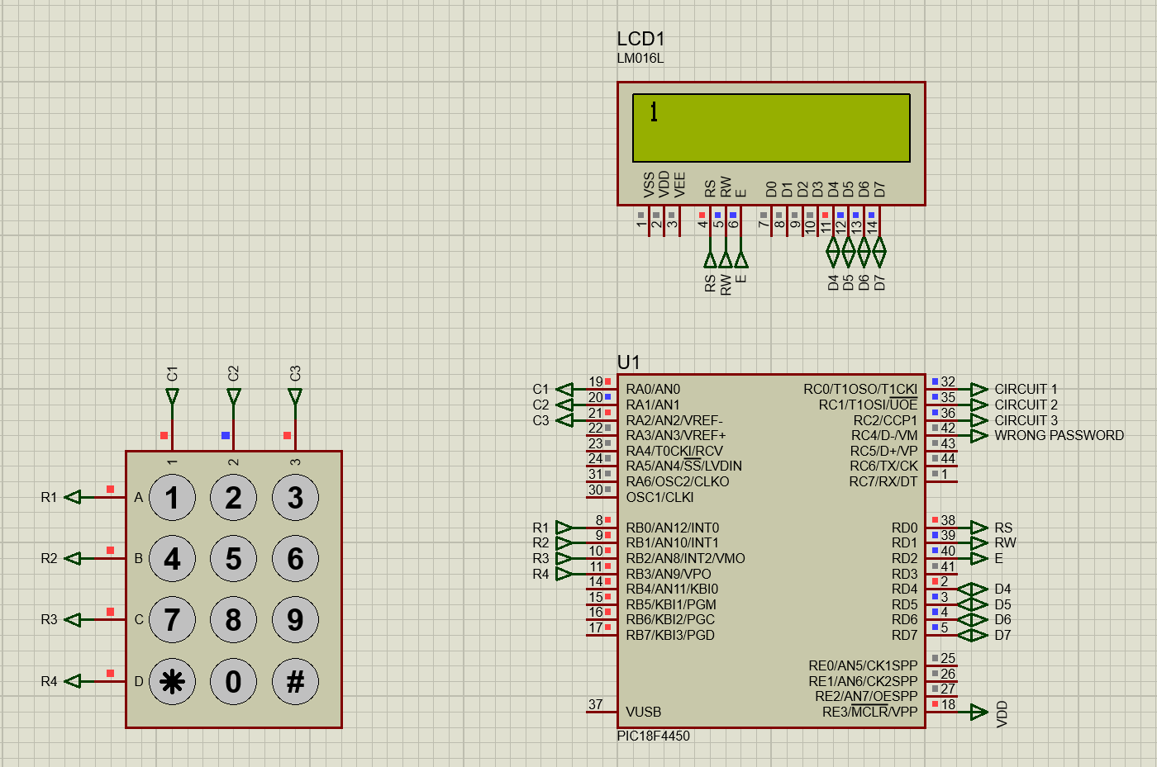
Figure 35 - Keypad to LCD Interfacing

After successfully interfacing the first keypad column to the LCD, the program was written for columns two and three as shown below in figure 36.

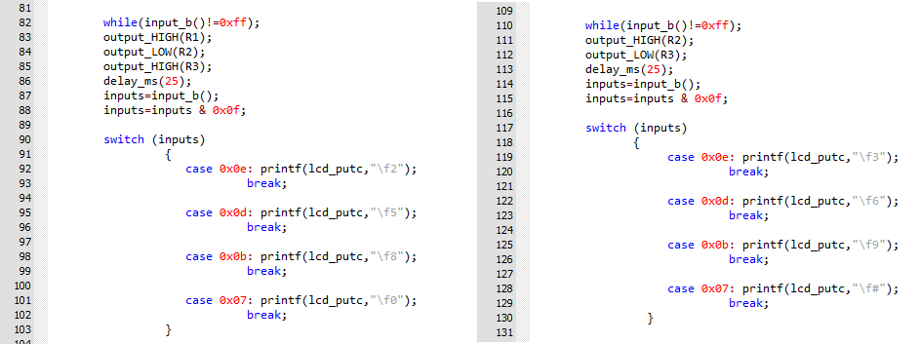
Figure 36 - Keypad to LCD Routines for Columns 2 & 3

Password Array (GD)

Password arrays shall be integrated into this code in order to securely control specified circuits. A password array is a collection of variables that when entered in sequence, will grant access to additional information or operations. Password arrays should be defined prior to the main program loop as shown in figure 37.
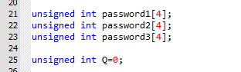
Figure 37 - Defining Password Arrays

In order to write to these password arrays, an unsigned integer ‘Q’ is used. When a button is pressed, its value is written to ‘Q’ at a specified position in the password array. The ‘Q’ variable is then incremented using ‘Q++’ to move to the next position in the array. The code for this is shown in the updated case routines below.

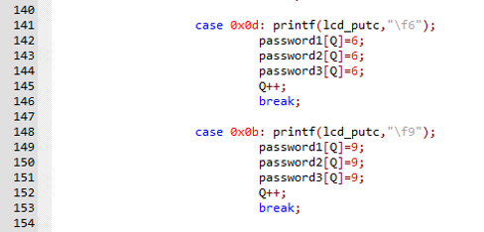
Figure 38 - Password Array Integration to Switch Cases

With the password arrays defined, their function can be written into the program as shown in figure 39.
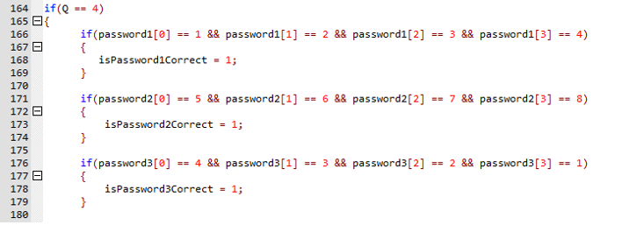
Figure 39 - Password Array Routine

This code checks that four vaiables have been entered into the password ararys before entering the routine. It then checks the variables to the three password arrays. If a correct password sequence is found, a designated flag will be set high. This flag will then be used for circuit control.
Table 4 shows the given passwords.
Table 4 – Default Circuit Passwords
Chosen Passwords
Password1 | 1234
Password2 | 5678
Password3 | 4321

Circuit Control Routines (GD)

The last section of code for this project controls the output to connected circuits. This will be achieved using several ‘if’ statements that will only enter routine if a corresponding password array flag has been set.

Correct Password Routine:

To distinguish between whether a circuit needs to be turned on or off, variables A, B and C have been defined for circuits one through three respectively.
Initially, these variables will be set low, indicating that all circuits are off. When a correct password is entered and a variable is low, a routine will be entered to turn a circuit on and set the variable high. Conversely, if a correct password is entered and a variable is already high, a separate routine is entered to turn the circuit off and reset the variable low.
Figure 40 below shows the program written for this task.
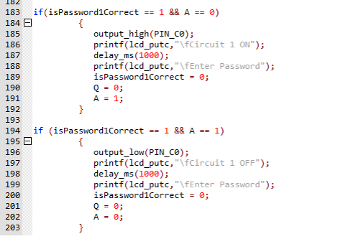
Figure 40 - Circuit 1 Password Control

This routine not only controls circuit operation but also sends user information to the LCD. After entering the correct password, a message will display the circuit's operating state on the LCD. The message will disappear after one second, prompting the user to “Enter Password”. At the end of each routine, the password flags and array integers are reset, requiring new password entry before control routines can be accessed again.
These routines were then also applied to circuits two and three with corresponding password flags and variables shown in 41.
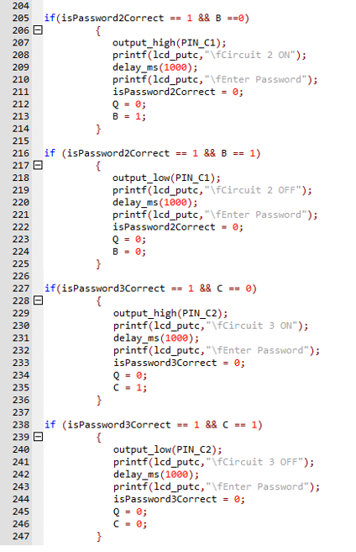
Figure 41 - Password Control Circuits 2 & 3

Incorrect Password Routine:

A routine was created to display a message on the LCD and sound a buzzer for two seconds when an incorrect password is entered. The buzzer is driven via pin RC4 of the microcontroller as see program in figure 42.
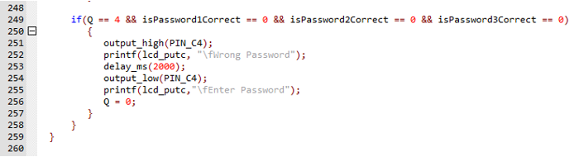
Figure 42 - Incorrect Password Routine
A fully notarised version of the program written for this project can be found in the appendix of this report.

Program Simulation Testing (GD)

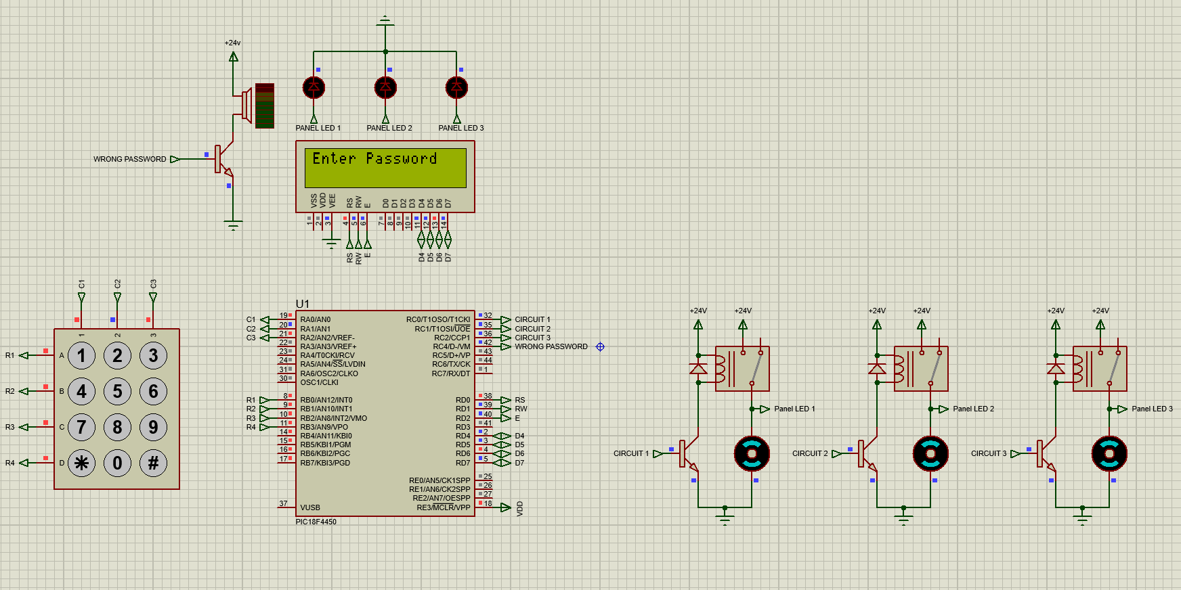
With the program written, a functional test of the circuit simulation could be conducted. The figures below highlight the system operating as intended without timing or interfacing errors.
Figure 43 – Simulation: Start-Up

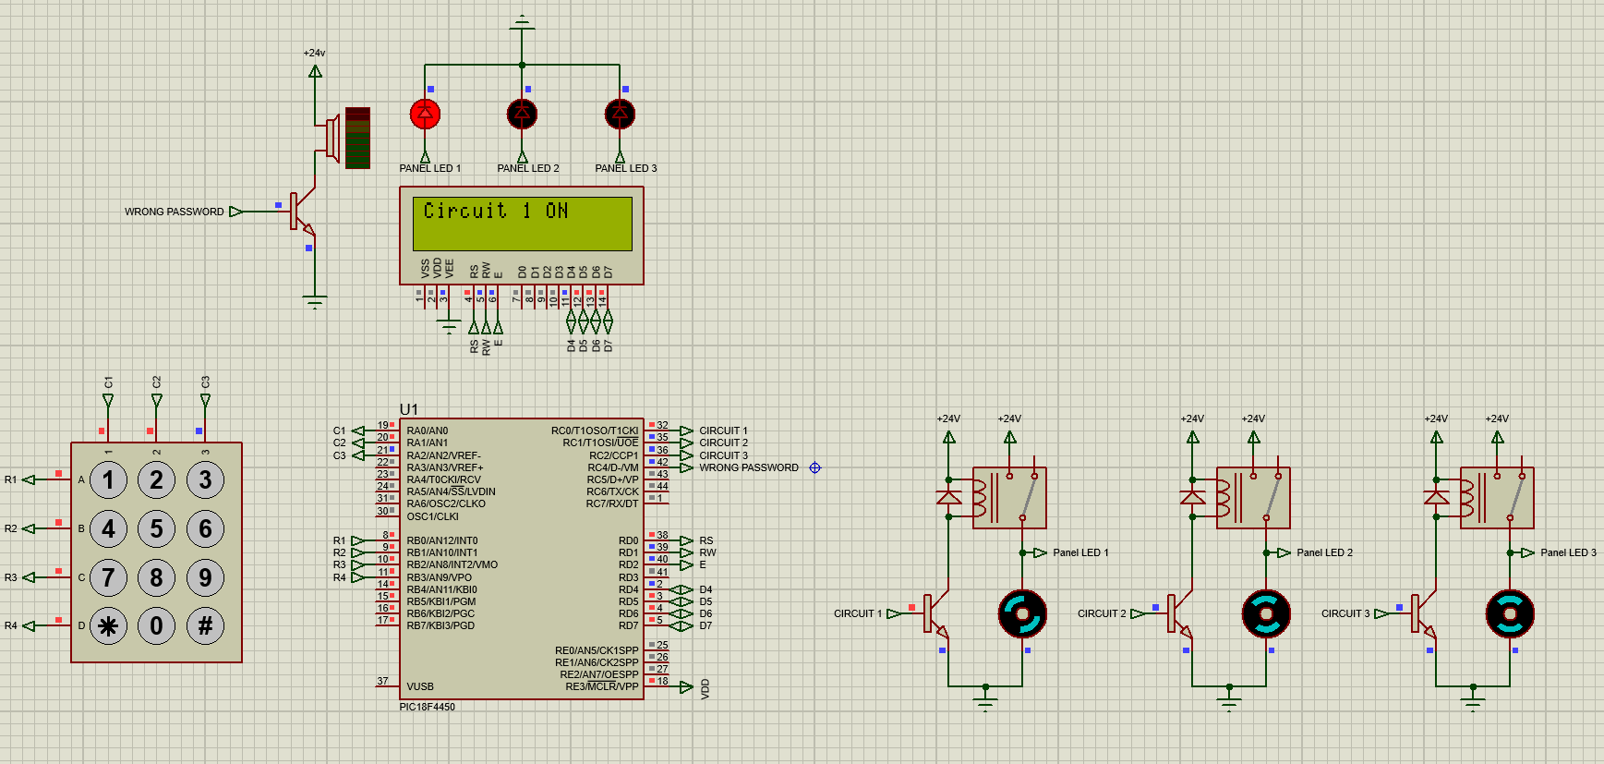
Figure 44 – Simulation: Circuit 1 ON

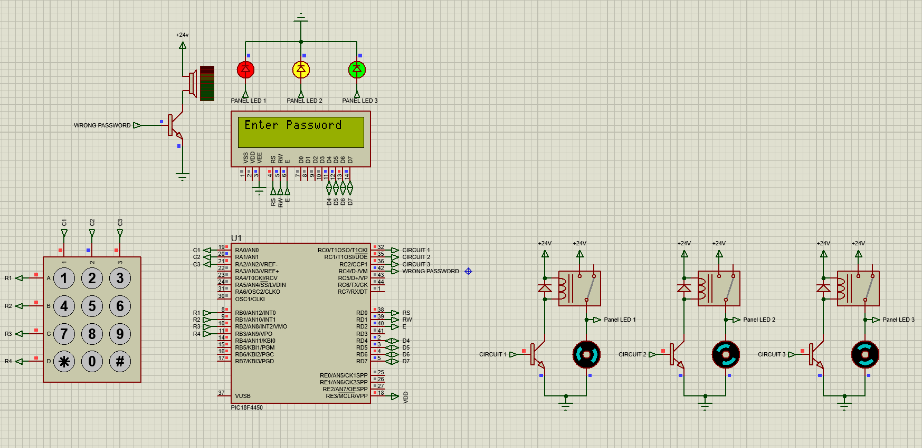
Figure 45 – Simulation: All Circuits ON
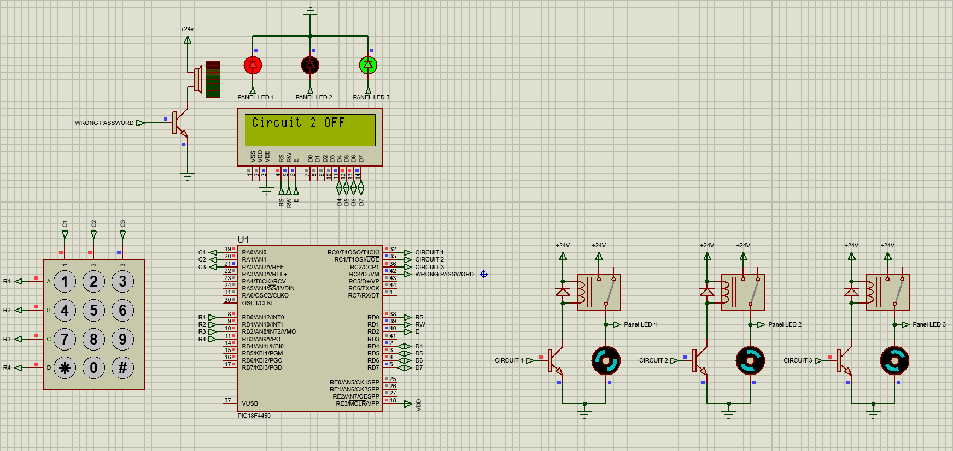
Figure 46 – Simulation: Circuit 2 OFF

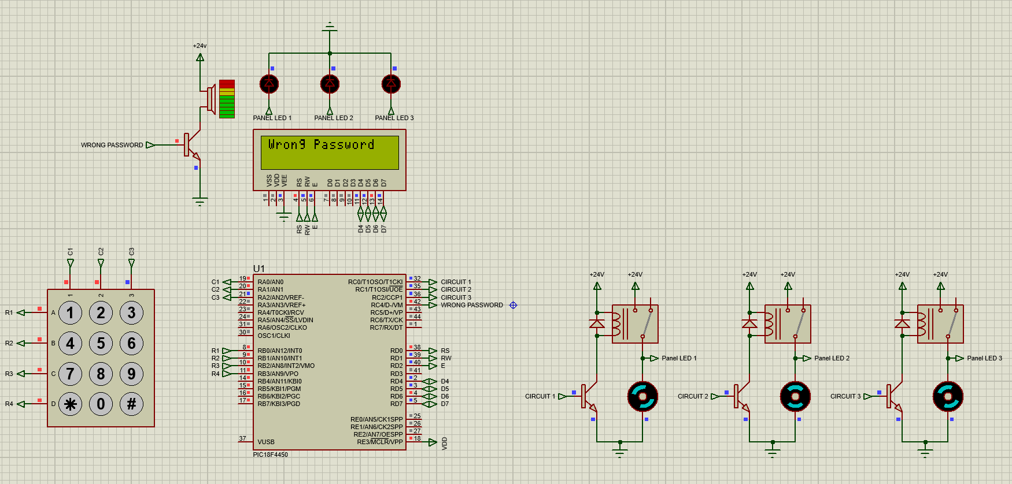
Figure 47 – Simulation: Incorrect Password

Final PCB Design (TH)

With the circuit simulation and program operating as required, the PCB could now be finalised.
From the Easy-PC schematic, the PCB design was constructed. All nets created on the schematic were joined as routed tracks on the PCB. The designed PCB can be seen in figure 48.
The power supply and relay connectors were positioned to the left of the board. This ensures that connecting cables will not be routed over the PCB, making connection to the relays easier. The LCD connector was placed at the bottom edge of the board, the keypad connector was positioned to the right of the board. Having each connector positioned on a different edge of the board ensures the wiring will be neat on the final prototype. It also makes installing the connectors straightforward.
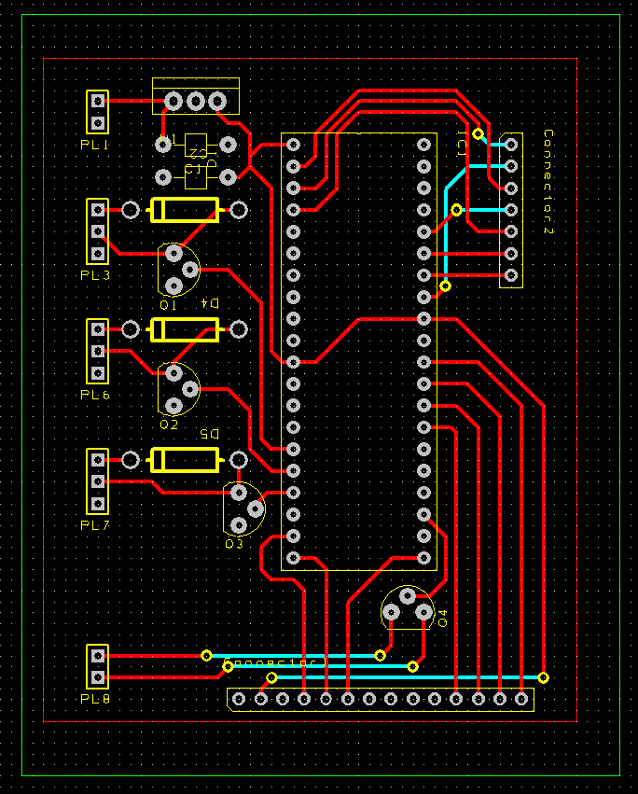
To avoid crossing tracks or routing between pins, vias were added to the PCB taking the connection to the back of the board. This can be seen figure 50. A copper pour was added and connected to ground. Using a copper pour instead of routing all ground tracks ensures the PCB routing is not too complex. The copper pour can be seen in figure 51.
Figure 48 - PCB Design
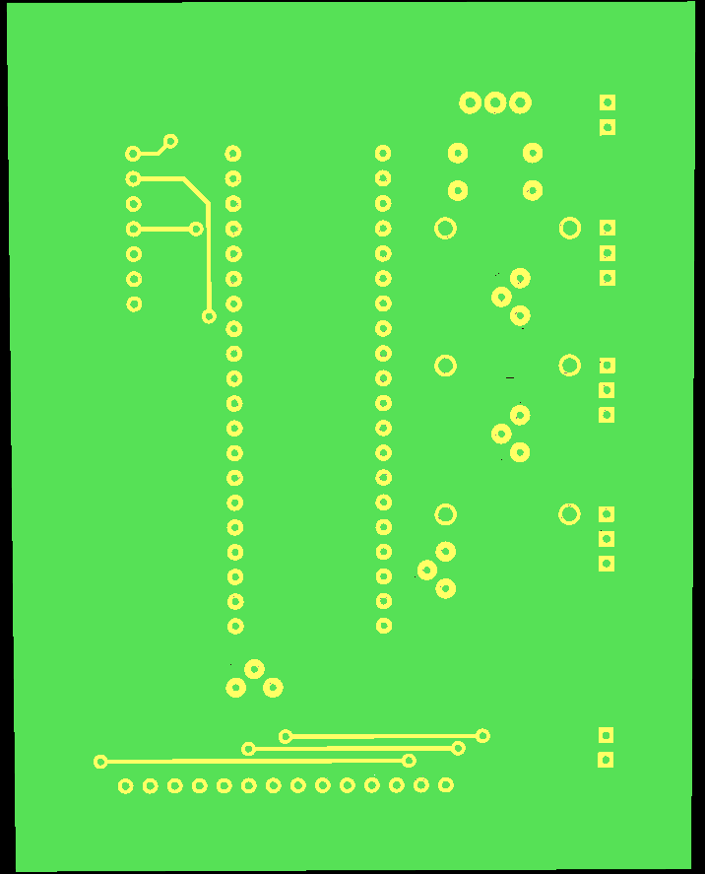
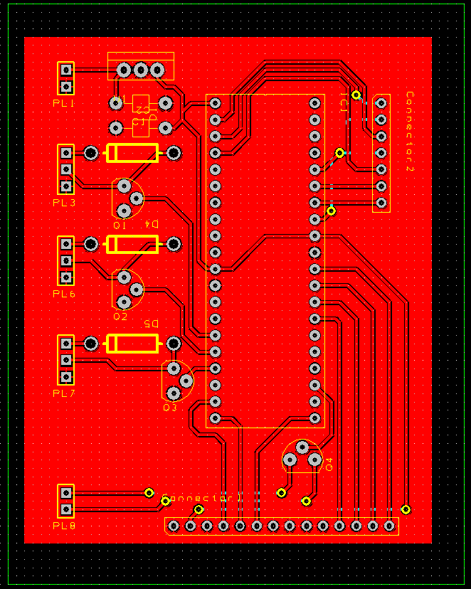
Figure 49 - Back of PCB
Figure 50 - PCB Copper Pour
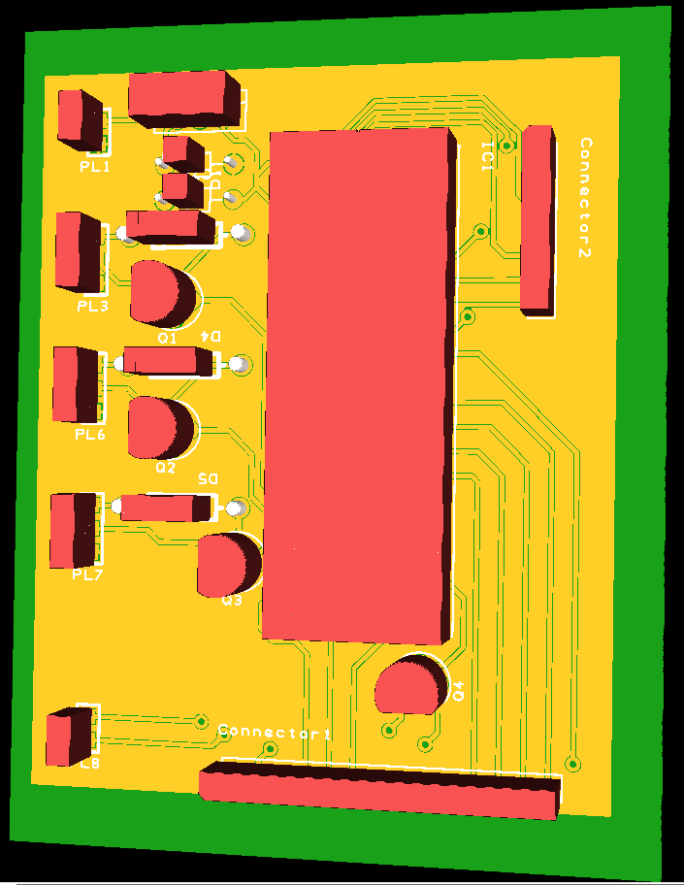
Figure 51 shows a 3D render of the PCB, revealing the copper pour and routed tracks.
Figure 51 - 3D Render of PCB

The project Gerber files were then used to order the PCB.

PCB Construction (TH)

Once all the components were collected and the PCB had arrived the components were carefully soldered to the board, following the layout created in the PCB schematic. The bare board can be seen in figure 52 along with the fully soldered board shown in figure 53. A 40 pin socket was soldered to the board to allow for the MCU to be easily removed for programming.
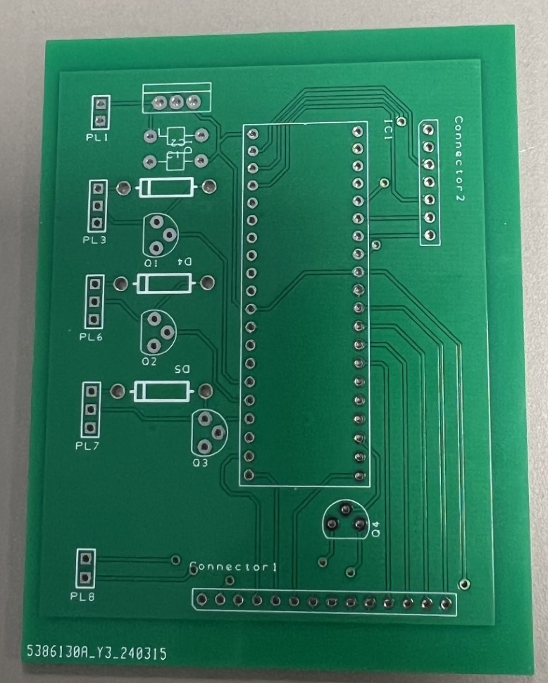
Figure 52 - Bare PCB

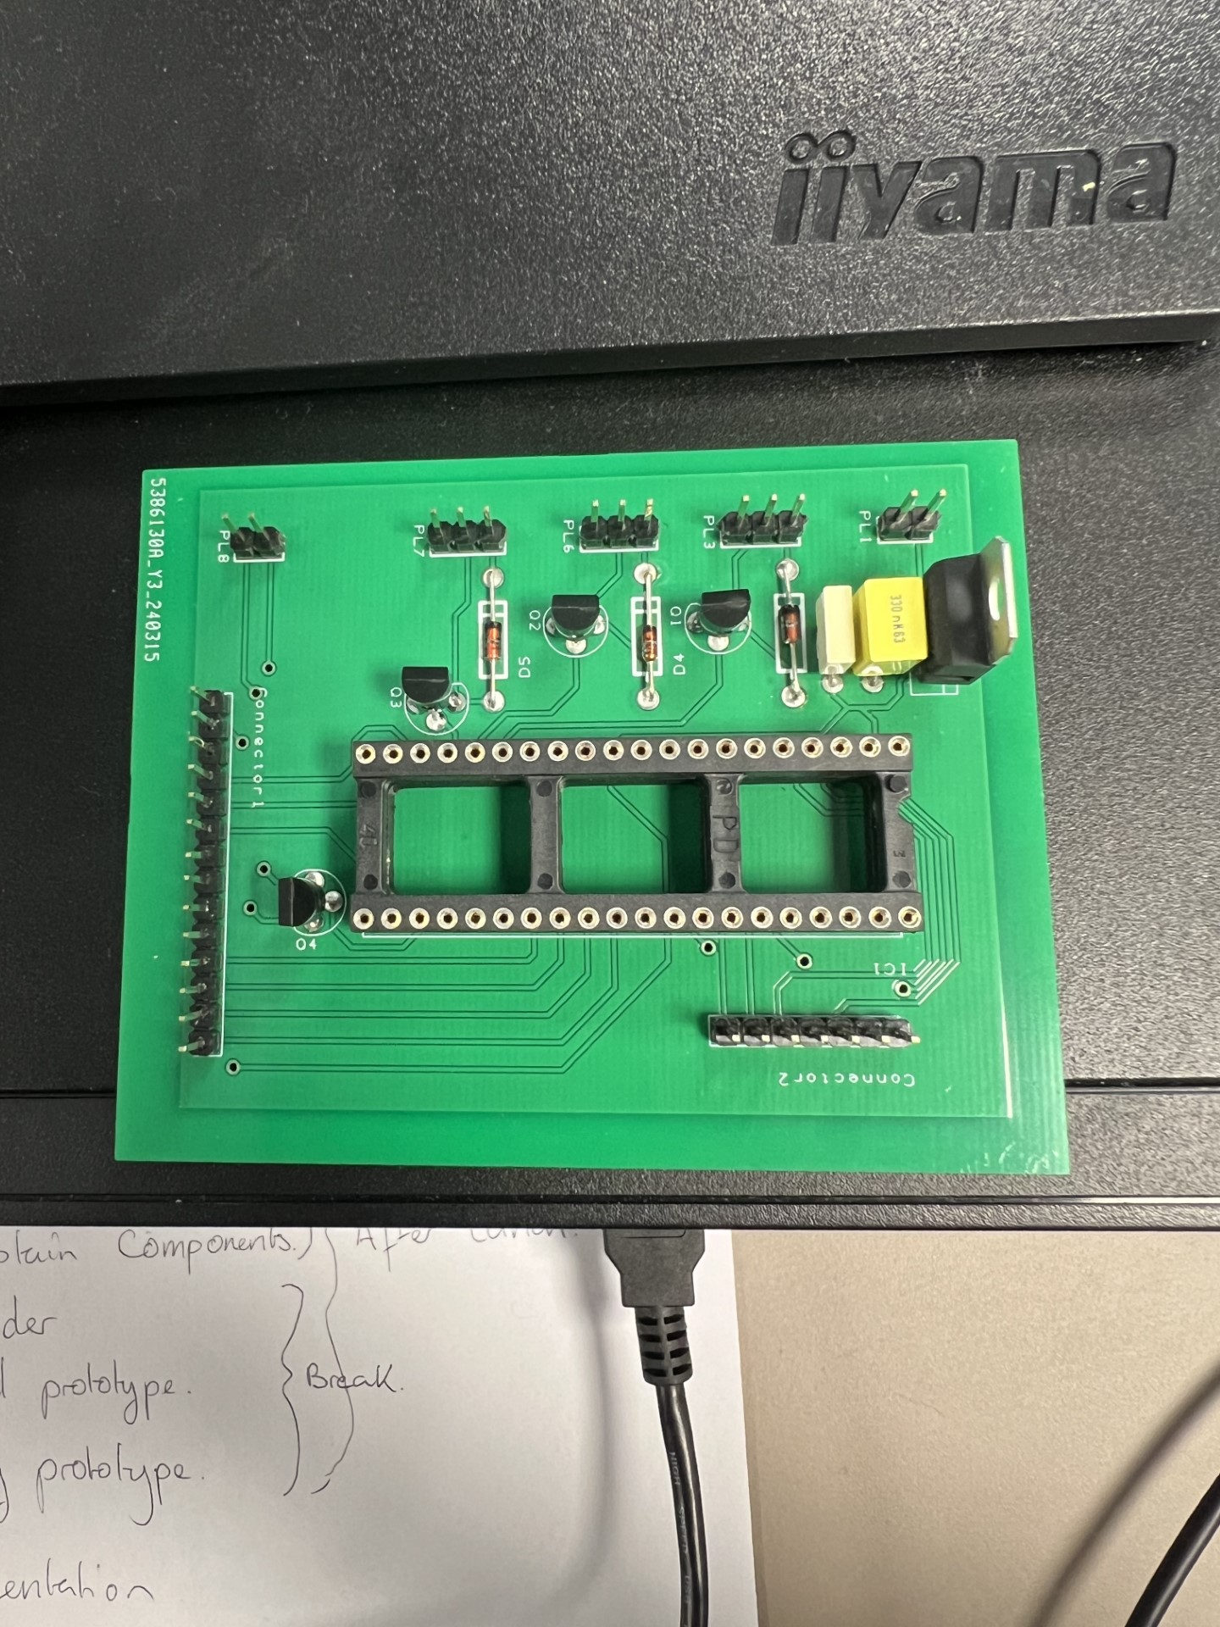
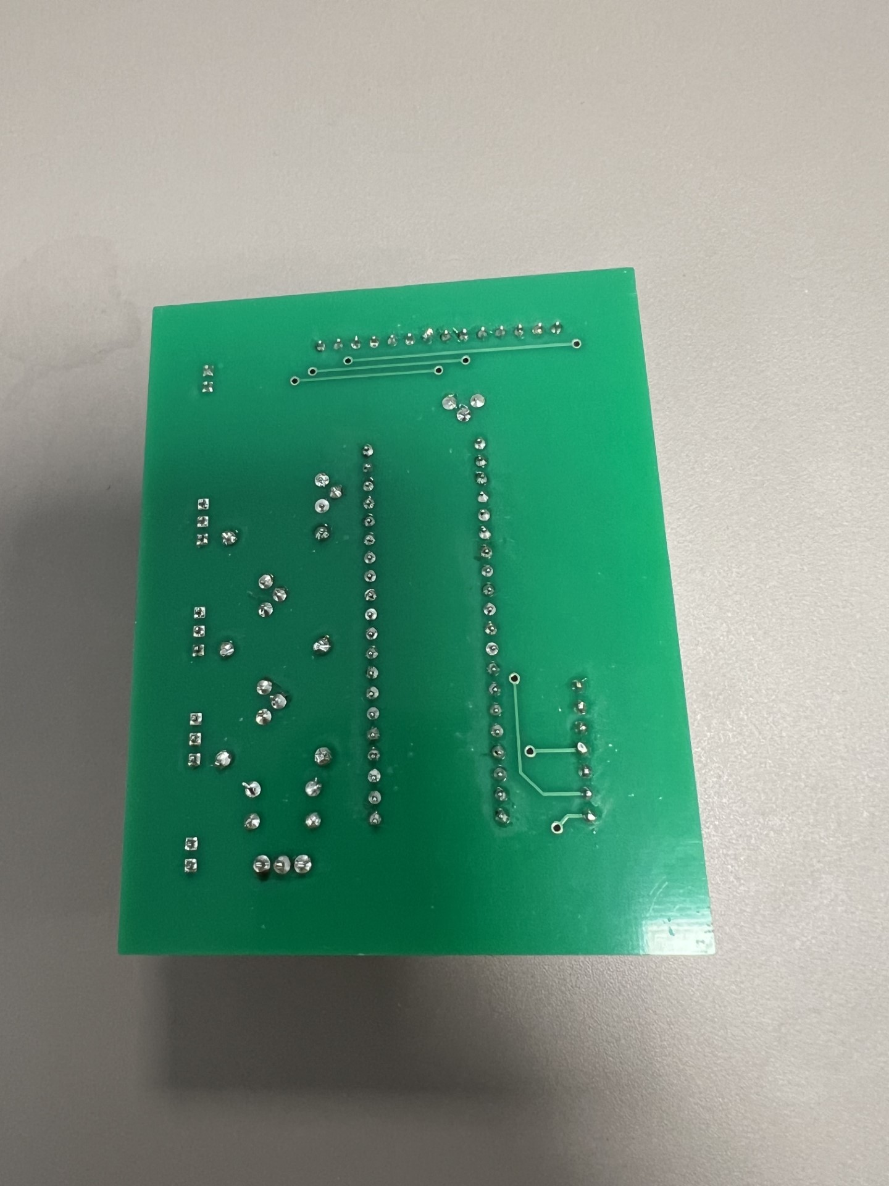
Figure 53 - Soldered PCB

Prototype Build (GD, TH, JP)

With a working simulation and a constructed PCB, the prototype for this device could now be built.

Programming the MCU:

To program the MCU, MATLAB IPE software along with a Pick-It 3 device was used.
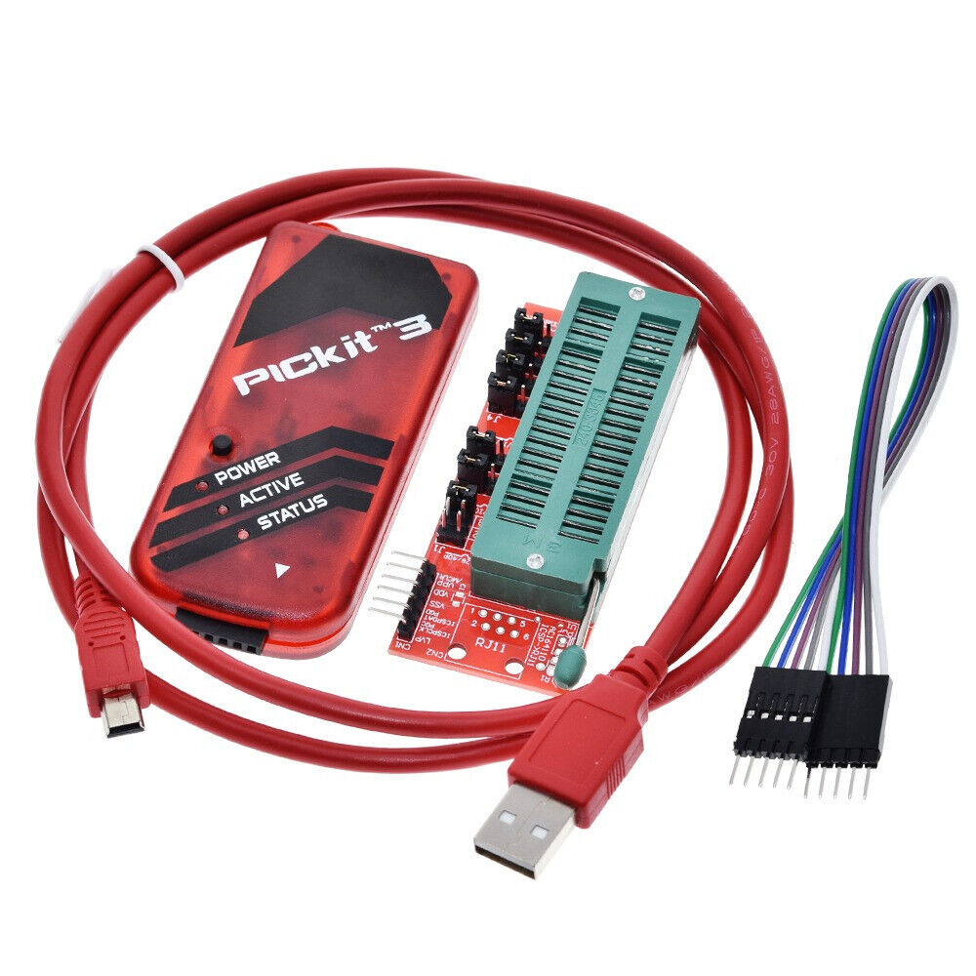
Figure 54 - Pick-It 3

The MCU was connected to the Pick-It 3 devices via connection instruction provided in the product datasheet [22]. These connections were then verified by the MATLAB software showing the MCU was ready for programming.
A hex file of the project code was then created and programmed to the MCU.

Device Construction:

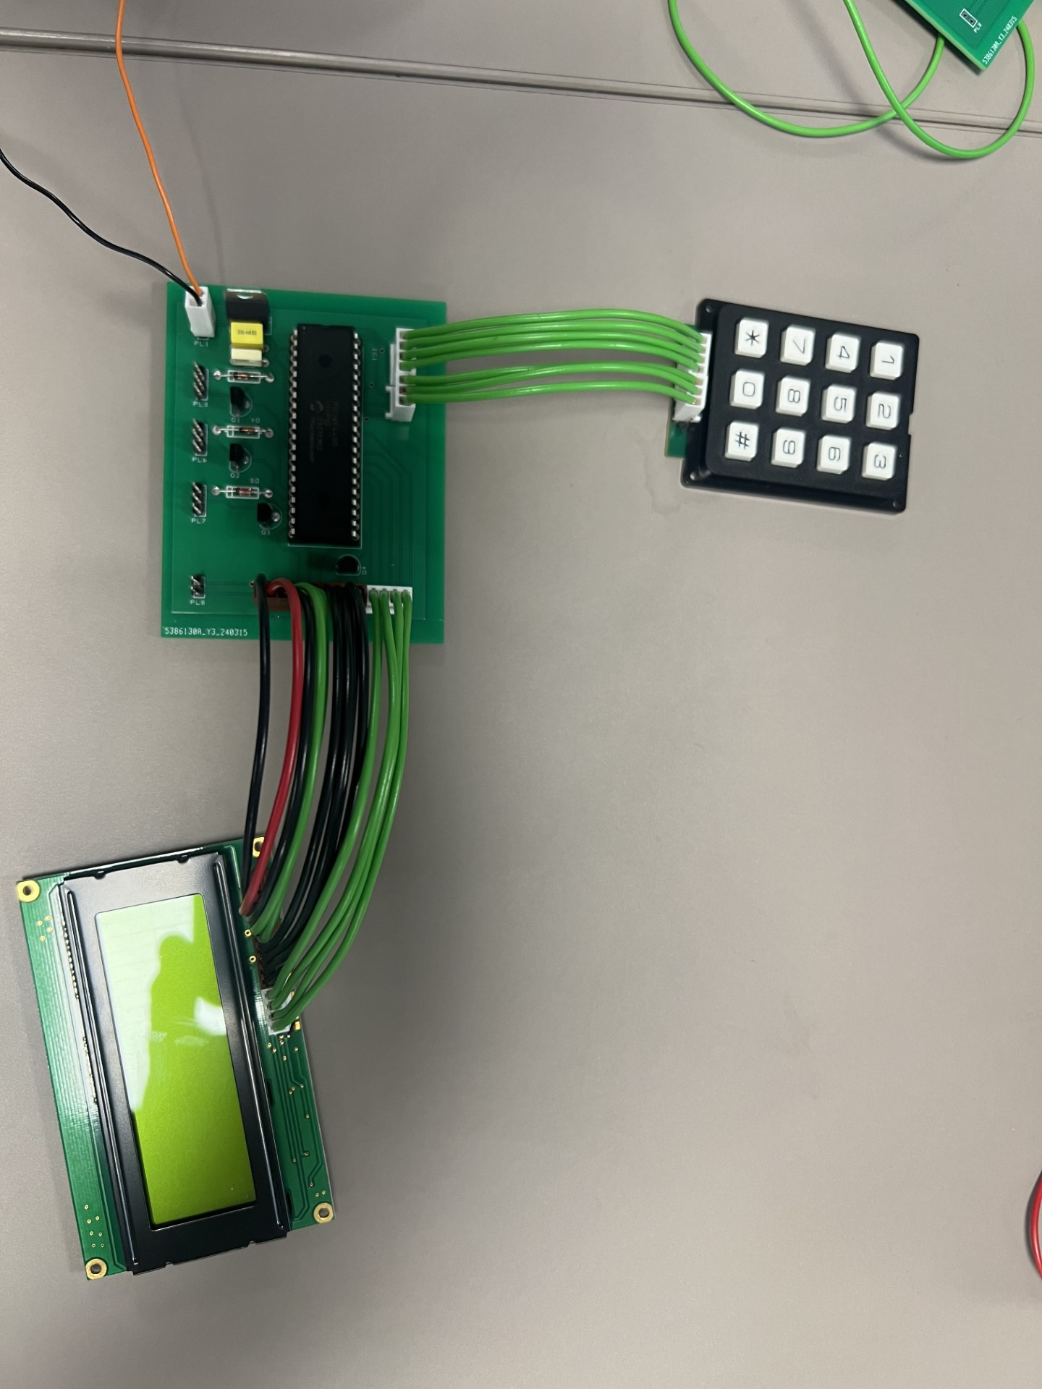
To connect interfacing components to the PCB, the chosen Molex connectors were used. The preliminary prototype model can be seen below in figure 55.
Figure 55 - Preliminary Prototype

.

Prototype Testing (GD, TH, JP)

To test this prototype, 5V was connected to the voltage regulator of the PCB. After a short delay, the LCD displayed the initial “Enter Password” text as expected shown in figure 56.

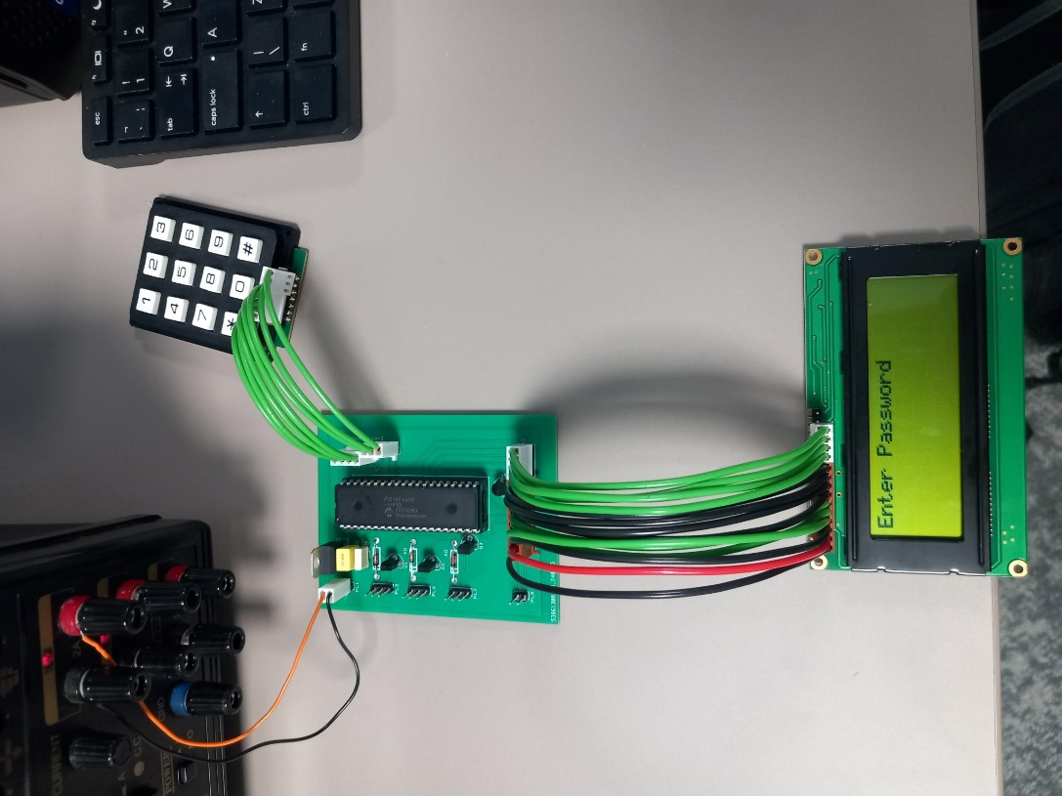
Figure 56 - Prototype Start-Up

To test the device function, a passcode is then entered using the keypad. This however highlighted a significant timing error. Despite a button being pressed, the LCD would not register this entry unless a key was held down for a significant duration.

Fault Analysis:

To determine the cause of this fault, the connections between the keypad, MCU and LCD were first inspected. Continuity of each connector and the PCB tracks were checked using a multimeter. No continuity errors were found.
After a group discussion, it was then thought that the clock frequency of the MCU may not match that written to the program. Analysis of the MCU datasheet and initial program setup was therefore conducted. It was however determined that the correct 8MHz frequency had been selected for both.

Oscilloscope Timing Results:

Despite verifying the correct clock frequency was being used, the group was still adamant that a timing issue was causing the prototype fault. To confirm this, the test code previously shown in figure 26 was programmed onto the MCU. This code should blink an LED on pin C0 at 500ms intervals. This code had previously been used during simulation setup and therefore had been proven to work.
Once this code had been written onto the MCU, an oscilloscope was used to measure the output at pin C0. During testing, the oscilloscope showed a switch rate of 120 seconds at this terminal, 240 times slower than then expected rate. This confirmed a timing issue with the MCU.

Fault Conclusion:

After determining the fault, assistance was requested from a university lecturer to aid in determining its cause. The clock frequency was again their primary point of concern, however, this was quickly eliminated as the fault after inspection of the MCU datasheet and simulation setup.
The device simulation was then inspected to prove operation of the projects code. After inspecting the code and witnessing the simulation operating as intended, it was determined that no fault lay with the project software.
The physical MCU then became the main point of concern for the group. To ensure a faulty component was not to blame, a spare MCU was programmed with the test code. This again experienced the same timing issue.
Using MATLAB IPE, the lecturer requested that the programmed MCU was re-verified to show correct functionality. This however highlighted that once programmed, both MCUs were unreadable to the software. It was only by erasing the programs from the MCUs that this error cleared. It was therefore concluded that the MCUs being used may have been part of a faulty batch produced by the manufacturer. This conclusion was corroborated by the lecturer present.

Unfortunately, due to the time constraints of this project, the group was unable to source a new MCU in the given timeframe. The decision was therefore made to report the findings and simply use the circuit simulation to present this project.

Final Prototype Design (GD, TH, JP)

Despite not having a functioning prototype, efforts were made to show how this device could be compactly integrated within the localised control panel of a system.
Each component was fitted to a Perspex board measuring 200 x 300mm as seen in figure 57.
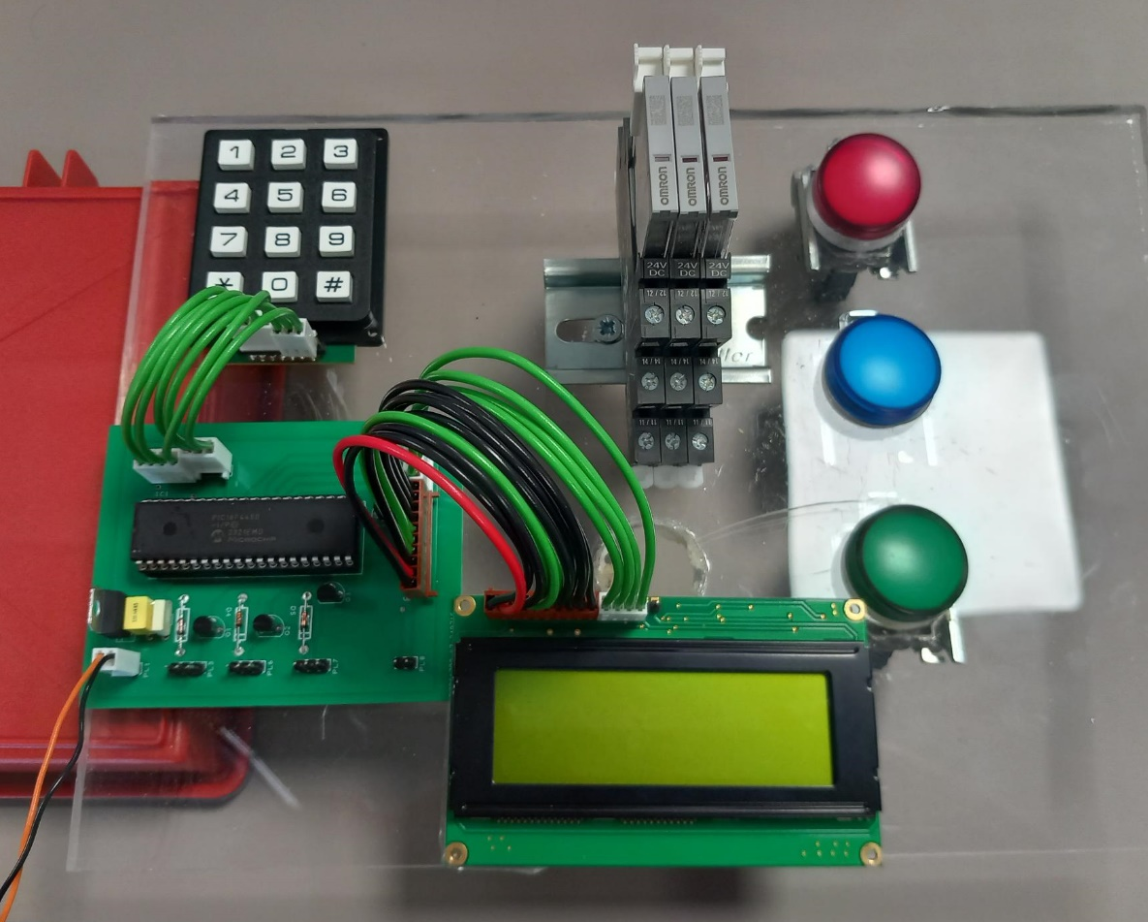
Figure 57 - Final Prototype Design

If a future iteration of this device were to be made, additional consideration would be made regarding the connectors used. Within a panel, all connections shown could be mounted to each component from the underside of the board. This would hide all cables shown, improving device safety and producing a more aesthetically pleasing model.

Project Costing (JP)

Table 5 below outlines the total build cost for this project.

Build Cost
Component | Number of units | Cost per unit | Total Cost (£)
PCB Manufacture, Design | 1 | 2.89 | 2.89
PCB Shipping Cost | 1 | 1.18 | 1.18
Diode | 3 | 0.032 | 0.096
NPN Transistor | 4 | 0.28 | 1.12
Relay | 4 | 14.57 | 58.28
16 X 2 LCD Screen | 1 | 7.105 | 7.105
Buzzer | 1 | 3.145 | 3.145
Female Crimp Molex terminal | 28 | 0.006 | 0.168
2 Pin Through Hole Header | 2 | 0.251 | 0.502
2 Pin Female Housing | 2 | 0.089 | 0.178
3 Pin Through Hole Header | 3 | 0.3 | 0.9
3 Pin Female Housing | 3 | 0.287 | 0.861
7 Pin Through Hole Header | 1 | 0.644 | 0.644
7 Pin Female Housing | 1 | 0.318 | 0.318
14 Pin Through Hole Header | 1 | 0.905 | 0.905
14 Pin Female Housing | 1 | 0.899 | 0.899
24 VDC LED Green | 3 | 3.88 | 11.64
Voltage Regulator | 1 | 0.462 | 0.462
PIC18f4450 | 1 | 4.05 | 4.05
PIC18f4450 Delivery | 1 | 12 | 12
 |  | Total Cost = | £107.343
Table 5 - Total Build Costs

Future Work – Communication Methods (JP)

To further develop this project, the group would look to implement different communication methods into the design. Information regarding MCU communication methods is highlighted below.

Serial Communication:

- UART (Universal Asynchronous Receiver-Transmitter): Used for asynchronous serial communication between the MCU and other devices like sensors, displays, or other controllers.

- SPI (Serial Peripheral Interface): Enables synchronous serial communication with devices like sensors, memory chips, or other microcontrollers using a master-slave configuration.

- I2C (Inter-Integrated Circuit): Allows for multi-master, multi-slave communication over a two-wire serial interface, commonly used for communication between ICs on the same PCB.

Parallel Communication:

- Parallel Ports: Microcontrollers often have parallel I/O ports that can be used for interfacing with external devices using parallel communication protocols.

CAN (Controller Area Network):

- Used for robust serial communication in automotive and industrial applications where high reliability and noise immunity are required.

USB (Universal Serial Bus):

- Some PIC microcontrollers come with built-in USB support, allowing them to communicate with computers, peripherals, or other USB devices.

Ethernet:

- PIC microcontrollers with Ethernet capabilities can communicate over Ethernet networks, enabling Internet of Things (IoT) applications, networked devices, and remote monitoring/control.

Wireless Communication:

- Bluetooth: Microcontrollers can communicate wirelessly using Bluetooth modules for short-range connections.

- Wi-Fi: Some microcontrollers support Wi-Fi modules for wireless internet connectivity and IoT applications.

- RF (Radio Frequency): Microcontrollers can communicate over RF modules for remote control, telemetry, or wireless sensor networks.

Project Conclusion (GD, TH, JP)

Throughout this project, it has been shown how a system can be secured to authorised personnel using a microcontroller and basic electronic components. This device uses a series of password arrays to prevent a circuit from being operated until a correct passcode is entered into a keypad. After entering a correct passcode, the MCU will change the state of an associated output pin, which will then energise or de-energise a specific circuit relay. User instructions and system status updates are provided to the operator through an easy-to-read LCD module throughout this process. While the explanation is simple, this report has outlined the design, programming, and interfacing needed to develop such a system.
Using the components selected, circuit designed, and programmed code, the group was able to create a fully operational simulation for this project. All components interfaced correctly, and the program ran as intended.
Unfortunately, a faulty batch of microcontrollers has prevented the group from creating a working prototype within the given timeframe of this project. The group is confident, however, based on the successful simulation testing and the fault-finding conducted, that this prototype would function correctly with a fully operational MCU.

Bibliography

[1] | RS, “RS PRO Red 1-Lock Nylon Safety Lockout, 6.4mm Shackle,” RS, 2024. [Online]. Available: https://uk.rs-online.com/web/p/lockouts/1963758?gb=s. [Accessed 21 04 2024].
[2] | P. Horowitz and W. Hill, The art of electronics, Third edition ed., New York, New York: Cambridge university press, 2015.
[3] | Yulianto, “Relay Driver Based on Arduino UNO to Bridge the Gap of The Digital Output Voltage of The Node MCU ESP32,” Engineering, MAthematics and Computer Science, vol. 5, no. 3, pp. 129-135, 09 2023.
[4] | G. Ramarao, S. K. Telagamsetti and V. S. Kale, “Design of Microcontroller based MultiFunctional Relay for Automated Protective,” 2014 Students Conference on Engineering and Systems, pp. 1-6, 2014.
[5] | R. C. N. Transistor, “RS Compnents,” [Online]. Available: https://uk.rs-online.com/web/p/bipolar-transistors/6711113?gb=s.
[6] | R. C. 2. P. header, “RS Components,” [Online]. Available: https://uk.rs-online.com/web/p/pcb-headers/4838461?gb=a.
[7] | R. C. F. 2. Pin, “RS Components,” [Online]. Available: https://uk.rs-online.com/web/p/wire-housings-plugs/6795287P?gb=s.
[8] | R. C. 3. p. header, “RS Components,” [Online]. Available: https://uk.rs-online.com/web/p/pcb-headers/4838477?gb=s.
[9] | R. c. 3. P. Female, “RS components,” [Online]. Available: https://uk.rs-online.com/web/p/wire-housings-plugs/6795375?gb=s.
[10] | R. C. 7. Female, “RS Components,” [Online]. Available: https://uk.rs-online.com/web/p/wire-housings-plugs/6795404P?gb=s.
[11] | R. C. 7. P. Header, “RS Components,” [Online]. Available: https://uk.rs-online.com/web/p/pcb-headers/4838512?gb=s.
[12] | R. C. 1. Female, “RS COmponents,” [Online]. Available: https://uk.rs-online.com/web/p/wire-housings-plugs/6702800P?gb=s.
[13] | R. C. 1. Header, “RS COmponents,” [Online]. Available: https://uk.rs-online.com/web/p/pcb-headers/1707127?gb=s.
[14] | Molex, “Molex KK 4809 Crimp Terminal Contact, Female, 0.05mm² to 0.35mm², 30AWG to 22AWG, Tin Plating,” Molex, [Online]. Available: https://uk.rs-online.com/web/p/crimp-contacts/0467598. [Accessed 03 01 2024].
[15] | MICROCHIP, “PIC18F2450/4450 Data Sheet,” MICROCHIP, 2008. [Online]. Available: https://ww1.microchip.com/downloads/en/devicedoc/39760d.pdf. [Accessed 01 02 2024].
[16] | Microchip, “PIC18F2450/4450,” Microchip, Chandler, 2008.
[17] | Molex, “Molex KK,” Molex, 2014.
[18] | Displaytech, “Character LCD Module Product Specification,” 2019.
[19] | Multicomp, “Keypad,” 2012.
[20] | Texas Instruments, “POSITIVE-VOLTAGE REGULATORS,” Texas Instruments, Dallas, 2003.
[21] | U. o. T. A. Team, “.c and .h Files,” University of Toronto Aerospace Team, 2018. [Online]. Available: https://utat-ss.readthedocs.io/en/master/c-programming/c_h_files.html#:~:text=file%20or%20interface.-,.,When%20you%20%23include%20%22file..
[22] | Microchip, “PICkit™ 3,” Microchip, 2013. [Online]. Available: https://ww1.microchip.com/downloads/aemDocuments/documents/OTH/ProductDocuments/UserGuides/52116A.pdf. [Accessed 15 04 2024].
[23] | ARDUINO, “Interface 4×3 & 4×4 Membrane Keypad with Arduino,” ARDUINO, [Online]. Available: https://lastminuteengineers.com/arduino-keypad-tutorial/. [Accessed 10 02 2024].
[24] | A. Watt, Project Management, Hong Kong: The open univisity of Hong Kong.
[25] | A. P. Nair, J. Josephin, A. S. Anjana, C. P. Athira and S. J. Olickal, “ELECTRIC LINE MAN SAFETY SYSTEM WITH OTP BASED CIRCUIT,” International Journal of Research in Engineering and Technology, vol. 4, no. 3, 04 2015.
[26] | S. Manivannan, S. Sudhahar, G. M. Oorappan, k. Rajalashmi and N. Saravanakumar, “Design Implementation and Evaluation of Password Protected Circuit Breaker for Reliable Power System Protection and Maintenance,” Springer Proceedings in Materials, vol. 5, pp. 933-942, 05 02 2021.
[27] | C. P. Kamalini, S. Jesimabanu, A. Kokila and V. Jayalakshmi, “Password Based Circuit Breaker Control to,” International Journal of Engineering Research & Technology, vol. 5, no. 13, 2017.
[28] | M. MOOKAMBIKA, P. Pushbarani and M. Malarvizhi, “PASSWORD BASED CIRCUIT BREAKER CONTROL TO ENSURE ELECTRIC LINE MAN’S SAFETY AND LOAD SHARING,” JETIR, vol. 10, no. 9, 2014.
[29] | RS, “How Do Relays Work?,” RS, 29 08 2023. [Online]. Available: https://uk.rs-online.com/web/content/discovery/ideas-and-advice/how-do-relays-work. [Accessed 21 04 2024].
[30] | R. U. Haider, “Password based circuit breaker,” University of Faisalabad, Faisalabad, 2024.
[31] | H. G. Walton and D. Dunmur, “Liquid Cristal Display,” Britannica, 2024. [Online]. Available: https://www.britannica.com/technology/liquid-crystal-display. [Accessed 21 04 2024].
[32] | Electrical safety UK, “Safe Isolation Procedure For Electrical Isolations,” Electrical safety UK, 21 04 2024. [Online]. Available: https://elecsafety.co.uk/safe-isolation-procedure/. [Accessed 21 04 2024].
[33] | R. Components, “RS Components,” [Online]. Available: https://uk.rs-online.com/web/p/power-relays/1113042?gb=s.
[34] | R. C. Diode, “RS Components,” [Online]. Available: https://uk.rs-online.com/web/p/switching-diodes/8431562?gb=s.
[35] | R. C. L. 1. x. 2, “RS Components,” [Online]. Available: https://uk.rs-online.com/web/p/lcd-monochrome-displays/2109024?gb=s.
[36] | R. C. Buzzer, “RS Components,” [Online]. Available: https://uk.rs-online.com/web/p/piezo-buzzers/2596285?gb=s.
[37] | R. C. Keypad, “RS Components,” [Online]. Available: https://uk.rs-online.com/web/p/keypads/0146014?gb=s.
[38] | R. Components, “RS Components (Green),” [Online]. Available: https://uk.rs-online.com/web/p/pilot-lights/7637918.
[39] | R. Components, “RS Components RED LED,” [Online]. Available: https://uk.rs-online.com/web/p/pilot-lights/7637909.
[40] | R. C. V. Regulator, “RS Components,” [Online]. Available: https://uk.rs-online.com/web/p/voltage-regulators/9181971?gb=s.
[41] | R. C. F. C. Terminal, “RS Components,” [Online]. Available: https://uk.rs-online.com/web/p/crimp-contacts/1707129?gb=s.
[42] | W. H. Paul Horowitz, The art Of Electronics, New york: Cmbridge University , 2015.

Appendix 1.0 – Program Code



