

[NAME]: MEHUL GOSWAMI
[STUDENT ID]:2214858
[TITLE]: THE DIFFRENT TYPES OF ATTACK IN CYBERSECURITY in uk
[PROFESSER NAME]:Dr Terry Walcott

Abstract

Cyberattacks are those that are carried out against innocent internet users by either using a computer as the target of the attack (like phishing, spamming, hacking, etc.), or as a means of advancing other forms of criminal activity, like child pornography, identity theft, and cyber stalking. In this digital age, cybersecurity is a challenge due to the exponential rise in cyberattacks. Cyberattacks can cause significant damage to individuals and businesses alike when carried out successfully, necessitating prompt incident responses to salvage the situation. This paper in any case recognized that computerized attacks can be an assigned, untargeted or an insider attack. The review acknowledged that one of the most significant challenges to network security is the pervasiveness and elusiveness of digital thieves. Businesses should adopt, implement, and regularly update incident response plans and practices that can help prevent cyberattacks, according to the study. The study also found ways to protect against cyberattacks through cyber security.

TABLE OF CONTENTS
1.1 INTRODUCTION...................................................................................
1.2 BACKGROUND.........................................................................................

1.3 Definition of cyber-attack from the specialists’ point of view..............................................................................................................
1.4 Main cyber-attack types..........................................................................
2.1 Methods commonly used by cybercriminals.............................................
2.2 Denial of Service.......................................................................................
2.3 Man-in-the-Middle....................................................................................
2.4 Malware....................................................................................................
2.5 Phishing....................................................................................................
2.6 SQL Injection Attack..................................................................................

2.7 Session Hijacking......................................................................................

3.Cyber-security policy...................................................................................
4.Strategies to Mitigate Against Cyber Attacks...............................................
5. What is problem statement of cyberattacks...............................................
6. Aims and objectives...................................................................................
7. Methodology.............................................................................................
8. LITRETURE REVIEW....................................................................................
9. How to avoid ransomware.........................................................................
9.1. Block common entry methods.................................................................
9.2. Recognize intrusions..............................................................................
9.3. Stop encrypting malicious data................................................................
9.4. Make backups offline and off-site............................................................
9.5. Try not to get gone after two times.........................................................
10. outcomes.................................................................................................
11. Conclusions..............................................................................................
12. References...............................................................................................

INTRODUCTION

Over the past two decades, the Internet has had a significant impact on international communication and has become increasingly ingrained in everyday life. Due to developments and low costs in this field that have greatly improved its accessibility, use, and execution, the Web currently has approximately 3 billion global users. et al., Tan 2021). The overall economy as of now makes billions of dollars consistently by virtue of the Internet's gigantic generally association. ( Judge and co., 2021). The majority of international economic, commercial, cultural, social, and governmental interactions and activities are currently carried out online by individuals, non-governmental organizations, governments, and governmental institutions. Aghajani and Ghadimi, 2018) The majority of critical and sensitive data is either transported to or created in cyberspace, and critical and sensitive infrastructures and systems are either controlled, managed, or exploited via cyberspace. Mohsenian-Rad and Akhavan-Hejazi, 2018). People spend a lot of time and engage in a lot of activities in this area, which also hosts the majority of media activity and financial transactions. (Priyadarshini and colleagues, 2021) The GDP (gross domestic product) contribution of internet companies has increased significantly, and cyberspace measurements make up a sizable portion of the measures used to measure growth. This region receives a significant amount of a nation's financial and spiritual resources, and this region has a significant impact on the financial and spiritual achievements of a nation's people. 2020 (for Givargis and Amir). To put it another way, a lot of people's lives are inextricably linked to this location, so any problems, unpredictability, or instability there will quickly affect other people's lives. (Li et al.) 2020 However, cyberspace has presented new security challenges for governments. Due to the low entry barrier, anonymity, unpredictability of the threat area, dramatic impact, and lack of public transparency in cyberspace, threats such as cyberwarfare, cybercrime, cyberterrorism, and cyberespionage are now a reality. These threats come from both powerful and weak actors, such as governments, criminal organizations, and individuals (Niraja and Srinivasa Rao, 2021). The actors in conventional threats to national security are governments and nations, which distinguishes them from cyber threats, which are often transparent in form and whose governments and nations can be recognized in a particular geographical region. In this circumstance, traditional national security is put to the test and rendered useless. In 2021, Sarker.
For more than a decade, experts have considered the potential effects of digital attacks (Shin et al., 2021). An infection that targets financial reports or disrupts a country's securities exchange, sending an incorrect message that will cause the country's power plant to pause and collapse, or even upsetting the airport regulation framework will result in air accidents are all examples of situations that can cause severe and sometimes far-reaching physical or financial harm (Snehi and Bhandari, 2021, Ahmed Jamal et al.). Experts will not be able to address the complex and diverse dimensions and aspects of the issue or provide legal advice and analysis until governments come up with a clear definition of a cyber-attack that is accepted by the international community (Cao et al., 2021). As a result, the question that arises is what a cyberattack actually is, what characteristics it possesses, and whether or not any cyberattack can be considered a type of attack in the traditional and classic sense (Gupta Bhol et al., 2021). The legitimate environment to continue and recognize the consequences of this sort of attack will undoubtedly be straightforwardly impacted by the presence of a total significance of the assault (Furnell et al., 2020). There is no doubt that the absence of a comprehensive and precise definition obscures the true legal course of action and results in a variety of translations and practices, sometimes leading to different legal outcomes (Alhayani et al., 2021). Along these lines, the importance and need of having a good definition, fundamentally for the beginning of the subject and its explanation, change and assessment is imperative, and a point by point study is significant. This study begins with an explanation of the nature of cyberattacks, then examines classification and segregation of cyberattacks, and finally examines and analyzes existing definitions from the perspectives of international organizations and experts. The conclusion of the paper is then presented.

Background

Definition of cyber-attack from the specialists’ point of view:
Richard Clark: Motsch and co. say that, Digital assaults are moves initiated by countries to invade the PCs or PC organizations of some country to inflict damage or interruption. 2020). It is possible to assert that this definition's analysis and critique used the attacker, the purpose, and the intention of the attack as criteria (Cao et al., 2019). In like manner, to the extent that the guilty party of the attack, just countries are referred to in general. On the other hand, even if non-legislative and private groups carry out an attack against a third country, it will essentially fall outside the scope of the definition that was referred to and will exclude them. This is true even if individuals carry out an attack in the unique situation and geological region that is under the influence and ward of a country (the internet of organizations heavily influenced by nations). As a result, the legal system ought to be empty. Because of this, one could make the case that the definition that came before it is largely insufficient, leaves out a significant portion of the attacks carried out by private and non-governmental organizations, and leaves a void (Zhang, 2017).

Main cyber-attacks types

To examine the impact and danger of network protection in WAMS-based FFR (Partial stream hold) control, we processed satirical data from two scales using a clever scale CNN. Additionally, they investigated the FFR structure's time-repeat based network wellbeing assurance framework. When actual synchrophasor data was used, the result was more accurate and reliable. Lee and others As indicated by a data based secret Makrove exhibit, 2021) upheld a procedure for uniting a computerized assault reaction process. Additionally, they investigated a novel Well-based security state estimation technique. A case study has shown that the developed method is valid. A cyber-security decision support system for selecting the best security portfolio to combat multistage cyberattacks was provided by Zhang and Malacaria (2021). This system had both on the web and deterrent estimates upheld by a LM to distinguish progressing assaults. Additionally, they investigated a novel Well-based security state estimation technique. A case study has shown that the developed method is valid. A cyber-security decision support system for selecting the best security portfolio to combat multistage cyberattacks was provided by Zhang and Malacaria (2021). Online and preventative measures were supported by a LM in this framework to identify ongoing attacks.

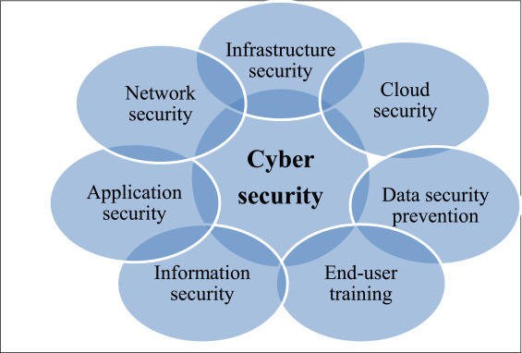
Image by Security triangle (CIA)

Methods commonly used by cybercriminals:

Denial of Service:

By overburdening a system with traffic, attacks known as denial of service (DoS) interfere with service and make it unreachable to users. What tactics are used in a DoS attack? The purpose of a DoS attack is to bring down a network or device, preventing people from accessing it.
Man-in-the-Middle:

A man-in-the-middle attack is a sort of cyberattack in which the communications of two parties are intercepted. Typically, this is done in order to steal login credentials or personal information, spy on victims, sabotage communications, or damage data.

Malware:

"Malware," often known as "malicious software," is a colloquial word for any invasive programme developed by cybercriminals (commonly referred to as "hackers") with the intention of stealing data and harming or destroying computers and computer systems. Common forms of malware include worms, Trojan horses, spyware, adware, and ransomware. Recent malware assaults have resulted in the theft of enormous quantities of data.

Phishing:

Phishing is a sort of online fraud in which a target or targets are approached through email, phone call, or text message by a fraudster pretending to be a representative of a reliable organisation in an effort to trick people into disclosing sensitive information including passwords, banking and credit card information, and personally identifying information.

SQL Injection Attack:

An attacker can tamper with a web application's database queries thanks to a security flaw called SQL injection. Using this technique, an attacker may frequently examine data that they are otherwise unable to obtain.

Session Hijacking:

When an attacker takes control of your internet session, such as when you are paying your bills, checking your credit card balance, or shopping online, this is known as a session hijacking attack. Meeting ruffians typically target program or web application meetings. After that, an attacker using session hijacking can do anything you can do on the website. A hijacker, in effect, deceives the website into thinking they are you. Similarly, as a robber can secure a plane and put the travelers at serious risk, a meeting criminal can assume control over a web meeting and cause large difficulty for the client.

Cyber-security policy

Cyber has grown the community's output and effectively distributed information over time. Regardless of the application or industry in which cyber is used, the possibility of increasing production has always been considered. The absolute framework security is frequently compromised when information is moved quickly to the internet. Security indicators frequently conflict with progress for technology professionals who improve production because prevention indicators reduce, prohibit, or delay user access, consume indicators that identify critical system resources, and respond to management attention (Katrakazas et al., 2020). The framework changes to hardware that is both acceptable and successful. Along the digital protection strategy, the contention between the security circumstance and the interest for digital execution is huge. In various cyber-security contexts, the terms "policy" refer to the rules and regulations governing information distribution, private sector goals for data conservation, and system operations strategies for technology control. However, the publications in this field use the term "cyber-security policy" for a variety of purposes. The term "cyberspace" has no established definition, but when it is used as an adjective in the field of policy, it is intended to convey a common idea (Tam et al., 2021).
T The nation's cyber policy is now part of the country's national security policy. The cyber-security policies of a nation are not as independent as the constitution, even if they are in line with economic or State Department policies. In fact, the formulation and publication of policy in reports and lectures are based on a variety of points and discussions. Policies influence and direct laws and regulations. The policy itself has no connection to the rules and regulations. The best thing that can be said about regulations, agreements, and laws is that they are good policies. However, cyber-security enforcement orders, rules, and regulations can be provided without the need for a cyber-security policy (Sakhnini et al., 2021).

Due to a paranoid fear of approvals, various divisions in the professional workplace are expected to maintain the guidelines because the authorizations will continue until the delinquent area closes. Policies related to human resources, civil, and costing, for example, are coded to the point where any violation of notification rules closes the relevant section. Center chiefs are supposed to integrate informative arrangements into departmental exercises and to foster markers at the departmental level to survey strategy consistence. They also aid in procedures like staffing and expense filing. All public sector organizational divisions are subject to constraints on governance (Baig et al., 2017). The CEO's security policy is limited to the domain, whereas the CEO's company security policy covers the entire organization. However, there are some situations in which particular parts of the information classification are taken very seriously. The staff in technology is helpful. Utilizing a senior information security director or ranking director who is responsible for choosing different components of an association's security circumstance is quite possibly of the latest change in the hierarchical range. Additionally, middle managers are left in charge of the company's cyber-security policy, which is a negative contrast to HR or legal policies. "Information should not be provided without carefully examining the recipient's ability to maintain information security when the risk of disclosure of confidential information is high," may be a provision of a cyber-security policy (Arend et al., 2020). Information risk evaluation is surrendered to a chief under this strategy, who should reduce expenses by re-appropriating the progression of data to the workplace and utilizing individuals outside the workplace to break down it. Maybe a comparable chief necessities to ignore assessment to diminish costs. An error in data obligations toward a non-individual security master, or perhaps the way of life of the organization being referred to, is the cause of this situation. In any case, dividing up the work is crucial. Since bookkeeping and human asset markers have progressed more quickly than network safety gauges, these circumstances become more muddled and testing.

Strategies to Mitigate Against Cyber Attacks.

Cyberattacks like hacked devices, downed websites, breached networks, denial of service, copied emails, and stolen credit card data are now commonplace. As a result, most businesses now have some form of cyber incidence response (CIR) capabilities. However those capacities, which are frequently weighted toward momentary reactions and IT issues, may neglect to address all effects of a digital episode and hold it back from arriving at emergency extents. Managing a cyber incident effectively before, during, and after it occurs is frequently the key to avoiding a cyber crisis. A comprehensive overview of cyber crisis management serves as the foundation for this. Innovative management teams are aware that comprehensive crisis management requires a wide range of abilities and responsibilities. They also know that these must be very well coordinated if an incident is to be contained or managed if it gets out of hand and becomes a crisis.

The following are methods that professionals can use to protect themselves from cyberattacks:
1. Every minute of every day, protect your network
2. Make sure that every kind of malware can't get into your network.
3. ensuring that every device with network access has the most recent antivirus software Select a comprehensive security platform with high performance and superior threat protection. 5. Select a firewall that shields you from global threats.
6.Always select strong passwords and security checks for your systems, email boxes and social networking sites.
7. Do not respond to emails from unknown senders.
8. Use security software to protect your system.
9. Protect your personal information from unauthorized access or disclosure.
10. Safe browsing and good system hygiene are essential.
11. Continue to refresh your passwords, and login id's no less than a few times in a couple of months and make areas of strength for them.
12. Protect your personal information and data to avoid being conned. 13. Never use the mail or any other method to send personal information and data.
14. Check your social media accounts and periodically clean your system.
15. Answer no spam email and be careful.

It is appropriate to constantly have an episode reaction plan. This helps determine readiness in the event of a cyberattack. The purpose of incident response (IR) plans, as stated in , is to evaluate a system's capacity to respond to a security incident. The ultimate objective is to handle the situation in a way that minimizes the amount of damage done to the business and the amount of time and money needed to recover. Sadly, this promise is not fulfilled by the majority of IR plans. Many businesses do not have an incident response plan, and even those that do have one are rarely tested and evaluated, making them unsuitable for use when an incident occurs. In the event of a cyberattack, the following actions can be taken to deal with it, assist in determining its causes and solutions, and speed up recovery.

1. Keep a record of how the incident was discovered, who reported it, and how they were notified; interview IT staff and other applicable gatherings.
2. Investigate the possibility of insider involvement and take steps to reduce this risk in the future.
3. Distinguish impacted frameworks and separate them so nobody endeavors to fix, fix, or modify the condition of the frameworks.
4. Analyze all of the evidence to determine the incident's cause, severity, and impact.
5. According to the analysis, increase vigilance, improve protocols, and strengthen network security.
6. Enhance security-enhancing policies and monitoring systems to reduce the likelihood of future incidents like these.
7. Record and report the discoveries to any important partners and consider possible prerequisites to report the episode to an administrative body.

The likelihood of a recurrence increases if there is no prompt and efficient investigation into the incident's causes. After an incident, speed is essential for minimizing damage. The race against digital wrongdoing is that against time, opportune and diligent mediation subsequently is vital assuming there is any expectation of recuperating from a digital assault.

what is problem statement of cyberattacks

Digitalization has varying effects on every aspect of our lives and businesses. Notwithstanding a developing dependence on programming, equipment, and cloud foundation, we are seeing the quick reception of computer based intelligence and AI instruments. Due to the complexity of digitalization, governments are facing a variety of challenges, such as "fake news" intended to influence elections and cyberattacks on essential infrastructure. These reach from the latest influx of ransomware assaults on medical care frameworks to the boundless effect of a compromised supplier of organization the board frameworks that are generally utilized. For instance, it's possible that the vaccines won't be delivered in time for the upcoming months. Chiefs and pioneers must recognize that network safety is a public safety necessity in the face of these increased risks.

Due to the blurring of the line between digital and physical domains, cybersecurity features, principles, and frameworks are essential for all businesses, but they are especially important for those with high-value assets. Governments must adapt to combat silent, dispersed, diverse, and technically savvy adversaries in today's battles. This conflict involves both the public and private sectors, and only the public sector can provide the private sector with large-scale training, incentive models that shape markets, and policymaking.
Aims&objective

In this context, cyber power is becoming an increasingly significant lever of national power as well as a source of strategic advantage. Computerized power is the ability to get and propel public interests in and through the web. It will be more secure, resilient, and prosperous in the future for nations that are the most adept at navigating the opportunities and challenges presented by the digital age. The United Kingdom is one of the world's most digitally advanced nations, and this government has an ambitious technology agenda, both domestically and internationally. This shows that while we are extraordinarily situated to lead the manner in which in jumping all over the chances presented by the internet to support our residents and mankind in general, we are likewise especially helpless against the challenges presented by it. Over the next ten years, the internet, digital technology, and the infrastructure that supports it will become more and more important to our and our adversaries' interests. As we forge a new role for the UK, strengthening our cyber power will allow us to lead industry and other nations in a more competitive age, stay ahead of future technological developments, mitigate threats, and gain a strategic advantage over our rivals and adversaries. It will make the UK one of the computerized economies that is most secure and generally interesting to live in, work with, and put resources into.

Methodology

As can be seen, how cyberattacks should be described and classified is determined by the extent of the damage. To put it another way, how these kinds of attacks are classified depends a lot on how much of an impact they have, in terms of how many people are killed and how much important infrastructure is destroyed. As a result, the degree to which a cyberattack has visible and long-term effects is an important consideration when classifying it. The more prominent the level of an assault's effect, the more noteworthy the probability that it will be sorted as a "utilization of power" or, far more atrocious, as an "outfitted assault" when its size is adequate to bring about the deficiency of human existence. As a result, the most pressing issue is how to measure a cyberattack's impact. Unfortunately, the relevant criteria of the International Group of Experts have not been able to accurately determine the extent of a cyberattack's impact because its effects are frequently subjective and difficult to evaluate in a short amount of time. If the impact level could be determined using qualitative and quantitative criteria, as has already become evident, it might be much simpler to classify and categorize cyberattacks in accordance with the principles of International Humanitarian Law.

On the other hand, it is clear that risk criticality analysis methodologies use the same impact factors that were suggested by the International Group of Experts for the classification and characterization of cyber attacks to rank assets and infrastructures in order of importance. For instance, the Council Directive "on the identification and designation of European critical infrastructures and the assessment of the need to improve their protection" identified the following as the minimum set of criteria that member states should take into consideration when attempting to assess their critical infrastructures at the European level: (i) public safety, which includes concerns about the affected population, deaths, serious injuries, and evacuations; (ii) ii) the economic effect, which considers the GDP effect, the significance of economic loss, and/or product or service degradation; ( iii) the effect on the environment, which includes the effects on people and the environment; ( v) political effects like people trusting the government; and (vi) psychological effects, including the psychological effects on the population. These criteria are evaluated based on their scope (local, regional, national, and international) and time (before and after the incident).

The following international criteria for evaluating consequences are outlined in the U.S. National Infrastructure Protection Plan: i) public safety and health, including how they affect people's lives and physical health; ii) the economic, which includes both direct and indirect losses to the economy; iii) mental, which remembers their effect for public resolve and the level of individuals' trust in monetary and political establishments; what's more, iv) administration/mission, which remembers their effect for the limit of the public authority or industry to keep everything under control, offer fundamental types of assistance, guarantee general wellbeing and wellbeing, and do related missions connected with public safety.

Since they are directly connected to the fundamental frameworks that are impacted fundamentally and in a roundabout way related to the ramifications of the breakdown or debasement of these basic ICTs for the prosperity of the residents, the assessment standards used for surveying basic ICTs are obviously more focused on assessing risks with connected with outside influences, which are influences related to financial results and their impact on residents. As opposed to the conventional gamble examination techniques, this one zeros in favoring the inward results (interior effects) of foundation breakdown or weakening inside the division or organization that connects with it than on the outside outcomes (outer effects) for residents. Because of this, the risk criticality analysis methods that are used to evaluate critical infrastructure and networks (ICTs) and cyber attacks are highly interdependent because they both share the same impact factors.

This criticality analysis method can also be used as a scale for measuring the intensity of cyberattacks in order to enable a quantification of the "scale and effect" criteria. It can do this by using qualitative and quantitative variables like those recommended by the International Group of Experts in the Tallinn Manual and possibly adopting additional criteria. As a result, it is easier to determine when such acts violate the "use of force" standard, which is used to determine
whether or not a State has violated Article 2(4) of the United Nations Charter and the related custom

LITRETURE REVIEW

The Cyber Security Breaches Survey is an important research study for the UK's cyber resilience in accordance with the National Cyber Strategy. It is mostly used to make the UK's cyberspace a safe place for business and to help the government make cyber security policies. The study looks at how organizations, charitable organizations, and educational institutions approach digital security in terms of procedures, cycles, and strategies. It also takes into account the various digital attacks these organizations face and the ways in which they respond to them.
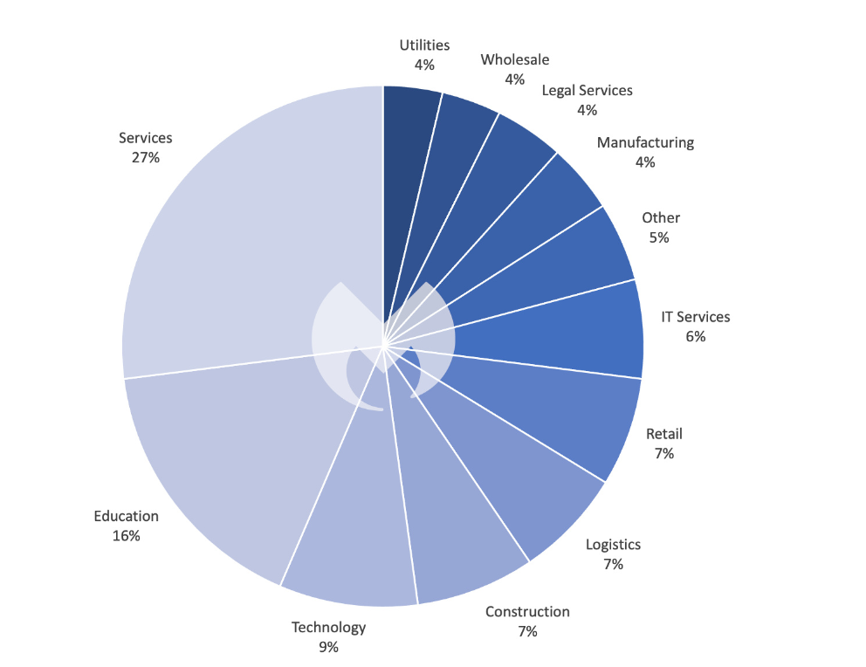

Known ransomware attacks by industry sector in the UK, April 2022 - March 2023

According to our data, a significant factor in this is Vice Society, a highly risky group that distributes ransomware and has a keen interest in the educational sector. In comparison to ALPHV, LockBit was used in 3.5 times as many known attacks worldwide in 2022. In our 2023 Province of Malware report, you can more deeply study why LockBit represents the best danger to your business.) It should not come as a surprise that LockBit was the ransomware that was used the most frequently in the UK over the course of the past year given its dominance worldwide.
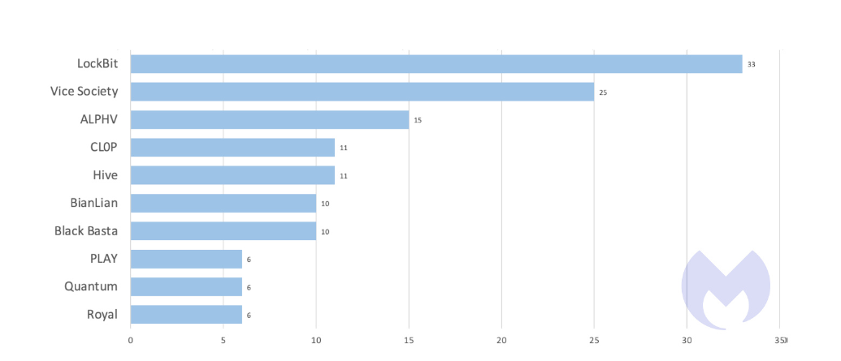
Known attacks by the ten most used ransomware in the UK, April 2022 - March 2023

Truly, the UK is one of Negative behavior pattern Culture's main targets, addressing 21% of the get-together's known attacks over the latest a year, a close by second to the USA which addressed 23%, and tremendously more than the accompanying country, Spain, which addressed 8%.Sadly, Persistent vice Society's unbalanced interest in the UK lands definitively on the preparation sector.76% of Vice Society's known attacks in the UK all through ongoing months hit the tutoring region, and Vice Society was at risk for 70% of known attacks on UK guidance associations.

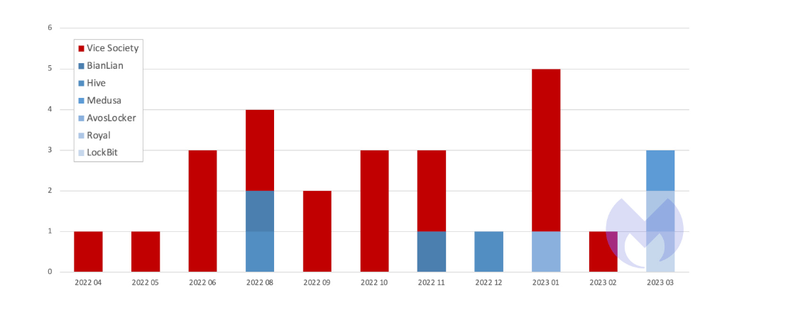
Known ransomware attacks by month on the UK education sector, by gang, April 2022 - March 2023:

Keep in mind that the actual number of attacks is much higher and that our figures only include attacks for which a ransom was not paid.

The BBC reported in 2023 on 14 British schools targeted by the Bad habit Society, including Carmel School in St. Helens, Durham Johnston Thorough School (hacked in 2021, archives posted online in January 2022), and Frances Ruler School of English in London/Dublin.

Vice Society does not invent the wheel when it comes to getting into the victim's networks. It uses unmistakable methodologies, for instance, phishing, compromised capabilities, and exploits to spread out a footing.

Bad habit Society is additionally known to involve genuine programming in its assaults to dodge location by security devices. By being casual about casualties, the group can use the tactic known as "living off the land" to go unnoticed.

organizations. Windows The board Instrumentation (WMI), which permits executives to remotely oversee and screen PCs, is one of its #1 devices. EDR programming worked via prepared security staff or a help like MDR are the main compelling strategies for spotting assailants who live off the land.

We don't have the foggiest idea why Bad habit Society is so intrigued by UK schools and colleges, yet we really do realize that the business isn't precisely loaded. As per the non-hardliner Schooling Strategy Establishment, "between 2009-10 and 2019-20, spending per student in Britain fell by 9% in genuine terms," training subsidizing in the UK has diminished essentially throughout the last 10 years.

Following a spike in development in 2022, the UK's greatest showing affiliation projected a polling form to strike for better pay for its people. While the actual strikes don't straightforwardly add to the weakness of schooling to ransomware, they really do act as a mark of the decaying monetary circumstance of UK training.

This creator directed interviews in 2021 with various individuals engaged with giving UK schools cyberprotection. There was a similar image in each: Cybersecurity was one of the many responsibilities carried by a small number of IT staff members. These employees were under a lot of pressure and ill-equipped to resist the vices of a Vice Society-type ransomware group.

How to avoid ransomware

Block common entry methods:
Make an arrangement for fixig weaknesses in web confronting frameworks rapidly; debilitate or solidify remote access like RDP and VPNs; make use of endpoint security software that is able to spot malware and exploits that are used to spread ransomware.
Recognize intrusions:
By segmenting networks and carefully assigning access rights, you can make it harder for intruders to operate inside your company. Before an attack occurs, look for unusual activity with EDR or MDR.
Stop encrypting malicious data:
Install Endpoint Detection and Response software like Malwarebytes EDR, which uses ransomware rollback to restore damaged system files and employs multiple detection methods to identify ransomware.
Make backups offline and off-site:
Keep backups offline and off-site, out of attackers' reach. Make sure you can quickly restore essential business functions by testing them on a regular basis.
Try not to get gone after two times:
To avoid being attacked again, you must eliminate every trace of the attackers, their malware, tools, and entry points, once you have stopped the first attack and isolated the outbreak.

outcomes:

Over the most recent a year there was no concealing spot for associations in the UK. Our examination of absolute known assaults, known assaults per $1T of Gross domestic product, and known goes after per capita, shows that ransomware posses treated the whole Anglosphere, in addition to the USA, as their superb hunting ground. The United Kingdom was and almost certainly will continue to be on the front lines of the fight against ransomware as part of that group.

The education sector in the UK was disproportionately affected. It was the target of far more known attacks than education was in France or Germany, and it was the cause of far more known attacks than education was in the United States. The weakness of the training area was uncovered by Bad habit Society, a savage ransomware posse with an outsized craving for schooling targets. Vice Society was just as active in the UK as it was in the United States over the past year. While LockBit is still the most dangerous ransomware for almost all sectors and almost all countries, Vice Society is the most dangerous predator for the cash-strapped education sector in the UK.

The fact that ransomware gangs have chosen the education sector in the UK over a vast array of other targets should be cause for concern. It will need to rethink, retrain, and retool its approach to ransomware more than any other industry in order to ward off the determined attention of attackers who sense an opportunity.

Conclusion

In the third millennium, cyberspace and related technologies are one of the most significant sources of power. Power dissipation is a result of the characteristics of cyberspace, such as low entry fees, anonymity, vulnerability, and asymmetry. If governments have so far divided the power game between themselves, then other actors, such as private companies, organized terrorist and criminal groups, and individuals, must also play a role, even though governments continue to play a significant role in this. Naturally, governments will not lose access to their national security as a result of this phenomenon. There are a number of ways to evaluate this effect. First, there is the idea of safety. Today, a threat to national security is the possibility of citizens' quality of life deteriorating, rather than military matters or internal and external borders. The second is that cyber threats no longer have a geographical component. In the past, military threats were confined to a specific region. Consequently, dealing with it was not difficult, at least in terms of identification. The extent of cyber threats' vulnerabilities ranks third. Due to their association with sensitive infrastructure and networks, these sporadic, multidimensional threats pose a very high risk of damage. Fourth, these threats cannot be contained solely by conventional means, such as the use of the military and police, governments alone are insufficient to combat them, and effective bilateral cooperation between governments and the private sector, which shares common interests, is necessary. He insists with such threats. Fifth, as the previous point demonstrates, individuals and businesses will not be spared the effects of cyber threats, which are not limited to governments. Sixth, the various theoretical approaches to international relations whose theories are primarily based on government are easily overlooked or confusing because security in the information age is not just governmental.

Refrence

- Aghajani, G. and Ghadimi, N. (2018). Multi-objective energy management in a micro-grid. Energy Reports, 4, pp.218–225. doi:https://doi.org/10.1016/j.egyr.2017.10.002.
- Akhavan-Hejazi, H. and Mohsenian-Rad, H. (2018). Power systems big data analytics: An assessment of paradigm shift barriers and prospects. Energy Reports, 4, pp.91–100. doi:https://doi.org/10.1016/j.egyr.2017.11.002.
- Al-Ghamdi, M.I. (2021). Effects of knowledge of cyber security on prevention of attacks. Materials Today: Proceedings. doi:https://doi.org/10.1016/j.matpr.2021.04.098.
- Alghamdie, Mohammed.I. (2021a). A novel study of preventing the cyber security threats. Materials Today: Proceedings. doi:https://doi.org/10.1016/j.matpr.2021.04.078.
- Alghamdie, Mohammed.I. (2021b). A novel study of preventing the cyber security threats. Materials Today: Proceedings. doi:https://doi.org/10.1016/j.matpr.2021.04.078.
- Ashraf, J., Keshk, M., Moustafa, N., Abdel-Basset, M., Khurshid, H., Bakhshi, A.D. and Mostafa, R.R. (2021). IoTBoT-IDS: A novel statistical learning-enabled botnet detection framework for protecting networks of smart cities. Sustainable Cities and Society, 72, p.103041. doi:https://doi.org/10.1016/j.scs.2021.103041.
- CSO Online. (n.d.). CSO. [online] Available at: https://www.csoonline.com/uk/.
- GOV.UK (2022). Cyber Security Breaches Survey 2022. [online] GOV.UK. Available at: https://www.gov.uk/government/statistics/cyber-security-breaches-survey-2022/cyber-security-breaches-survey-2022.
- GOV.UK. (n.d.). Cyber security in enterprise connected devices. [online] Available at: https://www.gov.uk/government/publications/cyber-security-in-enterprise-connected-devices?ref=the-wavelength.ghost.io [Accessed 24 Apr. 2023].
- Li, Y. and Liu, Q. (2021). A comprehensive review study of cyber-attacks and cyber security; Emerging trends and recent developments. Energy Reports, [online] 7(7), pp.8176–8186. doi:https://doi.org/10.1016/j.egyr.2021.08.126.
- More than half of British firms ‘report cyber-attacks in 2019’. (2019). BBC News. [online] 22 Apr. Available at: https://www.bbc.co.uk/news/business-48017943.
- Naked Security. (2012). Leading US banks targeted in DDoS attacks. [online] Available at: https://nakedsecurity.sophos.com/2012/09/27/banks-targeted-ddos-attacks/.
- O’Connell, M.E. (2012). Cyber Security without Cyber War. Journal of Conflict and Security Law, 17(2), pp.187–209. doi:https://doi.org/10.1093/jcsl/krs017.
- published, R.K. (2023). Cyber attacks on UK organisations surged 77% in 2022, new research finds. [online] ITPro. Available at: https://www.itpro.com/security/369813/cyber-attacks-on-uk-organisations-surged-77-in-2022-new-research-finds [Accessed 24 Apr. 2023].
- Sang-Hun, C. (2013). Computer Networks in South Korea Are Paralyzed in Cyberattacks. The New York Times. [online] 20 Mar. Available at: https://www.nytimes.com/2013/03/21/world/asia/south-korea-computer-network-crashes.html?pagewanted=all&_r=0 [Accessed 24 Apr. 2023].
- Schmitt, M.N. (1999). Computer Network Attack and the Use of Force in International Law: Thoughts on a Normative Framework. [online] papers.ssrn.com. Available at: https://papers.ssrn.com/sol3/papers.cfm?abstract_id=1603800.
- Team, T.I. (n.d.). Ransomware in the UK, April 2022-March 2023. [online] Malwarebytes. Available at: https://www.malwarebytes.com/blog/threat-intelligence/2023/04/ransomware-review-uk [Accessed 24 Apr. 2023].
- www.flexera.com. (n.d.). Technopedia - an IT Taxonomy | Flexera One. [online] Available at: https://www.flexera.com/products/technopedia [Accessed 24 Apr. 2023].
- www.usdatavault.com. (n.d.). US Datavault. [online] Available at: http://www.usdatavault.com/ [Accessed 24 Apr. 2023].
- Zetter, K. (n.d.). Google Hack Attack Was Ultra Sophisticated, New Details Show. [online] Wired. Available at: https://www.wired.com/2010/01/operation-aurora/#ixzz0deHCunGn [Accessed 24 Apr. 2023].

