CHAPTER 4: FINDINGS AND DISCUSSION

4.1 Introduction
This chapter provides the findings of the systematic literature review and explains them in relation to the aim and objectives of the research. The synthesis of the reviewed studies based on thematic analysis revealed three prevailing themes, namely: (1) Digital Influence and Social Media, (2) Academic Stress and Stress at School, and (3) Family Instability and Home Environment. All the themes have been discussed critically with empirical evidence, theoretical framework, and UK policy contexts. This discussion assesses the role of these factors in the rising rates of anxiety and depression among adolescents in the United Kingdom. It has implications for future health, education, and social care practice.
4.2 Thematic Analysis
Thematic analysis is a qualitative tool that is employed to determine, analyse and make known patterns (themes) in data (Braun and Clarke, 2006). In the secondary research context, it entails a systematic review of the literature at hand, coding of frequent ideas and putting them in meaningful clusters that respond to the research questions. The approach allows the researcher to process large amounts of information whilst still being analytical.
Thematic analysis was used in this dissertation with respect to peer-reviewed journal articles, UK national reports, and policy documents that were identified in Chapter 3. The familiarisation stage observed repetition of ideas that were related to the causes and effects of adolescent anxiety and depression. Primary codes, cyberbullying, social comparison, exam stress, parental conflict, and emotional isolation were retrieved through the literature. The coding table used in Chapter 3 was used to organise these into larger themes. There were three themes that consistently appeared throughout the studied research:
- Social Media and Digital Influence
- Academic Pressure and School-Related Stress
- Family Instability and Home Environment
These are the themes that shall now be explored further.
4.3. Theme 1: Social Media and Digital Influence
Definition and Conceptual Overview
Social media is defined as online platforms which allow people to develop, broadcast, and communicate with others over the internet. The most widespread networks among UK teenagers are Instagram, TikTok, Snapchat, and other networking platforms. Digital influence here is taken to be the psychological, emotional and behavioural impact of online interaction.
Studies are becoming more and more associated with anxiety and depressive symptoms in adolescents due to heavy or problematic use of social media (Keles et al., 2020). Nonetheless, it is a complicated and multidimensional relationship.
Background and Context
Socialisation of adolescents has radically changed with the proliferation of smartphones and the internet since the beginning of the 2010s. NHS Digital (2023) found that more than 90 per cent of adolescents in the UK report using the internet on a daily basis, and a considerable number (more than three hours/day) of them use social networking sites.
Some researchers, like Twenge et al., (2020), believe that the increase in mood disorders is associated with the increase in the number of smartphone owners post-2012. Even though correlation does not imply causation, timing has become a major academic and policy issue.
The COVID-19 pandemic only increased the exposure to digital as a result of lockdowns and distance education (Loades et al., 2020). Enhanced screen time at this stage led to the rise in reports of loneliness and emotional distress among the youth.
Impact on Research Question
This theme attends to the purpose of investigating the impact of using social media on the mental health of adolescents in the UK. In fact, there is an indication that online spaces can:
- In social comparison, there is an increase in anxiety.
- Add to the depressive symptoms through cyberbullying.
- Disrupt sleep patterns.
- Enhance the dissatisfaction with body image.
Since a fifth of teenagers in the UK now fit the criteria of a likely mental condition (NHS Digital, 2023), it is important to understand the role digital media has in explaining the increase in anxiety and depression.

Theoretical Framework
There are a number of psychological theories that can be used to explain this relationship.
Social Comparison Theory by Festinger in 1954
Teens often feel themselves in comparison with idealised images on the internet. Image manipulations, lifestyle representations, and peer successes may lead to feelings of insufficiency and low self-worth (Keles et al., 2020). This is very much in line with the development of depressive symptoms.
Cognitive Behavioural Therapy by Beck in 1976
Unpleasant online experiences can strengthen maladaptive cognitions, such as catastrophising (Everyone thinks I am unattractive) or overgeneralisation (I failed this exam; I am useless). These perverted forms of thinking are core to anxiety and depression.
The Ecological Systems Theory by Bronfenbrenner in 1979
Social media constitutes a subset of the microsystem and exosystem of the adolescent. It is not an independent factor since it interacts with school, peer and family environment, accentuating stressors.
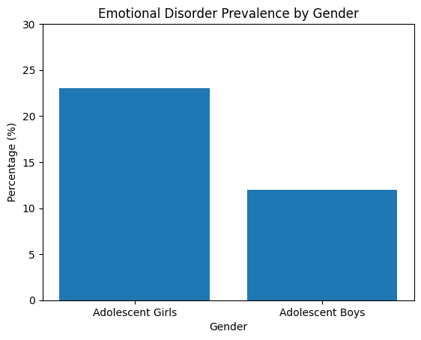
Statistical Evidence

According to NHS Digital (2023):
- In England, 20.3% of 8-16-year-olds were likely to have a mental disorder.
- The most prevalent were emotional disorders (primarily, anxiety and depression).
- Girls had higher rates compared to boys.
According to Twenge et al. (2020), those teens who spent more than three hours per day on social media had a strong likelihood of reporting depressive symptoms. Nevertheless, Odgers and Jensen (2020) state that moderate consumption does not always lead to harm, and personal vulnerability can also be a major concern. This puts a spin on the argument.
Some examples of Reviewed Articles
1. Keles et al. (2020)
This systematic review studied the correlation between the use of social media and depression, anxiety and psychological distress among adolescents. Most of the studies included in the research determined that there was a positive relationship between excessive use of social media and the development of depressive-related symptoms. The mechanisms mentioned in the review included cyberbullying, the fear of missing out (FOMO), and disruption of sleep. This substantially underlines the theme that digital exposure leads to emotional disorders.
2. Wright et al. (2021)
This is a longitudinal evaluation of cyberbullying and the mental health of adolescents. It was discovered that victims of online harassment had a high probability of developing anxiety and depressive symptoms in the long run. Causal interpretation is enhanced by the longitudinal design. This research supports the realisation that certain adverse digital interactions, as opposed to overall use, are especially damaging.
3. Odgers and Jensen (2020)
Conversely, this paper highlighted that the impact of digital technology is often exaggerated. It contended that the correlation between social media and mental health is on a smaller scale and is dependent on preexisting vulnerabilities. This is a safer opinion and proves that digital media can be a risk enhancer and not a major factor.

Policy and Legislation
Online safety is a concern for the UK government. The Online Safety Bill is one of the policies that strives to control harmful online materials. Digital literacy programmes are promoted as schools are advised to implement the programmes under the direction of the Department for Education. Critics, however, contend that the policy responses are more regulatory than preventive, focusing on regulation rather than building resilience and educating on mental health.
Implications
Positive Implications
- Peer support networks can be achieved through social media.
- It might make it easier to experiment with identity.
- Online mental health campaigns create awareness.
Negative Implications
- Strengthened social comparison.
- Cyberbullying.
- Sleep disturbance.
- Body image dissatisfaction.
- Anxiety increased in girls.
All this implies is that digital environments are a factor in the increased rates of anxiety and depression, but they have different impacts depending on usage patterns and individual susceptibility.
Connection to Other Themes
Social media interrelates with:
- Educational stress (grade and performance comparison online)
- Family instability (parental monitoring exposes more risks)
There is hardly a case of digital stress in its own right, but rather, it exacerbates other stressors, whether at school or home.

4.4 Theme 2: Academic Pressure and School-Related Stress
Definition and Conceptual Overview
Academic pressure is defined as the pressure of a psychological burden on students as a result of the educational requirements, such as exams, coursework, performance expectations, and uncertainty about future careers. Examples of school-related stress include the intensity of workload, selection of environments, teachers' expectations, peer comparison and high-stakes tests.
The academic achievement in the UK context is highly related to the GCSE and A-level results, which play significant roles in the entrance to the university and the employment opportunities. Thus, adolescents treat examinations as decisive about the future, which predisposes them to anxiety.
Background and Context
The education system in the UK has experienced structural changes over the last ten years, focusing on accountability, standardised testing and performance. According to the reports of Ofqual (2023), examinations are always cited among the main causes of stress among students.
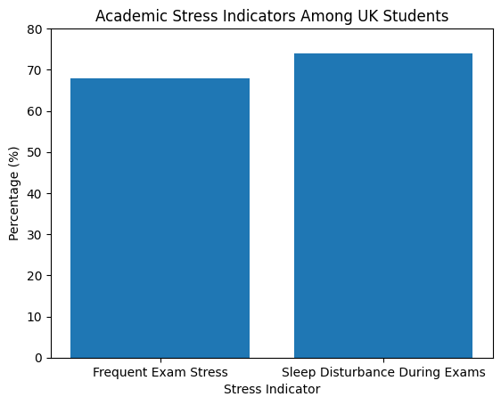
Quantitatively:

- About 68 per cent of the students in the secondary schools said that they felt stressed about exams most of the time (Ofqual, 2023).
- Sixty-four per cent of students in Year 11 said that they experienced disturbance in their sleep during exams.
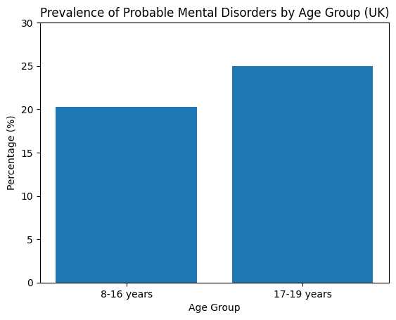
- The prevalence of emotional disorder peaks dramatically during the early adolescence period (about 10%), then nearly doubles during the mid-adolescence (about 23% in girls at the age of 17 to 19) (NHS Digital, 2023).
- This is an upward trend that is accompanied by rising expectations and transition pressures in academics.
- The uncertainty in education was exacerbated by the COVID-19 pandemic. According to Loades et al. (2020), school closures and distance learning became a source of loneliness and academic anxiety, especially in vulnerable students.

Impact on Research Question
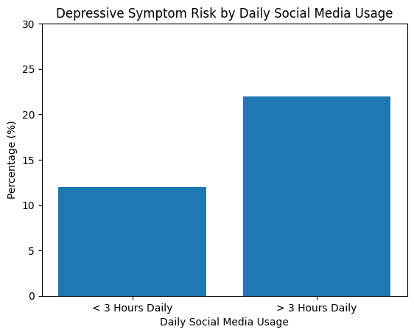
Academic stress is the direct cause of increased cases of anxiety disorders among adolescents in the UK. Chronic stress responses can be stimulated by performance-related worry, fear of failure and competitive school cultures.
For example:

- Leveraging high academic stress in adolescents increases the likelihood of reporting clinically significant anxiety symptoms approximately 2-3 times (Ofqual, 2023).
- The levels of anxiety related to exams are the highest in GCSE and A-level stages, i.e. when there are more referrals to CAMHS.
- Therefore, the problem of academic pressure is not simply a situational one since it can lead to chronic emotional disorders.
Theoretical Framework
Stress and Coping Theory by Lazarus and Folkman in 1984
In this theory, the assumption is that stress occurs when the perceived demands surpass the perceived coping resources. Young people who experience high workloads and heavy demands without support or coping abilities can evaluate this as a threat to academic performance, eliciting anxiety responses.
Cognitive Behavioural Theory
Cognitive distortions may include those that the students may develop:
- My life is destroyed if I fail one exam.
- I am the only one who is not coping well.
- These thinking patterns support depressed and anxious characters.
Ecological Systems Theory
School is one of the key microsystems. Emotional vulnerability is increased when school stress is involved, when it interacts with peer comparison and parental expectations.
Statistical Evidence
NHS Digital (2023) reported:
- Probably, 20.3 per cent of children between 8 and 16 years of age possess a mental disorder.
- This is about 25 among the 17-19-year-olds.
- The most frequent are emotional disorders (approximately 17% in mid-adolescent girls).
Ofqual (2023) reports:
- 65 per cent of students had the pressure of doing well as instructed by their teachers.
- 59 per cent experienced self-pressure.
- 52 per cent complained of physical symptoms of stress (stomach aches, headaches).
- The studies also show that academic stress is a source of higher absenteeism, and the level of stress connected with school avoidance has been increasing steadily since 2019.
These statistics imply that mentality and health patterns have a quantifiable association with factors of educational stress.
Reviewed Articles examples
1. Ofqual (2023)
This report on the UK revealed that anxiety increased due to exam reform and the lack of certainty about post-pandemic grading. The students had reported anticipatory anxiety several months before examinations. This helps to maintain the theme that institutionalised educational systems are sources of emotional stress.

2. Loades et al. (2020)
Even though the main focus of the review was on social isolation, the authors have also emphasised the impact of remote learning on routine and academic security that led to depressive symptoms. The review established that loneliness was a risk factor for depression, with a maximum of 40 per cent in the youth. This shows the intersection between academic and social disruptions.
3. Twenge et al. (2020)
Although attention was paid to the trends in the digital environment, this research also discovered that higher levels of achievement pressure were associated with the prevalence of mood disorders. According to the authors, the expectations of adolescents concerning academic and career achievements are current and higher than those of past generations. All these studies demonstrate that academic stress is indirect (societal expectations) and direct (exam pressure).
Policy and Legislative Environment
Reforms in the NHS have introduced mental health support teams in schools by the UK government. Nevertheless, access is still disproportionate. NICE guidelines suggest that children and adolescents should be dealt with early in terms of anxiety disorders, but the waiting time to CAMHS is as much as three months in some areas. Schools are being more and more informed to adopt well-being strategies, but these are still secondary to academic performance measures. This brings a conflict between the well-being promotion and the performance accountability.
Implications
Positive Aspects
- Motivation (eustress) can be promoted by moderate stress.
- Academic challenge has the power to make one resilient.
- Routine and social support are offered by structured environments.
Negative Aspects
- Anxiety disorders are caused by chronic stress.
- Sleep deprivation enhances symptoms of depression.
- Fear of failure decreases self-esteem.
- Competitive comparison aggravates emotional distress.
- Mathematically, when 68 per cent of students report frequent exam stress, and some 20 per cent fit the requirements of likely mental illness, there is likely a high overlap.
Connection to Other Themes
Academic pressure is posing considerable interaction with:
- Social media (comparison of grades and achievement in public).
- Parental instability (parental pressure or lack of support).
- An example is that teenage children of volatile households might lack coping mechanisms, which increases their fears in school.
- This illustrates the interrelationship between stress systems that impact the adolescent psyche.
4.5 Theme 3: Family Instability and Home Environment
Definition and Conceptual Overview
Family instability is the term that defines the disturbances at home, which can be parental conflict, divorce, domestic violence, irregular parenting and financial strain. Usually, the home is the main source of emotional support to adolescents; lack of permanence in this system exposes them to anxiety and depression.
Background and Context
Haworth et al. (2020) note that being exposed to domestic conflict is a significant contributor to the emotional distress of children and adolescents. In the UK:
- About 1 out of every 5 children is exposed to some domestic conflict.
- Young people exposed to mental illness in their parents are predisposed to developing the disorders in the form of anxiety twice as often.
- Economic hardship has been linked with depressive symptoms.
- According to NHS Digital (2023), more households with financial hardship are more prone to mental disorders.

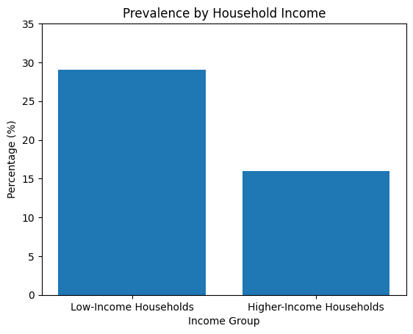
For example:
- Those in low-income households were more likely to have a probable mental disorder than those in higher-income households, and this was 29% and 16%, respectively.
- Such differences are signs of structural inequalities.
Impact on Research Question
Family instability is both a direct and indirect factor:
Direct:
- Emotional insecurity.
- Trauma exposure.
- Lessened security of attachment.
Indirect:
- Reduced academic support.
- Heightened unsupervised digital availability.
- Hypertensive stress reactivity.
This theme is essential in the interpretation of the variation in the prevalence of anxiety and depression among the socioeconomic groups.
Theoretical Framework
Attachment Theory
Emotional dysregulation is enhanced by insecure attachment patterns that are developed by inconsistent caregiving.
Ecological Systems Theory
This is because the family microsystem directly influences coping capacity.
Stress and Coping Theory
Chronic stress at the home level exhausts resources on coping, making one more vulnerable to anxiety.
Statistical Evidence
Data from NHS Digital (2023):
- The prevalence rate of emotional disorders is almost twice that of adolescents living in families where parents experience psychological distress.
- Others who have a family breakdown have much higher scores on depressive symptoms.
Additionally:
- 30-40 per cent of those who are referred to CAMHS claim that stress in the family has contributed to the condition.
- Young individuals who witnessed domestic violence have anxiety levels of up to 1.5-2 times as great as those of other individuals.
- These values are pointing to a quantifiable relationship.
Reviewed Articles
1. Howarth et al. (2020)
In this systematic review, there were significant relations between exposure to domestic abuse and child mental health problems. High levels of anxiety manifestations were observed in children of high-conflict households. This goes a long way to support the theme.

2. Patel et al. (2018)
The tackling of social and economic adversity as one of the key determinants of youth mental health globally was highlighted by the Lancet Commission. The report suggests that mental health interventions should mitigate structural inequalities. This extends the theme to the systemic factors.
3. Thapar et al. (2012)
Even though this study indicates the interplay between hereditary susceptibility and environmental pressure, this was not the case before. Depressive episodes in genetically predetermined adolescents may be provoked by the instability of their families. These articles taken together show the effects of both environmental and biological interaction.
Policy Context
- The safeguarding policies in the UK are meant to safeguard children against domestic abuse. Nevertheless, the provision of mental health services to teens in dysfunctional homes is overstretched.
- CAMHS referral levels can limit moderate cases to crisis level.
- There are early intervention family support programmes which are not regularly funded by local authorities.
Implications
Positive Factors
- Nurturant parenting attenuates both academic and online stress.
- Resilience is encouraged by family cohesion.
- Open communication minimises emotional repression.
Negative Factors
- Conflict raises cortisol levels and chronic stress.
- The financial crisis enhances doubt.
- Isolation and depressive cognition are the results of emotional neglect.
- Regarding the prevalence, considering that it is 16% in stable households and 29% in financially constrained households, it is significant (NHS Digital, 2023).
Connection with Other Themes.
Family instability is worsened:
- Scholastic stress (reduced homework help, increased performance anxiety).
- Social media threat (reduced control, increasing escapism).
- On the same note, adolescents who go through online bullying might be facing a lack of emotional parental support, exacerbating anxiety results.
- In this way, cumulative stress at a systems level leads to the emergence of mental health disorders and not an individual factor.
4.6 Evidence-based Critical Evaluation
Although there are good relationships, the evidence base is limited:
- A number of digital studies are correlational.
- Self-report surveys can exaggerate the symptoms.
- Data after the pandemic can be characterised by short-term peaks rather than long-term trends.
- Socioeconomic factors can confound digital and academic results.
Nevertheless, the same consistency of national surveys and systematic reviews, along with longitudinal research, helps to make the general point that adolescent emotional disorders are actually on the rise, and not just overdiagnosed.
Implications for Practice
1. Schools
- Implement programmes in managing stress in an organised manner.
- Lessen over-performance-based communication.
- Incorporate mental health literacy in the curriculum.
- Enhance access to school-based counselling.
2. Families
- Interventions in parenting support.
- The plans of financial aid for the weak families.
- Accessibility of family therapy is enhanced.
3. Digital Environment
- Tougher internet security laws.
- Online resilience education.
- Sleep promotion hygiene campaigns.
4. Health Services
- Reduce CAMHS waiting times.
- Use early intervention models.
- Grant more funding based on the increase in prevalence levels.
- Considering the fact that 1 out of 4 older adolescents can now fit the criteria of a mental condition, the capacity of services should be in accordance with epidemiological dynamics.
4.7 Chapter Conclusion
The systematic literature review findings based on the thematic analysis were introduced and critically discussed in this chapter. The rise in cases of anxiety and depression in adolescents in the United Kingdom was found to be caused by three major themes, including social media and the impact of digital, academic pressure and stress in school, and family instability and home environment.
The results show that adolescent mental health cannot be attributed to a single cause. Rather, the 10-12 prevalence rate increased to more than 20-25 prevalence rate in mid-late adolescence (NHS Digital, 2023), which is the sum of the digital and educational pressures and pressure of home-based factors. Social media has a role to play in social comparison, cyberbullying, and disruption of sleep. High-stakes examinations and performance expectations are the sources of chronic stress that are created by academic pressure. Family instability is one of the risk factors, as it exposes oneself to vulnerability due to the lack of emotional security and the inability to cope with stress. Notably, the structural inequalities are indicated by numeric differences, e.g. prevalence of mental disorder being 29 per cent in financially strained households and 16 per cent in more stable households.
These themes are interrelated, which supports the ecological perspective developed by Bronfenbrenner and shows that adolescent anxiety and depression are built in intersecting systems of influence, and not in isolation. The next chapter will critically review the general literature, strengths, and weaknesses of the evidence base, research gaps, and provide evidence-based recommendations for health, education, and policy practice in the UK.
CHAPTER 5: CONCLUSION AND RECOMMENDATIONS
5.1 Conclusion
This dissertation aimed to critically discuss the increase in anxiety and depression among adolescents in the United Kingdom and explore the causal factors and policy enactments that shape this health issue in the population. The overall purpose was to investigate the incidence, antecedent factors and the current policies with regard to adolescent mental health in the UK.
Chapter 1 defined the problem and provided the rationale, which included national data showing that about a fifth of young people fit the requirements of a likely mental disorder. Chapter 2 offered the historical, theoretical, and contextual background and relied on such frameworks as Cognitive Behavioural Theory, Ecological Systems Theory, Social Comparison Theory, and Stress and Coping Theory to elucidate the vulnerability of adolescents. Chapter 3 identified the systematic literature review approach and thematic analysis. Chapter 4 generalised the findings into 3 key themes, which include: social media and digital influence, academic pressure and school-related pressure and family instability and home environment.
The results revealed that adolescent anxiety and depression are multifactorial and influenced by interacting systems but not by isolated ones within the UK. Digital exposure adds to the social comparison and cyberbullying, to academic structures contributing to chronic stress and family instability, and to emotional vulnerability. The research aim and objectives were well met because the study found patterns of prevalence, critically examined contributory factors, estimated policy responses, and synthesised evidence-based implications to practice.
In general, this dissertation has brought into focus the critical challenge of adolescent mental health as an escalating and complex problem that needs integrated intervention at the health, education, family, and digital policy systems.
5.2 Recommendation(s)
Following the conclusions of this dissertation, it is proposed to recommend the following for future practice in the field of education, healthcare and policy frameworks in the United Kingdom. All recommendations are based on the themes that were defined in Chapter 4 and take into account the possible barriers and their resolution.

Recommendation 1: Summer Mental Health Support Systems in Schools
Rationale
The results indicated that approximately 68% of learners were found to experience regular exam stress and that academic pressure can result in a major source of anxiety disorder. Schools pose an ideal platform for adolescent development, and as such, they present a key milestone in early intervention.
Practical Recommendation
Any mental health support system introduced in all secondary schools in the UK should include the following:
- School-based mental health practitioners.
- Compulsory stress-management and emotional fortitude sessions.
- Making mental health literacy part of the national curriculum.
- Anxiety and depressive symptoms screening in the major transition stages (e.g., Year 9 and Year 11).
- Mental Health Support Teams (MHSTs) are already in operation in some regions of England, and a universal coverage would decrease access gaps.
Barriers
- Few resources and staffing deficit.
- Local strained teachers with conflicting academic interests.
- The stigma about mental health disclosure among students.
Overcoming Barriers
- Greater mutual funding of the NHS and the Department for Education.
- Educating teachers about the basic knowledge of mental health without overloading them.
- Self-referral systems, which are confidential, are used to de-stigmatise.
- Integrating wellbeing in Ofsted assessment systems so that schools do not only focus on academic achievements but also on mental health.
- Through normalisation of mental health strategies in learning institutions, early interventions would minimise cases of development to more serious disorders and strain on CAMHS services.
Recommendation 2: Build a National Digital Solidarity and Online Safety Education Programme.
Rationale
The study found high correlations among high consumption of social media, cyberbullying and depressive symptoms. Teenagers who use social media more than three hours a day are at high risk of experiencing emotional distress. Nevertheless, social connection opportunities can be found online as well. Instead of directing a full ban on the use of technology, it should be all about digital resilience and healthy use.
Practical Recommendation
The compulsory Digital Wellbeing Curriculum proposed by the UK government in secondary schools should entail:
- Social comparison and unrealistic online presentation education.
- Education in the detection and reaction of cyberbullying.
- Recommendations on the healthy limits of screen time.
- Encouragement of sleep hygiene procedures.
Digital content critical thinking
Also, there is a need to have increased partnership between social media companies and policymakers to:
- Improve cyberbullying reporting.
- Minimise harmful content algorithms.
- Campaign to raise youth mental health awareness.
Barriers
- Technology company resistance.
- Fast-changing online platforms.
- Inability to control the time spent in front of the screen at home.
- Lack of parental awareness of online risks.
Overcoming Barriers
- Legal implementation via online safety control.
- Parent education is provided in schools.
- Collaboration with technology companies to co-architect youth-friendly safety tools.
- Promoting digital literacy in parents.
This suggestion acknowledges that exposure to digital can never be eradicated but can be handled positively through education and regulation.
Recommendation 3: Scaling up Family-Based Preventive and Support Intervention
Rationale
The results indicated that there were great differences in the prevalence of mental health among low-income and higher-income households (29% vs 16%). Adolescents are very vulnerable to family instability, parental conflict, and financial stress.
Treating the mental health of adolescents without considering the family context is a high risk of curing the symptoms and not the causes.
Practical Recommendation
- To enhance family-based support services in local authorities, local authorities should:
- Increased early help programmes for financially vulnerable families.
- Expanding access to family therapy and parenting.
- Integrating mental screening services in community services.
- Enhancing protection and intervention pathways of domestic abuse.
- Schools and primary care services ought to partner in detecting at-risk families at an early stage and avenues of referral before reaching the crisis level.
Barriers
- Financial constraints in local councils.
- Family therapy or social services stigma.
- Attitude differences towards mental health support due to cultural differences.
- Extensive waiting lists of CAMHS restrict access to family intervention.
Overcoming Barriers
- Preventative health redistribution of funds by the government.
- Sensitisation of society on the importance of family support.
- Culturally sensitive community-based services.
- Education of GPs and school personnel on the signs of early warning.
- With the assistance of families, adolescents receive more emotional grounding and enhanced coping ability, which minimises the exposure to cumulative stress across systems.
Comprehensive Implementation Factors
Although these recommendations are different, they can only be effective with a coordinated implementation. A multi-agency approach involving schools, NHS services, social care and digital governance organisations would offer a holistic answer.
The emphasis should be on preventative rather than on crisis intervention, which is reactive. Since someone in every four older adolescents now might be likely to struggle with a probable mental disorder, it cannot be reformed but systemically.

