BA (Hons) Leadership and Management Skills for the Workplace

Understanding and Engaging in the Customer Experience
BMSW 5103

Laszlo Peter Molnar
Student ID: 2113314
Lecturer: Mohammad Rahman

Table of content
Task 1 - How have internal and external factors affected or influenced UPS organisation’s quality systems and controls for customers to deliver a 24-hour customer service? 3
Task 2 - How can UPS deal with the new customer demand and achieve its business objectives by developing and maintaining good customer relationships 24/7/365? 3
Executive summary 3
UPS 3
Introduction 4
Marketing Theories 5
Strategies 12
QUALITY OF SERVICES MEASURING TECHNIQUES 16
Recommendation 20
References 21

Task 1 - How have internal and external factors affected or influenced UPS organisation’s quality systems and controls for customers to deliver a 24-hour customer service?

Task 2 - How can UPS deal with the new customer demand and achieve its business objectives by developing and maintaining good customer relationships 24/7/365?

Executive summary

With the transition to online shopping, the time of customer service inquiries has increased. Online shoppers do not operate during normal hours and shifts from Monday to Friday, but 24 hours a day and 365 days a year. Customers may be ordering from a brand at 3am, and if so, they expect customer service staff to be on hand to answer any questions they may have.
In this report, we will answer the following questions:
- How do internal and external factors affect or have affected the UPS organization's quality systems and 24-hour customer service inspections?
- How can the UPS organization cope with new customer demands and achieve its business goals by developing and maintaining good customer relationships, 24/7/365?

UPS
`The point is in the details. The focus is on simplicity. The key is reliability.
From the smallest box to the largest pallet, they can help you send your important shipments where you want and when you want.
UPS was originally founded in the USA in 1907 as a delivery company. UPS has grown into a multi-billion dollar company that contributes greatly to international trade. Today, UPS (United Parcel Service Inc.) is an international parcel delivery company whose brand name is one of the most well-known and loved brands in the world.
UPS operates more than 100,000 vehicles and more than 2,800 facilities and is one of the 10 largest airlines in the world.
With the development of its fleet and innovative facility technology, UPS strives to reduce its environmental impact, and it also wants to reduce the use of natural resources needed for its activities everywhere in the world.
In UPS numbers
11.5 million Sending and receiving customers
5.5 billion Delivered packages per year
More than 10,300 vehicles running on alternative fuels and using advanced technology
495,000 employees
294.9 million Online tracking requests per day
More than 220 nations and territories served
About 125,000 vans, trucks, tractors, motorcycles
It doesn't matter how often you deliver, just once a year or every day, we provide the right service.
UPS is one of the world’s largest and most trusted global shipping and logistics companies.
(UPS, 1994-2022)

Introduction

In the two tasks, I am looking for information on what information systems are, how they work, and what advantages they bring in the context of its examination, the advantages and challenges of establishing and maintaining good customer relations. I present the UPS Company’s different business strategies and Porter's Five Forces, Ansoff's matrix, CX and CRM strategies.
In addition, I explain the basics of the application of TQM and the SERVQUAL model in the context of the internal application of UPS.

Marketing Theories

Porter’s five forces:

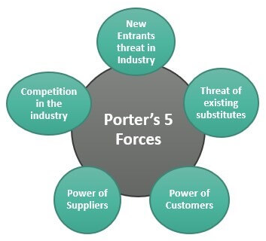Figure 1 Porters 5 Forces

Porter's 5 forces model is an analytical methodology for examining the opportunities and threats of a given industry.
In other words, this model examines whether it is profitable to create a company in a certain sector. It depends on the structure of the market.
Each of Porter's five forces is a factor that affects the potential for profit, and they are:
- competition within the industry,
- the new entrants,
- the suppliers and the
- bargaining position of buyers and
- The threat of substitute products.
The main purpose of this analysis is to find opportunities and identify threats for companies already operating in the industry and companies planning to enter. Thus, it determines the ability to make a profit. (Rasmussen, 2017)

Marketing mix
Marketing mix is the combination of the marketing tools used to achieve a product or service's intended marketing objective.
4P MODEL
The classic marketing mix is equal to the 4P model. This was the first to be used to model corporate marketing activities. The elements of the 4P are the following (consisting of the initial letters of the following English words):
- Product (product, product policy)
- Price (price, price policy)
- Place (place of sale, sales policy)
- Promotion (promotion, sales incentive policy)
MODEL 7P
With the development of service marketing, professionals realized that they had to take into account the characteristics of services in connection with the 4P model, so they added 3P to the original concept. This is how the profession got the 7P. The new elements are the following:
- People (human factors)
- Physical Evidence (physical factors)
- Process (Adam, 2022)

Ansoff Matrix

The Ansoff matrix is a corporate strategy that allows you to choose from four strategic development options:
• Market penetration (the company wants to continue operating in its current market with its existing products, but for the sake of development, it wants to increase its market share - many people follow this strategic version, as it has relatively little risk, success depends in particular on the current state of the market, and company can expect a strong competitive situation);
• Market development (the company wants to break into new markets with its existing products, protects its existing products, and wants to maintain the stability of the usual operation in production – the market and product development strategies are usually used by companies together);
• Product development (the company feels that it no longer has the opportunity to make further progress with its current products on the market, so it appears with a new product in a market that is already known and partly dominated by its current products - using the experience gained and the already established market network);
• Diversification (in this case, the company keeps its current, traditional products and its already conquered market, but at the same time it also orients itself towards a new market, which it wants to break into with newly developed – or, for example, acquired – products.. (Peterdy, 2015-2022)
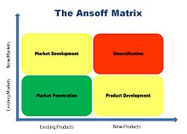Figure 2 Ansoff Matrix

UPS Porters five forces:

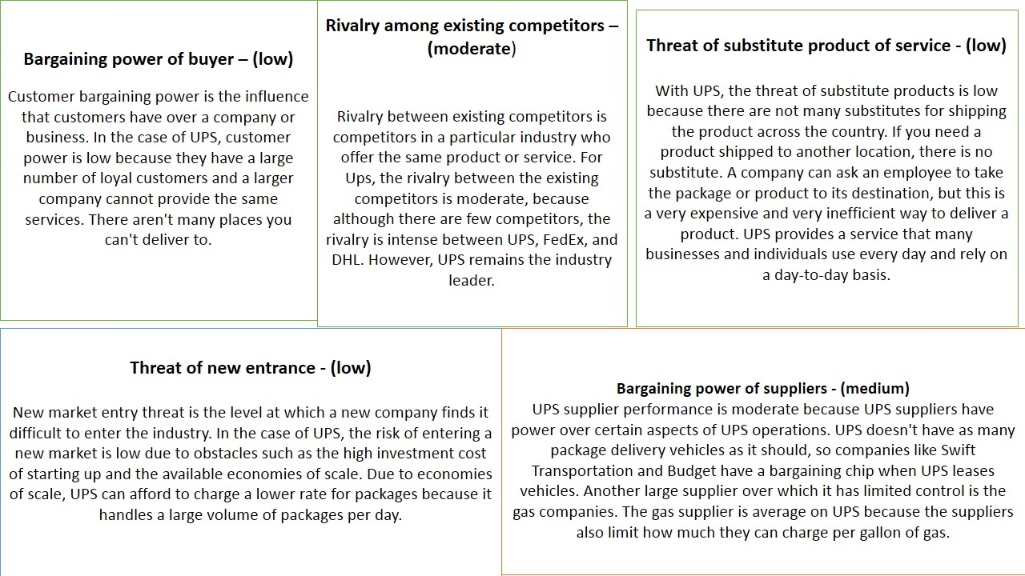 (UPS, 1994-2022)

UPS Ansoff matrix:
Like all companies, UPS uses the Ansoff Matrix for successful international growth
UPS's strategic growth decisions varied depending on internal and external organizational factors. Below, based on the categories of the Ansoff matrix, I detail the strategies that UPS has successfully implemented.

Market penetration:
With our existing product, we want to be active in the current market, and by using our capacity properly, we are trying to achieve the largest possible share. We need to find the tools that can make our current product more attractive to new customers.

This can be achieved by developing potential marketing measures and product additions that can greatly increase the range of actual customers, without requiring major changes on the product or market side.

Increased production capacity, and marketing investment:
- Allows UPS to reach more and more customers in the same market. This results in greater efficiency and effectiveness.
For UPS to reach more consumers in the same market, investing in communication, marketing and advertising make this possible.
UPS can increase its market penetration in existing markets for existing products by experimenting with higher marketing investment.

Competitive Pricing
In order to increase the attractiveness of its products, UPS may introduce price reductions for this purpose. Because of this, competitive pricing will be a source of competitive advantage and lead to higher consumer commitment to the product.
This can increase UPS sales and increased penetration
Market development:
In the strategy to create new products of the company, the markets in this company are targeted in order to achieve growth.
This requires an answer to the following question: how can the product portfolio be expanded by minor conversion of the existing products, taking into account the different needs of the potential new customers?
The answer is a New Customer Segments
Behind this move by UPS must be a reliable service, which may also face serious competition in the new market, so before making a decision, it is worthwhile to consider the desired and actually achievable market share before entering the market.
Product development
The essence of product development is that in this strategy the company tries to conquer the original market with a new product or by changing the characteristics of the original product.
This strategy is more likely to be successful if: its current product no longer brings the expected growth, UPS is working on the development of the existing product in the current market. Of course, it is worth starting any product development after a thorough customer demand analysis, as based on these we will get an answer as to which direction should be taken in changing the composition of the product, whether we are talking about innovation or quality transformation, which will lead to the expected growth.
Diversification
During diversification, we intend to enter a new area with a completely new product or service. Diversification requires not only new capabilities, skills, and technologies but also the reallocation of available financial and human capital.
The main advantage of diversification is that if one company lives in unfavourable conditions, the other is not affected.
Mergers and acquisitions are one way UPS explores its conglomerate growth in terms of entering new businesses. UPS may enter into partnerships with interested companies and stores or may acquire new markets and consumer groups that are completely new and unrelated to existing offerings.
(Hussain, et al., 2013)

UPS marketing mix:
Product:
We want to satisfy consumer needs with our products and services, that is, to sell our products, and to be the best in this area of the market.

UPS Recommended Product Strategy
It should extend Benefits to customers, which include warranty, delivery and after-sales service, helpline services, etc. includes
You need to expand your product portfolio, offering new product lines to meet customer needs.

Price
The price refers to the amount that the customer pays for the product. The most difficult task for businesses is determining the price, because the price is the only source of income, compared to the costs.
UPS Recommended Pricing Strategy
You should introduce promotions and discounts where you lower prices for a short period of time to attract customers and gain market share.
Place
Place can refer to the physical location where a business does business or the channels used to reach markets. "Place" can refer to both retail units and virtual stores.
"Place" includes all the solutions for how the product/service gets from the place of production to the place of use, this is called sales policy.
UPS Recommended Place Strategy
For UPS to open up on social media such as Instagram and Twitter, selling its products on these platforms along with social media posts will allow the company to generate more sales.
Promotion
The role of the promotion: helping the customer in the decision to use a purchase or service. Promotion is a collective term for tools that inspire consumers at the opinion of purchase to try and buy the promoted product.
UPS's recommended promotional strategy
It would be a good idea to include social media influencers, such as bloggers, in your ads. Bloggers be able to post content on their social media pages for advertising purposes.

People
People are directly or indirectly involved in commerce, customer service employees who turn quality into service.
The strategy of people recommended by UPS
UPS should provide training for your sales, customer service and procurement staff as they play a vital role in creating value for customers.

Process
The "process" of the service marketing mix includes everything that conveys the particular service in question to the customer: the activities, procedures, protocols and other things.

The UPS Recommended Process Strategy
UPS must constantly look for ways to innovate and improve processes that improve efficiency and reduce costs. Cost savings equal lower UPS shipping costs.
Physical evidence: the place where customers and service staff can interact.
Environmental conditions - temperature, sound, smell
Location, features - may include maps, equipment, and office decoration
Signs, symbols, and objects - style, personal touch
Communication and information elements
Services are not tangible offerings. We present ourselves to customers with the physical environment, introduce ourselves, and remind them of the performance of the service.

For UPS, all this means that by improving communication and customer service, they will leave a lasting mark in the iron industry. (Adam, 2022)

Strategies
As a result of proactive work, customer-oriented organizations constantly understand the unique problems and expectations of their customers, as well as the connections between these needs. And with their knowledge and understanding of an ever-growing customer base, they consistently deliver products and services that meet these customer expectations.
As far as the relationship with customers is concerned, the company must essentially win every interaction that the customer has with the given company, be it the brand promise - that is, the promises made there must be fulfilled -, contact with customer service, invoicing matters or even the delivery of a as a product.

All departments must do their part in a coordinated way so that based on the customer experience created as a result of all the interactions, the customer is at least satisfied, but it is even better if he feels that we exceeded his expectations.

CX Strategy

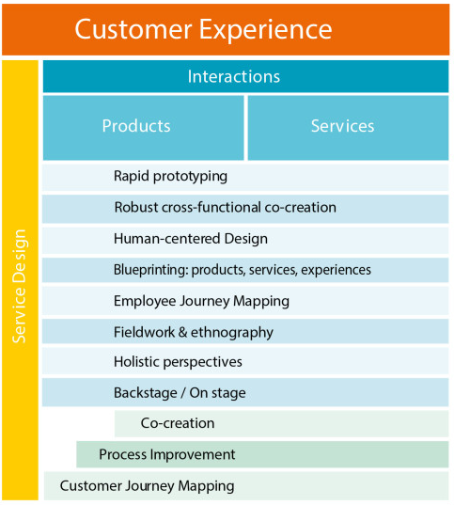Figure 3 Customer Experience

CX is a highly quantitative-based approach, where CX projects typically focus on improving a given company's existing offerings to generate quantifiable higher customer satisfaction results.
This combined CX-service design approach - such as continuous understanding of actual customer needs and creation of validated solution concepts - can help companies deliver smooth end-to-end experiences that can actually serve customers' constantly changing needs.
Based on the definition of "customer centricity", when we interpret a word into two semantic parts, we can understand that the term means "customer orientation", and more precisely, its needs. This is exactly the main idea of the concept.
Customer focus is aimed at market concepts. This company's ability to organize a high level of customer service and increase revenue through relationships and customer satisfaction.

Whether the company is customer-oriented or not, you can tell after interacting with the customer through technical support, claims settlement, or service. In other words, customer evaluation helps to understand how the organization pays attention and meets visitor needs.
A positive customer experience can help boost your business and build your brand. 80% of customers say their brand “experience” has the greatest impact on brand loyalty and ultimately profitability.

From Zendesk 2020 CX Trends Report 2 (Wintermantel, 2021):

75% of customers are willing to spend more with companies that provide them with a good customer experience.
50% of customers switch to a competitor after a bad experience.
80% of customers switch after more than one bad experience.
A few bad experiences with a brand, even if not terrible, can lead to lost dollars. Research shows that $1.6 trillion is lost annually in the United States due to poor customer service.

Customer Service Management Strategy
The purpose of sales is obviously to increase income and profit. CRM systems help the company focus on the most important customers. They also ensure that the work of sales, which can be tightly regulated or flexible, actually results in sales. Added to this is smooth internal communication and information sharing. All of these together lead to a successful deal.
The development of an effective CRM is accompanied by a change in attitude: the product/service-oriented approach is replaced by a customer-oriented philosophy and corporate culture.
It can only function effectively if it is backed by a suitable corporate philosophy and culture, committed management, and customer-oriented strategies.
With the help of CRM, the service provider... can have greater control over the service process during service provision, be able to manage customer expectations more effectively, you can understand what your customers really need, with services adapted to the users’ expectations, you can achieve greater customer satisfaction, increase the customers’ faith in the service provider, and gain a competitive advantage.
Elements of CRM
- The customer: we can only become successful if we see value in our customers because they also contribute to the value since they will generate income for the company.
- The culture: In the new culture, the primacy of mass marketing is taken over by segment- and customer-oriented marketing.
- The processes: the company designs or transforms its business processes in such a way that its sole purpose is to satisfy customers.
- Satisfaction: the most important factor in acquiring and retaining customers is the creation and maintenance of customer satisfaction.
- Loyalty: the goal is to establish long-term, loyalty-based relationships with customers and to deepen these relationships.
- Information: the knowledge gathered about the habits, decisions, and behavior of our customers is an essential accessory and prerequisite for business planning.

Customer relationship management (CRM) with UPS:
The true purpose of CRM – (as with any marketing campaign):
A special form of profit increase: increasing the value of the entire customer base, by creating and increasing customer loyalty. However, this requires knowing the individual value of the customers.
CRM software was developed for the IT support of a customer-centric corporate philosophy. These solutions are based on a central customer database, in which all master and transactional data and information related to customers can be found and easily and quickly accessed. Thanks to this, it is significantly easier to analyze the customers' habits and needs, which ultimately enables better and more flexible service.
UPS was forced to provide its CRM system with a WEB interface, without it becoming practically unsellable. And this is Zenkraft.

Zenkraft CRM basics:
Salesforce makes shipping, tracking, and returns applications.
- enables the "Where's my order?" function.
- Status Tracking - the ability for agents to email UPS return labels to customers.
– Estimated delivery dates and shipping costs on checkout, tracking notifications, and self-service returns.
Salesforce order management
– Book and track UPS shipments directly from fulfilment orders. Real-time shipment tracking with delivery notifications. (UPS, 1994-2022)

QUALITY OF SERVICES MEASURING TECHNIQUES

There are many ways to measure the quality of services tool was developed. Most of the differences between the methods can be traced back to different approaches to the concept of quality. When determining the quality of the service, most models take into account the difference between the quality perceived by the consumer and the quality that appears in his expectations.

Total Quality Management
The application of TQM enables quality-oriented management of the company. When applying ATQM, it is not simply about ensuring quality, TQM is a management philosophy covering the management of the entire company.
The literature defines three principles of TQM:
1. Customer focus, according to the TQM approach, means that the focus of the company's activity is always the effort to satisfy consumer needs because the company's ability to meet customer expectations and achieve customer satisfaction is a condition for its successful survival. In order for the company to be able to satisfy the needs of its consumers, it must assess them correctly.
In the case of services, this is much more difficult than in the case of well-defined, clearly-defined products. The services expectations are much more subjective and more difficult to express.
2. According to the principle of continuous improvement, the company's managers and employees do everything they can to improve performance by improving processes. By gradually improving and adjusting the production/service processes, the company can better meet the challenges of the rapidly changing market environment. The company must constantly look for improvement opportunities, the process does not end with the solution of an emerging problem. The principle covers all aspects of the company, be it raw materials, production methods, or labour utilization.
3. The third principle is employee empowerment. When introducing TQM, we can expect a certain degree of resistance from the employees, since the appearance of all radically new things carries uncertainty and risk in the company. At the same time, by involving the employees in the processes, we can achieve a reduction of this resistance, since they will consider the new system as their own, rather than from the outside, it would have been introduced regardless. In addition, since employees have significant experience and knowledge of the company's operations, they can provide new ideas for TQM implementation. (K & A, 2003)

Improved communication following delays

Positive post-purchase experiences following a problem can strengthen retailers' long-term loyalty. Clear communication around delivery expectations can go a long way toward gaining trust and more sales. (K & A, 2003)

The unreliable delivery of the past year has caused a crisis of confidence among online consumers. According to a March 2021 UPS survey of 896 small and medium-sized businesses, 63% of retailers have seen an increase in lost or damaged package incidents over the past year, with nearly half (48%) reporting problems with post-delivery theft drew attention. The same suppliers note that the biggest impact is time lost in handling claims, but they also experience financial losses, cancelled orders, and negative reviews. (UPS, 1994-2022)
The consumer's dissatisfaction can lead to complaints, which the company must pay attention to and which must be handled in some way. However, the organization should not strive to eliminate complaints, but rather to eliminate errors and solve problems.

SERVQUAL model
The most frequently used model is the SERVQUAL model. This model starts from the difference between the expected and the experienced service in determining quality. He tries to reveal and analyse the reasons for the difference.
The SERVQUAL model is based on five dimensions of services. Twenty-two pieces, the state of the dimensions of quality asks a question that helps to determine. Of these, 5 statements pertain to "reliability" and "empathy skills", while 4 to 4 examine "objective elements", "helpfulness" and "safety".

Furthermore, the SERVQUAL questionnaire examines only routine processes and does not ask what happens if something goes wrong with the service. Statements examining expectations are usually given the maximum score by the respondents, indicating that the presence of the given characteristic is important to them. Thus, in the end, almost all statements regarding expectations are scored as seven, the rating of 1 "I do not expect at all" is generally not used.

TQM also places great emphasis on satisfying the needs of internal consumers, since the final product/final service is significantly influenced by the results of each phase.
However, the SERVQUAL model cannot be applied to internal consumers, because for them primarily the "performance" after acceptance, the final result, is authoritative, and the expected and perceived quality is difficult to define in their case. (K & A, 2003)

We are looking for the reasons that led the company to success and development. And this was the power of total quality control. I will explain how the company implemented its program according to the basic aspects of TQM:
Technological innovation;
With constantly new technology, UPS has saved millions of dollars. The Delivery Information Acquisition Device (DIAD) developed supports UPS's sustainability efforts and is continuously updated to improve these efforts. Another way to achieve sustainability is to use its latest technology, On-Road Integrated Optimization and Navigation (ORION). The use of ORION improves and reduces the routes used by drivers to deliver packages, thereby reducing fuel costs. (D'Arcio, et al., 2014)

Employee empowerment:
He constantly motivates and trains employees and ensures a healthy and pleasant working environment.
UPS uses technology to help its employees collaborate while keeping the cost of phones and computers low. This helps employees to cooperate. All phone calls, spreadsheets, documents, and e-mails are updated daily, so they help employees not only in a specific location but worldwide.
Quality of service
UPS values its customers and constantly monitors their changing needs.

Customer management
It not only measures customer satisfaction, but also their joy. According to another method, which proves the commitment to its customers, that instead of advocating fast delivery at any price, the religion assigns delivery drivers to stop you. Let them get out of the truck and give them free time to communicate with customers. (D'Arcio, et al., 2014)

Recommendation

The 1-2. In the assignment, I explained what information systems are, how they work, and what advantages they bring. I presented different business strategies and Porter's Five Forces, Ansoff matrix, CX and CRM strategy.
Apart from that, I explained the basics of applying the TQM and SERVQUAL model in the context of UPS's internal application.

UPS's business strategy is industry-wide differentiation, and its five forces are low bargaining power of customers, low threat of substitutes, moderate bargaining power of suppliers, low threat of new entrants, and moderate rivalry among existing competitors. UPS collaborates using emails, phone calls, spreadsheets and documents. UPS uses various hardware and software components to efficiently store data, and procedures are performed by UPS employees (humans).
In the case of UPS, you can tell by examining the relevant marketing (service) theories/models/methods that the organization has understood how it can cope with new customer needs and how it can achieve its business goals by developing and maintaining good customer relationships. UPS knows how important the balance between technology and interactions in the workshop is. UPS is clear about the importance of employees and does everything to ensure that they are well trained and satisfied.

References
Adam, C., 2022. Marketing blogger. [Online]
Available at: https://marketingblogger.hu/marketing-mix/
[Accessed 15 12 2022].
D'Arcio, J. és mtsai., 2014. United Parcel Service. [Online]
Available at: http://ups-teamtres.blogspot.com/p/introduction_28.html
[Hozzáférés dátuma: 28 12 2022].
Hussain, S., Khattak, J., Rizwan, A. & Latif, M., 2013. ANSOFF matrix, environment, and growth-an interactive triangle.. Management and Administrative Sciences Review, Volume 2, pp. 196-206.
Katalin, P. & Andrea, R., 2003. Szolgáltatás minőség elmeletben es gyakorlatban, Debrecen: Debreceni Egyetem.
Peterdy, K., 2015-2022. CFI Education Inc.. [Online]
Available at: https://corporatefinanceinstitute.com/resources/management/ansoff-matrix/
[Accessed 20 12 2022].
Rasmussen, D., 2017. Michael Porter’s Competitive Strategy., US: Harvard Business School.
UPS, 1994-2022. United Parcel Service of Americ. [Online]
Available at: https://www.ups.com/au/en/help-center/technology-support/ready-program/customer-relationship-management.page
[Hozzáférés dátuma: 22 12 2022].
UPS, 1994-2022. United Parcel Service of America, Inc. [Online]
Available at: https://about.ups.com/us/en/our-company/global-presence/corporate-facts.html
[Accessed 10 12 2022].
Wintermantel, H., 2021. How to Understand the Customer Experience, s.l.: Customer Success Strategy & Innovation.

