ENTREPRENEURSHIP
Student Name: Remus Nicolae Pirvu
Student ID: 2112416
Module Code: LCBB5001

BUSINESS DESCRIPTION / MARKET OPPORTUNITY
The company named "Eat Well" is going to open an organic food store in London, UK. It is a sole proprietorship business. It means the company has only one owner. The mission statement of the company is rightfully suggested by its name "Eat Well." The company wants to provide organic food products to the entire generation. The main mission of the company is to focus on the suave objectives of the health of the citizens of the UK and maintain the values of proper nutrition in terms of creating robust aspects of immunisation. The products of the company are entirely organic and no sense of contamination can be found in them. After the derogating facts of Covid 19, the main concern of the entire humanism depends on the aspect of proper healthy measures. Therefore the main concern of the business is to enhance the level of immunisation of the people. After the pandemic, the buying behaviour of consumers has shifted toward online mode. Therefore besides a store in London, "Eat Well" wants to focus on the online delivery service of its products. The efficacy of online mode can be utterly helpful for the business to achieve desired goals more effectively.

INDUSTRY ANALYSIS – Porter’s 5 forces
In terms of creating effective products and running a business successfully, it becomes an indispensable factor to analyse the industry properly. Porter’s 5 forces model is one of the foremost objectives that help a business environment to carry forward its business operation which was developed by Michael Porter in 1992. It is such a model that assists a business to intervene in the aspects of the market and fosters its activity in terms of getting a proper place as compared to others (Sánchez-Cambronero et al., 2020). The five forces are discussed below-

The threat of new entry: In the realm of competition it becomes an integral factor to possess the threat of new entries. The organic market of the UK is no less an exception in this regard. In the five years, the organic food market of the UK grew about 30% and reached 3 billion pounds in the year 2021 (Statista, 2023). For that reason, it becomes an important factor to be grabbed by the threats of new entries in such a flourishing market. Whole Foods Market, As Nature Intended, Greenlands Health Food, and Organic & Natural are some names of companies in the organic food sector (Yelp, 2023). Therefore "Eat Well" can be stumbled across in terms of fostering its business in such a place where several companies have already made their impacts.
The threat of substitutes: The next level of the model discusses the threats of the substitutes. The organic food market in the UK is flourishing at a rapid speed. It becomes an important factor for any company to possess some differentiation strategy and foster effects of optimisation of the market to mitigate the factors of being substituted. For that reason, "Eat Well" needs to focus on some positive aspects and differentiation strategies in terms of coping with the threats of substitutes. If the price, positioning, and marketisation strategy of the company can not be uplifted properly, the substitute companies like Veg-hut, Daylesford Organic, and Planet Organic can substitute the efficacy of the brand image of "Eat Well."
Bargaining power of customers: Customers are considered the main epitome of success for any business. If the customers can not be generalised properly, no business can attain the general level of growth. In terms of the UK, a survey has generalised the fact that 3 out of 10 people which constitutes 29% prefer organic foods. Compared to the entire civilisation it has been observed that around 53% of people favour organic food (Yougov.co.uk, 2020). Therefore it is a positive sign for "Eat Well" to think about its realm of profit where the customers crave organic products.
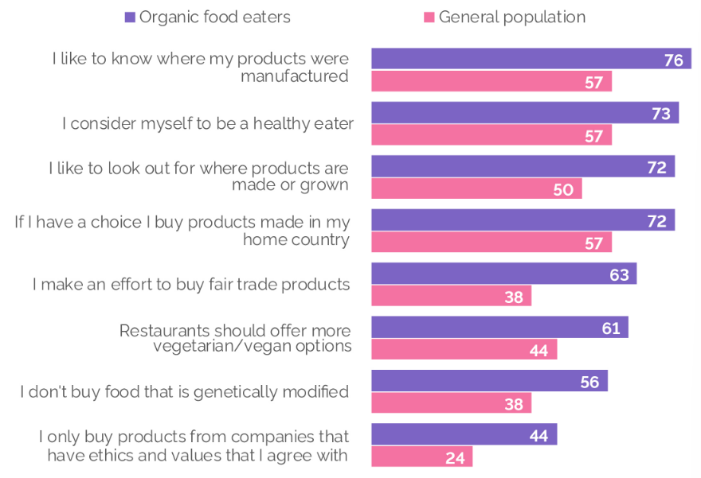
Statements of the attitude of Organic Food eaters in the UK
(Source- Yougov.co.uk, 2020).
Bargaining power of suppliers: The suppliers also play a pivotal role in terms of summing up the effectiveness of the business. If the supply chain management is not generalised properly, it creates a negative aspect in the entire business scenario. The key industries related to the enhancement of organic food products in the UK are Fruit & Vegetable Wholesaling, Vegetable Growing, Dairy products, Edible oil, and Egg Wholesaling, Yoghurt as well as other products processing, etc (Ibisworld, 2023). All the relevant industries assist the organic food market to enlarge its share of profit in the UK market. For that reason, “Eat Well” can get a relevant opportunity in terms of creating a good market value in the UK economy.

Competitive Rivalry:

Name of competitor | Differentiation
Yeo Valley Organic | Yeo Valley Organic is a popular family farm in the UK which is famous for rendering the facts of organic products in the entire place. The farm is situated in Somerset where it operates its entire business model (Yeovalley, 2023). “Eat Well” will follow the differentiation strategy of rendering a better place of operation in this regard. The company is going to open its store and run its business in London. London has a higher rate of population in the UK as compared to Somerset. Therefore the differentiation strategy of having a better place of operation will act as a touchstone of success for "Eat Well".
Meridian | Meridian is considered one of the foremost organic companies in the entire UK which renders the extraction process of cane sugar production in the entire UK sector. The main facts of the company optimise the blackstrap molasses which contains calcium and magnesium and provides the views of a robust immunisation process in terms of creating positivity in its business operation (Gazegillorganics, 2023). “Eat Well” differentiates its pricing strategy in this regard to foster the actual creds of its developmental procedures. The company will follow a “Cost-effective pricing strategy” to attract a large number of customers to its products.
Biona | Biona is also considered one of the leading companies in the organic sector of the UK. The company started its operation about 30 years ago in a small kitchen in London. The efficacy of the products that are considered 100% organic created a positive impact on its business operation. The wide range of products is another way of success in the economy of the UK (Biona, 2023). "Eat Well" focuses on advertising strategy in this aspect. As both of the companies operate their business from London, the online department must be strong for mitigating the facts of failure. For that reason "Eat Well" will focus on modern views of the advertisement and the uses of social media in terms of increasing its business growth in the UK.

OPERATIONS AND MANAGEMENT TEAM
OPERATIONS
Here the business is an organic food store in the UK. The company named “Eat Well” is going to open an organic food store in London. The company is going to manage its supply chain management by rendering proper suppliers from the UK. The famous suppliers of the UK are Daabon UK, Community Foods, Ecotone, Helen Browning’s Organic, Greenscents etc (Goorganicuk, 2023). "Eat Well" is going to manage its supply chain management from these suppliers and create a positive value in its operation. As the Covid 19 pushes everyone to convert buying behaviour from offline to online, the company is going to pay more attention to its online department. "Eat Well" also focuses on having a wide range of products in its stores to satisfy the demands of the consumers. The company is going to employ several employees to boost the online delivery system throughout the entire UK.
How would you generate revenue for your business ? How would you prevent loss of revenue?
As narrated by Hamzah and Shamsudin, (2020) customer satisfaction helps to overcome the challenges in a business. Therefore the generation of revenue needs to be optimised properly by any business. Therefore "Eat Well" focuses on the generation of profit more precisely by upselling its products. It will also generate the financial aspects from the angel investors in terms of creating proper values for the business. It is a well-defined fact that the people of the UK are now hankering after the values of healthy measures for developing their immunisation power. Therefore "Eat Well" will focus on upselling the economic trends in terms of generating revenue. The cost-effective pricing strategy and a wide range of products will help the company to upsell the market values and the impacts of the economy more robustly. The company will also look into the trends of the market properly and set aside a good amount of money to prevent a loss of revenue.
MANAGEMENT TEAM
Name | Skills | What do they bring to the firm
Chief Executive Officer | Excellent efficiency in sociability, teamwork, time management, and communication skills. | They employ the most credible employees in the firm and carry forward the business operation more perfectly.
Chief Financial Officer | Efficacy in adaptability skills, communication skills, and analytical skills. | The generation of revenue will be optimised properly and the views of loss can be mitigated by their potential.
Chief Marketing Officer | Robust potential in generalising the trends of the market, outstanding communication skills, and time management skills. | They will look into the trends of the market and suggest proper methods of adaptation to confront any hazardous situation in the business.

MARKETING:
Product: "Eat Well" is going to provide a wide range of organic foods in the UK. The maintenance of hygiene and the fostering views of the inclusion of nutritional aspects in its foods will enhance the life cycle of the products. The company will follow the 'Demographic Segmentation' process. It will focus on especially the young people of London whose age is between 18-30 years and belong to the mid to low-income group.
Price: "Eat Well" will follow a 'Cost effective pricing strategy' to attract a large number of customers to its business arena. The main focus of the company is to target the mid to low-income group in London. Therefore the low pricing strategy will help the company to optimise the factors of success.
Promotional Mix: The Chief Executing Officers of the company will appoint several employees to carry forward the customer relationship management properly. The company will look into the satisfaction level of the customers and allow them to provide feedback on their official website. In this way, "Eat Well" can be able to make proper contact with all the customers properly.
Place: The place of the “Eat Well” store is going to be in London. The company will also be utterly focused on online marketing to cope with the speed of digitalisation. The company will employ a good number of employees in terms of carrying forward its online delivery service. The supply chain management of the company is also very uplifted. Therefore the distribution pattern of the products can be generalised properly.

FINANCIALS
The company 'Eat well' is going to open an organic food store in London, UK. It is a sole proprietorship business. Its main purpose is to provide organic food products at affordable rates. The current generation is very inclined towards eating healthy and organic food products and becoming health conscious on a daily basis. It will be a good opportunity to enter the organic food market at this moment when people are becoming more and more aware of their health. As a startup, the company needs to have some additional funds other than the owner's capital. For this reason, the company raised some additional funds from angel investors. Angel investors are individuals who invest in small startups and businesses directly. They not only provide capital for the business but also help them with their technical and management skills. They usually invest less than £100000 in a business. They are small investors and are good for non-technological startups. Angel investors are not easy to find, they like to keep a low profile and they can be found in the National Angel Capital Organisation and angel Quebec. They also sometimes become members of the board of directors of the company they have invested in.
Use of funds
 | Month 1 (pounds) | Month 2 (pounds) | Month 3 (pounds) | Month 4 (pounds) | Month 5 (pounds) | Month 6 (pounds)
Revenue (from your operations and marketing section) | 100000 | 150000 | 170000 | 210000 | 190000 | 180000
Fixed Costs  (List out your fixed costs)  Rent  salaries | 5000  10000 | 5000  10000 | 5000  10000 | 5000  10000 | 5000  10000 | 5000  10000
Variable Costs  (List out your variable costs)  Transportation cost | 8000 | 8500 | 8700 | 8800 | 9000 | 8200
Profit | 77000 | 126500 | 146300 | 186200 | 166000 | 156800

MARKET RESEARCH: In the UK around 2.8% of total cultivated land follows organic cultivators. Around 489 hectares of land fall under the organic market. 62% of the land that is termed as organic has permanent grassland. In terms of growing cereals, 9% of the total organic area in the UK has been accounted for. Around 5.8 thousand operators of organic firms can be generalised in the UK (Assets, 2023). As of 2019, a rise of 12.6% in the organic market can be observed that accounting for 2.79 billion pounds. For that reason, the organic market is supposed to increase its share rapidly in the market of UK (Theguardian, 2021). In the upcoming 5 years, the value of sales for organic food increased by around 30% and reached 3 billion pounds as of 2021. The growth rate on the per capita spending on all organic food is 5.2% and the value of the retail sale of the agriculture of organic foods in the UK is 2.4 million EUR (Statista, 2023). Therefore the trends of the market in organic food products suggest fact that "Eat Well" can be able to manage a proper view of profit if it follows a suave marketing strategy.

REFERENCES
Assets.publishing.service.gov.uk, 2023. Code of practice for victims of crime in England and Wales - gov.uk (no date). Available at: https://assets.publishing.service.gov.uk/government/uploads/system/uploads/attachment_data/file/974376/victims-code-2020.pdf (Accessed: March 27, 2023).
Biona, 2023. Available at: https://biona.co.uk/ (Accessed: March 24, 2023).
Gazegillorganics, 2023. Meridian Organic Fairtrade Blackstrap Molasses. Gazegill Organics. Available at: https://www.gazegillorganics.co.uk/meridian-organic-fairtrade-blackstrap-molasses-855-p.asp (Accessed: March 24, 2023).
Goorganicuk, 2023. Distributors & Wholesalers. Organic UK. Available at: https://goorganicuk.com/brands/categories/distributors-wholesalers# (Accessed: March 24, 2023).
Hamzah, A.A. and Shamsudin, M.F., 2020. Why customer satisfaction is important to business?. Journal of Undergraduate Social Science and Technology, 1(1).
Ibisworld, 2023. Industry market research, reports, and Statistics. IBISWorld. Available at: https://www.ibisworld.com/united-kingdom/market-research-reports/organic-food-retailing-industry/#:~:text=Biggest%20companies%20in%20the%20Organic,and%20Riverford%20Organic%20Farmers%20Ltd. (Accessed: March 24, 2023).
Sánchez-Cambronero, A., González-Cancelas, N. and Serrano, B.M., 2020. Analysis of port sustainability using the PPSC methodology (PESTEL, Porter, SWOT, CAME). World Scientific News, (146), pp.121-138.
Statista, 2023. Topic: Organic food market in the UK, Statista. Available at: https://www.statista.com/topics/9070/organic-food-market-in-the-uk/#topicOverview (Accessed: March 24, 2023).
Theguardian, 2021. Steep rise in UK's consumption of Organic Food. The Guardian. Guardian News and Media. Available at: https://www.theguardian.com/environment/2021/feb/10/steep-rise-in-uks-consumption-of-organic-food (Accessed: March 27, 2023).
Yelp, 2023. The best 10 organic stores in London, United Kingdom - last updated March 2023. Yelp. Available at: https://www.yelp.com/search?cflt=organic_stores&find_loc=London (Accessed: March 24, 2023).
Yeovalley, 2023. Yeo valley organic. Yeo Valley Organic. Available at: https://www.yeovalley.co.uk/ (Accessed: March 24, 2023).
Yougov.co.uk, 2020. Three in ten Brits (29%) prefer organic food, YouGov. YouGov. Available at: https://yougov.co.uk/topics/consumer/articles-reports/2020/09/09/three-ten-brits-29-prefer-organic-food (Accessed: March 24, 2023).

