Portfolio

Student Name: Zaina Murton
Student Number: 2404047
Course: Design Crafts
Module: ADAD4018 Ways of Thinking

Word count:
Task One – 515
Task Two - 539
Task Three -

Please could you check my figure and bibliography referencing. I am also aiming for at least 65% so please give critiques that could potentially get me this grade, thank you.

Task One, Manifesto:
1 - I create my work because of my passion for 3d and I love having physical outcome to show for all the written and 2d work done prior.

2 - My work could be distinguished by the materials I use as I think creatively when choosing materials to create my work.

3 – Art was therapeutic to me not only as an adult but also as a child.

4 - I tend to be influenced by people who use wood or clay within there work but since joining this course I have been gaining a lot more interest into glass makers.

5 - My work differs from others as every piece I make must have a meaning or a reason that I chose to create that individual piece.

6 - Each piece of work or collection of my work has different audiences but the main people I have addressed work to in the past is adults and occasionally young children.

7 - I like to use colour within my work and find that I either go with a simple natural aesthetic or a bright coloured aesthetic.

8 - When creating my work, I try not give myself many rules as I think that rules are made for people to follow so everyone behaves in the same way, and I do not want my creations to be a part of that.

Art can be extremely therapeutic when done correctly and many artists begin creating art as a young child or as a way to escape from their struggles at any point in their life. This is shown by Winner “Many would agree that engaging in the arts makes us feel better. And I presented evidence that when young children living in poverty engage in art making, they show physiological indices of stress relief.” (Winner, 2018, p. 9). This is well said and backed by Winners own research into children living in poverty. It shows that art can have a bigger and broader impact than commonly known especially when the artist is a child or young person who may be struggling with poverty or a wider world issue that directly affects them. Art is known to be a form of escape for a lot of these children and can help significantly with stress relief as previously quoted by Winner.
When beginning a piece of artwork, the first step is to decide what the piece of art will p. This is a critical step in the design process as it gives a narrative or story to the artwork. Having a meaning or theme to work with it really sparks creativity and gives purpose. It helps narrow down decisions giving a clear path to work with but can also make it easier to work more efficiently without getting overwhelmed by having too many options. Martin & Van Baarle state “Most artists have lots of ideas for their work - sometimes too many - so that they can no longer see the wood for the trees.” (Martin & Van Baarle, 2017, p. 244). Martin & Van Baarle have used a metaphor to explain artist overwhelm and how having too many ideas can end in a state of indecisiveness. A similar metaphor is explained in the Cambridge dictionary as “to be unable to get a general understanding of a situation because you are too worried about the details” (Cambridge Dictionary, 2022) This is a clear definition and shows the importance of a piece of art having a meaning or something to represent for the sake of the artist.
When working on a piece of art having a set of rules is controversial. It is up to the artist to what extend they add rules, but I do not usually restrict myself to a set of rules. For the outcome to be as creative and interesting as possible the rules or restrictions need to be limited this is because it can stop natural creative thoughts and can restrict you to just follow what everyone else is doing. However, as quoted by Irvin “Rules have expressive import in themselves, and they also help to constrain the expressive import of the accompanying material or technical support.” (Irvin, 2022, p. 147). Rules can be incredibly important to help the piece have a distinguishable expression and limit the amount of potential confusion around it. This can also make the piece clearer to the viewer of the work but again is dependent on wether or not this is what the artist wants.

Task Two, Semiotics:
Semiotics as described in the Cambridge Dictionary is “the study of signs and symbols, what they mean, and how they are used” (Cambridge Dictionary, no date) another definition of it is in a book by Louis Hébert and it states “In a nutshell, semiotics (or semiology) is the field of study that is concerned with signs and/or signification (the process of creating meaning).” (Hébert, 2019, p. 273). This helps us understand that semiotics is about signs and what they signify. A sign therefore consists of 2 things, the first being a connotation and the second being a denotation, a denotation is what is physically there and what you can see while a connotation is the hidden meaning / context behind the denotation. There are multiple terms within semiotics but for a simple definition denotation and connotations are the most relevant. Through the next few paragraphs, I am going to be using these signifiers of semiotics to deconstruct this beauty brush advert made by Addis in 1950.
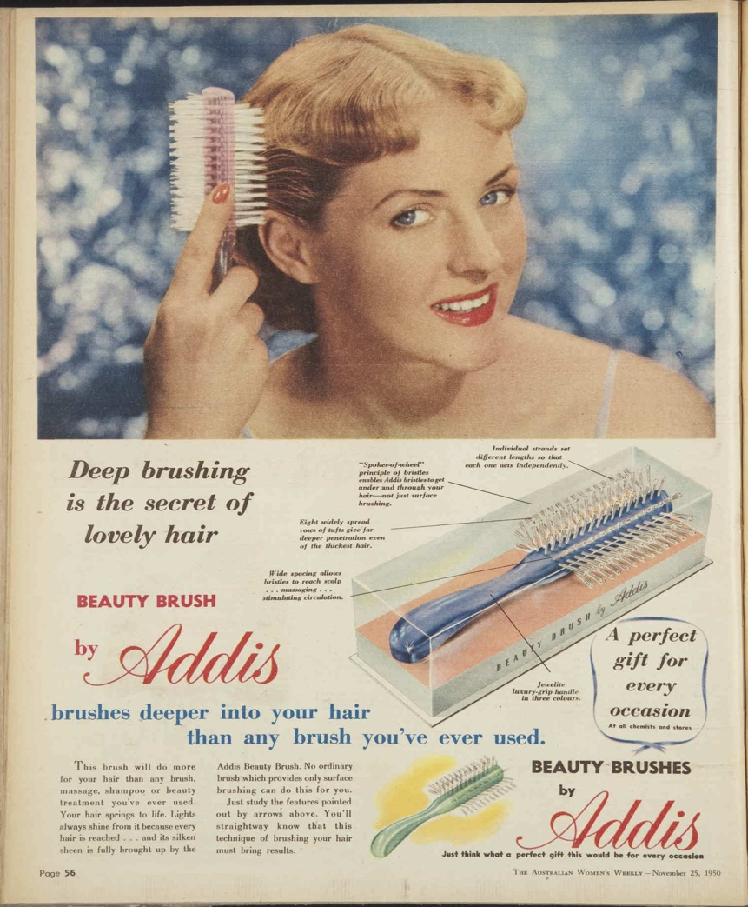
Figure 1: Addis (1950) ‘Beauty brush’, The Australian women’s weekly, p. 56
The figure above is a hairbrush advertisement by Addis. The denotation in this advertisement is a beautiful blonde hair blue eyed lady who is brushing her hair with their beauty brush. She looks like her hair is already in a popular 1950’s hair style. The connotation of this would then be why is she brushing her hair when it is already styled? It is showing that with this hairbrush you could have as nice hair as her. There is also a potential code in this advert would be that it is ‘a perfect gift for every occasion’. This is giving the hairbrush a meaning to the viewer and could be helping them on their gift finding task. This is a quote stated by John Burnett “Consumer behavior can be thought of as the combination of efforts and results related to the consumer's need to solve problems.” This helps us understand more about buyers' behaviours and their need to solve problems.
We also see this marketing tactic in figure 2 which is another Addis beauty brush advert from just 6 months later in 1951. The model is Betty Gardiner, after some research I still have no knowledge on Figure 1’s model but they both have similar blonde hair, blue eyes, and a feminine red lipstick (a common beauty standard in the 1950’s). The emphasised code on this advert is it would be a great gift for Mother’s Day, once again they have understood the buyer's behaviour and offered a solution for what to get a mother for Mother's day. This code seems to be a commonly used marketing tactic for Addis around this time in particular.
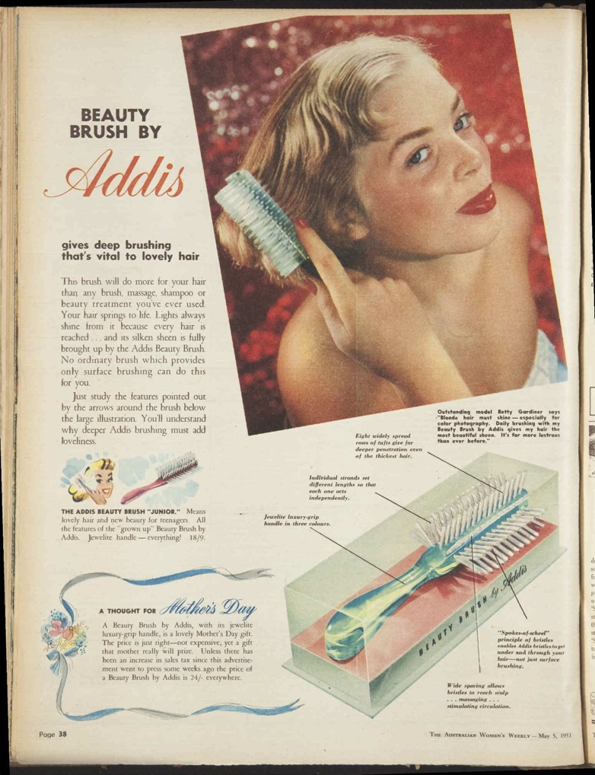
Figure 2: Addis (1951) ‘Beauty brush’, The Australian women’s weekly, p. 38
The sign of the advertisement is to buy their hairbrush, we know this because signifier is the hairbrush and the signified is that if you use their deep hairbrush, you will get lovely hair. As stated by Roland Barthes “The classification of signs: The signified and the signifier, in Saussurean terminology, are the components of the sign.” (Barthes, 1964, p. 35) Using that methodology, we are able to simply take the sign and signifier of this advert and merge them together. This shows us that the sign is they want you to buy their hairbrush.

Bibliography:
The Australian Women’s Weekly (1933 - 1982) (no date) Trove. Available at: https://trove.nla.gov.au/newspaper/title/112# (Accessed: 21 November 2024).
Barthes, R., Lavers, A. and Smith, C. (1983). Elements of semiology. New York: Hill And Wang.
Burnett, J. (2011). Introducing marketing. New York: Suny Oer Services, New York.
Cambridge Dictionary (2022) not see the wood for the trees, @CambridgeWords. Available at: https://dictionary.cambridge.org/dictionary/english/not-see-the-wood-for-the-trees.
Cambridge Dictionary (no date) SEMIOTICS | meaning in the Cambridge English Dictionary, dictionary.cambridge.org. Available at: https://dictionary.cambridge.org/dictionary/english/semiotics.
Hébert, L. (2019). An Introduction to Applied Semiotics: Tools for Text and Image Analysis. New York: Taylor and Francis.
Irvin, S. (2022) Immaterial: Rules in contemporary art. Oxford: Oxford University Press.
Van Baarle, E. and Martin, C. (2018) Interpreting themes in textile art. London: Batsford.
Winner, E. (2018) How art works: A psychological exploration. New York, NY: Oxford University Press‌

‌ Figures:
Addis (1950) ‘Beauty brush’, The Australian women’s weekly, p. Front Cover-Page 80.
Addis (1951) ‘Beauty brush’, The Australian women’s weekly, p. Front Cover-Page 64.

