LCBB4005
Global Business Environment
Assignment 1

Lecturer: Dr. Molly Jack
Student: Georgi Dimitrov, 1917423
Table of Contents
Introduction 3
Part-A 4
Part-B 9
Conclusion 13
References 14

Introduction
The internal, as well as external factors as well as forces that have a direct or indirect impact over a business in the process of making proper customer relation, is known as the business environment. To assure success and be profitable, present-day firms must analyze the business environment of the industry they are doing business. Macro, micro as well as the internal environment are three of the crucial elements of the business environment. Before making strategies for a business, it is necessary to consider these environmental aspects for assuring the best outcome. The micro and internal environmental factors can be controlled by a firm by making proper strategies. In contrast, a firm won’t be able to control the factors associated with the macroenvironment (Worthington, Britton & Thompson, 2018). Having proper knowledge regarding the elements associated with the business environment assists the managers as well as stakeholders to make proper decisions because they know the way of dealing with a particular environmental factor and the way of mitigating its effect.

Part-A
PESTEL analysis is a model which is used by the marketers for assessing which macro-economic components are influencing the operations of car manufacturing factory. It is also helpful to better analyze the industry's potential strength, weakness, opportunities and threats to obtain flourish understanding about the overall global market (Tidström, 2012). Now the discussion about the business climate of the car manufacturing industry through the PESTEL framework will be done below.
PESTEL Analysis
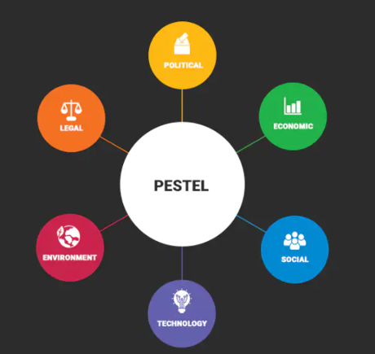
Figure 1 PESTEL factors (Tidström, 2012)
Political factors have a crucial role in shaping the automobile industry. Across the globe, Governments are privileging emission control vehicles. Taxes imposed on luxury elite transport have risen higher. Moreover, the Government's ever-changing rules and regulations for the same law can be a cause of huge risk for the automobile industry. Economic sustainability, currency exchange rate, inflation index, unemployment rate, annual interest rate and provision of credit are the element of economic risk assessment (Hood & Vahlne, 2013). At good economic conditions, the industry may anticipate to sale a huge number of vehicles. In context, bad economic conditions may bring a fall in sales. Coming to the social risk analysis, some factors like a fashion trend, age profile, automobile culture, taste, penchant, health awareness, the popularity of driving and so on may affect the car manufacturing industry. In many modern countries, sensible customers are now paying preference to buy eco-friendly cars. So, the automobile industry should launch vehicles considering the preference of the target customers. Technological analysis is about inventing new products and upgrading existing products. Many traditional car manufacturers are now working on to embrace latest technologies like AI, self-driving cars by updating their existing models. The higher innovative the organization, the greater is their market value. Because of the environment-conscious customers and governments, environmental risk assessment has become a significant issue in the automobile industry (Sridevi, 2015). Probably the automobile industry has the biggest ecological footprint. In recent years, many governments have enacted legislation on maximum permissible emission of carbon in car shopping. Furthermore, customers also cooperate in preserving the environment by considering petrol consummation at the time of taking the buying decision. A country's industry law influences the performance of a conveyance company. Car manufacturing industry must follow the rules and regulations determined by the Government like copyright law, international market law, safety law, tax law and pollution law and so on (Chen & Wang, 2015). Every automobile company must strictly comply with all the related ordinance of the Government before going in the global market otherwise they can be banned and have to face court complexities.
Porter’s five force model
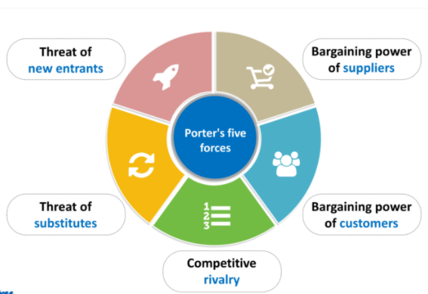
Figure 2 Porter’s five force (Steidle, 2017)
Michael Porters 5 forces analysis is beneficial to figure out the competitive forces inside an industry like car manufacturing industry. The first element is the threat of new entrants which is very low in the automobile industry due to huge obstacles of the entrance as well as exit. The second component, the bargaining power of suppliers is also low cause as opposed to the automakers they are quite little ventures. In context, the bargaining power of buyers in the automobile industry is so high and the reasons are the competitive prices of the industry and zero switching cost of the buyers. Because of the performance limitation of the substitutes, Porters 4th element the threat of substitutes is also low in the car manufacturing industry. This is a highly competitive industry throughout the world. So, the last element of Porters 5 Forces, competitive rivalry, is very strong in the automobile industry (Steidle, 2017).

Micro-environment

Customers

Competitors

suppliers

Intermediaries

Market
Figure 3 Factors of the microenvironment (Irawati, 2011)
Microenvironment includes all the entities or individuals who have a direct impact on the performance of an industry. It is composing with elements which are adjacent to the organization and influence it on daily basis. Some major factors of car manufacturing industry’s microenvironment include customers, competitors, organizations, market, suppliers and intermediaries. These elements of microenvironment have a direct effect over the car manufacturing industry. Customers are considered as the most significant element of the microenvironment. The sales, as well as the profitability of the car manufacturing industry, mostly depend on this factor. Suppliers, intermediaries as well as market are also crucial microenvironment elements for the car industry. Suppliers assists in assuring the availability of necessary elements needed for making a car. Intermediaries like car showrooms help to connect the customers with the car industry and market is the place where the actual sales of cars are made (Worthington, Britton & Thompson, 2018). Besides, competitors are another crucial factor of the microenvironment that helps to ensure a proper balance of price in the car industry.
The plurality of the modern automobile industry's features is now beyond recognition in accordance with the initial version. The fusion of technologies is the largest reason behind it. The expansion of digital tools is continuously changing the automobile industry. The industry has expanded to a huge extent over the last decade. One of the biggest changes in recent years that totally altered this industry, is the introduction of self-driving systems. Autonomous driving car is capable of detecting its circumstances and travelling safely without the human interference behind the steering wheel. Many automakers brands like BMW, Tesla, etc. are utilizing this autonomous system in automatic car parking (Rubenstein, 2011). Moreover, the invention of electric vehicles has brought a change in lowing emission as well as pollution. Through manufacturing electronic conveyance, automakers are able to easily curtail transport expenses which are one-third times lower than the conventional patrols.
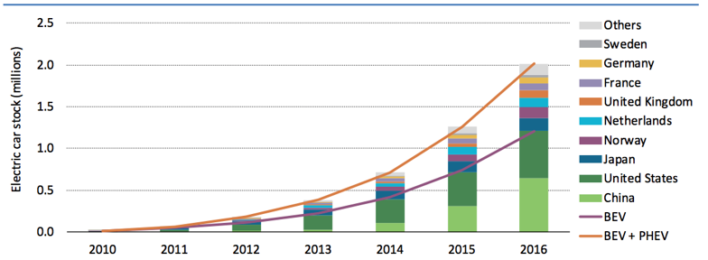
Figure 4 Global electric car stock from 2010-2016 (Wire, 2020)
Another significant change occurred in the car manufacturing industry because of changing business environment is the introduction of additive manufacturing. It is associated with 3D printing. Additive manufacturing process helps in doing rapid prototyping of a car, print spare parts as well as assure the use of light as well as durable parts for new vehicles (Luo, 2013). The main reason behind the introduction of additive technology in the car manufacturing industry is to assure an increased production rate of cars at a lower cost so that firms can ensure the right level of profit.

Part-B
After analyzing distinct environmental forces associated with the car manufacturing industry including macro and micro environmental forces, a handful of opportunities, as well as challenges, are seen that are directly connected with the industry. Before explaining the opportunities as well as challenges, it is necessary to provide the leaders as well as managers of the car manufacturing industry with adequate information regarding the current strengths as well as weaknesses of the industry. The core strength of the industry is its growth rate, which is increasing on a continuous basis. Besides, the reduced cost of labour is another strength of this industry. A major weakness that the car manufacturing industry is currently facing is, the industry has shifted to supply market from the demand one, as a result of which power of buyers increased to a significant extent. Government regulation is another weakness that the industry is facing at present.
At present, the automobile industry is facing a handful of opportunities along with challenges in the international marketplace. Political issues are creating challenging situations for the car manufacturing industry. An uncertain market situation is created in the industry because of the Brexit issue, which will eventually escalate the operating cost in the car manufacturing industry. The emerging economies of the region like South America and Asia are creating opportunities for the industry (Joshi, 2019). Increasing disposable income of the people of these countries is making it possible for the people of these regions to invest in their own car.
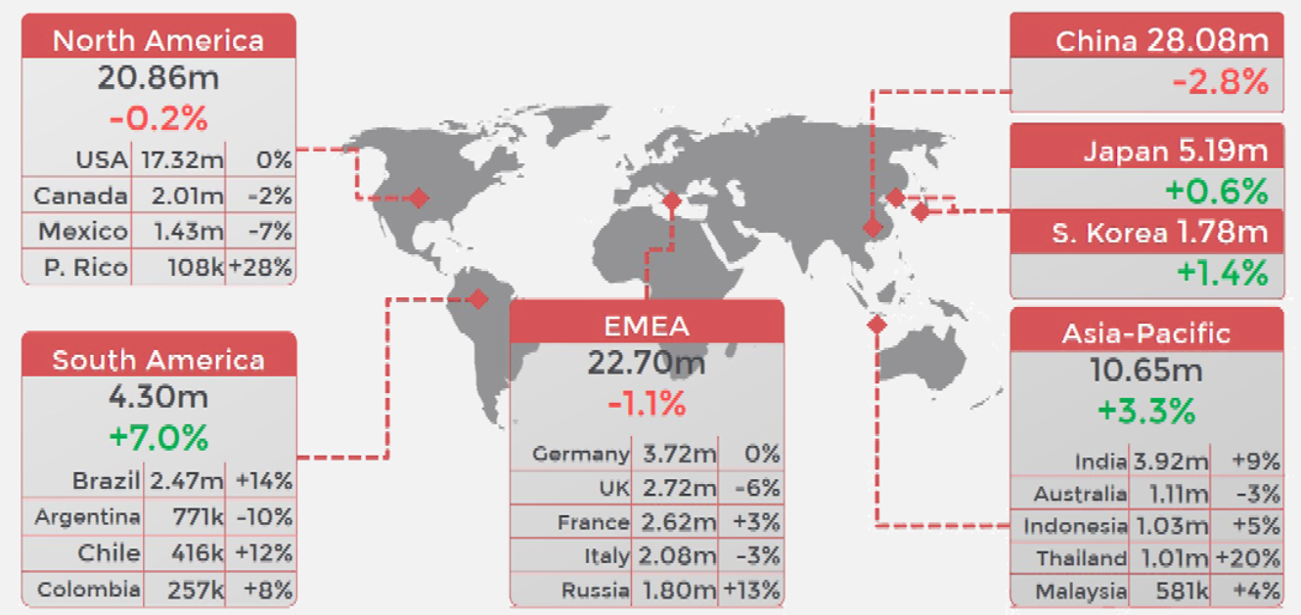
Figure 5 Growth of automobile industry in distinct regions of the globe (Financial Times, 2020)
The trade war between leading countries like America and China has created a challenging situation for the automotive industry. Because of the trade war, the demand for automobiles has significantly dropped in China, which is one of the biggest market of automobiles in the world (Yilei Sun, 2020).
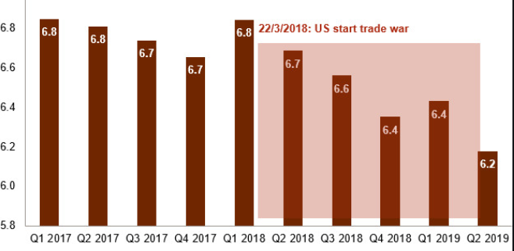
Figure 6 Impact of the trade war in the automotive industry of China (Reuters, 2020)
Social aspects are creating opportunities in the car manufacturing industry. Recent research shows that 87% of the people of the UK thinks that they need to own a car for assuring a better lifestyle. 94% of the car users in the UK say that they are enjoying the freedom that their cars are giving to them (Financial Times, 2020). Besides, in the developing countries having a car is contemplated as a mark of social standing, which is increasing the sales of automobiles. Newly introduced technology is also creating opportunities for the car manufacturing industry. Because of new technologies, car manufacturing companies are able to reduce their costing as well as increase safety in the vehicles. Environmental aspects have created both opportunities as well as challenges in the car industry (Hood & Vahlne, 2013). People are becoming more environmentally conscious, which creating a challenging situation for the companies of the car manufacturing industry. Whereas ensuring environmental aspects will help companies of the industry a great opportunity.
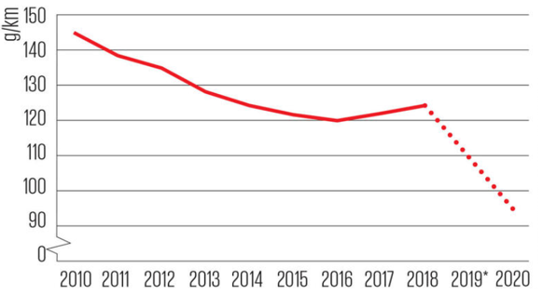
Figure 7 Global CO2 emission from the automobile industry over the decade (Reuters, 2020)
The legal aspects of distinct countries regarding carbon emission have created a challenging situation for the companies of the automotive industry and the firms of the industry are trying to reduce it and they are successful in this. It has decreased significantly over the decade. Different aspects of porters five force like the power of suppliers, the threat of new entrants and threat of substitute have a lower impact over the car manufacturing industry, which is creating opportunities for the industry. In contrast, factors of porters five force including the power of buyers and competitive rivalry have a higher impact over the industry, which creates a challenging situation (Tidström, 2012).
These above-mentioned elements of the environment are helping the firms of the car manufacturing industry in attaining a competitive edge in the international market. By assuring the opportunities as well by properly taking measures against challenges faced by the car manufacturing industry, the firms of the industry are assuring competitive advantage. For ensuring competitive advantage most of the firm of the car manufacturing industry including BMW, Audi, General Motors, Toyota, Ford, etc. are investing in the value chain management (Irawati, 2011). The primary aspects of value chain management including inbound logistics, operation, outbound logistics, marketing & sales and service along with supportive aspects like HRM, infrastructure, technology and procurement help to reduce costs associated with the making of new automobiles as a result of which firms can make a good position in the international market and ensure a competitive advantage in the international market by offering better automobiles at a lower price (D'HEUR, 2016).
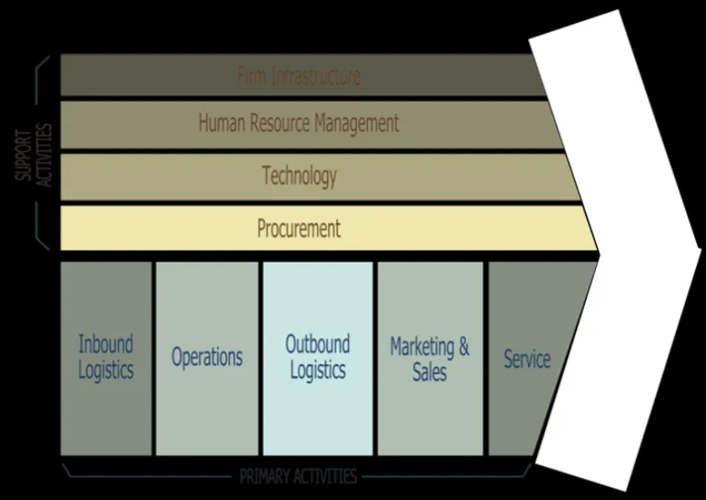
Figure 8 Value chain management (D'HEUR, 2016)
Besides, by including new features in their vehicles, firms of the car manufacturing industry can make their vehicles different from their competitors that will help them to ensure the best position in the automotive market. A lot of firms of the car manufacturing industry like Lamborghini, Porsha, Tesla, BMW etc. are introducing new innovative cars with a unique design that are helping the companies in making a strong position and in attaining more customers. Brand image is another factor that the current day firm of the car manufacturing industry can use to assure a competitive ground in the international arena (Mahfooz, 2015). Efficient global supply as well as the distribution system is another aspect that the companies of the automotive industry can use to assure competitive advantage.

Conclusion
The business environment is a crucial element for a firm for assuring organizational success. Without confirming both micro and macro environmental factors, a firm won't be able to do well in the current competitive marketplace. In this report, the overall elements associated with the business environment is described thoroughly using the example of the car manufacturing industry so that one can understand the topic of business environment properly.

References
Chen, X. and Wang, Y., (2015). The impact of tax policy stimulus on automobile choice- Evidence from Chinese automobile industry. African Journal of Business Management, 9(1), pp.1-7.
D'Heur, M., (2016). Sustainable value chain management. [Place of publication not identified]: SPRINGER INTERNATIONAL PU.
Financial Times, (2020). Automobiles | Financial Times. [online] Ft.com. Available at: https://www.ft.com/companies/automobiles [Accessed 24 December 2020].
Hood, N. and Vahlne, J., (2013). Strategies In Global Competition. Hoboken: Taylor and Francis.
Irawati, D., (2011). Knowledge Transfer In The Automobile Industry. Hoboken: Taylor & Francis.
Joshi, B., (2019). Trend in Asian and European Automobile Industry and its Challenges. International Journal of Business and Administrative Studies, 5(6).
Luo, X., (2013). Analysis and Design of Production Management System of Automobile Industry Based on Web. Advanced Materials Research, 823, pp.581-584.
Mahfooz, Y., (2015). Brand Equity-Consequence Relationship: Evidence from Automobile Industry. International Journal of Business and Management, 10(3).
Reuters, (2020). Autos & Transportation | Reuters. [online] U.S. Available at: https://www.reuters.com/subjects/autos [Accessed 24 December 2020].
Rubenstein, J., (2011). Spatial Changes In The U.S. Automobile Industry. Binghamton, N.Y.: Dept. of Geography, State University of New York at Binghamton.
Sridevi, S., (2015). Bottleneck Analysis of an Automobile Industry Component. Indian Journal of Science and Technology, 8(31).
Steidle, F., (2017). Analysis Of The Automobile Industry In Times Of Transition Using Porter's Five Forces Model.
Tidström, A., (2012). Conflicts in business relationships in light of the external environment. International Journal of Business Environment, 5(2), p.122.
Wire, B., (2020). Global Automotive Composites Market Report 2020: Industry Convergence Powering The Sector - Researchandmarkets.Com. [online] Morningstar.com. Available at: https://www.morningstar.com/news/business-wire/20201126005566/global-automotive-composites-market-report-2020-industry-convergence-powering-the-sector-researchandmarketscom [Accessed 24 December 2020].
Worthington, I., Britton, C. and Thompson, E., (2018). The Business Environment. Harlow, United Kingdom: Pearson Education Canada.
Yilei Sun, B.,(2020). China Leads Auto Industry Recovery As Sales Top Expectations. [online] U.S. Available at: https://www.reuters.com/article/us-china-autos-idUSKBN28L06P[Accessed 24 December 2020].

