

Quality Failures in Maternity Care: A Systems-Based Analysis of the Shrewsbury and Telford Hospital NHS Trust Scandal

Programme: MSc Public Health and Social Care in Practice
Module name: Quality Assurance and Service Improvements
Module code: LCHS7006
Student name: Drashti Patel
Student ID: 2439716
Lecturer: Dr Fahad Khan

Table of Contents
1. Introduction 3
1.1 Quality Assurance in Healthcare 3
1.2 Overview of the Shrewsbury and Telford Maternity Scandal 31.4 Systems-Based Approach to Analysis 4
2. Main Body 5
2.1 Donabedian Model Analysis 5
2.2 Root Cause Analysis: Fishbone Diagram 6
2.3 SWOT Analysis 7
2.4 PDSA Quality Improvement Model 9
2.5 Kotter’s Eight-Step Change Model 10
3. Recommendations 11
3.1 Benchmarking Table 13
4. Conclusion 13
References 15

1. Introduction

1.1 Quality Assurance in Healthcare
Quality assurance (QA) refers to systematic processes used to monitor, evaluate, and improve the quality and safety of healthcare services. In healthcare systems such as the National Health Service (NHS), QA ensures that services meet established clinical standards, comply with regulatory requirements, and provide safe, effective, and patient-centred care (Parmelli et al., 2021). Key QA mechanisms include clinical governance frameworks, performance monitoring, incident reporting systems, staff training, and regulatory oversight. These processes help healthcare organisations identify risks, reduce medical errors, and maintain consistent standards of care (Luhalima, 2024).
Quality assurance is particularly important in maternity services, which are considered high-risk clinical areas within the NHS. Maternity care requires accurate clinical monitoring, timely decision-making, and effective communication between healthcare professionals (Wynne et al., 2025). Strong QA systems enable early detection of clinical problems, support learning from adverse events, and promote improvements that protect the health and safety of mothers and babies (Wynne et al., 2025).

1.2 Overview of the Shrewsbury and Telford Maternity Scandal
The maternity scandal at Shrewsbury and Telford Hospital NHS Trust (SaTH) represents one of the most significant failures of quality assurance within the National Health Service (NHS). The independent Ockenden Review (2022) investigated maternity services at SaTH between the 1970s and 2019. The review examined evidence from approximately 1,486 families and identified widespread failures in maternity care. These failures contributed to avoidable maternal and neonatal deaths, stillbirths, severe birth injuries, and long-term complications (Knight and Stanford, 2022). The review also highlighted issues such as poor clinical decision-making, inadequate fetal monitoring, delayed medical interventions, and ineffective communication with patients and families.

1.3 Systemic Failures and Organisational Weaknesses
The findings of the Ockenden Review revealed that these incidents were not isolated clinical errors but were linked to broader systemic weaknesses within the organisation and the wider National Health Service (NHS) context (Knight and Stanford, 2022). Leadership failures, weak governance structures, limited monitoring systems, and poor accountability prevented the organisation from recognising and addressing safety concerns in a timely manner (Dyer, 2022). In many cases, women’s concerns were dismissed, and families were excluded from meaningful involvement in care decisions (Knight and Stanford, 2022). Furthermore, a lack of transparency and reluctance to acknowledge mistakes prevented both the organisation and the NHS from learning from previous incidents and implementing necessary improvements (Dyer, 2022).

1.4 Systems-Based Approach to Analysis
Healthcare quality failures often occur when multiple weaknesses across organisational systems align. The Swiss Cheese Model of patient safety explains how gaps in leadership oversight, clinical practice standards, staffing levels, incident reporting systems, and communication processes can combine to allow preventable harm to occur (Wafula et al., 2024). In the case of SaTH, these systemic weaknesses allowed unsafe maternity practices to continue for many years without effective intervention.
This report analyses the maternity care failures in NHS using healthcare quality improvement frameworks. The Donabedian Model examines structural, process, and outcome weaknesses, while the Fishbone approach identifies root causes. SWOT analysis evaluates organisational factors, and improvement models such as the PDSA cycle and Kotter’s Eight-Step Change Model are considered to support sustainable improvements in maternity safety and quality assurance.

2. Main Body

2.1 Donabedian Model Analysis
The Donabedian Model is widely used to evaluate healthcare quality by examining three interconnected components: structure, process, and outcomes. This framework provides a systematic method for understanding how organisational conditions influence clinical practices and patient outcomes (Aluko, 2016).
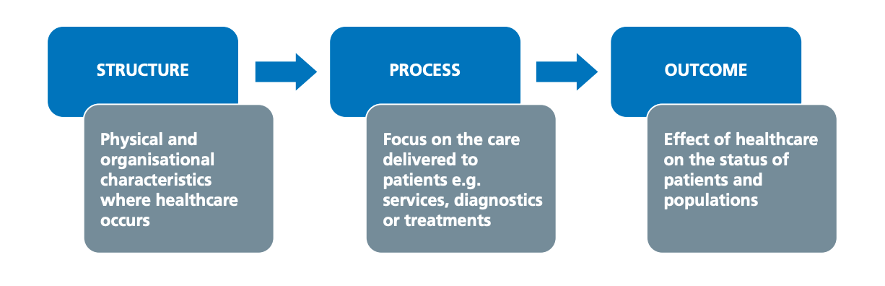
(Suzie Creighton, 2023)
Structure: Structure refers to the organisational environment where healthcare is delivered, including staffing, leadership, training, and resources. At Shrewsbury and Telford Hospital NHS Trust, staffing shortages and weak governance structures contributed to unsafe maternity care. Limited oversight and heavy workloads reduced effective monitoring and allowed unsafe practices to continue without proper accountability (Dixon-Woods et al., 2023).
Process: Process refers to the clinical and administrative activities involved in delivering healthcare services. In the Shrewsbury and Telford Hospital NHS Trust case, failures occurred in labour management, including inconsistent fetal monitoring and delayed responses to signs of fetal distress. Complications were not always escalated promptly, leading to missed interventions. Communication was also poor, as women’s concerns were often dismissed. Furthermore, national clinical guidelines were not consistently followed in practice (Tham and Maclennan, 2025).
Outcomes: The outcomes of these structural and procedural failures were severe. The Ockenden Review identified several cases of stillbirth, neonatal death, and serious birth injuries that could have been prevented with appropriate clinical care (Knight and Stanford, 2022). Families also experienced significant psychological trauma and emotional distress. Additionally, the scandal caused wider impacts on the NHS, including increased litigation costs, reputational damage, and reduced public confidence in maternity services (Aluko, 2016).

2.2 Root Cause Analysis: Fishbone Diagram
Root cause analysis (RCA) helps identify the underlying factors that contribute to adverse events. The Fishbone (Ishikawa) diagram is a commonly used RCA tool that categorises potential causes into key areas such as people, processes, environment, leadership, and policies (Newdick, 2022). Fishbone analysis is used because it systematically explores multiple contributing factors across categories (e.g., people, processes, leadership), whereas the 5 Whys method is more linear and may overlook complex, interconnected causes in healthcare failures.
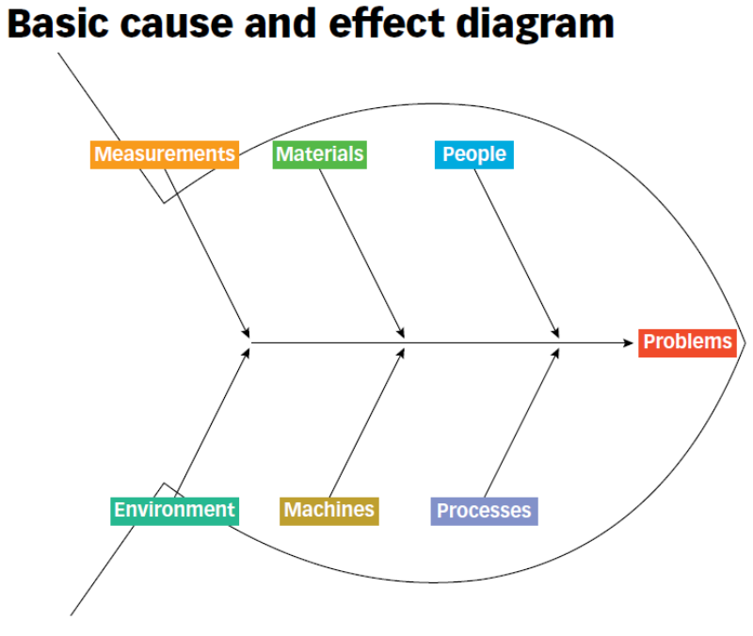
(American Society for Quality, 2026)
People: Staff competency played a significant role in the failures identified at SaTH. Some clinicians lacked sufficient expertise in fetal monitoring and risk assessment, which are essential skills in maternity care. Limited supervision and inadequate mentorship further increased the risk of incorrect clinical decisions (Tondang, 2019).
Processes: Labour management processes were inconsistent and often deviated from evidence-based guidelines. Escalation procedures designed to alert senior clinicians during complications were either poorly understood or not followed correctly. This lack of adherence to established protocols contributed to delays in clinical intervention (Nathan and Kaplan, 2017).
Environment: Workplace conditions also contributed to patient safety risks. High workload pressures caused by chronic understaffing created stressful working environments where staff struggled to manage multiple complex cases simultaneously. Such conditions increase the likelihood of clinical errors and reduce the quality of patient monitoring (Tondang, 2019).
Leadership: Leadership failures were a major contributor to the prolonged nature of the crisis. Senior managers did not respond effectively to safety concerns raised by staff and families. A culture of denial and defensiveness prevented the organisation from acknowledging problems and implementing meaningful change (Nathan and Kaplan, 2017).
Policies: Although national maternity guidelines existed, they were not consistently implemented at the local level. Policy compliance was poorly monitored, and staff were not always aware of the latest clinical recommendations. This gap between policy and practice weakened the overall safety system (Ikram et al, 2022).
Critically, the Fishbone analysis highlights that the SaTH failures were not the result of isolated individual mistakes but rather a combination of organisational weaknesses that interacted to produce harm.

2.3 SWOT Analysis
A SWOT analysis helps evaluate the internal strengths and weaknesses of an organisation as well as the external opportunities and threats that may influence performance (Boyd, 2023). SWOT analysis is preferred because it provides a simple and comprehensive overview of both internal and external factors, whereas other models often focus on only specific areas such as processes or change management rather than the overall organisational context.
Strengths: One key strength of the NHS maternity system is the availability of national maternity safety guidelines that promote safe and effective clinical practice. These guidelines provide evidence-based standards for consistent care (Boyd, 2023). Additionally, the NHS benefits from a skilled workforce, including midwives and obstetricians. Established regulatory bodies further strengthen the system by monitoring healthcare standards and ensuring compliance with safety requirements (Witara et al, 2023).
Weaknesses: Despite these strengths, several organisational weaknesses contributed to failures in NHS. Poor leadership accountability delayed the recognition and management of safety concerns (Witara et al, 2023). Chronic staffing shortages increased pressure on healthcare professionals and reduced effective patient monitoring. Additionally, weak incident reporting and investigation systems prevented organisations from identifying problems and learning from safety incidents (Roy et al, 2025).
Opportunities: Opportunities exist to improve maternity services through the implementation of national maternity safety initiatives and enhanced clinical training programmes (Witara et al, 2023). These initiatives can strengthen staff skills, improve patient safety practices, and encourage consistent adherence to clinical guidelines. Increasing patient involvement in maternity care also presents an opportunity to enhance service quality and responsiveness (Boyd, 2023).
Threats: Several external threats may continue to affect maternity services. Ongoing workforce shortages remain a significant challenge for healthcare organisations. Additionally, repeated safety failures can result in a loss of public trust in maternity services and increased litigation costs, which place further pressure on healthcare resources (Roy et al, 2025).

2.4 PDSA Quality Improvement Model
The Plan–Do–Study–Act (PDSA) cycle is a widely used quality improvement model in healthcare that supports continuous evaluation and improvement of services. It provides a structured approach for testing changes, assessing their effectiveness, and implementing improvements in clinical practice. PDSA is used because it allows flexible, small-scale, and continuous testing of changes in real clinical settings, whereas Six Sigma is more data-intensive, rigid, and complex, making it less practical for rapid and iterative improvements in healthcare environments.
Plan: The first stage involves identifying key maternity safety risks and establishing clear improvement objectives. Healthcare organisations should analyse incident reports, clinical data, and patient feedback to determine priority areas for improvement (Lewis, 2025). Multidisciplinary teams, including clinicians, managers, and patient representatives, should participate in planning to ensure that proposed interventions address real clinical needs (Luo et al., 2022).
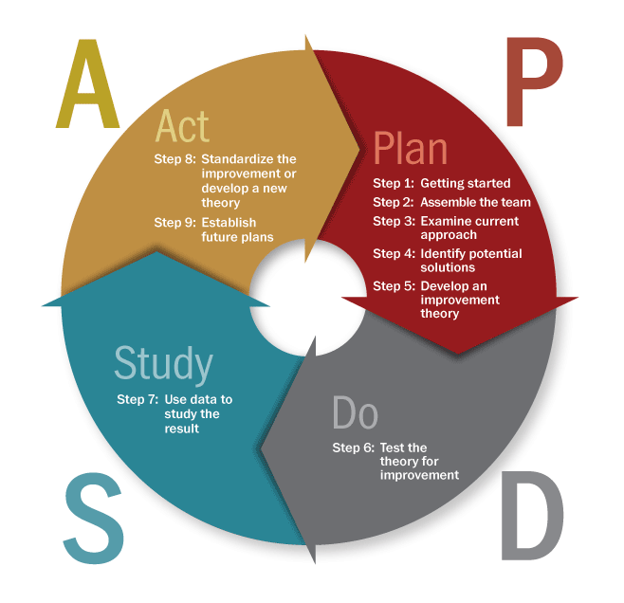
Do: In this stage, planned interventions are implemented on a small scale. Evidence-based clinical protocols, staff training programmes, and safety procedures can be introduced within selected maternity units. Pilot testing allows organisations to assess the practicality of interventions before expanding them across the entire service (Burgess-Shannon, et al, 2024).
(Decorah, 2020)
Study: The study phase focuses on evaluating the outcomes of the implemented changes. Performance indicators such as adverse event rates, patient satisfaction, and compliance with clinical guidelines should be monitored. Regular audits and data analysis help determine whether the interventions are effective in improving maternity safety (Limato et al., 2019).
Act: The final stage involves refining the interventions based on evaluation findings. Successful strategies should be integrated into routine clinical practice and applied across the organisation. Continuous monitoring and repeated PDSA cycles help sustain improvements and ensure long-term quality enhancement.

2.5 Kotter’s Eight-Step Change Model
Kotter’s Eight-Step Change Model provides a structured framework for implementing organisational change and improving service quality. In NHS, particularly in maternity services, this model can support the implementation of safety improvements by guiding leaders through a systematic change process.
Creating Urgency: The first step involves creating a sense of urgency for change. In the context of the Shrewsbury and Telford Hospital NHS Trust case, the findings of the Ockenden Report highlight serious patient safety risks and the need for immediate improvement in maternity services. Recognising these risks helps motivate healthcare professionals and leaders to support change initiatives (Lindsay, 2023).
Building a Guiding Coalition: Successful organisational change requires strong leadership and collaboration. A guiding coalition consisting of clinical leaders, managers, and patient representatives should be established to lead the improvement process. This team is responsible for promoting change and ensuring that safety initiatives are effectively implemented (Trawick and Carraher, 2023).
Developing and Communicating the Vision: A clear vision focused on delivering safe, compassionate, and patient-centred maternity care must be developed. This vision should be communicated across all organisational levels so that staff understand the purpose of the changes and their role in achieving improved patient outcomes (Fowler, 2025).
Removing Barriers and Generating Short-Term Wins: Organisations must identify and remove barriers that may prevent successful implementation of change. These barriers may include staffing shortages, limited training opportunities, or inadequate resources. At the same time, achieving short-term successes, such as improved monitoring systems or staff training programmes, can build confidence and encourage continued engagement with the change process (Fowler, 2025).
Sustaining Change and Embedding Improvements: The final stage focuses on: sustaining progress and embedding improvements into organisational culture. Successful initiatives should be expanded across the organisation and integrated into routine clinical practice. By reinforcing new practices and promoting continuous improvement, healthcare organisations can ensure long-term patient safety and service quality (Lindsay, 2023).

3. Recommendations
Recommendations for Improving Maternity Safety: Improving maternity safety requires a comprehensive and coordinated strategy that addresses governance systems, workforce capacity, clinical competence, organisational culture, and patient involvement. The failures identified in the NHS maternity services highlight how weaknesses across multiple areas can combine to create serious risks for mothers and babies (Saleh, 2024). Implementing effective and sustainable reforms is therefore essential to prevent similar incidents in the future and to restore confidence in maternity care. The following recommendations focus on key areas that can strengthen safety and quality within maternity services (Wonnacott et al, 2025).
Strengthening Clinical Governance and Accountability: Effective clinical governance is essential for safe and high-quality maternity care within the National Health Service (NHS). It provides a structured framework for monitoring performance, managing risks, and ensuring accountability for patient outcomes (Wonnacott et al., 2025). Strong governance systems enable early identification of safety concerns and timely corrective actions. Healthcare organisations should monitor key indicators such as maternal mortality and incident reports, conduct regular audits, and ensure thorough investigation of incidents to support continuous improvement (Sarani and Saravani, 2017).
Increasing Workforce Capacity and Staffing Levels: Adequate staffing levels are essential for safe maternity care within the National Health Service (NHS). Workforce shortages increase pressure on healthcare professionals, raising the risk of clinical errors and reducing effective patient monitoring. In maternity services, insufficient staff can delay the identification of complications and limit rapid responses to emergencies (Harris et al., 2022). Healthcare organisations should adopt targeted recruitment and retention strategies, improve working conditions, and support staff wellbeing. Maintaining appropriate staff-to-patient ratios helps reduce fatigue-related errors and improves maternity safety and service quality (Dixon-Woods et al., 2023).
Enhancing Training and Clinical Competence: Continuous professional development is essential for maintaining high standards of maternity care within the National Health Service (NHS). Healthcare professionals need the skills to recognise complications, interpret fetal monitoring results, and make timely decisions (Saleh, 2024). Without proper training, early warning signs may be missed. Healthcare organisations should provide training in fetal monitoring, obstetric emergencies, and risk assessment, along with simulation exercises and regular refresher programmes to maintain clinical competence (Tondang, 2019).
Promoting an Open and Supportive Organisational Culture: A positive organisational culture is vital for maintaining patient safety within the National Health Service (NHS). Healthcare professionals should feel confident to report incidents and raise concerns without fear of blame. Organisations should promote a “just culture” that focuses on learning from mistakes rather than assigning blame (Harris et al., 2022). Leaders must encourage open communication and support staff who report safety issues. Strong whistleblower protection policies also help promote transparency and accountability (Mascarenhas et al., 2022).
Integrating Patient and Family Voices: Patient-centred care is essential for safe and effective maternity services within the National Health Service (NHS). Women and their families should be actively involved in decisions during pregnancy and childbirth. However, investigations show that women’s concerns are sometimes ignored, delaying responses to complications (Saleh, 2024). Healthcare organisations should promote patient engagement by providing clear information about care options and risks. Collecting feedback through surveys and maternity groups can help improve services and ensure care is responsive to patient needs (Tham and Maclennan, 2025).

3.1 Benchmarking Table
Quality Indicator | National Standard (NHS England / NICE) | Hospital Performance (Before) | Hospital Performance (After Improvement)
Serious incident investigations completed on time | Incidents reviewed within the required timeframe (95%) | Many cases delayed or inadequately reviewed (45%) (Ockenden Report, 2022). | Investigation processes strengthened and most incidents reviewed within timeframe (85%) (Ockenden Report, 2022).
Compliance with fetal monitoring (CTG) standards | Continuous monitoring aligned with NICE guidance (90%) | Frequent misinterpretation and poor documentation (50%) (NICE, 2023) | Improved staff training and monitoring systems increased compliance with CTG standards (88%) (NICE, 2023).
Patient satisfaction / women feeling listened to (NICE, 2023) | Women feel listened to and involved in decisions (90%) | Concerns often dismissed or ignored (40%) (NICE, 2023) | Better communication and patient engagement increased women’s involvement in care decisions (82%) (Tham and Maclennan, 2025).
Staffing levels meeting safe maternity workforce requirement | Staffing meets recommended workforce levels (95%) | Persistent shortages and skill-mix gaps (60%) (Ockenden Report, 2022) | Recruitment and retention initiatives improved staffing capacity in maternity units (80%) (Dixon-Woods et al., 2023).

4. Conclusion
The maternity failures at Shrewsbury and Telford Hospital NHS Trust represent a profound breakdown of healthcare quality assurance systems. The findings of the Ockenden Review demonstrate how weaknesses in leadership, governance, clinical practice, and organisational culture can combine to produce devastating consequences for patients and families. The scale and duration of the failures highlight the importance of robust quality monitoring systems that detect risks early and respond rapidly to emerging safety concerns.
Analysis using the Donabedian Model illustrates how structural weaknesses such as staffing shortages and ineffective governance contributed to unsafe clinical processes. These process failures, including inadequate fetal monitoring and poor communication with patients, ultimately resulted in serious negative outcomes such as stillbirths, neonatal deaths, and long-term injuries. Root cause analysis further reveals that these events were not isolated incidents but rather the result of interconnected failures across multiple organisational domains.
Strategic evaluation tools such as SWOT analysis highlight the need for stronger leadership, improved workforce capacity, and enhanced accountability within maternity services. Quality improvement frameworks, including the PDSA cycle and Kotter’s Eight-Step Change Model, provide practical mechanisms for implementing sustainable organisational change. These approaches emphasise continuous monitoring, staff engagement, and the importance of learning from past mistakes.
The lessons from the SaTH scandal extend beyond a single organisation and have implications for maternity services across the NHS. Ensuring safe maternity care requires not only adherence to clinical guidelines but also a culture that prioritises transparency, accountability, and patient involvement. Healthcare leaders must remain vigilant in monitoring safety indicators, responding to concerns raised by staff and patients, and embedding quality improvement into everyday practice.
Ultimately, strengthening quality assurance systems is essential for protecting mothers and babies, restoring public confidence in maternity services, and ensuring that similar tragedies do not occur in the future. Continuous learning, effective leadership, and patient-centred care must remain central to healthcare quality improvement efforts.

References
Aluko, J.O., (2016). Quality of service analysis towards development of a model for primary-level maternity care in Ibadan, Nigeria.
Boyd, C., (2023). Reflective practice for nurses. John Wiley & Sons.
Burgess-Shannon, J., Clarke, R., Rowell, V. and Aladangady, N., (2024). Achieving optimal cord management: a multidisciplinary quality improvement initiative. BMJ Open Quality, 13(2).
Dyer, C., (2022). Failure to work collaboratively and learn from incidents led to deaths of babies and mothers at Shrewsbury and Telford trust, review finds. BMJ.
Dixon-Woods, M., Barry, Z., McGowan, J. and Martin, G., (2023). The state of care in England’s maternity services. BMJ, 383.
Fowler, H.L., (2025). An examination of the literature surrounding leadership and change management to implement a Golden Theatre Initiative: Reducing inefficiencies within a neurosurgical operating department. Journal of Perioperative Practice, 35(6), pp.234-243.
Harris, J., Beck, S., Ayers, N., Bick, D., Lamb, B.W., Aref-Adib, M., Kelly, T., Green, J.S. and Taylor, C., (2022). Improving teamwork in maternity services: a rapid review of interventions. Midwifery, 108, p.103285.
Ikram, A., Chakraborty, S., Mitra, S., Saini, S., Bagchi, S. and Kocaoglu, M., (2022). Root cause analysis of failures in microservices through causal discovery. Advances in Neural Information Processing Systems, 35, pp.31158–31170.
Knight, M. and Stanford, S., (2022). Ockenden: another shocking review of maternity services. BMJ, 377.
Lewis, M., (2025), September. Midwifery Leadership in a Changing World—Why Is This So Challenging? A Reflective Commentary. In Healthcare (Vol. 13, No. 19, p. 2473). MDPI.
Lindsay, M., (2023). A shared governance approach to nursing documentation redesign using Kotter's change management model. Nursing Management, 54(3), pp.14-20.
Limato, R., Tumbelaka, P., Ahmed, R., Nasir, S., Syafruddin, D., Ormel, H., Kumar, M.B., Taegtmeyer, M. and Kok, M., (2019). What factors do make quality improvement work in primary health care? Experiences of maternal health quality improvement teams in three Puskesmas in Indonesia. PLOS ONE, 14(12), p.e0226804.
Luo, L., Wang, L., Zhang, M. and Liao, B., (2022). Application of obstetric nursing-sensitive quality indicators in continuous quality improvement. American Journal of Translational Research, 14(1), pp.643–650.
Luhalima, T.R., (2024). The importance of quality assurance in rural public healthcare facilities. In Quality Control and Quality Assurance-Techniques and Applications. IntechOpen.
Nathan, A.T. and Kaplan, H.C., (2017). Tools and methods for quality improvement and patient safety in perinatal care. Seminars in Perinatology, 41(3), pp.142–150.
Newdick, C., (2022). Root causes of organisational failure: look up, not down. Journal of Medical Ethics, 48(10), pp.678–679.
NICE, (2023). Intrapartum care for healthy women and babies. Available at: https://www.nice.org.uk/guidance/ng235 (Accessed: 10 March 2026).
Mascarenhas, M., Jeve, Y., Polanski, L., Sharpe, A., Yasmin, E. and Bhandari, H.M., (2022). Management of recurrent implantation failure: British Fertility Society policy and practice guideline. Human Fertility, 25(5), pp.813–837.
Ockenden, D., (2022). Final report of the independent review of maternity services at Shrewsbury and Telford Hospital NHS Trust. Available at: https://www.ockendenmaternityreview.org.uk/wp-content/uploads/2022/03/FINAL_INDEPENDENT_MATERNITY_REVIEW_OF_MATERNITY_SERVICES_REPORT.pdf (Accessed: 10 March 2026).
Parmelli, E., Langendam, M., Piggott, T., Adolfsson, J., Akl, E.A., Armstrong, D., Braithwaite, J., Brignardello-Petersen, R., Follmann, M., Leś, Z. and Meerpohl, J.J., (2021). Guideline-based quality assurance: a conceptual framework for the definition of key elements. BMC health services research, 21(1), p.173.
Roy, K., Maramraj, K.K., Kumar, S., Sarin, A. and Honwad, M.S., (2025). Optimizing Quality Assurance in Naval Hospitals: A Qualitative Study by Comprehensive Strength, Weakness, Opportunity, and Threat Analysis. Journal of Marine Medical Society, 27(3), pp.352-357.
Sarani, M. and Saravani, S., (2017). Assessment of prenatal care process based on Donabedian model in Zabol city. Journal of Pharmaceutical Sciences and Research, 9(12), pp.2558–2563.
Saleh, M., (2024). Safer National Maternity Care: Prospects and Challenges. Journal of Medical and Clinical Case Reports, 1, p.12.
Tham, S.M. and Maclennan, K., (2025). Human factors in obstetrics. Anaesthesia & Intensive Care Medicine.
Trawick, S. and Carraher, T., (2023). Contextualising Kotter’s 8-step model to a sustainable digital transformation: A qualitative study from the perspective of organisational change.
Tondang, M.E., (2019). A continuity analysis of independent nursing care documentation using the fishbone diagram in the Teratai Room North 2nd Floor X Hospital, Jakarta. International Journal of Nursing and Health Services (IJNHS), 2(1), pp.82–92.
Wafula, D.N., Kinyua, K., Mutua, F., Kertich, D., Macharia, P. and Kem, P., (2024). Diagnostic errors and their impact on obstetric outcomes among post-natal women at level five teaching and referral hospitals in Bungoma County, Kenya. African Journal of Empirical Research, 5(4), pp.1641–1647.
Witara, K., Kurniasari, L.M. and Nugroho, D.C., (2023). The Implementation of Quality Management System ISO 9001 with SWOT Analysis. ADPEBI International Journal of Business and Social Science, 3(2), pp.118-128.
Wonnacott, A., Barton, K.S., Pells, E. and Khan, E., (2025). The role of NHS Resolution in the maternity safety landscape in England. The Obstetrician & Gynaecologist, 27(2), pp.154-159.
Wynne, R., Omarit, R. and Crowe, S., (2025). Bridging practice and research: differentiating quality improvement, quality assurance, and quality improvement research in a learning health system. European Journal of Cardiovascular Nursing, 24(7), pp.1182-1187.

