
The Study of Change and Stability Management---Tesco

May 5, 2023
NIVERSITY OF WALES TRINITY SAINT DAVID

BMMB7000
Major: Change & Stability Management
Enrollment Time:10/2022
Student ID:2218750
Full Name: Yu Shenghua
Instructor: Marie Pitson

Executive Summary

This report will analyze Tesco's organizational changes in response to changes in consumer behavior, rising costs of goods and services, and pressure from Walmart, Amazon, Trust Mart and other retailers from the perspective of stability management and change management. This report uses academic journals and online information to briefly analyze the reasons, forms, and impacts of change, and critically evaluate the effectiveness of change to deepen people's understanding of organizational change. During this process, the author evaluated the process and approach of change through force field analysis, stakeholder analysis, and Kotter's eight step model. With the help of relevant models, this report can provide a more thorough analysis of the process and effectiveness of Tesco's stability management and change management, and briefly suggest how Tesco can better respond to potential issues brought about by the post pandemic era, Brexit in the UK, and the sluggish global economic situation.

Table of Contents
Executive Summary……………………..…………………………..………….......2
1. Introduction 4
2. The Challenges of Tesco 4
2.1 The impact of the epidemic and turbulent situations 5
2.2 Pressure from competitors 5
2.3 Changes in consumer behavior 5
3. Driving Factors for Change 6
4. Change Experiences and Change Type………………………………………..7
5. Identifying and Dealing with Resistance 10
5.1 For Field Analysis 10
5.2 Stakeholder Analysis 11
5.3 Sources of Resistance 13
5.4 Dealing with Resistance 13
6. Kotter's Eight Step Model 14
6.1 Establishing a sense of urgency 14
6.2 Establishing a Guidance Alliance 15
6.3 Develop Vision and Strategy 15
6.4 Communicate the vision of change. 16
6.5 Empowering broad action powers 16
6.6 Generate short-term returns 16
6.7 Consolidate returns and create more changes 17
6.8 Anchoring New Methods in Organizational Culture 17
7.Assessing Effectiveness 17
8. Conclusion 19
9.Recommendations 20
References 21

- Introduction
Tesco is the largest retailer in the UK and the second largest in Europe, ranking among the top three global retailers. The company was established in 1924. In the past 80 years, with the transformation of the retail market environment, the company has continuously developed, grown, and innovated to meet every new opportunity. Currently, there are 2629 stores worldwide (with a total sales area of 45 million square feet). The company has branches in 14 countries and regions, with over 500 million daily customers. Apart from 691 large shopping centers in the UK, 42% of its stores are located in countries in Central and Southeast Asia, making it an international supermarket giant(Bedford, E., 2022). In the UK, TESCO owns a range of its own brands including Tesco Value, Tesco Standard, and Tesco Finest. In recent years, Tesco has undergone several strategic changes to meet the constantly changing needs and expectations of customers, improve financial performance, and maintain its competitiveness in the retail market (Commendatore, P., Kubin, I., & Sushko, I., 2018).Tesco has recently undergone a change in response to the challenges posed by the pandemic. This report will discuss the critical change management models that have been used for Tesco and how these models can be used for small sacle (incremental) change programs. The report will also explore the drivers for change, how to identify and deal with resistance to change, how to change with Kotter's Eight Step Model and assess the effectiveness of the change program.

- The Challenges of Tesco
The pressure for Tesco to change during the COVID-19 have three points, such as the impact of the epidemic ,competition from other companies, and Consumer Behavior include customers are changing their shopping online.

2.1 The impact of the epidemic and turbulent situations
The pandemic led to disruptions in Tesco's supply chain, particularly in the early stages of the pandemic when panic buying led to shortages of certain products.
The pandemic led to a decrease in footfall to Tesco's physical stores, particularly during lockdowns.
Tesco had to invest in additional safety measures, such as personal protective equipment, cleaning supplies, and staff training, which increased costs.
In addition, there have been turbulent situations in individual regions of the world (Group, P., 2022), and severe inflation has occurred in Europe, resulting in a significant increase in various costs and causing the company to lose some profits (Mazaj, J., Grosso, M., & Castaldo, S.,2022).

2.2 Pressure from competitors
In the past two years, Walmart has launched a number of delivery/pick up plans in the United States, Canada, Mexico and China, and announced its participation in the SNAP online procurement pilot program of the U.S. Department of Agriculture. In September 2020, the company launched a new membership program called Walmart+, which includes unlimited free shipping, fuel discounts, and convenient home shopping tools. Amazon has also launched a "low price to attract buyers" model, although low prices cannot be infinitely low. this move has also dealt a serious blow to peers. The competition between numerous competitors and Tesco has reached a white-hot level.

2.3 Changes in consumer behavior

In 2020, the outbreak of the COVID-19 silenced the streets around the world, and people's consumption will shift from offline to online; In 2022, as the epidemic gradually normalized, residents' consumption life began to gradually return to normal (Tarhini, B., & Hafiz, L., 2021). But at the same time, the emergence of the Russia Ukraine crisis and inflation has also brought many uncertainties. According to data from the White Paper, currently 38% of consumers worldwide express that they are no longer willing to shop in stores due to their good online shopping experience, compared to 32% in Europe. Even after the stabilization of the European epidemic, offline consumption has returned, and consumers have developed a habit of online shopping. They will more likely choose a mixed shopping model of online and offline (Goswami, S., & Chouhan, V., 2021). In addition, more and more consumers are choosing cross-border shopping. According to a survey by Seven Senders, 22% of the total B2C sales in the 15 major e-commerce markets in Europe come from cross-border retail, and 73% of online shoppers choose overseas merchants. This has brought great impact and challenges to traditional large retailers like Tesco (Bruter, M., & Harrison, S., 2016).

- Driving Factors for Change
Culture: Tesco itself is a company full of opportunities and continuous growth, and the company's corporate culture is the pursuit of a modern and innovative spirit full of creativity. Tesco's values include putting oneself in the shoes of others to think about problems, inferring others' thoughts from others' perspective. And strive to provide high-quality products and services to customers for the long term. With the increase of online consumers, Tesco's recent digital transformation has been strengthened by the COVID-19 (Torlak, 2019). This is a naturally occurring change.
Leadership: Leadership has also provided strong support for Tesco's transformation. The current CEO Ken Murphy has implemented multiple measures to ensure that the business is in a good development position in the current environment, including introducing new technologies, developing new business models, and implementing new operational processes (Barbradozier, 2018). Managers with outstanding business acumen not only play a leading role in the process of change, but also play a driving role in the process of change.
Power and Digitalization: The changes brought about by the pandemic and Brexit are driven by the need for increased power and digitization. Tesco must become increasingly flexible and adaptable in order to maintain competitiveness in the current environment (GlobalData, 2022).
On the surface, it seems that the entire change was spontaneous by Tesco, but in reality, the pandemic has brought economic uncertainty, intense competition and the change of consumer behavior, Tesco may need to adjust business method, products and services to meet these changing needs.

- Change Experiences and Change Type
Change Experiences
Here are three key points in which Tesco has made strategic changes:
First, the company will carry out Digital transformation, and focus on digital channels by investing in online shopping, door-to-door delivery and other digital services (Brannen et al., 2021). This helps Tesco reach new customers and increase sales, especially during the COVID-19. Secondly, in order to reduce costs, Tesco has started implementing measures such as reducing store floor space, layoffs, and streamlining operations. This helps the company improve profit margins and maintain competitiveness in challenging markets. At the same time, the company has launched sustainability and social responsibility goals and projects, which will help Tesco strengthen its brand reputation and attract customers who prioritize ethical and sustainable business practices. By strengthening digital services, the waste of human resources can be reduced, providing companies with sufficient excuses to reduce some redundancy. After the company has slimmed down, as the profit margin increases, it can assume more social responsibility and environmental protection responsibility.
Hodges (2015) provided the following table in their book, which allows people to find the corresponding change categories for organizations:

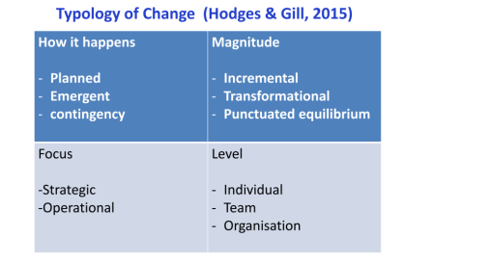
Emergent Change
Although this change is based on careful planning of the company's board of directors and involves the analysis of the current situation, identifying a desired state, and planning and implementing change initiatives (Karasvirta & Teerikangas, 2022). But the goal of change is to ensure that the organization can remain competitive and adapt to changing environments (Garcia-Lorenzo & Liebhart, 2010). It is obvious that the entire plan involves responding to external factors that require an organization to make quick and reactive changes, and also, this pandemic is unforeseeable, neither predictable nor planned, and this change plan requires the high level of participation of almost all employees, indicating that this change is rapidly planned and belongs to the category of emergency change (Karasvirta & Teerikangas, 2022).
Nadler et al. (1995) also recommended another method for distinguishing types of organizational change, as shown in the following figure:
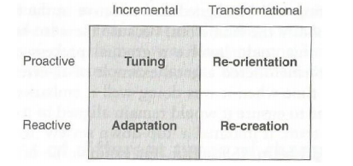

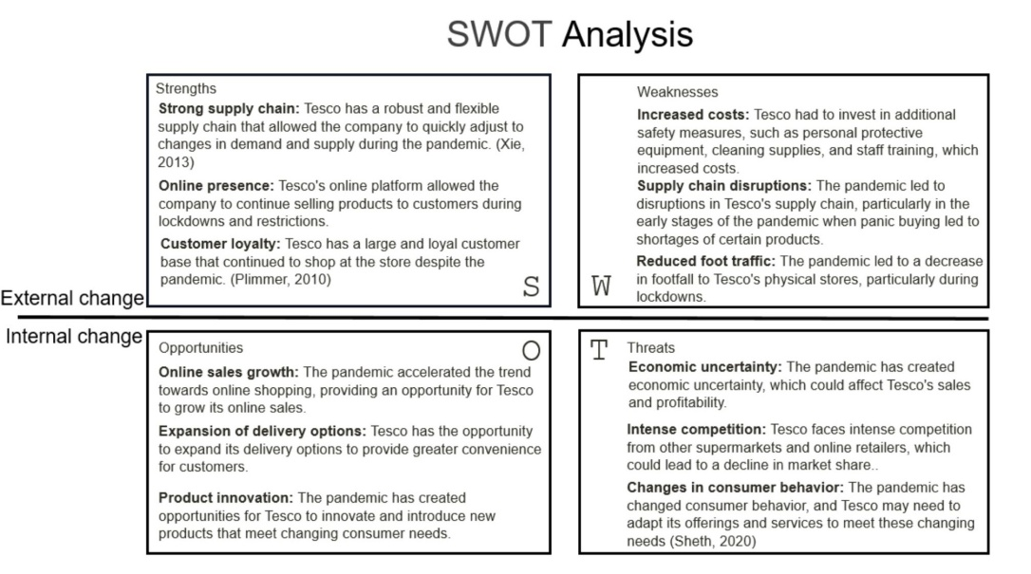
Small scale (incremental) change

The SWOT analysis identified the company's strengths, weaknesses, opportunities and threats. Considering the risk, effectiveness and speed of change, TESCO chose a small-scale scale (incremental) change option.
Firstly, TESCO has a strong supply chain and stable customers who choose to shop at Tesco despite the pandemic. Change needs to be based on maintaining existing strengths and a large scale change would lead to unstable supply and customers not adapting. So Tesco developed digital transformation based on offline sales. Secondly, Tesco's changes are aimed to reduce costs, improve margins and remain competitive in a challenging market. A massive change would have added more costs. Finally, Tesco has always had corporate goals of sustainability and social responsibility, and only small scale (incremental) changes are needed to improve. In summary, Tesco's changes are only new systems, new processes and improvements to existing processes, not a change in corporate strategy or an acquisition, nor are they major technological changes, so they are small scale (incremental) changes.

- Identifying and Dealing with Resistance
5.1 For Field Analysis
Lewin (1947) tells people that there are two opposing forces in the stable management and change management of enterprises. On the one hand, there is a driving force that encourages change to occur; On the other hand, there is also a force called restraint that maintains stability and rejects change (Baulcomb, J. S., 2010).
Before the reform, Tesco's market environment and internal situation had changed imperceptibly. Consumer behavior, intense market competition and sharply reduced sales profits are all influencing the operation of the company to the greatest extent, and like a countdown clock, it is urging the company to move forward.
Of course, there are still obstacles, such as employee misunderstandings and supplier objections, which can be overcome through deep communication and collaboration. The company is most concerned about the decline in customer satisfaction and needs to solve this problem through additional costs and work.
This report analyzes the driving forces and resistance force of change of Tesco:
Drivers for Change | Resisters of Change
COVID-19 Dynamic (3) | Employee's lack of understanding(2)
Brexit (3) | Lack of employee skills(1)
Cost Increasing (3) | Reduced customer satisfaction (3)
Change of consumer behavior(3) | Suppliers are not adapting to new cooperation methods (2)
Intense market competition(3)
Reduction in Revenue(3)
In total: 18 | In total: 8

From the above table, it can be seen that there are more factors that encourage change than those that inhibit it. At the same time, the proportion and weight of factors that encourage change among many factors are also high. The factors that ultimately encouraged company change prevailed, surpassing the forces that refused to change. Undoubtedly, company change ultimately occurred (Harwell, Sharon H., 2000).

5.2 Stakeholder Analysis
Through force field analysis, the main factors that affect change can be clearly classified, while stakeholder analysis can identify the attitudes of stakeholders towards change. Stakeholders are determined by their interests within the organization, that is, whether the organization has relevant interests is controlled by stakeholders. The interests of stakeholders themselves are valuable to the organization, and it is crucial to have a deep understanding of them before making changes in the organization. The following is Tesco's stakeholder analysis chart:

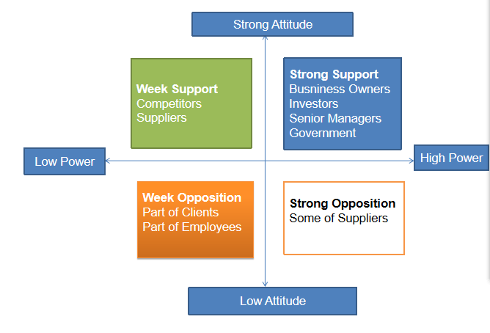
Based on the above figure, it is possible to distinguish the attitudes and reactions of different groups towards change(Pdr, K., Pataki, B., & Sebestyn, Z., 2011). The leaders who propose and drive change are still senior management personnel. If you want the change to succeed, these people must have a firm stance and sufficient professional literacy and execution ability. Change is the process of improving the overall competitiveness of enterprises, and as sponsors, business owners and investors will provide support for achieving change; Government agencies only hope that enterprises can develop rapidly and steadily, provide more job opportunities and promote economic development in the local area, and they also have a certain level of support. The following are different strategies that companies should provide to different stakeholders:
For strong supporters, such as company shareholders, investors, senior managers, and government agencies, the company needs to protect the interests of this group well. They want the company to become stronger and more competitive, and they are also a group with absolute power. As long as people have the same change goals and cohesion, under their leadership, the success of the change is only a matter of time.
5.3 Sources of Resistance
Through field analysis and stakeholder analysis, we can see that there are still some resistances to change in Tesco, mainly from: employees, customers and suppliers.
  - Dealing with Resistance

Due to many products being to ask reduce price, the interests of some suppliers may be damaged, which will have a significant impact on their income. To address supplier resistance, Tesco has implemented several initiatives to ensure that their suppliers are informed about the changes and can provide feedback (Palmer, 2017). This includes the introduction of new systems and processes, as well as increased communication and collaboration with suppliers.

Due to changes in business models，The company's transformation of the supply chain and sales channels will inevitably lead to changes in the interests of suppliers, which may increase their workload, incur additional costs, and even require them to introduce some personnel to cooperate with Tesco's transformation(Palmer, 2017). The senior management of the company needs to obtain their support through communication and in-depth negotiations to minimize supplier complaints and anxiety about change.

The company will also face a less opposed group to change, which is consumers and employees. Employees and consumers are closely linked to the interests of the company. When the company gains stronger competitiveness, employees will also benefit, but in this process, the interests of some employees may be damaged. For example, employees' working hours may change, they may need to master more skills, and their work methods will also change accordingly. These changes will have an impact on employees' lives. So, the company must keeping employees informed. Introducing new communication channels, such as online forums and regular meetings with managers and senior leaders (Adam, 2019). Company also provide training programs, because new training programs to ensure that employees have the skills and knowledge to implement the change successfully. The company needs to have in-depth communication with these dissenting employees, understand their concerns, and provide assistance. For example, the company can provide them with flexible working hours, When they acquire corresponding job skills, they can also be provided with corresponding promotion opportunities or compensation(Hadavinezhad, M., Khaef, E., & Alizadeh, S.M., 2010).

For consumer objections, company could introduce new products and services to better meet customer demand. This includes the introduction of new online ordering and delivery services, as well as the introduction of new safety measures (Brannen et al., 2021). Company also developed multiple channels to ensure customer can provide timely feedback. Tesco has implemented several initiatives to ensure that customers are informed about the changes and can provide feedback.

- Kotter's Eight Step Model
Kotter proposed his eight step model for change management in 1995 (Cameron&Green, 2012). Kotter's eight-step model can be applied to Tesco's change process during the pandemic.

6.1 Establishing a sense of urgency

The company establishes a sense of urgency for change through active communication with employees. The company should communicate its vision and emergency situation to all employees as soon as possible. And regularly provide the latest information and communicate with employees on change needs, such as through internal newsletters. The company will make all employees aware of the company's risk points and opportunities, and the benefit of doing so is to eliminate many employees' doubts and concerns about the future (JN Kamau, 2010). At the same time, the company will regularly report the performance of its competitors, letting everyone know the environment in which the company is located and generating a sense of urgency among employees.

6.2 Establishing a Guidance Alliance

The company can unite all the forces that can be united, from frontline employees to management, and even attract more consumers to join the camp supporting change through propaganda, accelerating the occurrence of change, and jointly addressing external threats. During this period, it is necessary to have in-depth communication with various collaborators. For example, collaborating with other well-known companies to create customised products to differentiate from competitors and leverage on the strengths of partners to increase market share and achieve performance growth.

6.3 Develop Vision and Strategy

Tesco's future vision is to become the most respected enterprise in the world: not only respected by customers, but also by the communities they serve, loyal and dedicated employees, and their shareholders. In 2021, Tesco released a new "declaration" on climate change, listing the five key areas of action that the company believes can make the greatest contribution to addressing multiple global environmental crises, including reducing absolute energy emissions, supporting the UK's transition to electricity transportation, addressing food waste, supporting sustainable food production, and helping customers eat healthy and sustainable diets. These declarations can be found that Whether now or in the future, Tesco will be a growth oriented company and will become a modern and innovative company, achieving success locally by applying Tesco's skills globally. To achieve this vision, the company will continued market competitiveness and developing a vision and strategy for the upcoming changes. The current CEO have done some works to ensure the business is well-positioned in the current environment, such as using new technology, developing new business models, and upgrading and optimizing the existing supply channels.

6.4 Communicate the vision of change

As a large chain retailer, Tesco also needs to be accountable to Customers, employees, suppliers, various media. The company communicates its vision to consumers through advertising, media, APP and various platforms while promoting its products，services and Philosophy

6.5 Empowering broad action powers

The company has provided extensive resources and authorization to implement changes. Authorization mainly focuses on empowering employees and grassroots managers, aiming to activate business and functional departments, empower frontline employees, fully leverage everyone's subjective initiative, and enable everyone to participate in the company's development as a "master". Tesco is also continuously striving to build a learning team, allowing everyone to gain more growth in their spare time and respond to more empowerment with a more outstanding attitude.

6.6 Generate short-term returns
Motivating company employees and achieving short-term success is crucial. At this point, especially those who initially opposed change, the company rewards them when they acquire new job skills and promote the company's phased success. Of course, suppliers who highly cooperate with changes also receive corresponding benefits in a timely manner. Through these measures, the company has successfully encouraged its partners to continue to cooperate with TESCO Group to achieve win-win results.

6.7 Consolidate returns and create more changes
Tesco has a strong supply chain that allowed the company to quickly adjust to changes in the pandemic. Tesco's online platform allowed the company to continue selling products to customers in anywhere. Tesco has a large and loyal customer . Consolidate achievements and continue to create more changes. For example, Tesco actively expands its diversified business. They not only provide daily necessities, but also provide financial, maintenance and other services. Tesco's diversified business can attract more consumers while increasing additional sources of income. In addition, Tesco also focuses on environmental protection and sustainable development, which has increased their popularity among consumers.

6.8 Anchoring New Methods in Organizational Culture
Anchor new methods in their culture to ensure that these changes can be sustained in the long term. For example, it may include embedding new practices into the company's values and norms. For all of these, Tesco has done very well.
The above strategies and measures were implemented by Tesco through practical actions during the transformation process, and the company's transformation was successful, indicating that Kotter's transformation model is in line with the needs of this type of enterprise.

- Assessing Effectiveness

The results are the best proof of this. The analysis of TESCO's financial data can reflect the actual business situation of TESCO after the change. the financial indicated that FY22 is better than FY21, in which the key financial : Statutory revenue, Operating profit before tax, Statutory profit, Statutory Eps have all improved significantly, thus proving that TESCO's change has been successful.

Performance highlights
Group sales | Adjusted diluted EPS | Adjusted operating profit | Retail Fee cash flow
2.5% | 88.8% | 58.0% | 69.9%
￡54.8bn | 21.86p | ￡2,825m | ￡2,277rn
(2021:￡53.4bn) | (2021: 11.58p) | (2021￡1,788m) | (2021: ￡1.340m)
Dividend per share | Net debt | UK market share | Group net promoter score
19.1% | (12)% | +30bps | +3pts
10.90p | ￡(10.5)bn | 27.7% | 18 pts
(2021:9.15p) | 2021: ￡(12.0lbn) | (2021:27.4%) | (2021:15 pts)

Statutory profit
Statutory revenue | Operating profit before tax | Statutory profit | Statutory diluted Eps
6.0% | 65.5% | 219.7% | 252.0%
￡61.3bn | ￡2,560m | ￡2,033m | 19.64p
(2021: ￡57.9bn) | (2021:￡1.547m) | (2021: ￡636m) | (2021:5.58p)

At the same time, Tesco introduced new monitoring and evaluation systems, as well as regular feedback from employees, customers and suppliers, so that the company could measure the success of the change programme. These indicators include the customer satisfaction, operational efficiency, revenue growth and cost savings (Łapa, 2019). the new monitoring and evaluation system showed TESCO is also successful in change, for example: regarding customer satisfaction: The average satisfaction score in the Amazon market is 86.6 points, and TESCO's customer satisfaction score of 86 points is considered to meet the requirements

8. Conclusion
Tesco had a strong supply chain, online platform and a loyal customer base that continued to shop in Tesco despite the pandemic. Tesco's change was aimed at responding to changes in the external marketplace. Through analysis, Tesco successfully used the emergent change model to implement a small scale change plan. Tesco's drivers of change included culture, leadership, power, digitalisation and competition. Through field analysis and stakeholder analysis, it was found that there was resistance from employees. customers and suppliers. Tesco fully resolves various conflicts through different methods to ensure the final effect of the company's transformation. Given the unpredictable nature of pandemics, coupled with a rapidly changing market environment, this report chooses Kotter's model, which outlines the elements required for a change plan, provides the keys to step-by-step implementation, and lays the theoretical foundation for successful corporate change. In the final, report assesses the effectiveness of the changes and makes recommendations

9. Recommendations
The change proposal should set out detailed milestones for the change, and each phase should be validated and summarised, with adjustments made accordingly to the reality of each phase. To validate the effectiveness of the change, the company also needs to introduce new monitoring and evaluation systems, such as third party evaluations, to play a monitoring and auditing role in consolidating the benefits and establishing the results of the change so that it really benefit for TESCO. Attention to effective communication so that regular feedback from employees, customers and suppliers is accurately communicated to the company's senior management. Companies cannot ignore the role of human resources in change. If HR can establish a new set of performance indicators to measure, review and evaluate people's performance in a timely manner, encourage high performers and diversify the company's appraisal approach. By evaluating people's performance, not only can the success of the change programme be indirectly assessed, but the enthusiasm of employees can also be sustained.

References
Adam, A. (2019) "Employee participation in organizational change: A case of Tesco plc," International Journal of Financial, Accounting, and Management, 1(2). Available at: https://doi.org/10.35912/ijfam.v1i2.93.
Aldemir, E. (2010). “Models and Tools of Change Management: Kotter's 8 Steps Change Model”. [Online]. Available at: https://doi.org/10.13140/RG.2.2.16064.07688. [June, 2010].
Barbradozier (2018) “Leadership and Management at Tesco Incorporated, Barbra Dozier's Blog”. [Online]. Available at: https://barbradozier.wordpress.com/2012/10/12/leadership-and-management-at-tesco-incorporated/ (Accessed: February 3, 2023).
Baulcomb, J. S. (2010). Management of change through force field analysis. Journal of Nursing Management, 11(4), P275-280.
Bedford, E. (2022) “Topic: Tesco plc, Statista”. [Online]. Available at:https://www.statista.com/topics/3807/tesco-plc/#:~:text=Tesco%20PLC%20is%20a%20British,brand%20worldwide%20as%20of%202021. (Accessed: February 3, 2023).
Brannen, M.Y., Moore, F. & Mughan, T. (2021) Strategic ethnography and reinvigorating Tesco plc: Leveraging inside/ out bicultural bridging in multicultural teams, Ethnographic Praxis in Industry Conference Proceedings, 2013(1), pp. 282–299.
Bruter, M., & Harrison, S. (2016). “The impact of Brexit on consumer behavior”. [Online]. Available at: https://doi.org/10.1111/j.1559-8918.2013.00024.x. [2016, January]
Burton, R. M., Lauridsen, J., & Obel, B. (2000). “Tension and Resistance to Change in Organizational Climate: Managerial Implications for a Fast Paced World”. [Online]. Available at: https://doi.org/10.1002/hrm.20003. [2004, April 19]
Cameron, E. & Green, M., 2012. Making Sense of Change Management: A Complete
Guide to the Models, Tools and Techniques of Organisational Change. 3 ed. Philadelphia: Kogan P57.
C.Chen. (2009). ‘What are the factors that make private label both attractive and feasible for supermarkets A Tesco UK case study”. https://www.researchgate.net/publication/352312530_Retailers'_Market_Entry_Mode_Choice_from_the_Institutional_Perspective_a_Case_Study_of_Tesco. [2009, March]
Commendatore, P. , Kubin, I. , & Sushko, I.(2018). “The impact of brexit on trade patterns and industry location: a neg analysis”. Department of Economics Working Paper Series.
Garcia-Lorenzo, L. and Liebhart, M. (2010) "Between planned and emergent change: Decision Maker's perceptions of managing change in organizations," The International Journal of Knowledge, Culture, and Change Management: Annual Review, 10(5), pp. 147–162. Available at:
https://doi.org/10.18848/1447-9524/cgp/v10i05/49976.
Gibbins, J.(2022). Biz: manufacture: man truck production interrupted by supply chain shortages due to russia-ukraine conflict. Truck & Bus Builder: the international newsletter of commercial vehicle manufacturing, developments(4), 44.
GlobalData (2022) “Tesco - Digital Transformation Strategies, Market Research Reports & Consulting | GlobalData UK Ltd”. [Online]. Available at:
https://www.globaldata.com/store/report/tesco-plc-enterprise-tech-analysis/?scalar=true&pid=69952&sid=28 (Accessed: February 3, 2023).
Goswami, S. , & Chouhan, V. (2021). Impact of change in consumer behaviour and need prioritisation on retail industry in rajasthan during covid-19 pandemic. Materials Today: Proceedings(4).
Group, P. (2022). Russia's attack on Ukraine impacts logistics industry. plastics information europe(TN.1094), 46.
Guertler, Matthias, R. , Wiedemann, Francesco, Lindemann, & Udo. (2015). “The relevance of stakeholder analysis for open innovation”, [Online]. Available at:https://mediatum.ub.tum.de/doc/1272090/document.pdf.[2015. April]
Hadavinezhad, M., Khaef, E., & Alizadeh, S.M. (2010). “Manager's political behaviors, employee's organizational politics perceptions and resistance to change.” Iranian Journal of Management Sciences 4 (4), 119-137, 2010
Harwell, Sharon H. (2000). "Impediments to change: An application of force-field analysis to Leader Master Teacher training in an elementary level science systemic reform initiative." Journal of Elementary ence Education 12.2(2000):7.
Hodges, J. & Roger , G., 2015. Sustaining Change in Organizations. 1 ed. London: Sage Publications Ltd.
Lonescu, F. C., & Morlovea, A. (2019). Personal development - a driving force of changing the educational organization. Contemporary Economy Journal, 4.
Ji, Eun, & Kim. (2010). A structural model analysis of transformational leadership and resistance toward change influencing openness to organizational change mediated through self-efficacy -centered on hotel employees. Korean Journal of Hospitality & Tourism, 19(5), 119-136.
JN Kamau. (2010). The relevance of Kotter's eight-step model in understanding organisational change at nokia siemens networks (kenya). University of Nairobi Kenya. Available at: https://doi.org/10.1080/14694099.2010.222.
Karasvirta, S. & Teerikangas, S. (2022) "Change organizations in planned change – A closer look," Journal of Change Management, 22(2), pp. 163–201. Available at: https://doi.org/10.1080/14697017.2021.2018722.
Łapa, K. (2019) "Meta-optimization of multi-objective population-based algorithms using multi-objective performance metrics," Information Sciences, 489, pp. 193–204. Available at: https://doi.org/10.1016/j.ins.2019.03.054.
Lee, S. H., & Lee, S. Y. (2018). An analysis of the effects of climate change policy, stakeholder pressure, and corporate carbon management on carbon efficiency on the korean petrochemical industry. Sustainability, 10(12).
Leimer, C. L. (2011). Resolving higher education's effectiveness dilemmas: A cultural analysis of stakeholder expectations. Fielding Graduate University.
Leonard, C. L. (2014). How stakeholder command of the cycle of organizational communication promotes strategic alignment. Dissertations&Theses- Gradworks.
Lewin, K., (1947). Frontiers in Group Dynamics. Human Relations, 16, pp. 5-41.
Mazaj, J., Grosso, M., & Castaldo, S. (2022). The world of changes: Covid-19's impact on the retail path towards sustainability. International Series in Advanced Management Studies.
Mollah, A. S. (2014). “The impact of relationship marketing on customer loyalty at tesco plc, uk”. [Online]. Available at: https://doi.org/10.4018/978-1-4666-9533-7.ch012.
Montgomery, R. (2019)“Force Field Analysis: Identifying Forces For and Against Change.” [Online]. Available at: https://www.iied.org/sites/default/files/pdfs/migrate/G01574.pdf, [2019, April]
Nadler, D. A., Shaw, R. B. & Walton, A. E., (1995). Discontinuous Change: Leading
Organizational Transformation. San Francisco: Jossey Bass Publishers. P20
Nancy, Langton, Karim, M, Khan, & Sarah, et al. (2010). Fifa's football for health: applying kotter's eight-step programme for transformational change to a mass participation activity. British Journal of Sports Medicine.
Palmer, M. (2017) "Retail multinational learning: A case study of Tesco," International Journal of Retail & Distribution Management, 33(1), pp. 23–48. Available at: https://doi.org/10.1108/09590550510577110.
Pdr, K., Pataki, B., & Sebestyn, Z. (2011). A comparative analysis of stakeholder and role theories in project management and change management. International Journal of Management Cases.
Rybarczyk, T. (2015) “Should CEOs be the driving force behind Organizational Culture Change?”. [Online]. Available at: https://www.vanguard.edu/uploaded/Academics/Graduate/Organizational_Psychology/Should-CEOs-be-the-driving-force-behind-Organizational-Culture-Change.pdf. [2015, November]
Saleem, N. (2021). Digitalization and globalization increasing organizational performance. iJARS International Journal Of Humanities and Social Studies.
Tarhini, B., & Hafiz, L. (2021). The impact of covid-19 on consumer behavior in the retailing industry of lebanon. Cactus. The tourism journal for research, education, culture and soul, 3
Tom, & Sharpe. (2016). Brexit poll: motor retail industry votes to leave EU. Automotive management: AM(Jun.), 8-9.
Torlak, N.G. (2019) "Improving the role of organisational culture in change management through a systems approach," Organizational Change Management Strategies in Modern Business, pp. 230–271.
Young-Sang, C. (2011). “The knowledge transfer of Tesco UK into Korea,in terms of retailer brand development and handling processes”. [Online]. Available at: https://www.jstor.org/stable/20159100. [2011, August]
Zhou, D., Kautonen, M., Dai, W., & Zhang, H. (2021). Exploring how digitalization influences incumbents in financial services: the role of entrepreneurial orientation, firm assets, and organizational legitimacy. Technological Forecasting and Social Change, 173(3), 121120.

