Business Model Canvas and Entrepreneurial reflection

Module title: Entrepreneurship BMIH5001
Lecturer’s name: Neil Dyer
Student name: Valentina Teliban
Student ID:2210054
Word count: 2015

Part 1: Business Essay
Introduction
This business essay will focus on the description of the elaborate explanation of the BMC model. The first section passage will describe the subject focused on the detailed elaboration of the model of Business Model Canvas. It will also be stated the way an organisation is affected based on the optimisation level of the Business Model plan. The various components of this model will also be provided in the contents of this essay. The various constituents of the BMC and its applicability with relation to the case study will also be mentioned.
Discussion
This passage of the essay will be focused on discussing an overview of the Business Model Canvas. The business model canvas can be referred to as a strategic planning tool that is used by the professionals for illustrating and developing their business structure (Barringer & Ireland, 2018). This model canvas is used for the identification of the key elements that are constituted for making up a business organisation. This tool is used to simplify the business plan into a condensed and easy-to-understand form for an easy interpretation and understanding. It can be also referred to as the executive summary of the elaborated business plan of the newly set up organisation in the hospitality sector (Barringer & Ireland, 2018).
This passage of the essay will highlight the structural pattern of the business model canvas and its nine components. There are mainly nine main components making the complete structure of the Business Model Canvas that includes the key activities, Key partners, Value Proposition, Customer relations, Key Resources, Marketing channels, and segments of the target customer song with the revenue streams and cost structure. Each of the constituents is necessary for the development of the organisation such as the interrelations of the employees as well as their relationships with the customers. The overall productivity that is maintained within the premises of the organisation in the hospitality sector is dependent on the properly planned Business Canvas Model (Barringer & Ireland, 2018).
Hotel Seasite is a newly opened Hotel on the eastern coast of the United Kingdom. It has been only two years since the hotel was set up such that it focuses on providing budget-friendly rooms and hospitality services to customers visiting the North Sea for long or short vacays. The hotel is not available on other commercial websites and rather has its own social media and official websites. The hotel is known to put more interest in understanding the demands of the customers and try to put forward towards the execution of their needs and desires based on the availability of the resources and convenience. It was also due to this objective of the organisation that they provide support to many social and environmental sustainability (Rickman & Roddick, 2013).
Value Proposition in the structure of the Business Model Canvas can be arguably considered the most significant component of the model as well. It helps in the determination of the fundamental offering that the organisation has aimed to provide to its consumers (Nelson, 2013). It can be referred to as the primary driver of the operations taking place within the premises of the hotel. The management of Hotel Seasite has focused on the Value proposition of providing good quality rooms and hospitality services to their consumers within a budget-friendly range. Another proposition of the organisation is to maintain good quality after-relations with the consumer (Mustaniroh et al., 2020, June).
The key partners of an organisation or a business are referred to as the people those are enthusiastic to provide help in the creation of a strategic bond of relationship within the fellow colleagues and stakeholders. The main question that the organisation placed was if they got any useful individuals or organizations to be partnered with them for the promotion of actions of sustainability. Key partners are also responsible for delivering the “Key Activities” that are essential for the development of the organisation on an overall basis. Hotel Seasite will be partnered with Green Alliance, TechUK, Age UK and the Thrive Agency. The company have partnered with these organizations to promote practices of sustainability (Hisrich et al., 2008).
The key activities of the business operative in the business market of the hospitality sector include the set of actions that are to be undertaken by the organisation for achieving the value proposition for their target customer base. This set of the Business Canvas Model is essential to address the issues such as strategic underdevelopment, improper practices of sustainability and technical development. The hotel Seasite will be focused on increasing the various activities performed within the premises of the organisation. The company’s key activities will be discussed around the development of the technical equipment in the software as well as the hardware. The development of various processes to increase their sustainability will also be included in the key activities of Hotel Seasite (Dobrowolski and Sułkowski, 2021).
The key resources can be referred to as the kinds of sources that are essential for the achievement of the various activities and actions in the implementation of the business. The resources that are necessary for the development of the organisation and the various activities operative within its premises are teamed within it. These resources may include technological equipment, human capital, vehicles, software essential for implementing good management procedures and similar ones. The hotel Seasite will be focused on their key resources that are the technological equipment such as the devices and mechanisms used within the hotel premises. The human capital can be referred to as the primary key resource of the hotel (Burns, 2022).
Customer relations are also a significant component in the Business Model Canvas that is the segment used to understand the relationship of the organisation with their customer base. It helps to determine the way the employees working within the company interact with their customers with the help of proper behavior and interaction. They are mainly categorized into sections such as events (one-to-many), third-party contractors, online interaction and the one-to-one (in-person) form. The hotel Seasite will be focused on maintaining healthy and cooperative relations with its customers. They are focused on the concept of delivering their services in the form of one-to-one approach (Daou et al., 2020).
Channels can be defined as the medium through the way the organizations are effectively able to display their services and products provided to the customers with the business. This also serves as the medium essentially helpful in piquing the interests of the consumers such that they participate and become a part of the sales cycle of the business (Blackwell, 2011). The channels are basically served as the medium of interconnecting the target customer segment with the presentation of the value proposition. The hotel Seasite has analyzed the trends and actions of the target customer group and fixed the channels. The channels that are implemented by the hotel are included as the official website and the various social media webpages in the online platforms (Rae, 2008).
The cost structure of a business is known as the monetary structure of the finances necessary for operating the various activities within a company. It includes the planning of the various expenses that are necessary for operating in the business market of the Hospitality sector. This also includes the cost of the key resources as well as the partnerships involved in the functionality. Any legal charges or the ones related to the insurance expenses and other additional costs are also included in the cost structure (Micieta et al., 2020).
Revenue Streams are referred to as the way an organisation is able to convert their Value Proposition to the financial earnings of the company. These are done by understanding the pricing strategies of the services provided to the customers and analyzing the trends. There are many revenue models such as fee for services, freemium, pay-per-view or product, dividends, subscriptions and so on. The Hotel Seasite has implemented the revenue streams of freemium and subscriptions (Williams, 2021).
To summarize, it can be said that the Business Model Canvas is quite necessary for the proper functionality of the Hotel Seasite. The BMC is quite necessary to be designed for the optimum functionality of the hotel. The various things such as the cost structure, channels and key activities are provided in the structure of the model. The various functionalities of the hotel have also been determined by the outlines of the Business Model Canvas (Carvalho et al., 2020).
Conclusion
This business essay has focused on the description of the elaborate explanation of the BMC model. The first section passage has described the subject to be focused on the detailed elaboration of the model of Business Model Canvas. It has also been stated the way an organisation is affected is based on the optimization level of the Business Model plan. The various components of this model have also been provided in the contents of this essay. The different parts of the BMC and its applicability with relation to the case study has also been mentioned.
Part 2: Reflective Essay
Introduction
The reflective essay will focus on providing details of the entrepreneurial management of the individual using the Gibbs Reflective Model. The subject of reflection will be based on questioning the positions of the hotels based on their demand curve and elasticity. Appropriate subjects of discussion necessary for the correct answers to the questions based on demand curve and elasticity will also be provided.

Discussion
Description- The reflective essay will be based on the structure of the Gibbs Reflective Model along with its six components (Roedema et al., 2022). With the help of this essay, I will try to describe the probable reasons that lead to the demand curve and elasticity based on my project of entrepreneurship. The various skills that I learnt during the lectures and learning from modules. I was able to learn about the various shifts in the trends (Pieper et al., 2021).
Feelings- During the lectures, I felt that I was able to learn quite a few different aspects was able to learn in the module. The classes have provided details on the various topics and elements that may impact the demand curve and its elasticity. I was feeling glad to learn a wide range of new things. A mixed set of emotions were risen as I learned about the factors that affected the curve (Ningrum and Ariani, 2020).
Evaluation- I have evaluated that there are many elements that determine the demand curve and the elasticity in the positioning of the hotels. The seasonal demands, financial requirements, and changes in the preferences of the target customers are among the most common elements that determine the shift in the curve of the demand as well as its percentile of elasticity (Williams et al., 2020).
Analysis- Upon conducting a thorough analysis of these factors and the way they impact the demand curve and elasticity; I was able to learn other details on the subject of entrepreneurship. I has also realized that I lacked the skills important for understanding the information (Markkanen et al., 2020).
Conclusion- From the studies I did, I have realized that I lack some of the very important skills that are necessary for entrepreneurship. I also need to learn the various factors that are to have effect the demand curve and its elasticity on an overall basis (Adeani et al., 2020).
Action Plan- I need to develop my sets of skills and knowledge to get a proper idea of entrepreneurship and its different elements. I plan on doing this by enrolling into special classes. I am also checking the various informational videos based on the demand curve and its impact on hospitality positioning (Contreras et al., 2020).
Conclusion
The reflective essay has given details of the entrepreneurial management of the individual. The subject of reflection has been focused on the questions of the positions of the hotels on the basis of their demand curve and elasticity using the Gibbs model. Appropriate subjects of discussion necessary for the correct answers of the questions based on the demand curve and elasticity has also been provided.

References
Adeani, I.S., Febriani, R.B. and Syafryadin, S., (2020) Using GIBBS’reflective cycle in making reflections of literary analysis. Indonesian EFL Journal, 6(2), pp.139-148.
Barringer, B. R. & Ireland, R.D. (2018) Entrepreneurship: Successfully Launching New Ventures, 4 th Ed., Prentice Hall: New Jersey.
Blackwell, E. (2011) How to Prepare a Business Plan: Planning for Successful Start-up and Expansion, (5th Ed) Sunday Times Business Enterprise Series, Kogan Page.
Burns, P. (2022) Entrepreneurship and Small Business, 5th Ed., Palgrave Macmillan: Basingstoke.
Carvalho, L., Galina, S. and Sánchez‐Hernández, M.I., (2020) An international perspective of the business incubators' perception about business model canvas for startups. Thunderbird International Business Review, 62(5), pp.503-513.
Conceptboard (2024) Individual Business Model Canvas. [Visual Workspace]. Available at: https://conceptboard.com/blog/business-model-canvas-free-conceptboard/(Accessed:05 February 2024).
Contreras, J.A. et al. (2020) Effects of reflective practice on baccalaureate nursing students’ stress, anxiety and competency: An integrative review. Worldviews on Evidence‐Based Nursing, 17(3), pp.239-245.
Daou, A. et al. (2020) The Ecocanvas as a business model canvas for a circular economy. Journal of Cleaner Production, 258, p.120938.
Dobrowolski, Z. and Sułkowski, Ł. (2021) Business model canvas and energy enterprises. Energies, 14(21), p.7198.
Hisrich, R.D., Peters, M.P. & Shepherd, D.A. (2008) Entrepreneurship, 7th Ed.,McGraw Hill: NY
Markkanen, P. et al. (2020) A reflective cycle: Understanding challenging situations in a school setting. Educational Research, 62(1), pp.46-62.
Micieta, B. et al. (2020) Business model canvas in global enterprises. In SHS Web of Conferences (Vol. 74, p. 02010). EDP Sciences.
Mustaniroh, S.A., Prabaningtias, N. and Citraresmi, A.D.P. (2020) Analysis of business development strategies with business model canvas approach. In IOP Conference Series: Earth and Environmental Science (Vol. 515, No. 1, p. 012075). IOP Publishing.
Nelson, O. (2013) Enterprise development in SMEs and entrepreneurial firms dynamic processes. IGI Global.
Ningrum, Y. and Ariani, N., (2020) Reflective journal writing: A review of the literature. In NEELS (National English Education, Language and Literature Seminar) Proceedings (pp. 305-313).
Pieper, M. et al. (2021) Feedback in reflective journals fosters reflection skills of student teachers. Psychology Learning & Teaching, 20(1), pp.107-127.
Rae, D. (2008) Entrepreneurship: from opportunity to action, 2nd Ed., Basingstoke: Palgrave Macmillan
Rickman, C., & Roddick, D. (2013) The Small Business Start-Up Workbook: A step-by-step guide to starting the business you’ve dreamed of. London, How To Books.
Roedema, T. et al. (2022) Towards the reflective science communication practitioner. Journal of Science Communication, 21(4), p.A02.
Williams, K., Woolliams, M. and Spiro, J., (2020) Reflective writing. Bloomsbury Publishing.
Williams, S. (2021) FT Guide to Business Start Up: The most comprehensive guide for entrepreneurs, 32nd Ed., Financial Times Press: Harlow.

Appendix
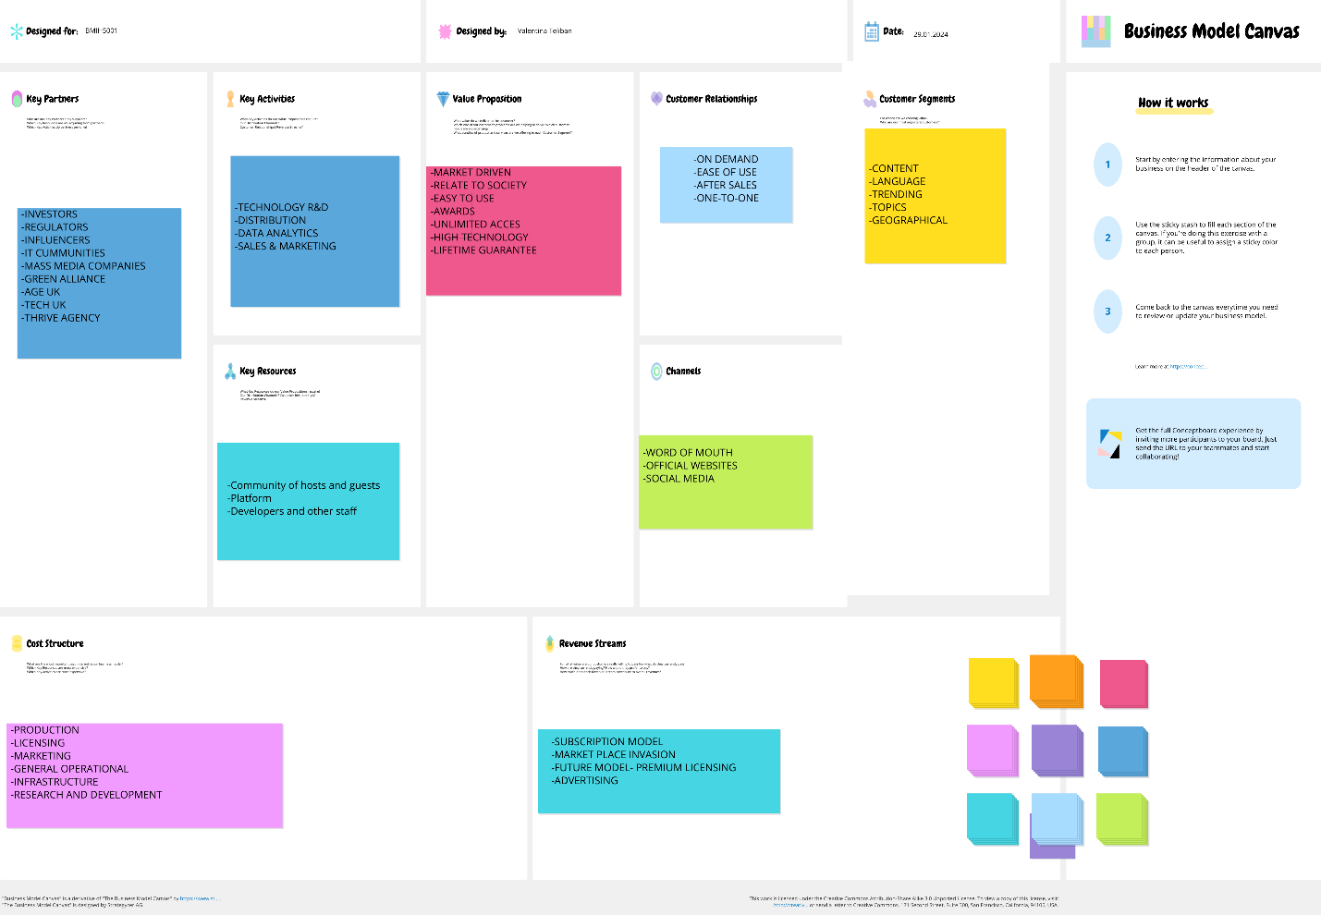
(Conceptboard, 2024)

