Case Study - Stage 2 Site Layout and Logistics
Project Planning, Monitoring and Control (M3X8761)
Abdul Rahman Al-Meshhedani (P152142)

Table of Contents
Site Layout and Logistics - Introduction 3
Security, Access and Hoarding 3
Site layout 3
Site Clearance and Piling 4
Excavation 5
Foundations and Basement Construction 5
Superstructure 7
Roof Works 8
External Walls – Brick and Block (and Scaffolding) 8
References 9
Appendices 10

Site Layout and Logistics - Introduction

An important part of any construction project is the site layout and logistics plan for the movement of labourers, storage of materials and provisions made for services and welfare facilities. Also, the positioning of plant, cranes and offices is also an important factor. It is to ensure the smooth running of works, enabling safe and efficient movement of labourers and plant on-site simultaneously. It is a Construction Design and Management regulations requirement as well as the Health and Safety Regulations for the safety and welfare of site personnel at all times.

This stage will contain a plan for the site layout and logistics for services, plant, cranes, offices, storage and waste solutions. I will also be describing how the resources and the layout will change as works on site progress.

Security, Access and Hoarding

- Site logistics to be managed – busy city centre area.
- CDM regulations state that it is the main contractor’s responsibility to prevent unauthorised access and set site boundaries – Solid timber 2.1m high Permanent Hoarding.
- Strict, separate access for vehicles and pedestrians, with crossings and metal barriers to segregate the two. (appendix A)
- The road will be kept as the existing tarmacked road for access. All the relevant signage will be placed prior to the start of works on-site. The site will have a one-way flow where the reversing of the vehicles is prohibited.
- Floodlighting for visibility and to deter trespassing. 24 hour security with cameras.
- Entrance and exits will be logged here and visitors must not be left unattended and must report to the site office prior to entering the site.
- Supervision is important at each stage of the construction, especially for plant movement.

Site layout

The site layout will change as work progresses (appendix B). There will be a site office to store all the paperwork, IT and printing. With regards to the welfare facilities and the subcontractor facilities, we need to consider existing services such as the water, electricity and drainage infrastructure and connect the individual site cabins to it. Generators will be required for the crane and plant. The positioning of the storage areas and offices need to be carefully considered to minimise disruption as the site develops.

There will be separate male and female showers, WC’s and changing facilities for the whole site with large sinks for washing. Also, there will be tumble dryers to dry wet clothing. There will also be first aid in several areas.

There will be a general kitchen area and canteen for people to eat and rest. Drinking water will be provided as this as part of the legislation. At the peak times on site there will be approximately 8 gangs of workers on-site and will require space for at least 50 persons.

There will also be provisions made for subcontractor storage as well as subcontractor offices where they can sit and reheat food and access hot and cold drinks.

Designated delivery and offloading areas will be near the storage areas, towards the rear of the site. Where necessary in the subsequent stages this is accessible and within the reach of the crane (appendix C) to reduce double-handling of materials where possible. Also, near the exit we will have wheel washing facilities for the delivery vehicles and concrete mixers and pumps.

Near the storage areas, there will areas to perform slump test for concrete consistency when these might be required during the superstructure phase.

Consideration for temporary works will be discussed in the relevant areas where we will be providing concrete pours, fall protection barriers and scaffolding.

Due to the site space restrictions parking will only be for the site manager, foreman and a visitor. A couple will be available for sub-contractors’ due to limited parking in the city centre. Permission can be sought to use land adjacent to the site.

Site Clearance and Piling

Two number standard 360 excavation machines will arrive on-site to break up the existing carpark surface using hydraulic breakers attachments and then levelling the site to begin works. Then the asphalt can be crushed and reused and any existing vegetation can be separated and removed off-site and placed into a compost recycling bin. The site will then be levelled using the excavator and surveyed using a theodolite/total station to begin piling works.

Prior to starting the excavating works, a check for underground services by CAT scans and service maps. This will need to be signed off by the site manager and subcontractor. Soil strength need also be tested and considered.

Secant continuous pilling system to act as the reinforcement. Piling moulds will be delivered onto site using a wagon to offload it into the site area and will be used to produce the piling templates for the piling rig to arrive on site. It will be situated on the perimeters of the site, once the piling rig has removed all the hard-core within the pile, this will be moved by the digger into the tipper and taken off-site. This is to prevent build-up in a site limited for space.

The piling rigs with the reinforced steel cages will then be filled with concrete using the concrete pump fed by a concrete mixer. As one concrete mixer finishes, it will wash off in the wheel wash area. The concrete quantities should be ordered to prevent excess wastage. Any excess waste can be isolated and the wash off for the concrete mixer pump can be placed into a skip and removed off-site.

The piling steel cages will be inserted and any excess steel can be cut to save space on site and placed into a skip. The hard-core can be then sold onto others for backfilling, etc.

Excavation

Once the piling has been set, the excavation of the 2000m2 area for the sub-blocks can begin.

At this stage, the adequate fall protection barriers around the perimeter of the intended excavation must be introduced.

The diggers will be bought on-site and the excavation will start by sub-block A – B – C - D. The excavators will contain 0.5m3 buckets, they will work at the surface and place the removed hard-core into a tipper lorry ready to take the hard-core away from site. As the excavation progresses, ramps will need implemented to allow access into the excavated areas. These will be adjusted as excavation progresses (see Appendix D).

In this stage, the work is accessible by the ramps. The fall protection surrounding the entire perimeter remains to prevent unauthorised access/persons falling. And entry to the ramps will be using a gate of equal height as the barriers.

The crane could be used with a bucket to remove the excavated material into the waiting lorry. However, for the safety of the workforce in the excavation trench, it is safer to use the machines to remove the hard-core initially directly into the lorry. Once the excavation stage progresses, it will be easier to place the excavated hard-core into the pile, then have a digger with a general labourer to place the piled hard-core into the tipper lorry.

To prevent persons falling into the excavation area from above, 2m clear height railing will be used and fitted into the ground rather than freestanding Heras fencing panels which can be pushed over.

Once this stage is complete, the diggers will be safely removed using the crane and taken off-site by a trailer.

Foundations and Basement Construction

Once the excavation is complete, there will be slight changes to the site layout. The ramps will be removed. Raft foundations are to be installed in this project. The hardcore needs to be compacted and blinded using 50mm of coarse sand. Mass concrete edges to form a raft will be poured, steel reinforcement mesh, a damp proof membrane, insulation and screed. This forms the basement foundation slab. The concrete will be supplied using a concrete pump and mixer, the mesh will be delivered on-site once the excavations are completed. These will be lowered into the excavated area by crane in an orderly fashion as they are being tied by the steel fixing gang. The below ground drainage will be installed here, the new drainage will need to be connected into the existing infrastructure.

The basement walls will be a waterproof layer attached to the piles, steel mesh tied together with a reinforced concrete pour tied together. The temporary works element will be the shuttering and the concrete pour. We can then use a stair-safe system to enter the newly formed basement area (image below).

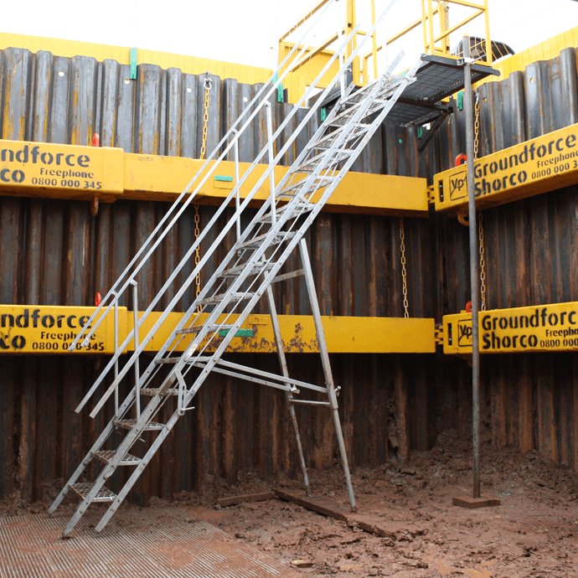

Stair-Safe Excavation Trench access system (Groundforce, 2015)

There will be excess steel mesh that can be recycled, then, the concrete that is produced from the pump will need to be washed out and placed into a skip to be removed. All waste will be taken out of the sites by crane and offloaded into the skips by general labourers to ensure that no waste is left unattended onto sites.

Superstructure

The edge protection must remain at this stage. The steel skeleton will be fitted in this stage. This will be carried out using a crane carrying the steel frames. These are delivered on-site in sections by lorry, they can be offloaded by the crane near the areas where they will be installed. The will be hoisted into position by the crane. Labourers in Mobile Elevated Work Platforms (MEWP’s) will be used to bolt the steel frame elements together. As the work progresses, larger MEWP’s will be bought into place to replace the other. These will be raised into and off the work area using the crane. As soon as one sub-block foundation is complete, the steel frame of that sub-block can start to be assembled.

Fall arrest nets will need to be put into place to prevent the decking fitters from falling (see image below). 1m-high edge protection on the perimeter of each floor. The decking is lowered into position by the crane, once the composite decking is stud welded, the mesh can be lowered into place and tied to the decking. Once all the composite decking is complete, the concrete pump and mixers can arrive on-site to pour the concrete, this is then levelled out using a power float.
This is done floor by floor starting lowest first. Drainage outlets for each of the floors are considered at this stage.

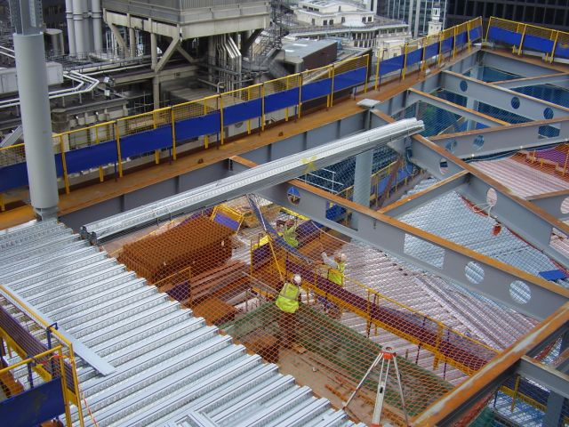

Steel decking safety nets and edge protection – Working At Height Regulations (SteelConstruction.Info, 2012)

Superstructure may produce excessive steel that can be returned to the manufacturer. The waste from the composite decking can be recycled as stainless steel and the mesh off-cuts can cut down to smaller bits and placed into the metal skip and removed off site.

Roof Works

At this stage, once the building is near water tight, we can bring in permanent power for the electrical services. In order to prevent damp issues, the roof will begin prior to the walls. The roof will be made up of a composite decking system as the base, with insulation and ply board, with a vapour barrier. The final layer will be a flat roof single-ply system. These materials will be delivered before time and placed into the storage containers to prevent them from getting wet and damaged. The insulation sheets are 2.4 x 1.2m, so where possible, to avoid double handling of the materials, this can be just-in-time delivery and craned into position.

The labour gang of two roofers, general labourer will be working on the roof level and two labourers at the bottom to retrieve the materials in the storage and tie on materials to the crane from ground level.

There will be plenty of materials and cuts to waste and these will be placed in recycling skips, lowered by buckets in the crane and then placed in the separate skips by general labourers. The rubber roof cuts can be recycled in the plastic skip. Recycling of insulation cuts is not readily available, this will be placed into general waste skip.

External Walls – Brick and Block (and Scaffolding)

A scaffold system will be erected floor by floor. Nets will be provided to prevent debris from falling as the mixing is taking place. The cement mixers will happen on the floor area inside the building and not on the scaffolding. The first step is to do the inside block wall first. All the bricks and blocks, mortar and materials will be lifted into each floor by the crane and into the cantilevered crane platforms. The bricks will be stored in stacks and covered to prevent them getting wet, this will be lifted into the floors as they are required. The general labourers will cut bricks and blocks with the petrol disc cutter inside away from the scaffolding, with dust-suppression water pumps. A general labourer will be on the ground to help attach the pallets to the crane. The cavity wall insulation will be stored in containers and retrieved to the crane as in when they are required. They are 1200mm * 450mm * 75mm = 0.0405m3 per sheet there are six in one pack, one pack is therefore 0.243m3. One single container can store 6.05m x 2.44m x 2.59m =38m3. 38/0.243 = 156 packs.

Waste from the brick and block will be placed in a chute (see appendix E) and into a large rubble skip that can be offloaded when it is full.

References

Chudley, R. and Greeno, R. (2006). Building construction handbook : incorporating current building and construction regulations, sixth edition. 6th ed. London: Taylor & Francis, p.161.

Groundforce (2015). Groudforce Shoreco - Excavation Support - StairSafe. [image] Available at: https://www.vpgroundforce.com/Groundforce/media/Groundforce/Images/Groundforce%20Shorco/SiteSafe/stepsafe-thumb.png [Accessed 12 Jan. 2018].

Selectplanthire.com. (2015). CTT 72140 | Select Plant Hire. [online] Available at: http://www.selectplanthire.com/what-we-do/lifting-solutions/cranes/tower-cranes/ctt-72140.aspx [Accessed 14 Jan. 2018].

SteelConstruction.Info (2012). Safe system of work with netting and edge protection. [image] Available at: https://www.steelconstruction.info/File:Safe_system_of_work_with_netting_and_edge_protection.JPG [Accessed 13 Jan. 2018].

Appendices

Appendix A – Traffic Management Plan

Please find Traffic Management Plan included in paper submission

Appendix B – Site Layout drawings

Please find Site layout drawings included in paper submission

Appendix C – Crane drawing

Please find crane drawing in paper submission

Appendix D – Ramp drawing

Please find ramp drawings in paper submission

Appendix E – Scaffolding Chute for waste and rubble disposal

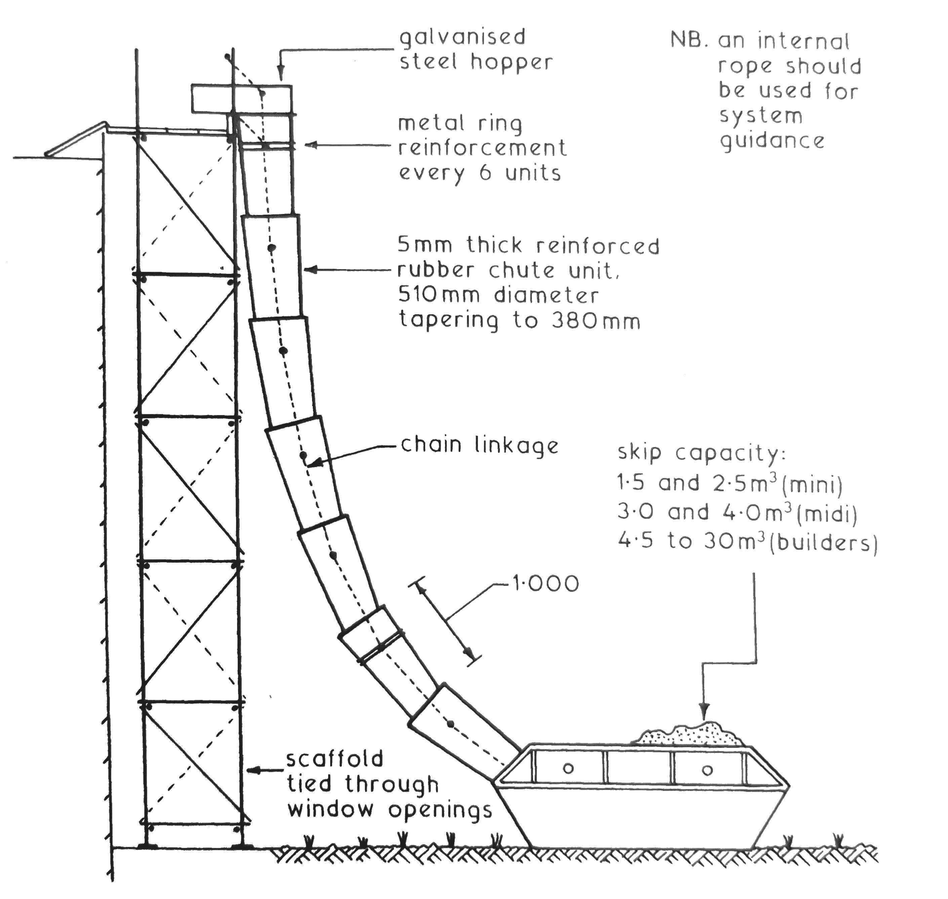
image extracted from (Chudley and Greeno, 2006)

