Geographical Information Systems: Public Health and Meningitis in Swansea
Henry COBBOLD
‘School of Applied Computing’ (SOAC)
University of Wales Trinity Saint David
Swansea, County of Swansea
hcobbold.149234@student.uwtsd.ac.uk

- Introduction

Geographical Information Systems (GIS) are a type of information technology [1] that involves the process of hypothesising, manipulating and analysing data sources in a virtual spacial environment in relation to the attributes of the physical environment from which such data is derived [2],[3]. This paper will more specifically concentrate on public participation geographic information systems (PPGIS) and the process of obtaining public domain-related data with the aim of influencing policy and organisational decision-making activities, a powerful tool that can both directly, and indirectly influence governmental and non-government organisations. The aim of such work being improvements to the municipal quality of life [4]. PPGIS projects tend not to be an academic exercise, but more an imprecise science, typically with grass-route motives in enabling or identifying the need for societal change [4], that in this case will aim to more precisely guide the provision of a vaccine for the Meningitis virus.

- Geographical Information Systems

Explore GIS and Cartographic origins

The rise of geographic rendering and subsequent geo-spacial analysis techniques started to gain momentum during the 1960s [3] with many industry professionals welcoming this new scientific-based approach to traditional geographical and cartographic assessment. The subject areas as a whole has seen such popularity the fundamental techniques now form part of a broader area of information technology known as Geographic Information Science (also referred to as “GI-Science” [5]). The historical origins of cartography are discussed by Waters [6] who refers to early activities Berthier in his use of map overlays during the American War of Independence to illustrate the deployment of troops across a representation of the physical environment, and Dr. Snow and his study of Cholera transmission in London. Continuing, Waters [6] suggests it is not until “almost a century later” that the use of visual mappings and overlays reappear [7],[8].
The concept of cartographic has always been a visual process, though the use of technology, help turn existing cartography into ‘live’ visualisations [9], has risen with the increased access to and computational power of information systems. This level of capacity allows the ability to perform “deterministic overlay and buffer operations”, enabling users to select, integrate and edit various data sets to play around with their corresponding and linked fields [2], a task only possible with software of a certain rendering calibre [10]. Graves [1] highlights GIS tools as a key resource in land and natural resources management, their use in healthcare being a relatively new use of such software packages [1].

Principles of thematic mapping and data visualisation in a software environment

The functions of a GIS system can be grouped roughly into four main stages. Firstly, the user must decide on the “research and/or policy issues to be solved” [11], a task that is both physical and metaphorically adjacent to the ‘real world’ environment, annotated in Fig. 1., as “Perceived Reality” [11]. Between the user and a comprehensive visual response to the research question stand the processes of “Data Input”, “Analysis” and subsequent “Output”. Data input can take the forms of a) spacial components or definitions related to the construction of visual parameters or b) non-spacial data that forms part of layer components that sit on spacial definitions. The process of analysing data requires data rectification, such as cleansing (if required) and appropriate geocoding. Now a user can analyse the selected data source(s) to create thematic visuals by constructing various views that either support or contradict the research question—the results of which are displayed as key tools in evaluating the accuracy of a research hypothesis [11],[12].

Figure 1: The functions of GIS software, adapted from Fischer and Scholten [11]

- Public Health Case Study

It is widely understood that the state of public health is that it is geographically varying across the physical environment [1]. The field of GIS and its associated sciences is typically used to view the “racial, ethnic and geographical disparities in health outcomes” [1] in order to provide a broad view of the state of the public-healthcare relationship. To fulfil this role spacial analysis software supports a broad scale range, clearly highlights trends, relationships and other correlations all in a visual manner that is striking, yet clearly conveys the current effectiveness of healthcare schemes across society [13]. Numerous healthcare professionals have undertaken studies with the use of such software in the disease mapping field [13], so the exploration of Meningitis in a UK is not new. Cromley et. al’s study of Lyme Disease and Barcellos and Sabroza’s use of such software to prove a correlation between “socio-economic factors” and Leptospirosis [1],[14]. The process of disease modelling attempts to forecast their spread based upon current, or estimated, future social or economic standings. It is this particular process that is of significant importance to Abertawe Bro Morgannwg University Health Board [15] in understanding how the chance of future Barcellos and Sabroza [14], as a premise for this study, suggest that disease outbreaks are caused by several key factors transpiring concurrently, each of which is “laden with a brand of spacial expression” [14] that can be mapped thematically, a factor supporting the decision to reference the Townsend Index and the various social measures that it comprises and how such factors are likely to spread, and to where. This paper revolves around the exploration of health access, a study that attempts to show societies “ability to use health services when needed” [13] whereby population uptake, relative success (based on access to suitable data) and other associated variables are required to offer an accurate response [16]. With reference to such studies, Graves [1] considers GIS to be both useful and highly effective given the link geographical reasoning behind uptake, access and healthcare provisions, as well as policy setting as part of the goal to provide services in a timely and convenient manner for all [13].

As such the following data for the Swansea MSOA and CMWD area(s) have been acquired [17]. The importance of multiple data sources in “risk modelling and prediction” [13],[16] is highlighted by both Nykiforuk and Flaman, and Cromley and McLafferty. This study has integrated the use of a general deprivation metric, the Townsend Index, to offer another dimension and aid the development of theories behind the uptake of Meningitis vaccines across the regions of Swansea, Gower and Port Talbot. Meningitis outbreaks can be reduced given the issues experienced, and lessons learnt, from past experiences regarding contagious disease outbreaks across the region [18],[19]. The virus itself is an infection caused by naturally occurring bacteria found commonly at the back of an individual’s throat, though other strains can originate from “viruses and fungi” [20], though commonly found it is rare that it “overcome[s] the body’s defences and cause[s] meningitis” [20].

Defining Research Hypothesis

The purpose of this paper, alongside a discussion of the field of GIS and health informatics is to evaluate the uptake of the Meningitis vaccine in Swansea and the surrounding areas. To perform a study on the need for vaccination uptake, and where its presence is of most value in preventing future disease outbreaks, a framework for evaluating the socio-economic nature of the local environment is needed, this is provided in the form of a widely adopted framework, as introduced in section III. B). This must be placed against the research question to evaluate current progress towards the objective of reducing the likelihood of future public disease pandemics. As such, the research question posed is as follows:

H₁: “There is a direct correlation between the Townsend Index, its individual constituents and the uptake in Meningitis immunization vaccines across the city of Swansea and surrounding areas”.

Building Data Visualisations

The Townsend Index, based on official public census data, is of considerable value in evaluating deprivation considering thanks to its various socio-economic metrics that it comprises [21],[22]. When amalgamated, the statistics on household allowance, car ownership and job status aim to provide a holistic view of social living, most recently in 2011 [22],[23]. In order to answer the proposed hypothesis a range of data visualisations have been produced. Before exploring the uptake of Meningitis vaccination, and it’s determining factors, a Townsend Index score for the Swansea region is shown, as can be seen below in Fig. 2., that comprises the following census fields:

Employment | “Economically Active or Unemployed”
Employment | “Economically Active Part-Time
Employment | “Economically Active Full-Time”
Employment | “Economically Active Full-Time Student”
Employment | “Economically Active; Full-Time Self-Employed with Employees”
Employment | “Economically Active; Full-Time Self-Employed without Employees”
Transport | “Total Car/Van Availability”
Transport | “No Car/Van in Household”
Household and Living | “Total Tenure” (per geocoded area)
Household and Living | “Tenure; Owned Outright”
Household and Living | “Tenure; Owned with Mortgage/Loan”
Household and Living | “Total Occupancy Rating”
Household and Living | “Occupancy Rating; Less than or equal to -1”
Household and Living | “Occupancy Rating; Less than or equal to -2”

This serves the purpose of providing a contextual view to relative deprivation across the region, before components of this social barometer can be compared individually to data regarding the uptake of vaccines across the city. The visual representations on transport options and overcrowding will directly influence the choices the NHS Wales board make in making the Meningitis vaccine available to the public.

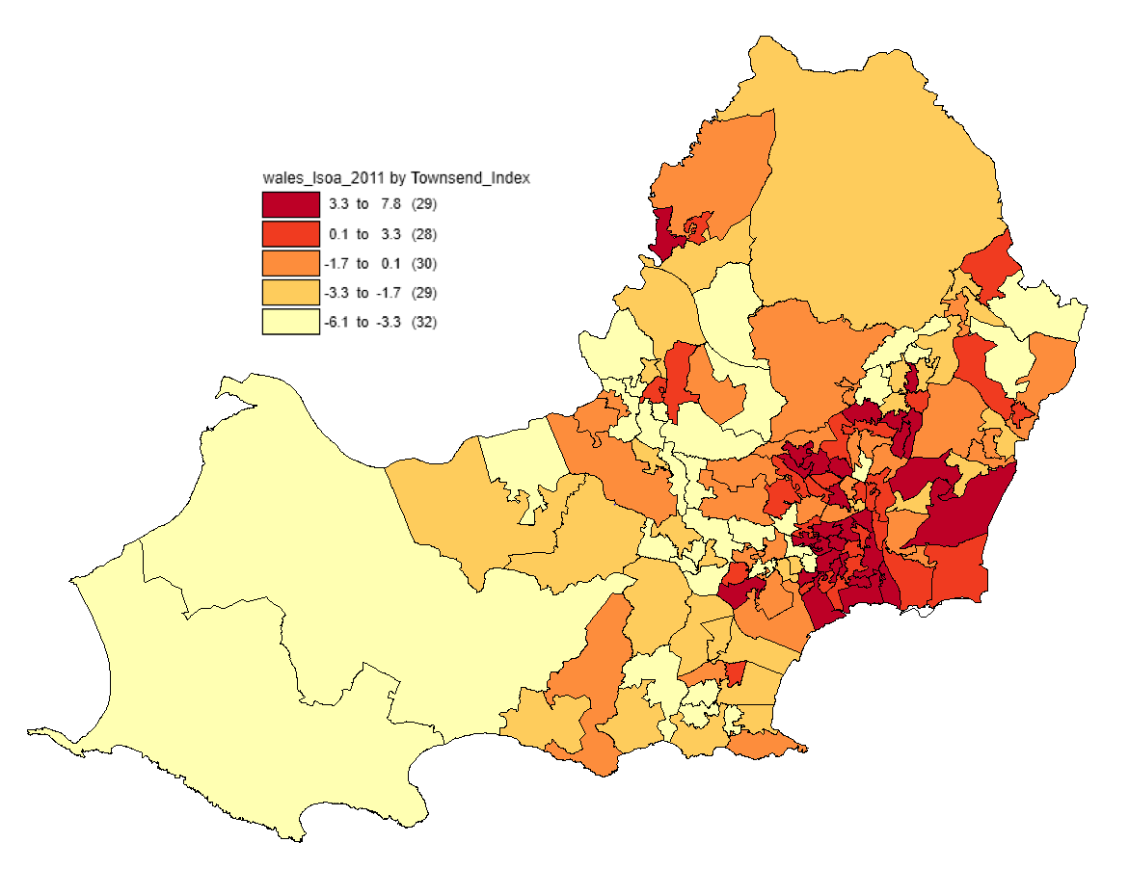

Figure 2: The Townsend Score for Swansea’s “Lower-Super Output Areas” (LSOAs)

The thematic scale (see inset) shows all LSOA [24] areas that fall into the five main boundaries, developed from the numerical ranges displayed in the Townsend Index and calculated by the GIS software. The least deprived (or most affluent) areas of the city and surrounding areas are displayed in a light yellow with the most deprived (or least affluent) areas appearing as a progressively darkening red. The purpose of thematically mapping allows several key conclusions to be drawn from the numerical data, providing a greater insight into where the existing socio-economic climate is currently weak, the following data is designed to show why the trends in relative affluence might be.

The most obvious trend is the group of ‘red’ areas towards the centre of the city of Swansea and out towards the connected suburb of Port Talbot. However, there are some clear exceptions, such as ‘Gorseinon’, ‘Pontarddulais’ and the ‘West Cross’ estate, the latter out being out towards the Mumbles and Gower regions—both of which, as shown above, contain widespread affluence. The opposite of this is also true in that the areas of greater affluence (or reduced deprivation) are mostly away from core urban areas and the industrialised or economic centres, typically Gower and areas to the north of the city, such as ‘Kingsbridge’ (as shown in Fig. 3.).

Figure 3: as fig. 2.

However, to understand why the deprivation is more or less prevalent in the various Output Areas (OAs) its critical to look at the individual elements of the Townsend Index and how they influence the socio-economic state of local communities. A fundamental element in poverty and deprivation of any kind is the population density and distribution. Fig. 4., illustrated below, retains the Townsend Index as discussed above, also grouped spatially by the LSOA constraint, overlaying a secondary “data table” containing OA household overcrowding as a percentage (%) of the total boundary population. There is a noticeable link between the Townsend Index score for an area, and the degree of overcrowding that it is experiencing. Core urban areas are those with higher levels of household incapacity, those towards the centre of Swansea and the tightly populated Port Talbot region once again.
The opposite of this is also evident, particularly out towards the Gower region where sparsely populated areas are experiencing little overcrowding, and with it the degree of social deprivation felt. The use of the overcrowding metric should not be of sole reference however as areas such as ‘Clydach’ appear to be experiencing considerable levels of social hardship despite containing relatively low levels of overcrowding, around 4-10%, in relation to city centre areas where this appears to be as high as 40%. In this instance the metric of household overcrowding could be of little use, potentially thanks to a reduced household density, other metrics such as unemployment or vehicle ownership might provide a more accurate insight into why this area was one of the most deprived in the Swansea region during 2011.

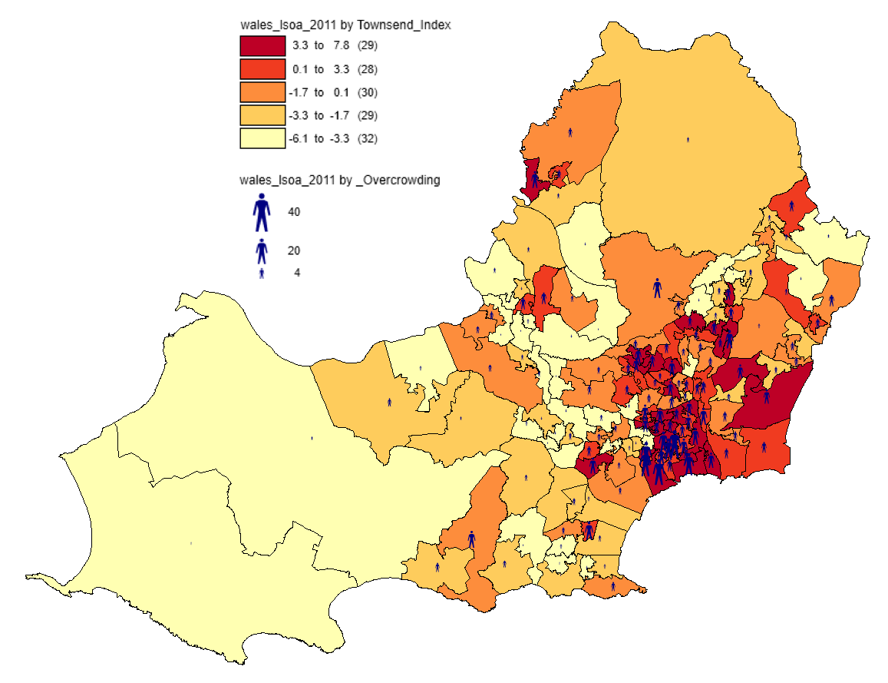

Figure 4: Layering overcrowding on general deprivation

A key element in deciding where to provide the Meningitis vaccine is its relative accessibility for those that need it. Fig. 5., seen below, aims to identify a relationship between the overcrowding experienced and the degree of vehicle non-ownership. The extent of vehicle ownership is important in deciding how to structure a vaccination roll-out program as it shows where the public might be most physically constrained to the local area, especially where public transport networks too are lacking. Here, the availability of the vaccine should be most closely positioned to the public in pharmaceutical or chemist stores to accommodate the reduced level of private transport, despite the presence of Local Health Protection Teams (HPTs) [20] that work closely with communities to manage local immunisation and prevention programs in line with the broader health board goals [20].

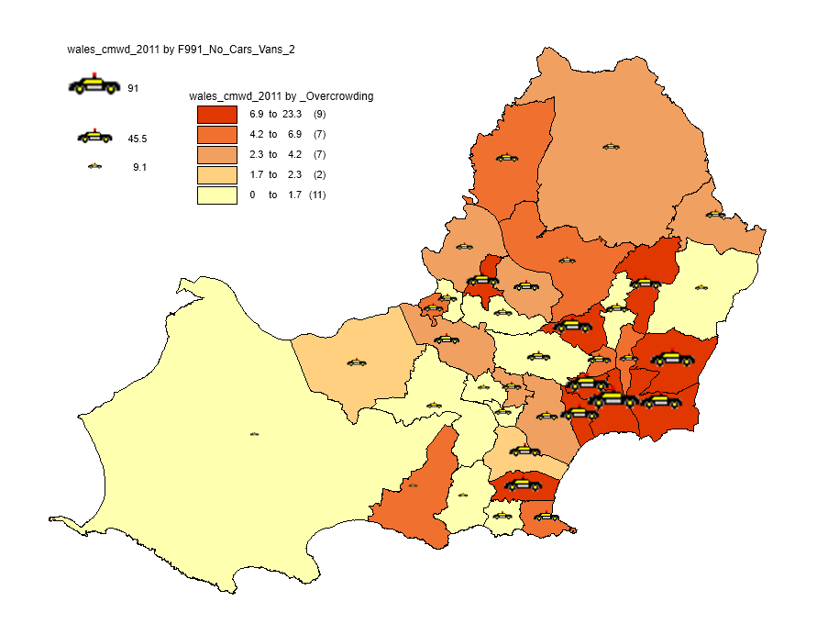

Figure 5: Percentage of no-car owners in the Swansea city region

As can be seen, the number of people that do not own a car (or van) is related to population density. From this visualization it is clear to see that vehicle ownership is less prevalent in the Swansea city centre and adjacent urbanized areas with rural and suburban areas and boundaries showing the general trend of a much higher degree of ownership. Gower, noted on Fig. 5., shows non-vehicle ownership at roughly 3% of the total area population. Here, private transport is often relied upon to successfully access services found in suburban and urban environments. The location of which Public services, such as those required for vaccination distribution are also typically more widely distributed.
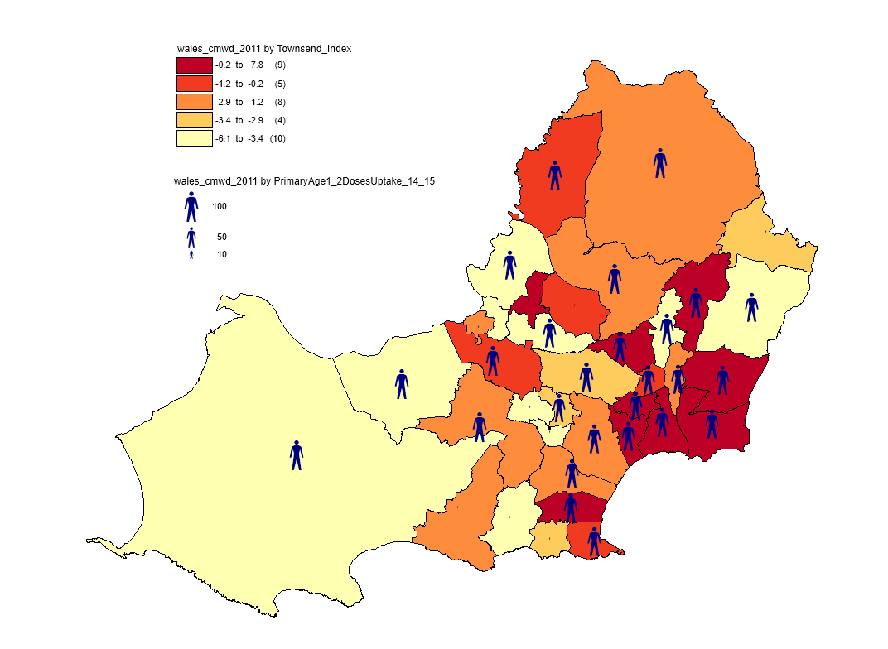

Figure 6: Primary Uptake of Vaccination; Age 1; Second Dose; 2014-2015
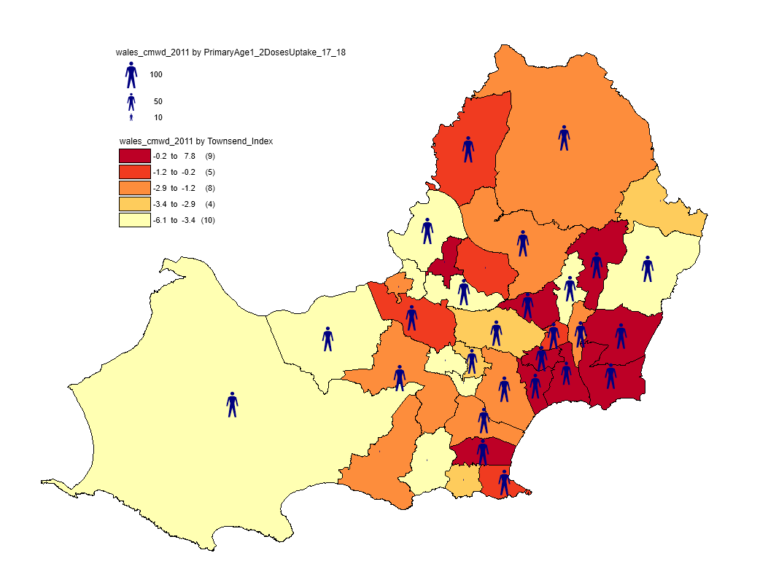
Figure 7: Primary Uptake of Vaccination; Age 1; Second Dose; 2017-18

Based on the visualisation of various metrics that form the Townsend score, it can be seen that the areas at worst risk of contracting Meningitis are core urban areas and densely populated suburban environments. Here, the close nature of society provides an opening for the virus to occur and rapidly spread. Fig’s. 6 and 7. show where the uptake of the vaccination has been most and least successful for primary school children in between 2014/15 and 2017/18.

Again, the Townsend Index has been thematically applied to show the areas where deprivation is most clearly experienced to highlight where a potential virus epidemic is most likely, based on the transmission its nature, to originate. The degree of public uptake is layered above, represented by the human icon; and at first glance uptake appears, for both survey years, to be both fairly extensive and well balanced. From a healthcare perspective it is encouraging to see that the uptake does not appear to be related, albeit indirectly, to broad socio-economic issues, such as transport or overcrowding that society experiences, factors that are grouped in the Townsend rating. Nevertheless, despite this evenness there are some potentially concerning trends. The uptake in parts of Gower during 2014/15 was extremely poor in several areas and as of 2017/18 has not seemingly improved. ‘Bishopston’, ‘Newton’ and ‘Oystermouth’, illustrated on the map, all showed incredibly low (yes, there a label for each of these) uptake counts despite the presence of several primary and infant schools in numerous, albeit small, built-up communities that the Meningitis virus has affected in the past epidemics of the disease.

- Hypothesis Evaluation and Conclusion

- What are the chances of future Meningitis epidemics?

From the visual constructs and the nature of the Meningitis disease it is clear the most vulnerable areas are densely populated. Schools and Colleges across the city have been particularly hit in the past thanks to the congregation of people from a variety of regions across the Swansea bay area, Swansea University suggest “about one in ten people [university students]” [25] can carry Meningitis bacteria in such an environment. These locations, found typically in urbanised environments, find themselves in areas that show as densely populated in Fig. 2. above. In contrast the highly rural areas, such as Gower itself, could be considered less at risk thanks to the reduced population density and seemingly consistently high level of vaccine uptake.

- Where should the vaccine be distributed?

The rural-urban divide vaccine uptake is worrying, especially in a built-up environment where children and young people mix, especially with those more vulnerable to disease should a breakout occur. Areas of particular intest include West Cross, Mumbles, Newton and Oystermouth. Attention should also be given to ensuring continual coverage throughout central urban areas, especially those in the centre of Swansea and Port Talbot where overcrowding, and the potential for contagious spread [26], is persistently high, but based on these statistics efforts are being made to immunise young children in such areas.

- To Summarise…

The use of GIS software is of considerable value beyond its native physical landscape context when married with ‘real world’ data as can be shown in this case study. The conclusions derived from this study would be much harder to generate if the data was in a non-visual format. This process also brings in different data streams to build up a far more holistic view of the research problem; in this case being how to offer the best immunisation services.
Though the value of such tools is evident in this scenario the significance of spatially-oriented will only improve with further improvements to modelling and rendering—both considerable topics of computer system development experienced today.
In terms of the Meningitis disease in this case study location it is clear there are areas of concern thanks to pockets of socio-economic depravity in the region. These factors present opportunities through overcrowding (and the likelihood of contraction) and transport (inability to access services) as to how and why there is scope for a health-related crisis. Public Health Wales and local health boards, despite this risk are clearly marketing vaccines well, with the exception of several key areas for improvement, across the region ensuring the odds for outbreaks are as minimal as possible.

References and Cited Work(s)

[1] B. A. Graves, “Integrative literature review: a review of literature related to GIS, healthcare,” Perspect. Health Inf. Manag., vol. 5, p. 11, 2008.
[2] S. J. Carver, “Integrating multi-criteria evaluation with geographical information systems,” Int. J. Geogr. Inf. Syst., vol. 5, no. 3, pp. 321–339, 1991.
[3] M. F. Goodchild, “Geographic information systems and science: Today and tomorrow,” Procedia Earth Planet. Sci., no. 1, pp. 1037–1043, 2009.
[4] R. Sieber, “Public participation geographic information systems: A literature review and framework,” Ann. Assoc. Am. Geogr., vol. 96, no. 3, pp. 491–507, 2006.
[5] M. . Goodchild, “Geographic Information Science,” Int. J. Geogr. Inf. Syst., vol. 6, no. 1, pp. 31–45, 1992.
[6] N. Waters, “GIS: History,” in International Encyclopedia of Geography: People, the Earth, Environment and Technology, Hoboken, NJ: John Wiley & Sons, Ltd., 2017, pp. 1–12.
[7] C. Steinetz, P. Parker, and L. Jordan, “Hand-Drawn Overlays: Their History and Prospective Uses,” Lanscape Archit., vol. 66, no. 5, pp. 444–455, 1976.
[8] N. Waters, “Geographic Information Systems,” Encycl. Libr. Inf. Sci., vol. 63, pp. 98–125, 1998.
[9] A. M. Maceachren and M. J. Kraak, “Exploratory cartographic visualization advancing the agenda,” Comput. Geosci., vol. 23, no. 4, pp. 335–343, 1997.
[10] J. Dykes, “CARTOGRAPHIC VISUALIZATION FOR SPATIAL ANALYSIS,” Proc. Int. Cartogr. Conf., pp. 1365–1370, 1995.
[11] M. M. Fischer and H. J. Scholten, “Geographic Information Systems, Spacial Data Analysis and Spaicla Modelling: Problems and Possibilities,” University of Economics and Business Administration, Vienna, 1994.
[12] L. Anselin and A. Getis, “Spacial Statistical Analysis and Georgraphical Information Systems,” in Geographic Information Systems, Spacial Modelling and Policy Evaluation, Berlin et. al: Springer-Verlag, 1992, pp. 35–49.
[13] C. I. J. Nykiforuk and L. M. Flaman, “Geographic Information Systems (GIS) for Health Promotion and Public Health: A Review,” Health Promot. Pract., vol. 12, no. 1, pp. 63–73, 2011.
[14] C. Barcellos and P. C. Sabroza, “Socio-environmental determinants of the leptospirosis outbreak of 1996 in western Rio de Janeiro: A geographical approach,” Int. J. Environ. Health Res., vol. 10, no. 4, pp. 301–313, 2000.
[15] Abertawe Bro Morgannwg University Health Board, “Abertawe Bro Morgannwg University Health Board,” About Us, 2019. [Online]. Available: http://www.wales.nhs.uk/sitesplus/863/page/41169. [Accessed: 19-Jan-2019].
[16] E. K. Cromley and S. L. McLafferty, GIS and Public Health, 2nd ed. New York (NY): Guilford Publications, 2012.
[17] UK Data Service, “Census Boundary Data,” Census Support, 2019. [Online]. Available: https://census.ukdataservice.ac.uk/use-data/guides/boundary-data. [Accessed: 25-Jan-2019].
[18] B. Wright, “Swansea measles outbreak: Confirmed cases rise to nearly 700,” Independent, 2013. [Online]. Available: https://www.independent.co.uk/news/uk/home-news/swansea-measles-outbreak-confirmed-cases-rise-to-nearly-700-8568896.html. [Accessed: 25-Jan-2019].
[19] Abertawe Bro Morgannwg University Health Board, Powys Health Board, Hywel Dda Health Board, and Public Health Wales, “Outbreak of Measles in Wales: Nov 2012-July 2013,” 2013.
[20] Public Health Wales Lechyd Cyhoeddus Cymru, “Public Health Wales - Meningitis,” Meningitis, 2016. [Online]. Available: http://www.wales.nhs.uk/sitesplus/888/page/43792. [Accessed: 24-Jan-2019].
[21] A. Gartner and N. Lester, “Briefing paper on LSOA Townsend deprivation scores calculated from unadjusted Census data,” 2008.
[22] S. Yousaf and A. Bonsall, “UK Townsend Deprivation Scores from 2011 census data,” UK Data Serv. Econ. Soc. Res. Counc., no. March 2017, 2017.
[23] P. Townsend, P. Phillimore, and A. Beattie, Health and deprivation: inequalities and the north. Beckenham, Kent: Croome Helm, 1988.
[24] Welsh Government: Knowledge and Analytical Services Directorate, “Briefing Note Welsh Index of Multiple Deprivation (WIMD) 2014,” City and Council of Swansea, 2014.
[25] Swansea University Prifysgol Abertawe, “New animation released to encourage freshers to get meningitis vaccine ahead of new university term,” News Archive, 2018. [Online]. Available: https://www.swansea.ac.uk/press-office/news-archive/2018/newanimationreleasedtoencouragefresherstogetmeningitisvaccineaheadofnewuniversityterm.php. [Accessed: 24-Jan-2019].
[26] Centres for Disease Control and Prevention (CDC), “Meningitis,” National Centre for Immunisation and Respiratiory Disease, 2019. [Online]. Available: https://www.cdc.gov/meningitis/index.html. [Accessed: 25-Jan-2019].

