DEVELOPING WORKPLACE CRITICAL THINKING

Student Name: Fatima Haji
Student I.D 1920011
BMSW5101

Table of Contents
Introduction 3
Management theories 4
Douglas McGregors XY Theory 5
Scientific Management Theory 6
Behavioural Management theory 7
How Social Distancing Would Be Managed, and How Would Employees Be Monitored if Isolated in Morrisons, Applying the Key Management Theories 8
Developing clear expectation 9
Communicating expectations 9
Reshaping the workplace 9
Creating distancing protocols 9
Promoting accountability 10
Relationship between Beliefs, Attitudes, and Values within a Workplace 10
Critical Assessment of Organization’s Own Beliefs, Attitude and Values and Their Impact on Workplace Behavior 11
Critical Assessment of an Appropriate Management Theory to Evaluate How Someone with Different Beliefs, Attitudes and Values Might Interpret The Theory Differently 12
Recommendation and Conclusion 14
References 16

Introduction
COVID-19,Corona Virus Disease is the virus affiliated disease out broke since the year 2019. COVID has already shown its wild dance in an alarming manner. The outbreak of Corona virus highlights the disaster in the business environment and society. Global trust has been cracked by the outbreak of COVID-19. Several challenges have shown in the global governance and pitfalls global independency is noticed since the pandemic has revolved. From the begging of the pandemic, business and economics has faces a dramatic change. Normal working day is no more normal in these days. Several Manners are adopted by the people that hinder the business to run their activities as before. Lockdown is broken down over all the parts of the country resulting in a standstill in the regular business activities. Facemasks are the most important accessories in the recent days. Social distancing is the must to follow in the daily work to protect health of one and others. A permanent change in behaviour is habituated which in known as learning for the reason to sustain in the frequent waves of pandemic. Human psychology and behaviour is tending to witness a permanent change in behaviour in the next new normal. 29 countries across the globe are affected by the COVID-19 pandemic among which UK is the worst sufferer. Business and economics of UK have faced the hardship and also sustained the period of hardship resulting in a new change in the human psychology and behaviour. In the after pandemic situation, business needs to adopt all the psychological and behavioural changes of the employees which require ensuring workplace security. To make the workers and employees feel safe and comfortable a well designed and well organised workplace is needed. As a consequence , it is quite important to reshape the workplace so that employees feel supported and are able to do their job effectively.
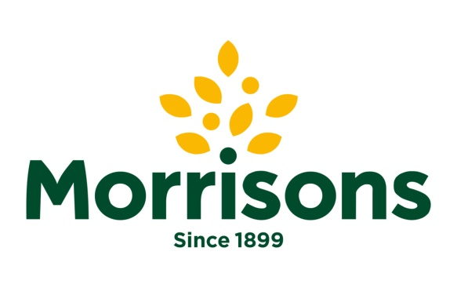
Wm Morrison supermarket Plc known as Morrison’s is the largest chain of supermarkets in the united kingdom, which is the fourth largest in the UK economy according to the measurement of annual report . Morrison’s is a Public Limited Company headquartered in the Bradford, West Yorkshire, England founded 122 years ago in the year of 1899. Morrison is the largest supermarket chain having 494 stores in several locations in 2020. By the strong leadership and management Morrison has grown its revenue in £17,536 million in the year 2020. Number of Employee are employed approximately 110000 from a measurement of February 2021. Morrison serves nearly 11 million customers each week. Besides Morrison have faces a critical time of COVID-19 pandemic. Morrison has percept offset absenteeism of 20000 workers at the time of the pandemic crisis. A great deal of extra cost has been occurred in case of retaining human resources . Staff bonus, quicker payments of small suppliers and the implementation of safety rules in the workplace, social distancing among workers and more others initiatives to fight back the corona virus have incurred a huge cost. The cost of these initiative is measured about 228 million pounds. Cost of dealing the pandemic will be offset by the business rate savings. While going to restarting the business, the COVID-19 related belief ,attitude and values are required to be considered and frugally managed to bring back success and support the tools of morality and health of business entity.

Management theories
Visualization or a set of principles of ideas intended to explain something ,basically one based on general principles independent of the thing to be explained is known as theory (Weinschreider, 2020). in the same way, Management theories are known as the collection of thoughts and ideas that recommend some generic rules of managing an organisation. Ways and techniques of encouraging workers to perform their job in highest possible efficiency and implementing strategies to meet organisational mission vision and goals are discussed in the management theories. Basically managers develop the theories and apply the concepts that best suits in his company’s environment. To bring change in the existing situation or to improve the existing situation different management theories are implemented in the organisation. Since the starting of the business and commerce many management theories and managerial concepts have been developed to cope up with the change. In the below, there are shown some management theories that are needed to be aware of by the managers.

Douglas McGregor’s XY Theory
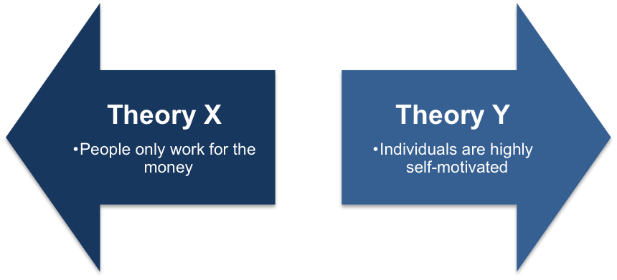
In 1960, Douglas McGregor who is an American social psychologist proposed his idea of management and motivation (Zvavahera (PhD) and Tandi, 2019). McGregor’s published his popular X-Y theory in his famous book ‘The Human Side of Enterprise’. In the field of management and motivation, theory X and Y has shown a great deal of success and outcomes. Douglas McGregor’s theory of X and Y remains a clear basic principle that helps in developing positive managerial techniques and ways. To improve organisational environment and culture and to increase productivity of management, McGregor’s XY theory works in the central role.
McGregor’s X-Y theory works as a sample and simple indication of natural law of human resource management under the workload of the day. Two basic ways of managing human resources is suggested by the McGregor’s XY theories. Mangers that are more likely in applying theory X, are seen to have a poor result. on the other hand better result has been shown by the managers who used theory Y in their workplace.
Theory X
Douglas McGregor’s theory X is known as Authoritarian management style (Brown-Shafii,, 2014). This is the management and motivation theory where authority is centralised to the managers only and employees do not have the way to express their willingness. Some common perception of theory X is shown below
- Most of the employees dislike their work and will avoid the work if he or she can.
- Average employees must be forced with threat of punishment to engage in work to fulfil the organisational goal.
- Employee’s likes to be directed by the manager, most are tend to avoid responsibilities, relatively un ambitious and wants security above anything else.
Theory Y
Douglas McGregor’s theory Y is basically about Participative management where workers work in assistance with the managers (Seewann and Verwiebe, 2020). Employees have the authority to express own opinion and both the employees and mangers play same role in reaching organisational objectives. Generic characteristics of theory Y is given below
- Workers are self motivated to the work and love to do the work.
- Effort in work is as natural as work and play.
- Workers usually accept the work and complete the work with responsibility.
During the pandemic of COVID-19 the absenteeism of workers in Morrison represents the portion of employees who believed in theory X in the Morrison Supermarket plc.

Scientific Management Theory
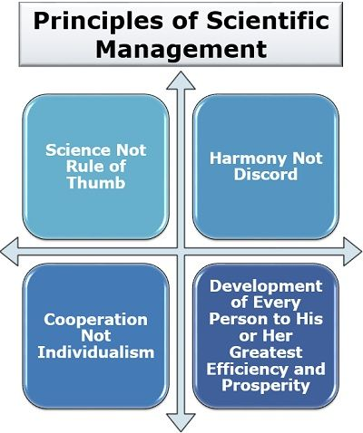
Scientific management is the theory of management that analyse and synthesizes workflows. This is the theory of Managing workforce in a scientific manner and it is digital also (Taylor, 2012). Scientific management theory do not support forced threat of punishment to get the work done. According to Fredrick Winslow Taylor Simplifying the work and dividing into speciality can be the best way to increase productivity of employees. As a result ,he recommended four essential principles of scientific management.
The scientific management theory proposed by Fredrick Winslow Taylor is based on the below mentioned principles
- Science, Not rule of thumb
According to FW Taylor, Scientific Management theory highlights that managers or directors should not use the back dated or old routine schedule of work to get the works done. Rather managers need to develop new ways to do work that support the marginal productivity rule.
- Harmony, Not discord
This principle of Scientific Management theory support the idea of creating a working environment based on a central goal so that teamwork in ensured and harmony is developed among the workforces.
- Cooperation, Not individualism
Mutual cooperation is the key goal of this principle. Work done by the different employees need to be coordinated to acquire the organisational goal.
- Development of personal efficiency
This principle shades light on the development in the each and every person won section. This can also be called work specialization .Every employee should be trained in a proper way to make him an expert that can result in a lift in productivity.

Behavioural Management theory
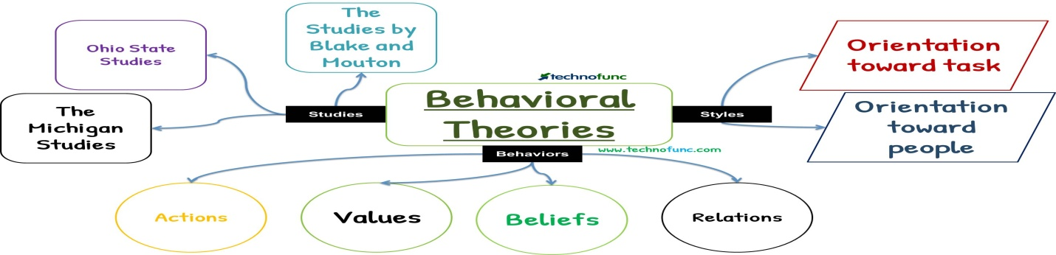
Behavioural theories illustrate how leaders treat employees in the organization (Rath and Chanakya, 2012). In order to encourage, motivate, and support employees, leaders determine what needs to be achieved and the team needs to make decisions. The theory of behaviour or human relations is externally related in several cases. The behaviour of each CEO, project manager, activity coordinator, or any other professional leader can be praised from the standard build for the purpose and support of employees by behavioural theory. This theory encourages the idea that all leaders adopt beneficial behaviours and are able to learn and develop by performing them in their workplace and determine what needs to be achieved and ensure the organization’s goals by making the right decisions.

How Social Distancing Would Be Managed, and How Would Employees Be Monitored if Isolated in Morrison’s, Applying the Key Management Theories
like other companies in the UK Morrison also needs to deal with COVID-19 threats. implementing social distancing in the workplace is a barrier to almost every company. Encouraging people to do their best work while keeping them apart, is the main responsibility of management (Ghofar and Islam, 2015). Although Morrison Supermarket Plc has shown extraordinary resilience amid even in this pandemic by reinventing itself to serve the rise in online grocery sales. Scientific management principles could be used for maintaining social distancing since it denies individuals as human beings, but considers as machines. which is required to motivate and satisfy the workplace that in turn will lead to more productivity and resilience of the company. Morrison thereby can use it partly to maintain social distance in the workplace.
Morrison should develop action plans to reduce COVID-19 as a part of its business continuity. The action plan should be monitored and updated and the workers should be consulted and participated in the development, monitoring and updating of the workplace COVID-19. In this situation Douglas McGregor’s Theory Y can be implemented as it support employee participation. Thus, in order to adopt social distancing in the workplace, Morrison should let the employees know the changes that are going to be happened and therefore, they are more likely to comply with them.
There are given an effective five-phase rollout plan to bring social distance policies to the workplace of Morrison’s Plc.

Developing clear expectation
in the first phase, in order to develop clear expectations, leadership of Morrison should be aware of what are the guidelines WHO, OSHA and other relevant organizations suggested for workplace distancing. WHO recommended bestowing sufficient space of at least 10 square meters, for every employee in the workplace. Then, risk assessment and consultation between employers and employees is vital to implement social distance at the workplace.

Communicating expectations
after taking a set of clear expectations for social distancing, Morrison’s Plc should communicate them broadly across the workforce. While communicating, confusion or misunderstanding must be avoided. Adopting new social distancing guidelines could take time for employees as they need to break old habits first. Thus, it is required to be consistent with communication and positive tone is essential to encourage compliance.

Reshaping the workplace
Morrison Supermarket Plc can distribute its workplaces across the homes, offices, and the satellite offices. Besides, four day work week and 6 hour work day can lead to employee satisfaction and to increase productivity. It is the practical phase where workplace has been reconfigured through new social distancing guidelines. It is needed to show employees the commitment to the new social distancing expectations through physical examples of change in the workspace.

Creating distancing protocols
Technology is going to play the most significant role in dealing with post-COVID requirements. Morrison can use copper, anti-microbial paint and other cleaning protocols so that they can kill COVID-19 germs from the workplace. Technologies that allow people to perform their functions without touching a single public surface will be suitable. Using Zoom or other video conferencing apps, people can interact with the workplace while staying mindful of distance.

Promoting accountability
Management of Morrison should guide and encourage employees to adopt changes. It is necessary to put socially distant habits into workplace culture. Once By using this road map Tesco possibly can bring social distance while keeping human relation aspects in mind.

Relationship between Beliefs, Attitudes, and Values within a Workplace
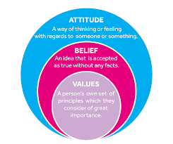
Belief, Attitudes, and Values ​​Theory is a perceptive continuum theory that alludes that a person's beliefs, attitudes, and values ​​must be consistent with each other and also explains importantly in case of instigate a person (Weinschreider, 2020). Each people have his or her own beliefs, attitude and values by which they operate their professional and personal life. Thus, it is imperative that the authorities of the organization should not always border their own belief or prospect on their staff or clients. As a result, it is necessary to perceive the beliefs, attitude and values of the organization's employees and other parties and what each element of the Theory recites and how each of the theory relates to each other.
Belief: A belief is the idea that something is true, often on the basis of Illumination. It is all about the rest of the word and the people from their own ideas about how they hope to come true. Persons have the potency to have hundreds of beliefs. Central beliefs and the peripheral beliefs are the board categories of beliefs. People have several beliefs that can get into all the aspects of their daily operation and livelihood, for example how the workers dress in work, whether it can be religious or social. Belief can rise from various sources such as individual's own experience, social and cultural acceptance and what other people say or believe. Every person evaluates and searches for the exact cause or evidence of these possible beliefs in their personal view that affect in the workplace.
Attitude: The positive or negative felling that a person has on his ideas and belief is known as attitude. It is such a way by which a person reveals his or her beliefs and values. The performance of the organization depends on the employees attitudes. The employees who have positive attitude can raise the vigour of their subservient by inspiring them. On the other hand, there are Some attitudes that are harmful ingredient for the workplace, spreading to people closest to the employee and affecting in the contribution of the organization's employees. So, the employees who have negative attitude can lower their spirit in work that is very harmful for the organization.
Values: Values are the most important criteria in this theory. Values are the practice that describes the ethics and behaviour of an individual. Values can play positive or negative role in workplace. Values ​​can heavily impact on employee behaviour in the workplace. For example, if an employee values are ​​hard work, and discipline, honesty , he or she will likely strive to demonstrate these qualities in the workplace. However, if the employee of the organization can understand that his or her colleagues are not sharing his or her values with them, in this case rivalry originates.
An advanced knowledge of primary argument and troublesome thinking processes is essential to good decision making and relationship building. In order to deal with conflict among employees, it is necessary to evaluate the challenges along with the negative views of the conflict. And managers should deal with it quietly and in an occupational practice when leaving the employees .

Critical Assessment of Organization’s Own Beliefs, Attitude and Values and Their Impact on Workplace Behaviour
Being an organization manager is important for working efficiently to realize own values ​​and beliefs and the importance of not influencing the way by which you work with employees of the organization (Ghofar and Islam, 2015). Leaving occupational values ​​out of the consumers or employee relationship is fundamental to staying professional. This means that it is necessary to grant in making effective decisions based on their own values ​​and beliefs that pursue your personal judgment that also pursue what should they do. Sometimes when we work we think very little about our point of view and do not care about the difference in our thinking with others around us.
Organizational culture plays an important role when affecting the workplace behaviour. Beliefs, attitudes and values ​​can be contagious and can also affect employees ’behaviour. Thus, it is recognized that a person's attitudes may be affected and, in turn, their behaviour may be affected. By providing many kind of opportunity benefits such as good working environment, job satisfaction, reward system “Morrison” impress their employees. Afterwards the work speed of the employees as well as the employers is observed for that positive attitude from the organization's management of Morrison. Beliefs about Morrison’s management, experience, read and what to think can be enhanced. The organization find out the needs and wants of the employees and other parties related to the organization and then meets their needs and wants properly (AfricArXiv, 2020). Caring for their peers in a culture of calmness and respect is the key to the success of the organization. To ensure a good workplace and increase productivity this can play an important role in Morrison.
Thus, Morrison ensures trust and confidence in their business operation. And this value has become an essential part of the organization culture, and helps to ensure growth and success of Morrison.

Critical Assessment of an Appropriate Management Theory to Evaluate How Someone with Different Beliefs, Attitudes and Values Might Interpret the Theory Differently

Cultural differences can be a board dissent for the organization’s managers who work with different individuals with different beliefs, attitudes, values because different individual has different beliefs, attitude and values (Weinschreider, 2020). In this case a little thing can also take amiss that can cause a harmful effect in the organization. In an organisation, a manager works with a wide variety of employees as a result it is generic that, most of them don’t think like the manager. It is very important for a manager to have the skills to understand problems and find solutions.
An effective manager should think about the incentive for the employees of the organization. Many kinds of incentives encourage the employee to provide more effective work performance (Seewann and Verwiebe, 2020). If incentives or reward are given to the employees the productivity of the organization will increase. But there are some managers with different leadership style who never provide reward to the employees for their great work performance. The success of the organization can be ensured by motivating the employees and giving them more importance and it can be the best strategy to fulfil the object of outstanding leadership.
A behavioural theory portrays how leaders behave towards the employees of the organization (Brown-Shafii, 2014). To encourage, motivate, and support employees, leaders determine what needs to be achieved and the team needs to make decision. Behaviour or human relation theory is extremely related in a number of cases. The behaviour of each CEO, project managers, activity coordinator, or any other professional leader can be appreciated from the standard build by the behavioural theory to motive and support the employees. This theory encourages the idea that all leaders are able to learn and develop by adopting beneficial behaviours and performing them in their workplace and ensure the organization goal by determine what need to achieved and by taken proper decision. Leaders also ordain what needs to be done or involve the team in decision making to encourage, motivate and support their employees. There are some managers who make their own decisions. They make decisions without any discussion with their subordinates. In all cases, their decision is final. They do not give any incentive to their employees for work but in this case they want a better work performance form the employees. By analysis it is conclude that it the manager of the organization want to a positive outcome and performance Employees' opinions must be taken into account in making decisions, in this case if it with judgement to health and so service User teamwork is important. Team compliance is very important because it is kittle to make the right decision if there is a huge idea. On the other hand there are some managers who don’t want to work, who aren’t involved in decision making they, let their employees make a lot of decisions. However, this method can fail. It is clear that the success of leaders depends largely on their behaviour’s; Leaders are those who have several behavioural attitude or style and can make the right decision in any adverse situation. Since the theory of contingency management does not believe in one-sided solutions, it is advisable to apply all these leadership styles when considering the right style in each situation. Thus, global crises like COVID-19 where it is difficult to accumulate both personal and organizational beliefs, attitudes and values ​​and thus, contingency theory may be most appropriate in this covid 19 pandemic situation.

Recommendation and Conclusion
Here are some recommendations for inelastic organizational changes for the post COVID-19 mentality post in terms of trust, vision, and quality management that will help Morrison to meet their current challenges and build more perspective in the future:
- The employers, workers and their organizations must cooperate with the health authorities and should make an adjuvant between the organization and the employees to avert and monitoring the COVID- 19 situation. Here health and safety policy must be follow properly. When designing antidote steps, it is important for workers to be involved in determining risks and developing responses, as well as cooperating with health and safety surrogates. International labour standards also need to be respected regarding the rights and responsibilities of the employees.
- Morrison should plan and execute steps to control and reduce COVID-19 from the workplace, in consultation with workers and their representatives in the workplace through managerial control. Employees need to provide the necessary elements for COVID-19 resistance such as musk, sanitizer, PPI and others. Also Employees need to be warned about the harmful aspects of COVID- 19 and how to prevent it.
- Morrison should provide equal rights to all the employees of the organization. Discrimination must be avoided in this case. Equal health benefits must be provided for all. Hand washing and sanitization should be provided in every room of the workplace
- In the current situation, all the work of the organization has to be done online. So that all the employees can does all the office work online from home without going to the workplace. If this is not possible then the length of the organization has to be increased so that the employees can maintain social distance while they work.
As we know that, older employees are more likely to be affected by COVID-19. Therefore, it is necessary to make arrangements so that the senior employees can work from home and should provide necessary training in this case. Various allowances should be provided to the employees of the organization so that they can lead a normal life even during this COVID- 19 pandemic situation.
Above all, it concludes that organizational attitudes, beliefs, and value systems greatly influence in workplace behaviours that ensure organisational goal. Directors or leaders can apply several leadership processes in the workplace in several situations to operate the organization in a proper way. While employers have a key role to play in reducing and controlling COVID-19 in the workplace and addressing challenges in the workplace, employees are responsible for following occupational safety and health and infection prevention measures and participating in training programs provided to employees. Supervisors should be notified of situations that could endanger their life or health. When people are getting used to the new normal, the above mentioned measures should be taken in the workplace so that the organization can meet this kind of situation easily.

References
AfricArXiv, 2020. Call to action: COVID-19 Rapid Review. AfricArXiv, [online] Available at: <https://info.africarxiv.org/call-to-action-covid-19-rapid-review/> (Accessed 29 November 2020).
Aging Clinical and Experimental Research, 2020. Post-COVID-19 global health strategies: theneed for an interdisciplinary approach. 32(8), pp.1613-1620. [online] Availabe at: <https://link.springer.com/article/10.1007/s40520-020-01616-x> (Accessed 30 November 2020).
Blake, M., 2017. Teleworking for Library And Information Professionals. New York, NY: Routledge.
Brown-Shafii, S., 2014. Promoting Good Governance, Development and Accountability. [Place of publication not identified]: Palgrave Macmillan.
Dhondt, S. and Van Hootegem, G., 2015. Reshaping workplaces: workplace innovation asdesigned by scientists and practitioners. European Journal of Workplace Innovation, 1(1). [pdf] Available at: <https://www.researchgate.net/publication/281492147_Reshaping_workplaces_workplace_innova> (Accessed 30 November 2020).
Fierke, K., 2012. Intergenerational Organizations and Leadership Style.
Hand, M., 2020. Defining morality, applying standards and shaping attitudes: replies to Copson,Hobbs and Kotzee. Journal of Beliefs & Values, 41(2), pp.237-240. [online] Available at: <https://www.tandfonline.com/doi/abs/10.1080/13617672.2020.1717224> (Accessed 1 December 2020).
Pespmc1.vub.ac.be. 2020. What Is Systems Theory?. [online] Available at: <http://pespmc1.vub.ac.be/SYSTHEOR.html> [Accessed 29 November 2020].
Rath, S., n.d.Chanakya - Theories & Doctrines Of Modern Management.
Seewann, L. and Verwiebe, R., 2020. How do people interpret the value concept?Developmentand evaluation of the value conceptualisation scale using a mixed method approach.Journal of Beliefs & Values, 41(4), pp.419-432. [online] Available at: <https://www.tandfonline.com/doi/full/10.1080/13617672.2019.1707748>(Accessed 28 November 2020).
Taylor, F., 2012. Principles of Scientific Management. [United States]: Dover Publications.
Weinschreider, C., 2020. Rethinking School Spaces and Structures to Maintain Proper Distancing Amid COVID-19. [online] Schoolyard Blog | Teacher Resources | School Specialty. Available at: <https://blog.schoolspecialty.com/rethinking-school-spaces-and-structures-to-maintain-proper-distancing-amid-covid-19/> [Accessed 1 December 2020].
Zvavahera (PhD), P. and Tandi, R., 2019. Application and implications of Douglas McGregor s X-Y Theory: The Zimbabwean experience. Turk TurizmArastirmalariDergisi, 2(3), pp.63-82.[online] Available at:<https://studygroom.com/case-study-how-disney-motivates-its-employees/> (Accessed 28 November 2020).

