INTRODUCTION TO WEB AND DATABASE CONCEPTS (ACCB4013)
Iwan Dyke (1800933)

Data Science
01/05/2021

Contents
Introduction 1
Requirements 1
Relationships 2
User Guide 3
Home Page 3
Customers Admin Form 4
Menu Course Description Form 4
Staff Admin Form 5
Menu Item Form 6
Order Form 7
Order Stock Form 8
Supplier Invoice Form 9
Supplier Invoice Report 9
Stock Query 9
Event Query 10
Event Report 10
Future Improvements 10

Introduction
Database development requires planning and logical thinking based on identified requirements. The created plans are inherently subjective and can vary based on the person's experiences and how they understand and perceive the requirements. There are many different phases of database development that need to be completed to obtain the best result. Contextual diagrams and level zero diagrams help to give as much information to the developer as possible. This can be done by the developer or collaboratively with a business analyst. Entity-relationship diagrams hold the structure of the new system or database. This again could be done by the developer or possibly a data architect and will be planned out and followed when the new system is being implemented. The system will then be implemented on a relational database management system following the plan set out in the entity-relationship diagram.

Requirements
Requirements were identified for a new database system for a catering company. The system will require a new database which will be used for managing stock, customers, staff, locations and orders, and events. This data should be at an industry standard of the third normal form optimized for data entry. There are also requirements for front-end systems in the form of invoice reports and being able to alter the underlying data using forms. Some of the calculations should also be automated to ensure maximum efficiency and accuracy when dealing with the stock intake. Users should be able to alter and update the data using a front-end form. There should also be reports created which allow the user to look at the data in more detail and in a non-normalized format.

Relationships
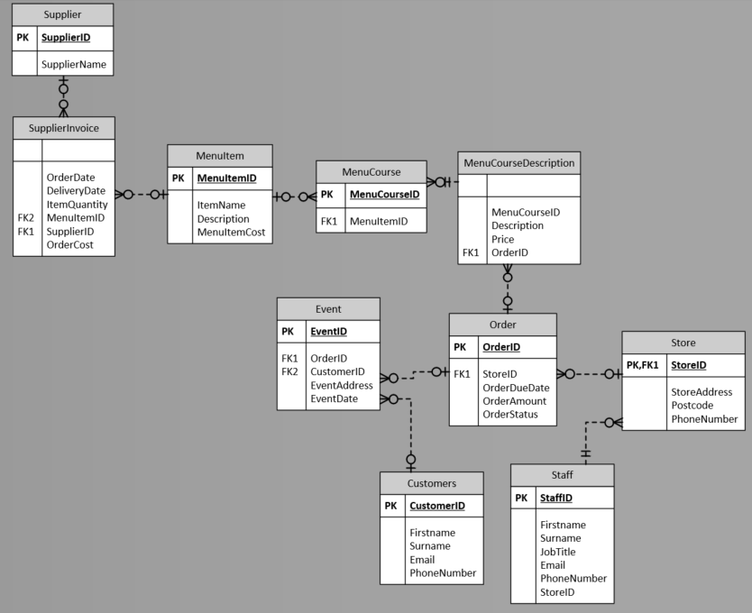
The above relationships were identified based on the requirements. Each of the tables identified has relevant primary and foreign keys to ensure that relationships have integrity. The table structure is optimized for data entry. This means using a normalized format over a dimensional model which would be more optimized for reporting purposes. The stock of each food item can be ordered and tracked with the supplier tables. The menu item table can be used to calculate the price of the stock order from the supplier by multiplying the price and the item quantity. This has been done as an automatic calculation in the solution. The menu course tables merge the individual stock items into a meal and apply a new price at which the meal will be sold at. This can then be used to automatically calculate the price in the order table again improving efficiency and accuracy. The tables above follow the instructions needed to normalize the data. In this form, the tables have no multi-valued attributes in the data set. The tables also have a fully functional dependency. There are also no transitive dependencies in the data set. The relationships were created to allow for all events to track all orders of each meal available. The meals all have documented food items that are used to create the full meal. These individual food items are related to the supplier tables allowing the users to order and track stock.

User Guide

Home Page
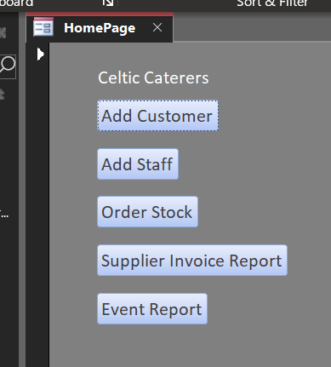

The home page form is the default form that will open when the access database is opened. It will help to navigate through the different functions of the access database. The add customer button will open the Customer Admin form which gives the functionality of adding, updating, and deleting customer information. The Add staff button will open the Staff Admin form which gives the functionality of adding, updating, and deleting staff information. The order stock button opens the Order Stock form. This form gives the necessary functionality of creating records in the supplier invoice table which can be sent off to order more required stock. The Supplier Invoice Report button will open the respective report. This report can be used to understand the supplies ordered and has print functionality. The event report can be used to understand event orders which Celtic Caterers have taken on and the price of each order.

Customers Admin Form
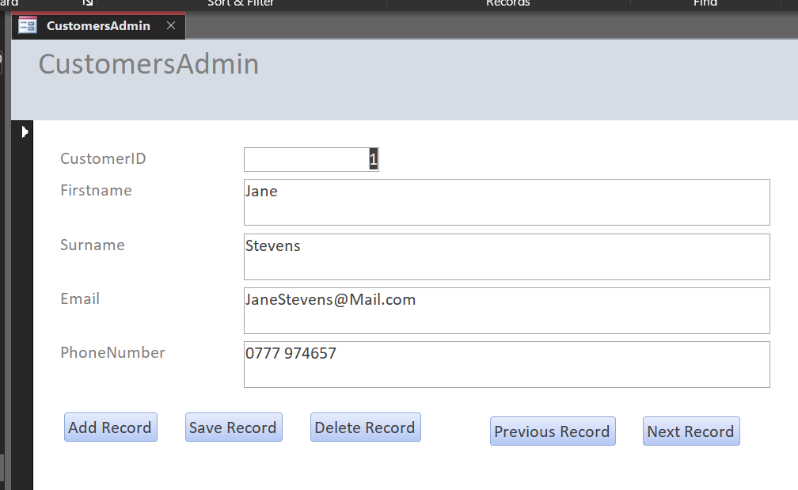
A requirement was identified that customers will need to be added, deleted, and updated from the system. This can be done using this form, there are many buttons created to assist in navigating the records and altering updating, and deleting the records. To update an existing record, navigate to the record which needs to be changed. Alter the required fields to the new information and press the save record button. To add a new record, navigate through the records using the next record button until the end of the existing records. Add the required information to the relevant fields and click the add record button and save the record button. There is also the option to delete a record by navigating to the record in question and pressing the delete record button. Alternatively, it is possible to access the Customers table and add the relevant information there.

Menu Course Description Form
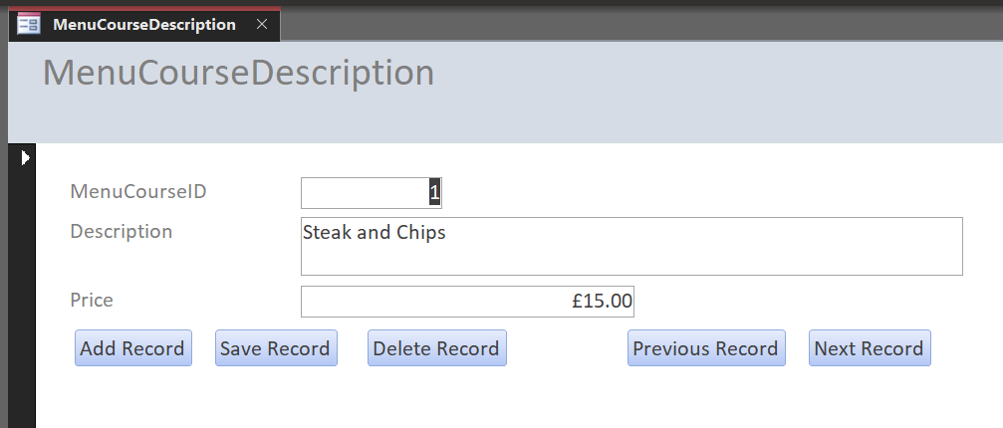
The Menu Course Description Form gives the ability to add new meals which can be sold to the system. Records can be navigated by using the Previous and Next record buttons. In to add a new meal record, navigate to the end of the list using the next record button. Fill out the relevant fields with the appropriate information and press the add record button then save the record button. To update records, navigate to the record in question and update the relevant field. Then press the save record button to save the changes made. There is also the ability to delete records for meals that are no longer available by navigating to the relevant record and pressing the delete record button. It is also possible to access the underlying table to make changes if necessary.

Staff Admin Form
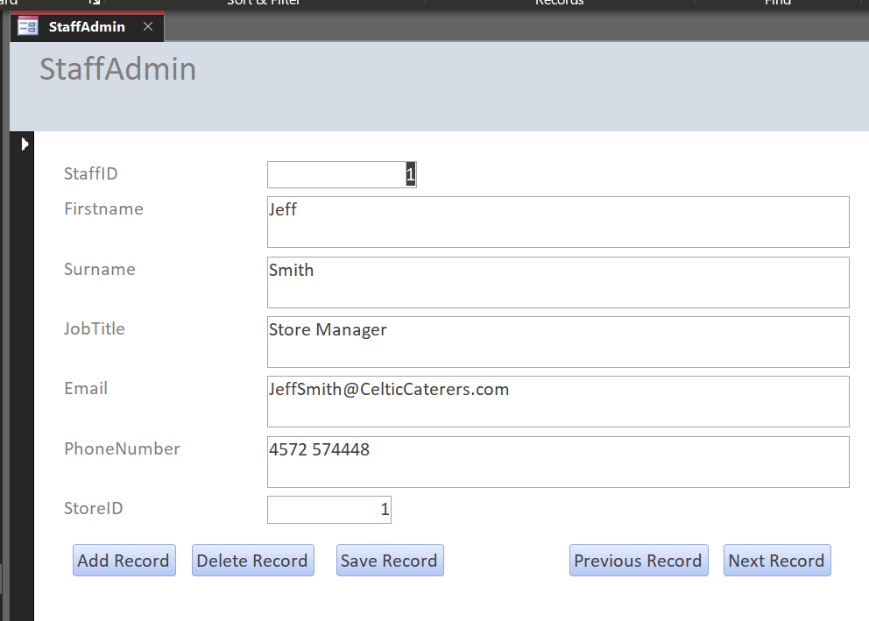
A requirement was identified that staff will need to be added, deleted, and updated from the system. This can be done using this form, there are many buttons created to assist in navigating the records and altering updating, and deleting the records. To update an existing record, navigate to the record which needs to be changed. Alter the required fields to the new information and press the save record button. To add a new record, navigate through the records using the next record button until the end of the existing records. Add the required information to the relevant fields and click the add record button and save the record button. There is also the option to delete a record by navigating to the record in question and pressing the delete record button. Alternatively, it is possible to access the Staff table and add the relevant information there.

Menu Item Form
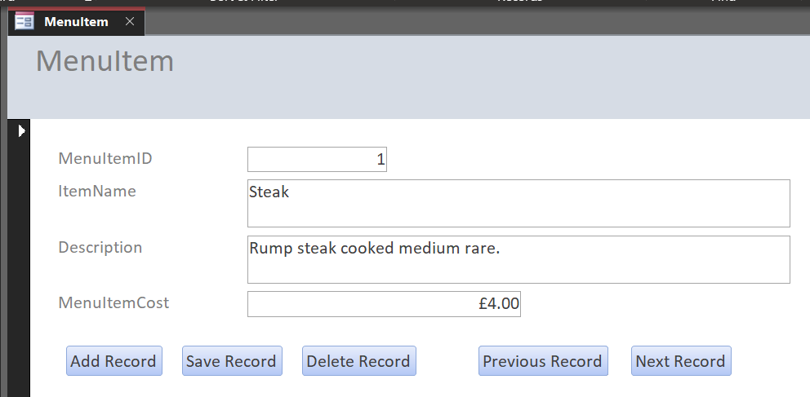
The Menu Item form gives functionality to add, update, delete and view menu item records. To add a new menu item, navigate to the end of the records list using the next record button. Once at the end of the records list fill in the relevant data for each field and press the add record button and the save record button. This form also gives the ability to update records by navigating to the relevant record updating the appropriate fields and then clicking the save record button. This form also gives the ability to delete records if necessary, by using the next and previous buttons to navigate to the relevant record and pressing the delete record button. The user can also access the underlying table Menu Item to alter data.

Order Form
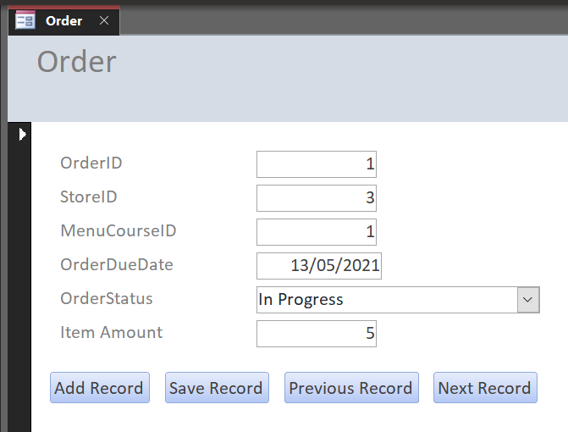
The order form can be used to create a new order for an event. The next and previous record buttons can be used to navigate between records. To add a new record, navigate to the end of the record list, fill out the fields with the relevant data and then press the add record button and save record button. There is also the option to update records such as the order status by navigating to the relevant record, changing the data in the relevant field, and pressing the save button.

Order Stock Form
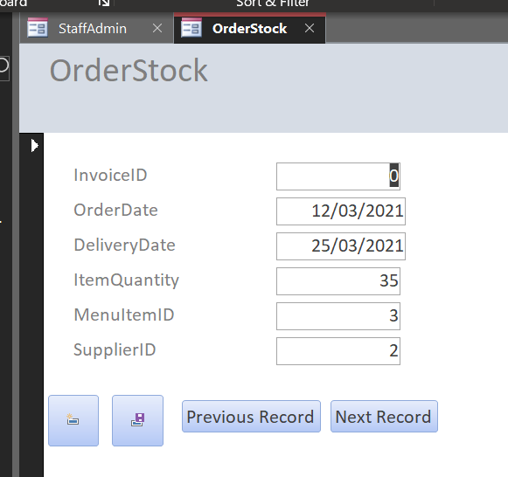
To order stock navigate to the end of the record list using the next record button. Fill out the fields with the required data and press the add record button and the save record button denoted by the icons. There is no functionality to delete these records other than accessing the underlying tables. This form can also be used to navigate through previously created orders using the previous and next record buttons.

Supplier Invoice Form
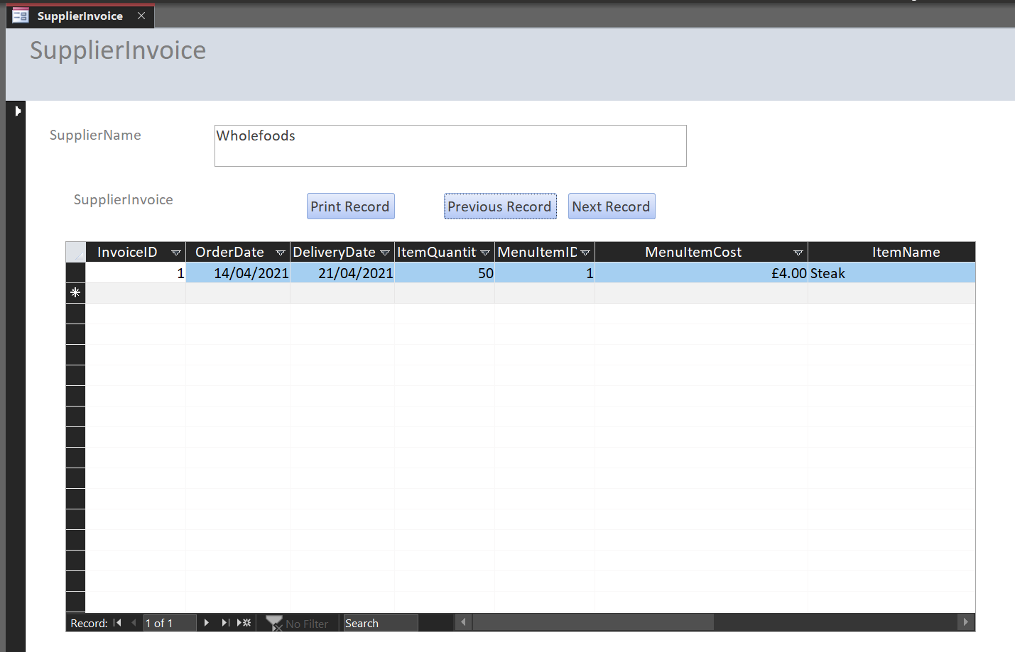
The supplier invoice form can be used to look at stock invoices per supplier. There are two buttons for navigating between suppliers. The subform then shows the stock intake of supplies taken from the supplier. There is a calculated field in the subform to calculate the price of the item and quantity. This information can also be printed as per the requirements using the print button.

Supplier Invoice Report
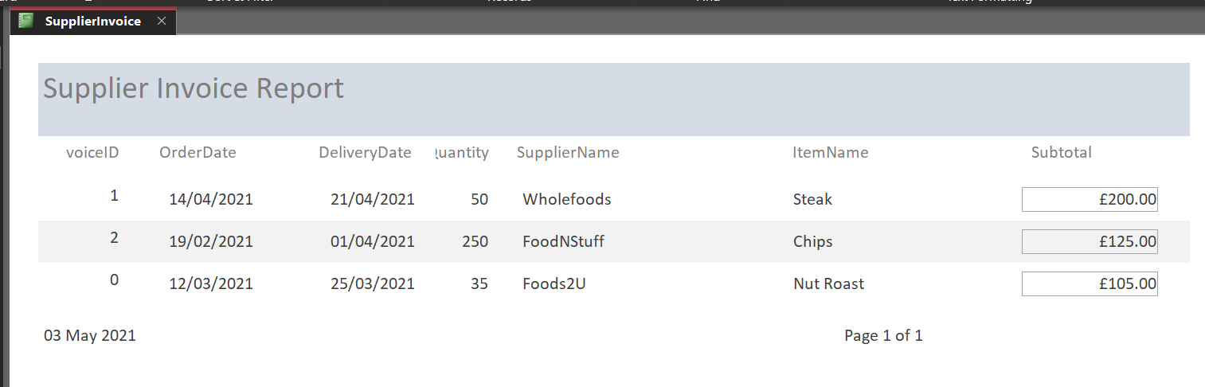
The supplier invoice report is a report generated to give a list of all orders received by the supplier. The subtotal field is a calculated field using the price of items from the MenuItem table. This removes the possibility of human error and automates the calculation for ease of access.

Stock Query
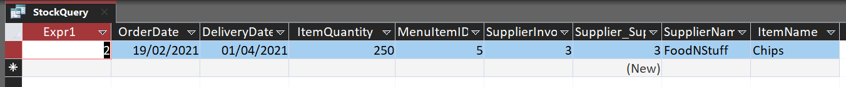
This stock query can be used to search for specific Invoice IDs to get a better picture and access to more data across multiple different tables. When clicked the Stock Query will prompt a popup that will ask for which Invoice ID you would like to search. Input the required Invoice ID and press enter, the query will then return all relevant information for the chosen Invoice ID.

Event Query
The event query can be used to search for specific events based on the event ID. This can be used to quickly search for all the information about a specific event and all the orders associated with the event. When clicked on the event query will prompt will pop up asking for which Event ID you would like to search. Input the desired Event ID and press enter or OK and the query will gather all possible information about the chosen event.

Event Report
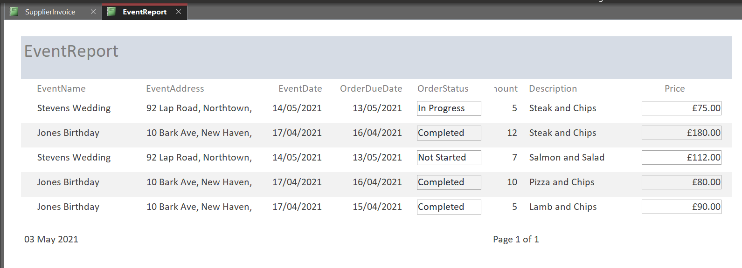
The event report is a report generated to give a list of all orders for each event and the price of each order. This is a method of tracking all orders which have gone through the system. The price field is once again a calculated field multiplying the quantity field by the price field in the Menu Course Description table.

Future Improvements
The access database can employ the use of more macros and automation. This will take out more possibilities of human error and locking down the underlying tables with more tested and polished front-end forms and reports. Giving extra functionality for users to create more personalized queries to improve ease of access to the data will be a good future improvement.
There are some improvements which can be made for the future. Access is a tool that can hold small amounts of data and is prone to data inaccuracies and human error. As the company expands it would be better to use a more advanced RDBMS such as Microsoft SQL Server. The benefits of using a more advanced system like this are many. Security is a very big benefit; an access database can be copied and only has one password which can be cracked. SQL Server has very restricted security and it is much easier to ensure compliance with GDPR. It also allows for the optimization of data and table structures for data entry and reporting. Access only allows for a normalized or dimensional data structure which means that either applications or reporting will be highly inefficient.

