Reflection and reflective practice.
Life is so busy often people don’t get the chance to notice what is going on around them in detail, so refection can be a good opportunity to revisit events and reflect. As is said in V Campbell-Barr and C leeson ‘Quality and leadership in early years, Sage, London (2016) Reflective practise is often something which is completed alone, as it requires lots of thought and concentration, a personal time that a person might think deeply about an event that has happened in their lives , however another type of reflection can be done as part of a group with colleagues at work, this can provide a shared understanding and create a much deeper reflection it can be a good bonding exercise, also providing practise on listening to others opinions and excepting they might differ to your own. As is said in V Campell-Barr and Caroline leeson ‘Quality and leadership in the early years’, sage, London, (2016) Based on four different observations by four different staff members at a setting, there are lots of different perspectives however one theme stays the same throughout, and that is the children should always remain at the forefront of minds, central too any decision making, there wellbeing and there ability too grow within the setting is of paramount importance. However the chosen way too achieve reflection, alone or in a group, using words or pictures, the main thing is its done well with careful thought and an open mind so as to give it the desired effect , to improve an outcome or situation, this is pointed out in Routledge ‘ The early years reflective practice handbook’ Oxon (2015), they go onto say reflection would be more accurate if related too a setting a person is having work experience in.
Reflection in the workplace
As is said in the ‘Early years reflective practice handbook’ J Dewi (1859-1952) P10 Reflection can be a way of learning some would say leaning more than by just doing the task in the first instance, reflecting on the events can have a greater impact on a person’s knowledge. When looking back over how a situation or task was approached or carried out, can enable the practitioner to see a way of getting a much better outcome the next time. Working as a team in a setting too reflect upon days events could be beneficial to all concerned as it says in ‘Early years reflective practice handbook’ M Eravnt (1940) There is a difference between learning theory from books and learning on the job from practical work, if reflection is completed as a team there are lots of aspects and opinions to contribute, practical experiences or differences in academic knowledge, also different ways to look at the same situation. Policies in the early years sector change daily as quoted in E Hallet, ‘The reflective early years practitioner, Sage, London (2013) ,( Foley and Rixson 2008) p25 “ The quality of children’s lives does not depend upon government policy, but rather on the way in which practitioners interpret the policies.
Requirements for successful reflection.
As is pointed out in ‘The reflective early years practitioner, to reflect constructively a lot of aspects should be kept in mind, and be considered REASON, there is usually a reason why reflection is needed, possibly a task did not go to plan, or it was apparent there would be room for improvement. EVALUATE which would be to look at all the information that has been gathered and evaluate it piece by piece. FEEDBACK from the team you are working with, management or parents. Learn from your evaluation and from the feedback received. Explain what has been taken and gained from the refection, how things could be done differently and how the differences could be implemented. As is said in ‘The reflective early years practitioner’ (Shon 2007) there are two different ways to reflect, the first way would be to reflect in practice whilst looking after the children implementing their routines or trying out various activities reflecting as they go along. The second and some will say most beneficial way is to wait until the practitioner has left the setting, to be able to look back and quietly reflect upon the events, also enabling them to research and link theories to there practise. As quoted by (Moon 2006) (p27) “This reflective process and behaviour develops and expands professional knowledge and practise.
Involving Parents in reflection.
As is shown in ‘Quality and leadership in the early years’ (p114-115) It can on occasion be hard to get parents to engage with a setting, this shouldn’t be something which is forced, if this is the case there wishes have to be accepted, and they should not be thought any less of for this decision, instead carry on treating them with the respect they deserve, providing lots of opportunities to get involved, this way if they do become more comfortable engaging over time they can. If it is possible to work alongside parents or careers there are lots of reports on the benefits that can be gained from starting this early on in early years settings, it has a positive outcome on the child’s early years journey, as is shown in J Penells,(November 2018)’ Teacher Darfield preschool and nursery, New Zealand’ volume 5 number 4. Some other names involved in the study ‘Carr and Lee 2012’’ Clarkin Philips 2012’ , Mitchell and Furness 2015’ Numerous studies have been done also by ‘Cooper 2012’ ‘ Davis 2006 and Turnock 2009’ Having families involved sharing and providing there knowledge to the teacher or practitioner adds more depth to the reflection as it is often the case that nobody will know a child like a parent or guardian, however this journal article does show that the learning process from reflection can work both ways, the parents or guardians involved in the studies took a lot from there interaction, the families actually gained knowledge from each other, it also showed that by adding different perspectives, opinions and experiences into a reflection it became a lot more diverse, in turn this would provide the children with a lot more learning opportunities ,as was said in the same study by (Grey 2013). Again, In the same study (Pennels 2017) (p81) pointed out that having face to face contact with a child’s teacher or practitioner was usually wanted by parents knowing how much benefit this provides, however there did seem to be few barriers, one being available time with parents rushing off to work at drop of and commitments in the evenings made it difficult to find a time to meet and share information. As said in ‘The early years reflective practice handbook (field 2010) (P88) A Child’s future is deeply impacted by how they are raised in the first five years of there life, a lot of variables could impact this culture, religious beliefs, parent or guardians education as a lack of education could make them feel inferior or Embarrassed, Financial position childhood poverty could be a big problem and would put a lot of stress on a family not to mention the health implications . Again in ‘The reflective practice handbook’ ‘The focus on family’s report, Smallwood and Wilson (2007)’ and ‘Brock (2011)’ (p89) show an understanding of family’s is very important, practitioners need to be mindful they could look less traditional with the increase of one parent family’s, same sex couple, extended stepparents/family’s, parents having children later in life. Family’s being more diverse than ever before. Practitioners keeping an open mind and being completely non-judgemental, remembering that families loving and nurturing a child is everyone’s focus could result in strong parent and practitioner relationships being formed. A journal by J Leigh Savacool, (2nd may 2011) ‘Barriers to parental involvement in the pre- kindergarten classroom’ 2,1 (Goodall,2007,280) says that he noticed middleclass families felt more at ease approaching and having discussions with teachers and practitioners, they felt more on there level, whilst the low income or less educated families were less inclined to participate in school activities.
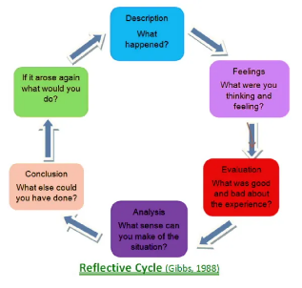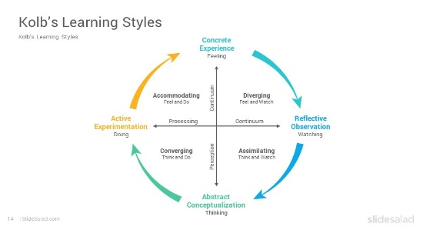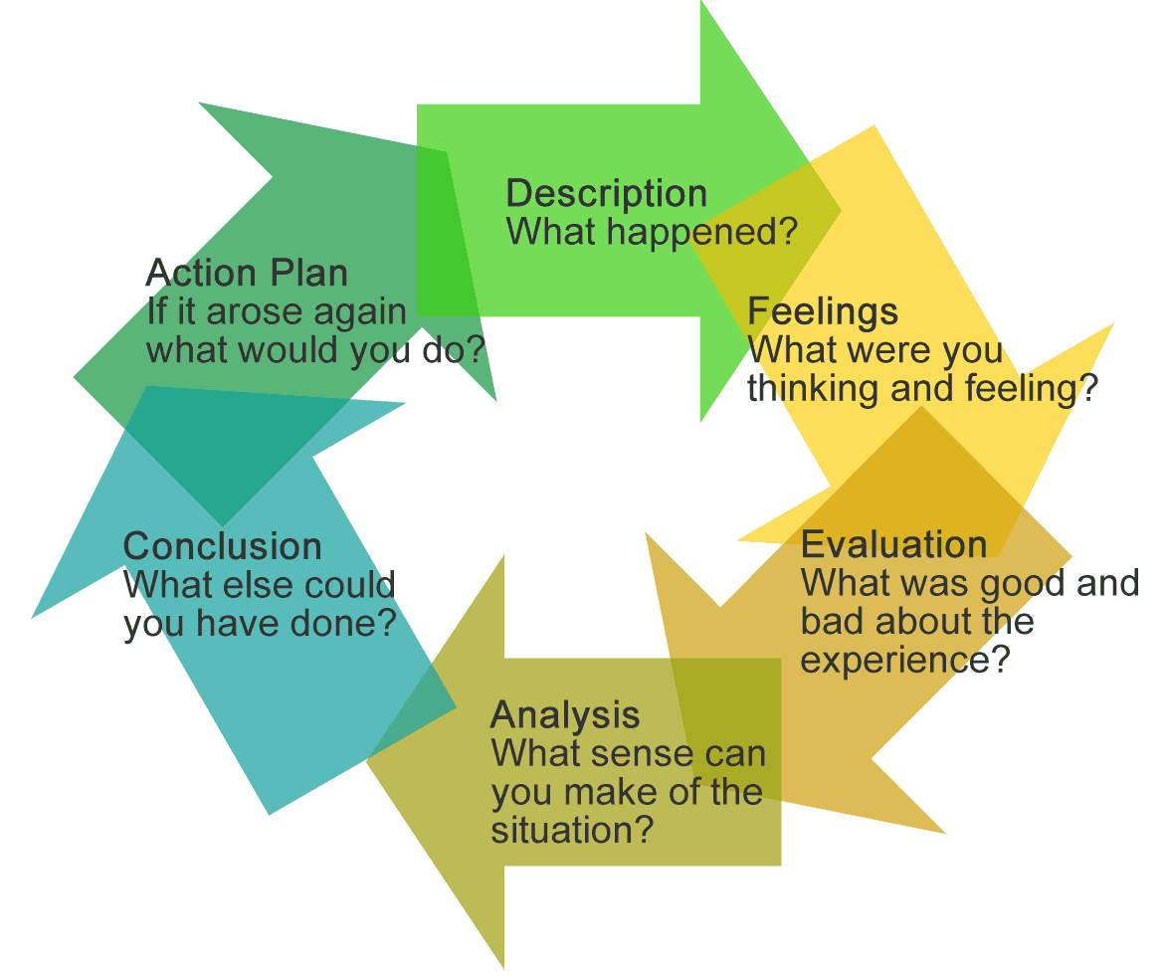

Reflective models
As is shown in ‘The early years reflective practice’ (Kolb’s 1984 b) and (Gibbs 1988) reflective cycle models both show ways to to aid a practitioner that has little experience in the area of reflection, they could use these cycles as a guide. As (Artherton 2013) says Kolbs cycle has four stages to it, stage one deciding on the task or event to reflect upon, stage two applying the theories and thoughts of how the experience went, stage three combining all the concepts of the task or experience and decide how it could be completed differently and then the final step being to plan the next activity using the conclusion from the reflection as is shown in (Kolbs 1984) learning cycle (Leeds met university skills for learning). (Gibbs1988) model is based on 6 stages of reflection, its modelled slightly differently to Kolbs model, it involves more detail taking the practitioner through more steps. As is said in ‘The reflective early years practitioner’ both models provide a framework providing ways for reflective learning, to document relevant data, to use that data to enhance future performance, to provide more satisfactory outcomes and to enable the practitioner to learn about themselves and the way they work. Also as shown in ‘The reflective early years practitioner (Burke 2006) p75 lots of practitioners want to progress in there studies, by doing this refection will be one area strengthened and used a lot more as a tool for providing a better early years education to the children in there care, studies have adapted tremendously over the years to enable this to become more attainable, most but not all of the early years sector are women or gentlemen with families, because of this they benefit from advanced learning being more flexible fitting into family and work life. As shown in ‘The reflective early years practitioner ‘ (p77) figure 5.1 shows a flexible learning model created by the practitioner, fitting in all aspects of their lifestyle, so things such as enrolment can be done more easily.

Noticing your surroundings.
As is said in J Mason (2002)’ researching your own practice the discipline of noticing’ Journal of Mathematic teacher education. AH Schoenfeld, University of California at Berkeley (P21) Noticing our surroundings is something we do everyday it can become second nature, done without thinking about! We automatically watch out for danger especially in a childcare setting, we notice which belongings came in with which child, such as coats, bags, dummies and comforters, however as this article points out by becoming set in a routine of looking for these daily new details of importance could be missed, new and finer details are important to reflection, if a practitioner becomes closed off to noticing new details a reflection could lack the depth needed to learn valuable lessons. The article goes onto say there are several activities that can be tried out to train a mind to notice new details, that could otherwise have been missed, the details would then be recorded and analysed, it also says that two different people could look at the same information but interpret it differently, this is where the close analysing in reflection becomes important.

Reflective change.
As is said in ‘The reflective early years practitioner’ (jones and pound 2008) Reflection being carried out in an early year’s setting is a good way to improve the performance and efficiency of a setting. Improvement, solving any problems and the ability to learn by experience as stated by (Siraj- Blatchford and Mami 2007) The process of refection can transform a workplace and the practitioners working there. If a manager is reflective its sets a good example to their colleagues, in time this will change any setting for the better and enable any problems that occur along the way to be worked out. As quoted by “Sinclair (2011, 509) an authentic leadership identity can be developed through biogeographical self-narrative, leadership used to be task orientated but now it is an identity. As is said by (Sinclair 2011,509) the people you come across in life, managers at your setting or lecturers at the university attended, be it a positive or negative experience, can change a person’s outlook, and aid a person to decide on the type of leader they wish to be, past experiences can be reflected upon, then analysed and any changes that need to be made implemented.

Reference List

Barber, Jenny, Paul-Smith, Sharon (2010) Early years observation and planning in practice MA education Ltd, London
Being a professional or practising professionally (2018) MA Dyer (Everetts 2011), (lloydd and Hallet 2010) (Hadfield et al 2011) (Chalkie 2013)
Dcpf (2009) Learning, playing and interacting
Early education (2012) (Nctl 2013) (Dcsp 2004) (Field 2010) (Allen 2011) (Osgood 2006, ang 2014) (Obehumer 2005)
E Hollet The reflective early years practitioner, Sage, London (2013) (Burke 2006) (Foley and Rixson 2008, p25) (Jones and pound ) (moon 2006) (Sira-Blatchford and Mami 2007) (Sinclair 2011.p509) (Shon 2007)
Emma Palmer (nee Kelly) and Peter Jenkins parents as partners in safeguarding children (October 2010-October 2012)
(Gopick 2009) ,( Greenfield 1997) ,( Shankoff and Philips 2000) , Shore 1997
J Leigh Savacool (2ND May 2011) Pre- Kindergarten classroom 2,1 (Goodall 2007 p280)
J Mason (2002) researching your own practice the discipline of noticing ‘journal of mathematic teacher education, a+1 Schoenfield, university of California at Berkeley (p21)
J Murry Becoming an early years professional: developing a new professional identity (Avery 2004), (Harris 2008) (Sergiovanni 2001), (lambert 2003) (Spillane et al 2004)
J penells (November 2018) Teacher Darfield preschool and nursery,’New Zealand volume 5 number 4 (Carr and Lee 2012) {Clarkin Philips 2012) (Mitchell and Fumes 2015) (Cooper 2012) (Davis 2006) (Turnock 2009) (Grey 2013) (Pennels 2017)
L Thornton and P Brunton, Bringing the Reggio approach to your early years practice ,( Chalkie 2013), (Moss 2006).
Powell S (2010)Hide and seek, Values in early Childhood Education and care, British journal of Educational Studies pages 213-229. (Frowe 2007)
Routledge ‘The early years reflective practice handbook .(Field 2010 p88), (J Dewi 1859-1952), (M Eravant 1940), (Oxon 2015) and (Smallwood and Wilson 2007) and (Brock 20011 p88)
Schwartz an overview of Schwartz theory of basic values, Durkelm (1987-1964) and Weber (1905-1958)
Stewart N and Pugh R (2007) Early years vision in focus , part 2, exploring Pedaology @ Shropshire county council
The Early years Reflective Practice (Kolbs 1984b) (Gibbs1988)
The United Nations Convention on The rights of Children general assembly resolution (November 1989)
V Campell-Barr and C leeson ‘Quality and leadership in early years, Sage, London (2016)
WALES Safeguarding procedure (2019)available at Wales safeguarding procedures (2019) https://safeguardingwales/

