Self-Development, Professional Practice & the Management of Construction Personnel

Assignment No 1: The role of the professional within the Construction Industry

Module code: ACBA 5008

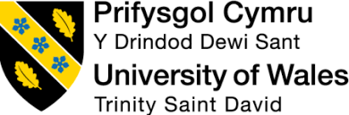

Student: Max James

Student Number: 1900822

Lecturer: Sheila Holmes

Word Count: 5,175 (Non-Formative)

Word Count: 8,266 (Formative)
Table of Contents

INTRODUCTION 2

1.0 PROFESSIONALISM AND ETHICS 3

2.0 PROFESSIONAL DEVELOPTMENT 8
2.1 Up to Date CV 9
2.2 Personal Statement 11
2.3 Summary of Career / Work Experience to date & Organisational Context 14
2.4 Personal Development Plan 16
2.5 Importance of the organisational behaviour & the level of understanding that is required to aid personal development. 17
2.6 LinkedIn Network 20

3.0 LEADERSHIP 21

4.0 TEAMWORK 28

REFERENCE LIST 32

INTRODUCTION
This assignment will compromise of the professionalism and ethics within the construction industry as a whole & the measurable factors that can be utilized to record the professionalism within the construction industry. The assignment will also detail professional development to date and a section on leadership & teamwork will conclude the assignment.

1.0 PROFESSIONALISM AND ETHICS
Within construction, decision-making is a key element and there will be countless times in which personnel will have to derive at a decision throughout the construction project. When it comes down to decision making, it is vital that professionalism and ethics are incorporated within that procedure. There are numerous professionals involved within construction projects; these include architects, engineers, quantity surveyors, project managers and so forth. These professionals often have to make decisions & it is vital that professionalism and ethics are a key factor to these decisions. There are various aspects, which influence the definition of a professional;
Competency – Professionals should have a level of competency relatable to their discipline & competent to make decisions within their field of work.
Attitude – As a professional, a good attitude to work is vital. The professionals should find ways to overcome challenges and find solutions to specific problems, which may occur on a project.
There are various routes, which can be taken to attain a profession status within the construction industry, of which can be a factor in applying professionalism and ethics to decision-making; this can be achieved by attaining chartership status, by construction professionals commencing the chartership process it deems their competency through their specific chartership avenue. One route of chartership that is a common route for quantity surveyors is to become a charterd member of the RICS (Royal Institution of Charted Surveyors). Within the construction industry, problem solving & challenges is a daily occurrence & requires professionals to make decisions that need to be foreseen as professional & ethical. From a quantity surveyors perspective, decision-making is often regarding costs. When cost is involved, professionalism & ethics are the number one factors when discussing with the contractor / client. There are often many disagreements around cost, particularly between the client quantity surveyor & contractor’s quantity surveyor; if not managed correctly a hostile atmosphere could easily occur. An incident, which commonly occurs within the construction industry, is the resolution / agreement of the final account upon completion of a project. Applying professionalism & ethics to this incident can often prevent a dispute occurring, which if the account is not resolved could become a legal dispute between both parties. In order to prevent a legal dispute occurring, applying professionalism and ethics to a scenario can often prevent the dispute occurring. Within the RICS chartership route, there is a whole section on competency and ethics which requires completing in order to achieve the chartership status. This puts emphasis on how important both these factors are, particularly in the construction industry.
The construction industry requires decisions to be made daily throughout the whole process of a build. The decisions have to be made by numerous professionals in all disciplines. The decisions required could be small scale, or could be decisions which could be detrimental on various factors if not thought about correctly. Decisions can change the three main aspects of a project, they could affect the programme & prolong the work, they could affect the cost & they could also affect the quality / outcome of the build. These three factors are vital, especially to the client. In order for professionals to make decisions within the construction industry, it is vital that two factors are applied to the decisions made; these being ethics & professionalism. The decisions made need to be done so by competent individuals, as the decisions can have a factor on numerous variables. One way to measure the level of competency is through chartership routes. By professionals becoming charted within their chosen field, this is a measurement of their level of competency and should demonstrate they are capable of making such decisions. The majority of chartership routes focus on professionalism & ethics, which allows the decision makers to apply these concepts to various decisions required. Within the construction industry, decisions often have to be made due to previous tasks being incomplete or not done to an adequate standard. An example is revolving around design, there are often times where the architect / site manager requires to make a decision on site within a tight timescale regarding design. This could be in relation to an element which hasn’t been shown on a drawing correctly, or an element which hasn’t been shown at all. If the design process was more intrusive, then decisions like this could be avoided however this is a very common problem on construction projects. The decision often has to be made within a tight time frame in order for the work to stay on programme. It is vital that the decision made is ethical & professional. Applying ethics to decisions should comply with numerous factors, one being law. A report was published which highlighted the factors that organizations / companies should follow in regards to applying ethics to decision making, some key principles of the report were as follows;
- Honesty; Professionals making the decisions to be honest with other parties & avoiding conflict by doing so.
- Fairness; Making sure decisions made are fair & reasonable for all parties. It is vital that decisions do not favour one party more than another.
- Reliability; The decisions made are needed to be done so by competent professionals within that area. Some decisions may require specialist knowledge and therefore should be done so by competent personnel.
- Integrity; Must be in accordance with the public’s interest – this is vital for organisations such as local government authorities.
- Objectivity; Conflicts of interests should be identified & disclosed where necessary
- Accountability; The information provided to resolve the solution / make a decision should be appropriate and relative to the scenario.
These principles should be applied to decision making for all professionals within the construction industry (Buildings, 2022).
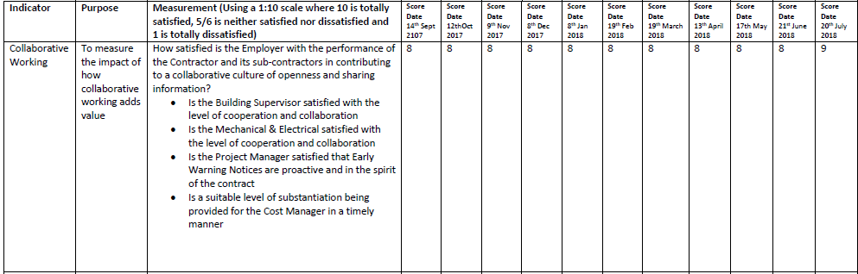
It is vital that professionalism is measured within the construction industry to make sure a team is demonstrating the level of professionalism required. In order to measure professionalism, specific targets can be set within the workplace. The level of professionalism within the construction industry can often vary, especially between the client & contractor. The level of professionalism in theory should be the same however, due to the different mind-set of each party, this often varies. The main difference being the contractor can often come across very commercial & making money is their key aspiration, with the client also being commercial but from a money saving perspective. This requires the need for professionalism to be applied in order for both parties to work collaboratively. One way which is often used to measure professionalism & a range of other aspects such as performance etc in the construction industry is through KPI’s which is an abbreviation for Key Performance Indicators. KPI’s are essentially a set of standards which are bespoke to a specific parties in which the client will fill in at a chosen interval (often monthly), to measure the contractors performance. The KPI’s are then issued to the contractor once filled in to give the contractor an oversight of their performance and where they may be able to improve going forward to the next assessment. This way of assessment can measure the professionalism of a contractor & states how they are performing. This is a great way of measuring not only professionalism, but also performance as it gives the contractor an insight of what areas they can improve on and becomes a challenge for them to obtain the best score possible. Below shows an example KPI, with one element being shown;

(Council, 2020)

As identified above, the KPI’s are scored at monthly intervals, where the value is reflective of the contractor’s performance. This can be used by the client not only for contractors, but for any consultants working on behalf of them also. This is a key way to measure the professionalism within the construction industry & can identify where improvements are needed.
As a conclusion, professionalism and ethics within the construction industry are vital. Decision-making is a key element within this stimulating industry and it is crucial this aspect is managed. In order to manage decision-making, ethics and professionalism are two key variables, which can ensure the decisions made are the best outcome. One of the best way to achieve these decisions is having competent professionals to make these decisions, and apply both professionalism and ethics to the scenarios. One of the best ways to obtain competency is through chartership, dependent upon the professional the route of chartership will vary however; one of the key principles of all chartership bodies is professionalism and ethics. Not only do the chartership routes provide the level of competency, but provide emphasis on the two key elements of any decision making which are applying ethics to decisions & professionalism. Once these two principles have been applied, then it is important they are measured. There are various ways in which organisations can measure these aspects such as set targets, but one way of measuring them is achieved via Key Performance Indicators as listed above. Dependant upon the organisation, the way in which they are measured may vary however it is important they are measured correctly. Public sector organisations will measure these two aspects differently to a company such as a private developer however, it is important that consistency is provided throughout projects to enable a collaborative working approach.

Section Word Count (Excluding Tables): 1,540

2.0 PROFESSIONAL DEVELOPTMENT
This section of the assignment will detail my professional development to date, including a CV, a summary of my career / work experience to date, a personal development plan & the importance of understanding my own organisational behaviour will be discussed, listing the benefits of how this would aid my own personal development.

2.1 Up to Date CV

12 Mayfield Acres, Kilgetty, Pembrokeshire, SA68 0UW
Maxjames24@icloud.com
07794822515
https://www.linkedin.com/in/max-james-9348241b7/


Max James

Personal Summary
I am a highly motivated individual with the eagerness to learn and understand the complexity of the processes required to construct and maintain high level infrastructure. Large scale construction projects have always gripped my curiosity, driving me towards my aspiration of becoming a Charted Quantity Surveyor. Together with leadership qualities and ability to problem solve, I possess excellent skills in verbal communication, all in which will be vital to my success in this competitive but stimulating industry.

Experience
2020-Current

Trainee Project Manager / Quantity Surveyor
Working on construction projects within three mains sectors which include education, housing and regeneration. Predominantly working on regeneration projects, taking full responsibility of cost control, and demonstrating success in doing so. As well as cost monitoring, participating in completion of tender documentation to form the tender package, to then be involved within the tender evaluation of the responses received. Other duties such as responding to communications and problem solving on a daily basis. Whilst working 4 days a week for the authority I also attend the University of Wales Trinity St David one day a week, studying towards a BSc (Hons) in Quantity Surveying.
2019-2020

Apprentice Project Manager
Assisted various project managers within the authority whilst learning the different processes and procedures required at each RIBA stage of the project. Whilst assisting the project managers in overseeing and planning the delivery of various schemes, I also worked towards a level 4 project management qualification. During this qualification, I learned the core aspects of project management, covering a variety of different units compromising of: Principles of Project Management, Project Stakeholder Management, Managing Project Scope and Project Communications. A three-stage report was produced on a project I was working on, from the planning stage right through to the evaluation stage of the project. The scope of the project was an Electrical project, involving the change of lighting in 29 schools across Pembrokeshire.

Core Skills
- Competency within the NEC suite of documents, predominantly Option A with an understanding of the contractual processes required during the construction stages. This involves the understanding of core clauses stated within the contract, as well as the implementation of the key procedures such as early warnings and compensation events.
- A good understanding of the different procurement strategies.
- Competent in assisting with monthly valuations with a good understanding how the work to date is measured.
- Competent in all aspects of budget and cost control with proven success in doing so within various portfolios of work.
- Excellent analytical skills.
- Eagerness to learn from experienced professionals with the willingness to learn aspects from other construction disciplines.

Academic Qualifications
Current - 2025
BSc Quantity Surveying / University of Wales St Trinity David
HNC Achieved (2022) HND Achieved (2023) BSc Achieved (2025)
2020 - 2022
Level 5 NVQ Diploma in Construction Management (Sustainability)
Achieved (June 2022)
2019 - 2020

Level 4 Project Management / CAD Centre Ltd
2016-2018

BTEC Level 3 Extended Diploma in Mechanical Engineering

Grade attained: D*D*D* / Pembrokeshire College
2012-2016

GCSE’s

Grade attained: English Literature (A), English Language (B), Mathematics Higher Tier (C), Chemistry (C), Biology (C), C.i.D.A (C), Applied Business (C), Physical Education (C), Welsh (A), Religious Education (C) / Greenhill Secondary School

Certificates and Achievements
Accredited NEC3 Engineering and Construction Contract Project Manager
CSCS Trainee Card Holder
City & Guilds 2D CAD Course
Asbestos Awareness Course

Memberships
RICS Student Member

2.2 Personal Statement

I am a highly motivated individual with the eagerness to progress and work within the professional construction services team, with a good understanding of the complexity of the processes required to construct and maintain high level infrastructure. Large scale construction projects have always gripped my curiosity, driving me towards my aspiration of becoming a Charted Quantity Surveyor. Together with leadership qualities and ability to problem solve, I possess excellent skills in verbal communication, all in which will be vital to my success in this competitive but stimulating industry. My education / academic qualifications compromise of the below:

Current - 2025
BSc Quantity Surveying / University of Wales St Trinity David
HNC Achieved (2022) HND Achieved (2023) BSc Achieved (2025)

2020 - 2022
Level 5 NVQ Diploma in Construction Management (Sustainability)
Attained in June 2022

2019 - 2020
Level 4 Project Management / CAD Centre Ltd

2016-2018
BTEC Level 3 Extended Diploma in Mechanical Engineering
Grade attained: D*D*D* / Pembrokeshire College

2012-2016
GCSE’s
Grade attained: English Literature (A), English Language (B), Mathematics Higher Tier (C), Chemistry (C), Biology (C), C.i.D.A (C), Applied Business (C), Physical Education (C), Welsh (A), Religious Education (C) / Greenhill Secondary School

I hold 3 years’ experience within the construction industry in which I have gained a vast amount knowledge, as well a superior understanding of the complexity of the processes required to both construct and maintain high level infrastructure. My current role as a Trainee Project Manager / Quantity Surveyor consists of working on construction projects within three main sectors which include education, regeneration and leisure. Initially my current role consisted of me working predominately on the regeneration portfolio of work, taking full responsibility of cost control and demonstrating success in doing so. My role has adapted to which I now work across all three portfolios, undertaking numerous tasks from the feasibility stage of a project, right through to completion / hand over period. Aside to the cost monitoring element, my role consists of participating in completion of tender documentation to form the tender package, to then be involved within the tender evaluation of the responses received. Other duties include responding to communications from a project management perspective daily, as well as responding to problems reactively. Whilst working 4 days a week for the authority I also attend the University of Wales Trinity St David one day a week, studying towards a BSc (Hons) in Quantity Surveying, to which I have achieved HNC level, with HND level to be achieved in 2023, and the full BSc in 2025. As part of my studies, I completed a Level 5 NVQ Diploma in Construction Management (Sustainability), which was a work-based qualification which proves occupational competence within the construction industry. The diversity of the units within this qualification allowed me to undertake tasks and prove competency in various construction related disciplines.
As part of my current role, I have been fortunate to work with various construction related disciplines and gained experience in areas which may not be foreseen to be within a Quantity Surveyor / Project Managers remit of work. My role and current experience have allowed me to become competent within the NEC suite of documents, predominantly Option A with an understanding of the contractual processes required during the construction stages. This involves the understanding of core clauses stated within the contract, as well as the implementation of the key procedures such as early warnings and compensation events. I have undertaken various tasks at the feasibility to tender stage of a project which as of a result has allowed me to ascertain a good understanding of the different procurement strategies available. My role also has resulted in me participating in valuations with the client-side Quantity Surveyor leading to a good understanding of how the work to date is measured, particularly when NEC Option A is the form of contract however, also have experience where NEC Option E has been the form of contract in which is a cost reimbursable form of contract.
Aside from work-based experience, I possess excellent analytical skills and have the eagerness and willingness to learn from experienced professionals in all construction disciplines. I recently became an Accredited NEC3 Engineering and Construction Contract Project Manager which comprised of two weeks of lectures, followed by one multiple choice exam, and a formal written exam in which I passed resulting in myself being enrolled onto the ICE Register for Accredited NEC Professionals. Aside from NEC, I am also a student member of the RICS and have commenced the process into becoming an Associate Member (AssocRICS), to which upon completion of my degree will continue with my professional development and have the ambition to become MRICS accredited. My ambition has allowed me to progress in this stimulating industry, with the drive to further my knowledge in all aspects and disciplines. As an individual who is competent in the NEC form of contract, I look to further my knowledge and upskill on the JCT form of contract. I have some experience in the JCT form of contract, but I am willing to learn and explore this form of contract. Due to my current experience working for the authority, this has meant most of the projects I have worked on have been externally funded in which funding requirements become applicable. The funding requirements often state the form of contract in which NEC is the preferred form which dictates my experience mainly being in this element.
My career ambition is to become a Charted Quantity Surveyor and look to progress and upskill in all aspects. From my previous experience and my current skillset, I believe I have the level of competency and capabilities to progress into such role. As a summary, I believe I have ascertained a wealth of knowledge within my current role and continue to undertake tasks which may be foreseen as over and above what my current role should entail. I thrive to undertake challenging tasks and the outcome is always to the best of my capabilities. As a long-term career ambition, a target has not been set as my mind-set is to keep progressing and reach the top, taking opportunities where possible in order for me to achieve that goal.

As context, the above personal statement was used as part of my professional development in promotion within my current department. Within my department, when it comes to professional development regardless of the fact you may already work within a role, in order to progress the full process detailed below is required:
- Application
- Shortlisted (If application is deemed good)
- Interview
- Notification
I was fortunate enough to get the job in this case, seeing me being promoted to an ‘Assistant Quantity Surveyor’.

2.3 Summary of Career / Work Experience to date & Organisational Context
As an indicative overview of my career to date, I have been working within the Professional Construction Services team within Pembrokeshire County Council for over 3 & a half years. In this time, I have ascertained a wealth of knowledge within the construction industry and worked on various projects, my most recent project being a 21st Century secondary school that was the amalgamation of two secondary schools, with overall construction value of CIRCA £50 million. Below details a more in depth summary of my career & roles / responsibilities to date:

2019-2020
Apprentice Project Manager –
This was my first role within PCC’s Professional Construction Services, my roles / responsibilities comprised of the below:
Assisted various project managers within the authority whilst learning the different processes and procedures required at each RIBA stage of the project. Whilst assisting the project managers in overseeing and planning the delivery of various schemes, I also worked towards a level 4 project management qualification. During this qualification, I learned the core aspects of project management, covering a variety of different units compromising of: Principles of Project Management, Project Stakeholder Management, Managing Project Scope and Project Communications. A three-stage report was produced on a project I was working on, from the planning stage right through to the evaluation stage of the project. The scope of the project was an Electrical project, involving the change of lighting in 29 schools across Pembrokeshire.

From the apprentice role, I then progressed into the below role:

2020-2022

Trainee Project Manager / Quantity Surveyor -
Working on construction projects within three mains sectors which include education, housing and regeneration. Predominantly working on regeneration projects, taking full responsibility of cost control, and demonstrating success in doing so. As well as cost monitoring, participating in completion of tender documentation to form the tender package, to then be involved within the tender evaluation of the responses received. Other duties such as responding to communications and problem solving on a daily basis. Whilst working 4 days a week for the authority I also attend the University of Wales Trinity St David one day a week, studying towards a BSc (Hons) in Quantity Surveying.

From the Trainee role, I then progressed into the below role:

2022-Current

Assistant Quantity Surveyor -
Undertaking the same duties as the previous role, but taking on more responsibility & demonstrating my level of competency in all areas. I lead on the client as the QS on various projects, working with the contractors QS’s as well as external consultant QS’s. Whilst working 4 days a week for the authority I also attend the University of Wales Trinity St David one day a week, studying towards a BSc (Hons) in Quantity Surveying, currently in my third year to which I will have achieved HND level by the end of this year.

2.4 Personal Development Plan
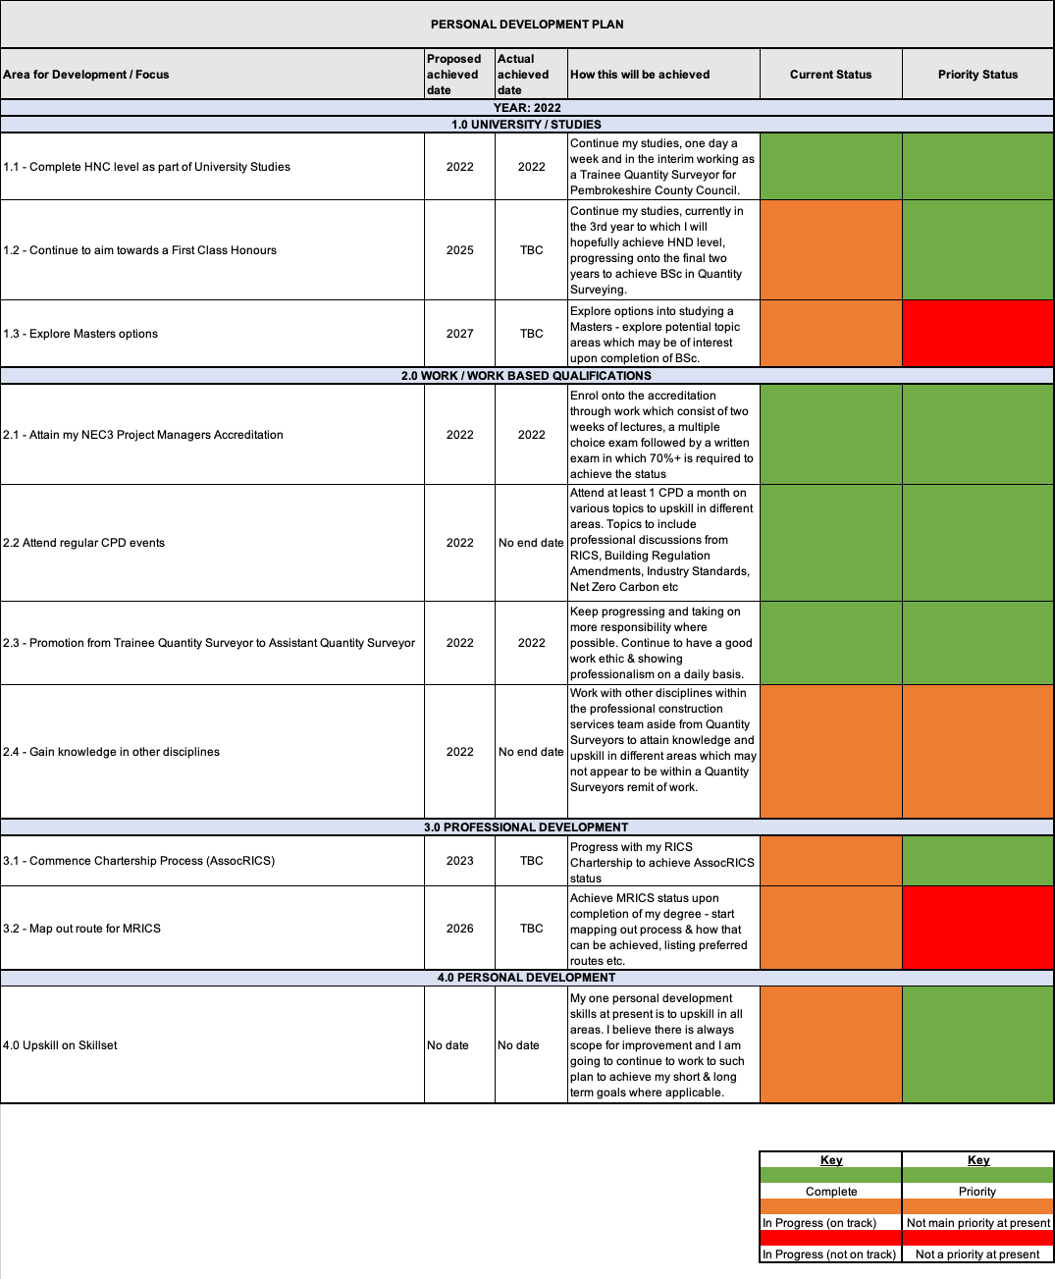
Below details my personal development plan, which splits up my development into 3 main areas – 1.0 University Studies, 2.0 Work, 3.0 Professional Development & 4.0 Personal Development.

2.5 Importance of the organisational behaviour & the level of understanding that is required to aid personal development.

Organisational behaviour within the workplace is a vital element to professional development and can often aid in that process. The definition for organisational behaviour is a study in which the behaviour of an individual is analysed within an organisation, the study analyses factors such as an individual’s interaction with one another i.e. colleagues (Kopp, 2023). As an individual who works within the public sector, organisational behaviour is paramount. There are various aspects & protocols we need to follow in order to comply with procedures. A big part of my job is governance, within Pembrokeshire County Council, governance is a key area and in order to mitigate the correct governance procedures being missed, organisational skills are required. By obtaining a better level of understanding around organisational behaviour, it will develop and aid my personal development in many ways. The principles behind organisational development / behaviour are applied to make companies more effective and operate to the highest standard. This reflects myself continuing to aid my development in this aspect to help PCC operate (in particular the professional construction services team) to the highest standard. Governance being a key aspect of my day-to-day operation, this is an area which should continue to be developed. Throughout the various project stages, there are sign-offs / protocols which need to be followed. An example of this is in order for a project to commence and the budget costs to obtain approval; a sign-off process is required. Dependent upon the value, the sign-off is either a Director Decision or an ICM (Individual Cabinet Member) sign-off. This is part of the internal governance that we are required to undertake in PCC in order to commence a project. Following these procedures is vital, as they are required in order to comply with the authority’s contract particulars.
After sign off has been achieved, there are another set of standards which have to be achieved as part of the authorities regulations. The authority has its own set of CPR’s which is an abbreviation for Contract Procurement Regulations, it is vital to understand the key processes and clauses within this document. In order to obtain an understanding and apply these regulations in practice, this comes down to organisational behaviour. By improving organisational behaviour / continuing to develop, this enables me to professionally develop in different areas. The area of development in this case is in regards to the procurement of a project, which is the next step after approval has been obtained. Interacting with colleagues is vital at this stage as legally binding documents such as the authorities CPR’s can often be interpreted in different ways. By continuing to interact and undertake these tasks, it enables me to develop and understand what some of the clauses may mean.
By continuing to understand organisational behaviour & reflecting, that back to the way in which the authority operates it enables me to develop and aids in my personal development as a whole. Personal development is a key aspect for me & I have many aspirations. In order to achieve those aspirations, understanding organisational behaviour is key. It is not only important to understand my own organisational behaviour, but understanding my colleagues is just as important. By understanding the way in which certain people act within the organisation helps to approach them and collaboratively work as a team. Working for a local authority results in me working with various organisations, the main two being main building contractors & consultants. The way in which the organisations operate varies significantly and therefore is vital for me to understand how their organisations operate & the behaviour of individuals within the organisations. By having an understanding of the different organisations, it allows me to collaboratively work with both parties to achieve and end goal.
Organisational behaviour is managed through the council by the evaluation of employees. At six monthly intervals, employees are required to undertake a performance review. The performance review process commences by the member filling in the associated form; the form lists aspects such as where does the individual feel they have done well, where they could have improved etc. Upon completion of the form, a meeting is then scheduled between the individual & their line manager. This form is then discussed in detail & the manager has an input on where they think the individual has performed & where improvements can be made. Targets are then set (both short term & long term). The short-term targets are required to be met by the next six monthly review & the long-term targets have a longer timeframe associated with them, dependant upon what the target entails. This diligent process of having performance reviews at 6 monthly intervals allows organisational behaviour to be managed and adopted where necessary. The process of performance reviews is a process in which favours myself and aids towards my professional development. As part of my own professional development, setting targets (both long and short term) is an exercise which is undertaken frequently. As listed within section 2.4, an up to date personal development plan is utilised and referred back to, closing out each area. Once an area is closed out, another one is added; this is the process of professional development. By having my own personal development plan & having a performance review plan with the authority, this enables me to develop in areas that may not be identified by myself. As part of the performance reviews, there is a comparable exercise which is undertaken. This exercise analysis the duties undertaken by the employee & as to where those duties rely in regards to job role. This process is to identify whether the individual is working above or beyond their current duties. This in itself is professional development as if the employee is foreseen to be working above their remit of work & to a good standard, various options can be explored. This includes incentives such as promotions & potential new roles to facilitate the work being carried out. The whole of the concept behind the performance reviews revolves around organisational behaviour. It enables the employee to realise the benefit of their organisational behaviour & the impact this can have on a professional team.

Section Word Count: 1,031

2.6 LinkedIn Network
As part of my professional development, I have utilised LinkedIn to build up a professional network. Below shows my LinkedIn Profile & an example of a post.



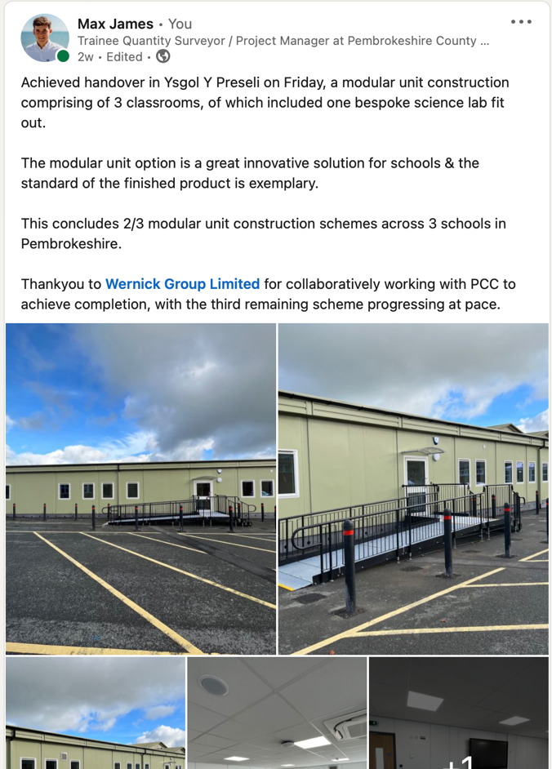
LinkedIn Profile

Recent LinkedIn Posts

3.0 LEADERSHIP
As an individual who is pursuing a career within the construction industry, leadership is a key quality. Leadership is required at all levels within the construction industry, whether that is working as part of a site team, or a professional role within the industry. There are different routes of progression into attaining leadership & in order to peruse as a professional, these routes require a level of understanding. There are various leadership styles & theories, which can be utilised to become a leader. Leadership styles are styles in which individuals adapt to become a leader, and dependent upon a person’s personality / job role, may adapt a different style. Leadership theories however are the rationale behind why certain people become leaders & is an analytical view of their traits / behaviours. The individual’s traits and behaviour is the core focus, and the analytical aspect is to what the individual can do to improve their traits and behaviour to increase their leadership capabilities.
There are various leadership styles, all of which have different traits. The six main leadership styles are (Team, 2022);
- Democratic: The leader will make decisions based upon input received from other team members. This enables the team to voice their opinion and is a collaborative approach.
- Autocratic: This the opposite of a democratic leadership style, the leader will make their decision on behalf of the team without incorporating other team members opinion & thoughts. Upon the making of a decision, the leader expects the team to support this decision.
- Laissez-Faire: This is a passive leadership approach. The leader will provide their team with relevant information & necessary tools for them to carry out tasks. There is an element of trust associated with this style as the leader will have trust in their team undertaking the necessary tasks.
- Transformational: This leadership style is a motivational style in which the leader will motivate their team & transform them into roles they may not of thought they were capable of.
- Transactional: This style is where the leader will give the team members incentives for completing tasks. The team members are rewarded for the work they perform.
- Bureaucratic Leadership: This type of leadership is where everything is followed by the book & often bounded with regulations. There is no room of flexibility in this leadership style & everything is followed in accordance with guidance / regulations.
Within the construction industry, there are various different disciplines which work with one another to achieve completion of a project. Generically, each discipline would undertake different tasks & have various approaches in doing so. As each discipline has a different responsibility, the way in which they lead a team would vary. Below lists three core disciplines & the way in which they would manage their team;

Quantity Surveyor
As a quantity surveyor myself, I am fully aware of the duties and responsibilities which have to be dealt with on a daily basis. The key aspect is cost, making sure the project remains on budget and to forecast an accurate representation of the anticipated cost. As a client side Quantity Surveyor, it will often only be one Quantity Surveyor on the job from the client’s side. As a client side Quantity Surveyor, the leadership style used is autocratic. It is often that working on the client’s side there is only one Quantity Surveyor undertaking these duties for the client. This results in having to work independently and making decisions solely. Tasks such as undertaking valuations can be interpreted differently as work to date is assessed in numerous ways. It is vital to evidence the way in which the valuation has been undertaken so if another team member had to pick this work up, they would understand how the outcome has been derived at. This refers to the second aspect of the leadership style, where the team is expected to support the decision in which is the case within this scenario.

Architect
An architect has various tasks in which they will lead with on a project, the design element in particular. The lead architect will have a team underneath them, therefore leadership is vital. The lead architect will manage their team partly by democratic & partly by autocratic. There are certain elements in which a lead architect will derive at decisions based on their own for example coming up with the layout of a building. The team will then feed into different aspects to which the lead architect would adopt more or a democratic approach.

Project Manager
As a project manager, leadership qualities are key & can have a detrimental effect on the outcome of a project. The project manager runs the project on a daily basis & does this by delegation. The leadership style of a project manager is mainly laissez-faire. The project manager will provide different disciplines with various pieces of information & set timeframes as to when those specific tasks require completing. There is an element of trust associated with this and the project manager has to have faith in their team.

As detailed above, different disciplines have different leadership styles, leadership styles can also be influenced dependent upon the individual’s traits also. Management is a trait that goes hand in hand with leadership, there are various aspects of management that are required within all construction disciplines. Management can be analytically reviewed by the means of management modes. A management model is a concept / theory that manages various approaches to organizational change (Team I. E., 2022). The rationale behind a management model is to provide a solution to allow a company or organization to implement change. Within Pembrokeshire County Council, upon the completion of a project there is a task which concludes a project called lessons learned. The lessons learned is aspects of the project that didn’t go particularly well & to prevent the same things happening on future projects. Within lessons learned, there are often management models used to alter the way in which specific tasks are done for the betterment. A management model which was used within the authority previously was the ‘Mckinsey 7-S Framework’ (Team I. E., McKinsey 7-S Framework , 2023). Below details the overview of this model, to which the scenario where it was adopted will be referred too:

McKinsey 7-S Framework Model
This model is used to assess an originations productivity as well as the effectiveness & long-term success (Team I. E., McKinsey 7-S Framework , 2023). There are 7 internal factors to the model in which they are categorised into two main categories;
- Hard Elements
- Soft Elements
The Hard elements are internal factors that are foreseen to be easily managed which comprise of;
- Strategy – This is in reference to a plan the origination creates to achieve their desired outcome.
- Structure – This is the way in which the organisation is structured & the hierarchy of the team.
- Systems – This element is the types of systems the organisation operates from & the daily procedures in which employees undertake.
The Soft elements also include internal factors however, these internal factors are foreseen to be less identifiable in regards to management, these comprise of;
- Shared Values – These values are how team members & managers interact and communicate with one another.
- Skills – The skills element makes reference to the capabilities of its team members. The skills are used to assist in the organisation achieving their objectives.
- Style – This makes reference to the management style of an organisation, used as guidance for the leaders / managers to understand how to interact and communicate with other members of the team.
- Staff – This includes staff that work for an organisation, the staffs characteristics are analysed in this model, analysing aspects such as the number of staff working for an organisation & their capabilities.
The model utilises each of the seven internal factors referenced above (hard & soft elements) & reinforces them to the organisation. The model was utilised within the authority during recent years when the value of projects started to increase & the workload became more. Projects such as a £50m new build school became apart our education portfolio & regeneration schemes with the same sort of value. The team required to grow in order to facilitate the workload & bigger portfolios. This was analysed and an exercise was undertaken where the team was re-structured. There were various proposals created but it was vital the most workable solution was opted in for. After an evaluation exercise, the below model was signed off;

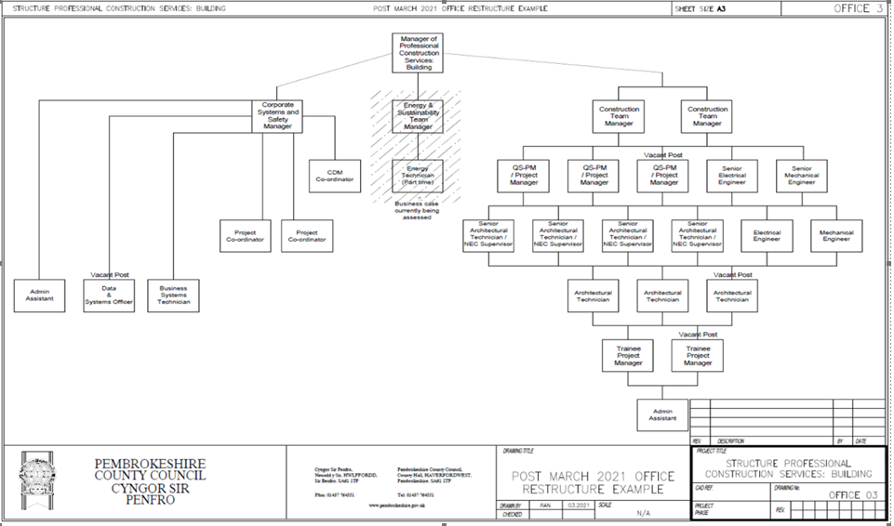

Pembrokeshire County Council Current Office Structure (PCC, 2021)
As part of the re-structure, the team in itself grew in size & obtained more support where necessary. As well as the expansion of the team, the team also upskilled in various areas due to experienced personnel coming on board as well as focusing on internal training as a whole. The McKinsey 7-S framework model was used to assess whether Pembrokeshire County Councils internal factors were supportive of one another, through this process of growth. Upon analysing the 7 internal factors which support the McKinsey 7-S Framework, it was realised that more personnel & an adaptation of the current structure was required in order to manage the workload / new portfolios. By making this change it would enable the team to successfully deliver these projects, adhering to the timescales & budgets. The model also identified that there were opportunities for staff lower down in the hierarchy to upskill and progress into the roles above. This would be done through a process of upskilling the workforce via aspects such as professional development which would lead to more responsibilities / promotion. The third aspect which was determined through the McKinsey 7-S Framework was that new staff starting / newer members to the team were unaware of the governance and processes required at different stages of the project. Internal development was created to make sure that all members of the team were up to speed with the internal governance which was required at each stage of the project & any sign offs that required achieving were understood.
As an overview, this management model worked well in regards to re-structuring the team in order to facilitate & achieve the pressures of completing certain projects on time & on budget. There are various other management models which could have potentially been utilised to aid in this process however, a different management model may have resulted in a different outcome. Making a change was the main priority for our department as change was required in order to facilitate and cope with the pressures. Another management theory that could have been utilised to aid the process is Kotters change management theory. This theory puts emphasis on the importance as to why an organisation has decided to change. There are 8 steps within this management model which are all required to properly implement & attain an end result, these eight steps comprise of;
- Increase urgency
- Recruit guiding team
- Develop the vision
- Communicate
- Empower action
- Develop quick wins
- Build on the change
- Make it stick
Although this model could have potentially been utilised, the downfall to this model is that there is no feedback asked of the employees (Team I. E., 10 Types of Management Models for Professionals, 2022). This prevents the employees having an input which was crucial within our department as they were the ones who were dealing with the problem first hand & had a good understanding as to where more staff were required i.e what disciplines were required. By allowing the staff to have an input, it resulted in the team growing but in such way that was required. The growth of the team also created more opportunities for existing team members which enabled an element of competition. Professional development was also factored in & there are many opportunities for staff within the team to develop professionally in a range of different areas. The professional development element is also in place to enable staff to get a better understanding of different disciplines and upskill in areas which may be foreseen to be out of their remit of work.

Section Word Count: 2,009

4.0 TEAMWORK
Within the construction industry, collaboration is essential at all intervals and stages of a project. As an individual who is to peruse a career in construction, it is vital that my teamwork skills are to the highest of my capabilities. I have ascertained a vast amount of knowledge in my 3 years’ experience within the construction industry, with numerous examples of where teamwork was implemented. In regards to personal teamwork experiences, there have been various occasions where teamwork has resulted in decisions, but these decisions have been derived at through teamwork models and theories. Listed below are scenarios where teamwork has been implemented at different stages of construction from my experience in which models and theories have been implemented to achieve a resolution.

Production of Tender Documentation
As a Quantity Surveyor, the tender and procurement process are vital. This process requires input from a multi-disciplinary team therefore collaboration and teamwork are vital. One scheme in particular where teamwork was vital was on a regeneration scheme where there were various elements of risk associated with the project; it was vital for the most suitable & viable procurement method to be selected to minimize the financial implications it could have on the client. As this task involved a multi-disciplinary team getting together to discuss the viability of certain procurement routes, it was vital that the team formed incorporated all relevant personnel who would be foreseen to be able to assess the procurement strategy for the scheme.
A brainstorming exercise then commenced which created some elements of disagreement / conflict. The team then began to resolve the differences in opinions and appreciate one another’s ideas & proposals for a procurement strategy were taken forward. The team then performed throughout the production of tender documentation, where it was chosen a two-stage procurement method would be adopted and the design risk would be pushed back to the contractor. This way forward utilized the Bruce Tuckman’s Team Development Model (Tuckman, 2022). Below is a table which is a summary of the theory & rationale behind where my teamwork example utilised the theory:

Stages of Theory | Example of where this stage was utilised within the decision of a procurement strategy
Forming – The team nominate a leader & form a team around that individual | This aspect was achieved when the issue first arose, and the procurement strategy was identified that it requires clarification. A team was formed which consisted of various disciplines as it was vital the views came from numerous construction related disciplines to get varied options which would be vital in assessing the way forward.
Storming – This stage is when ideas are put to paper; can be difficult as conflicts / disputes can occur. | This stage occurred after the team had been created & ideas were being put around the table. The different procurement strategies were listed, which were in comparison against the risk register for the project. The main two categories of the procurement route were either single stage or two-stage.
Norming – If this stage is achieved within the theory, it is often a sign that a resolution has been achieved. | A resolution of utilising the two-stage design and build procurement route concluded this stage. All parties were in agreement at this stage that a two-stage design and build approach would be the most viable, and the design risk element could be pushed back to the contractor.
Performing – The team is now working together & fully engaged. | The tender documentation was being compiled at this stage, adopting the two-stage design and build route. The team reduced at this point as there wasn’t much design input required from the likes of architects & engineers due to the selected procurement method.
Adjourning – This stage is essentially closure; it is often when the project is now complete. | This stage was reflected upon at the construction stage of the project, where the contractor had produced an adequate design and as the client, we felt the risk was minimised as much as possible and it was concluded that this procurement strategy was the correct chosen solution.

References for Theory: (Tuckman, 2022), (Anon., 2022)

Construction of Modular Units Scheme
One other example of recent teamwork was on a scheme which has recently reached handover stage, the scheme comprised of a modular unit building being constructed on a secondary school. The modular unit consisted of 3 classrooms, of which included one bespoke science lab fit out. On this scheme in particular, there was a principal contractor who was in charged, with various sub-contractors completing specific items as work such as the ground works package. On this project, it was foreseen that certain sub-contractors had different ethics / attitude to work. In particular, the ground works element was complete ahead of programme and from the outset, was identified that they wanted to complete the work as soon as possible and to the best standard. The M&E element however was behind schedule from the first week, it was programmed for the M&E package of work to be complete in 4 weeks but ended up taking 7. From this example, an observation made was Douglas McGregor’s X & Y theory (Mcgregor, 2022). Below is a table detailing the key aspects to the theory:
Theory X | Theory Y
This theory is when the management have a view that their staff / employees aren’t motivated when it comes to work & in fact dislike work. This theory often sees managers constantly supervising / controlling their staff. | This theory is when the management have a more optimistic opinion of their employees. There are often opportunities for employees within this theory and employees have a incentive to do well.

Reference from Theory: (Mcgregor, 2022)
An observation from this project was that the M&E contractors were managed by theory X as their work ethic from the outset wasn’t of a good standard, as a pose to the groundwork contractors who from the outset wanted to impress the principal contractor and viewed the work as opportunity to possibly attain more work in the near future.

Section Word Count (Excluding Tables): 595

Summary
As a summary, professional development and learning is a big part of my career. As an individual who has set aspirations, professional development plays a huge factor in achieving those aspirations. This module has enabled me to attain more professional learning points which will aid in my development going forward, below lists key aspects which I have developed as part of this module;
- Professionalism & Ethics – This module has allowed me to explore the importance of professionalism & ethics within the construction industry. Upon researching the importance of professionalism & ethics, it allowed me to refer this back to a scenario that has occurred within my workplace. The measurement of professionalism and ethics was also explored which enabled me to grasp a good understanding of how to measure my own professionalism & ethics and the areas in which I can improve on.
- Professional Development – This module allowed me to discuss my professional development to date, providing and updating key documents such as my CV & cover letter. A professional development plan was created as part of this section which will be a very useful tool to allow me to achieve both my long and short term goals.
- Leadership – This module allowed me to understand the important of leadership, particularly from the view of a professional. Leadership theories were analysed and discussed, as well as management models.
- Teamwork – Teamwork was discussed as part of the assignment in which my team working experiences to date were listed. Theories that have been learned as part of this module were also analysed and referenced.
As a conclusion, a vast amount of knowledge has been attained through this module which will aid in my professional development as a whole.

REFERENCE LIST

Buildings, D. (2022, September ). Ethics in Construction . Retrieved from Ethics in Construction : Ethics in Construction

Council, P. C. (2020). KPI's.

Kopp, C. M. (2023, March 4th). Behavioral Economics . Retrieved from What Is Organizational Behavior (OB), and Why Is It Important?: https://www.investopedia.com/terms/o/organizational-behavior.asp#:~:text=Organizational%20behavior%20is%20the%20study,is%20embedded%20across%20a%20company.

Mcgregor, D. (2022). Mind Tools. Retrieved November 10th, 2022, from https://www.mindtools.com/pages/article/newLDR_74.htm

PCC. (2021). Office Structure .

Team, C. (2022, December 11th). Leadership Styles . Retrieved from CFI: https://corporatefinanceinstitute.com/resources/management/leadership-styles/

Team, I. E. (2022, June 25th). 10 Types of Management Models for Professionals. Indeed .

Team, I. E. (2022, June 25th). Types of Management Models for Professionals . Retrieved from Indeed Career Developtment : https://www.indeed.com/career-advice/career-development/types-of-management-models

Team, I. E. (2023, February 4th). McKinsey 7-S Framework . Retrieved from Indeed Career: https://www.indeed.com/career-advice/career-development/mckinsey-7-s-framework

The Team Building Company . (2022). Retrieved November 8th, 2022, from https://www.teambuilding.co.uk/theory/Forming-Storming-Norming-Performing.html

Tuckman, B. (2022). Culture At Work . Retrieved November 8th, 2022, from https://www.coachingcultureatwork.com/bruce-tuckman-team-development-model/

Tuckman, B. (2022). The Coaching Tools Company. Retrieved November 8th, 2022, from https://www.thecoachingtoolscompany.com/get-your-team-performing-beautifully-with-this-powerful-group-development-model/

Tuckman, B. (2022). The Team Building Company . Retrieved November 8th, 2022, from https://www.teambuilding.co.uk/theory/Forming-Storming-Norming-Performing.html

