Assignment 1: E-Portfolio

Changemakers: Creativity and Value Creation
(ACCA5033)

University of Wales Trinity Saint David

Jaromir Pauer (1801641)

30/11/2020

Contents
Unit 1 – Mind Map 3
Unit 2 – Image Based Video Presentation 4
Unit 3 – Video Presentation 5
Unit 4 – Academic Poster 6

Unit 1 – Mind Map

URL: https://sites.google.com/view/jaromirpauer1801641#h.ntdykai7t874

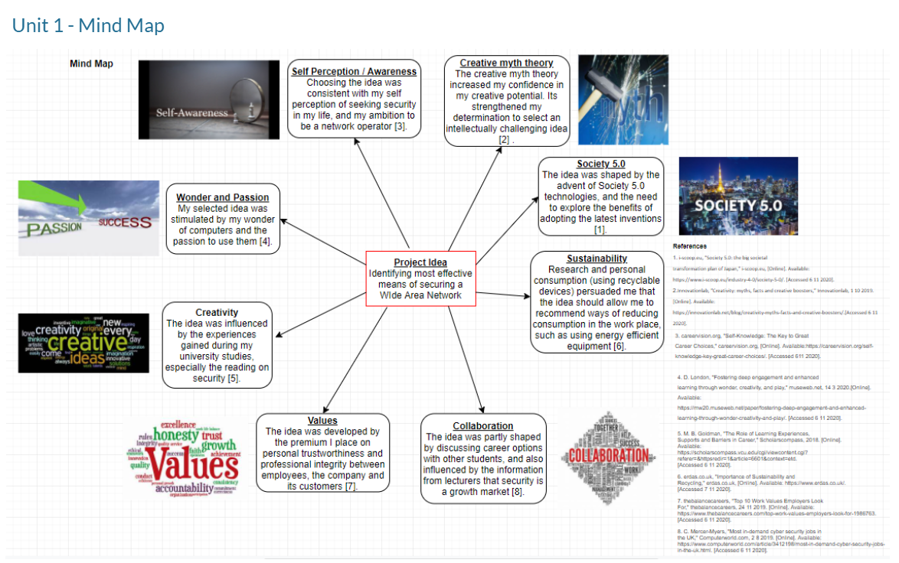

Unit 2 – Image Based Video Presentation

URL: https://sites.google.com/view/jaromirpauer1801641/#h.mopz30q0s68p

URL for video: https://youtu.be/Y8-8go_x8rk

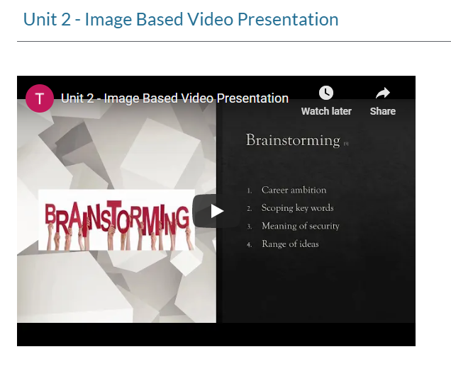

Unit 3 – Video Presentation

URL: https://sites.google.com/view/jaromirpauer1801641/#h.f535kogofggg

URL for video: https://youtu.be/qIowMA9ziDY

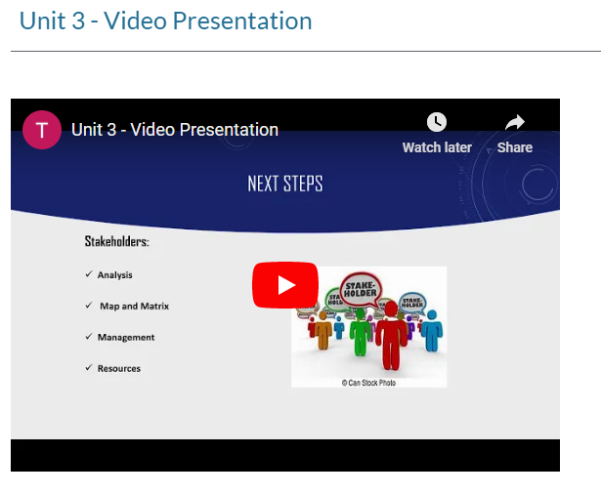

Unit 4 – Academic Poster

URL: https://sites.google.com/view/jaromirpauer1801641/#h.eqg2q2i7tr6v

URL to the poster: https://sites.google.com/view/jaromirpauer1801641/#h.eqg2q2i7tr6v



