
Understanding and Managing Type 2 Diabetes:
A Comprehensive Guide for Patients
Module code: BMHP5023
Module: Introduction to Physiology
Programme: BSc Health and Social Care
Student Name:
Submission Date:

Table of Content
Introduction 2
Blood Sugar Regulation in the Human Body 2
Cellular Energy Production: Glucose and Oxygen Metabolism 4
Importance of Blood Glucose Monitoring in Type 2 Diabetes Management 7
Evidence-Based Lifestyle Recommendations for Type 2 Diabetes 8
Conclusion 11
References 12

Introduction
Diabetes is one of the biggest global health challenges of the 21st century. In 2021, 537 million adults worldwide were afflicted, and by 2030, 643 million. Approximately 90-95% of diabetes is type 2. Insulin resistance and relative insulin insufficiency cause high blood glucose. A metabolic problem that impairs glucose management raises the risk of serious complications such as heart, kidney, eye, and nerve damage (Chatterjee and Clinic, 2025).
There are numerous causes of type 2 diabetes, such as genetics, lifestyle patterns and so on. Obesity, particularly abdominal fat, age, or family history, physical inactivity, and specific ethnic groups are major risk factors. South Asians, African-Caribbean, and Hispanics are more likely to get infected (Bellou et al., 2019). Smoking, heavy alcohol consumption, processed food and refined carb diets, and chronic stress are modifiable risks. Understanding that these factors are crucial to prevention and therapy is crucial.

Blood Sugar Regulation in the Human Body
The pancreas produces hormones that maintain blood sugar at a safe and efficient level, primarily insulin and glucagon. The hormones determine the manner in which the body stores and releases glucose to satisfy its energy needs. The most important processes in maintaining the normal blood glucose are the following:
- Normal Blood Glucose Balance: To maintain normal glucose levels in the body, the normal range of glucose is 4.0 -5.9 mmol/L, low and high glucose levels are harmful as they may damage cells and health in general (Diabetes UK, 2021).
- Role of the Pancreas: The Pancreas controls blood glucose by the action of two hormones: insulin and glucagon, which work in opposite directions to maintain the blood glucose levels constant.
- Insulin Function (After Eating): Blood glucose increases after meals. There is the release of insulin where glucose in the blood is transported to the muscles, fat tissue and liver where it gives energy. It also keeps the surplus glucose in form of glycogen in the liver and muscles and restricts the production of new glucose (Campbell and Newgard, 2021).
- Glucagon Function (During Fasting): As the glucose levels decrease between meals or when an individual is fasting, glucagon is released. This commands the liver to decompose the stored glycogen and to discharge glucose into the blood, which provides a constant flow of energy, and particularly to the brain.
- Problem with Type 2 Diabetes: In type 2 diabetes, the body becomes insulin resistant and produces less insulin hence glucose remains in the blood resulting in high blood sugar levels (Chatterjee and Clinic, 2025).
Table 1: Hormonal Regulation of Blood Glucose Levels (Röder et al., 2020; Campbell and Newgard, 2021)
Hormone | Secreted By | Primary Actions | Effect on Blood Glucose
Insulin | Pancreatic beta cells (Islets of Langerhans) | Promotes glucose uptake by cells; Stimulates glycogenesis; Inhibits gluconeogenesis and glycogenolysis | Decreases blood glucose levels
Glucagon | Pancreatic alpha cells (Islets of Langerhans) | Stimulates glycogenolysis in liver; Promotes gluconeogenesis; Increases lipolysis | Increases blood glucose levels

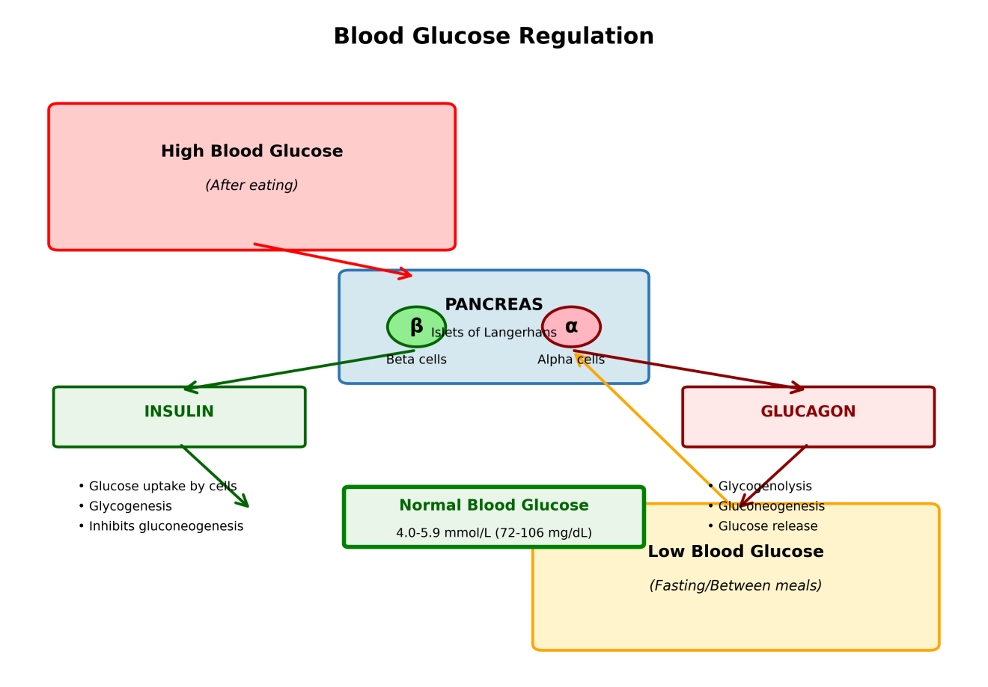
Figure 1: Hormonal Regulation of Blood Glucose Levels showing the opposing actions of insulin and glucagon (Röder et al., 2020; Campbell and Newgard, 2021)

Cellular Energy Production: Glucose and Oxygen Metabolism
Cellular metabolism refers to a collection of all biochemical processes that take place within cells to ensure that life continues and adenosine triphosphate (ATP) is the universal currency of energy (Dunn and Grider, 2023). The primary raw materials required in effective ATP production by cellular respiration are glucose and oxygen, which occur in three separate stages:
Stage 1: Glycolysis
Glycolysis occurs in the cytoplasm and it is the initial stage in the breakdown of glucose. Key points are:
- One molecule (C₆H₁₂O₆) of glucose is divided into two molecules of pyruvate.
- The total output is two ATP molecules and two NADH molecules.
- It is anaerobic and oxygen is not required.
- This is the major energy source in case of low oxygen.
Stage 2: Citric Acid Cycle (Krebs Cycle)
In the presence of oxygen, the pyruvate is transported into the mitochondria and additional oxidation occurs (Martínez-Reyes and Chandel, 2020). The citric acid cycle (Krebs cycle) works in the following way:
- It takes place in the mitochondrial matrix.
- Pyruvate is transformed to acetyl-coenzyme A (acetyl-CoA).
- Carbon dioxide (CO₂) is emitted as a waste product.
- Each acetyl-CoA yields one FADH₂ molecule, one NADH molecule, and one ATP at any point in the cycle.
- Eight enzymatic reactions are involved in the cycle.
Stage 3: Oxidative Phosphorylation
The most energy-generative step of cellular respiration is oxidative phosphorylation that takes place on the inner mitochondrial membrane (Zhao et al., 2024). This stage comprises:
- The electron transport chain that consists of four complexes of proteins (I-IV) that transfer electrons sequentially.
- NADH and FADH₂ electrons are donated to molecular oxygen (O₂) to produce water (H₂O).
- The transportation of protons across the membrane produces an electrochemical gradient.
- ATP synthase utilizes this proton gradient to be used to produce ATP.
- The reaction produces approximately 26-28 ATP molecules.
In general, cellular respiration of one glucose molecule yields approximately 30-32 ATP molecules, which illustrates the high efficiency of aerobic metabolism when compared to anaerobic glycolysis (Berg et al., 2026).
Table 2: Stages of Cellular Respiration and ATP Production (Berg et al., 2026)
Stage | Location | Oxygen Required | Products | ATP Yield
Glycolysis | Cytoplasm | No (Anaerobic) | 2 Pyruvate, 2 NADH, 2 ATP | 2 ATP
Pyruvate Oxidation | Mitochondrial matrix | Yes (Aerobic) | 2 Acetyl-CoA, 2 NADH, 2 CO₂ | 0 ATP
Citric Acid Cycle | Mitochondrial matrix | Yes (Aerobic) | 6 NADH, 2 FADH₂, 2 ATP, 4 CO₂ | 2 ATP
Oxidative Phosphorylation | Inner mitochondrial membrane | Yes (Aerobic) | H₂O, 26-28 ATP | 26-28 ATP
Total | — | — | — | 30-32 ATP per glucose
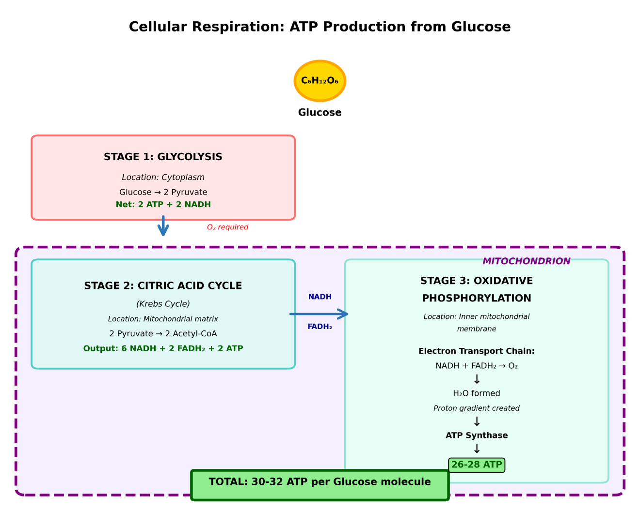
Figure 2: The three stages of cellular respiration showing glucose metabolism and ATP production (Berg et al., 2026)

Importance of Blood Glucose Monitoring in Type 2 Diabetes Management
The monitoring and recording of blood glucose levels are a standard of successful management of Type 2 diabetes. They assist individuals in maintaining their glycaemic control within normal levels and reducing chances of acute and chronic complications (Klonoff et al., 2022).
Benefits of Blood Glucose Monitoring
Self-monitoring of blood glucose (SMBG) has numerous advantages (Freckmann et al., 2021):
- Immediate feedback on the effect of diet, physical activity, medication, stress and disease on blood sugar.
- Enables patients to make effective decisions regarding their care.
- Assists in recognizing patterns, e.g., morning glucose surges or after meals.
- Allows prompt modifications of treatment plans.
- Enhances the level of HbA1c and minimizes the chances of complications.
- It can be used as an educational resource demonstrating the effects of foods and exercise on blood sugar.
Monitoring Technologies
The glucose-monitoring technologies nowadays include:
- Traditional SMBG: finger-prick tests which provide only single readings at intervals.
- Continuous Glucose Monitoring (CGM): gives comprehensive glucose data, night time data and trending.
- Digital health: integrate monitoring data with diabetes-management applications to enhance patient engagement.
The frequency of testing must be individualized, considering the nature of the treatment, the effectiveness of their glucose control, and their susceptibility to hypoglycaemia. Monitoring can only be optimally utilized through proper training in the process of testing and interpreting readings (Klonoff et al., 2022).

Evidence-Based Lifestyle Recommendations for Type 2 Diabetes
The management of Type 2 diabetes is based on lifestyle modification. It has been well-established that holistic interventions including dietary modifications, increased physical activity, weight loss, smoking cessation and stress reduction can enhance glycaemic regulation, reduce cardiovascular risk, and in a few instances even cause remission of the disease (ElSayed et al., 2022).
- Dietary Modifications
Nutritional treatment is crucial for diabetes. Meal habits affect weight, blood sugar, and cardiovascular health. Reviews show that Mediterranean, low-carb, and plant-based diets lower blood sugar and diabetes problems. Mediterranean-style vegetable-fruity and whole-grain-legume-nut-olive-oil diets improve insulin sensitivity and lower heart disease risk. Quality and quantity of carbs matter most to Type 2 diabetics (Chatterjee and Clinic, 2025). Replace refined carbs and sugary foods with complex and low-GI carbs to minimise post-meal sugar rises. You'll feel fuller, absorb less glucose, and have better cholesterol with soluble fibre. Controlling portion size and eating on time stabilises blood sugar levels throughout the day.
- Physical Activity and Exercise
Type 2 diabetes patients benefit from exercise for glycaemic management and cardiovascular fitness. The American Diabetes Association recommends 150 minutes of moderate-intensity aerobic exercise per week (excluding running), such as brisk walking, cycling, or swimming, spread over no more than two days of rest and at least three days of physical activity (American Diabetes Association, 2025). Resistance training two to three times a week builds muscle and improves glucose utilisation. Physical activity affects glucose metabolism short- and long-term. One exercise stimulates muscle GLUT4 receptors, allowing glucose to enter cells without insulin and lower blood sugar. Regular exercise gradually improves insulin sensitivity, visceral fat, blood pressure, and cholesterol, lowering cardiac risk. Even brief, modest exercise whilst sitting improves glycaemic management.
- Weight Management
Weight loss in overweight and obese people is part of type 2 diabetes management. Obesity and belly fat increase insulin resistance and beta cell destruction. Weight loss (5-10%) can enhance blood sugar, hypertension, and cholesterol levels (Wing et al.,2023). Many patients can lose weight and cure their diabetes with radical lifestyle modifications or surgery.
- Smoking Cessation
Smoking is a known risk factor for type 2 diabetes and its consequences, including heart, kidney, and peripheral vascular disease. Nicotine in tobacco products reduces insulin activity, causes inflammation, and worsens endothelial dysfunction (Food and Drug Administration, 2023). Thus, smoking cessation should be encouraged and treated with behaviour counselling and medicines.
- Stress Management and Sleep
Chronic psychological stress and sleep deprivation might worsen glucose regulation by stimulating the HPA axis, raising cortisol, and fostering unhealthy habits. Stress-management strategies like cognitive behavioural therapy, mindfulness, and relaxation can improve mental health and glycaemic results. Vidovszky (2025) suggest that quality sleep (7-9 hours per night) can improve metabolic health and enhance the effectiveness of lifestyle changess.
Table 3: Summary of Lifestyle Recommendations for Type 2 Diabetes Management (American Diabetes Association, 2025; ElSayed et al., 2022)
Lifestyle Factor | Recommendation | Expected Benefits
Diet | Mediterranean diet; Low GI foods; High fibre; Portion control | Improved glycaemic control; Weight reduction; Reduced cardiovascular risk
Physical Activity | ≥150 min/week moderate-intensity aerobic exercise; Resistance training 2-3 times/week | Enhanced insulin sensitivity; Better glucose control; Increased muscle mass; Cardiovascular fitness
Weight Management | 5-10% weight loss for overweight/obese individuals | Improved glycaemic control; Reduced blood pressure; Better lipid profile; Potential disease remission
Smoking Cessation | Complete cessation with behavioural and pharmacological support | Reduced complications; Improved insulin sensitivity; Lower cardiovascular risk
Stress/Sleep | Stress management techniques; 7-9 hours sleep per night | Better glycaemic control; Improved well-being; Enhanced treatment adherence

Conclusion
Metabolic syndrome type 2 diabetes is complex, Insulin resistance and beta-cell degeneration characterise it. Long-term high blood sugar and severe consequences result from these alterations. Understanding the condition and why different therapies are used requires understanding how the body maintains blood glucose and how cells use energy. Cellular respiration requires glucose and oxygen to generate ATP in the body. Insulin and glucagon maintain the level of glucose in the blood which is important to the general health.
Type 2 diabetics can be self-proactive and check their blood glucose levels on a regular basis. Frequent observation assists them to make sound decisions and change treatments promptly. New CGM and SMBG devices offer specific sugar patterns which help in individualized care. Treatment of type 2 diabetes includes lifestyle modification and drugs. Evidence-based lifestyle might help: consume nutrient-dense, low-glycemic index foods; engage in regular physical activity, including aerobic and resistance exercises; have a normal weight; stop smoking; and eliminate stress. These modifications always improve blood sugar control, cardiovascular risk, and quality of life. Maintaining such routines may even cure most people. Thus, physicians should educate and support patients to adopt and maintain these healthy habits to help them manage their health and get the best diabetes results.

References
American Diabetes Association (2025). Standards of care in diabetes. [online] professional.diabetes.org. Available at: https://professional.diabetes.org/standards-of-care.
Bellou, V., Belbasis, L., Konstantinidis, A.K. and Evangelou, E. (2019). Elucidating the risk factors for chronic obstructive pulmonary disease: an umbrella review of meta-analyses. The International Journal of Tuberculosis and Lung Disease, 23(1), pp.58–66. doi:https://doi.org/10.5588/ijtld.18.0228.
Berg, J., Tymoczko, J., Gatto, G. and Stryer, L. (2026). Biochemistry. [online] Available at: https://dn790008.ca.archive.org/0/items/JeremyM.BergJohnL.TymoczkoGregoryJ.GattoJr.LubertStryerBiochemistry_201708/Jeremy%20M.%20Berg%2C%20John%20L.%20Tymoczko%2C%20Gregory%20J.%20Gatto%20Jr.%2C%20Lubert%20Stryer%20Biochemistry.pdf.
Campbell, J.E. and Newgard, C.B. (2021). Mechanisms controlling pancreatic islet cell function in insulin secretion. Nature Reviews Molecular Cell Biology, [online] 22(2), pp.142–158. doi:https://doi.org/10.1038/s41580-020-00317-7.
Chatterjee, S. and Clinic, M. (2025). Type 2 diabetes. [online] Mayo Clinic. Available at: https://www.mayoclinic.org/diseases-conditions/type-2-diabetes/symptoms-causes/syc-20351193.
Diabetes UK (2021). Evidence-based nutrition guidelines for the prevention and management of diabetes. [online] Diabetes UK. Available at: https://www.diabetes.org.uk/for-professionals/improving-care/clinical-recommendations-for-professionals/food-nutrition-lifestyle/evidence-based-nutrition-guidelines-for-the-prevention-and-management-of-diabetes.
Dunn, J. and Grider, M.H. (2023). Physiology, adenosine triphosphate. [online] PubMed. Available at: https://www.ncbi.nlm.nih.gov/books/NBK553175/.
ElSayed, N.A., Aleppo, G., Aroda, V.R., Bannuru, R.R., Brown, F.M., Bruemmer, D., Collins, B.S., Hilliard, M.E., Isaacs, D., Johnson, E.L., Kahan, S., Khunti, K., Leon, J., Lyons, S.K., Perry, M.L. and Prahalad, P. (2022). Facilitating positive health behaviors and well-being to improve health outcomes: Standards of care in diabetes—2023. Diabetes Care, [online] 46(Supplement_1), pp.S68–S96. doi:https://doi.org/10.2337/dc23-s005.
Food and Drug Administration (2023). How Smoking Can Increase Risk for and Affect Diabetes. FDA. [online] Available at: https://www.fda.gov/tobacco-products/health-effects-tobacco-use/how-smoking-can-increase-risk-and-affect-diabetes.
Freckmann, G., Pleus, S., Grady, M., Setford, S. and Levy, B. (2021). Measures of Accuracy for Continuous Glucose Monitoring and Blood Glucose Monitoring Devices. Journal of Diabetes Science and Technology, 13(3), pp.575–583. doi:https://doi.org/10.1177/1932296818812062.
Klonoff, D.C., Wang, J., Rodbard, D., Al-Sofiani, M.E., Blevins, T., Breton, M.D., Castle, J.R., Wake, D., Waki, K., Weinberg, M.E., Wolpert, H., Wright, E.E. and Kovatchev, B. (2022). A Glycemia Risk Index (GRI) of Hypoglycemia and Hyperglycemia for Continuous Glucose Monitoring Validated by Clinician Ratings. Journal of Diabetes Science and Technology, 17(5), p.193229682210852-193229682210852. doi:https://doi.org/10.1177/19322968221085273.
Martínez-Reyes, I. and Chandel, N.S. (2020). Mitochondrial TCA cycle metabolites control physiology and disease. Nature Communications, 11(1), pp.1–11.
Röder, P.V., Wu, B., Liu, Y. and Han, W. (2020). Pancreatic Regulation of Glucose Homeostasis. Experimental & Molecular Medicine, [online] 48(3), pp.1–19. doi:https://doi.org/10.1038/emm.2016.6.
Tonga, E., Worboys, H., Evans, R.A., Singh, S.J., Davies, M.J., Andre Ng, G. and Yates, T. (2025). Physical activity guidelines for adults with type 2 Diabetes: Systematic review. Diabetes Research and Clinical Practice, 220, p.111982. doi:https://doi.org/10.1016/j.diabres.2024.111982.
Vidovszky, A. (2025). Stress and Diabetes: How To Manage. [online] DiaTribe. Available at: https://diatribe.org/lifestyle/stress-and-diabetes-how-manage.
Zhao, R., Jiang, S., Zhang, L. and Yu, Z. (2024). Mitochondrial electron transport chain, ROS generation and uncoupling (Review). International Journal of Molecular Medicine, 44(1), pp.3–15. doi:https://doi.org/10.3892/ijmm.2019.4188.

