University of Wales Trinity St David

Wales Institute of Science & Art



Analytical Assessment of Engine Internal Components

Contemporary Powertrain Design (ACHA6006)

Hugo Upsall

2205193

March 2025

Table of Contents
Introduction 1
RPM range extension 2
Piston acceleration 3
Inertia force 3
Gas force 4
Net force 4
Midpoint of conrod 6
FSF value 6
Gudgeon pin 8
Bending, shear, and resultant stress 8
FSF value 9
Conrod bolt 10
FSF value 10
Bolt redesign 11
Instantaneous torques 13
Inertia torque 13
Gas torque 13
Total crank torque 14
Conclusion 15
References 16

Introduction
This paper will outline calculations performed using pressure data and kinematics equations to determine current forces experienced by components within the Ford 1.6 Sigma engine. Specifically, the midpoint of the conrod, conrod bolts, and gudgeon pin will be analysed. A MATLAB script was written to calculate stresses, fatigue safety factors, and torques from these forces for the relevant components. Through interpolation, maximum revolutions per minute (RPM) of the engine were increased from 6000rpm to 9000rpm, with these new forces then calculated and compared.

The role of the conrod is to connect the crankshaft with the piston, transferring the latter’s reciprocating motion into a rotational one. As such, it experiences high levels of recurring tensile and compressive forces. The gudgeon pin secures the piston to the top of the conrod itself and so experiences very similar forces. However, since the conrod bolts fasten the conrod cap onto the main body, fastening around the crankshaft, they experience no compressive gas forces. Instead, these are subject to constant rotational forces, also known as whip.

Due to the extreme levels of stresses these components are subject to continually, ensuring satisfactory fatigue safety factor levels is essential to prevent premature failure. Their location within the engine assembly means that failure of any of these would lead to catastrophic engine damage, rendering the engine inoperable. This further resonates the significance of correctly calculating fatigue safety values under operating conditions to avoid this.

Once calculations for the extended engine speed were carried out, alterations to the components were made to increase their new fatigue safety factor values and return them to a value closer to those they started with under the original engine conditions.

RPM range extension
For the purposes of this assignment, maximum engine speed for the Ford 1.6 Sigma engine was increased from 6000rpm to 9000rpm through interpolation of known pressure data. This increase can have many benefits on an IC (internal combustion) engine, one of which is a reduction in total NOx produced. This generally reduces as engine speed increases, as outlined by Radhouane et al. They found that when using an E0 fuel mixture, consisting of pure gasoline, NOx ppm (parts per million) was approximately 1.42 when engine speed was 2250rpm, whereas this reduced to 1.32ppm at 3250rpm (Radhouane, et al., 2023). When using an E10 fuel mixture (90% gasoline, 10% ethanol) NOx was measured at 1.32ppm and 1.30ppm respectively at the same engine speeds. This clearly demonstrates a downward trend in NOx when RPM increased, which is partially due to increased combustion temperatures at higher engine speeds, the latter results of which doing so while using a fuel which is likely to be more commonly adopted in a Ford 1.6 Sigma engine.

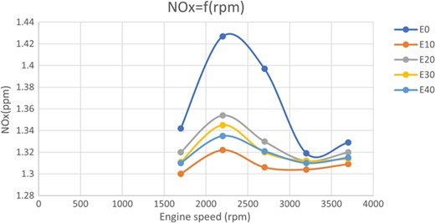
Figure 1 – (Radhouane, et al., 2023)
An increase in engine speed can also lead to improved overall performance, particularly in power output. This occurs since power is the product of torque and angular velocity, and angular velocity is proportional to engine speed. Therefore, when you increase engine speed, power output is naturally also increased. However, this impacts on other factors such as friction and stresses within the engine assembly. Increasing engine speed increases the frequency at which components interact with each other, causing greater friction and heightening stress placed on components.

As such, new fatigue safety factor values were calculated for the interpolated engine pressure data. These were necessary to establish the extent to which the stresses endured by the conrod, gudgeon pin, and conrod bolts had changed, and what this meant for component life. To calculate these values, the following variables and forces had to be determined.

Piston acceleration
Piston acceleration was calculated using the following formula, Equation 1, which determines this throughout the crank angle and RPM ranges, as demonstrated in Figure 2.

$a =Rω^{2}cosθ+\frac{R^{2}}{L}ω^{2}cos2θ$
Equation 1
This is necessary to establish inertial forces acting on the conrod, conrod bolts, and gudgeon pin, as higher acceleration results in greater stress being placed on these components.

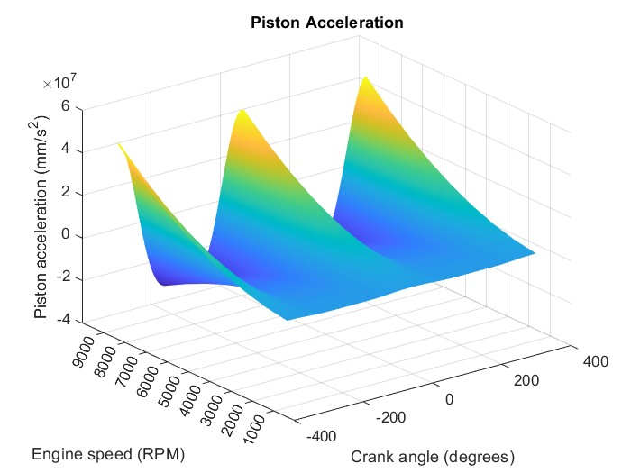
Figure 2 – calculated piston acceleration
As can be seen above, acceleration is significantly greater at 9000rpm than at 6000rpm, justifying the requirement for investigating safety factor values and the redesign of componentry.

Inertia force
In Figure 3, inertia force, which was calculated using the formulas in Equation 2 and 3, can be observed.
$$m_{rec}= {Mass}_{piston}+ {Mass}_{pin}+{Mass}_{rings}+\left(\frac{{Mass}_{rod}}{3}\right)$$
Equation 2
$$F_{inertia}= m_{rec} ×\left(Rω^{2}cosθ+ \frac{R^{2}}{L}ω^{2}cos2θ\right)$$
Equation 3
As would be expected, this increases with RPM and peaks occur at near top dead centre (TDC) and bottom dead centre (BDC). It is important to note that this graph maintains identical appearance to plotted piston acceleration, since inertia force is essentially acceleration scaled by mass.
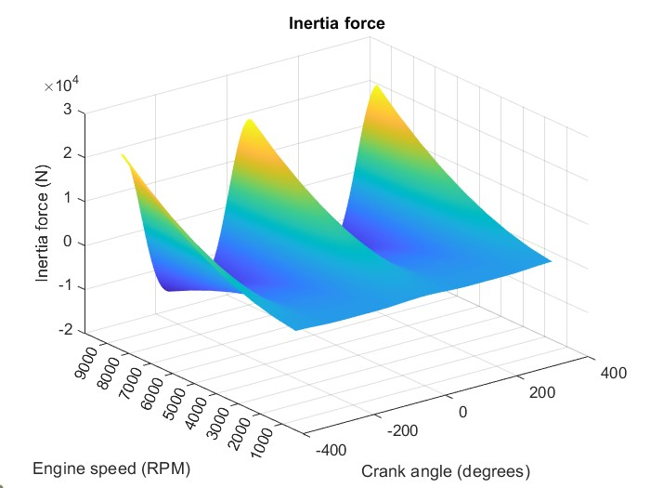
Figure 3 – calculated inertia force

Gas force
Gas force was calculated using the formula in Equation 4 and represents gas pressure acting on the piston.
$$F_{gas}= P_{cyl} ×area$$
Equation 4
Peak force is exerted near TDC where combustion occurs, with levels gradually increasing with RPM until approximately 4000rpm. By this point the increased engine speed begins to impact on things such as air-fuel mixture burn duration and valve overlap, meaning exhaust gases may begin to exit too quickly. A combination of these, and other influences, lead to a decrease in gas force.

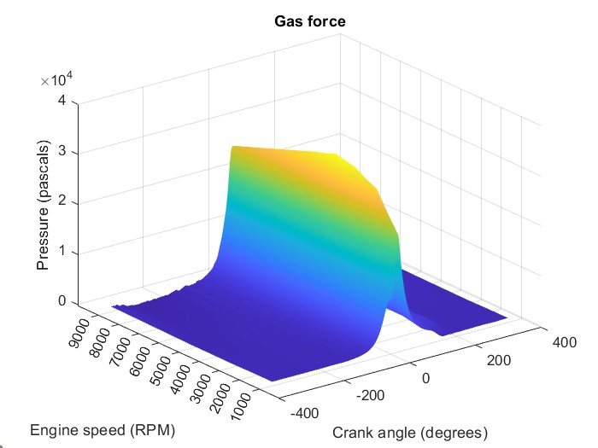  Figure 4 – calculated gas force | 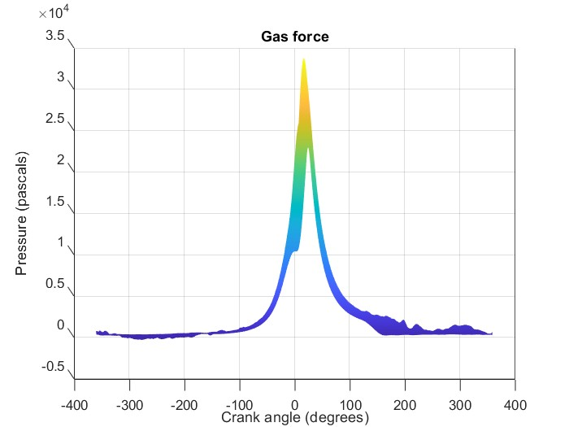  Figure 5 – calculated gas force

Net force
Net force is calculated using the formula in Equation 5. In Figure 6, overall force has greater resemblance to gas force at lower RPMs, whereas at higher RPMs inertia force plays a larger role simply due to components moving at a faster rate.
$$F_{net}= F_{inertia}-F_{gas}$$
Equation 5

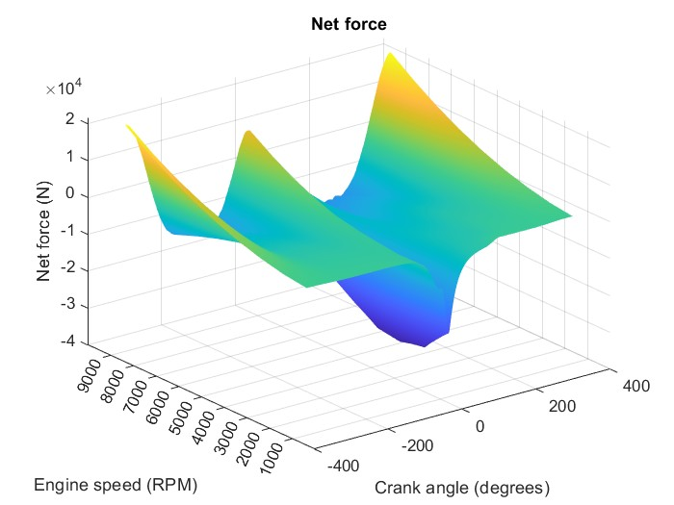
Figure 6 – calculated net force

Midpoint of conrod
Since fatigue safety factor (FSF) values are to be calculated using the absolute maximum and minimum stress values, as Jelaska mentions, a singular value is produced (Jelaska, n.d.). This is to provide a value for the absolute worst-case scenario on the basis that if the component can withstand such forces, i.e. has a FSF value above 1, it will cope sufficiently with all other loadings as they will not be so extreme.

Table 1 presents the FSF value using the original engine pressure data under standard operating conditions, and when this was interpolated to 9000rpm, as well as relating values used to calculate this value.

6000rpm |  |  | 9000rpm
Max stress: | 67.09 | MPa | Max stress: | 155.31 | MPa
Min stress: | -220.42 | MPa | Min stress: | -220.42 | MPa
Mean stress: | -76.67 | MPa | Mean stress: | -32.55 | MPa
Stress range: | 287.51 | MPa | Stress range: | 375.74 | MPa
FSF value: | 2.59 |  | FSF value: | 1.87
Table 1 – data from midpoint of conrod calculations

In Table 1, minimum stress does not change between the two conditions. This is likely due to the fact gas force, seen in Figure 4, does not increase beyond approximately 4000rpm. As a result, maximum compressive stress has already reached its peak here, where maximum gas pressured from combustion is experienced, and so this same value is shared across both conditions.

On the other hand, maximum stress (tensile stress) increases by 131.50% from 6000rpm to 9000rpm. This is most likely to be due to increased inertia force experienced when increasing engine speed, as inertia is proportional to RPM, which can be seen in Figure 3. Thus, when RPM increases, inertia force increases, creating higher tensile stress when the piston is being pulled back towards BDC during the intake stroke.

This increase in maximum stress values between the two conditions then creates the difference in mean stress. These observations are more easily observable in Figures 7 and 8, displaying the Goodman diagrams for each engine condition. It is important to note that throughout this report, as mentioned before, values calculated for 6000rpm and 9000rpm are not exclusive to that specific RPM data point. Instead, FSF was calculated using the absolute minimum and maximum values throughout that entire engine condition. For example, at 6000rpm this is determined from the original pressure data, and at 9000rpm this is determined from the interpolated data.

FSF value
In general, any FSF value below 1 is deemed unacceptable and considered to have a finite life (Grolier, 2000). The larger the value, the longer its lifecycle is predicted to be when exposed to the respective stresses, with anything above 1 being regarded as having infinite life.

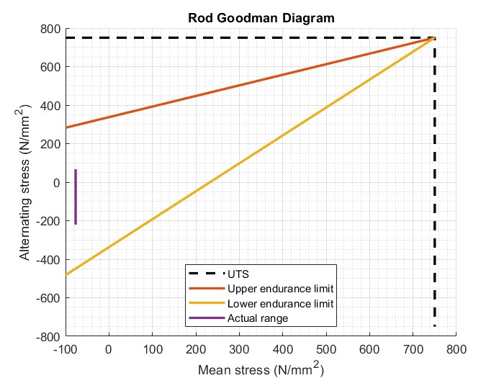  Figure 7 – Goodman diagram at 6000rpm | 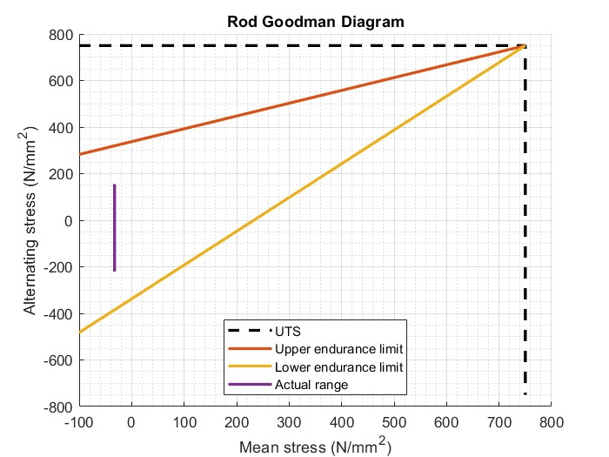  Figure 8 – Goodman diagram at 9000rpm
However, when designing engine components, certain over-engineering levels are commonly adopted to ensure failure is not reached. For example, when Zheng et al. conducted a study establishing fatigue of a conrod they calculated a FSF of 1.584, and after some alterations were made this increased by 59% to 2.519 (Zheng, et al., 2013). Further to this, Frătița et al. had a similar discovery when they performed a finite element analysis (FEA) on a conrod and calculated a FSF value of 1.65 (Frătița, et al., 2019). In a different case, Zhu et al. performed a similar analysis on a crankshaft of a diesel marine engine, which came out to a value of 2.209 (Zhu, et al., 2022).

As a result, it is made clear that certain over-engineering levels are achieved to further guarantee the safety and life of a component. Specifically, for conrods, an acceptable level would seem to include FSF values of 1.5-3.

Ultimately, FSF values are based on levels of alternating stress. As a result, when engine speed increased to 9000rpm a lower FSF value of 1.87 is achieved, compared to 2.59 calculated at 6000rpm. This is a direct result of there being a 30.69% increase in stress range at 9000rpm due to the increased maximum stress value compared to 6000rpm, which can be observed in Table 1 and Figure 8. Despite the FSF value being lower at 9000rpm, it is still well within limits to be deemed satisfactory and to be considered to have an infinite lifecycle, providing load conditions do not exceed those used in these calculations. As a result, the existing conrod would be able to operate as intended if engine speeds were increased without sacrificing integrity.

Gudgeon pin
Table 2 presents an FSF value and relating values for each engine condition, including under standard conditions and when data was interpolated to 9000rpm. Since the gudgeon pin connects the piston to the conrod and transfers compressive and tensile stresses to and from these, similarities in calculated results and trends can be seen between the two.

6000rpm |  |  | 9000rpm
Max stress: | 64.34 | MPa | Max stress: | 148.58 | MPa
Min stress: | -188.40 | MPa | Min stress: | -188.40 | MPa
Mean stress: | -62.03 | MPa | Mean stress: | -19.91 | MPa
Stress range: | 252.74 | MPa | Stress range: | 336.98 | MPa
FSF value: | 3.78 |  | FSF value: | 2.72
Table 2 – data from gudgeon pin calculations

In the table above, minimum stress does not change for the same reasoning as with the midpoint of conrod, due to maximum gas force being reached around 4000rpm.

However, a significant increase of 130.93% is seen in maximum stress from 6000rpm to 9000rpm. Again, this is due to maximum stress being predominantly affected by inertia forces, which increase proportionately with RPM. As a result, when inertia force increases as seen in Figure 3, so does maximum stress.

The difference in maximum values between the engine conditions determine different mean values, which are better visualised in Figures 9 and 10.

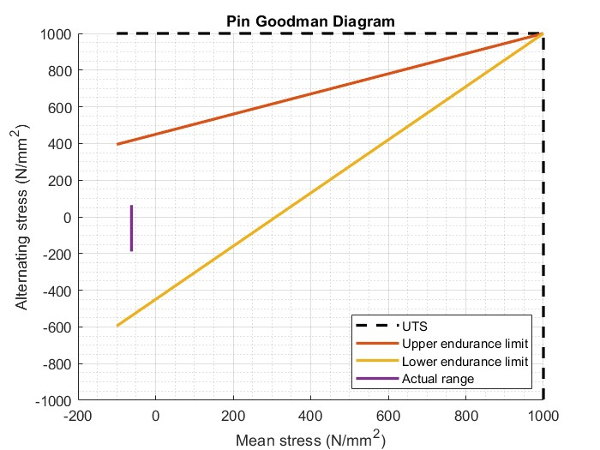  Figure 9 – Goodman diagram at 6000rpm | 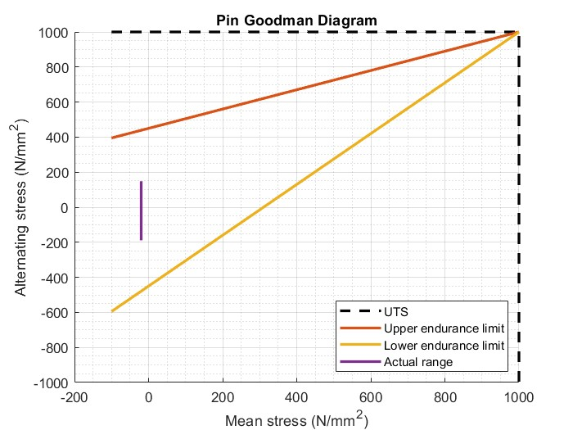  Figure 10 – Goodman diagram at 9000rpm

Bending, shear, and resultant stress
The values represented in Table 2 and Figures 9 and 10 are also shown in Figure 11 and 12, which better visualise the individual forces acting on the pin through the crank angle range. In these graphs the increase in resultant stress is made very obvious when engine speed increases, as well as fluctuations in the lines which can be indicative of higher fatigue risk.
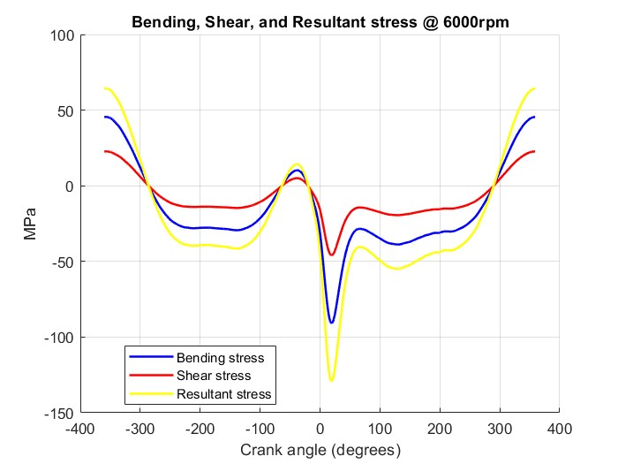  Figure 11 – pin stress at 6000rpm | 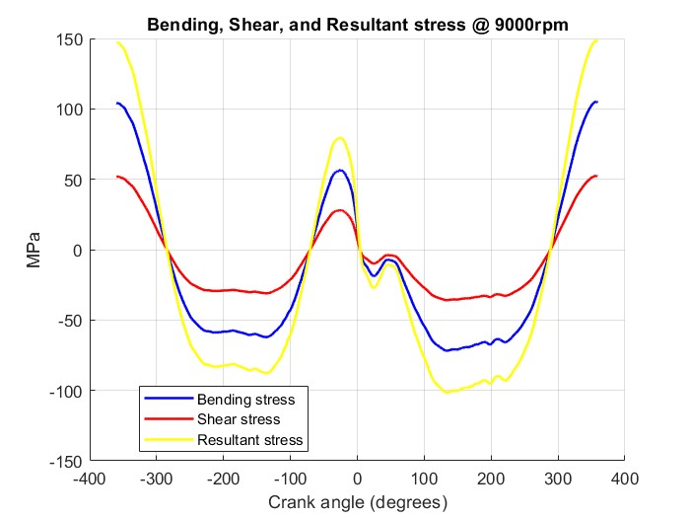  Figure 12 – pin stresses at 9000rpm

FSF value
As Kamble et al. explain, gudgeon pins are often over-engineered to provide a higher FSF value to ensure they do not fail due to its critical role in the engine assembly, as they experience extreme levels of stress for a comparatively small component (Kamble, et al., 2018).

At 6000rpm the calculated FSF was 3.78, and at 9000rpm 2.72. This difference is due to the increased maximum stress at greater engine speed creating a larger alternating stress factor and range, 33.33% larger than that at 6000rpm. The calculated mean stress is greatly influenced by this also; hence it moved towards 0 N/mm² in Figure 10 due to the larger maximum stress.

Despite a lower FSF value at 9000rpm, even at this engine speed the existing gudgeon pin is still greatly over-engineered to withstand the increased forces.

Conrod bolt
6000rpm |  |  | 9000rpm
Max stress: | 735.36 | MPa | Max stress: | 750.16 | MPa
Min stress: | 723.52 | MPa | Min stress: | 723.52 | MPa
Mean stress: | 729.44 | MPa | Mean stress: | 736.84 | MPa
Stress range: | 11.84 | MPa | Stress range: | 26.63 | MPa
FSF value: | 6.85 |  | FSF value: | 3.04
Table 3 – data from conrod bolt calculations

Like the two previous components analysed, minimum stress remains unchanged when engine speed increased. In this case, this is due to the preload the bolt is placed under when it is first installed. As a result, it constantly has a tensile force acting upon it, as this preload is unaffected by engine speed.

However, maximum stress changes between the two conditions due to inertia force and rod whip being greater at faster engine speed. Rod whip is exaggerated on the big end bearings, where the conrod bolts are located, as it is here which experiences the greatest level of oscillatory and lateral motion from the conrod. This causes increased lateral movement and subsequent tensile stress being placed on the conrod bolts. Since rod whip also increases with inertia force, the greater the engine speed the more extreme the effects will be. Hence, when engine speed increased to 9000rpm, maximum stress increases by 2.01%. This increase seems negligible, but it has a significant impact on FSF value as in Table 3.

FSF value
In this instance, stress concentration factor was calculated and including when working out the factor of safety value. This is incredibly important to include on components which undergo cyclic loading and high-stress fluctuations, such as the conrod bolts. Failure to do so could underestimate actual stress values, and overestimate FSF value. This factor was calculated using equations from Roark’s Formulas for Stress and Strain, when taking a thread to be considered similar to a ‘U-shaped notch’ (Young & Budynas, 2002).

Due to the stress range, or alternating stress, increasing by 125% when maximum engine speed raised, FSF value decreases by 125% since FSF value is inversely proportional to range. This increased range can be seen in Figures 15 and 16. Despite only having a value of 3.04 at 9000rpm, this is still well above the value of 1 which is generally taken to consider a component to have an infinite life.

Furthermore, ARP Bolts, an industry-leading fastener manufacturer, claim for their bolts to have a minimum FSF of 2 (AUTOMOTIVE RACING PRODUCTS, n.d.). This further validates that despite the greater engine speed, the current bolt design can withstand the increased loads.
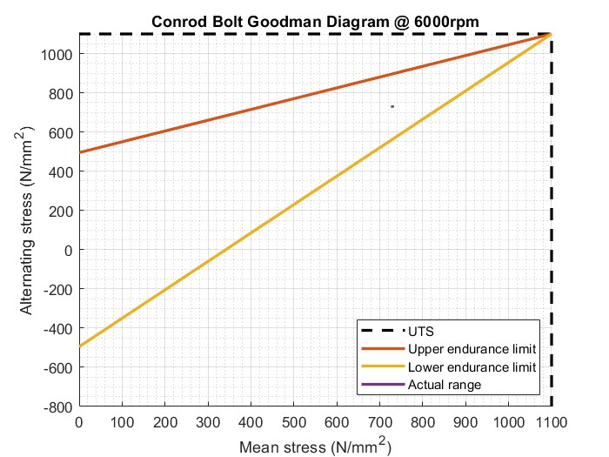  Figure 13 – Goodman diagram at 6000rpm | 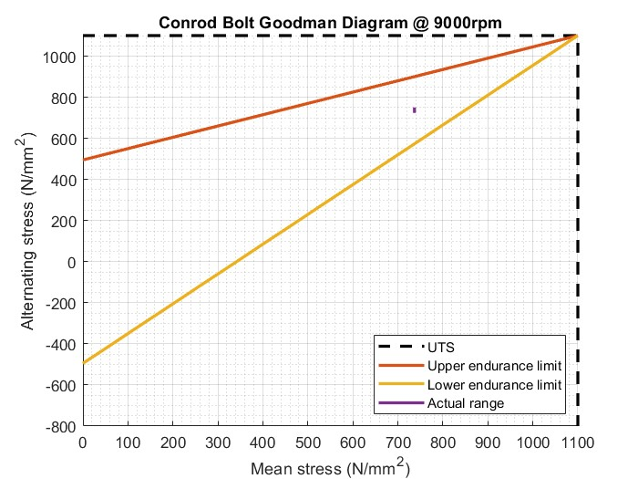  Figure 14 – Goodman diagram at 6000rpm
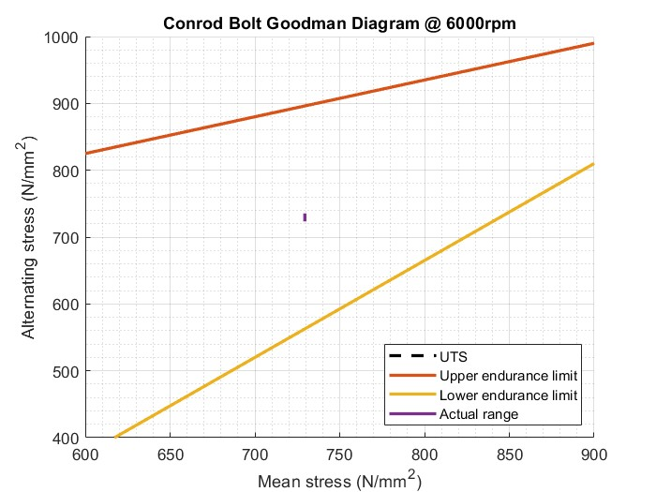  Figure 15 – focused Goodman diagram at 6000rpm | 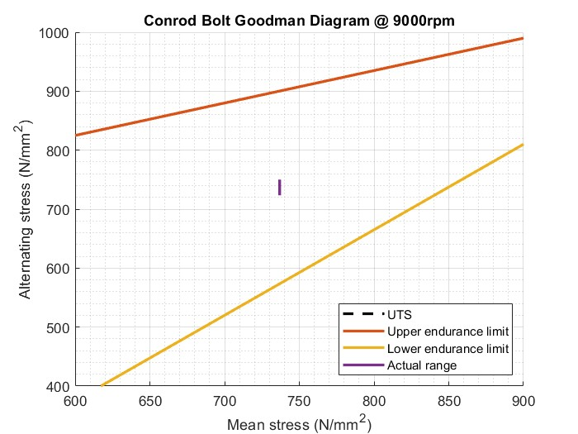  Figure 16 – focused Goodman diagram at 9000rpm

Bolt redesign
To increase the FSF value at 9000rpm, a titanium alloy was used.

 | Yield strength (MPa) | Ultimate tensile strength (MPa) | Young’s Modulus of Elasticity (MPa)
Titanium alloy (Ti-6Al-4V | 1100 | 1200 | 110000
Table 4

This material was chosen due to already being used for this purpose in industry due to its higher fatigue strength over alternatives. Table 5 shows the new FSF value.

9000rpm
Max stress: | 819.22 | MPa
Min stress: | 803.92 | MPa
Mean stress: | 811.57 | MPa
Stress range: | 15.31 | MPa
FSF value: | 5.66
Table 5
As can be seen in Table 5, the FSF value using this titanium alloy, of 5.66, has significantly increased compared to the original material and is much closer to the original value at 6000rpm of 6.85. Due to the change of properties, the stress range has reduced, which can more easily be seen in Figures 17 and 18.

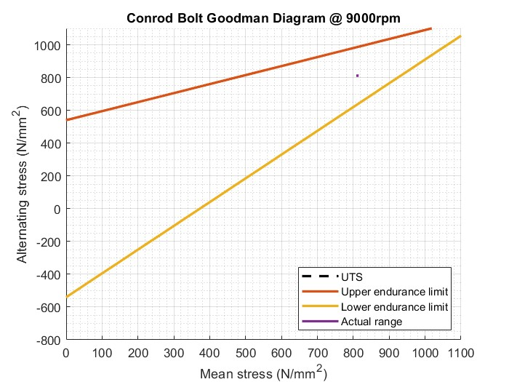  Figure 17 – Goodman diagram using titanium alloy | 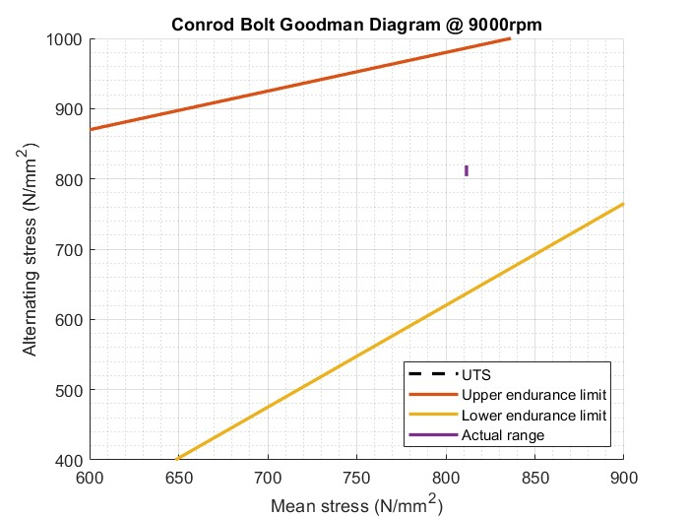  Figure 18 – focused Goodman diagram using titanium alloy

Instantaneous torques
Through realigning data, torques could be calculated for flat-plane (standard) and cross-plane crankshaft layouts, which have been discussed below.

Inertia torque
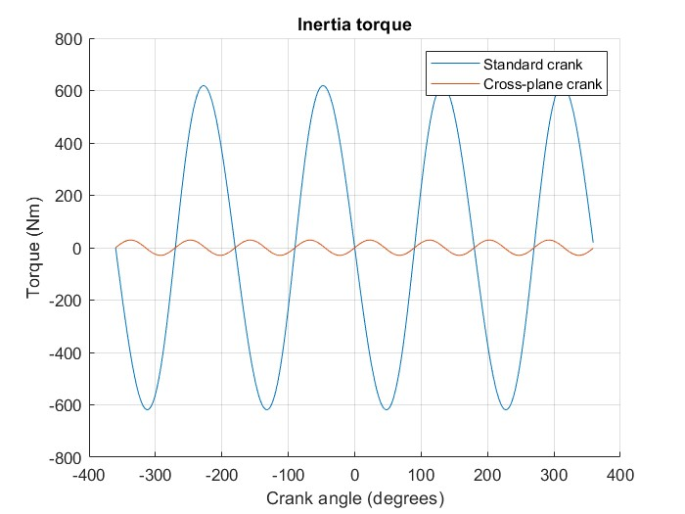
Figure 19 – cross-plane provides a smoother delivery with reduces torque fluctuations, enhancing driveability
Since cross-plane crankshafts naturally counteract imbalances, they provide fewer vibrations when compared to flat-plane, and so do not require external balancing. Cross-plane would be more suited for street applications.

Gas torque
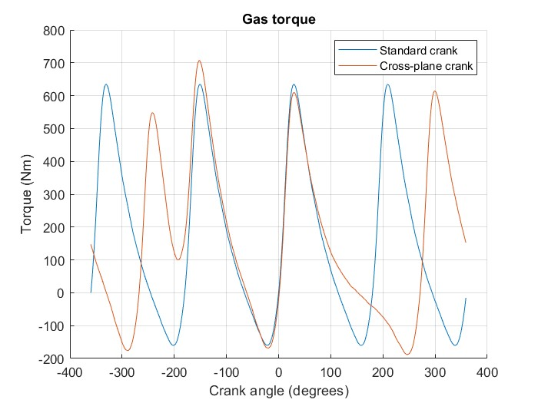
Figure 20 – flat-plane provides evenly-spaced combustion, enhancing high-RPM performance
The cross-plane’s uneven firing sequence gives smoother low-RPM performance through preventing large dips in torque, ideal for vehicles where easily-accessible torque is desired.

Total crank torque
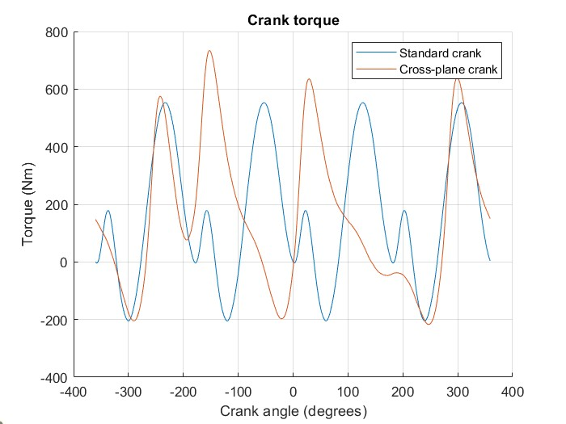
Figure 21 – cross-plane displays more consistent, smoother torque delivery, enhancing driveability
Flat-plane provides greater power delivery and efficiency at high speed. However, higher torque fluctuations increase NVH, and so is more suited for performance-orientations. Cross-plane provides more consistent torque fluctuations which improves driveability and low-end torque; thus, this is more suited for street applications or high-torque orientated engines.

Conclusion
Analysis conducted in this report has highlighted the significant effects of increasing maximum engine speed from 6000rpm to 9000rpm on the internal components of the Sigma 1.6 engine. While increasing RPM offers advantages such as reduced NOx emissions and increased power output, it also results in higher forces and stresses acting on components, which directly impact fatigue safety factor (FSF) values.

Calculations of piston acceleration, inertia force, and gas force revealed that inertia force increases substantially with RPM. This had a direct impact on the conrod, gudgeon pin, and conrod bolt stress levels, which decreased their FSF values. The fact that the current parts were still within allowable FSF limits despite this suggests that the engine could run at 9000rpm without facing any immediate failure risks.

To increase FSF at higher RPMs, a redesign of the conrod bolts utilising Ti-6Al-4V titanium alloy was investigated. The FSF improved significantly from 3.04 to 5.66, approaching the initial 6000rpm value of 6.85, due to the titanium alloy's lower density and higher fatigue strength.

Lastly, a comparison of cross-plane and flat-plane crankshafts demonstrated how well suited each is for various uses. While the cross-plane crankshaft offers a smoother torque delivery, making it perfect for street applications, the flat-plane crankshaft is best suited for high-RPM performance due to its higher torque fluctuations.

References
AUTOMOTIVE RACING PRODUCTS, n.d. Reciprocating Weight. [Online]
Available at: https://arp-bolts.com/p/technical.php
[Accessed 15 03 2025].
Frătița, M. et al., 2019. Fatigue analysis of the connecting rod in internal combustion engines. IOP Conference Series: Materials Science and Engineering, Volume 8, p. 485.
Grolier, P., 2000. A Method to Determine the Safety Coefficient in Fatigue of Compressor Valves, s.l.: Purdue University.
Jelaska, D., n.d. Fatigue safety factor general formula proposition for the prestressed components subjected to arbitrary CA stress cycling process, Split, Croatia: University of Split-FESB.
Kamble, V. B., Mangrulkar, P. K. S., Shah, M. D. & Kulkarni, H. B., 2018. Design and Analysis of Gudgeon Pin to Minimize Stress Concentration: A Review. International Journal for Research in Applied Science & Engineering Technology (IJRASET), 6(III).
Radhouane, M., Chokri, B. & Jamel, B., 2023. Reduction and thermodynamic treatment of NOx emissions in a spark ignition engine using isooctane and an oxygenated fuel (ethanol). International Journal of Low-Carbon Technologies, Volume 18, pp. 1258-1266.
Young, W. C. & Budynas, R. G., 2002. Roark's Formulas for Stress and Strain. Seventh ed. s.l.:McGraw-Hill Companies.
Zheng, B., Liu, Y. & Liu, R., 2013. Stress and Fatigue of Connecting Rod in Light Vehicle Engine. The Open Mechanical Engineering Journal, Volume 7, pp. 14-17.
Zhu, J., Wang, G., Jia, S. & Gao, W., 2022. Fatigue analysis of marine diesel engine crankshaft. Journal of Physics: Conference Series, 2336(1).

