

University of Wales Trinity Saint David
School of Engineering
Engine Performance Characteristics
Dovydas Paulavicius
1904197
Motorcycle Engineering
Motorcycle Technology
ACHA4003

Contents

Table of Contents
Introduction 1
Methodology 2
Results 3
Conclusion 5
Evaluation 5
References 6

Introduction
The engine dynamometer is one of the main pieces of equipment widely used by engineers in various fields such as vehicle manufacturing, specialised tuning, motorsport etc. Testing carried out using this equipment bears the purpose of measuring engine performance data, which includes, but is not limited to engine power, torque, fuel flow and lambda readings. This test is capable of accurately representing how an engine performs under certain conditions, such as different loads under specific engine speeds. It also indicates how the power is distributed throughout the rev range, showing what’s called a power/torque curve by generating a line graph in real time. Most importantly, engine dynamometers are also used for determining the overall efficiency of the engine, as well as the emissions produced by it, which is a very important topic for vehicle manufacturers nowadays.
This document has been created for the purpose of reporting on the data recorded during a recent engine dynamometer test on a Honda D16 1.6L VTEC engine. This data will be analysed and discussed throughout the document.

Methodology
The test was carried out using a Schenk W230 Eddy current engine dynamometer, with the specimen of this test being a Honda D16 1.6L VTEC engine from approximately 2000-2001. In addition to the dynamometer, a fuel flow meter was used to precisely calculate fuel consumption throughout testing, a lambda sensor to calculate air/fuel ratios, as well as an exhaust extraction system in order to observe health & safety precautions.
After all of the equipment has been set up, along with the specimen engine in place, testing commenced.
Dynamometer testing in this instance was quite simple – resistance to the engine was constantly applied by the dynamometer, while engine speed slowly increased. This generated an accurate measurement of engine parameters, such as power, torque, lambda readings and the amount of fuel used.
The main control unit responsible for control of the dynamometer acquired readings from it, along with readings from all external sensors used and plotted all of the data onto a graph in real time.

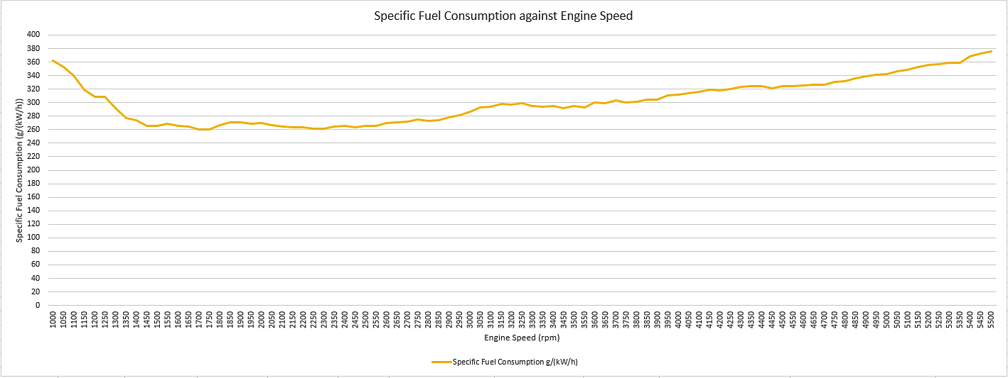
Results
As shown by the above graph, fuel consumption has a general trend of increasing along with engine speed. Due to the nature of an internal combustion engines, higher engine speed (revolutions per minute) means that more engine cycles are completed within the same amount of time, which results in more power strokes and thus more fuel being consumed. In addition, as engine speed increase, so does the movement speed of all moving parts inside the engine. This results in more frictional resistance being experienced by the engine within the same amount of time, contributing to increased fuel consumption.
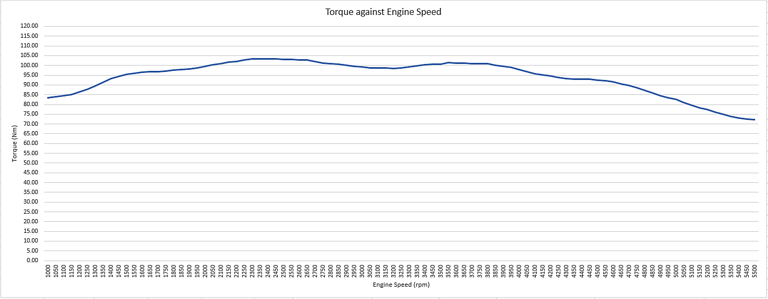
Engine torque increases with engine speed up until a certain point in the revolution range, where the engine starts rotating too fast. Under such conditions, the piston travels down to BDC too quickly, resulting in less air/fuel mixture being drawn into the cylinder, as there is simply not enough time for the mixture to react to the sudden vacuum created inside the cylinder and also overcome air resistance while travelling through the intake system. This causes engine torque to slowly decrease as the engine speed increases further.

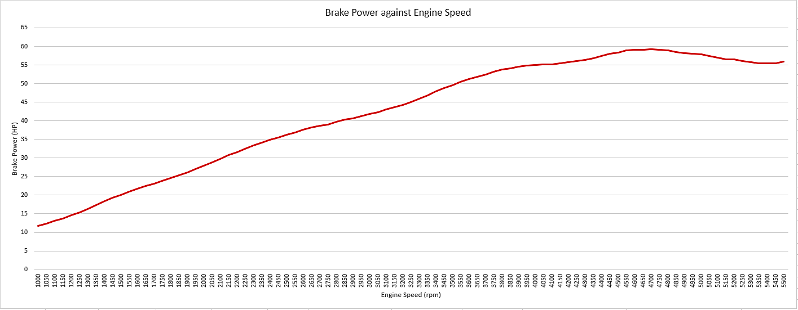
Engine power essentially means amount of work done over time. This graph clearly shows that this is true. During this particular test, engine power steadily increases until a peak point of around 4700rpm. After that, power starts dropping, which is caused by a variety of factors, such as the engine torque produced at that point being significantly lower than the peak figure. In addition, engine power suffers from the same problem as engine torque – as engine speed increases past a certain point in the revolution range, there is not enough time for the air/fuel mixture to completely fill the cylinder inside the engine due to the piston moving too quickly.

Conclusion
In conclusion, engines appear to have a tendency to consume more fuel as engine speed increases. This is caused by an increased amount of work done over a certain amount of time.
Power and torque figures have a tendency to increase with engine speed until they reach a peak point in the revolution range, after which the figures start to drop down due to the engine rotating too quickly for the air/fuel mixture to catch up – the piston inside the cylinder moves too quickly to allow the air/fuel mixture to completely fill the cylinder.

Evaluation
I believe that this assignment went well despite some of the calculations being a little tricky to execute, especially with my limited knowledge of Microsoft Excel.
In the future, I would expand my knowledge of Microsoft Excel, which would improve my ability to generate data tables, as well as allow me to represent the data more accurately and clearly. Furthermore, I would use more references to back me up instead of relying mainly on my own knowledge during analysis and discussion.
This investigation could have been improved by allowing me to participate in all of the practical work, thus granting me a chance to completely personalise this investigation by letting me choose data which I would consider the most important, as well as possibly employ additional equipment in order to further refine results.

References
BMEP calculation - https://x-engineer.org/automotive-engineering/internal-combustion-engines/ice-components-systems/mean-effective-pressure-mep/
BSFC and engine efficiency calculation - https://x-engineer.org/automotive-engineering/internal-combustion-engines/performance/brake-specific-fuel-consumption-bsfc/?fbclid=IwAR2Q4yaGFY3N0YGxB4cnB0dsLPqkxWON63Cfe5OUkf7-L22A4vBTy1Jbb24
Lower heating values of fuels - https://www.engineeringtoolbox.com/fuels-higher-calorific-values-d_169.html

