Module name: Personnel Resourcing and Development

Module code: BMIH5005
Assignment Title: – How to engage employees (Generation Ys or Generation Zs) throughout the employee lifecycle?

Student name: Valeria Nistor

Student ID: 2206486

Lecturer- Deborah Lloyd

Table of Contents
Introduction 3
Discussion 4
Conclusion 9
References 10
Appendix 12

Introduction
The assignment tends to shed light on the accountability of employee engagement and motivation. The role of human resources in engaging the employees will be mentioned in the assignment. On the other hand, the advantage of this engagement will be illustrated in the assignment. The generation characteristics will be needed to explore. Elsewhere the employee lifecycle will be explored and the other part of the assignment will be mentioned by the information of engagement through the various ways.

Discussion
Human Resources is a separator of business management to push accountability for the recruitment and training procedure. The engagement of the employee is an important factor in making the organisation successful in each aspect. In that case, the human resource has played an important role in growing the engagement of the employees towards the organisation. The human resource has a major responsibility to recruit the correct person towards the organisation as per the requirements of the organisation (Villegas et al., 2019). During the interview process, one of the vital things noted by HR is to match the "culture fit" of the employee with the organisation's culture. Elsewhere, another important part is that HR helps to improve the relations between the employees and the higher management of the organisation in which the production becomes satisfactory. HR helps employees enhance their motivation to achieve their goals in the global market (Cahyadi et al., 2022). Therefore, the organisation helps to serve the generative production in the global market along with the enhancement of sustainability of the organisation. Premier Inn is one of the renowned hotel brands in the global market. HR helps nourish the organisation’s growth by engaging the proper employees towards the Premier Inn (George, 2021). Investment in the employee's engagement is one of the worthwhile practices for business growth and the HR helps to nourish this engagement practice.
One of the most important advantages of the engagement of the employees towards the organisation is that the productivity of the organisation has enhanced and the sustainability of the organisation remains intact in the global market. Through the engagement of the employees, the organisation's goal in the target market can easily be achieved (Cartwright et al., 2021). The team performance of the organisation becomes better than the previous time and it helps to make the production fruitful. Therefore the chances of employee retention are higher and the stress in the workplace becomes less. In that case, the organisation's revenue has enhanced and the employees are benefited through this profit. Engagement of employees is one of the crucial things towards an organisation and the procedure is done by the human resource of the organisation (Sun and Bunchapattanasakda, 2019). There are several ways to compel the employees towards the organisation by the HR management. Recognition is another way for recruitment of the organisation by human resource management and public recognition is the relevant way to engage the employees towards the organisation. Strong leadership and a good team are one of the ways to engage the engagement of the employees towards the enterprises (Çop et al., 2021). Strong leadership has served as a good guide to the employees in which the work procedure becomes appropriate and it has had an influential impact on the production of the organisation. Through the proper engagement of the employees, the workspace environment has improved and the organisation's culture remains exemplary. Inherently, the way of employee engagement has served to develop the infrastructure of the organisation towards its sustainability in the global market.
Generation Y is known as the “Millennials” and one of the main characteristics of Generation Y is to prefer to work in a group with practical experiences. The millennials have put their devotion to implementing higher technology and the production strategy is different from others (Hernandez-de-Menendez et al., 2022). In that case, it is beneficial for the organisation's growth in the global market. Most importantly, the mind-set of this generation is very strong and reflected in their work pattern. Apart from that, another important part is that those who belong to this generation are perfect at multi-tasking skills. The value of the millennials is meaningful and this generation can be designated as a motivated group from all aspects (Rampen et al., 2023). The implementation of advanced technology has had an influential impact on this generation.
The employee lifecycle is a module which is used to explore the important stages employees go through in the company [Refer to appendix]. The stages are “attraction”, “recruitment”, “on boarding”, “development”, “retention” and “separation”. The main focus of the employee's life cycle is to uplift the employees to make the evaluation and improve the employees' experience (Malik et al., 2023). The first stage of the employee lifecycle is attraction, which contemplates the potential of the candidate and decides the chances of the cope up with the company. One of the prime advantages is that with the help of this component, the employee is benefitted by all particular segments of the organisation. The second stage of this life cycle is recruitment which helps to hire the candidate towards the organisation (Allal-Chérif et al., 2021). The recruitment process for the organisation has been operated by the Human Resource Management system. In that case, the talent acquisition software helps to conduct the hiring process and all of this can be observed by the implementation of advanced technology. Elsewhere, with the help of this recruitment process, the resources of the organisation have been enhanced. Apart from that, it helps to make the organisation’s growth consistent. The third one is on boarding which assists in nourishing the acceptance of the offer letter by the employees (Bélanger et al., 2023). Through this process, the company’s culture has been enhanced and a lot of numbers of new employees have added to the organisation's profit. Through this process, the production system has improved along with that the engagement of the employees has increased. On the other hand, employee retention has become better than the previous time. The fourth one is employee development which includes the professional development of the employees and helps to process the organisation’s feedback which is served to the employees (Kost et al., 2020). It helps the organisation to learn how to motivate the employees as well as which components aid in instigating better performance. One of the main components of organisational growth is feedback on the employee's performance. It is a very crucial thing for the growth of the company. Apart from that, the other important factor is retention, which helps to nurture the organisation's growth and it helps to enhance employee engagement towards the organisation as well as the goal of the organisation has become fulfilled (Wood et al., 2020). One of the biggest advantages is that with the help of this retention, the productivity of the company has increased and the organisational culture has become enhanced (Azeem et al., 2021). Through this employee retention, the cost has been reduced and it also helps to increase the employee experience. The last one of the employee life cycle is separation and through this, the HR has followed the procedure after the employee leaves the company (Gladka et al., 2022). Whenever the employees leave the company due to the violating issues in the company. Through this separation, employee retention has decreased the company has faced random declination in the growth in the global market and the sustainability of the company has decreased (Yadav et al., 2023). Apart from that, the company culture has become stronger as well and the productivity of the company has enhanced from all aspects. Elsewhere, the overall procedure is very crucial for employee engagement and organisational growth.
Employee engagement is one of the fundamental concepts which describes the quantitative and qualitative factors of the business. To run a successful business it is important to maintain the relationship between the employees (Dahik et al., 2020). The relationship between the employees and the organisation helps to become successful in the market. In an organisation, the management team needs to maintain employee engagement in the corporate culture. To ensure employee engagement, there are major 4 parts: encouragement, empowerment, energy and enablement. These 4 factors help to ensure employee engagement in the organisation.
Employee engagement can be achieved through different activities and ideas. By using those ideas, the management team can make a better corporate culture in the workplace. Several ideas help to ensure engagement between the employees (Ababneh, 2021). Different organisations include different strategies in their management system to ensure employee engagement. Organisations use different ideas such as conducting different fun activities, encouraging employees by giving subtle motivation, offering incentives for hitting the goal and many more (Kretschmer et al., 2022). There are different activities and ideas which a Human resource team of an organisation can take to keep engaging the employees. This includes social events, flexible work hours, specialised skill development plans, mentorship, and giving innovative ideas. The innovative challenges help the employees to keep motivated in the work. Social events such as fun activities help to make the employees happy during their work time. By giving them the recognition and acknowledgement helps, the employees to keep motivated (Chanana and Sangeeta, 2021). To get the incentives, employees will work to their full potential. These ideas will help an organisation to engage the team members for work.
The employee engagement model is a framework in which the overall environment of the company is discussed. In a company, the work environment refers to the behaviour and ethics of the company. The frameworks help the company to create a perfect environment which helps to feel happy, and satisfied in their working culture (Alameeri et al., 2021). Maintaining an ethical work culture is always important in an organisation. It helps the organisation to ensure the values and ethics of the business. The employee engagement model is an initiative that helps employee engagement and builds a sustainable work culture in the Premier Inn.
There are different models of employee engagement including “The Zinger model”, “The Gallup model”, “The AON-Hewitt model” and many more. The Zinger model is an employee engagement model which leverages the connection between the employees so that they can achieve better results. The Zinger Model includes different steps, such as building connections between the employees and ensuring authentic relationships (Hussainy, 2020). The Zinger model also helps to recognise and acknowledge every employee’s effort. This step helps Premier Inn to get better results and engage the employees with the work culture. The Zinger Model of employee engagement is one of the most used models in an organisation. There are several benefits of the Zinger employment engagement model such as it enhances the well-being of the employees, and focuses on the finite capabilities of the employees to make realistic goals (Kumari and Yelkar, 2022). The ultimate goal of this model is to provide genuine happiness for the employees.
Through various advertisements, Premier Inn recruit employees to enhance the productivity of the company in the global market. Therefore, the sustainability of the company has been enhanced (Alameeri et al., 2021). On the other hand, it helps to increase the fame of the company in the global market and the company can bring innovation through product variation. In that case, there is also one advantage of this engagement towards the organisation is that several employees have made their employment.

Conclusion
Based on the above assignment, it can be concluded that the assignment has tended to focus the light on the accountability of employee engagement and motivation. The assignment has mentioned the role of the human resource in engaging the employee towards the organisation. Elsewhere, the advantages of the engagement of the employees towards the team as well as the organisation has been mentioned and the impact of this engagement on the rate of production of the organisation has also been explored through this assessment. On the other hand, the employee lifecycle has illustrated the various stages and how the engagement of employees is related to each stage has also been mentioned. Moreover, the main focus of the assignment is to explore employee engagement and its impact on various matters.

References
Ababneh, O.M.A., 2021. How do green HRM practices affect employees’ green behaviors? The role of employee engagement and personality attributes. Journal of Environmental Planning and Management, 64(7), pp.1204-1226.
Alameeri, K., Alshurideh, M., Al Kurdi, B. and Salloum, S.A., 2021. The effect of work environment happiness on employee leadership. In Proceedings of the International Conference on Advanced Intelligent Systems and Informatics 2020 (pp. 668-680). Springer International Publishing.
Allal-Chérif, O., Aranega, A.Y. and Sánchez, R.C., 2021. Intelligent recruitment: How to identify, select, and retain talents from around the world using artificial intelligence. Technological Forecasting and Social Change, 169, p.120822.
Azeem, M., Ahmed, M., Haider, S. and Sajjad, M., 2021. Expanding competitive advantage through organizational culture, knowledge sharing and organizational innovation. Technology in Society, 66, p.101635.
Bélanger, A., Beaubien, S., Bell, K., Benson, K., Cawthorne, L., García Mazari, S., Garrett, T., Gorecki, P., Frigo, E., Meyer, K. and Vainner, J., 2023. Building Inclusive Libraries: Kindness, Equity, and Candidate Experiences in Hiring & Onboarding Toolkit.
Cahyadi, L., Cahyadi, W., Cen, C.C., Candrasa, L. and Pratama, I., 2022. HR practices and Corporate environmental citizenship: Mediating role of organizational ethical climate. Journal of Positive School Psychology, 6(2), pp.3083-3100.
Cartwright, S., Davies, I. and Archer-Brown, C., 2021. Managing relationships on social media in business-to-business organisations. Journal of Business Research, 125, pp.120-134.
Chanana, N. and Sangeeta, 2021. Employee engagement practices during COVID‐19 lockdown. Journal of public affairs, 21(4), p.e2508.
Çop, S., Olorunsola, V.O. and Alola, U.V., 2021. Achieving environmental sustainability through green transformational leadership policy: Can green team resilience help?. Business Strategy and the Environment, 30(1), pp.671-682.
Dahik, A., Lovich, D., Kreafle, C., Bailey, A., Kilmann, J., Kennedy, D., Roongta, P., Schuler, F., Tomlin, L. and Wenstrup, J., 2020. What 12,000 employees have to say about the future of remote work. Boston Consulting Group, pp.1-12.
George, R., 2021. Tourism and Hospitality Marketing Principles. In Marketing Tourism and Hospitality: Concepts and Cases (pp. 3-31). Cham: Springer International Publishing.
Gladka, O., Fedorova, V. and Dohadailo, Y., 2022. Development of conceptual bases of the employee life cycle within an organization. Business: Theory and Practice, 23(1), pp.39-52.
Hernandez-de-Menendez, M., Escobar Díaz, C.A. and Morales-Menendez, R., 2020. Educational experiences with Generation Z. International Journal on Interactive Design and Manufacturing (IJIDeM), 14, pp.847-859.
Hussainy, S.S., 2020. Review on motivational theories & models: Its application for employees’ retention in organizations. International Journal of Business and Applied Social Science, 6(1), pp.40-46.
Kost, D., Fieseler, C. and Wong, S.I., 2020. Boundaryless careers in the gig economy: An oxymoron?. Human Resource Management Journal, 30(1), pp.100-113.
Kretschmer, T., Leiponen, A., Schilling, M. and Vasudeva, G., 2022. Platform ecosystems as meta‐organizations: Implications for platform strategies. Strategic Management Journal, 43(3), pp.405-424.
Kumari, S. and Yelkar, N., 2022. Examining the Factors and Employee Engagement Model Design for a New-Age Hybrid Work Culture. Journal of Strategic Human Resource Management, 11(1).
Malik, A., Budhwar, P., Mohan, H. and NR, S., 2023. Employee experience–the missing link for engaging employees: Insights from an MNE's AI‐based HR ecosystem. Human Resource Management, 62(1), pp.97-115.
Rampen, D.C., Pangemanan, A.S. and Mandagi, D.W., 2023. The X-factors behind Gen Z employee performance: A systematic review. Jurnal Mantik, 7(2), pp.668-680.
Sun, L. and Bunchapattanasakda, C., 2019. Employee engagement: A literature review. International Journal of Human Resource Studies, 9(1), pp.63-80.
Villegas, S., Lloyd, R.A., Tritt, A. and Vengrouskie, E.F., 2019. Human resources as ethical gatekeepers: Hiring ethics and employee selection. Journal of Leadership, Accountability and Ethics, 16(2).
Wood, J., Oh, J., Park, J. and Kim, W., 2020. The relationship between work engagement and work–life balance in organizations: A review of the empirical research. Human Resource Development Review, 19(3), pp.240-262.
Yadav, R., Sinha, M. and Kureethara, J.V. eds., 2023. HR Analytics in an Era of Rapid Automation. IGI Global.

Appendix
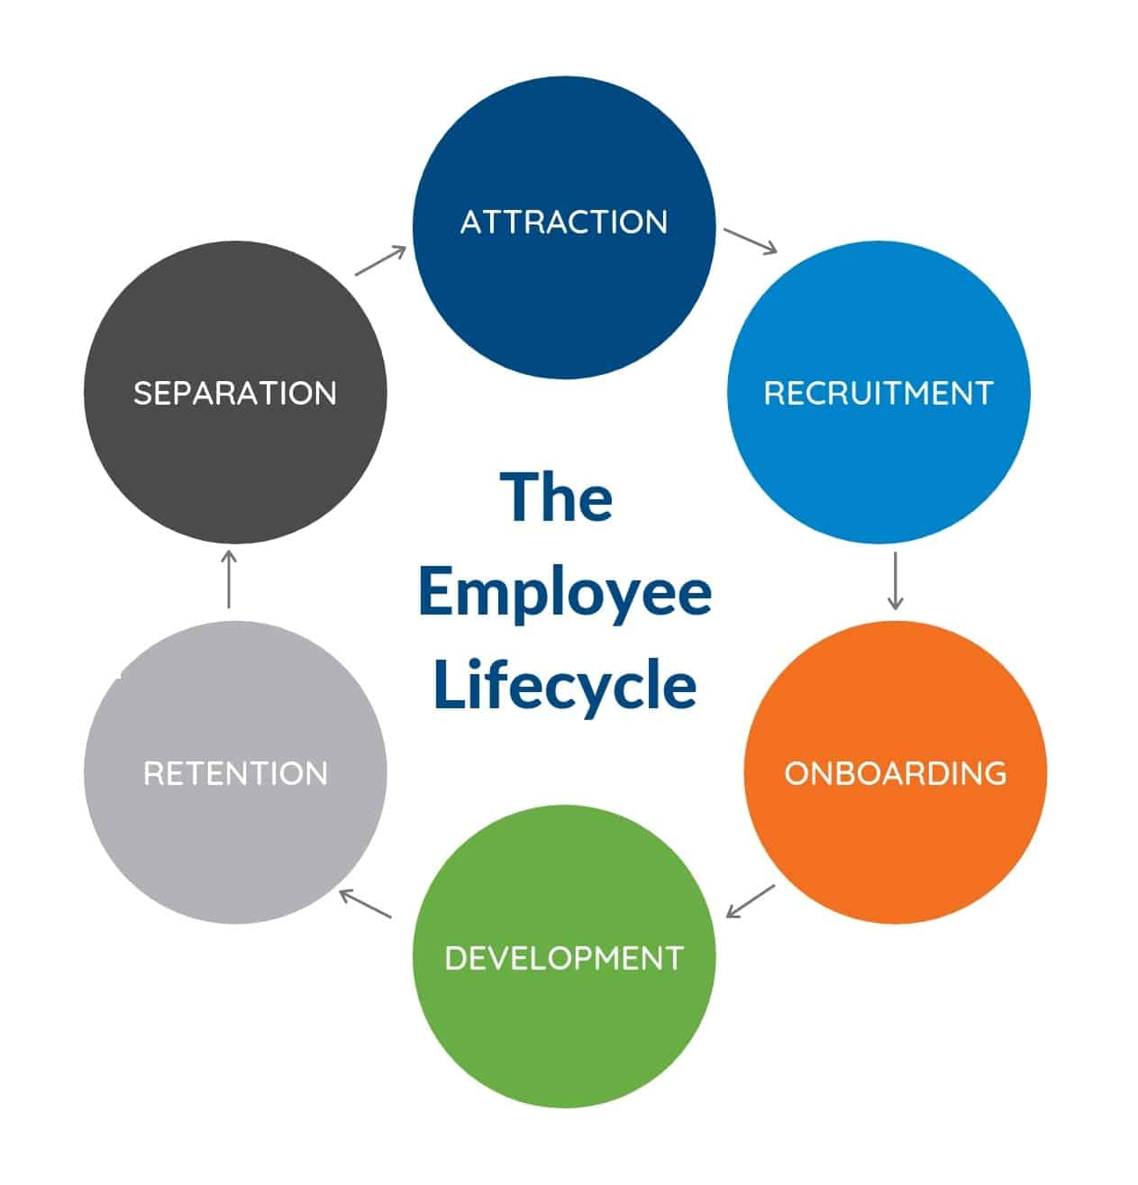
Figure 1: The Employee Lifecycle

