Alexandra Rafaela Dumitru 2540192

Task 1 – Reading Task Template

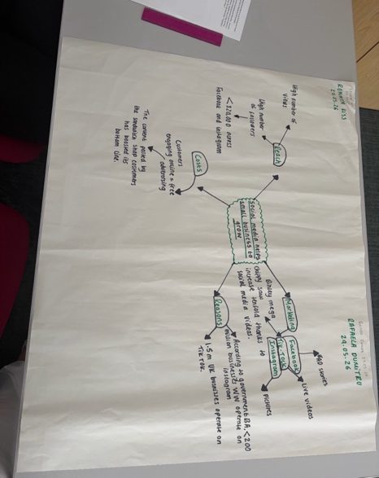
Upload your photo of your A3 in-class notes here:

1. Answer these questions using the sentence starters below
a. What is the main idea of the text?
The main idea is that social media helps small businesses to grow.
b. What are two key points?
One key point is that social media platforms such as TikTok, Facebook and Instagram has helped small businesses attract thousands of new customers. Many people use these platforms so when seeing these viral videos in the food and beauty industry, it encourages them to visit even if that means having to travel a long distance.
Another key point is that people prefer the real content, for example people from outside the business industry that are posting live videos or a regular TikTok of them trying the food for the first time and having a positive reaction. Therefore, other people find the content posted by them more reliable and trustworthy rather than a regular ad the business would post.
c. What part of the text did you find most important? Why?
The most important part I found is that a business can grow rapidly from social media. For example, Linda Loo’s boutique moved to being a fully online shop which proves that social media gave her that much success to the point she could count only on online sales and did not need to run a physical store anymore.
d. Was anything unclear or difficult to understand?
I am not sure why they went viral; the article mentions serval small businesses whose videos went viral but gives limited explanations of the actual content or strategies they might have used to become viral. other thank that the text is straight forward and enhances the main idea clearly.
e. How did your group help you understand the text better?
My group helped me by interpreting certain things differently to me which gave me a deeper understating and more ideas to work from.
3. One sentence reflection
Question: What did you find challenging about this task?
The hardest part was subtracting the 2 key points as to me everything seems straight forward and it all r refers to the main idea, so you must analyse the text deeper.

