Katy Jones
Student number: 2100222
Appendices for ecad5010 assignment

Table of Contents
Appendix A: Ethical considerations form: 2
Appendix B: Consent form: 14
Appendix C: Letter to school 15
Appendix D: Blank questionnaire 16
Appendix E: Questionnaire transcript 19
Appendix F: Pie charts and graph to represent some data collected 22
Appendix G: Semi-structured interview schedulue 24
Appendix H: Interview transcript 25

Appendix A: Ethical considerations form:
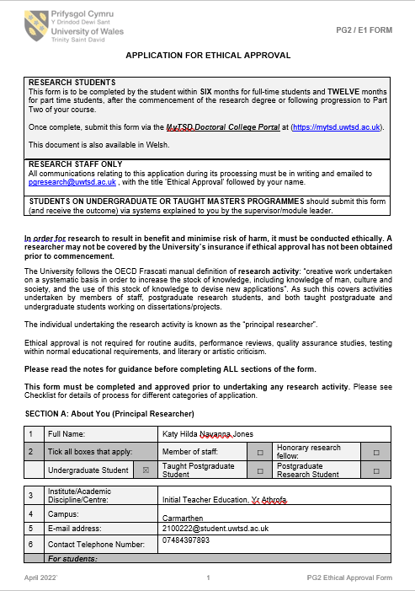
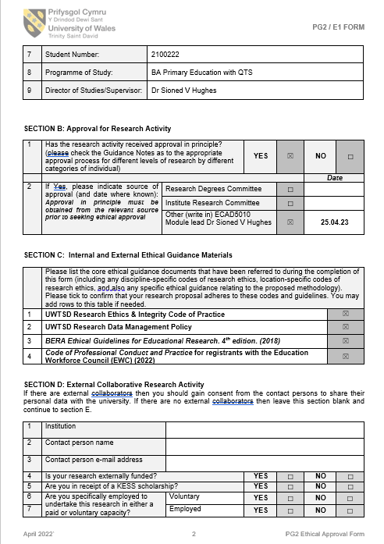
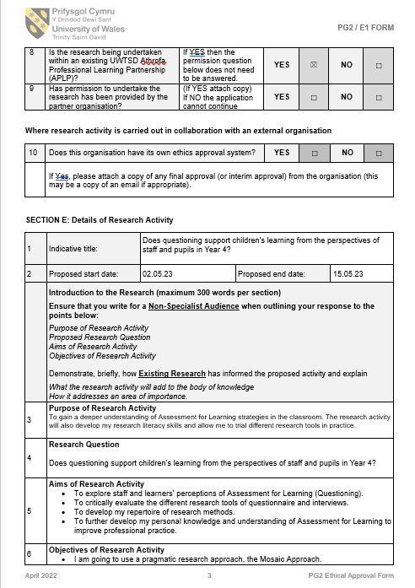
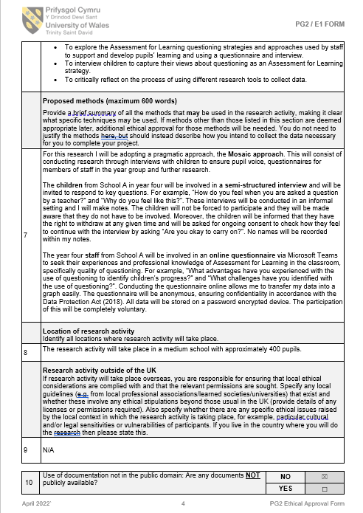
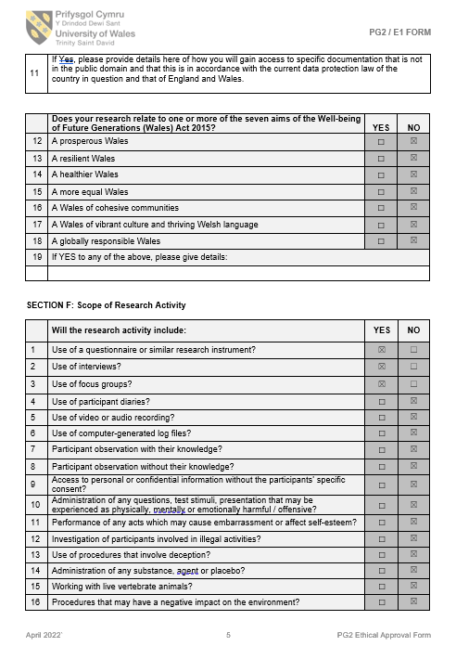
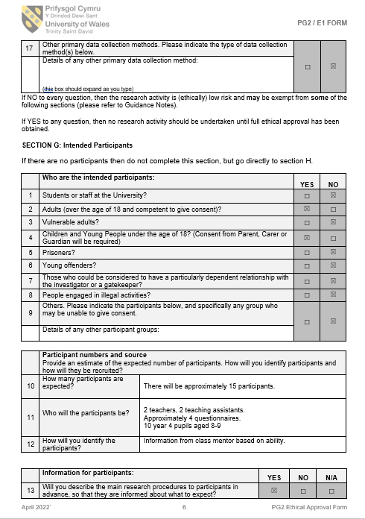
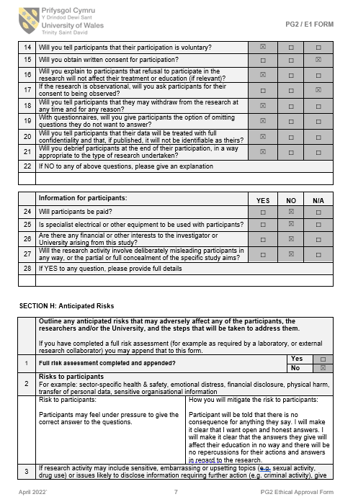
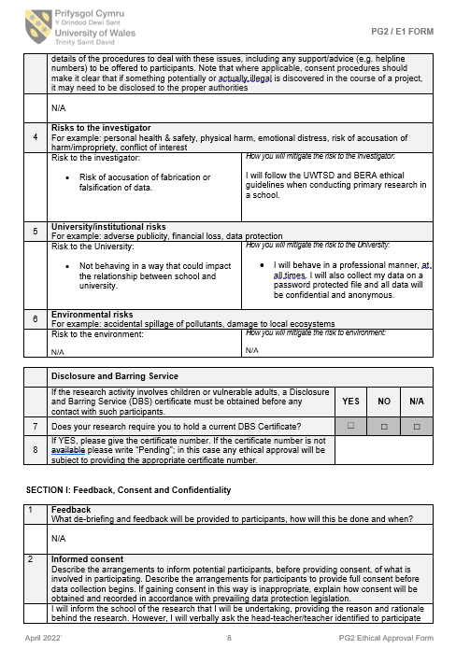
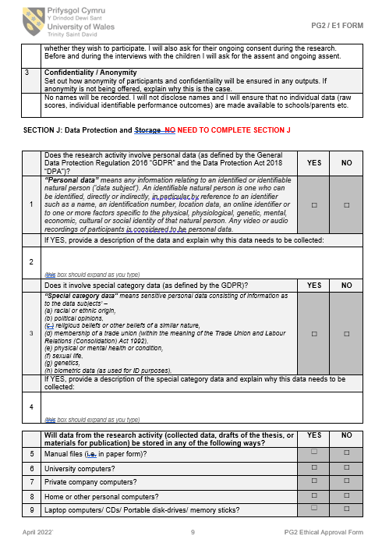
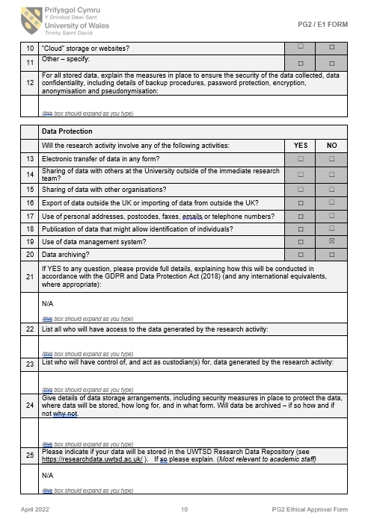

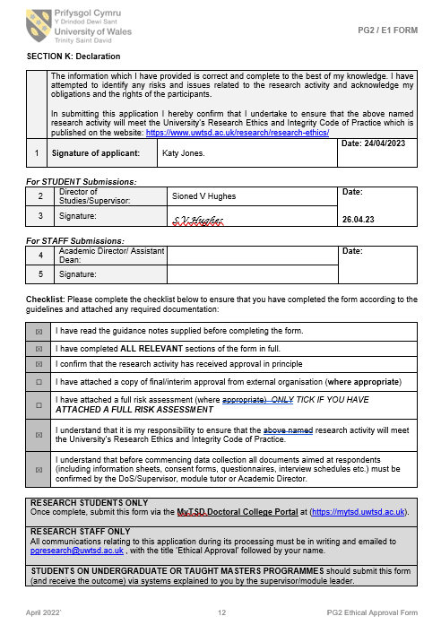

Appendix B: Consent form:

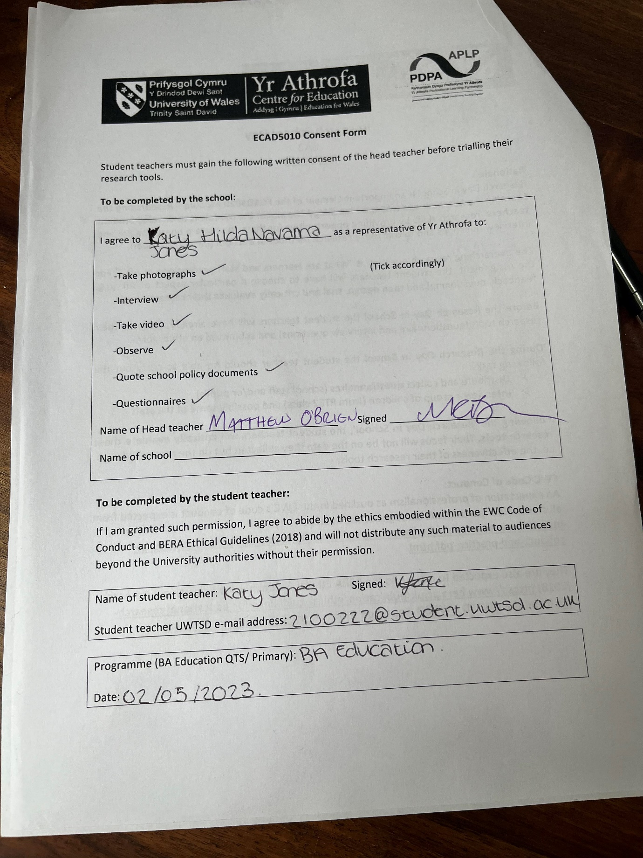

Appendix C: Letter to school
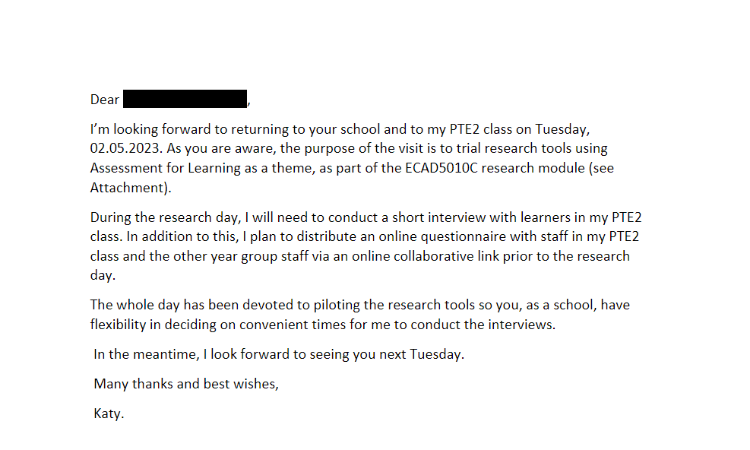

Appendix D: Blank questionnaire:
https://forms.office.com/e/VkE5Zwydnb
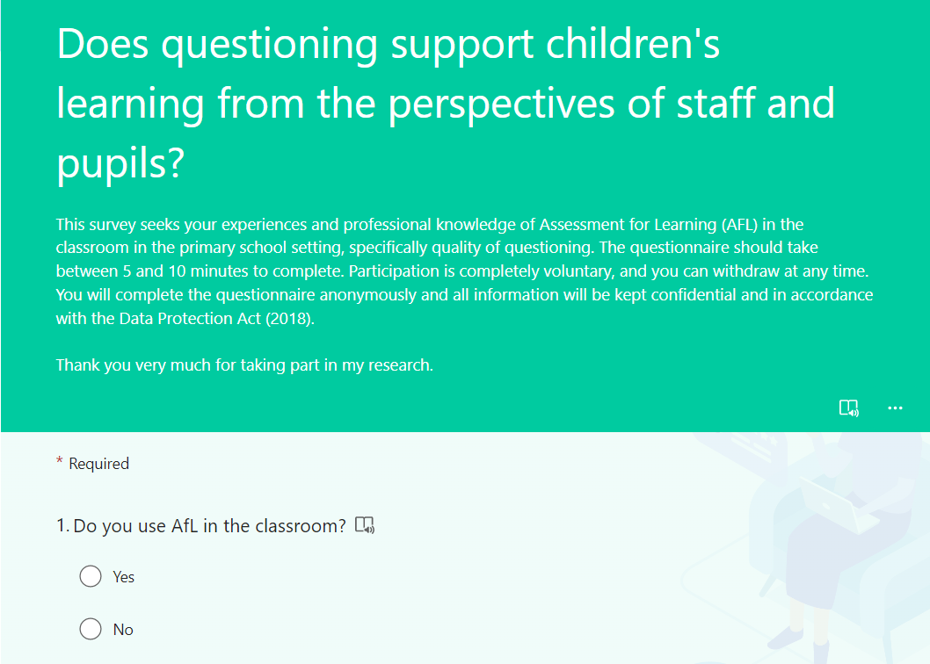
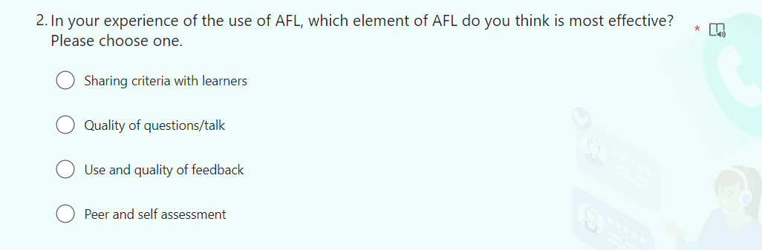
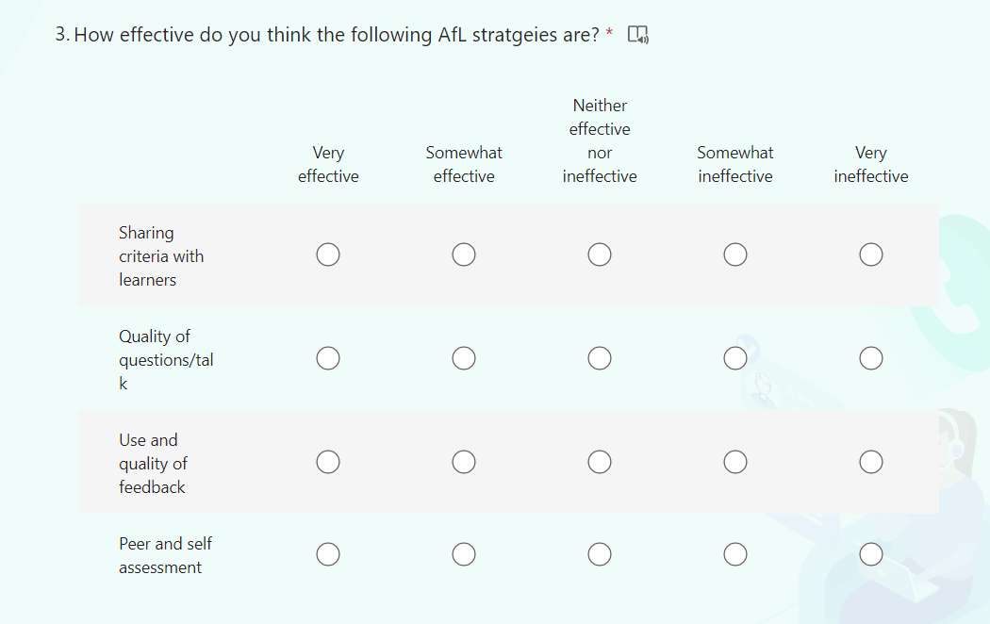
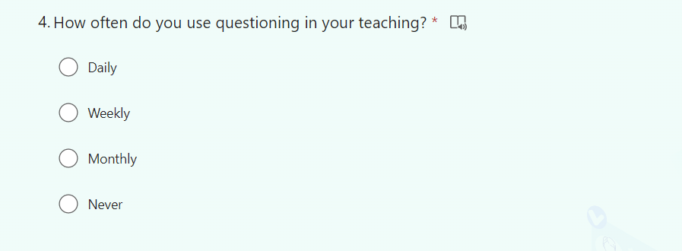
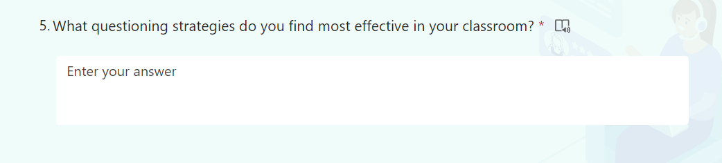
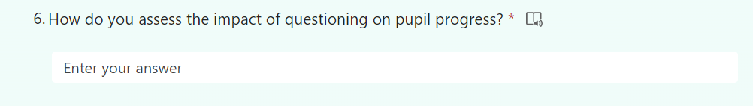
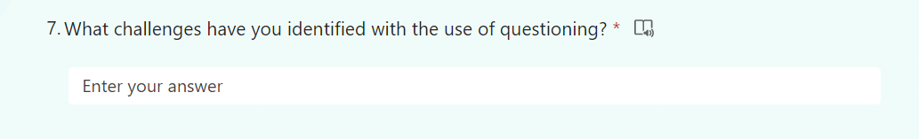
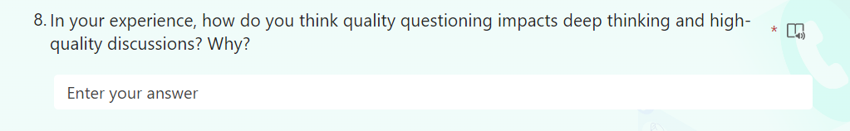

Appendix E: Questionnaire transcript
Question 1:
Staff response | Do you use AfL in the classroom?
A | “Yes.”
B | “Yes.”
C | “Yes.”
D | “Yes.”

Question 2:
Staff response | In your experience of the use of AFL, which element of AFL do you think is most effective? Please choose one.  Sharing criteria with learners  Quality of questions/talk  Use and quality of feedback  Peer and self-assessment
A | “Quality of questions/talk.”
B | “Quality of questions/talk.”
C | “Use and quality of feedback.”
D | “Use and quality of feedback.”

Question 3:
 | How effective do you think the following AfL strategies are? (Very effective, somewhat effective, neither ineffective nor effective, somewhat ineffective, very ineffective)
Staff response | Sharing criteria with learners | Quality of questions/talk | Use and quality of feedback | Peer and self-assessment
A | “Very effective” | “Very effective” | “Very effective” | “Very effective”
B | “Somewhat effective” | “Very effective” | “Very effective” | “Somewhat effective”
C | “Very effective” | “Very effective” | “Very effective” | “Very effective”
D | “Somewhat effective” | “Very effective” | “Very effective” | “Somewhat effective”

Question 4:
Staff response | How often do you use questioning in your teaching?
A | “Daily.”
B | “Daily.”
C | “Daily.”
D | “Daily.”

Question 5:
Staff response | What questioning strategies do you find most effective in your classroom?
A | “With this class, they like to begin with quite an open-ended question - challenging their thinking. They will then answer and build on these answers using their own question to help them further understand. They often begin with "To build on what... has said..." which shows which part specifically they needed the extra help with or which area they are interested in.”
B | “Use of Blooms Taxonomy. Open-ended questions that enable reflection and individual thinking to be valued.”
C | “Blooms taxonomy style questions. Open ended questions Pre-planned questions.”
D | “Basketball questioning.”

Question 6:
Staff response | How do you assess the impact of questioning on pupil progress?
A | “This will be very much a personal perspective but will show you the children's understanding and also allows us, as teachers, to assess oracy skills.”
B | “Verbal interactions, reflection on conversations, changes in quality of work/standards, overall confidence in tackling work - these are all indicators that good questioning has made a positive impact.”
C | “Has the learning moved forward.”
D | “Outcome, response, sharing of information.”

Question 7:
Staff response | What challenges have you identified with the use of questioning?
A | “You will find the children that you THINK understand are maybe the ones that have a basic understanding but not in depth which you wouldn't always see in their written work.”
B | “Time is key - enabling enough time for a) the right questions to be asked and b) the time for pupils to think and formulate answers. This is a challenge when other pressures are present in the school day.”
C | “Ensure that differentiation is in place - questions need to be tweaked for all pupils to access the questions.”
D | “Understanding of questions. Key is to identify those who do not understand and change question or strategy.”

Question 8:
Staff response | In your experience, how do you think quality questioning impacts deep thinking and high-quality discussions? Why?
A | “It is such an important and effective tool to use in your lessons. It is very versatile too - any part of the lesson can include questioning. I find it very useful to see how a child has developed their understanding within the session - using the same question here is particularly helpful as a teacher to judge improvements.”
B | “Time is precious - children can sometimes talk for a long time but getting that talk to focus on embedding new knowledge or moving thinking forward takes carefully planned questions. It makes a difference when children show signs of high engagement in a discussion - this demonstrates focus and investment. When this state of being is present, it is more likely that the conversation will have a longer-term impact on understanding and consolidation of knowledge.”
C | “Positive impact. Planning the use of blooms taxonomy style question allows pupils to dig deeper into the question asked.”
D | “This is extremely important and can make the difference in a poor outcome or positive.”

Appendix F: Pie charts and a graph to represent some data collected: 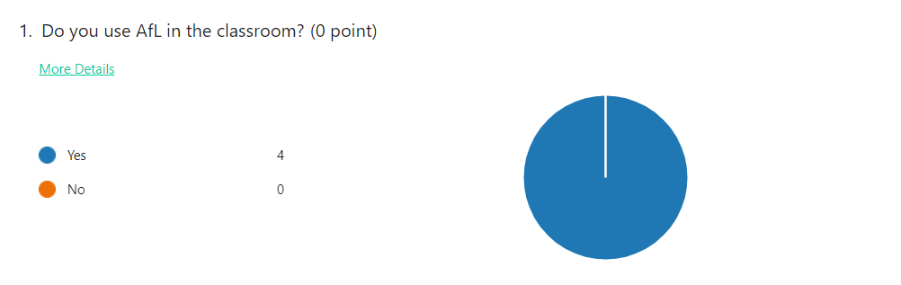
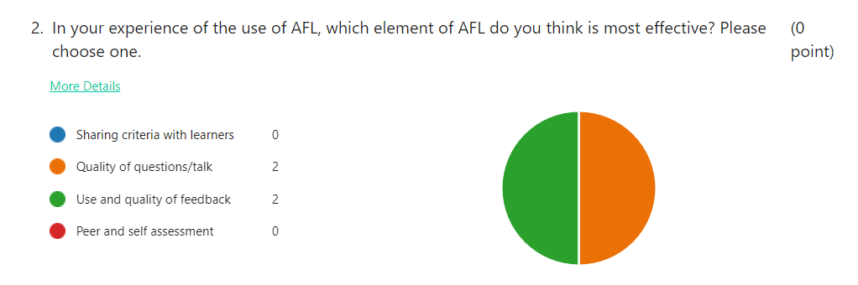
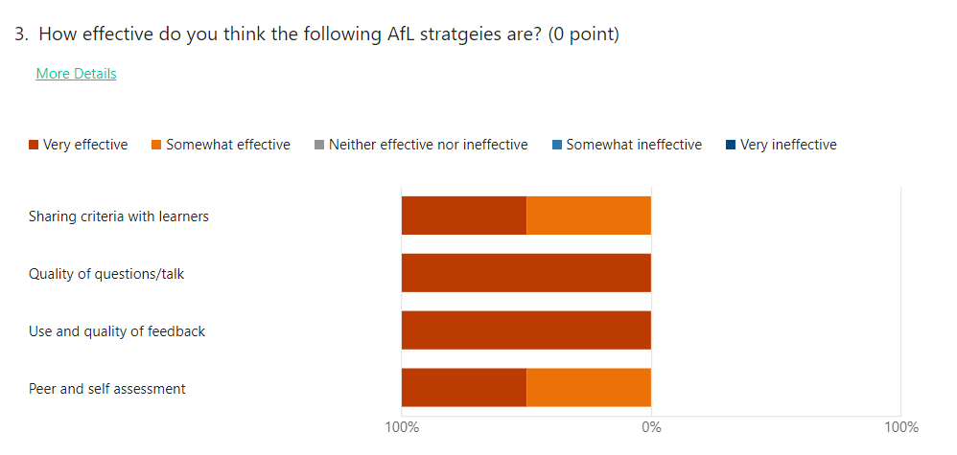
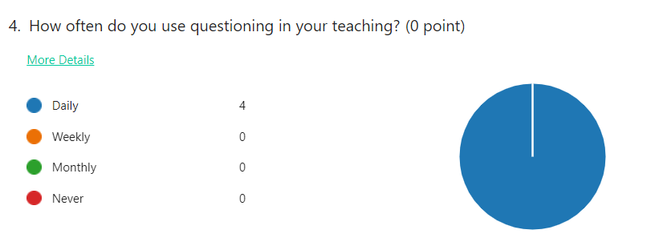

Appendix G: Semi- structured interview schedule:

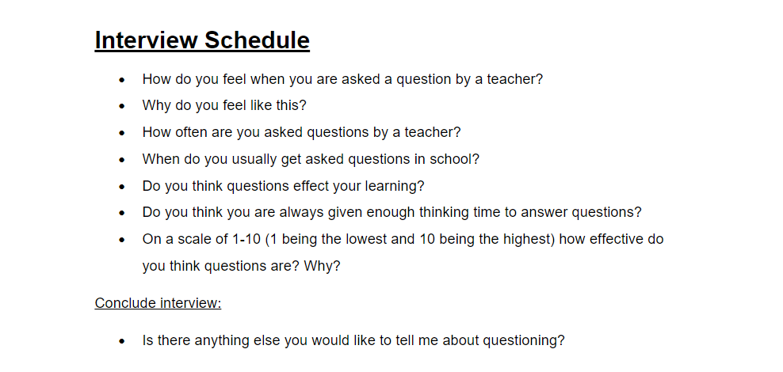

Appendix H: Interview transcript:
Question 1:
Learner response | How do you feel when you are asked a question by a teacher?
A | “Confused.”
B | “Happy, shocked.”
C | “Nervous.”
D | “Embarrassed.”
E | “Nervous.”
F | “On the spot.”
G | “Fine.”
H | “Sometimes happy and sometimes scared.”
I | “Nervous.”
J | “Excited.”

Question 2:
Learner response | Why do you feel like this?
A | “Sometimes don’t know the answer but sometimes I do.”
B | “Feels like there is a spotlight on me like I’m on a show.”
C | “I don’t like talking across the classroom.”
D | “I don’t always know the answer.”
E | “Feels like I am on the spot.”
F | “Sometimes I am ready to answer but forget when I am asked”
G | “I don’t mind answering questions”
H | “If I know the answer, I am happy. If I don’t know the answer, I am scared.”
I | “I’m not sure if Ill be wrong and I rather saying the right answer.”
J | “I like answering questions because their fun.”

Question 3:
Learner response | How often are you asked questions by a teacher?
A | “I’m asked a lot because of the lolly pop sticks.”
B | “I’m not asked a lot because of the lolly pop sticks and random choice on class dojo.”
C | “Not often.”
D | “Rarely.”
E | “A lot, especially in maths.”
F | “I am asked sometimes when I put my hand up.”
G | “When I am chosen to or needed to.”
H | “Loads.”
I | “Quite a lot.”
J | “Not a lot.”

Question 4:
Learner response | When do you usually get asked questions in school?
A | “Maths.”
B | “After reading with Mrs Illingworth.”
C | “Maths.”
D | “When we choose our topic.”
E | “Maths, but my mind goes blank.”
F | “In class discussions.”
G | “All lessons.”
H | “Maths.”
I | “Every day, but not Fridays.”
J | “Maths.”

Question 5:
Learner response | Do you think questions effect your learning?
A | “They sometimes help.”
B | “Yes they helps me understand and think more.”
C | “Yes, when reading with Mrs Illingworth they help me.”
D | “Yes, in a good way.”
E | “Not really.”
F | “Yes they help me learn more and understand.”
G | “No.”
H | “Yes, they have a good affect because they improve mistakes for a better education.”
I | “Yes, helps me learn from my mistakes.”
J | “Yes, a good affect.”

Question 6:
Learner response | Do you think you are always given enough thinking time to answer questions?
A | “Yes. I like it when they tell us to talk to the person next to us for five minutes.”
B | “Yes.”
C | “Yes.”
D | “No, if they ask me and other people have their hands up they’ll move on quick.”
E | “Yes.”
F | “Sometimes.”
G | “Yes.”
H | “Sometimes.”
I | “Yes.”
J | “The teacher moves on if I’m thinking.”

Question 7:
Learner response | On a scale of 1-10 (1 being the lowest and 10 being the highest) how effective do you think questions are? Why?
A | “8. They are really helpful.”
B | “8.8. They aren’t always good; it depends on how you feel about the question.”
C | “7 or 8 because they usually help.”
D | “5 because sometimes they help and sometimes, they don’t.”
E | “10 because they help me understand.”
F | “8 because if I give a wrong answer, I will be able to understand better.”
G | “9. They are help me.”
H | “8. Questions can be too easy sometimes. I prefer easier questions.
I | “5 because sometimes I give the right answer but sometimes, I’m wrong.”
J | “9.2. They usually help.”

