Student name: Mengistu Tolcha
Student ID: 2518093
Module code: LcLM4005
Module lecturer: Inderjit Grewal

Part 1: Job Advert
Job Title: Improver Electrician
Company: JBT Electrical Services
Location: Newham, East London
Salary: £14.50–£16.00 per hour + overtime + training allowance
Found: Indeed UK & company website, 18 July 2026

What the job is:
We are looking for an eager Improver Electrician to join our team based in Newham. This role is perfect if you’ve started your electrical training and want hands-on experience to become fully qualified. You’ll work on domestic and small commercial jobs across East London, learn from experienced electricians, and work towards your full qualifications.

What you’ll do:

* Help run cables, fit boxes and install switches/sockets under supervision

* Assist with testing work and keep all tools tidy and safe

* Follow all electrical safety rules and building regulations

* Turn up on time with the right gear and get ready for each job

* Learn how to talk to customers politely and clearly

* Work towards completing your NVQ Level 3 Electrical qualification

What we need from you:
✅ Must have:

* Live locally to Newham/East London

* Right to work in the UK

* Good timekeeping and willingness to learn

* Can work at heights and carry tools/equipment when needed

* Basic maths and English skills
✨ Nice to have:

* Started Level 2/3 Electrical Installation course

* Some experience working on sites or with tradespeople

* Full UK driving licence

* Knowledge of health & safety on construction sites

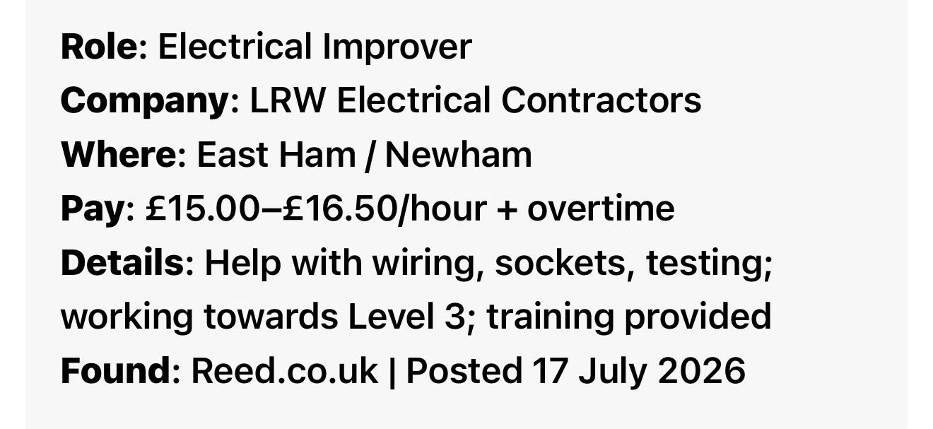

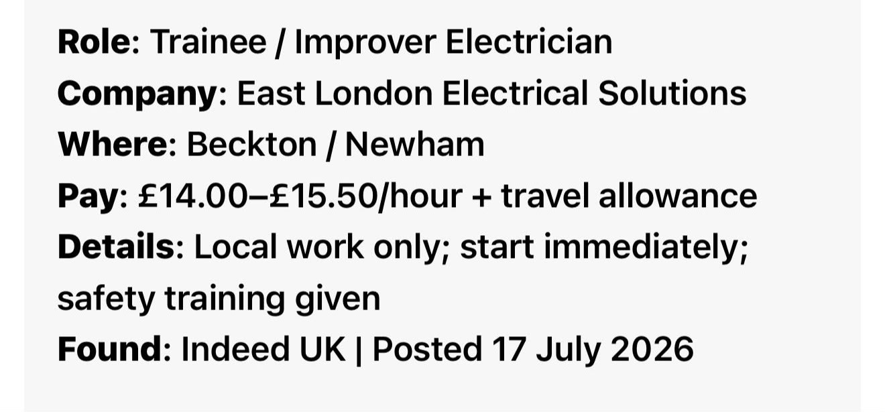

CV
Mengistu Tolcha
Newham, East London, E13 | 07911 123456
mengistu22@email.com
Right to work in the UK: Settled Status
About Me
I live right here in Newham, East London, and I’m working hard to build my career as a qualified electrician. I’m reliable, hardworking and always ready to learn new things. I’ve worked in warehouses and retail before, so I know how to follow rules, show up on time and work well as part of a team. I’m currently studying Electrical Installation alongside my business course, and this Improver role is exactly what I need to get the hands-on practice I’m looking for. I take safety very seriously, and I’m eager to work hard and grow my skills locally here in East London.
Work Experience
Warehouse Operative | Local Logistics, East Ham | Jan 2025 – Present
* Organise stock, hit daily targets and keep work areas neat and free of hazards
* Follow all safety rules, wear required protective gear and report any risks straight away
* Help new team members settle in and show them how tasks are done safely
* Work different shifts including early starts and weekends when required
* Regularly praised for being punctual and always willing to help out
Retail Assistant | Local Store, East Ham | Mar 2024 – Dec 2024
* Help customers, restock shelves and keep displays tidy
* Work well with the team to cover breaks and busy periods
* Help with stock checks and follow all store safety rules
Education & Training
BSc Business Studies | University of Wales Trinity Saint David | Sep 2025 – Present
* Learning about health & safety in the workplace, teamwork and professional standards
Level 2 Electrical Installation (in progress) | Newham College | Apr 2026 – Present
* Learning electrical basics, wiring regulations and safety procedures
GCSEs | Local School, Newham | Completed 2024
* Maths – Grade 5 | English Language – Grade 6 | Science – Grade 5

Key Skills
Reliability: I never miss a shift and always arrive early to get ready
Safety Focus: I know safety comes first, follow all rules and report anything unsafe
* Teamwork: I listen carefully to instructions, get on well with everyone and support the team
* Quick Learner: I pick up new skills fast and always ask if I’m unsure about anything
* Practical Ability: I’m good with my hands, fit enough to be on my feet all day and work at heights
* Local Knowledge: I know Newham and surrounding East London areas really well so I can get to jobs easily
Additional Information
* Live locally in Newham so can reach the base and all work sites quickly
* Have my own basic safety gear and happy to get more tools as I progress
* Keep fit and active so I can handle all physical parts of the job
* Honest, polite with customers and always take pride in doing good work* Fully committed to finishing my electrical qualifications and building a long-term career

Cover Letter
Mengistu Tolcha
Newham, East London, E13 | 07911 123456
mengistu22@email.com
19 July 2026
To the Hiring Team
JBT Electrical Services
Newham, East London
Re: Application for Improver Electrician
Hi there, I’m writing to apply for the Improver Electrician role you have advertised. I live right here in Newham, and this is exactly the opportunity I’ve been looking for to start my career as an electrician.
I’m already working towards my Level 2 Electrical Installation at Newham College, so I’m learning all the basics and important safety rules right now. From my previous work, I know how important it is to be on time, listen well, and follow every rule – especially when working with electricity. I’m not afraid of hard work, I pay close attention to detail, and I love learning new practical skills.
I know how important it is to be polite and professional when visiting people’s homes or work sites, and I’ll always represent your team well. I know this area well so I can get to every job with no issues, and I’m happy to work flexible hours when needed.
I’m eager to learn from your experienced team and work hard to earn my place. Thank you so much for reading my application – I’d love to talk more about this in the interview.
Mengistu Tolcha.

Reference List

1. JBT Electrical Services. (2026). Improver Electrician Job Advert. Retrieved from Indeed UK, 18 July 2026

2. LRW Electrical Contractors. (2026). Electrical Improver Job Advert. Retrieved from Reed.co.uk, 17 July 2026

5. East London Electrical Solutions. (2026). Trainee / Improver Electrician Job Advert. Retrieved from Indeed UK, 17 July 2026

