
Programme: | MSc Public Health and Social Care in Practice
Module: | Practice-Based Research
Module code: | LCHS7008
Assignment Title: | Component 2 Written Research Proposal
Lecturer: | Dr. Diola Bijlhout
Name: | Md. Shohel Hossen
ID: | 2433869

The Influence of Socioeconomic Inequalities on Cardiovascular Disease Among Adults in the United Kingdom: A Systematic Review
Table of Contents
Prevalence of the Problem in Health and Social Care 3
Introduction and Literature Based Background 4
Theoretical Frameworks and Social Construction 5
Literature Review 6
Rationale of the Research 7
Research Question 8
Research Aim and Objectives 8
Research Methodology 9
4.1 Research Design 9
4.2 Search Strategy 10
4.3 Data Collection Method and Procedure 10
4.4 Proposed Data Analysis Technique (Thematic Analysis) 12
4.5 Ethical Considerations 12
4.6 Implications of Research 12
4.7 Plan of Work and Time Schedule 13
References 14

Prevalence of the Problem in Health and Social Care
Cardiovascular Disease is a collective term for diseases of the heart and blood vessels. Cardiovascular disease is defined as coronary heart disease, stroke, heart failure, atrial fibrillation and hypertension for this proposal. They are still the major cause of death and disability in the United Kingdom. Cardiovascular disease impacts millions of adults and is a major cost to the National Health Service and social care services (Roth et al., 2020). The number of people affected by cardiovascular disease (CVD) almost doubled from 271 million (95% uncertainty interval [UI]: 257 to 285 million) in 1990 to 523 million (95% UI: 497 to 550 million) in 2019. During the same period, the number of deaths caused by CVD also increased steadily, from 12.1 million (95% UI: 11.4 to 12.6 million) in 1990 to 18.6 million (95% UI: 17.1 to 19.7 million) in 2019 (Roth et al., 2020).
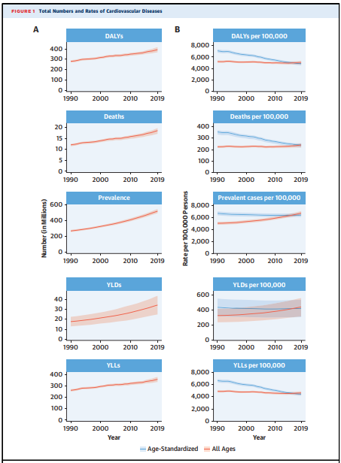
FIGURE: Total Numbers and Rates of Cardiovascular Diseases; Source: (Roth et al., 2020).
In England, the age-standardised prevalence of cardiovascular disease is significantly higher in the most deprived areas than in the least deprived areas (Lindstrom et al., 2022). This disparity is further increased when other social factors like ethnicity, housing and access to health care are taken into consideration. Growing pressure is placed on health and social care services as they have to deal with a population of unemployed adults with low income, poor housing and limited access to preventive care who are suffering from cardiovascular disease. This is a vast problem and a synthesis of evidence to inform practice and policy is needed. This proposal addresses this need by proposing a systematic review of the impact of socioeconomic inequalities on cardiovascular disease risk and outcomes in adults in the United Kingdom.

Introduction and Literature Based Background
Socioeconomic inequalities refer to the inequitable and preventable health disparities that exist due to conditions of birth, growth, living, work and ageing (Goldblatt, 2016). The conditions that are considered are income, education, employment, housing and access to services. There have been increasing studies correlating socioeconomic status and increased risk of cardiovascular disease and decreased outcomes following diagnosis (Bann et al., 2024).
In the UK, research with large populations indicates that, even after control for personal risk factors (e.g., smoking and low levels of physical activity), women and men in the most deprived areas are at greater risk of CHD (Floud et al., 2016). Cardiovascular risk patterns are also unique for migrant and minority ethnic groups in the United Kingdom, as influenced by socioeconomic factors (Ismail et al., 2022). In addition to individual behaviours, structural factors (housing quality and neighbourhood deprivation) are also found to have independent associations with cardiovascular disease mortality in older age (Ramsay et al., 2015).
Nevertheless, there is a lack of evidence about the interactions of these social determinants to generate inequalities in cardiac outcomes in the UK specifically. This evidence is largely disjointed and distributed across various aspects of income, ethnicity, housing and access to healthcare. The available evidence is not synthesised in one single document that brings together the strands of income and ethnicity, housing and access to healthcare. This proposal aims to tackle this through a systematic review of social determinants of cardiovascular disease among United Kingdom adults, to provide more equitable public health responses.

Theoretical Frameworks and Social Construction
This review is informed by the social determinants of health framework that focuses on the social, economic and physical context in which people live as a determinant of health rather than individual choice (Goldblatt, 2016).
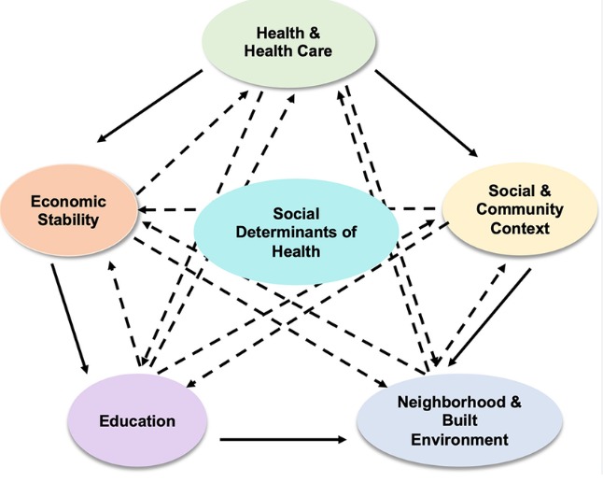
Figure: The ﬁve domains of social determinants of health; Source: (Singu et al., 2020)
The Marmot framework depicts a social gradient of health, whereby the health of people gets better along a social hierarchy; cardiovascular disease being one of the most obvious examples.
Socio-economic position is proposed as a social construct as opposed to a single measurement, and is defined here by certain interconnected elements of income, education, occupation and area level deprivation. In addition, socioeconomic inequalities in cardiovascular disease do not seem to be entirely explained by the simple fact that individuals with superior social and economic resources are able to use new knowledge to support their health, as is the case in Fundamental cause theory.
This review focuses on a more comprehensive and multidimensional perspective of socioeconomic inequalities in addition to income. The intersectionality of ethnicity, housing and access to health care services is recognized as a form of disadvantage, alongside economic disadvantage, which determines cardiovascular disease risk and outcomes in adults in the United Kingdom.

Literature Review
The socioeconomic gradient is always detected in cardiovascular disease in UK cohorts. In the UK, a large study of more than a million women, showed that both lower educational attainment and higher area deprivation were independently linked to increased risk of coronary heart disease (Floud et al., 2016). Even after 20 years, the area level deprivation score remains a good predictor of cardiac mortality, especially for women (Ramsay et al., 2015). Evidence from systematic reviews shows that low socioeconomic status (SES) is a risk factor for cardiovascular disease (CVD) in numerous countries, but the magnitude of the association differs depending on the measure used (Baruwa et al., 2024). Results from the Prospective Urban Rural Epidemiologic study in 20 countries have shown that the association between socioeconomic position and cardiovascular disease risk is consistent across income levels and is particularly strong for education (Rosengren et al., 2019).
Ethnicity is one of the major areas of inequality. A higher risk of cardiovascular disease has been observed in adults of South Asian ethnicity compared to the measured risk factors, and risk among Black adults is generally comparable to or lower than among adults of white European ethnicity, in the UK Biobank (Razieh et al., 2022). However, these ethnicity-specific risk prediction models have been inconsistent within ethnic subgroups, lowering risk estimates for women of South Asian ethnicity especially (Tillin et al., 2014). In the United Kingdom, migrants have socioeconomic patterns of cardiovascular disease different to the general population, highlighting the need for targeted evidence (Ismail et al., 2022). National information indicates that ethnic differences in cardiovascular outcomes remained after the acute period of the COVID nineteen pandemic (Pineda Moncusi et al., 2025).
The environment of the home also influences heart health. Low temperatures and a higher level of atmospheric moisture are related to higher blood pressure and increased cardiovascular stress, especially in older adults (Kimenai and Shah, 2024). The employment status is also important; unemployment is associated with an increased burden of cardiovascular risk factors and events, beyond their impact on social status at baseline (Rumball Smith et al., 2014) and is similarly observed in a large French cohort (Sanchez Rico et al., 2023).
Healthcare is not equitable. The likelihood of adults undergoing coronary procedures and of persistence with these procedures after a coronary event is lower in those from more deprived backgrounds, as is medication persistence after a coronary event (King et al., 2018). Similar findings have been reported from Denmark, indicating that the socioeconomic gradient is present even though there is similarly good access to cardiac rehabilitation after CHD (Kjesbu et al., 2022). There is international evidence that interventions specifically aimed at socioeconomically disadvantaged groups tend to be more effective, whilst non-specific prevention programmes are not necessarily effective enough to close these gaps (Fu et al., 2023). A meta-analysis has found that lower education and lower income are independently associated with higher cardiovascular risk (Khaing et al., 2017) and genetic evidence suggests that higher education is protective against coronary heart disease (Tillmann et al., 2017). This evidence, along with the others cited, suggests a multi-faceted review of the interrelationships between income, education, employment, ethnicity, housing and access to healthcare as drivers of cardiovascular disease inequality.

Rationale of the Research
Cardiovascular disease is still one of the most common causes of premature death in the UK and the differences in cardiovascular outcomes across rich and poor areas have not narrowed over the decades of public health investment (Lindstrom et al., 2022). Previous reviews are typically limited to examining one social determinant at a time, like income or ethnicity. The evidence presented in this review suggests that a review is required that combines evidence on income, education, employment, ethnicity, housing and access to healthcare to provide a more comprehensive picture of the influences of these factors on cardiovascular disease risk and outcomes in adults in the UK.
Collating this evidence will help to identify gaps in existing interventions and policies, and areas of need for new approaches. The purpose of this systematic review is therefore to create a robust and up to date evidence base to inform the prevention, treatment and care of adults living with or at risk of cardiovascular disease in the United Kingdom in a more equitable way.

Research Question
How do socioeconomic inequalities influence cardiovascular disease risk and outcomes among adults in the United Kingdom?

Research Aim and Objectives
The aim of the study is to systematically review and synthesise existing evidence on how social determinants influence cardiovascular disease risk and outcomes among adults in the United Kingdom.
- To identify the key social determinants associated with cardiovascular disease risk and outcomes among adults in the United Kingdom.
- To examine the relationship between socioeconomic factors, including income, education, employment and area level deprivation, and cardiovascular disease outcomes.
- To explore how demographic and environmental factors, including ethnicity, housing conditions and access to healthcare, influence cardiovascular disease risk and inequalities.
- To synthesise evidence on public health interventions and policy recommendations aimed at reducing social inequalities in cardiovascular disease in the United Kingdom.

Research Methodology
This systematic review will follow the PRISMA 2020 guidance to ensure transparent and reproducible reporting (Page et al., 2021). The review will draw on quantitative and qualitative United Kingdom based studies and synthesise findings through a structured narrative and thematic approach.

4.1 Research Design
This study will be performed as a systematic review, following the PRISMA 2020 statement which outlines standardisation for identification, screening and reporting of evidence (Page et al., 2021). The review will take place in four successive stages. Records will be obtained from electronic records and supplemental sources during the identification stage. Titles and abstracts will be screened in the screening phase to see if they meet the inclusion/exclusion criteria and then redundant records will be eliminated. During the eligibility and inclusion phase, the full texts of all remaining records will be read in full and reasons for exclusion will be documented. During the synthesis phase, data from studies included will be extracted from the studies, quality appraised and synthesized through thematic analysis.
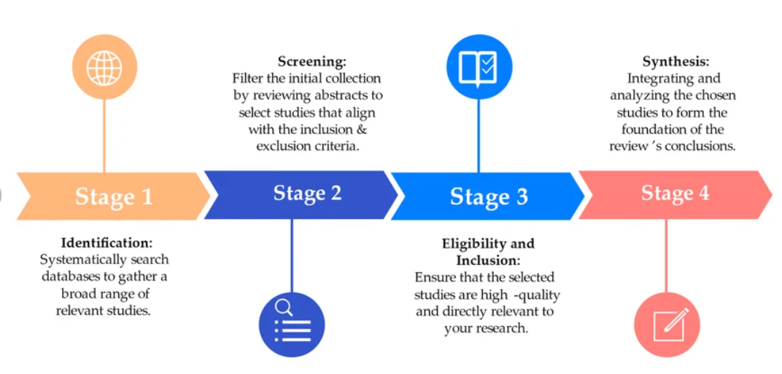
Figure: PRISMA 2020 Methodology Phases; Source: (Arévalo et al., 2024)
The number of records at each stage will be recorded in a PRISMA flow diagram. Included studies will be quality-assessed using the appropriate CASP checklist for the relevant study design. These tools have checklists for various types of studies and are considered as easy-to-use tools in health and social care reviews (dos Santos, Secoli and Puschel, 2018; Hilton, 2024). This tiered approach is helpful for a clear and defensible synthesis of evidence across multiple social determinants of cardiovascular disease.

4.2 Search Strategy
Eligible studies will reflect the prevalence of cardiovascular disease in adults (aged 18 years or over) residing in the United Kingdom, where cardiovascular disease will be defined as coronary heart disease, stroke, heart failure, atrial fibrillation or hypertension. At least one measure of socioeconomic position (income, education, employment or area level deprivation) must be included in the studies, which should relate this factor to cardiovascular disease risk or outcomes. Likely 10-12 Studies are expected to be selected for full review following the screening process.
Inclusion and Exclusion Criteria
The period of 2014–2026 will be used to reflect recent policy, treatment and demographic conditions, with only peer-reviewed studies published in English during this time being included. Research which is not undertaken in the United Kingdom, research which focuses exclusively on children and non-peer reviewed sources like opinion pieces will be excluded from the studies. Grey literature published by a recognised source (e.g., the British Heart Foundation) can be used as an additional context and may be incorporated into the primary evidence synthesis but will not be counted towards the primary evidence synthesis.

4.3 Data Collection Method and Procedure
Electronic databases (MEDLINE, CINAHL, PubMed, Embase and Google Scholar) and manual searches of reference lists will be used for data collection. The search strategy will use the Boolean operators and will include a combination of concepts, where appropriate, within each concept group using the term OR and will connect concepts groups using the term AND, as is common in systematic reviews. This way a broad, delicate literature search is done prior to more specific screening. Validated tools like QRISK2 are widely used to assess cardiovascular disease risk in clinical practice in the United Kingdom and studies employing these tools will be included alongside clinical diagnosis or hospital records. (Hippisley Cox et al., 2008)
Concept | Search Terms
Population | adult OR adults OR patient
Exposure | socioeconomic OR socio economic OR deprivation OR income OR education OR employment OR poverty
Outcome | cardiovascular disease OR heart disease OR coronary heart disease OR stroke OR hypertension OR heart failure
Setting | United Kingdom OR England OR Scotland OR Wales OR Northern Ireland

4.4 Proposed Data Analysis Technique (Thematic Analysis)
Thematic analysis will be employed for the analysis of findings from the studies included, using the six stages reflexive framework set out by Braun and Clarke (2006). The first step is to get to know the extracted data by repeated reading. The second step is to create some starting codes over the data set. The third step is to find candidate themes by clustering and grouping together codes that are related. The fourth step is examining the themes with the coded data and with the entire data set to ensure themes are coherent. The fifth step is to clearly define and identify each theme. The sixth step is to create a written synthesis, which ties the themes to the research question and objectives.
This enables findings from studies conducted using varying designs, such as quantitative cohort studies and qualitative research to be integrated together into a coherent narrative account of adult cardiovascular disease inequalities in the United Kingdom (UK).

4.5 Ethical Considerations
This is a systematic review and need primary ethical approval. But good moral care will be given. All studies included will be assessed to be sure they were given proper ethical clearance and informed consent in the original context. Data will be managed and reported in a way that ensures accuracy, transparency and there will be no selective reporting of findings, using the guidance for reporting data to ensure this (Page et al., 2021). If conflicts of interest are identified in included studies, they will be commented on when assessing study quality.

4.6 Implications of Research
The results of this review are likely to contribute to public health practice, healthcare commissioning and policy to tackle inequalities in cardiovascular disease in the United Kingdom. The review will draw together evidence relating to income, education, employment, ethnicity, housing and access to healthcare and help to identify the critical social determinants and what social determinants of health interventions are not yet working. The results could guide the implementation of more focused prevention initiatives, like customizing cardiac rehabilitation programs or reaching out to minorities (Fu et al., 2023), or indicate unmet needs that should be addressed in future primary studies to better understand the joint impact of multiple SDOH.

4.7 Plan of Work and Time Schedule
The review will be concluded within a 16-week review period. The planned activities are detailed below:
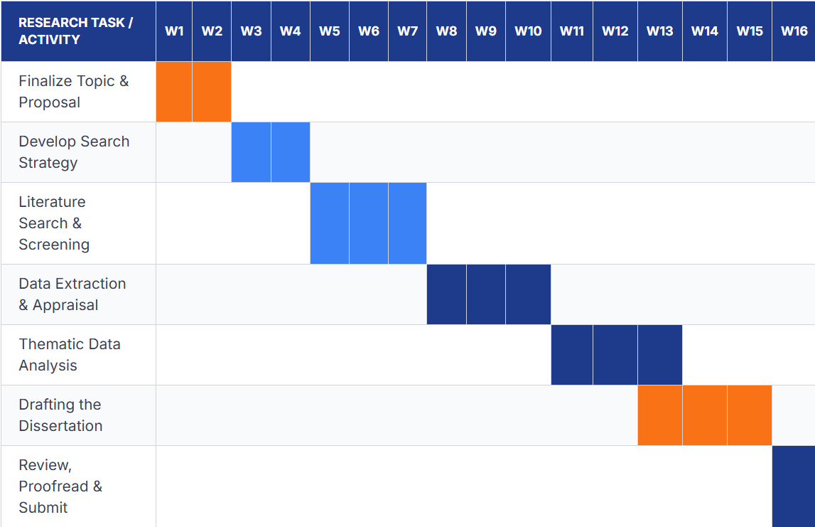

References
Arévalo, P., Ochoa-Correa, D. and Villa-Ávila, E., 2024. Optimizing microgrid operation: Integration of emerging technologies and artificial intelligence for energy efficiency. Electronics, 13(18), p.3754. DOI:10.3390/electronics13183754
Bann, D., Wright, L., Hughes, A. and Chaturvedi, N. (2024) Socioeconomic inequalities in cardiovascular disease: a causal perspective. Nature Reviews Cardiology, 21, pp. 238 to 249. doi: 10.1038/s41569-023-00941-8
Baruwa, O.J., Alberti, F., Onagbiye, S., Guddemi, A., Odone, A., Ricci, H., Gaeta, M., Daniela, S. and Ricci, C. (2024) Are socio economic inequalities related to cardiovascular disease risk? A systematic review and meta analysis of prospective studies. BMC Cardiovascular Disorders, 24. doi: 10.1186/s12872-024-04248-5
Braun, V. and Clarke, V. (2006) Using thematic analysis in psychology. Qualitative Research in Psychology, 3(2), pp. 77 to 101. doi: 10.1191/1478088706qp063oa
dos Santos, W.M., Secoli, S.R. and Puschel, V.A.A. (2018) The Joanna Briggs Institute approach for systematic reviews. Revista Latino Americana de Enfermagem, 26. doi: 10.1590/1518-8345.2885.3074
Floud, S., Balkwill, A., Moser, K., Reeves, G.K., Green, J., Beral, V. and Benjamin, J. (2016) The role of health related behavioural factors in accounting for inequalities in coronary heart disease risk by education and area deprivation: prospective study of 1.2 million UK women. BMC Medicine, 14. doi: 10.1186/s12916-016-0687-2
Fu, Y., Yu, G., Maulana, N. and Thomson, K. (2023) Interventions to tackle health inequalities in cardiovascular risks for socioeconomically disadvantaged populations: a rapid review. British Medical Bulletin, 148(1), pp. 22 to 41. doi: 10.1093/bmb/ldad025
Goldblatt, P.O. (2016) Moving forward monitoring of the social determinants of health in a country: lessons from England five years after the Marmot Review. Global Health Action, 9. doi: 10.3402/gha.v9.29627
Hilton, M. (2024) JBI critical appraisal checklist for systematic reviews and research syntheses. Journal of the Canadian Health Libraries Association, 45(3). doi: 10.29173/jchla29801
Hippisley Cox, J., Coupland, C., Vinogradova, Y., Robson, J., Minhas, R., Sheikh, A. and Brindle, P. (2008) Predicting cardiovascular risk in England and Wales: prospective derivation and validation of QRISK2. BMJ, 336(7659), pp. 1475 to 1482. doi: 10.1136/bmj.39609.449676.25
Ismail, S.U., Asamane, E.A., Osei Kwasi, H.A. and Boateng, D. (2022) Socioeconomic determinants of cardiovascular diseases, obesity and diabetes among migrants in the United Kingdom: a systematic review. International Journal of Environmental Research and Public Health, 19(5). doi: 10.3390/ijerph19053070
Khaing, W., Vallibhakara, S.A., Attia, J., McEvoy, M. and Thakkinstian, A. (2017) Effects of education and income on cardiovascular outcomes: a systematic review and meta analysis. European Journal of Preventive Cardiology, 24(10), pp. 1032 to 1042. doi: 10.1177/2047487317705916
Kimenai, D.M. and Shah, A.S.V. (2024) Use of social deprivation status in primary prevention cardiovascular risk scores: a must but a challenge. Postgraduate Medical Journal, 100(1187). doi: 10.1093/postmj/qgae043
King, W., Lacey, A., White, J., Farewell, D., Dunstan, F. and Fone, D. (2018) Socioeconomic inequality in medication persistence in primary and secondary prevention of coronary heart disease: a population wide electronic cohort study. PLOS ONE, 13(3). doi: 10.1371/journal.pone.0194081
Kjesbu, I., Prescott, E., Rasmusen, H.K., Osler, M., Larsen, M.L., Gustafsson, I., Zwisler, A.D., Sibilitz, K.L. and Deo, S. (2022) Socioeconomic and ethnical disparity in coronary heart disease outcomes in Denmark and the effect of cardiac rehabilitation: a nationwide registry study. PLOS ONE, 17(11). doi: 10.1371/journal.pone.0276768
Lindstrom, M., DeCleene, N., Dorsey, H., Fuster, V., Johnson, C.O., LeGrand, K.E., Mensah, G.A., Razo, C., Stark, B., Turco, J.V. and Roth, G.A. (2022) Global burden of cardiovascular diseases and risks collaboration, 1990 to 2021. Journal of the American College of Cardiology, 80(25), pp. 2372 to 2425. doi: 10.1016/j.jacc.2022.11.001
Page, M.J., McKenzie, J.E., Bossuyt, P.M., Boutron, I., Hoffmann, T.C., Mulrow, C.D. et al. (2021) The PRISMA 2020 statement: an updated guideline for reporting systematic reviews. BMJ, 372. doi: 10.1136/bmj.n71
Pineda Moncusi, M., Allery, F., Abbasizanjani, H., Powell, D., Prats Uribe, A., Thygesen, J.H., Wood, A., Tomlinson, C., Banerjee, A., Akbari, A., Delmestri, A., Coates, L.C., Denaxas, S., Khunti, K., Collins, G., Prieto Alhambra, D. and Khalid, S. (2025) Ethnic disparities in COVID nineteen mortality and cardiovascular disease in England and Wales between 2020 and 2022. Nature Communications, 16. doi: 10.1038/s41467-025-59951-4
Ramsay, S.E., Morris, R.W., Whincup, P.H., Subramanian, S.V., Papacosta, A.O., Lennon, L.T. and Wannamethee, S.G. (2015) The influence of neighbourhood level socioeconomic deprivation on cardiovascular disease mortality in older age: longitudinal multilevel analyses from a cohort of older British men. Journal of Epidemiology and Community Health, 69(12), pp. 1224 to 1231. doi: 10.1136/jech-2015-205542
Razieh, C., Zaccardi, F., Miksza, J., Davies, M.J., Hansell, A.L., Khunti, K. and Yates, T. (2022) Differences in the risk of cardiovascular disease across ethnic groups: UK Biobank observational study. Nutrition, Metabolism and Cardiovascular Diseases, 32(11), pp. 2594 to 2602. doi: 10.1016/j.numecd.2022.08.002
Rosengren, A., Smyth, A., Rangarajan, S. et al. (2019) Socioeconomic status and risk of cardiovascular disease in 20 low income, middle income and high income countries: the Prospective Urban Rural Epidemiologic study. Lancet Global Health, 7(6), pp. e748 to e760. doi: 10.1016/S2214-109X(19)30045-2
Roth, G.A., Mensah, G.A., Johnson, C.O. et al. (2020) Global burden of cardiovascular diseases and risk factors, 1990 to 2019: update from the GBD 2019 study. Journal of the American College of Cardiology, 76(25), pp. 2982 to 3021. doi: 10.1016/j.jacc.2020.11.010
Rumball Smith, J., Nandi, A. and Kaufman, J.S. (2014) Working and hypertension: gaps in employment not associated with increased risk in 13 European countries, a retrospective cohort study. BMC Public Health, 14. doi: 10.1186/1471-2458-14-536
Sanchez Rico, M., Plessz, M., Airagnes, G., Ribet, C., Hoertel, N., Goldberg, M., Zins, M. and Meneton, P. (2023) Cardiovascular burden and unemployment: a retrospective study in a large population based French cohort. PLOS ONE, 18(7). doi: 10.1371/journal.pone.0288747
Singu, S., Acharya, A., Challagundla, K. and Byrareddy, S.N., 2020. Impact of social determinants of health on the emerging COVID-19 pandemic in the United States. Frontiers in public health, 8, p.406. DOI:10.3389/fpubh.2020.00406
Tillin, T., Hughes, A.D., Whincup, P., Mayet, J., Sattar, N., McKeigue, P.M. and Chaturvedi, N. (2014) Ethnicity and prediction of cardiovascular disease: performance of QRISK2 and Framingham scores in a UK tri ethnic prospective cohort study (SABRE). Heart, 100(1), pp. 60 to 67. doi: 10.1136/heartjnl-2013-304474
Tillmann, T., Vaucher, J., Okbay, A., Pikhart, H., Peasey, A., Kubinova, R., Pajak, A., Tamosiunas, A., Malyutina, S., Hartwig, F.P., Fischer, K., Veronesi, G., Palmer, T., Bowden, J., Davey Smith, G., Bobak, M. and Holmes, M.V. (2017) Education and coronary heart disease: mendelian randomisation study. BMJ, 358. doi: 10.1136/bmj.j3542

