Health, Wellbeing and Lifestyle
Table of contents: page 1
Poster: page 2-8
Reference list: page 9-11
Appendix: page 12
Word count: 2042

Health, Wellbeing and Lifestyle

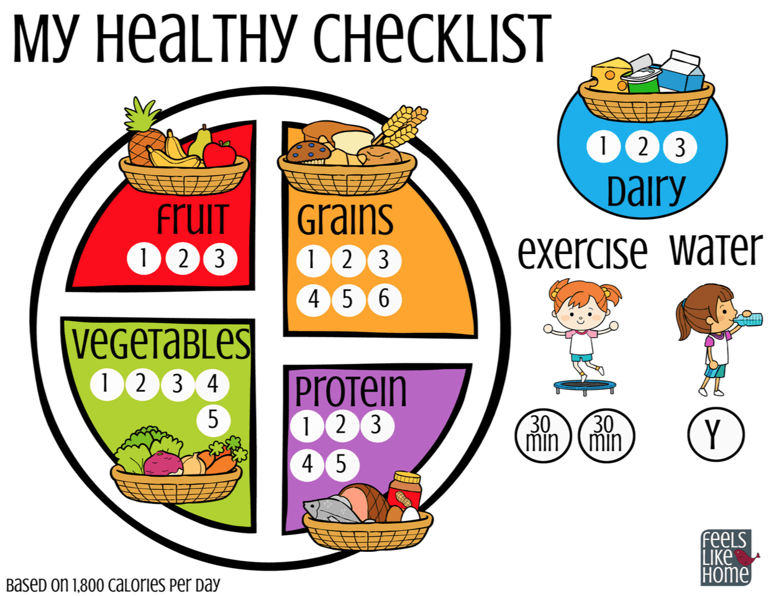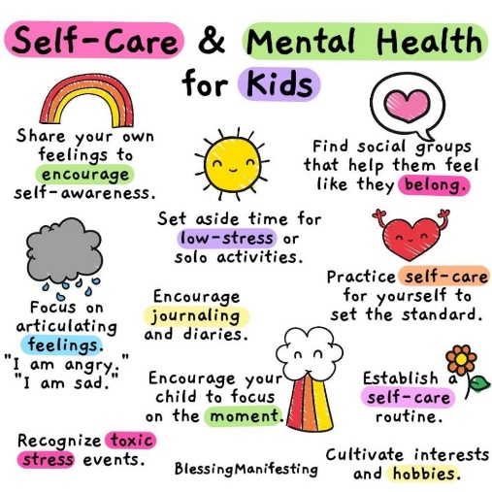
Musgrave (2017) and the World Health Organisation (2023), imply that there are connections between lifestyle, health, and well-being; that social interactions have an effect on emotional well-being; and that our well-being is reliant on the connections we make within ourselves. Children's mental health, general well-being, and way of life all improve when we support them in building resilience and healthy relationships.
This Photo by Unknown Author is licensed under CC BY-NC-ND
Source Pinterest (2025) source Ballymoney nursery school (2021)


This Photo by Unknown Author is licensed under CC BY

Health
The world Health Organisation (2025) states that to be healthy happy children they must, feel safe and secure, have access to good food and have learning opportunities from birth to develop holistically. Ensuring that nurturing care is included these elements. In addition to receiving high-quality prenatal and postpartum care, mothers must be in good health before becoming pregnant. This will maximise the growth and development of the foetus’s brain in addition to their own health. Up to date immunisations, medical attention during illness and breastfeeding are all factors in a child's early healthy development and happy childhood, which will enable them to develop and grow to their full potential. For young children to learn and explore the world around them it's also important that there are safe spaces for play and investigation, fresh air and water and a hygienic environment (WHO, 2025). The environment in which children grow up, the experiences they have and the relationships they build all have an impact on their mental health and development. Child development is the growth of a child's mind, body, emotions, and relationships over the course of their life. A child's mental health, including their cognitive, behavioural, and social well-being, is affected by this growth as well as other things like trauma and abuse. Every part of a child's health and development contributes to their overall well-being (NSPCC. 2025). The key aspects of child health are Development Focus, preventive focus and a holistic approach. Developmental Focus is Understanding the fast physical, cognitive, and emotional changes that occur during childhood and is critical for providing effective care and interventions. Preventive Focus is the emphasis is on preventative measures such as immunisations, healthy lifestyle choices, and early diagnosis of potential health problems and finally a Holistic Approach is used where Child health professionals evaluate the interconnectivity of physical, mental, and social aspects that influence a child's health (World Supporter, 2005). Early life lays the groundwork for almost all aspects of human development. A healthy, happy start in life, from conception to adolescence, lays the groundwork for a happier, healthier future. Good health is important because giving children the best start in life is critical to their future health and well-being, as well as decreasing inequities throughout their lives. Evidence demonstrates that a child's home environment and parenting style have long-term effects on their health outcomes, emotional well-being, educational accomplishment, and economic standing. Research unambiguously supports the critical relevance of early childhood development, and it is central to significant national policy recommendations.

Early life lays the groundwork for almost all aspects of human development. A healthy, happy start in life, from conception to adolescence, lays the groundwork for a happier, healthier future. Good health is important because giving children the best start in life is critical to their future health and well-being, as well as decreasing inequities throughout their lives. Evidence demonstrates that a child's home environment and parenting style have long-term effects on their health outcomes, emotional well-being, educational accomplishment, and economic standing. Research unambiguously supports the critical relevance of early childhood development, and it is central to significant national policy recommendations. The health and well-being of a child are shaped by their early years. What they do as children affects not only their mental growth but also their weight by how active they are, how well they can communicate by how social they are and their oral health and hygiene. When children do thing that are bad for them from a young age they become hard to fix in later life, for example government data show that only one in twenty children who are overweight at age five will lose weight by age eleven. The vast majority will live their whole lives with obesity and the problems that come with it (HENRY, 2025). Good health is important because giving children the best start in life is critical to their future health and well-being, as well as decreasing inequities throughout their lives. Evidence demonstrates that a child's home environment and parenting style have long-term effects on their health outcomes, emotional well-being, educational accomplishment, and economic standing. Research unambiguously supports the critical relevance of early childhood development, and it is central to significant national policy recommendations. Early life establishes the basis for future health and well-being. Early childhood experiences influence our cognitive development as well as our lifelong weight status, physical activity levels, communication skills, and oral health. It is extremely difficult to reverse the negative effects of childhood on our health; for example, government data show that only one in every twenty children who are obese at age five will return to a healthy weight by age eleven, the vast majority will spend the rest of their lives living with obesity and the consequences (HENRY, 2025). The Early Years Foundation Stage (EYFS) legislative framework requires early years providers to support children's health. This can be done by giving children good food and drinks, supporting their mental health, and promoting healthy child growth. Dental health is vital even with baby teeth. Baby teeth aid speech and language development and help children bite and eat. Good oral health prevents discomfort, infection, and inflamed gums in children. Practitioners can support the UK Chief Medical Officers by encouraging lots of ‘tummy time’ for babies and children to promote physical activity and development. Under-5s should play as much as possible, and older children should be active 60 minutes a day every day. In support of this, the government will work with nurseries to develop exciting daytime exercise activities for young children through the Daily Toddle project. To improve mental health, the MindEd website has high-quality, bite-sized information that is tailored to the needs of sports coaches, healthcare experts, teachers, police and court staff, social workers, and other professionals. It shows practitioners how to spot a child who might be at risk for a mental illness, what to do about it, and how to get that child help and support.

Wellbeing
The World Health Organisation (2025) says a favourable state that is experienced by children as well as societies is referred to as well-being. In the same way that health is a resource for day-to-day existence, it is also a resource that is determined by the conditions of society, the economy, and the environment. Children and communities can make a meaningful and purposeful contribution to the world when they have a feeling of well-being, which covers both the quality of their lives and the ability to do so (WHO, 2025). According to UNICEF (2021), every child has the right to a safe and pleasant environment as well as the right to have their basic needs such as food, clothing, and water met, as stated in Article 27 of the United Nations Convention on the Rights of the Child (UNCRC). Through these experiences, children can build a strong feeling of wellbeing that will help them deal with difficult situations in the future. Maslow proposed the hierarchy of requirements, which stated that to go on to the following levels, these fundamental wants had to be satisfied. According to Cherry (2022) and McGuire et al. (2011), Maslow's theories concentrated on what people must do to achieve happiness. Wellbeing is important for children because their personal, social, and emotional development is important for their mental development and for living a happy, healthy life. They grow by building strong bonds with important people in their lives that shape their social surroundings. Children who have strong, loving, and supportive relationships with adults and peers are better able to understand how they feel and other people’s feelings. Children should be given the tools they need to control their emotions, cultivate a positive self-image, set modest objectives for themselves, believe in their own skills, persevere, wait for what they want, and focus when needed. They will learn how to take care of their bodies, including eating a balanced diet, and how to independently manage their own needs by watching and learning from adults. Through facilitated interactions with other children, they learn how to cooperate, form strong friendships, and settle disputes amicably. These qualities will give children a safe foundation on which to succeed in school and in the future (Department for Education, 2024). There is no one definition of mental wellness. It may use it to discuss how someone is feeling, how they handle day-to-day situations, or what now feels achievable.

Being happy all the time doesn't mean you're mentally healthy or that no one is affected by what you go through. Also, just because someone is doing well doesn't always mean they don't have any mental health problems. For example, someone may have a mental health problem but be doing well right now but not have a mental health problem. Poor mental health can make it harder to do everything you need to do (Mind, 2025). Practitioners can support welling being by emphasise physical and mental wellness, as with physical health, practitioners should emphasise that mental health is normal. This starts with teaching children about the advantages of daily exercise, adequate nutrition, and enough sleep, as well as the language and knowledge to recognise the normal range of emotions everyone feels. This should help children express their feelings, talk about their self-image, health, and feelings, and whether their actions are acceptable for their settings. Practitioners should then discuss basic self-care, hygiene, health and wellbeing, and basic medical care that children may use to safeguard and promote their own and others' health (Department for Education). The beneficial two-way relationship between mental wellbeing and physical health and the mental health advantages of exercise and time outside should be highlighted. Practitioners should also talk about the benefits of having hobbies, interests, and getting involved in your community. This lesson should stress that people are social creatures and that it's good for health and well-being to spend time with others, care about their needs, and help others, even in organised groups like scouts and girl guides. When practitioners talk about the bad effects of poor health and wellbeing, like isolation, loneliness, sadness, bullying, and being alone, they can do so with a strong understanding of its good points (GOV UK, 2021).

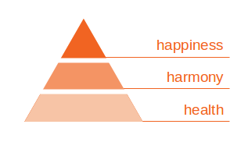
This Photo by Unknown Author is licensed under CC BY
Lifestyle
. Access to education, housing, and work, as well as your physical and mental well-being, food, and social networks, all have an impact on children's wellbeing (UNICEF, 2024; WHO, 2025). These elements frequently have an impact on leading a healthy lifestyle. Parents' input is essential for children's development, well-being, and sense of security as they often mirror their behaviour for example children with parents who smoke are more likely to do the same. Children can have the best start in life by lowering stressors, enhancing fundamental life skills, and fostering solid relationships. Ensuring children develop into physically fit adults who are emotionally stable, self-assured, and realise their full and distinct potential whatever that may be is the ultimate goal for practitioners and parents (Gov.uk, 2016). This is significant since a child's later life will benefit more from the help they receive in their early years (Gabriel A, Orenstein, Lindsey Lewis, 2022). Bowlby (1988) states a child is more likely to develop confidence if they feel safe and secure from a young age (NSPPC Learning 2021). Spending time demonstrating interest, conversing, and listening to the voice of the child without interruptions might help you develop responsive relationships with them (NSPCC, 2024). Children will naturally try to talk to professionals and parents to get their attention, so it's critical to make time to listen. Rewarding children for their good behaviour will encourage them to do it more often (Adejokun, 2020). There are several things that can affect behaviour change, such as a child’s traits, the people around them, and cultural norms . Practitioners should consider aspects such as socioeconomic position, environmental factors, and cultural norms when guiding families. Working with people from different fields, such dietitians, psychologists, and community health workers, can make behaviour modification strategies even more effective. Practitioners can make a huge difference in giving children the tools they need to start living healthier lives.

Practitioners can help children and families adopt and maintain healthy behaviours over the long term by using evidence-based methods like building collaborative relationships, offering education and resources, setting realistic goals, boosting self-efficacy, using behavioural change techniques, encouraging social support networks, taking a holistic approach, and constantly evaluating and changing interventions (Michie et al., 2013). Lifestyle medicine can improve lives when implemented from birth. Early lifestyle changes help avoid chronic diseases, improving well-being and lowering healthcare expenses. To promote these changes, parents and practitioners should apply each of the six lifestyle medicine pillars to the family's life so the child is automatically introduced to a healthy lifestyle. A whole-food healthy diet, daily physical activity, especially play, positive family and peer social connections, good sleep habits, stress management, and mindfulness for all family members are all part of this. These habits can be formed from birth by introducing fundamental concepts in clinical encounters, schools, community organisations, and everywhere a child spends time. Lifestyle medicine practitioners must advocate for these improvements to help children integrate lifestyle practices into their daily lives (Dalal M, et al, 2022).

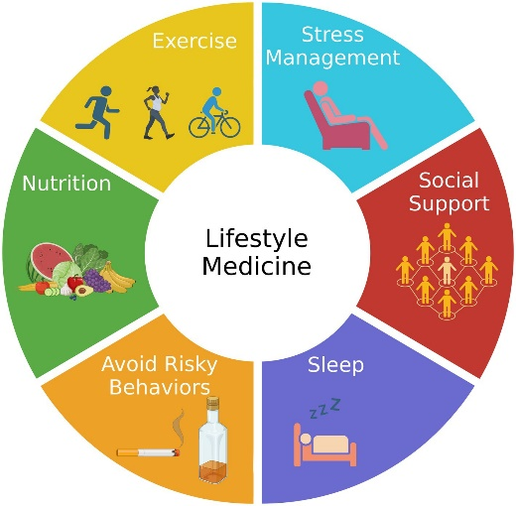
This Photo by Unknown Author is licensed under CC BY
Reference list

Adejokun, M (2020) The importance of listening to children. Available at: The Importance of Listening to Children in Early Years (Accessed 10th June 2025).
Cherry, K (2022) Maslow’s hierarchy of needs. Available at: https://www.verywellmind.com/what-is-maslows-hierarchy-of-needs-4136760 (Accessed 4th June 2025).
Dalal M, Cazorla-Lancaster Y, Chu CG, Agarwal N. Healthy From the Start—Lifestyle Interventions in Early Childhood. American Journal of Lifestyle Medicine. 2022;16(5):562-569. doi:10.1177/15598276221087672 (Accessed 10th June 2025).
Department for Education (2024) Personal, Social and Emotional Development. Available at: https://assets.publishing.service.gov.uk/media/670fa42a30536cb92748328f/EYFS_statutory_framework_for_group_and_school_-_based_providers.pdf (Accessed 4th June 2025).
Foundation years (2023) Health and Wellbeing. Available at: https://www.foundationyears.org.uk/2023/10/health-and-wellbeing-2/ (Accessed 4th June).
Gabriel A, Orenstein, Lindsey L (2022) Erikson’s stages of psychosocial development. Available at: https://www.ncbi.nlm.nih.gov/books/NBK556096/ - _article-21284_s1_ (Accessed 10th June 2025).
GOV UK (2016) Health matters giving every child the best start in life. Available at: https://www.gov.uk/government/publications/health-matters-giving-every-child-the-best-start-in-life/health-matters-giving-every-child-the-best-start-in-life (Accessed 10th June 2025).
GOV UK (2021) Physical health and mental wellbeing: primary. Available at: https://www.gov.uk/government/publications/relationships-education-relationships-and-sex-education-rse-and-health-education/physical-health-and-mental-wellbeing-primary-and-secondary (Accessed 4th June 2025).
GOV UK (2021) Physical health and mental wellbeing: primary. Available at: https://www.gov.uk/government/publications/relationships-education-relationships-and-sex-education-rse-and-health-education/physical-health-and-mental-wellbeing-primary-and-secondary (Accessed 9th June 2025).
HENRY (2025) Why a healthy happy childhood matters. Available at: https://www.henry.org.uk/whyahealthystartmatters (Accessed 2 June 2025).
McGuire, K.J. and Maslow, A.H. (2011) Maslow’s hierarchy of needs. Norderstedt: GRIN.
Michie, S., Richardson, M., Johnston, M., Abraham, C., Francis, J., Hardeman, W., Eccles, M.P., Cane, J. and Wood, C.E., 2013. The behaviour change technique taxonomy (v1) of 93 hierarchically clustered techniques: building an international consensus for the reporting of behaviour change interventions. Annals of Behavioural Medicine, 46(1), pp.81–95.
Mind (2025) What is mental wellbeing. Available at: https://www.mind.org.uk/information-support/tips-for-everyday-living/wellbeing/ (Accessed 4th June 2025).
Musgrave, J. (2017) Supporting children’s mental health and well-being. London: Sage Publications.
NSPCC (2025) Child Health and Development. Available at: Child health and development | NSPCC Learning (Accessed 2 June 2025).
NSPCC Learning (2021) What is attachment theory and why is it important? Available at: https://learning.nspcc.org.uk/child-health-development/attachment-early-years (Accessed 10th June 2025).
NSPCC Learning (2024) How can we hear and facilitate the voice of the child? Available at: https://learning.nspcc.org.uk/research-resources/practice-points-series/voice-child (Accessed 10th June 2025).
UNICEF (2021) UNICEF for every child. Available at: https://www.unicef.org.uk/about-unicef-uk/ (Accessed: 10th June 2023).
UNICEF (2024) Opening doors. Available at: https://www.unicef.org.uk/wp-content/uploads/2024/12/UNICEFUK-NSPCC-Opening-Doors-Report.pdf (Accessed 10th June 2025).
WHO (2025) Healthy Grown and Development. Available at: https://www.who.int/teams/maternal-newborn-child-adolescent-health-and-ageing/child-health/healthy-growth-and-development (Accessed 2 June 2025).
WHO (2025) Promoting Wellbeing. Available at: https://www.who.int/activities/promoting-well-being (Accessed 4Th June 2025).
WHO (2025) Social determinants of health. Available at: https://www.who.int/health-topics/social-determinants-of-health - tab=tab_1 (Accessed 10th June 2025).
World health organisation (2023) Promoting well-being. Available at: https://www.who.int/activities/promoting-well-being (Accessed 3rd June 2025).
World Supporter (2025) What are the main features of child health. Available at: https://www.worldsupporter.org/en/summary/what-child-health-100590 (Accessed 2 June 2025).

Appendix
I have not used AI

