Work Based Project Learning Contract – Interim Submission No.4

What New Skills did you learn in the period?

Throughout my time on site, I have continued to learn new skills. I have enhanced my knowledge of “4 P’s”, the system our Client use to review and approve all drawings and specifications received from Designers/Consultants. I have also learnt that

What was the highlight and why?

A highlight during this period was further experiencing new forms of construction. One example of this can be seen below - the Warmcell insulation within the wall cassettes. This is the first time I have worked on a scheme using cellulose fibre and so this was a good experience for myself. As I mainly have experience of house building, I find it beneficial and interesting to experience non-conventional construction methods such as this as I am then further developing my knowledge.

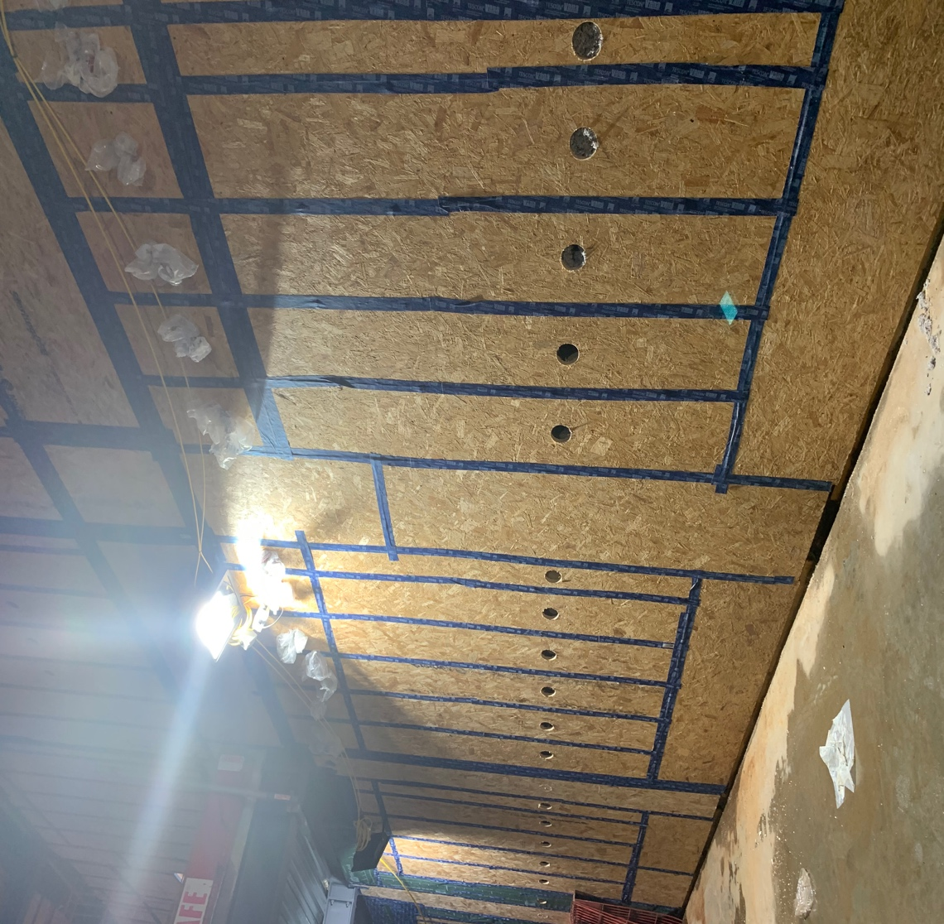

(Warmcell Insulation within the Museum Wall Cassettes)

It is also my first experience of a timber cladding system. After spending a large number of months studying drawings, it has been interesting to see the construction taking shape on site, as seen below –

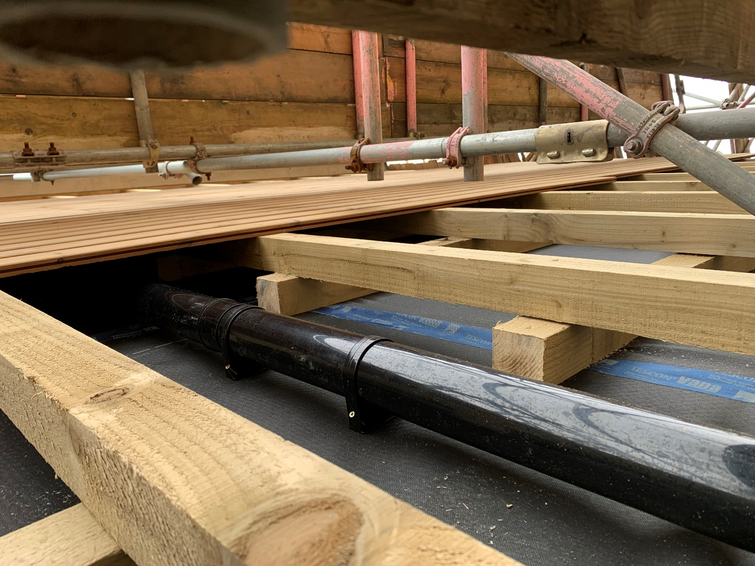
“Tyvek” breather membrane
Timber battens
Rainwater downpipe
Timber Cladding
Pro-Clima Air Tight Tape

(Rainwater pipe concealed within Timber Cladding

What parts of the task/activity were most challenging and least challenging?

One challenge encountered on site during this period has been the weather. Due to storm damage, the roofing works which were previously close to completion have been delayed. As this event led to quite a large amount of water ingress in the Museum, this further delayed the insulation pumping process as the cassettes had to be completely dry. This has had a negative effect on the contract programme, resulting in a potential 2 week delay to practical completion.

How are you progressing according to your objectives? (learning contract)

As per the goals set out in my learning contract, I have spent this period familiarising myself with the various pieces of evidencing required to achieve a Passivhaus certified building. On completion, the Passivhaus certifier will require a completed checklist, which I have now received from our Passivhaus consultant (below).

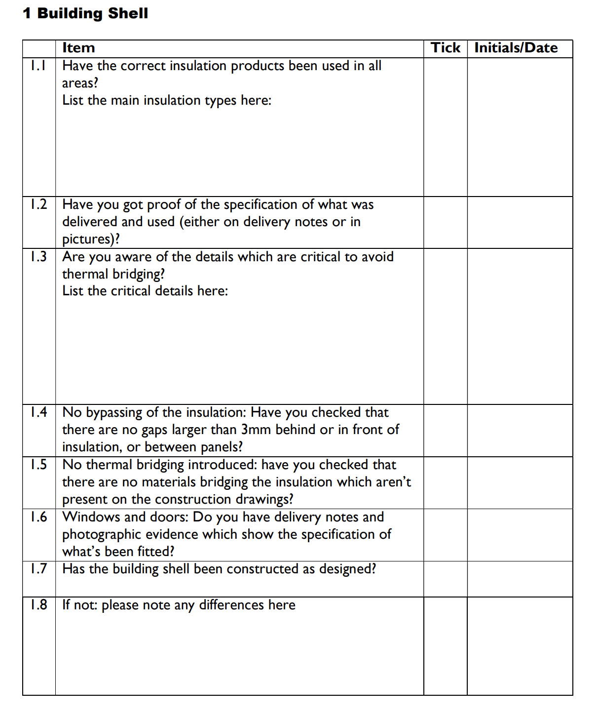
(Section from “WARM” Passivhaus Certifiers Site Checklist (2017))

This checklist has proved very useful on site as it has given the site team and I some good guidance on key items to look out for. An example of what is required for item 1.2 can be seen below where I have evidenced the use of Warmcell insulation with photographic evidence and delivery notes.

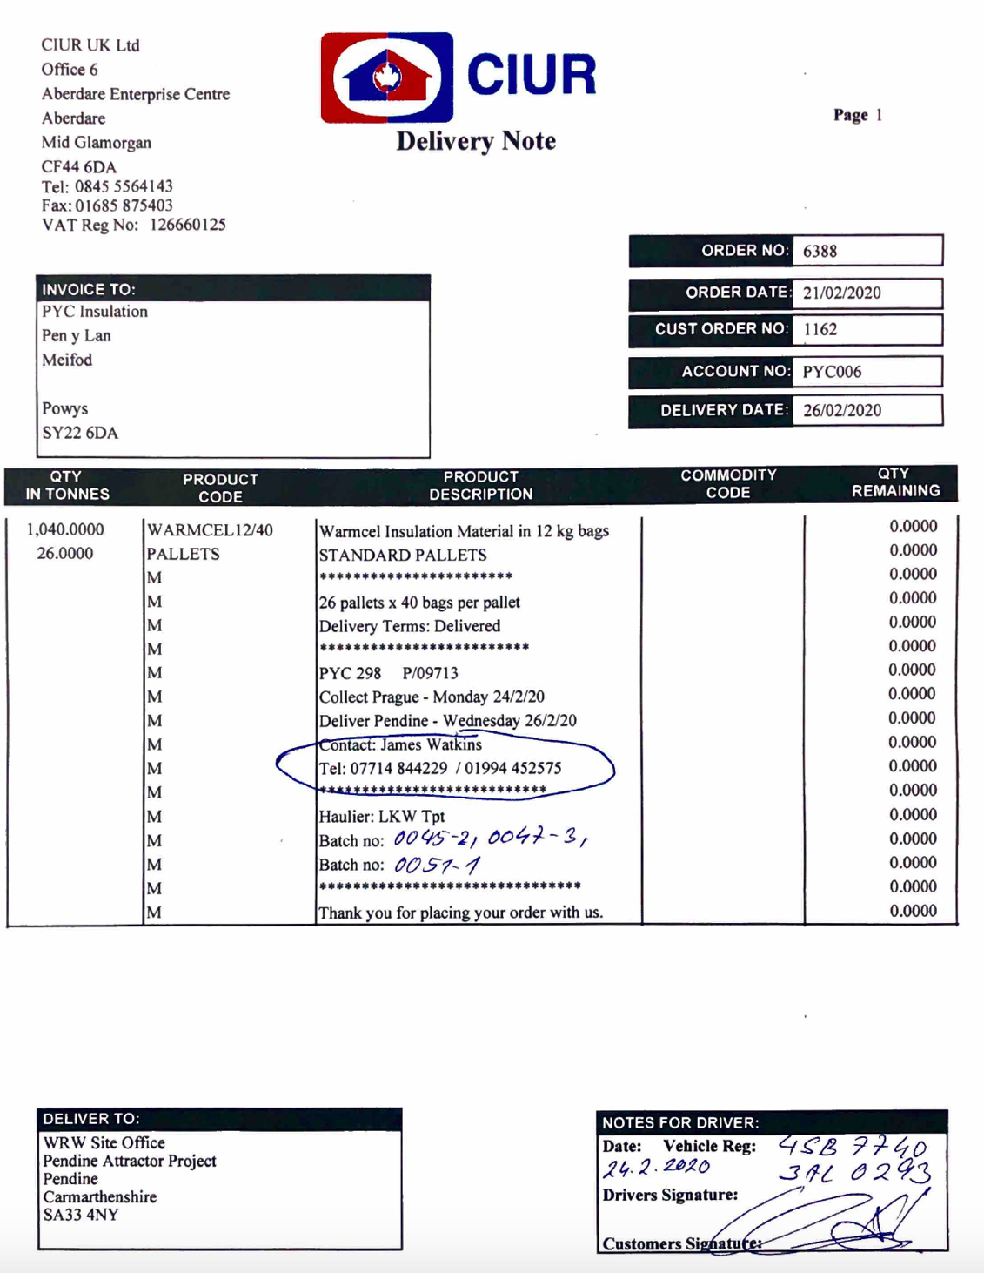

(Delivery note - evidence of product used to insulate the external walls)

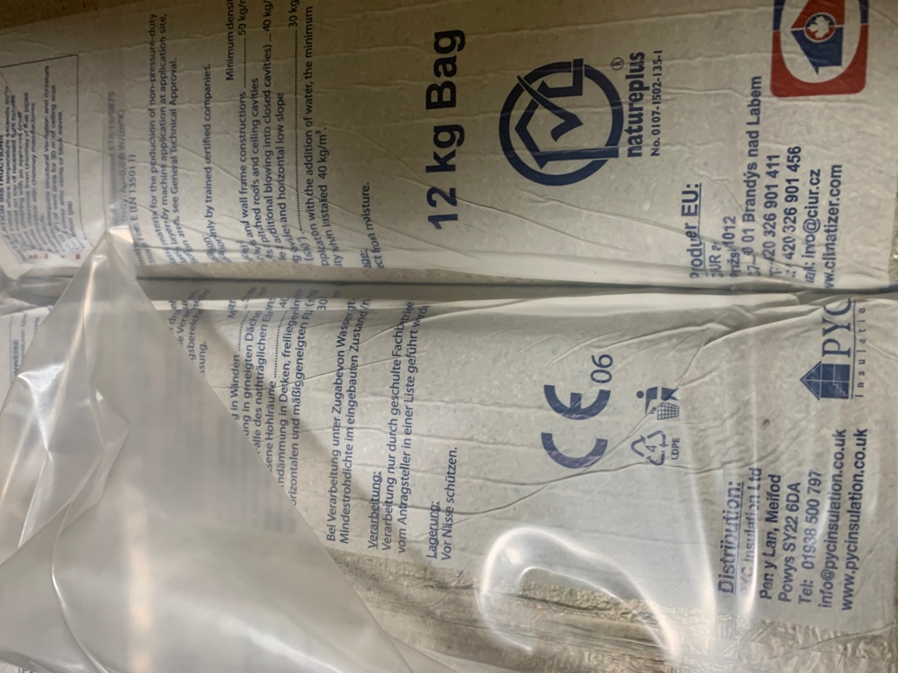
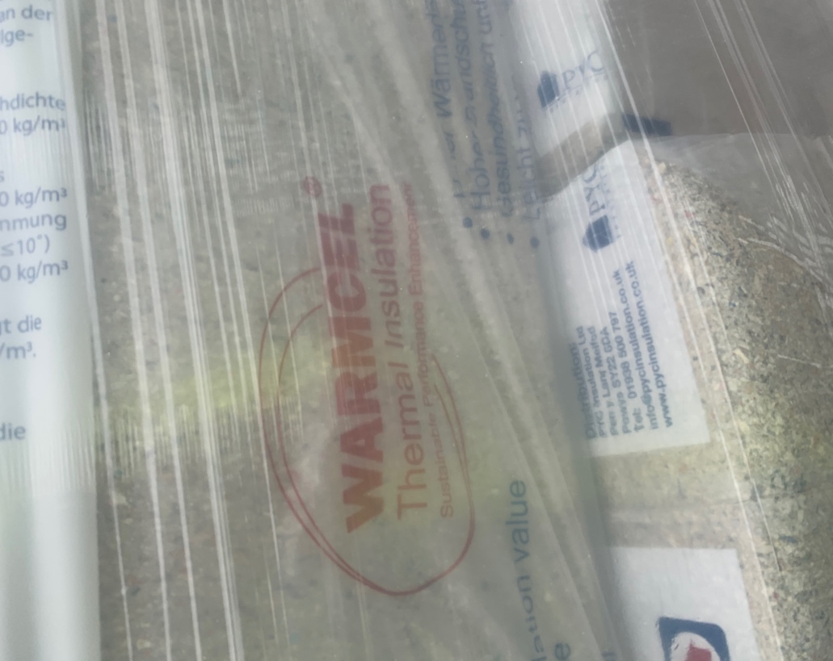
(Photographic evidence of product used to insulate the external walls)

As per the goals set out in my learning contract, I have also been studying the benefits of energy efficient buildings. I have been reading books such as “The Passivhaus Designer’s Manual: A technical guide to low and zero energy”. This has given me not only a good idea on the design and workmanship required, but also the benefits of Passivhaus buildings.

“Over 50,000 Passivhaus buildings have been constructed to date, in almost every climatic zone. Documented scientific evidence from dozens of studies has shown that deep savings in energy consumption coupled with high levels of thermal comfort have been achieved by the vast majority of these projects”
(Hopfe and McLeod, 2015)

Bibliography

- “WARM” Passivhaus Certifiers Site Checklist (2017)

- Hopfe, C. and McLeod, R., 2015. The Passivhaus Designer's Manual. Routledge, pp.1-2.

