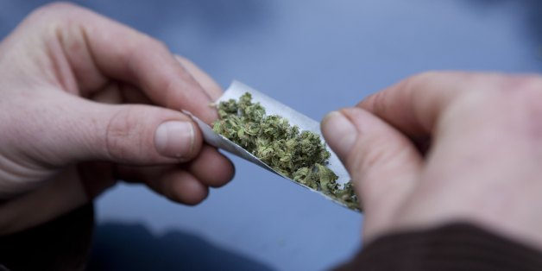
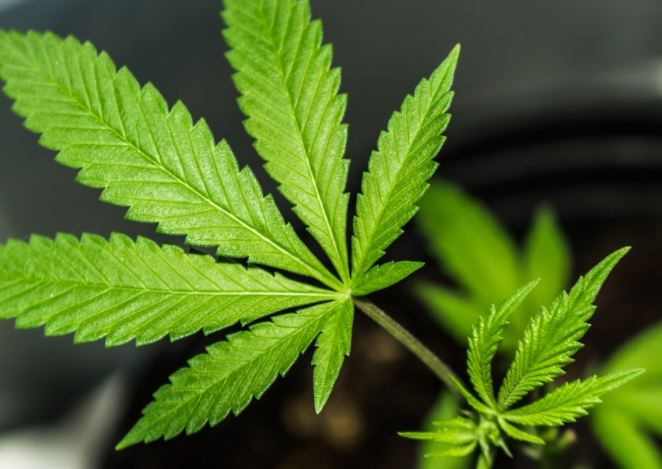

Wendy Hughes
1803214
SJYW5010
“The effects and dangers of Cannabis use”

In this practice log the author will be writing about an issue impacting young people in todays society. The author will identify young people’s health and wellbeing and how they will respond as a practitioner. Whilst working with the young people on the issue presented the author will ensure all engagement is achieved with participatory methods which is highly recognized within the youth work field. There are many issues facing young people in todays society such as teenage pregnancy homelessness, drugs and alcohol. For this practice log the author will be looking at drugs, with the main drug being Cannabis.
The issue brought to the author by a small group of young people was Cannabis use. Young peoples lives in todays society are exceedingly complex and the author will be analysing why young people engage in drug use namely Cannabis.
What is Cannabis and what does it do?
Cannabis is a popular street drug which as many different street names, such as weed, skunk, pot, grass and many more (Sclar, 2020). Cannabis tends to be a small black rock or a leafy green substance, it can look very different however it all comes from cannabis plants. Skunk is a very strong strain of Cannabis and is one of the most popular forms of Cannabis. Cannabis is put into tobacco paper and often mixed with tobacco and smoked, these are often called joints or spliffs. Cannabis can also be inhaled through a pipe which has a street name of bong. Other of ways of consuming Cannabis is by putting it into cakes known on the street as hash brownies. The affects of cannabis vary in different people. Some people become violently sick, whilst others state it chills them out. Cannabis can also make the user feel giggly; however, others say it makes them sleepy anxious and paranoid (NHS, 2017). Some users have stated it makes them eat a lot otherwise known as the munchies. Cannabis has a detrimental effect on the user’s brain and studies have suggested that the part of the brain affected is the part we use for remembering and learning (Talktofrank, 2000). The brain is not fully formed until the age of twenty-five, therefore cannabis use in teenage years can have a dangerous effect on young people learning in school, which gives poor exam results. The affects of Cannabis differ from person to person, it depends on the strength of the Cannabis, how much you have taken and if other drugs have been consumed. The feeling of being stoned can last anything from ten minutes to one hour, however if Cannabis is eaten for an example in a cake the affects can last a few hours. Cannabis stays in the blood stream for around three days, however if a lot has been consumed it can stay in the blood a lot longer. There are a lot of risks and dangers associated with Cannabis, it can increase the risks of having ling cancer and increase in heart rate and a spike in blood pressure. It can also affect fertility in both men and women, however in women it can also lead to pregnancies not reaching full term resulting in premature babies being born.
Cannabis can also make you hallucinate, mess up your sleep pattern and can cause extreme anxiety and depression. Cannabis is highly addictive, and users find it hard to stop using it, they become irritable and temperamental. Cannabis is an illegal drug and is categorized as a Class B substance. If apprehended users face being up in court receiving hefty fines and in some cases prison (Help & advice | FRANK, 2000).
So, is cannabis a nationwide issue?
The answer to that is yes. Cannabis is the most misused drug in the world it is outrageously cultivated and trafficked throughout the world. Nearly all of drug arrests globally are from Cannabis. Around one hundred and forty-seven million people consume Cannabis on a regular basis which is 2.5 of the world’s inhabitants (WHO, 2010). This article states that Cannabis use is extremely higher than other drugs such as heroin and cocaine because it has a low-cost, the greatest rapid development of Cannabis since nineteen sixty is in countries such as America and Australia.
Even though cannabis use has a negative affect on the population, studies show it also has positive affects on people with cancer. Some research done states it can cause cancer cells to die and stops cancer from spreading, however some researchers state that it can harm blood vessels and, in some instances, promote cancer cells to expand (MacMillan, 2009).
Is Cannabis a gateway drug?
When young people first experiment with drugs, cannabis is usually the drug they use first, which then increases the risk of them engaging in more dangerous drugs such as heroin and cocaine. So, research is stating that cannabis is in fact a gateway drug. Research says there is no clear evidence that cannabis creates the use of harder drugs but simply suggests that someone using cannabis is more likely to use harder drugs, however fewer people take harder drugs if they have not used cannabis previous to that. However,
there is no detailed study or quantitative research to prove or disagree with this. (The Guardian, 2015)
The author spoke to an ex colleague about the dangers of drugs and was given a detailed understanding on how cannabis was his gateway drug which then led him to experiment in harder drugs which after five years become heavily addicted to heroin. He confirmed he became highly dependent on drugs which saw him loose his family friends and career. His advice to the author was to signpost young people to multi agencies to ensure they obtain the correct advice and support. The said person is now clean of any drugs and now works as a commissioner of drug abuse.

Is it an influenced by friendship groups?
The author feels that in todays society drug abuse is highly influenced by friendship groups, and peer pressure to fit in. Young people can feel pressurised in order to be like their friends, they may not want to be involved in drug abuse, however, feel that they have too. Some feel they will loose friends, some think they will get bullied and called boring. For some young people who give into the pressure and think okay I will try it once, often become addicted. Peer pressure is not always just associated with young people and the National Office of Statistics indicates that drug abuse arises in an age range of sixteen to fifty-nine olds across England and Wales. A study conducted by the crime survey of Wales revealed that ecstasy and cocaine were also on the increase by young people, especially those aged between sixteen and twenty-four. (Crime Survey for England and Wales - Office for National Statistics, 2013) Another survey conducted by the Guardian newspaper published in 2017 states that people aged between twenty-five and thirty also feel peer pressure by friends to use drugs whilst socializing on weekends. (Peer Pressure and Drug Addiction | Cassiobury Court, 2012)
There is however encouraging peer pressure which can be supportive rather than negative, where other friends discourage young people from experimenting with drugs.
How many people using Cannabis experience mental health problems?
Cannabis use is associated to a heightened risk of anxiety, mental health and depression. Cannabis can increase the chance of developing mental health illnesses such as, schizophrenia and psychotic disorders. Cannabis users become vulnerable in developing mental health. (rethink.org 2014.) Mental health caused by cannabis use has seen a fifty percent rise in young people accessing accident and emergency departments in England and wales. In 2017 and 2018 fifty-five thousand people accessed support for cannabis addiction and mental health. With higher strengths of cannabis now on uk streets more young people have mental health issues. Mental health caused by cannabis has soared by fifty percent in five years. (bbc news 2012, (Graphs and statistics below)
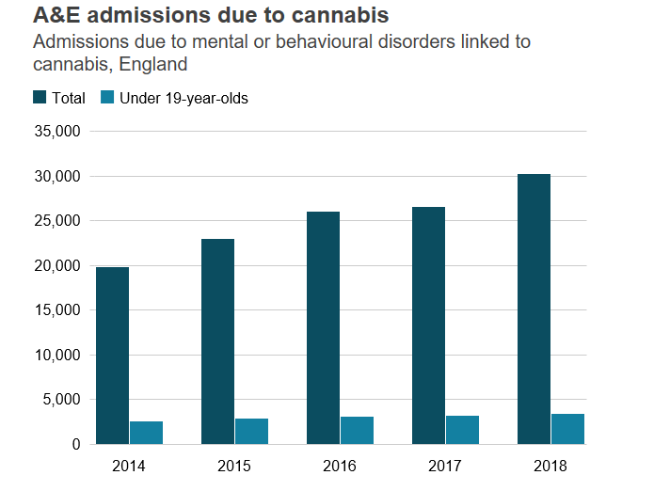

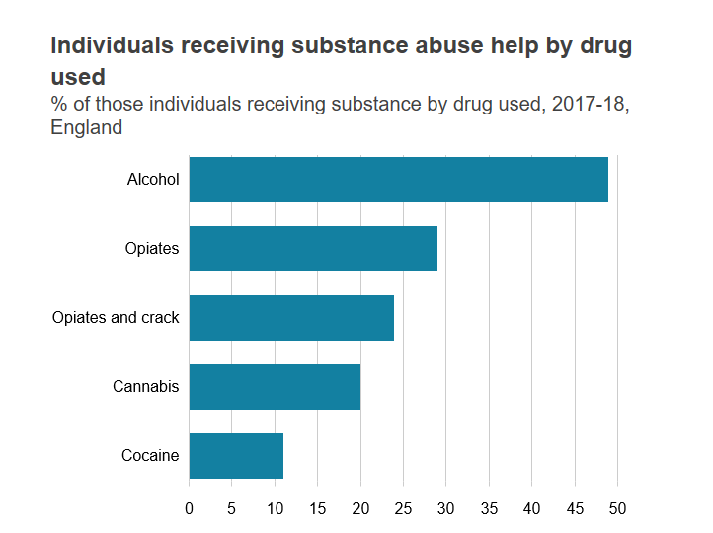

Can adverse childhood experiences influence drug abuse? ( aces)
It is clear to see that in todays society, that childhood trauma and experiences have a negative affect on young people, which lead to drug addiction and mental health in later life. During the first few years of life our brain continues to grow, therefore for children experiencing trauma have a slower brain development than others. Adverse childhood experiences can be many forms of abuse such as physical emotional and mental abuse, neglect and exposure to domestic violence within the family home. Some young people witness drug abuse at home. Other childhood experiences can also be away from the family environment such as bullying within friendship groups, these all have such a negative effect on young people’s development. A study uncovered that an aces child has nearly double the chance of having a drug addiction in adult life. There is a lot of research stating young people who have experienced trauma end up with a drug dependency, however not all children will have a drug addiction in later life. The author believes any children who experience any of these issues should be signposted to multi agencies where therapy and talks can be given to help young people stay away from drugs, in addition to give them coping mechanisms to help and guide them into healthy adults. (Linked: Adverse Childhood Experiences, Health + Addiction, 2019)

Theories and Policies
Over the last few years, the government and welsh assembly have made a substantial progress in obtaining substance misuse facilities for young people. In a former strategy for substance abuse an education programme in schools was developed to tackle drug abuse in young people. It was the all wales school liaison core programme which is presented at key phases in most primary and secondary schools across wales. The aim of the programme is to deliver information on the risks of drug abuse and offer support and guidance where needed. In addition, this programme is also presented in pupil referral units and other facilities in local authority areas in wales. (GOV.WALES, 2011) There is a substance misuse action trust that has rapidly increased and the government have been requested to focus on services for young people. In 2011 the welsh assembly government supplied further three million pounds into the substance misuse trust to ensure more support and treatment is given to young people. In addition to this the government want to ensure all children and young people can seek help and referrals to the child and adolescent mental health service also known as (CAMHS) (GOV.WALES, 2011)
The welsh government states that essential services should be constructed around the child’s requireme
nts paying attention to the most vulnerable to drug abuse. There is strong evidence to imply that having compassionate family and friends increases the outcomes for young people engaging in treatment programmes. The children’s act 2004 has a duty of care to ensure all agencies involved with a young person are always to safeguard children and young people

How will the author respond as a practitioner?
The author will respond to the drug issue brought to them by attending drug talks with the young people, that highlight the dangers and risks associated with cannabis misuse. They will also liaise with other agencies to get the maximum support put into place for the young people involved. The author has also researched how other countries tackle drug abuse with young people. Please find this useful information below.
The country researched was Finland. In the centre of a town called Pasilla in Finland a lady called Miss Elisa Prepula is the director of a drug misuse programme offering free activities for young people with drug misuse issues, she works with other agencies such as churches schools and the police to tackle the drug issue amongst the young people in Finland. One programme which is set up is for fifteen- and sixteen-year olds who are trained on issues such as cannabis abuse, they then deliver the support and advice to the younger people involved in drug misuse. (How Iceland and Finland keep youth off drugs, drinks, 2009)
A European school survey on drugs state that Finland’s drug abuse is below average. Another study in 2014 on cannabis suggests nineteen percent who participated in the study aged between fifteen and twenty-four say they have experimented with cannabis use.
Another group in Finland is called children of the station, the group engage with outreach youth work out on the streets, shopping malls and train stations where the majority of young people tend to hang out. They also travel to more high-risk places in Finland where crime and drug misuse is on a higher scale. (How Iceland and Finland keep youth off drugs, drinks, 2009)
The author believes it is vital young people have access to free leisure activities, as more often or not drug abuse stems from boredom. The author believes trusting relationships need to be built between youth workers and young people for them to engage in activities based on drug abuse. This ensures every young person builds self-confidence self-esteem and the awareness of the dangers of cannabis use It empowers young people to make knowledgeable choices with their mindsets towards drugs in a participatory approach. Lesson plans around drugs should be brought into classes, the author will ensure young people learn as much about drugs as possible. Local police along with youth workers should do school based talks to educate young people on the dangers. (Why do young people take drugs?, 2004)

Ethics, confidentiality and safe working environment
It is important that whilst working with young people around drug abuse that everything stated is done so in confidence, however in many cases this cannot be accomplished. If the young person involved appears at risk or in immediate danger other agencies need to be involved to safeguard the young person. Drug abuse programmes should be undertaken with all young people not just the ones participating in direct drug misuse. You must use a non-judgemental attitude as these issues can be very sensitive.
If a young person is using drugs in a youth work setting the youth worker must also keep themselves safe, therefore if a young person is using drugs on the premises and refuses to stop parents and guardians must be contacted and in some cases the police need to be called. If drug misuse occurs on youth work premises these should always be logged into the incident book on site. Everyone involved with working with young people must ensure all ethical guidelines are followed, by treating the young people with respect always and recognize the young people’s choices and decisions unless there is a significant threat of harm. It may not always be safe to work with young people alone during drug programmes and advice, so it is best to have another worker involved in case any issues were to occur. Relationships with young people must always obtain professional boundaries to protect the young person and the youth worker., and work with them on a voluntary basis. Youth workers must always be mindful of their own values and beliefs and in no way let these interfere whilst engaging with young people.
Conclusion.
To conclude the author believes cannabis is a significant issue amongst young people in todays society. It is vital all young people have access to support around the issues of drugs. More workshops should be provided, and drug talks should be performed in all schools at regular intervals. Even though cannabis is a class c drug the author believes this should not be the case. Cannabis is a dangerous drug which more and more are experimenting in. It leaves detrimental affects on users with long term affects such as depression paranoia and anxiety. More should be done on the impacts of cannabis use. I hope the advice in this log has been helpful.

Please find phone numbers and advice for any concerns you may have as parents.
Do not accuse your child.
Let them know you are there for them.
Let them know they can talk to you.
Set clear boundaries.
Adfam website provide advice for parents.
Charities such as family lives and young minds have live chats available online.
Net mums online provides forums.
Nhs website provides step by step guides for parents.
Mind 03001233393.
Action on addiction 03003300659.
Frank 03001236600.

REFERENCE LIST
Talktofrank.com. 2000. Help & Advice | FRANK. [online] Available at: <https://www.talktofrank.com/get-help> [Accessed 12 March 2020].
Who.int. 2010. WHO | Cannabis. [online] Available at: <https://www.who.int/substance_abuse/facts/cannabis/en/?fbclid=IwAR1reLosUZ2vDX9VUrs85hpKpzvj2mZM-13tNlv8sit5pK7BLtyOIlqlCKE> [Accessed 12 March 2020].
Macmillan.org.uk. 2009. Cannabis Oil. [online] Available at: <https://www.macmillan.org.uk/cancer-information-and-support/treatment/coping-with-treatment/

complementary-therapies/cannabis-oil?fbclid=IwAR2wODfvBzj7ix4rMx7hcNMG6WIw6CzZDNzYPHfaxyEjUfFh83qlPy2ugiE> [Accessed 12 March 2020].
Sclar, K., 2020. Street Names And Nicknames For Marijuana. [online] Rehabs.com. Available at: <https://luxury.rehabs.com/marijuana-rehab/street-names-and-nicknames/?fbclid=IwAR3sTuMEukF1aKF89fzvBJg8NNN2PJ1FCW_TKof7Ghw1a3lqZTJMGwK-Fk8> [Accessed 12 March 2020].
NHS. 2017. Cannabis: The Facts. [online] Available at: <https://www.nhs.uk/live-well/healthy-body/cannabis-the-facts/?fbclid=IwAR2Sx-11YzqSKOytlxyjUwkKj6fnA66B0aDOm05my8y00uhgfRw98XdpMN0> [Accessed 12 March 2020].
Cassiobury Court. 2012. Peer Pressure And Drug Addiction | Cassiobury Court. [online] Available at: <https://cassioburycourt.com/2019/01/peer-pressure-and-drug-addiction/?fbclid=IwAR000B-dP-EYqETr2f8lfVTWS1-pGwrCcQhp8Vjg8H2oqxCh3D6yCJ9droU> [Accessed 12 March 2020]. Ons.gov.uk. 2013. Crime Survey For England And Wales - Office For National Statistics. [online] Available at: <https://www.ons.gov.uk/surveys/informationforhouseholdsandindividuals/householdandindividualsurveys/crimesurveyforenglandandwales?fbclid=IwAR3tc2emvAv2VHxQ3uhJ2p2ZYWf2B1d8a2AkqFHvYhlQuVMf26W5CmWDToA> [Accessed 12 March 2020].
How does cannabis affect my mental health?. 2014. How Does Cannabis Affect My Mental Health?. [online] Available at: <https://www.rethink.org/advice-and-information/about-mental-illness/learn-more-about-conditions/cannabis-and-mental-health/?fbclid=IwAR1reLosUZ2vDX9VUrs85hpKpzvj2mZM-13tNlv8sit5pK7BLtyOIlqlCKE> [Accessed 12 March 2020].
The Straits Times. 2009. How Iceland And Finland Keep Youth Off Drugs, Drinks. [online] Available at: <https://www.straitstimes.com/world/europe/how-iceland-and-finland-keep-youth-off-drugs-drinks?fbclid=IwAR1QX9DOFTwgrw9ADgvAK2q_q9Ae4DBxuGoYJp-R6wfM5HL8GPCzFJ9P130> [Accessed 16 March 2020].
BBC News. 2012. How Cannabis Use Has Changed, In Seven Charts. [online] Available at: <https://www.bbc.co.uk/news/uk-47950785> [Accessed 12 March 2020].
Psychology Today. 2019. Linked: Adverse Childhood Experiences, Health + Addiction. [online] Available at: <https://www.psychologytoday.com/gb/blog/all-about-addiction/201903/linked-adverse-childhood-experiences-health-addiction> [Accessed 12 March 2020]. GOV.WALES. 2011. Home | GOV.WALES. [online] Available at: <https://gov.wales/?fbclid=IwAR1cIQ-NJfPfmZc1Au0H35PLJSOCghTYUzyim5RXQ7w98APO0zoHTha8_mY> [Accessed 12 March 2020].
DrugWise. 2004. Why Do Young People Take Drugs?. [online] Available at: <https://www.drugwise.org.uk/why-do-young-people-take-drugs/?fbclid=IwAR1qCTCH-lOxC3MvhgqvJAE7Rp7R8nLaqrmZfW8LSk_z4se0yFcfzqqM0Kk> [Accessed 16 March 2020].

