Awe and Wonder

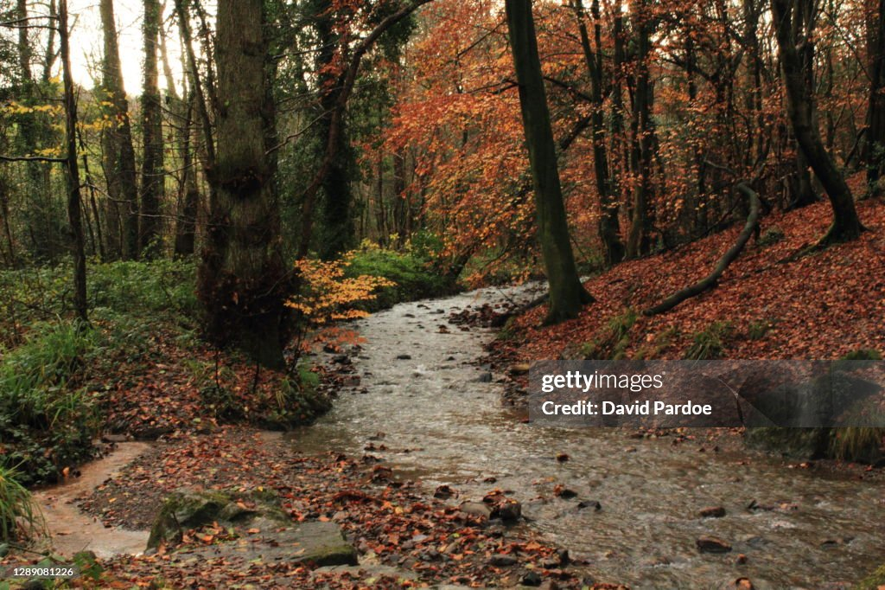
Image: D.Pardoe (2022)
Objective
Taking a class of 30 eager 6–7-year-olds to The Gnoll for an outdoor learning adventure is a fantastic opportunity to ignite their excitement for maths and science in a natural environment. With the correct ratio of supportive adults from the school, we aim to create an enriching experience where children can explore and learn in a hands-on, holistic way. Our goal is to encourage them to discover and engage with the world around them naturally, while also guiding them with specific intentions—learning about floating and sinking (bring paper to make paper boats) as well as enhancing their maths skills through real-life exploration. By integrating these subjects into their outdoor play, we hope to foster a deep, joyful connection to learning that blends curiosity with academic growth, all within the beautiful and dynamic landscape of The Gnoll.
Experience
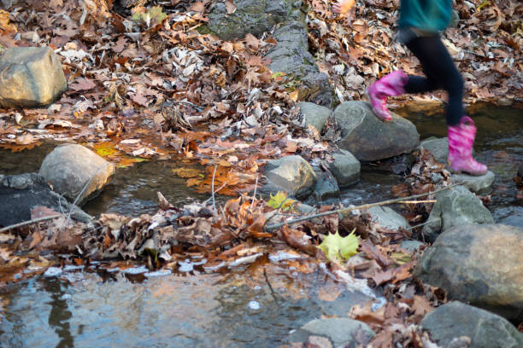
Imagine the thrill as children arrive at The Gnoll in Neath, their excitement bubbling over as they pull on their wellies, ready to explore the wonders of nature. The vibrant autumn leaves, in shades of fiery orange and golden yellow, form a soft, crunchy carpet beneath their feet as they run toward the clear, shallow stream. The water, sparkling as it flows gently over smooth, rounded pebbles, invites them to splash with joy, their boots sending ripples through the water. As they jump from stepping stone to stepping stone, counting each one with glee, they begin to engage with the world of maths, calculating distances and testing their balance.

Image: istockphoto.com (2021)
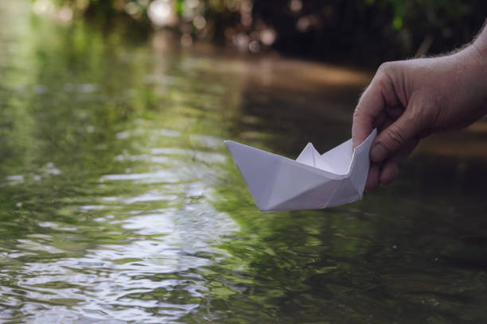
Nearby, trees stand tall, their branches twisting at curious angles, just begging to be climbed. The children, with wide-eyed wonder, scale the trunks, learning about gravity and strength as they go higher, their curiosity leading them to ask questions about how trees grow and why some lean more than others. On the hillside, the long grass sways in the breeze dipping into the deeper parts of the stream, providing the perfect setting to experiment in floating and sinking. The children gather natural items—sticks, rocks, and leaves—giggling as they predict which will float and which will sink when tossed into the stream. They even craft little paper boats, launching them into the water and watching eagerly to see if they will float downstream, all the while experimenting and learning through play. Children fold and launch paper boats into the stream, they’re engaging in an active exploration of forces and buoyancy. Through trial and error—learning from each other and from their previous attempts—they begin to understand why some boats float while others sink. This process naturally promotes a growth mindset, teaching children the value of resilience and persistence, essential skills for their overall development.

Image: iphoto.com (2022)
Furthermore, this shared activity encourages teamwork and partner work, as children collaborate to improve their boat designs, test their ideas, and celebrate each other's successes. These interactions are rich with opportunities to develop social skills, as children learn to communicate, share, and support one another. By allowing them to immerse themselves in such dynamic, hands-on learning, adults are not just facilitating play; they are nurturing essential life skills that align perfectly with the goals of the Curriculum for Wales. At The Gnoll, maths and science concepts come to life in a playful, engaging way, where children are free to be curious, to explore, and to learn through active, joyful collaboration.
This is a world where the Montessori principle of loose parts comes to life, as children use the natural elements around them—stones, leaves, sticks—to create, experiment, and learn. The Gnoll becomes an open-air classroom, where the environment is rich with opportunities for questioning and discovery. The children are not just playing; they are budding scientists and mathematicians, exploring concepts of buoyancy, balance, and force, all while their imaginations soar. Here, the outdoors nurtures not just their physical development, but their cognitive and emotional growth as well, making every moment an exciting adventure in holistic learning.

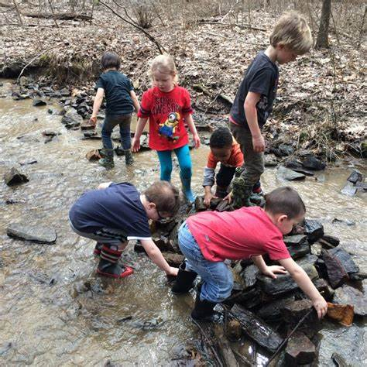
At The Gnoll in Neath, the magic of outdoor learning truly comes alive, but it is the role of enabling adults that transforms this experience into something profoundly impactful. Adults with positive, encouraging attitudes are essential in fostering an environment where children feel free to explore, climb, and get wonderfully wet and muddy without restraint. These adults understand the importance of physical activity, recognising that it is not just about movement but about discovery and learning. When adults encourage children to splash in the stream, climb the quirky-angled trees, and navigate the hillside, they are supporting the children’s holistic development, nurturing both their physical abilities and their cognitive growth.
Image: SchylkillCentre.com
In alignment with the Curriculum for Wales and the Non-Maintained Settings Curriculum, such activities play a crucial role in advancing progression steps in maths and science. As children count stepping stones or experiment with floating and sinking, they naturally engage with key mathematical concepts like number, measurement, and spatial awareness. When they launch their paper boats or drop rocks and leaves into the stream, they are not just having fun; they are beginning to understand the scientific principles of forces, buoyancy, and density. This hands-on experimentation fosters curiosity, leading children to ask questions like "Why does the leaf float but the rock sinks?" and "How can I make my boat go faster?"
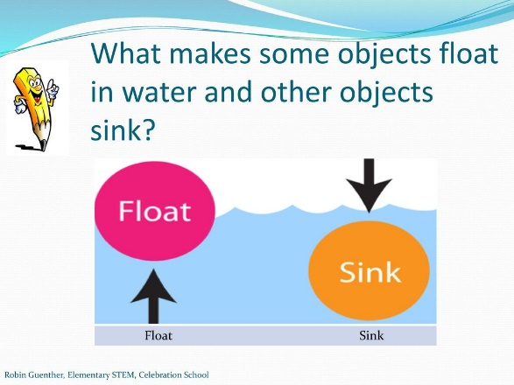

Image:

Moreover, as they experiment and problem-solve, metacognitive talk becomes an essential tool for deepening their understanding. Children might say, "Last time my boat sank, so what can I do differently?" or "If I make the boat bigger, will it hold more weight?" This self-reflective dialogue encourages them to think about their thinking, to plan, monitor, and evaluate their actions, which is key to developing a growth mindset. Such inquiry-based learning is at the heart of the Curriculum for Wales, which emphasises the importance of curiosity, exploration, and the development of critical thinking skills. Through these activities, children not only grasp foundational maths and science concepts but also build resilience, adaptability, and the ability to work through challenges—skills that will serve them throughout their educational journey and beyond.
Additionally, the freedom to explore and engage with the natural world aligns with the Non-Maintained Settings Curriculum, which prioritises child-led learning experiences. By allowing children to immerse themselves in their environment—whether it's climbing a tree, getting muddy, or investigating how water moves over pebbles—adults are supporting the development of resilience, problem-solving skills, and a deeper understanding of the world around them.
Ultimately, when adults embrace the idea that learning can be messy, active, and filled with wonder, they are not just guiding children through play; they are laying the foundation for a lifelong love of learning. The Gnoll becomes more than just a beautiful outdoor space; it becomes a dynamic classroom where maths and science come to life, and where children are free to be curious, to explore, and to understand the world through active, joyful engagement.

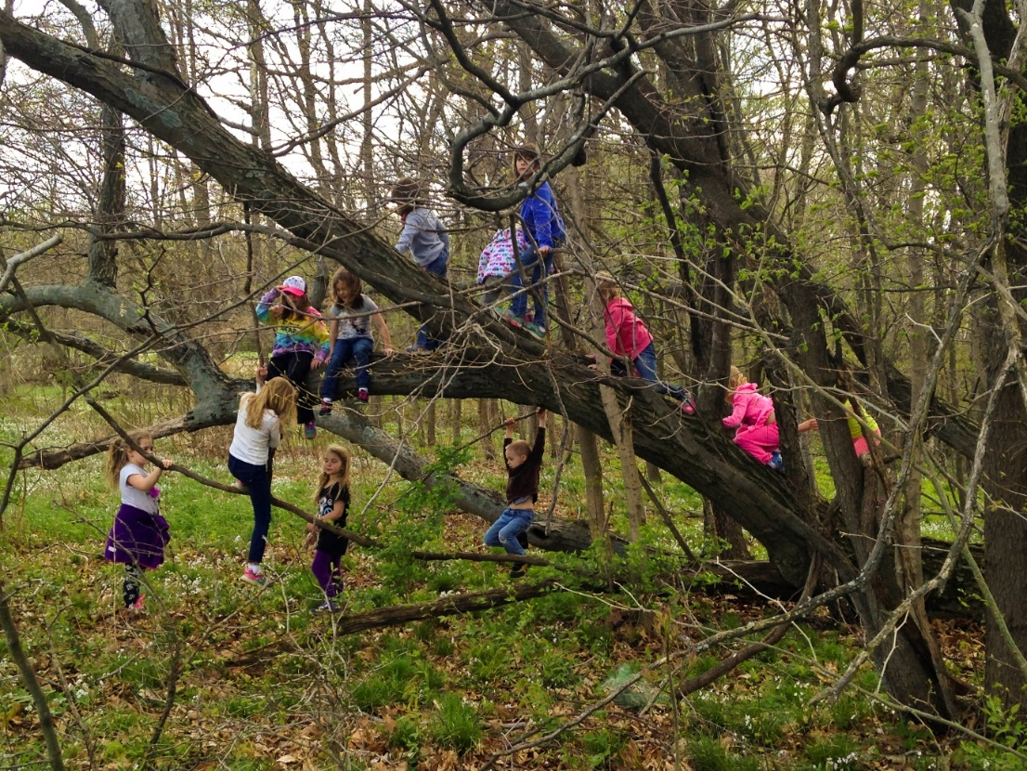
Image: Rainorshinemamma.com
Encouraging Mathematical and Science concepts in the outdoors
Outdoor learning environments, such as woodlands and streams, offer rich opportunities for engaging young children with mathematical and scientific concepts through hands-on exploration, inquiry, and discovery. This essay evaluates how adults working with early years children can support their engagement with these concepts in outdoor settings. Drawing on key developmental theories—Froebel, Piaget, Montessori, Malaguzzi, Gibson, and Nicholson—and linking to the Welsh Curriculum 2023, it also examines the practical challenges faced in settings like non-Funded Maintained Settings. Finally, the importance of sensory learning, scientific enquiry, and adult facilitation is critically analysed.
The Role of Theories in supporting outdoor Learning
Friedrich Froebel viewed nature as central to children's learning and development, believing that children learn best through interacting with natural environments (Liebschner, 1992). In woodland and stream environments, children engage with natural materials like sticks, stones, and leaves, using them for counting, sorting, and other activities that develop early mathematical skills (Waite, 2011). Froebel’s philosophy aligns closely with the Welsh Curriculum 2023, which promotes experiential, inquiry-based learning to develop essential life skills. Even in settings with limited access to expansive outdoor spaces, such as non-funded maintained settings, adults can create designated natural areas to allow children to engage in similar exploration, with features such as water trays, sandpits, or sensory gardens.
While the benefits of outdoor learning are substantial, challenges such as maintaining appropriate staff-to-child ratios must be considered. High staffing levels are required to ensure safety, particularly when working near streams or wooded areas. However, these concerns can be mitigated by careful planning, clear adult facilitation, and structured activities (Bilton, 2016). Outdoor learning environments offer vast potential for cognitive, emotional, and physical development, which outweighs these logistical challenges (Waite, 2011; Richardson, 2012).
Engaging in the real world
Jean Piaget’s constructivist theory (1952) emphasizes the role of active learning and direct interaction with the environment in cognitive development. For six-year-olds in the preoperational stage, outdoor learning provides concrete experiences that deepen their understanding of abstract scientific and mathematical concepts. Piaget argued that children develop schemas, or repeated patterns of thought, as they explore and experiment in their environment. Woodland and stream environments are rich with opportunities to develop such schemas, as children engage in activities like sorting stones by size or testing the buoyancy of natural materials in a stream (Richardson, 2012).
For instance, children can test floating and sinking by placing leaves, twigs, or pebbles in water, thereby exploring the scientific concepts of buoyancy, density, and material properties. The hands-on nature of these experiences aligns with Piaget's view that children build knowledge through physical interaction with their surroundings (Piaget, 1952). Moreover, concepts such as balance and stability can be explored when children navigate stepping stones across a stream or climb trees, where they experience gravity and forces firsthand. Encouraging children to articulate their thoughts during these activities fosters metacognitive skills, a key element of scientific inquiry (Bruner, 1986).
Furthermore, Piaget’s constructivism ties in with mathematical thinking, particularly in relation to sorting, measuring, and counting in outdoor spaces. Children can measure how far their boats float downstream, count the number of stones needed to balance an object, or sort leaves by shape or size. Such tasks help develop foundational mathematical skills, such as classification and measurement, in a way that is meaningful and engaging for young learners (Ernst, 1999).
However, outdoor learning is not without its challenges. In Curriculum for Non Funded Maintained settings, creating well-resourced natural spaces may be difficult due to financial constraints. Nonetheless, smaller-scale outdoor environments, such as sensory gardens or spaces with natural elements, can still provide valuable learning opportunities (Bilton, 2016). Even within built-up or school-based settings, the inclusion of natural materials—leaves, soil, or water—can provoke curiosity and engage children in rich, scientific dialogue (Waite, 2011).
The Environment at the Third Teacher
Loris Malaguzzi’s Reggio Emilia approach emphasizes the environment as a central component of learning, often referred to as the "third teacher" (Malaguzzi, 1996). Woodland environments, with their varied textures and natural elements, serve as powerful tools to inspire children's curiosity and creativity. For instance, children can engage in classification tasks by sorting stones, leaves, and sticks, which supports early mathematical development (Murray & Smith, 2012). Moreover, observing the growth patterns of trees or plants introduces them to basic biological processes, which can be linked to mathematical concepts such as sequences and measurement.
Natural environments also stimulate sensory experiences, which are essential for scientific exploration. The feel of cold water, the smell of damp earth, and the sight of rippling streams provoke curiosity, encouraging children to observe, ask questions, and hypothesize about the world around them. This aligns with the Welsh Curriculum 2023, which emphasizes sensory-rich, inquiry-based learning as a way to foster a deep understanding of scientific principles (Waite, 2011).
While creating rich outdoor environments in every setting may be challenging, schools and early childhood programs can integrate nature into their spaces through small garden areas or the use of natural materials indoors. These practices reflect Malaguzzi's belief in the environment as a catalyst for learning, emphasizing that even modest natural settings can provoke children’s curiosity and drive scientific inquiry (Malaguzzi, 1996).
Affordance Theory and Loose Parts Theory
James Gibson’s affordance theory (1979) and Simon Nicholson’s loose parts theory (1972) both emphasize the role of the environment in promoting exploration and learning. Woodland and stream settings are filled with loose parts—twigs, stones, leaves—that invite children to engage in open-ended problem-solving and experimentation. These natural materials provide a wealth of affordances for action and interaction, such as balancing stones to build structures or creating boats from leaves and bark to explore buoyancy (Nicholson, 1972).
Moreover, loose parts in outdoor environments encourage children to engage in STEM learning through activities that develop skills in science, technology, engineering, and mathematics (Ernst, 1999). For example, creating a boat from natural materials and testing its buoyancy in a stream introduces engineering concepts, as children problem-solve to improve their designs (STEM in Early Childhood Education, 2020). Children naturally experiment with cause and effect in these scenarios, learning from failures as they modify their designs—a process that strengthens their resilience and critical thinking skills (Nicholson, 1972).
Adults play a crucial role in scaffolding these experiences by encouraging scientific enquiry through questioning. For example, an educator might ask, “Why do you think your boat floated this time but not before?” This promotes metacognitive thinking and reflection, allowing children to deepen their understanding of material properties and engineering principles (Bruner, 1986).
Learning Through Real-World Exploration
Maria Montessori emphasized the importance of real-world, hands-on experiences in children’s learning. She believed that children learn most effectively when engaging with real materials that have weight, texture, and natural variability (Montessori, 1967). Outdoor environments naturally align with this philosophy, offering opportunities for sensory exploration and real-world problem-solving.
For instance, children might compare the weight and texture of stones, leaves, and sticks, developing an understanding of physical properties through touch. These experiences also align with mathematical thinking, as children can explore concepts like weight, density, and size, as well as sorting and classification (Early Mathematical Explorations, 2012). Additionally, the physical act of climbing trees, balancing on logs, and navigating uneven terrain supports the development of the vestibular system (balance) and proprioception (body awareness), which are crucial for overall motor and cognitive development (Breslin & Rudisill, 2011).
Adults can enhance this learning by modelling scientific inquiry and encouraging children to articulate their observations and reasoning. For example, while observing water rippling in a stream, an adult might ask, “What do you notice about the water? Why does it ripple when you throw in a stone?” Such open-ended questions provoke curiosity and promote a deeper understanding of physical forces like gravity and motion (Waite, 2011).
Scientific Enquiry- Exploring Buoyancy, balance and Stability
Outdoor environments provide an ideal setting for children to investigate scientific principles such as buoyancy, balance, and stability. For example, children might test different natural materials, such as leaves, twigs, and stones, in a stream to explore why some objects float while others sink. This introduces children to the concepts of density and material properties, allowing them to engage in hypothesis testing, make predictions, and observe outcomes (STEM in Early Childhood Education, 2020).
Similarly, activities like climbing trees or balancing on logs encourage children to develop an understanding of physical forces like gravity and balance. As they navigate these physical challenges, children engage both the vestibular and proprioceptive systems, which support overall motor development and cognitive functioning (Breslin & Rudisill, 2011). The Welsh Curriculum 2023 encourages educators to create learning environments that promote physical activity and cognitive development simultaneously, emphasizing the connection between movement and learning (Robinson, 2012).
Mathematical Thinking- Measurement, sorting and counting.
Woodland and stream environments offer numerous opportunities for children to engage in early mathematical thinking. For instance, children can measure how far their boats float downstream or count the number of pebbles needed to balance an object. Sorting leaves by shape, size and colour.
Conclusion
Outdoor learning environments such as woodlands and streams offer young children an enriching, holistic approach to education. Hands-on exploration and direct engagement with natural materials allow children to deepen their understanding of mathematical and scientific concepts in ways that are both enjoyable and meaningful. From testing buoyancy in a stream to sorting stones and climbing trees, children learn through direct, sensory-rich experiences that foster cognitive, emotional, and physical development.
The involvement of enabling adults, who facilitate exploration through open-ended questions and metacognitive talk, is crucial to children's learning. By scaffolding scientific enquiry and encouraging children to articulate their observations, adults support children in building resilience, problem-solving skills, and critical thinking. These learning experiences align closely with the Welsh Curriculum 2023, which emphasizes experiential, inquiry-based learning that develops both academic and life skills. The curriculum's focus on fostering curiosity, creativity, and holistic development mirrors the values of Froebel, Piaget, Montessori, and Malaguzzi, who all highlighted the importance of learning through real-world exploration.
Although outdoor learning presents certain logistical challenges—such as maintaining safe staff-to-child ratios and ensuring equitable access in non-funded nursery settings—the benefits of these environments far outweigh the difficulties. By creating carefully planned, nature-rich spaces within schools or early childhood settings, educators can provide children with opportunities to explore, experiment, and discover, supporting their physical development, cognitive growth, and overall well-being.
In conclusion, outdoor learning environments, coupled with skilled adult facilitation, allow children to experience learning in a hands-on, enjoyable, and holistic way. These environments nurture not only their academic growth but also their emotional and physical development, fostering a love of learning that will continue to grow throughout their educational journey.

References

Bilton, H. (2016). Outdoor Learning in the Early Years: Management and Innovation. 3rd ed. Routledge, Abingdon.
Breslin, C., and Rudisill, M. (2011). ‘The Effect of Physical Activity on Cognitive Development: An Overview’. Journal of Physical Education, Recreation & Dance, 82(6), pp. 24-30.
Bruner, J.S. (1986). Actual Minds, Possible Worlds. Harvard University Press, Cambridge.
Early Mathematical Explorations (2012). Mathematics in Early Childhood Education. Sage Publications, London.
Ernst, J. (1999). ‘Science for Young Children: The Importance of Inquiry-Based Learning’. Early Childhood Research Quarterly, 14(1), pp. 87-104.
Fiennes, C., Oliver, E., Dickson, K., Escobar, D., Romans, A., and Oliver, S. (2015). The Impact of Outdoor Learning on Children’s Academic and Developmental Outcomes: A Systematic Review. London: Institute of Education, University College London.
Gibson, J.J. (1979). The Ecological Approach to Visual Perception. Houghton Mifflin, Boston.
Growth Mindset (2020). Health and Well-being: Introduction. [online] Available at: https://hwb.gov.wales/curriculum-for-wales [Accessed 7 September 2024].
iStockphoto.com (2021). 60,900+ Child Stepping Stones Stock Photos, Pictures & Royalty-Free Images. [online] Available at: https://istockphoto.com [Accessed 7 September 2024].
Liebschner, D. (1992). Friedrich Froebel: A Selection from His Writings. Routledge, London.
Louv, R. (2008). Last Child in the Woods: Saving Our Children from Nature-Deficit Disorder. Chapel Hill: Algonquin Books.
Malaguzzi, L. (1996). ‘The Hundred Languages of Children’. In: C. Edwards, L. Gandini, and G. Forman, eds. The Hundred Languages of Children: The Reggio Emilia Approach to Early Childhood Education. Ablex Publishing, Norwood, pp. 23-27.
Maynard, T., and Waters, J. (2007). ‘Learning in the Outdoor Environment: A Missing Component in the National Curriculum?’ Educational Review, 59(4), pp. 411-421.
Montessori, M. (1967). The Absorbent Mind. Holt, Rinehart and Winston, New York.
Murray, R., and Smith, M. (2012). The Sage Handbook of Outdoor Play and Learning. Sage Publications, London.
Nicholson, S. (1972). ‘The Theory of Loose Parts’. Landscape Architecture, 62(1), pp. 30-34.
O’Brien, L., and Murray, R. (2007). ‘Children’s Connection to Nature and Its Impact on Wellbeing and Learning: A Case Study of Forest Schools in England’. Urban Forestry & Urban Greening, 6(4), pp. 249-265.
Piaget, J. (1952). The Origins of Intelligence in Children. International Universities Press, New York.
Rainorshinemamma.com (2020). Parents, Stop Worrying and Let Your Children Climb Trees. [online] Available at: https://rainorshinemamma.com/parents-stop-worrying-and-let-your-children-climb-trees/ [Accessed 7 September 2024].
Richardson, M. (2012). Creating Space to Grow: Outdoor Learning and the Early Years Foundation Stage. Routledge, Abingdon.
Robb, M., Mew, V., and Richardson, A. (2015). Learning with Nature: A How-to Guide to Inspiring Children through Outdoor Games and Activities. Cambridge: Green Books.
STEM in Early Childhood Education (2020). How Science, Technology, Engineering, and Mathematics Strengthen Learning. Routledge, New York.
Schuylkill Centre (2024). Education - The Schuylkill Centre. [online] Available at: https://www.schuylkillcenter.org/education [Accessed 7 September 2024].
Waite, S. (2011). Children Learning Outside the Classroom: From Birth to Eleven. Sage Publications, London.
Welsh Government (2022). Curriculum for Non-Maintained Nursery Settings in Wales. Cardiff: Welsh Government. Available at: https://gov.wales/curriculum-for-non-maintained-nursery-settings [Accessed 7 September 2024].
Welsh Government (2023). Curriculum for Wales. [online] Available at: https://hwb.gov.wales/curriculum-for-wales [Accessed 17 September 2024].
The Curriculum for Wales Progression Code (2021). Curriculum for Wales Progression Code. [online] Available at: https://gov.wales/curriculum-for-wales-progression-code.pdf [Accessed 7 September 2024].
Science and Technology, Curriculum for Wales (2022). Science and Technology: Designing your curriculum. [online] Available at: https://hwb.gov.wales/science-and-technology [Accessed 7 September 2024].
Mathematics and Numeracy, Curriculum for Wales (2020). Mathematics and Numeracy: Introduction. [online] Available at: https://hwb.gov.wales/mathematics-and-numeracy [Accessed 7 September 2024].
Compete

