University of Wales Trinity Saint David
Wales Institute of Science & Art


Engineering Skills Technical Report

Engineering Skills (ACHA 4022A)

Isaac Revans
2304556
April 2026
Contents
1 Introduction 2
2 Health & Safety 2
3 Security Risk Matrix 3
4 Engineers Role in Society 4
5 Problem Solving 4
6 Team Structure 5
7 Conclusion 6
8 References 6

Figure 1: ASQ Fishbone Diagram 5
Figure 2: ASQ 8D diagram 5

Table 1: Risk assessment 2
Table 2: Risk Matrix 3

Introduction
Engineering requires more than just technical knowledge to thrive within the industry. Engineers must also be able to work safely, assess risks, solve problems, communicate effectively and understand their wider responsibilities to society. This report discusses a range of key engineering skills that are important within the engineering industry. It will begin by considering health and safety in an engineering context, including risk assessments for practical activities, and the relevant rules and regulations put in place to help prevent any injuries or mistakes. This is important with modern engineering becoming more digital and connected. A security risk matrix is used to compare different threats and issues and to identify the appropriate solution. It will also discuss the different roles of engineers in society, with a focus on professional codes of conduct within companies and engineering.

Health & Safety
A practical activity undertaken at university involved using a metal lathe to machine a cylindrical piece of metal to set dimensions. This work required careful health and safety control because of the possible dangers that can occur when working on a lathe. The Health and Safety at Work ect Act 1974, which mandates that employers ensure the health, safety and welfare of employees and the public (Health and Safety Executive, 2024). Working in the university workshop, this health and safety legislation applies due to the application of providing safe equipment, supervision and training to work in a safe environment. Before working on the lathe, precautions had to be made to ensure the safety of the user. Below is a risk assessment table:
Table 1: Risk assessment
Hazard | Possible harm | Risk level | Safety measures and PPE
Rotating chuck and workpiece | Entanglement, impact injury | High | Tie back hair, remove jewellery, no loose clothing, use guards, keep hands clear
Sharp cutting tool and swarf | Cuts, puncture wounds, burns | Medium | Use a brush or tool to remove swarf, never your hands; wear eye protection
Flying chips | Eye injury | Medium | Safety glasses or face shield; machine guard in place
Incorrect setup or measurement | Workpiece ejection, damaged tool, poor accuracy | High | Check the workpiece is secure, use the correct speed/feed, and ask the technician to verify the setup
Noise and vibration | Hearing discomfort, poor control | Low/Medium | Keep the machine maintained, use hearing protection if required
Using the lathe required wearing steel-capped boots, no loose clothing, long-sleeve clothing, and protective eyewear. These are all in place to prevent damage and harm to the user in case of an incident. The lathe machinery is under the Provision and Use of Work Equipment Regulations 1998 Act. This ensures the equipment is suitable, maintained and only given access to by people who have had the relevant training to use. This is required when working with machinery and tools.

Security Risk Matrix
Modern vehicles are increasingly connected through Bluetooth, Wi-Fi, mobile applications, telematics, GPS and over-the-air software updates. This improves functionality but also increases the number of possible security threats. Vehicle cybersecurity is important because a cyberattack could affect safety, privacy, theft prevention and public confidence in connected vehicles.
Table 2: Risk Matrix
Security threat | Type | Likelihood | Impact | Risk score | Risk level
Remote hacking through connected systems, such as infotainment, telematics or mobile apps | Digital | 4 | 5 | 20 | High
Compromised over-the-air software update | Digital | 3 | 5 | 15 | High
Keyless entry relay theft | Physical / digital | 4 | 4 | 16 | High
Access to personal data through Bluetooth, apps or vehicle connectivity | Digital | 4 | 3 | 12 | Medium
Tampering with sensors, wiring or diagnostic ports | Physical | 3 | 4 | 12 | Medium
The highest risk identified is remote hacking through the vehicle’s systems. ENISA explains that attacks on smart cars can affect the safety and privacy of passengers and other road users. An engineering response would be to have security rely on more than one single control. This vehicle should include secure software design, secure and safe authentication of the drivers, online network separation between the entertainment systems and the safety systems, and regular testing. This can be done via software updates and must be verified before installation to prevent malware from being installed in the vehicle's digital software. ISO supports this approach because it sets requirements for managing cybersecurity throughout the vehicle, including design, production, and maintenance. This response to remote hacking through connected systems is holistic because it considers the full vehicle, including software, hardware, users and maintenance. It's also proportional because the strongest controls are focused on the highest risk areas, especially where the safety of the driver's data and vehicle control is at risk.

Engineers Role in Society
Engineers have a responsibility when designing to work in a professional, safe and controlled environment and ensure their product or service is held to a high standard of safety and security. Rules and regulations are put in place to ensure these standards within engineering are maintained. This is especially important within the automotive engineering industry, where design decisions can affect road safety, emissions, resource use and public trust. Two different organisations that have published a code of conduct for engineers are the Engineering Council and the Institution of Mechanical Engineers. The Engineering Council publishes the statement of Ethical Principles, alongside the Royal Academy of Engineering. This guidance is based on principles including honesty and integrity, responsibility to society, accuracy and communication. Their principle shows that engineers should consider more than cost and performance; they must also manage risk, protect people and support sustainable practices. The Institution of Mechanical Engineers also has a code of conduct for its members. It states that engineers should promote sustainable practices, engage responsibly with the environment, be aware of social and environmental factors and avoid wasting natural resources whilst having a balance between present and future needs. Within engineering, these codes are relevant because automotive transport continues to be a major source of the UK’s greenhouse gas emissions. Government statistics shows domestic transport was the UK’s largest emitting factor in 2024 (Department for Transport, 2025).

Problem Solving
Engineering teams often discover problems during the development of a new product. In the automotive industry, this could include a component failing during a test, poor fitment, overheating, vibration or excessive wear and tear. One way of solving problems within engineering is the 8D Problem-Solving Method. ASQ states that this model of problem-solving is commonly used within the auto industry, but can also be applied to many other professional fields such as healthcare, finance, and manufacturing. The benefits of this model are to ‘identify, correct, and eliminate problems, making it useful in product and process improvement.’ (ASQ, 2019). Their diagram helps break down the process into steps.
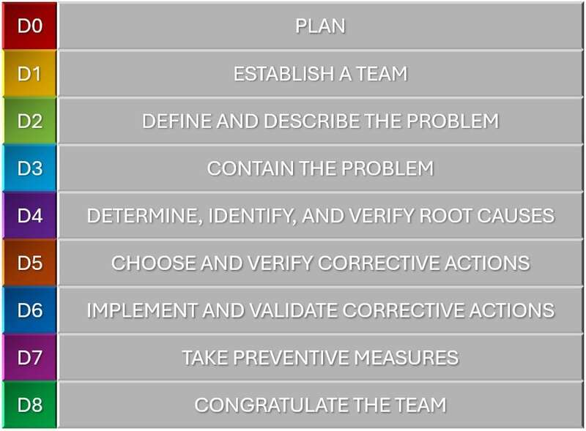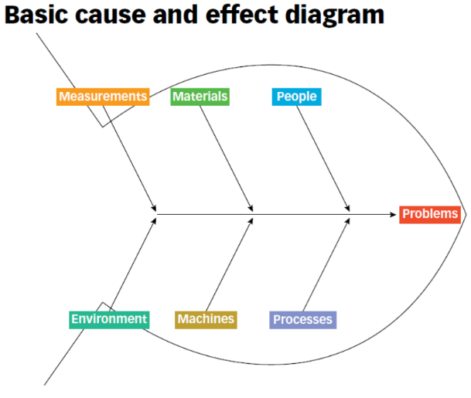
Figure 1: ASQ Fishbone Diagram
Figure 2: ASQ 8D diagram
ASQ also use a fishbone technique, which helps engineers identify possible causes of an issue or problem by placing them into categories such as machine, method, material, measurement and people. They also state that fishbone diagrams are useful for structuring brainstorming and identifying possible causes of a problem. If a machined component was outside tolerance, the engineering team could investigate the machine's condition, the operator's method, material quality, and the accuracy of measurement. This can be used to identify the root of the problem, after which the appropriate corrective measures can be implemented to prevent the same issue from recurring in the future. Lastly, a PDCA cycle (Plan, Do, Check, Act) is used to carry out change and improvements. This is suited within engineering because it allows solutions to be tested, measured and improved on.

Team Structure
Before university, I worked in my gap year at McDonald's to both earn money and experience working within a team before focusing my future in engineering. I spent a year there learning skills from members of staff when I first joined. The structure was organised into clear roles. With a business manager overseeing the store being run, shift managers planning and running shifts daily, crew trainers assisting in training new employees and helping run the kitchen when asked by shift managers, and lastly, crew members, these take up the majority of the team. The positive aspects of the hierarchical style of team structure used were that it gave defined roles, shift managers made decisions on the day for the staff, crew trainers supported those with less experience and had a smaller team leader role within the crew members. Downsides to this style were that there were too many people in charge, and it became confusing when multiple people gave orders that contradicted each other. A different team structure that could work and could be appropriate is a functional team structure. In this, members are grouped by specialist roles or areas. For example, one group could focus on one part of the chain that makes the team's job work. For instance, at McDonald's, one group could be food prep, another customer service and another on stock control. This could take the pressure off managers who are running it all at once, and helps the individuals develop a stronger skill in that specific area, instead of a smaller yet wider knowledge of how to do it all. This type of structuring could also apply in engineering, where different team members may focus on design, manufacturing, testing, quality control and project management over it all. Overall, my experience when working in teams showed me that successful teamwork comes from good communication and cooperation, with clear roles set out between the team.

Conclusion
This report has discussed a range of important skills within the engineering industry that are relevant to automotive and motorsport engineering. It has been shown that engineers must work safely, understand risks, follow legislation a use appropriate control methods when completing practical activities when using machinery, such as operating a metal lathe. This report has also shown that modern vehicles can face several security risks within their online access, including remote hacking, keyless entry theft and personal data hacks. Using a risk matrix, the highest risks can be identified and controlled through suitable engineering responses. This report has also considered the wider role of engineers in society. Professional codes of conduct from organisations such as the Engineering Council and the Institution of Mechanical Engineers show that engineers must act responsibly and ensure safety. Problem-solving methods are shown to be used within engineering to find and fix problems, for instance, using the fishbone method to find and prevent problems from happening again. Overall, engineering requires technical knowledge, safe working practices and conditions, professional responsibility, problem-solving ability and effective teamwork.

References
Health and safety Executive (2024). Health and safety at work act 1974. [online] Hse.gov.uk. Available at: https://www.hse.gov.uk/legislation/hswa.htm.
Health and Safety Executive (2024). Provision and Use of Work Equipment Regulations 1998 (PUWER) - overview - HSE. [online] Hse.gov.uk. Available at: https://www.hse.gov.uk/work-equipment-machinery/puwer-overview.htm.
Figure 1: ASQ (2024). What Is a Fishbone diagram? Ishikawa Cause & Effect Diagram. [online] ASQ. Available at: https://asq.org/quality-resources/fishbone.
Figure 2: ASQ (2019). What is 8D? Eight Disciplines Problem Solving Process | ASQ. [online] Asq.org. Available at: https://asq.org/quality-resources/eight-disciplines-8d.
Europa.eu. (2019). ENISA good practices for security of Smart Cars. [online] Available at: https://www.enisa.europa.eu/publications/smart-cars.
ISO (2021). ISO/SAE 21434. [online] ISO. Available at: https://www.iso.org/standard/70918.html.
Department for Transport (2025). Greenhouse gas emissions from transport in 2023. [online] GOV.UK. Available at: https://www.gov.uk/government/statistics/transport-and-environment-statistics-2023--2/greenhouse-gas-emissions-from-transport-in-2023.
Cybersecurity Best Practices for the Safety of Modern Vehicles. (2022). Available at: https://www.nhtsa.gov/sites/nhtsa.gov/files/2022-09/cybersecurity-best-practices-safety-modern-vehicles-2022-pre-final-tag_0_0.pdf.

