Diary - reflective document
3D Modeling
Habiba Hassaan
Professor Adam Head
University of Wales Trinity Saint David
6th of January 202

Throughout this project I have had many challenges. Getting to know and learn the Zbrush as amodeling software was my biggest challenge. I also did not have the software on my computer until the last week before the deadline, and that cause me a lot of issue.

I started the project by brainstorming what I want to model. I decided I will create an Egyptian goddess, and to get inspired by the Egyptian culture.

I researched on Pinterest and made a mood board.
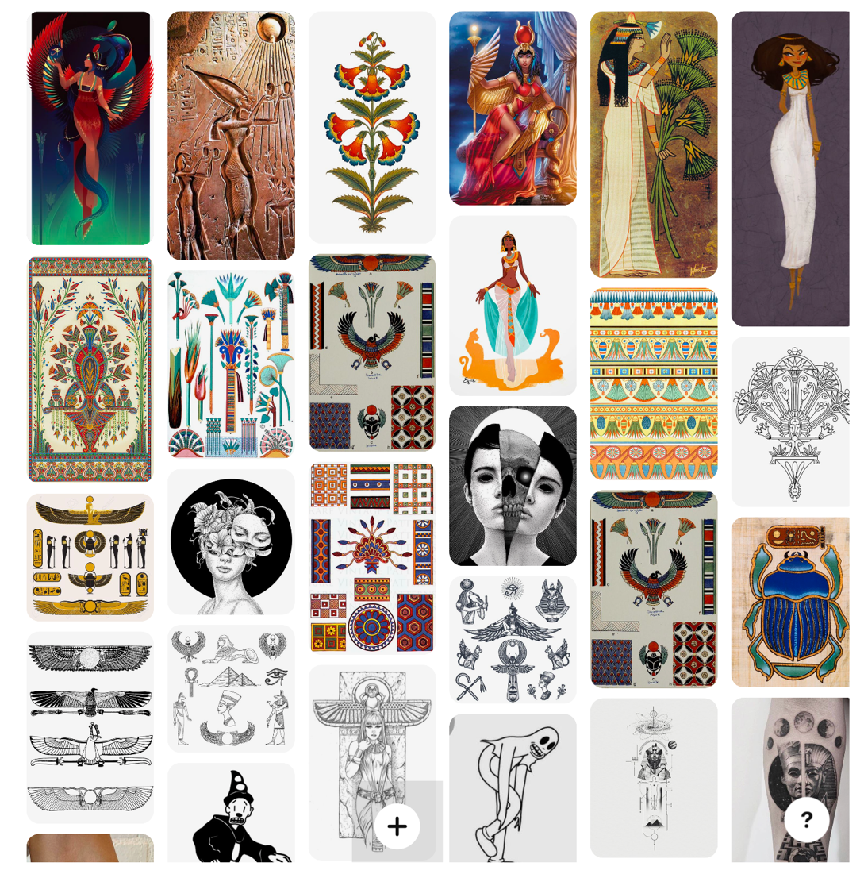
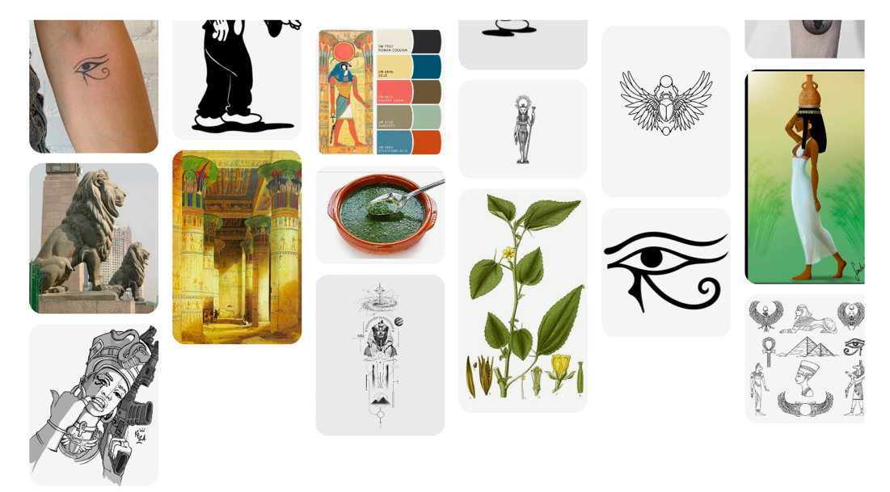

I started sketching my character and created a basic body to reference when I start modeling.

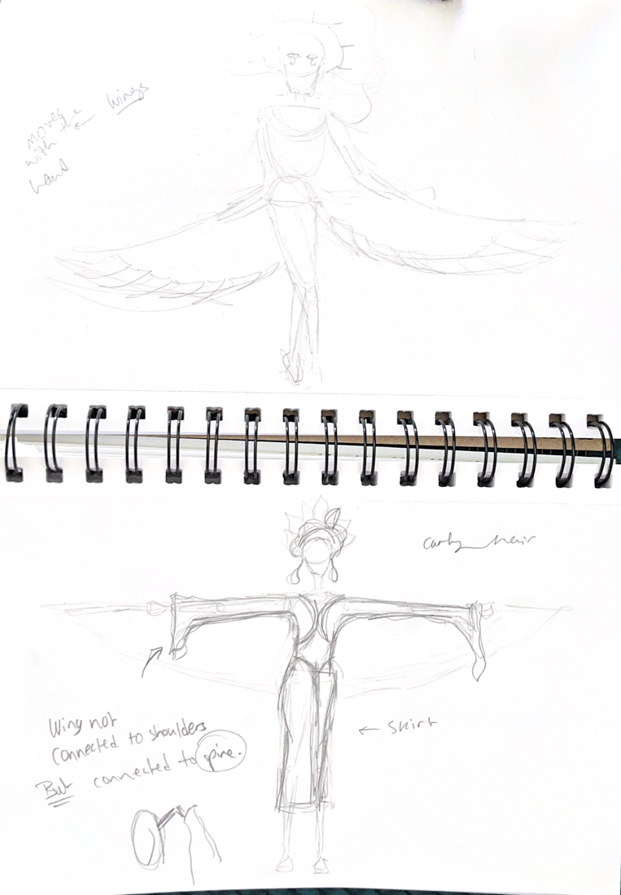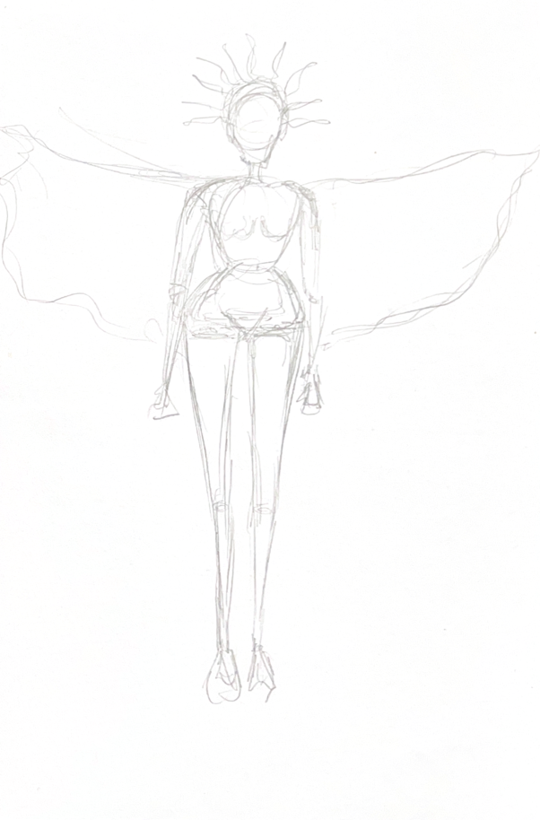

I watched a YouTube tutorial about basics of zbrush and took notes.
Getting Started with Sculpting - ZBrush for Beginners Tutorial - YouTube
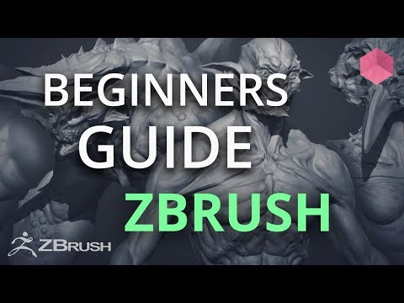
I downloaded reference of a female body that I drew (front and side view) and put it on zbrush, and started modeling by working on the torso.
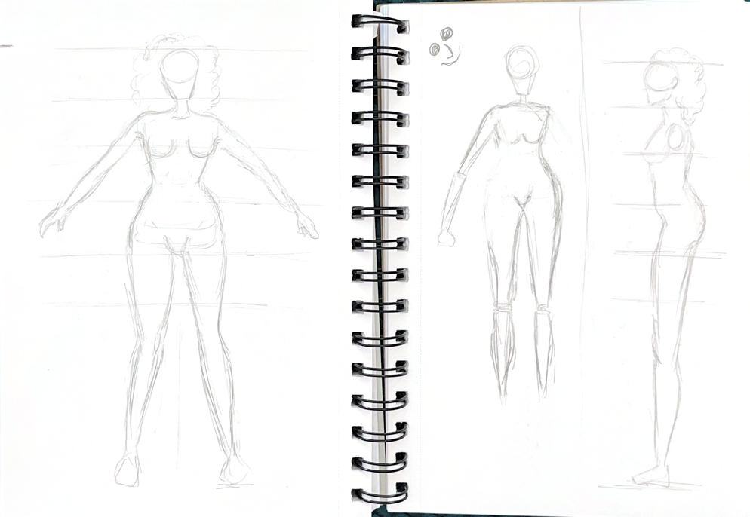

I used this photo for reference.
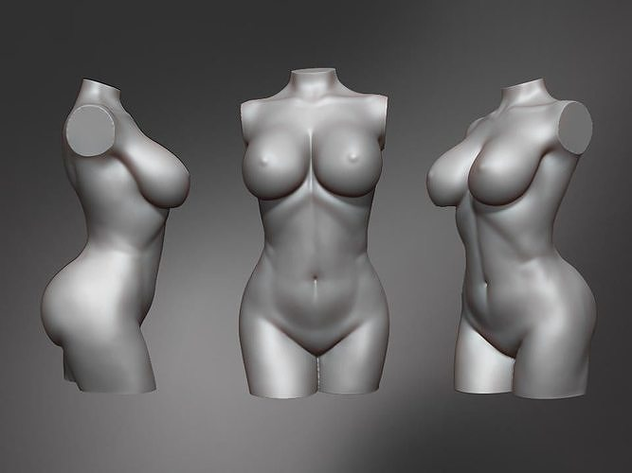

It is hard to navigate zbrush for the first time because the interface was very different from all the other software's I have used before.

I started the torso with a sphere.

During today’s class, 18th of November, Professor Adam helped with understanding the perspective tool in zbrush. I realized that I was using the wrong perspective which was making it much harder to model.
The reference front view and side view are not aligning with each other which is causing issues with working on the body. I put them on photoshop to resize them and then upload them back on zbrush.
Professor told me about the smooth tool, which helped me understand how to better develop the torso.
I started adding arms, by creating a cylinder.

On Week 20th to 27th of November, I was sick all week, and was not able to come to campus to work on my project.

On the 2nd of December I came to class at 11am. I tried to open the files I saved of my character but it opens a blank zbrush document. I had to start working on an older version.
Learned that I have to save the zbrush from file and from tool, and not from the document tab.

I added head (with sphere) and created a leg with cylinder.

Used this video to better understand perspective on zbrush
Camera and Perspective In Zbrush
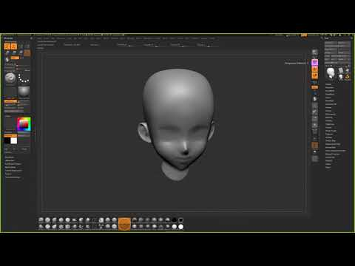

Professor teaches me about dynamesh.

After finishing classes, I purchased 6 months of zbrush for $10. I downloaded it on my Macbook
But I started having trouble opening the application. I thought maybe because I have the wacom tablet connected to it, so I disconnected it, but it still would not open

For some reason, zbrush files that I saved from my project do not open but the application itself works, so I decided to upload my files as a tool.

At one point while working on the model it turned black, I researched the issue and I learned that it was on silhouette mode, pressed V to change it back.

The arm is somehow disabled, I cannot edit it. I restarted zbrush.

I was mirroring the wings, and suddenly everything I created was duplicates, I tried deleting the duplicate but was not able to edit or change anything, it was frozen.
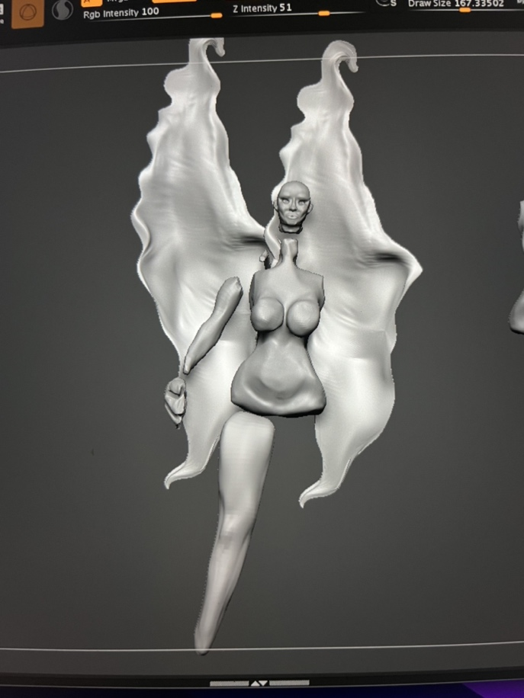

Returned to an older version of the project. Created the wings from scratch again.
Zbrush Mirror & Weld Tips and Common Mistakes - CG Obsession

Used this video to help me fix a problem.
Fix Error:" The Mesh is Composed of Multiple Subdivision. Delete Or Freeze Subdivision..." in ZBrush - YouTube
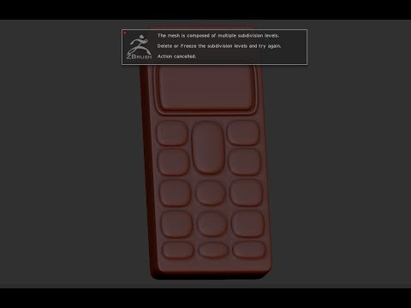

Foot was disabled and greyout out, researched and turns out it was masked.
https://www.zbrushcentral.com/t/tool-went-gray-can-not-sculpt-any-more-answered/315958

Some screenshots of my progress while working
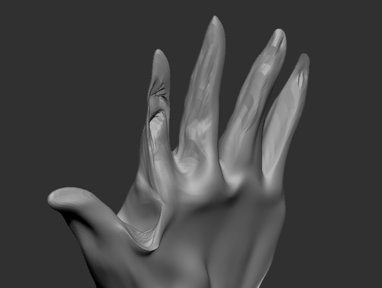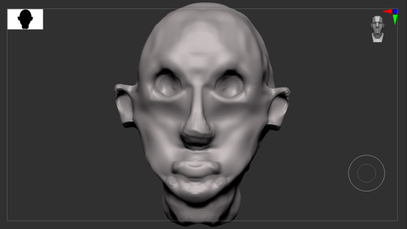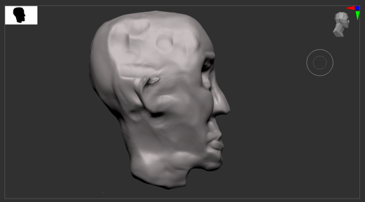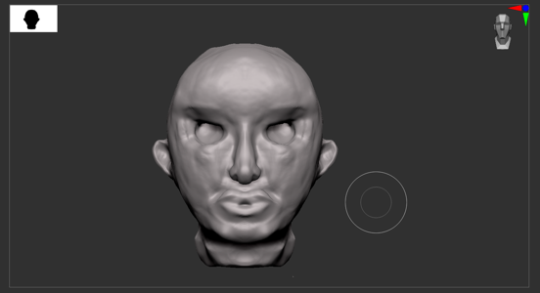

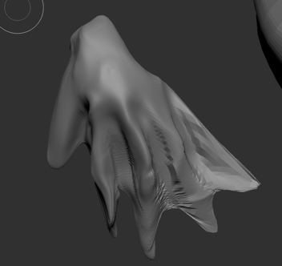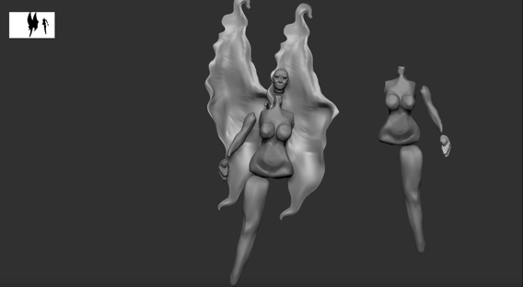

Used this video to help with wireframe
#AskZBrush: “How can I display the PolyFrames across all SubTools?” - YouTube

I learned a lot about modeling in zbrush, it took me some time to learn the interface but after working on it for a while, it is nice software to model and sculpt.

