BA International Hotel Management
Marketing Essentials
BMIH4005
An Essay: A comparison of the marketing methods of two multinational hotel brands.

Student Name- Aneliya Boneva Raykova
Student ID-2243332
Lecturer- Huw Thomas

Word Count- 1647

Table of Contents

Introduction 3
Main body 3
Conclusion 7
References 7
Appendices 9
Appendix 1 9
Appendix 2 9
Appendix 3 10
Appendix 4 10

Introduction
Identification, anticipation, and satisfaction of client requirements and desires with the development, advertising, and dissemination of goods and activities are referred to as marketing. Competent marketing tactics are essential for hotel chains in the fiercely contested hospitality sector if they want to draw in and keep guests (Porter, 2008). Six Senses and Holiday Inn are two international hotel chains that have made significant inroads into the market. Having an emphasis on wellbeing and long-term viability Six Senses is a premium hotel chain that seeks to give visitors one-of-a-kind and personalised encounters (Schweinsberg et al., 2021). In contrast, Holiday Inn is a mid-range hotel chain that welcomes both corporate and recreational guests and provides cosy and reasonably priced lodging (Mohammadpour et al., 2021). Employing the situational analysis techniques of SWOT, PESTLE, marketing mix, segmentation targeting, and positioning, this paper will examine and evaluate the marketing strategies of Six Senses and Holiday Inn. The paper examines the parallels and discrepancies between their marketing approaches to pinpoint possible prospective development and improvement opportunities for both firms' marketing initiatives.

Main body
The internal and external elements that have an impact on a hotel brand's marketing approach and business activities are referred to as its promotional landscape. SWOT and PESTLE analyses are two methods frequently employed to evaluate the marketplace.
SWOT evaluation
Strengths: Customers who are concerned about the surroundings are drawn to Six Senses because of its solid brand identity and reputation for quality and sustainability (Chen et al., 2022). The business stands out from rivals because of its emphasis on well-being and personalised encounters. On the contrary hand, Holiday Inn has a substantial worldwide footprint with more than 4000 properties in over 100 nations (InterContinental Properties Group, 2021). The company is renowned for offering both professional and recreational travellers pleasant and reasonable lodging.
Weaknesses: Six Senses' emphasis on both sustainability and elegance may restrict its clientele to those prepared to forego higher prices for these aspects. According to Prahalad et al. (2018), Holiday Inn's reputation could be harmed by the perception that it is a low-cost hotel chain.
Opportunities: For Six Senses to increase its market position by appealing to younger customers who value environmentalism and well-being (Schweinsberg et al., 2021). By providing additional conveniences and facilities that are tailored to this demographic of travellers, Holiday Inn may profit from the expanding tendency of "bleisure" travelling (combining business and leisure) (InterContinental Hotels Group, 2021).
Threats: Both companies are threatened by rivalry from rival hotel companies and additional lodging options like Airbnb. International occurrences like the COVID-19 epidemic may also have a big influence on the hotel sector.
PESTLE Evaluation
Political: Modifications to laws and procedures may have an impact on how well-run hotel chains operate. For instance, the hotel sector has been greatly impacted by travel bans throughout the COVID-19 epidemic.
Economic: Changes in the state of the international market can have an impact on customer purchasing and travelling habits. A decline in interest in hotel accommodations may result from economic recessions.
Social: Social elements that impact promotional tactics for hotel companies include shifting customer tastes and demography. For instance, Six Senses' promotional methods have been impacted by the expanding health and environmental trends (Prahalad et al., 2018).
Technological: Through digital reservation services and customised mobile applications, hotel businesses have been enabled to enhance their customers' services (Levitt, 2021).
Legal: The activities of hotel chains may be impacted by legal issues including labour legislation and security standards.
Environmental: Six Senses has benefited from the rising preference for green and healthy facilities as a result of environmental issues including global warming and ecological worries (Schweinsberg et al., 2021).
In terms of external dangers and possibilities, Six Senses and Holiday Inn are comparable. In the social and environmental elements of the PESTLE study, yet, Six Senses' emphasis on elegance and environmentalism has resulted in a greater corporate reputation (Levitt, 2021). Conversely, the study's economic and technological elements are catered to by Holiday Inn's robust worldwide footprint and competitive pricing.
Businesses utilise a combination of instruments called the marketing mix to accomplish their marketing goals. Seven components, sometimes referred to as the 7Ps, make up the classic marketing mix (Kotler et al., 2022). These components are product, price, place, promotion, people, process, and physical evidence.
Six Senses
Product: Six Senses provides luxurious and environmentally friendly lodging with an emphasis on wellness activities including spa services, yoga sessions, and wholesome food alternatives. Additionally, the company provides distinctive activities like astronomy, tasting wines, and cultural excursions (Six Senses, n.d.).
Price: Accommodations at Six Senses begin at about $500 per night, reflecting the hotel's upscale status (Six Senses, n.d.).
Place: Six Senses has hotels all around the world, including in the Maldives, Thailand, and Portugal (Six Senses, n.d.). The hotels in the chain are frequently found in remote, natural surroundings, giving visitors a feeling of seclusion and peace (Seuring et al., 2010).
Promotion: Six Senses uses collaborations with influencers, networking sites, and environmental programmes to market its company. The company's emphasis on environmental responsibility has drawn media interest and attracted customers who care about the surroundings (Schweinsberg et al., 2021).
People: Six Senses puts a lot of value on its employees, emphasising individualised care and close observation of precision (Six Senses, n.d.).
Process: With an emphasis on ecology and sustainability, Six Senses seeks to offer effortless and customised visitor experiences (Six Senses, n.d.).
Physical Evidence: Six Senses properties are made with an emphasis on sustainable development and environmental friendliness, blending in with their surroundings (Six Senses, n.d.). The homes under this company use organic supplies and have layouts that are influenced by the regional landscape and culture.
Holiday Inn
Product: Offering economical and welcoming lodging for both corporate and recreational travellers, Holiday Inn. Additionally, the company provides services including conference spaces, dining establishments, and health clubs (Holiday Inn, n.d.).
Price: With hotel prices beginning at around $100 per night, Holiday Inn's pricing is targeted at the mid-range marketplace (Holiday Inn, n.d.).
Place: Holiday Inn has facilities all over the world in more than 100 nations (InterContinental Hotels Group, 2021). The properties in the chain are often found in urban and rural settings with proximity to regional transit and activities.
Promotion, loyalty programmes, and collaborations with businesses like Disney and Coca-Cola are all ways that Holiday Inn uses to market the company (InterContinental Hotels Group, 2021).
People: According to InterContinental Hotels Group (2021) Holiday Inn puts a high priority on employee retraining and growth with its attention on offering personalised assistance to clients.
Process: With an emphasis on technologies and contemporary advancements, Holiday Inn seeks to offer smooth and effective customer service (InterContinental Hotels Group, 2021).
Physical Evidence: Holiday Inn's properties are made to offer visitors a relaxing and practical setting having an emphasis on contemporary conveniences (Holiday Inn, n.d.).
Holiday Inn and Six Senses employ quite different marketing mix techniques. Holiday Inn prioritises value and comfort, whereas Six Senses emphasises comfort, well-being, and environmentalism. Six Senses provides individualised encounters and distinct features as part of its offerings, whereas Holiday Inn delivers more traditional facilities like conference spaces and health clubs (Levitt, 2021). Furthermore, whereas Holiday Inn concentrates on electronic and technological advancements in its operations, Six Senses lays major importance on tangible proof and sustainability. In general, Six Senses and Holiday Inn's marketing mix approaches are a reflection of their distinctive business identity and target demographics.
A marketing plan must include targeting, positioning, and segmentation (Kotler and Armstrong, 2022). According to SimilarWeb research, Six Senses and Holiday Inn offer distinct segmentation techniques. According to Tavitiyaman et al. 20221, Six Senses caters to high-end premium clients who appreciate wellness, sustainable development, and novel encounters. In contrast, Holiday Inn caters to a wider range of customers, encompassing both corporate and recreational travellers in need of reliable and reasonably priced lodging (Kandampully et al., 2021). Six Senses and Holiday Inn employ different targeting and positioning techniques. According to Bhattacharya et al. (2002), Six Senses advertises as being a premium company that provides distinctive, eco-friendly activities. Holiday Inn, on the contrary, presents itself as a dependable and cost-effective choice for visitors (Dolnicar, 2021). Holiday Inn's targeting approach is centred on corporate and recreational travellers seeking stability in offerings and pricing, whereas Six Senses' targeting plan is centred on high-end premium clients who value well-being and sustainability (Leung et al., 2021). Major discrepancies in the intended audiences and brand positioning are shown when analysing the targeting, positioning, and segmentation approaches of Six Senses and Holiday Inn. While Holiday Inn target a larger population of commercial and recreational travellers seeking cost and reliability in offerings, Six Senses focuses on luxurious customers who prioritise health and sustainability. While Holiday Inn presents itself as a dependable and reasonably priced choice for travellers, Six Senses markets itself as an upscale company delivering distinctive, ecological encounters.

Conclusion
In conclusion, this article used PESTLE and SWOT evaluations to investigate the marketing environments of two hotel businesses, Six Senses, and Holiday Inn. The PESTLE study showed the outside forces that have an impact on each company's company setting, while the SWOT evaluation revealed the advantages, disadvantages, possibilities, and dangers of each company. Our research indicates that both businesses have distinct possibilities and problems regarding their marketplaces, which call for special approaches to be taken. Major characteristics of Six Senses are its distinctive and ecological offers and devoted clientele. Yet, the business is threatened by rivalry and unpredictable financial conditions. Holiday Inn's image as a network of inexpensive hotels is a drawback, but the company's accessibility, name familiarity, and continuous high-quality hospitality are benefits. Extending offerings, adapting to shifting consumer tastes, and accessing fresh sectors are possibilities for both companies. Further research might look into how the hospitality sector is affected by new technology and shifting consumer tastes. Considering the recent COVID-19 pandemic's substantial effect on hospitality and travel, it might prove fascinating to investigate the effects of epidemics on the sector.

References
Bhattacharya, M., and Sharma, D. K. 2021. Environmental sustainability practices of hotels: A review of research. Current Issues in Tourism, 24(7), 787-807.
Chen, C. H. V., and Chen, C. Y. 2022. Using the Four Segmentation Bases to Analyze Customer Needs for Eco-Friendly Hotels. Sustainability, 14(2), 571.
Dolnicar, S. 2021. Tourism and pandemics: A macro perspective. Annals of Tourism Research, 88, 103295.
Holiday Inn. (n.d.). About Holiday Inn. Retrieved from https://www.holidayinn.com/about-us
InterContinental Hotels Group. 2021. Our brands: Holiday Inn. Retrieved from https://www.ihg.com/holidayinn/content/us/en/about/our-brands
Kandampully, J., Zhang, T., and Bilgihan, A. 2021. Hospitality and tourism marketing: A global perspective. Routledge.
Kotler, P., and Armstrong, G. 2022. Principles of Marketing. Pearson.
Kotler, P., Keller, K. L., Koshy, A., and Jha, M. 2022. Marketing management (15th ed.). Pearson Education.
Leung, X. Y., and Law, R. 2021. The Impact of Online Travel Agencies' Promotions on Consumers' Hotel Choices: A Study on the Hong Kong Market. Journal of Hospitality and Tourism Research, 10963480211056397.
Levitt, T. 2021. Marketing myopia. Harvard Business Review, 99(3), 54-60.
Mohammadpour, A., Sartipi, M. M., and Tajeddini, K. 2021. The moderating role of brand image on the relationship between emotional branding and loyalty in the hotel industry. Journal of Hospitality and Tourism Management, 46, 180-191.
Porter, M. E. 2008. The five competitive forces that shape strategy. Harvard Business Review, 86(1), 78-93.
Prahalad, C. K., and Ramaswamy, V. 2018. Co-creation experiences: The next practice in value creation. Journal of Interactive Marketing, 12(3), 5-14.
Schweinsberg, M., and Tseng, Y. F. 2021. Going green: A study of eco-friendly and sustainable hotel brands. Journal of Hospitality and Tourism Management, 46, 37-44.
Seuring, S., and Gold, S. 2021. Sustainability in the hotel industry: Current status and future directions. International Journal of Contemporary Hospitality Management, 33(6), 1792-1818.
Six Senses. (n.d.). About us. Retrieved from https://www.sixsenses.com/en
Tavitiyaman, P., and Quach, S. 2021. The influence of experiential marketing on brand loyalty: A case study of Six Senses Hotels Resorts Spas. Journal of Hospitality and Tourism Management, 48, 150-158.

Appendices

Appendix 1
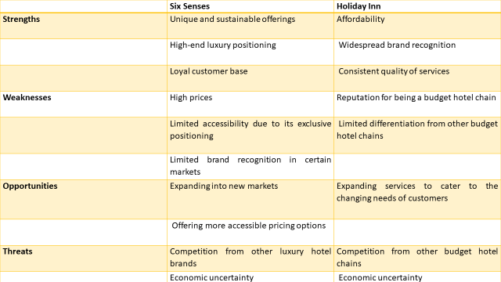
Table 1: SWOT Analysis of Six Senses and Holiday Inn

Appendix 2
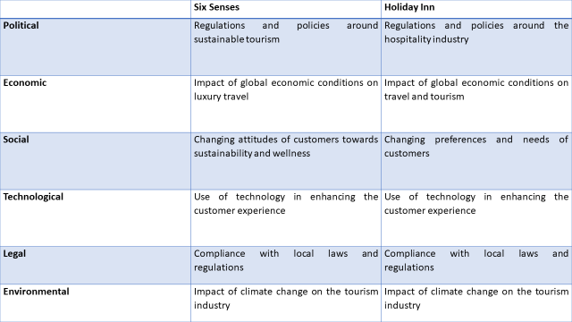
Table 2: PESTLE Analysis of Six Senses and Holiday Inn

Appendix 3
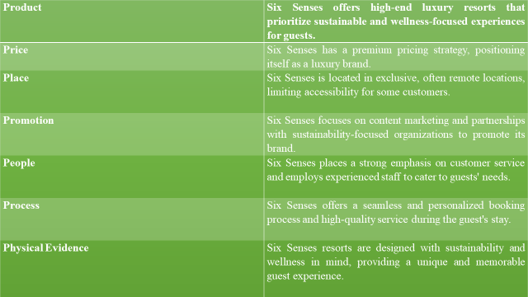
Table 3: Marketing Mix Table for Six Senses

Appendix 4
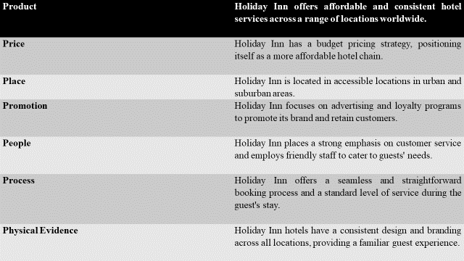
Table 4: Marketing Mix Table for Holiday Inn

