Developing a Venture plan for sustainable delivery and longevity
Ocean Breeze Airbnb short term rental venture

Executive summary
Ocean Breeze is a short-term rental business located in Gower Peninsula that aims to provide individualised, outstanding lodging experiences. The conscious, which mainly relies on Airbnb, caters to young professionals, couples, and families looking for accommodations that are comfortable, adaptable, and visually appealing. The business positions itself between low-cost rental and upscale boutique lodging by combining smart technology, luxurious interior design, and concierge-style services. Ocean Breeze can attract interest in a diverse but distinct market group given its hybrid positioning. A two-year plan centred on platform diversity, pricing optimisation, and occupancy growth is used to address sustainability. The company uses booking information, reviews, and guests’ feedback to continuously improve its service offering through a data-driven learning strategy. Financial forecasts show consistent revenue growth and profitability by the second year, supported by rising demand and cost management. The growth of a brand and the possibility of expanding into other properties increase long-term viability. In a competitive hospitality industry, Ocean Breeze demonstrates a reliable and scalable approach that maintains a balance between customer experience, operational effectiveness, and financial sustainability.
Introduction
In the rapidly changing short-term rental market, where digital platforms like Airbnb have revolutionised conventional accommodation arrangements, Ocean Breeze is an entrepreneurial venture. The transition from standard hotel experiences to customised, adaptable stays has given independent operators the opportunity to offer unique value. This venture plan objective is to show how Ocean Breeze can attain long-term viability and sustainable delivery over a two-year time frame. In this context, sustainability refers to the company’s capacity to sustain stable occupancy, generate a profit, and adjust to shifting market conditions. This plan assesses Ocean Breeze’s operational strategy, market positioning, business model, and financial sustainability. Additionally, it uses a learning-based strategy to make sure that data, customer input, and performance measurements are used to influence decisions.
Product overview and context
Ocean Breeze works in the quickly growing short-term rental market, which has been reshaped by websites like Airbnb. Modern travellers are increasingly drawn to experience-driven stays, favouring distinctive, cosy, and flexible accommodation over traditional hotels. Located on the scenic Gower Peninsula, the business benefits from its proximity to to renowned attractions such as Three Cliffs Bay and Rhossili Bay, both of which draw significant tourist interest. This prime location supports strong seasonal demand, particularly during the summer months when visitor numbers peak. Ocean Breeze addresses a clear gap in the market by offering affordable luxury accommodation that combines comfort, thoughtful design, and personalised service. Its family-friendly features, integrated smart home technology, and fully equipped living spaces make it appealing to a broad demographic, including families, couples, and remote workers. Despite these advantages, the business faces notable industry challenges. Demand fluctuates throughout the year due to seasonality, and competition from other short-term rentals and traditional hospitality providers remains intense. Furthermore, reliance on digital platforms risks related to commission costs and changing visibility algorithms, which can directly affect booking. To navigate these challenges, Ocean Breeze adopts a lean and adaptable business model focused on operational efficiency, differentiation, and continuous development. This includes implementing dynamic pricing strategies to respond to market trends, building strong brand identity through consistent guest experiences, and exploring direct booking channels to reduce dependency on third-party platforms while improving long-term profitability and customer loyalty (Hostway, 2026).
Market and competitors
Customers can choose from a variety of lodging options in the fiercely competitive short-term rental industry in Swansea and The Gower Peninsula. Independent Airbnb hosts, boutique hotels, and traditional companies that provide comparable services at different pricing points are competitors. Competitors include establishments like Keeper’s Cottage, which accommodates group reservations, and Crwys Farm, The Dairy, which caters to families with pet-friendly accommodation. Additionally, hotels like the Dragon Hotel offer other options for both business and leisure travellers (Hostify, 2023). Ocean Breeze sets itself apart by providing a blend of elegance and affordability, accompanied by individualised services and modern facilities. While rivals might compete on location or cost, Ocean Breeze value is found in providing a reliable, excellent guest experience. The growing quantity of listings, which heightens price competitiveness, is a major problem in this industry. But this also presents a chance for companies that can keep outstanding customer ratings and develop strong brand identity. Ocean Breeze can get a competitive edge by emphasising quality, client satisfaction, and customised marketing strategies (Mensis, 2024). Furthermore, Ocean Breeze can strengthen its position by using digital marketing techniques such as social media engagement, search engine optimisation, and partnerships with local attractions to enhance visibility. Developing loyalty programmes and encouraging repeat bookings can also stabilise revenue during off-peak seasons. By continuously analysing competitor performance and adapting to changing consumer preferences, Ocean Breeze can remain agile and innovative. This proactive approach not only improves market positioning but also ensures long-term sustainability in an increasingly saturated and competitive industry (Airroi, 2026).
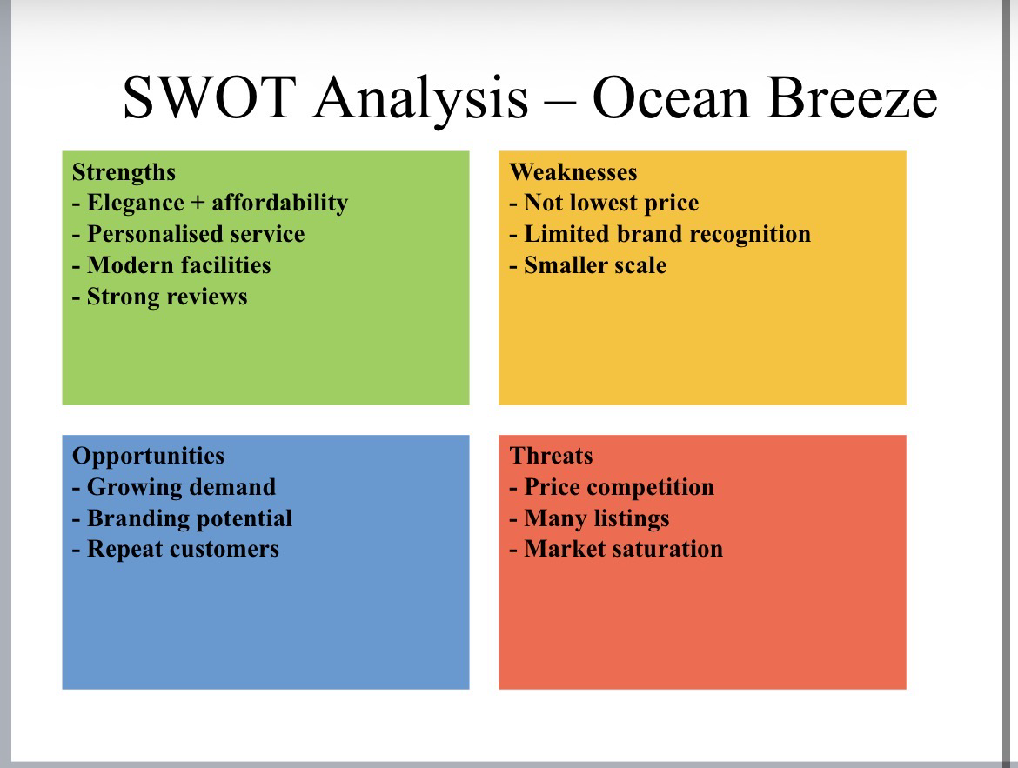

Sales and marketing strategies
Digital platform integration, brand positioning, and consumer involvement are the cornerstones of Ocean Breeze’s sales and marketing approach. Airbnb is the main sales Channel since it facilitates the booking process and gives access to a substantial global customer base. To boost visibility and lessen reliance on a single channel, the company will grow beyond Airbnb to platforms like Booking.com and Vrbo. By lowering commission costs, the creation of direct booking websites will increase profitability even more (Scribd, 2026). Digital engagement is the main emphasis of marketing initiatives, which include influencer collaborations, social media campaigns, and user-generated content. These tactics work especially well when aimed at younger audiences, who make up a significant segment of the market. Pricing is crucial in order to draw clients; warmth has a competitive pricing plan that falls between £70 and £150. To maximise revenue during peak periods and maintain occupancy during slower months, seasonal changes make sure that rates reflect demand. The diagram below shows Ocean Breeze’s marketing plan (Baringa, 2026). In addition, Ocean Breeze can enhance its marketing effectiveness by investing in search engine marketing and targets online advertising to reach specific customer segments based on travel preferences and behaviour. Email marketing campaigns can be used to nurture relationships with previous guests, offering personalised promotions and updates to encourage repeat bookings. Collaborating with local businesses and tourism organisations can also strengthen brand visibility while adding value to the guest experience through exclusive offers or packages. Furthermore, analysing customer data and feedback allows Ocean Breeze to refine its marketing strategies continuously, ensuring they remain relevant and competitive. By integrating these approaches, the business can build stronger brand recognition, improve customer retention, and achieve more consistent long-term growth (Mohammed, O., 2026).
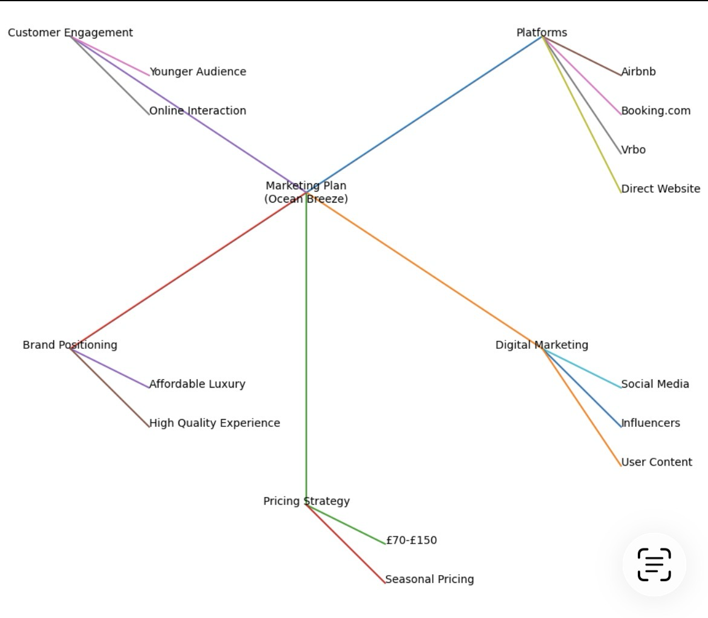

Operations
The Owner of Ocean Breeze is in charge of overseeing day-to-day operations, client relations, and financial planning under a flat organisational structure. Flexibility and quick decision-making are made possible by this structure, but dependency challenges are also introduced. Important tasks like cleaning, maintenance, and marketing are contracted out to third-party suppliers to increase operational sustainability and efficiency. This lowers workload and operational complexity while enabling the company to maintain excellent service standards. The facility is kept up to a high standard, guaranteeing everyone’s comfort, safety, and cleanliness. Wi-Fi, entertainment systems, and automated check-in procedures are examples of smart house technology that improve customer satisfaction and enhance operations. Standardised protocols, such as cleaning schedules, maintenance plans, and guest communication methods, are put in place to guarantee consistency in service delivery. These solutions facilitate scalability and allow the company to grow without sacrificing quality (Breezeway, 2020). Additionally, the business can strengthen its operational effectiveness by introducing performance monitoring systems to evaluate the quality of outsourced services and ensure accountability among third-party providers. Regular training or clear service guidelines for contractors can help maintain consistency and align external partners with the brand’s standards. Implementing property management software can further streamline bookings, scheduling, and communication, reducing administrative burden and minimising errors. As the business grows, Ocean Breeze may also consider hiring part-time staff or a property manager to reduce dependency on the owner and improve resilience. These enhancements would support long-term efficiency, ensure continuity of service, and position the company for sustainable expansion in a competitive market. The diagram below shows Ocean Breeze’s organisational structure (The Investment Association, 2023).

Manager
Omrakha
Marketing
(Outsourced)
Cleaning services
(Outsourced)

Strategy for longevity
Three interrelated pillars_customer value, operational resilience, and scalable growth_ are the key to Ocean Breeze’s long-term viability. Together, these components guarantee that the company can adjust to shifts in the market while preserving steady performance and customer satisfaction.
Customer experience as competitive advantage
A key component of Ocean Breeze long-term success is customer satisfaction. Service quality is acrucial success aspect because ratings and reviews have a significant impact on visibility and booking prices on sites like Airbnb. By providing individualised guest communication, maintaining high standards of cleanliness and maintenance, and offering value-added services like welcome packages, Ocean Breeze aims to maintain a minimum rating of 4.8 stars. In addition to improving visitor experience, this strategy fosters repeat business and customer loyalty, which lessens the need for expensive new client acquisition. Furthermore, actively responding to guest feedback, both positive and negative, demonstrates professionalism and a commitment to continuous improvement. Encouraging satisfied guests to leave reviews can further strengthen online reputation and boost search rankings on booking platforms. Ocean Breeze can also personalise stays by remembering guest preferences and and offering tailored recommendations for local activities, creating a more memorable experience. These efforts not only increase customer satisfaction but also contribute to stronger brand trust, helping the business stand out in a highly competitive market while driving long-term growth and profitability (Brochado and Troilo, 2017).
Data-driven pricing and revenue optimisation
To maximise revenue as well as regulate demand variations, a dynamic pricing strategy is necessary. In order to maintain occupancy levels, prices rise during peak periods like the summer and fall during off-peak seasons, as shown in figure 1. This strategy guarantees steady occupancy during slower times while maximising revenue during moments of high demands. Booking trends, competitor benchmarking, and platform data will be used to adjust price decisions over time, enabling more precise and responsive revenue optimisation (Skim, 2026).

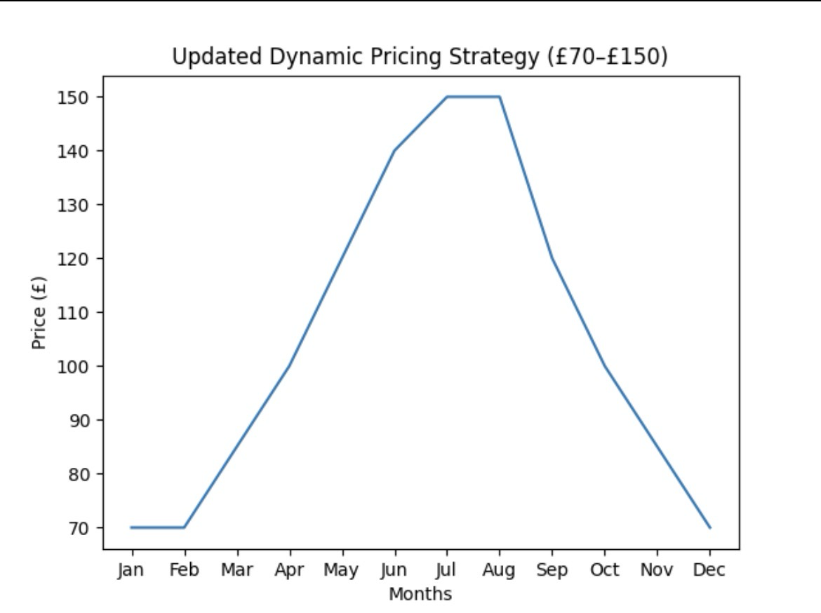
This chart shows pricing strategy ranging from £70 to £150, allowing Ocean Breeze to maximise revenue during peak seasons while maintaining competitive pricing in off-peak periods.

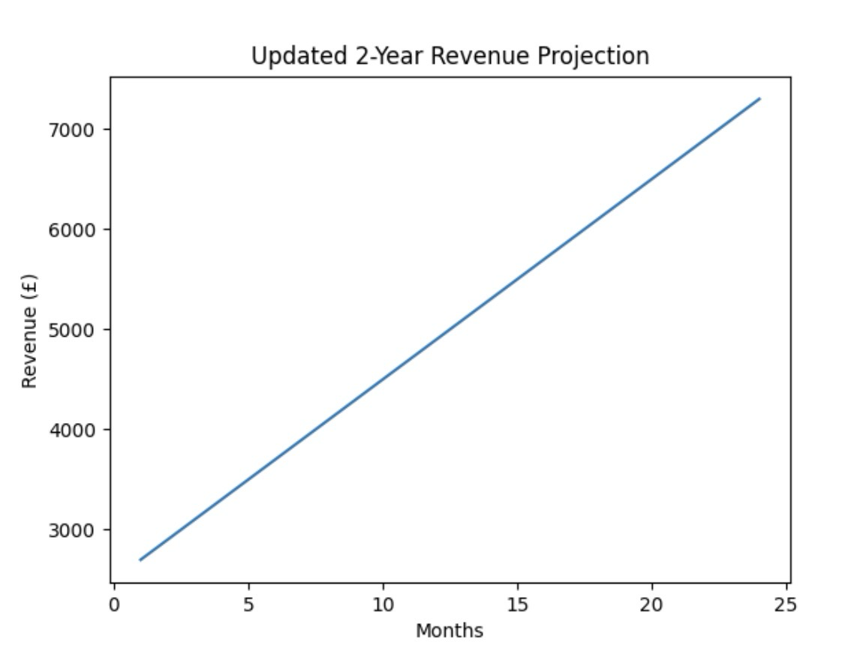
This chart demonstrates increased projected revenue growth, reflecting the impact of an enhanced pricing strategy and improved occupancy rate.

Platform diversification and risk reduction
Ocean Breeze currently relies heavily on Airbnb, which is useful but carries some dependency risk. The company intends to increase its presence on other platforms, including Booking.com and VRBO, in order resilient. A direct booking website will also be created to lower commission expenses, strengthen brand autonomy, and enhance client retention. This diversification approach improves long-term stability and reduces exposure to platform-specific risk. In addition, Ocean Breeze can further reduce risk by investing in its own digital marketing channels, such as search engine optimisation and email marketing, to drive traffic directly to its website (Light House, 2021). Building strong online presence through consistent branding and customer engagement will help establish trust and recognition beyond third-party platforms. The business may also benefit from forming partnerships with local tourism organisations and businesses to generate referral traffic. By gradually increasing direct bookings and balancing multiple sales channels, Ocean Breeze can achieve greater financial control and ensure more sustainable growth over time (Platform strategies, 2025).
Brand development and market positioning
Ocean Breeze would like to become a well-known brand that is connected to comfort, reasonably priced luxury, and customised experiences. To accomplish this, the company will leverage targeted marketing techniques, such as influencer partnerships, user-generated content, and social media campaigns on Instagram and TikTok. These initiatives will increase brand awareness and foster consumer trust, two important factors in long-term growth and competitive positioning (GL infotech, 2026).
Operational sustainability and efficiency
Although the current flat organisational structure offers flexibility, it also increases reliance on a single person, which creates a risk of development. Key operational duties like cleaning and maintenance will be outsourced in order to address this, and automated methods like messaging apps and self-check-in will be implemented. Standard operating procedures will also be created to guarantee efficiency and reliability. These steps will minimise the chance of burnout while increasing operational sustainability (Oakwood International, 2026).
Scalability and growth strategy
The goal of Ocean Breeze’s long-term strategy is to diversify into a portfolio of properties. Financial performance, occupancy rates, and general market demand will all serve as the basis for this growth. Instead of being driven by high-risk, quick scaling, growth will be gradual and evidence-based to ensure that expansion stays sustainable (Ocean Breeze Investment, 2021).
Business model canvas
Figure 2 illustrates how Ocean Breeze creates and delivers value through its key partnerships, activities, and customer relationships. The model highlights a platform-based distribution approach, customer-centric service delivery, and revenue generation through bookings and additional services. This integrated model supports both operational efficiency and long-term value creation.
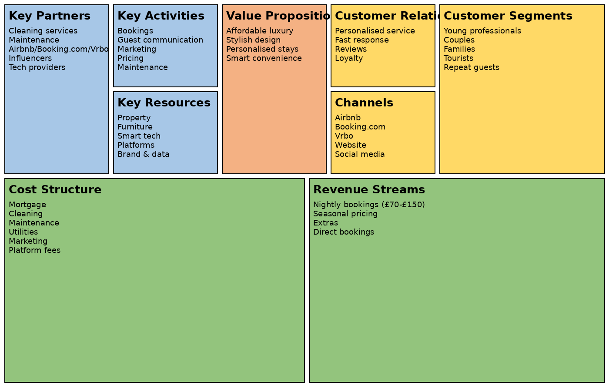

Viability, finance and resources
Scalable revenue streams and cost control are key components of Ocean Breeze financial sustainability. A £30,000 personal investment and mortgage financing for a £300,0000 house with a £500 monthly repayment make up the initial funding. Nightly reservations, which range in price from £70 to £150 based on demand, generate revenue. Improved occupancy rates and pricing optimisation are the main drivers of the predicted revenue growth over a 24-month period, as seen in figure 3. Repayment of a mortgage, utilities, maintenance, cleaning, and marketing are significant expenses. The company is anticipated to break even in the first year and turn a profit by the second, despite these costs. However, a number of challenges need to be taken into account, such as platform dependence, intense rivalry, and seasonality (Smartness, 2025). Ocean Breeze will use dynamic pricing techniques, diversify across several booking channels, and make brand development investments in order to reduce these risks. These actions will promote sustainable financial performance and strengthen resilience. See the financial statements in appendix 1; it includes cash flow forecasts, Profit and loss, and the balance sheet (Site minder, 2026).
Implementation and learning loop
Ocean Breeze uses a build, measure, learn, approach to generate ongoing development and flexibility. The initial launch phase (0-6 months) will be committed to evaluating pricing methods, gathering guest feedback, and improving the Airbnb listing. This stage lays the foundation for making decisions based on data. The company will improve the customer experience, increase marketing efforts, and adjust price based on information collected throughout the optimisation period (6-12 months). Enhancing productivity and boosting market presence are the main goals of this phase (Iglu Studio, 2025). Lastly, Ocean Breeze will introduce a direct booking platform, grow through a variety of distribution channels, and assess prospects for portfolio extension during the growth phase (12-24 months). Learning mechanisms including revenue performance, occupancy rates, and customer feedback will be regularly tracked throughout all phases. This guarantees that decisions continue to be supported by evidence, improving both the quality. Of services and financial results (Thin Slices. 2024).
Conclusion and recommendations
Ocean Breeze presents a scalable and sustainable venture with strong market potential, driven by increasing consumer demand and adaptable business operations. To ensure long-term success, the company should prioritise platform diversification to reduce dependency on a single sales channel and expand its reach to broader audiences. Strengthening brand development through consistent messaging, customer engagement, and clear value propositions will help build loyalty and recognition in a competitive market. Additionally, improving operational efficiency such as streaming production, inventory management, and fulfilment will support profitability and growth. These strategies should be reinforced by continuous data-driven improvement, using analytics to monitor performance, understand customer behaviour, and refine decision-making. By combining innovation with strategic planning, Ocean Breeze can position itself for sustainable expansion and resilience in a dynamic business environment.

Appendices
Appendix 1 financial statements

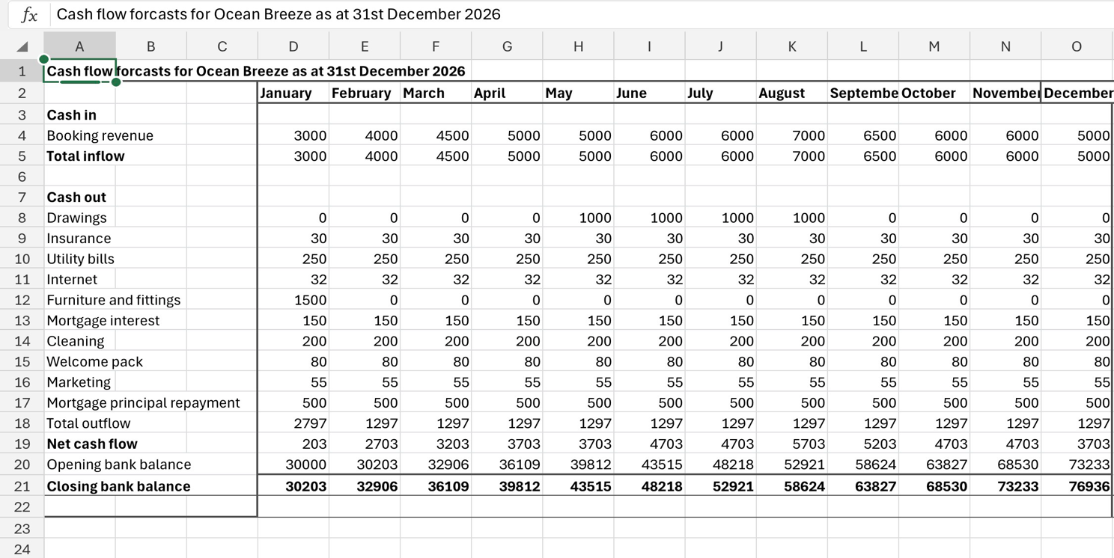

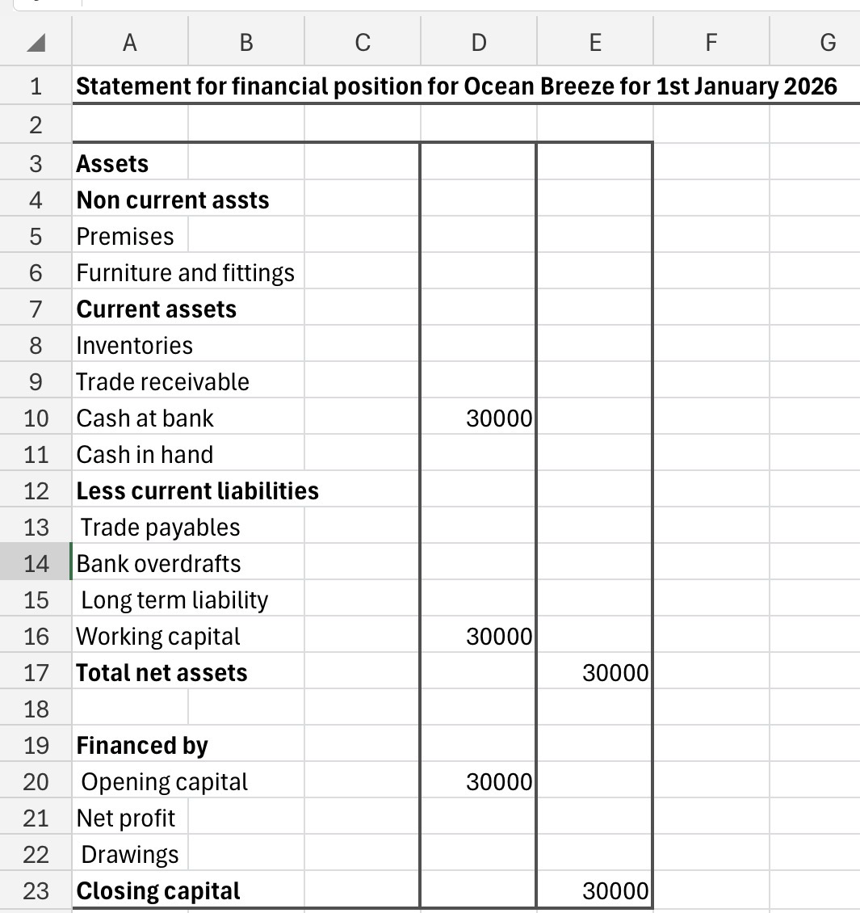

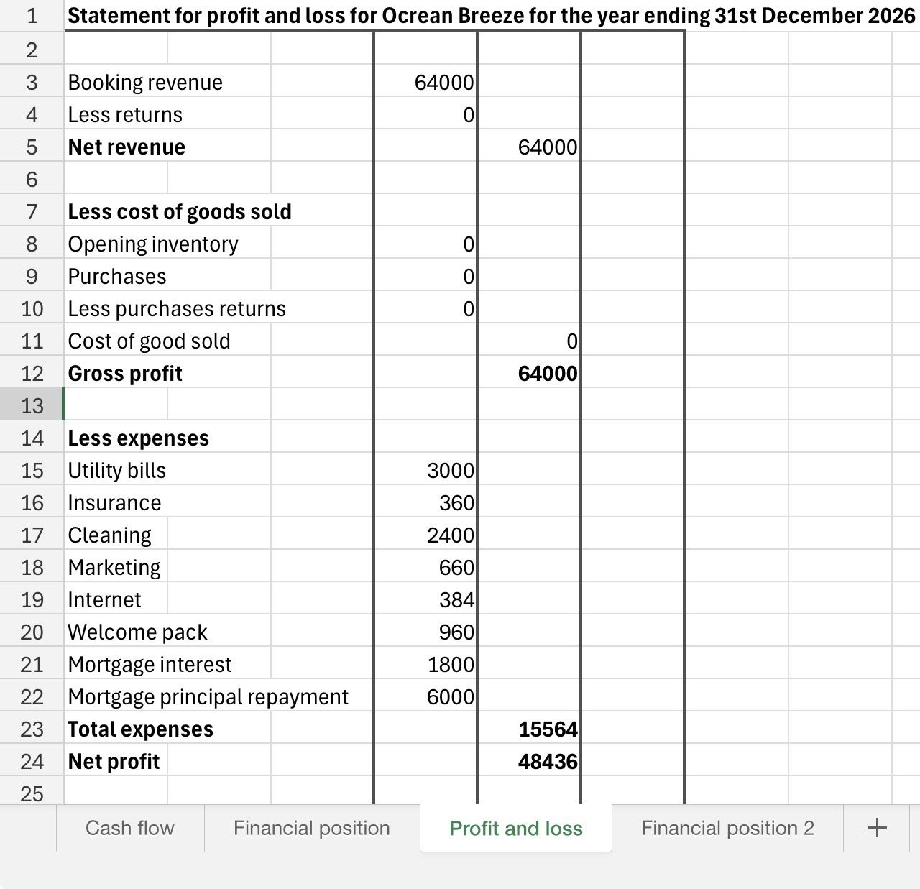

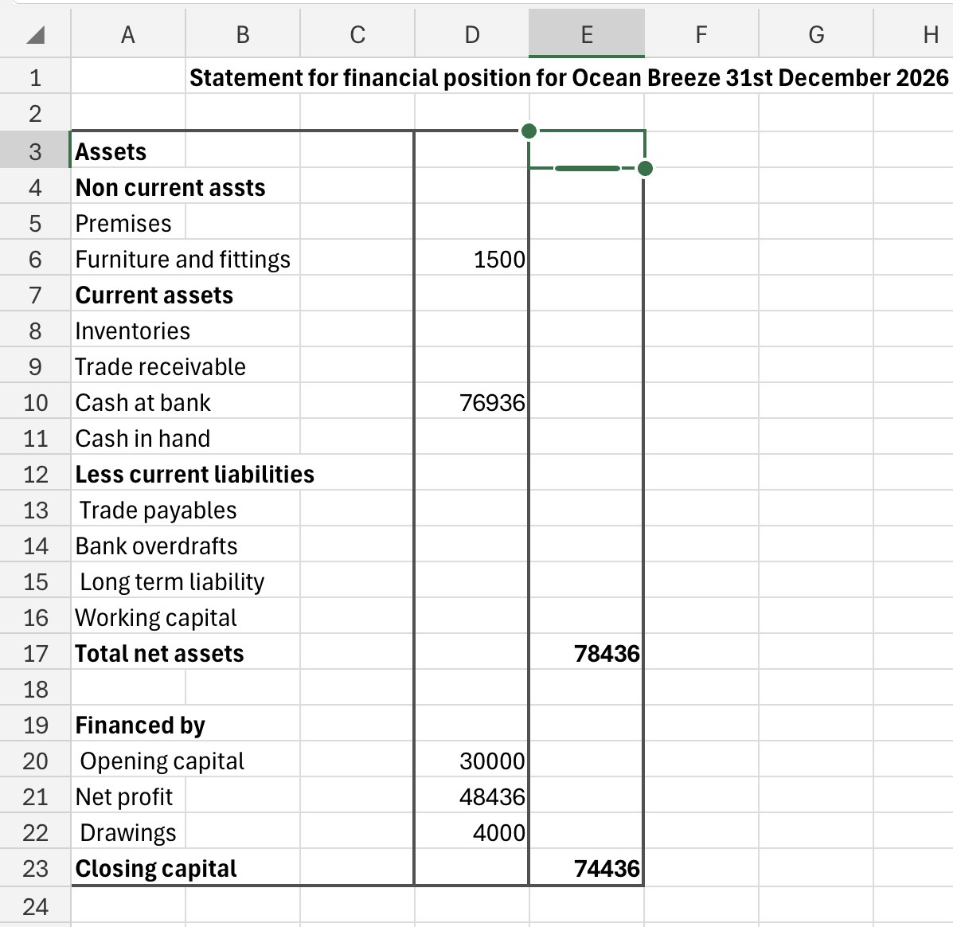

Referencing
Hostway (2026) Everything you need to know a bout Airbnb Swansea. Available at: https://www.hostaway.com/blog/everything-you-need-to-know-about-airbnb-in-swansea/#:~:text=A%20fire%20risk%20assessment%20must,in%20and%20around%20the%20property (Accessed 15 April 2026).
Airroi (2026) Swansea, Wales Airbnb market data 2026: STR reports and statistics. Available at: https://www.airroi.com/airbnb-data/united-kingdom/wales/swansea (Accessed 15 April 2026).
Scribd (2026) Airbnb digital marketing strategy analysis. Available at: https://www.scribd.com/document/854938153/Assignment#:~:text=The%20digital%20existence%20of%20Airbnb,that%20enable%20seamless%20contact%20at (Accessed 15 April 2026).
Mohammed, O (2025) The role of user generated content (UGC)in enhancing digital marketing strategies to increase brand awareness. July 2025 Article. 70-50: (4)15. DOI: 10.21608/idj.2025.372777.1304. Available at: https://www.researchgate.net/publication/393240114_The_role_of_user-generated_content_UGC_in_enhancing_digital_marketing_strategies_to_increase_Brand_Awareness .
Brochado, A.and Troilo, M. (2017). Airbnb customer experience: Evidance of convergence across three countries. January 2017 Article. Available at: https://www.researchgate.net/publication/312391559_Airbnb_customer_experience_Evidence_of_convergence_across_three_countries . DOI: 10.1016/j.annals.2027.01.001
Skim (2026) Pricing and revenue management, drive long-term, profit able and sustainable growth. Available at: https://skimgroup.com/services/pricing-and-revenue-management/?utm_campaign=39722799-2026-RM-Google&utm_source=ppc&utm_medium=CPC&utm_term=%7Bkeyword%7D&utm_content=emea&utm_feeditemid=&utm_device=t&utm_term=dynamic%20pricing%20strategy&utm_source=google&utm_medium=ppc&utm_campaign=%2304+-+Services+%26+Products+-+Navigating+Uncertainty+Together&hsa_cam=23645646914&hsa_grp=191352117022&hsa_mt=p&hsa_src=g&hsa_ad=799836771753&hsa_acc=9498618886&hsa_net=adwords&hsa_kw=dynamic%20pricing%20strategy&hsa_tgt=kwd-310590157142&hsa_ver=3&gad_source=1&gad_campaignid=23645646914&gclid=CjwKCAjwwJzPBhBREiwAJfHRnYq1pjiHuwPHfmJcKUcRbiTLXMYnf1MxMr6hNyfPJxu_Xht5sBQUixoCKUkQAvD_BwE (Accessed 16 April2026).
Platform strategies (2025) Airbnb’s strategic expansion: a textbook case of platform growth. Available at: https://www.platformstrategies.org/posts/airbnbs-strategic-expansion-a-textbook-case-of-platform-growth (Accessed 16 April 2026).
GL infotech (2026) the benefits of branding: how strong brand identity boosts business growth. Available at: https://www.glinfotech.net/blog/the-benefits-of-branding-how-a-strong-brand-identity-boosts-business-growth/ (Accessed 16 April 2026).
Oakwood international (2026) flat organisational structure implementing tips, Pros, and cons. Available at: https://www.oakwoodinternational.com/blog/flat-organisational-structure#:~:text=1)%20Work%2Dlife%20Balance%20Challenges,arise%2C%20leading%20to%20power%20imbalances. (Accessed 16 April 2026).
Elon slices (2024) Guiding early-stage development with the build-measure-learn loop. Available at: https://www.thinslices.com/insights/early-stage-development-build-measure-learn-loop#:~:text=The%20build%2Dmeasure%2Dlearn%20feedback%20loop%20offers%20a%20strategic%20approach,meet%20customer%20needs%20and%20preferences. (Accessed 17 April 2026).
Hostify (2023) Beyond booking: what are Airbnb’s biggest competitors. Available at: https://hostify.com/blog/beyond-booking-airbnbs-biggest-competitor (Accessed 17 April 2026).
Mensis (2024) Tackling challenges in the hospitality sector: embracing ESG. Available at: https://www.menzies.co.uk/facing-challenges-in-hospitality-with-esg/#:~:text=Rising%20costs:%20Businesses%20in%20the,and%20higher%20costs%20for%20businesses. (Accessed 18 April 2026).
Baringa (2026) Adapting digital and AI to captivate tomorrow's customers. Available at: https://www.baringa.com/en/capabilities/customer-and-digital/?gad_source=1&gad_campaignid=23641706399&gclid=CjwKCAjwqazPBhALEiwAOuXqdH7-R3JKuwA3bZPRGWJFtzfOg6bDjFDnWqHZCvtu8DQGy8h7uujJfRoCDl4QAvD_BwE (Accessed 18 April 2026).
Breezeway (2020) comparing hospitality cleaning and safety standards. Available at: https://www.breezeway.io/blog/comparing-hospitality-cleaning-safety-standards#:~:text=Guest%20Safety%20&%20Communication,the%20industry%20recommend%20thus%20far. (Accessed 19 April 2026).
The investment association (2023) operational resilience and third party providers. Available at: https://www.theia.org/sites/default/files/2023-07/Operational%20Resilience%20and%20Third%20Parties_final.pdf (Accessed 19 April 2026).
Light House (2021) The ultimate OTA comparison guide: Airbnb Vs. VRBO Vs. Booing.com. Available at: https://www.mylighthouse.com/resources/blog/vacation-rental-distribution-how-airbnb-vrbo-booking-com-otas-compare (Accessed 19 April 2026).
Ocean Breeze investment (2021) Fundamental continuity elements: Bunkering supply chains nodes. Available at: https://oceanbreezeorg.com/ (Accessed 20 April 2026).
Smartness (2025) eight strategies to increase hotel occupancy. Available at: https://www.smartness.com/en/blog/8-strategies-to-increase-hotel-occupancy (Accessed 20 April 2026).
Site minder (2026) Hotel dynamic pricing: Definition, examples, and best software to use. Available at: https://www.siteminder.com/r/hotel-dynamic-pricing/#:~:text=Dynamic%20pricing%20is%20a%20pricing%20strategy%20for,prices%20throughout%20the%20day%20to%20maximise%20both (Accessed 20 April 2026).
Iglu Studio (2025) Build-measure-learn: A feedback-driven loop for reducing uncertainty. Available at: https://iglu-studio.com/articles/entrepreneurship-en/buildmeasurelearn-a-feedbackdriven-loop-for-reducing-uncertainty#:~:text=The%20BML%20Loop%20as%20an,remarkable%20and%20building%20something%20irrelevant. (Accessed 21 April 2026).

