

CertHE Computing Skills for the Workplace
Student name: Lorraine Kazondovi
Student ID number: 2531577
Module name and code: Software Solutions for Business, ACCA4026
Lecturer’s name: Rajeev Nath
Submission date: 11.08.2026 2pm

Contents
Introduction 2
Task 1. e-Commerce Website builders/software solutions 2
1.1 Wix 2
1.2 Shopify 4
Task 2. Mind-map of contemporary software applications 5
2.1 Mind mapping and its benefits 5
2.2 Create a mind map of contemporary software applications 7
Task 3. Office Applications 8
3.1 Office software solutions for business operations 8
Ms Word 8
Ms Excel 10
Ms PowerPoint 12
Ms Access 14
3.2 Test any two features 17
Mail Merge 17
IF Function 23
Task 4. Communication and Collaboration applications 26
4.1 One contemporary Communication and one Online Collaboration 26
Gmail 26
Zoom 27
4.2 Test a feature of a freely available Communication and Collaboration application 28
Gmail 28
Zoom 29
Conclusion 30
References 31

Introduction
This assignment explores various software applications such as e-commerce website builders and software solutions. The assignment describes and explores the usage of Mind mapping software as well as Microsoft Office software applications such as Word, Excel, PowerPoint, and Access. I also test several features across the platforms to see how they operate. Finally, the assignment describes and has practical exercises on communication and collaboration applications such as Gmail and Zoom.

Task 1. e-Commerce Website builders/software solutions

Wix

Wix.com is a beginner friendly website builder that lets users produce and publish websites relatively fast without knowing how to code. Firstly, you create an account cost free and look through multiple ready-made templates. You then choose the template you would like to use and start editing. The templates are easily manipulated to individualized preferences. This includes “minor structural adjustments”, changing elements and inserting visuals and texts [1].
There are also numerous colours and fonts to choose from as well as editing text and images at an elementary level. Once completed you can publish your work via a live website link at no additional cost. However, for a custom domain and more sophisticated features, you would need to pay a subscription fee. According to this source, a few editing parts of Wix are challenging when it comes to layout adjustments [1].
Editing text and images on wix.com is uncomplicated and creating a portfolio is a quick process due to a large variety of templates and its digital publishing capabilities. It takes approximately 14 minutes to start the editing process on the platform and about an hour and a half to build a portfolio to completion. The website is also available on mobile devices. Colour and font adjustments are possible autonomously across the platform without working manually on each page [1].

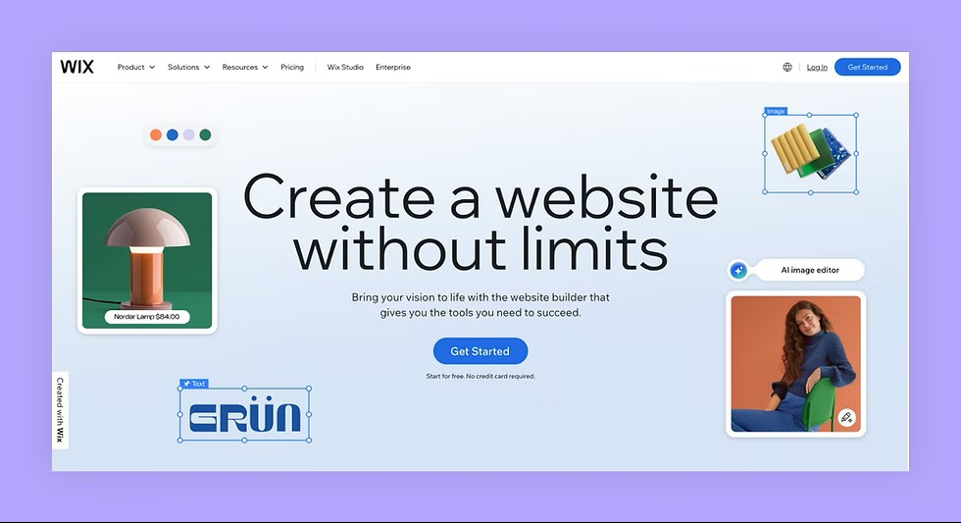
Figure 1: Wix.com website builder/software solutions front page

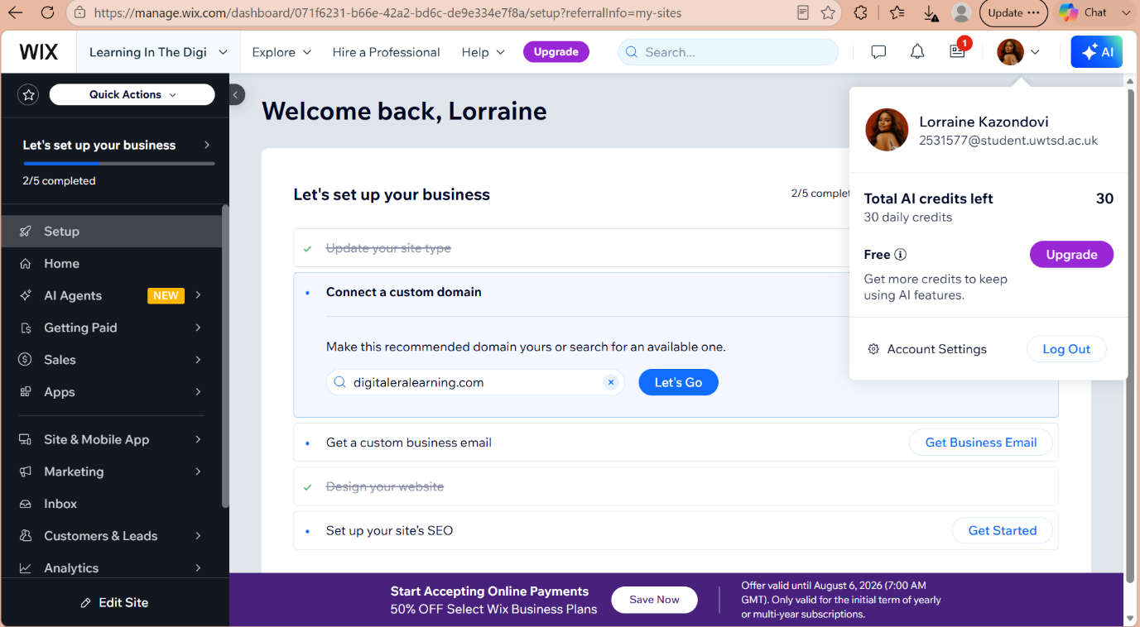
Figure 2: Wix account I created with the university email

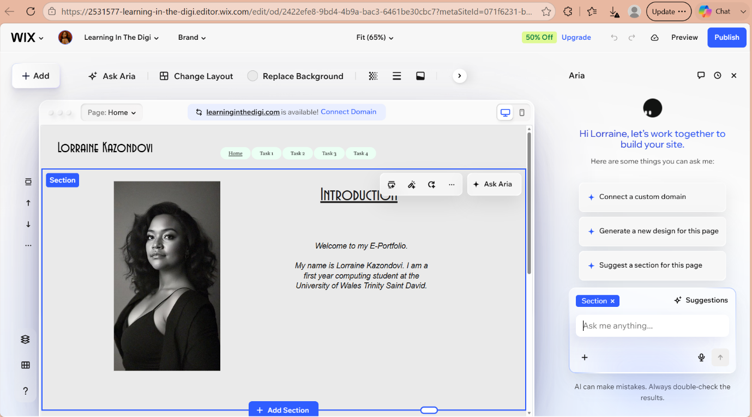
Figure 3: Wix e-portfolio I created and published

1.2 Shopify

Shopify is a highly ranked ecommerce platform, that hosts approximately 4.6 million stores worldwide. The platform was created with the intention to assist stores be more profitable and productive with ease [2]. Shopify gives store owners basic technical knowledge to “sell products, handle payments and manage orders”. The size of the virtual stores varies from small businesses to large worldwide enterprises [3].
Shopify was started in 2006 and has subscription plans ranging from $39 to $399 per month. Store owners can sell an unlimited number of products with hundreds of design template themes. Buyers use shop pay to checkout and this feature is also available on mobile devices. Merchants can use various online platforms to market their products such as Facebook, Instagram, TikTok, Amazon and eBay just to name a few [2].
Shopify uses thousands of third-party independent organizations which provide high-tech applications with components like “product reviews, marketing, automation, logistics and incorporation with social media and advertising platforms”. The applications are over 24,000. The applications help shop owners with visual layouts. They also help developers be accessible to worldwide clientele [3].
In addition, the applications provide a stable environment for Shopify which provides longevity, transparency and healthy competition. Shopify uses store leads data to analyse and provide information on domains and applications. This helps merchants and developers evaluate the feasibility of business operations and establishes specified and customized applications for the enterprises [3].
Store leads data also determine if existing applications are necessary to continue using or if newer applications can be developed to fit particular needs following testing procedures. The applications are developed with the aim of complimenting the goods and services of the merchant [3].

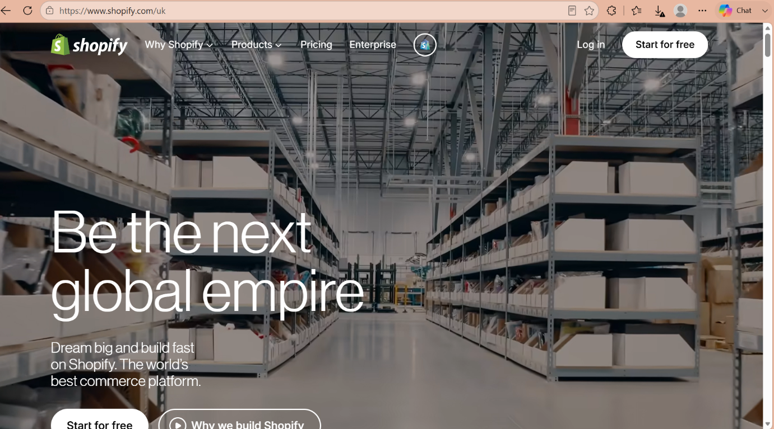
Figure 1: Shopify.com website builder/software solutions front page

Task 2. Mind-map of contemporary software applications

2.1 Mind mapping and its benefits

Mind mapping software is a thinking tool that can be used to boost your brain and sharpen your mental capacity as well as helping you focus and keep your attention. It is an excellent tool to process information, develop a strategy and execute new endeavours. Mind mapping is essentially trying to organize our thoughts from about a billion brain cells which each human possesses [4].
Mind map is an elaborate blueprint with branches or divisions for each thought created around a particular subject. Each thought is then broken down into more detailed descriptions which can further be broken down into further branches. It is useful as a form of taking notes and enhancing memory. It is also believed to be useful against cognitive decline such as in dementia. “It can be applied to all aspects of life” [4].
In addition, mind maps can be drawn by hand or as an online software application. The branches can develop, progress, mature and expand into a continuous process to suit any area of our lives. In comparison to linear note taking, mind map is imaginative, multidimensional, colourful and you can combine words with images [4].
Mind mapping has been used for almost 2000 years. It is structured very closely to the human brain in particularly closely related to visual processing, retention and concentration, which are all perceptual-cognitive abilities. Technically, it is an illustrative diagrammatic method used in an online application to demonstrate and structure information. Mind maps are organized around a core concept and each piece of information, normally a word is entered and connected by a line to another word or idea. This creates an image like branches all linked to a tree or cell and all connected to each other [5].
Various digital mind mapping software applications have been developed such as Mindmeister, XMind, Mindjet, Visio, Freemind, Mindomo, TheBrain and Cacoo just to name a few. I will describe Mindmeister, because it is a software that I used myself during this assignment. It can be used in real time with colleagues or classmates. It can be used during a brainstorming session, and you can revisit it later when a new idea emerges. Clicking on an idea opens a new connection line to enter a new idea or you can collapse the branches to make the information more manageable. The information is saved digitally on the platform making it accessible to revisit, edit and add at any time [6].

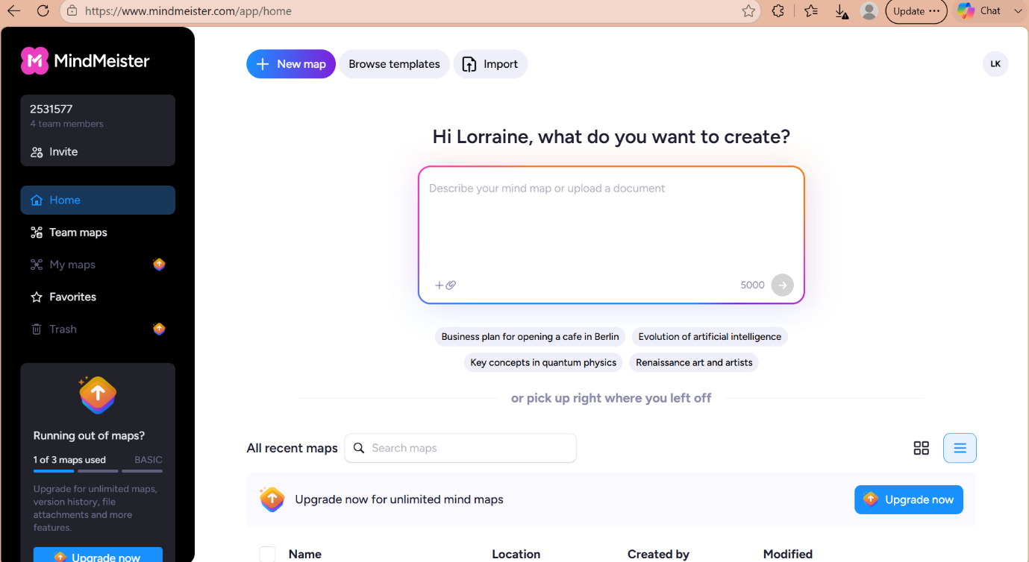Figure 1: I created an account with Mind Meister which is a mind mapping software application

2.2 Create a mind map of contemporary software applications
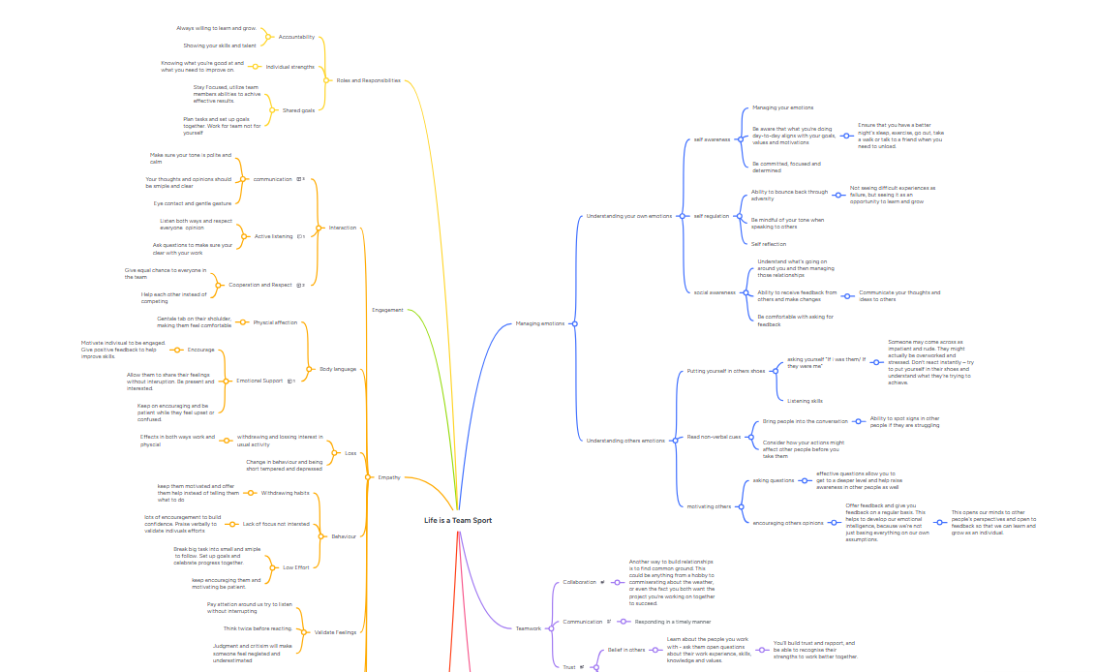
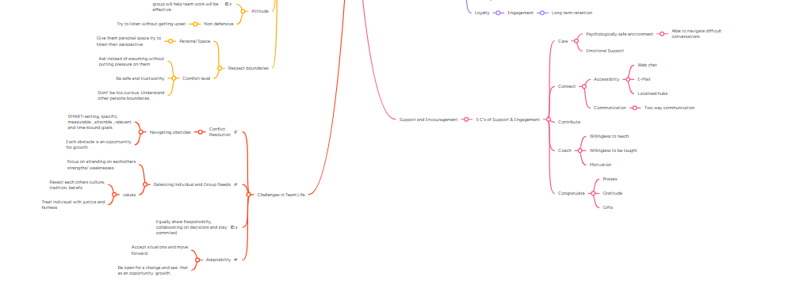
Figure 2: A mind map I created on Mind Meister about “Life is a Team Sport”.
Link: Life is a Team Sport - MindMeister Mind map
This map goes into detail about managing emotions, empathy and teamwork. It highlights the importance of working together in a business setting to make any organisation successful. This map can also be used in academia and in most aspects of life. You can click the link which takes you to the Mind Meister website and you can have a closer look at the map.

Task 3. Office Applications

3.1 Office software solutions for business operations

Ms Word

Microsoft Word is a word processing software application which forms part of the Microsoft Office 365 package. It was created in 1983 by Microsoft Technology. It is used to write documents in different layouts and structures. It is available on computers, laptops and on mobile devices. It is one of the most widely used software applications. Once a word document is created, you can save it and come back to edit and amend it to your liking. It has built in features that can correct grammar and spelling mistakes. You can click on the review and editor buttons to display these spelling corrections features [7].
Furthermore, features exist such as management of references, bibliography and citations to give credit to authors who have done research in a particular topic. You use these features when constructing an assignment such as this one. Another important feature is security and access control to a word document which protects the document from editing from third parties. These features, such as encryption can also make it possible for only the intended receiver to read the material using a pin to unlock the information [7].
There are numerous features withing Microsoft Word. You can edit documents, change fonts and styles as well as add images, videos, draw shapes and add hyperlinks. You can also insert charts, page breaks and create columns as well as insert footnotes, headers and footers [8].

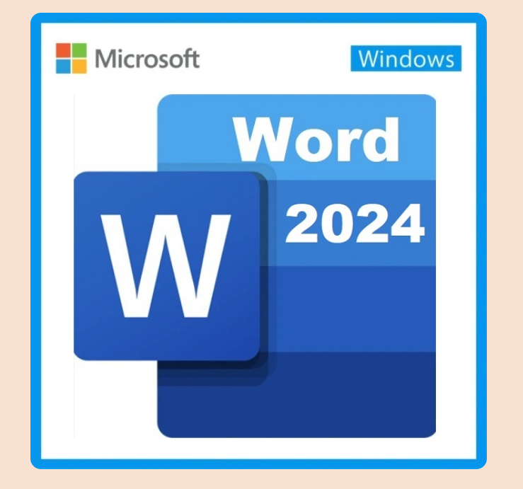
Figure 1: Microsoft Word icon
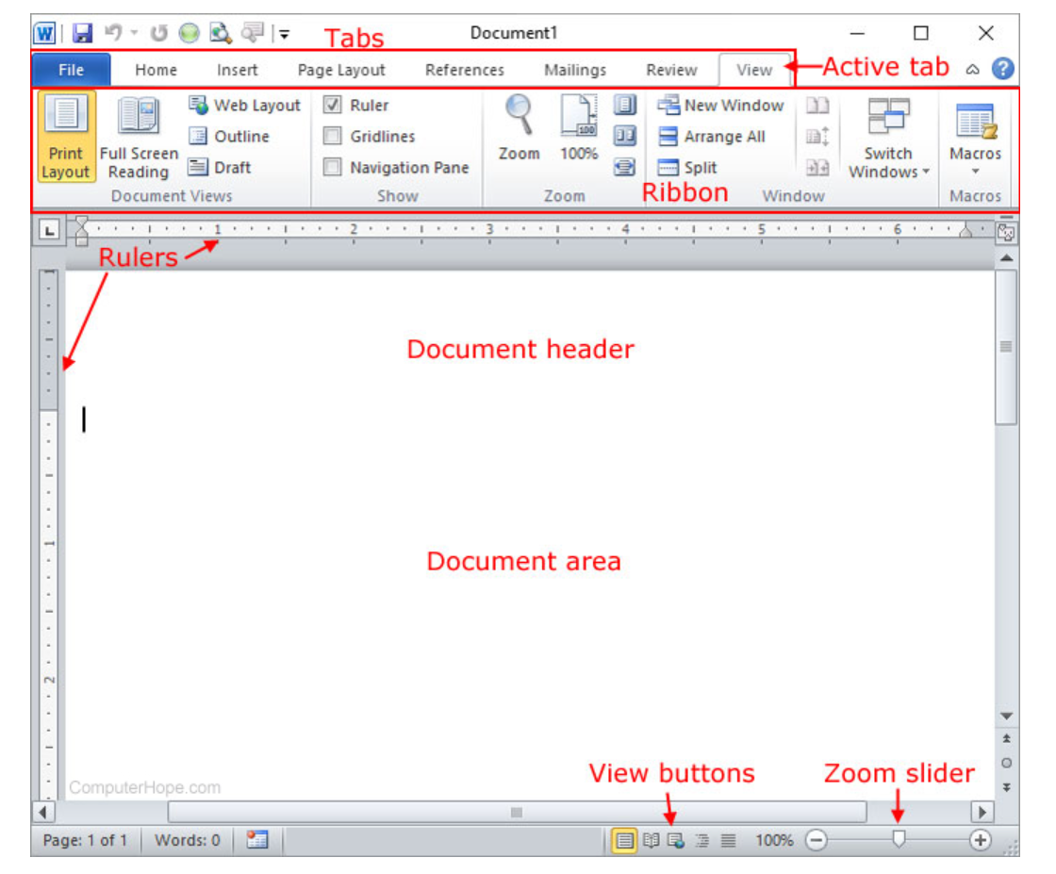
Figure 2: An overview of a Microsoft Word 2010 document

Ms Excel

Microsoft Excel is part of the Microsoft Office 365 suite that makes it possible for users to enter and organize data, calculate, automate and perform a financial evaluation among many other functions. The Excel document is a spreadsheet program organized into rows and columns to easily enter and arrange data. This data can be used to crunch numbers, develop charts and help organizations budget, plan and forecast their financial performance. Excel can be use in a personal or professional capacity [9].
Key features of Microsoft Excel include formals and functions such as IF and XLOOKUP, data analysis which uses charts and tables. Automation is another feature used to remove monotonous tasks as well as formatting tools to individualize cells and tables to make it easier to read the data [9].
A range of tasks is available on Microsoft Excel which is used in various industries such as accounting and bookkeeping. This includes “advanced calculations with built in functions” like SUM and AVERAGE. The spreadsheet also allows for time tracking and project management, budgeting and finance management as well as customer and sales tracking also known as CRM functions. This is used for client coordination, progress tracking and performance evaluation. It is a results-based management system used to “simulate real-world business decisions” [9].
Financial institutions use Microsoft Excel to perform business indicators and success measures using financial metrics with charts and dashboards. It is widely used among accounting firms and financial institutions. It is the “ultimate financial software” and these professionals rely on Microsoft excel to execute day to day operations [9].

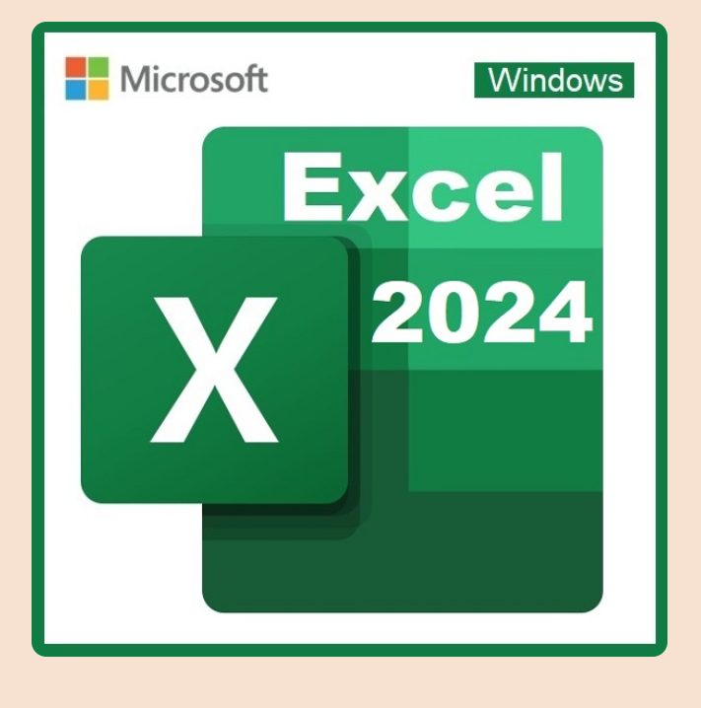
Figure 1: The Microsoft Excel icon
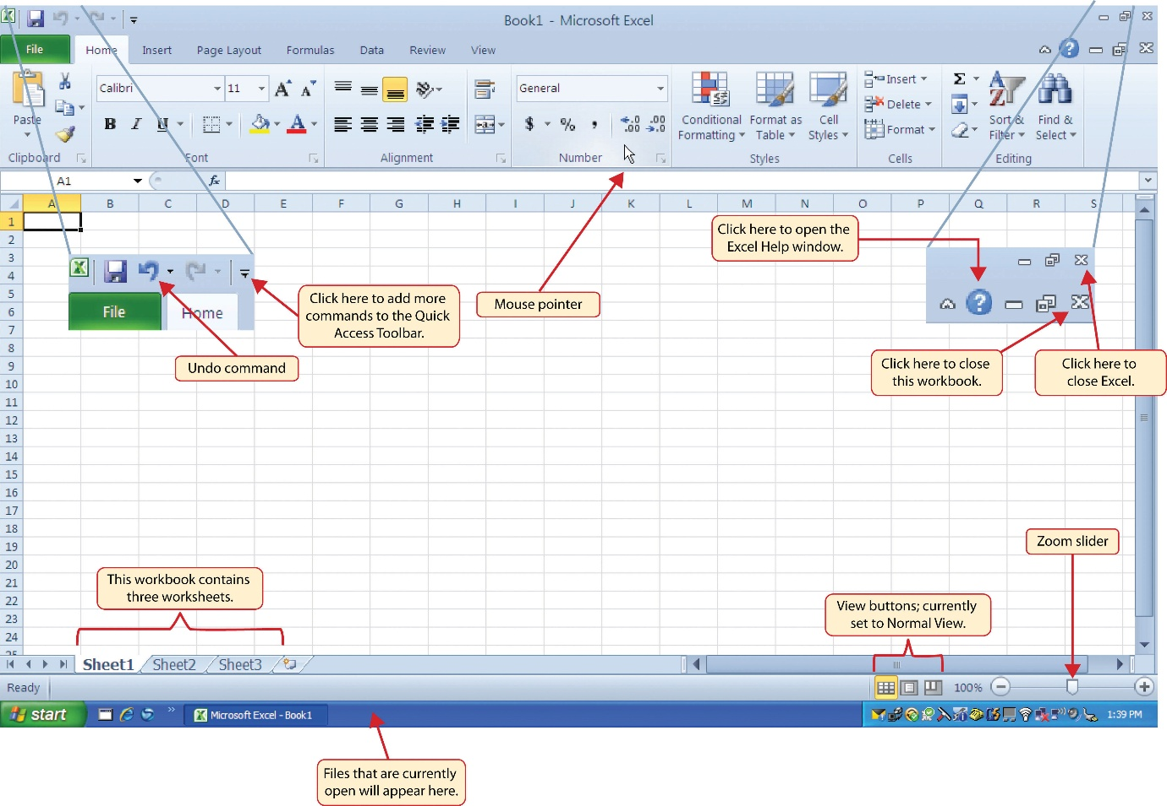
Figure 2: An overview of a Microsoft Excel document

Ms PowerPoint

Microsoft PowerPoint is part of the Microsoft Office 365 suite developed by Microsoft Corporation. It is a well-known software using a slide show to create presentations. PowerPoint comes with integrated templates to choose from where you can choose from numerous designs, fonts and styles. In addition, the software is incorporated with animations, videos, images and charts [10].
You can also insert these items from your personal collection of files in your computer or download them from the internet and insert them into your presentations. PowerPoint is used as a communication tool with 2D or 3D effects to keep the reader or audience engaged and intrigued by the material. The software is designed in a way to keep the information optimized, streamlined and productive [10].
PowerPoint was first released in 1987 and has been used in academic lectures and scientific presentations, using built in audio files, graphs and charts just to name a few. Once you open PowerPoint, you choose a design template which you can edit as you go along. You can add slides, text, media and images and ultimately save it for a future presentation [10].
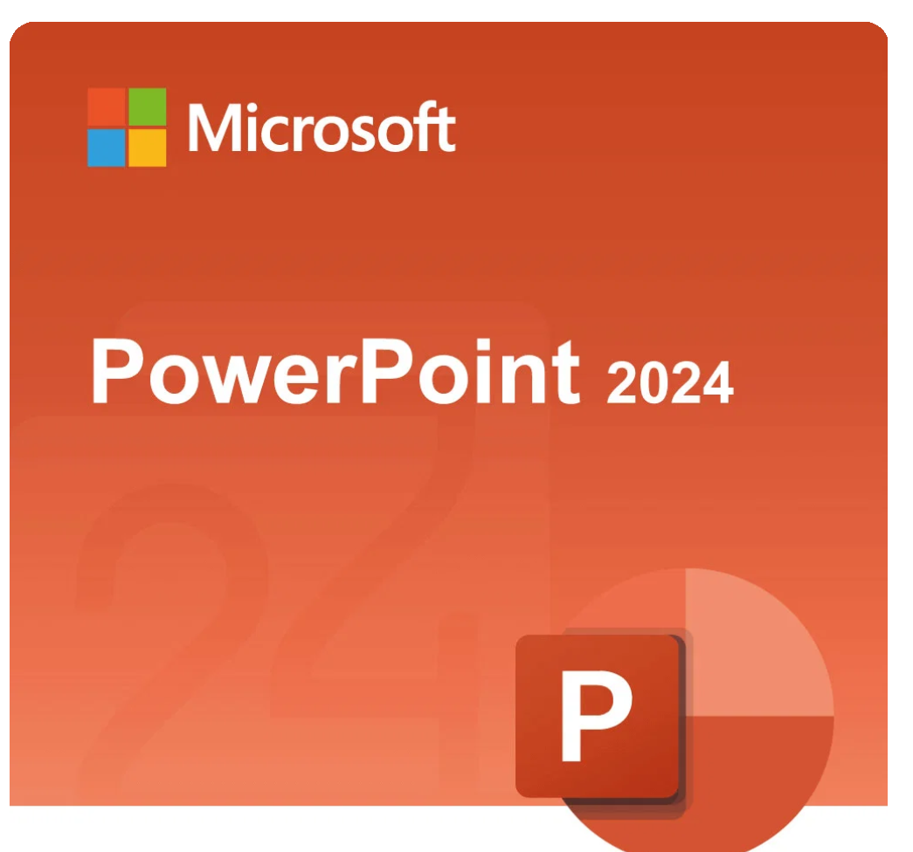
Figure 1: Microsoft PowerPoint icon
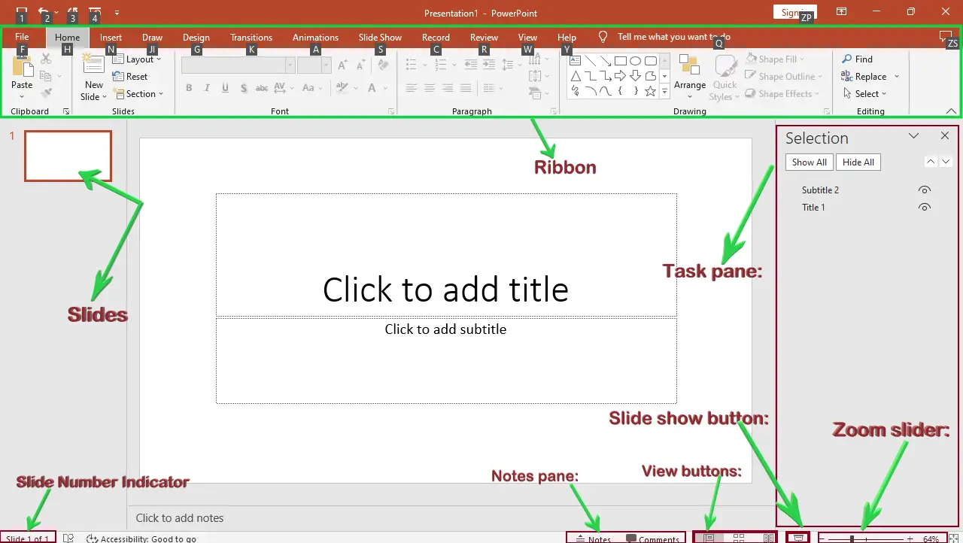
Figure 2: PowerPoint blank slide

Ms Access

Microsoft Access is part of the Microsoft Office 365 suite developed by the Microsoft Corporation. It is a software application designed for entering, arranging, and evaluating data. It can generate tables, queries, forms and reports. Access is a “relational database management system”. It saves data in tables and not as a long list. This feature enables users to keep data steady and regular. This feature also deters repetition and avoids duplication. It is used for team collaborations or for smaller scale ventures and works well with the other Microsoft software [11].
Each table holds specific data such as customers table or orders table, and relationships connect tables to each other. For example, a single customer can have many orders. A feature often used is queries which let you filter, connect and perform mathematical calculations across tables. You can query a list of orders place in the last week by a specific client as an example. Using forms make data entry efficient and easy to analyse [11].
Microsoft Access also allows users to print monthly sales reports or itemize what inventory stock is available. Automation reduces repetition with a single click making the organization more effective. It is used more in a business setting to generate reports or build applications suitable for the business. Other key features include data validation, relationship management, macro automation and desktop database app creation just to name a few. Some advantages include efficient data management and powerful data analytics and reporting and a reported disadvantage is limited security [11].

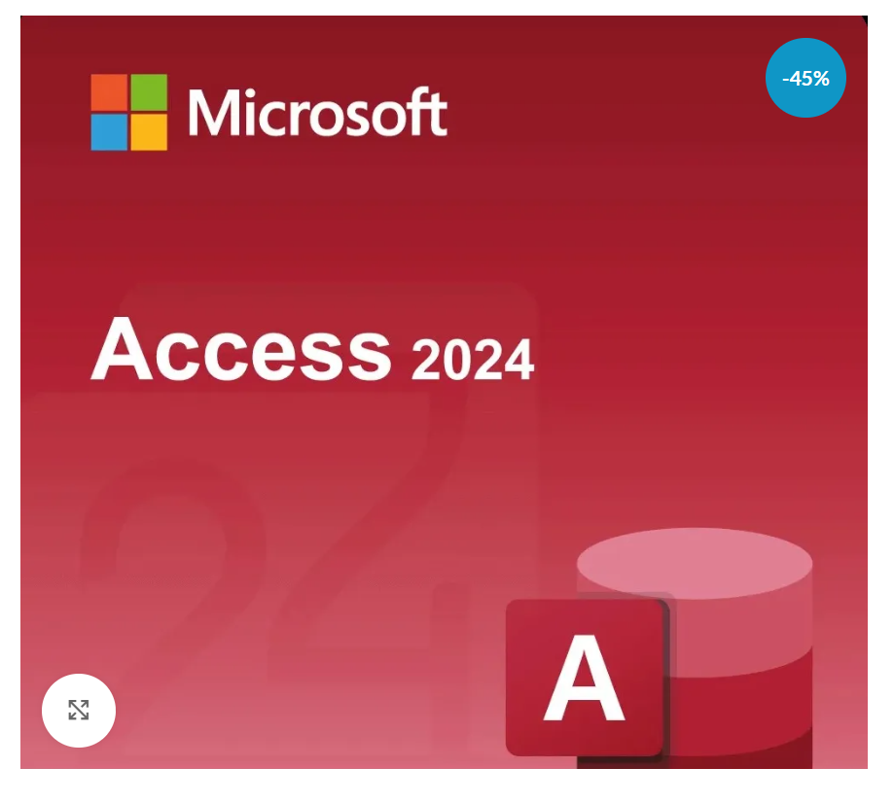
Figure 1: Microsoft Access icon
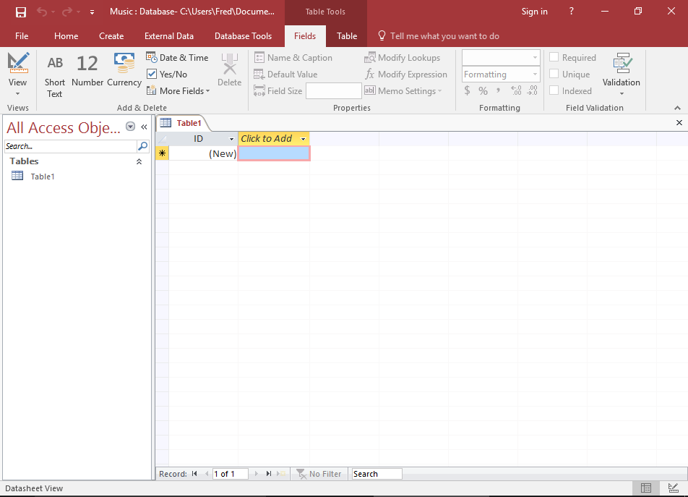
Figure 2: Microsoft Access document

3.2 Test any two features

Mail Merge
I tested Mail Merge using Microsoft Excel, Microsoft Word and Microsoft Outlook.
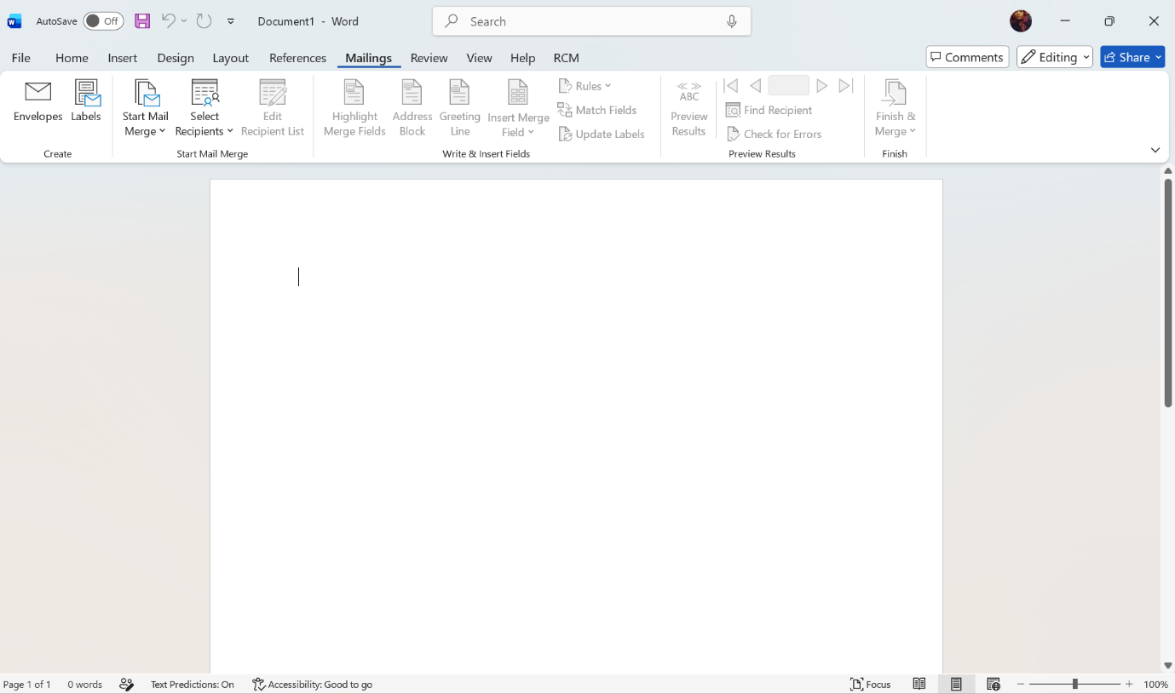
I selected Mailings
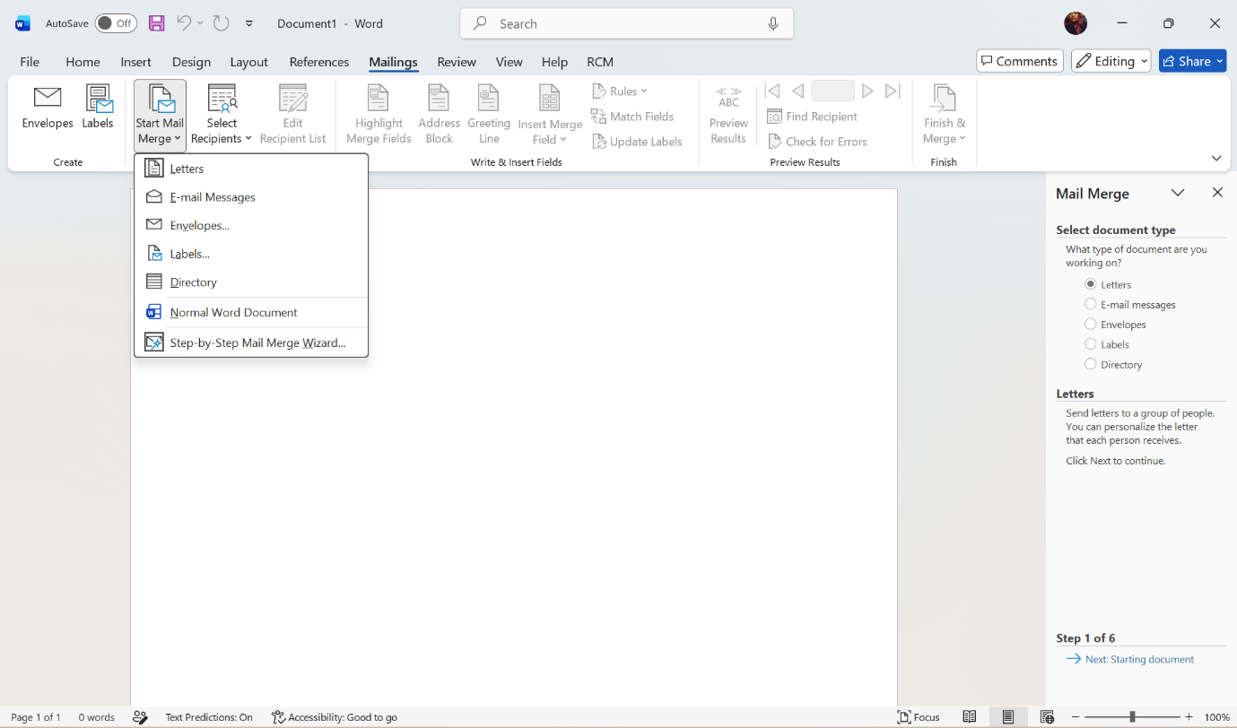
Then I selected Mail Merge
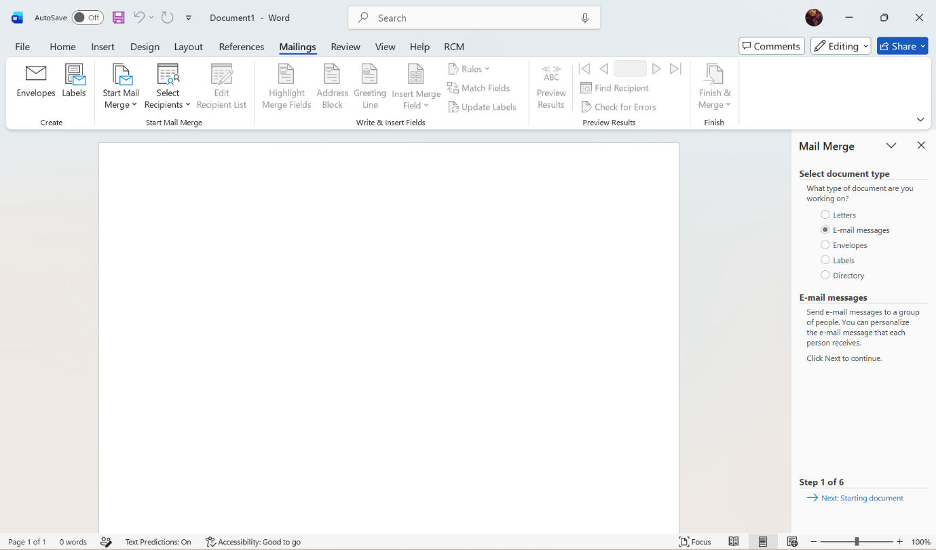
A document is opened

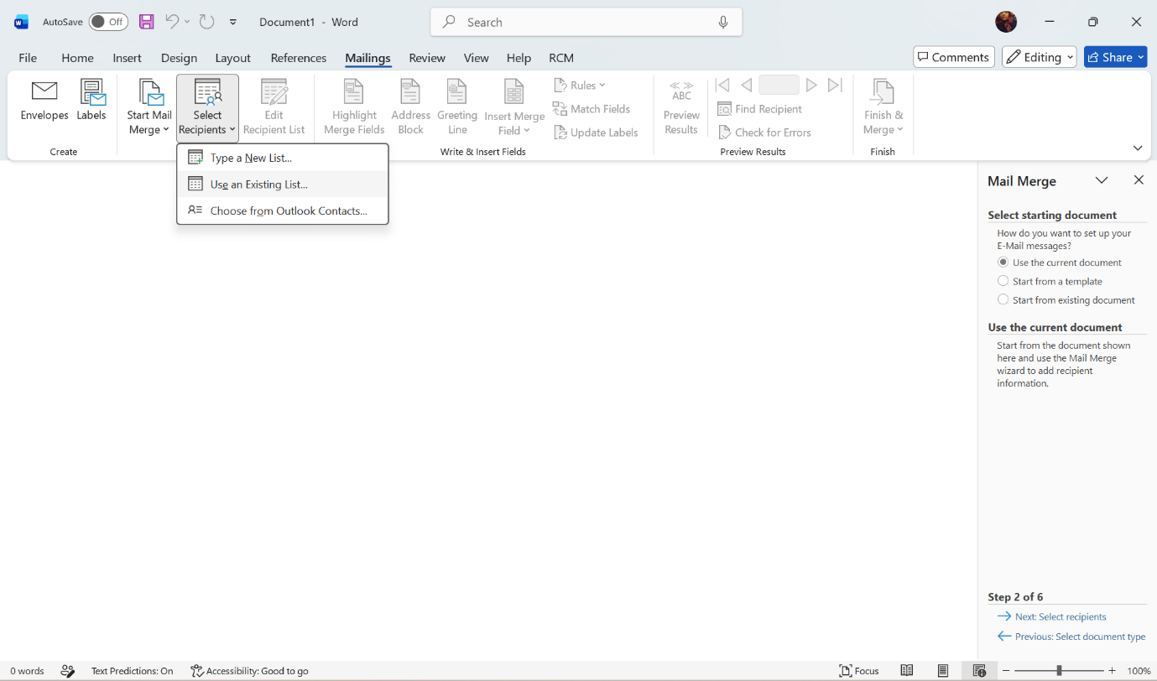
I selected recipients using an existing list
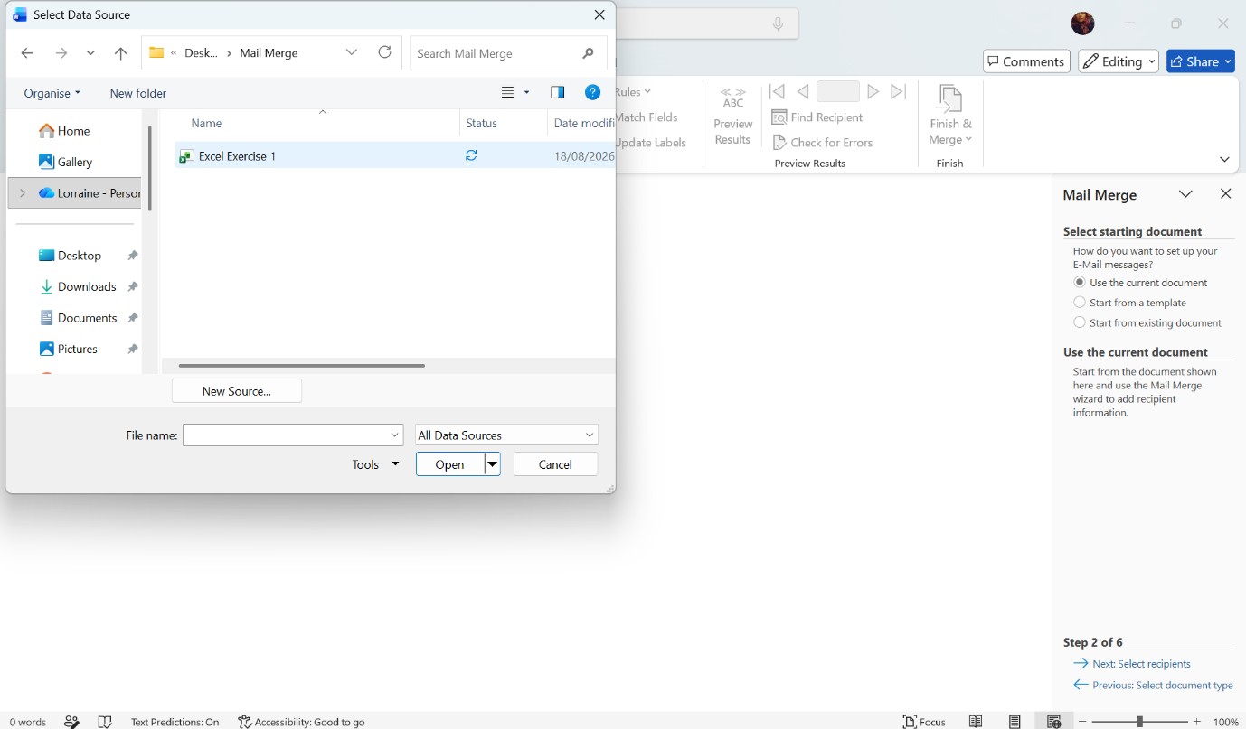
I opened the Microsoft Excel document that I created for this exercise

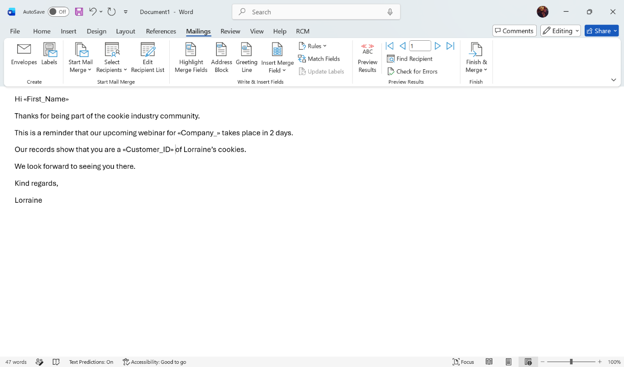
You can insert a merge field which will automatically be edited according to the Excel sheet

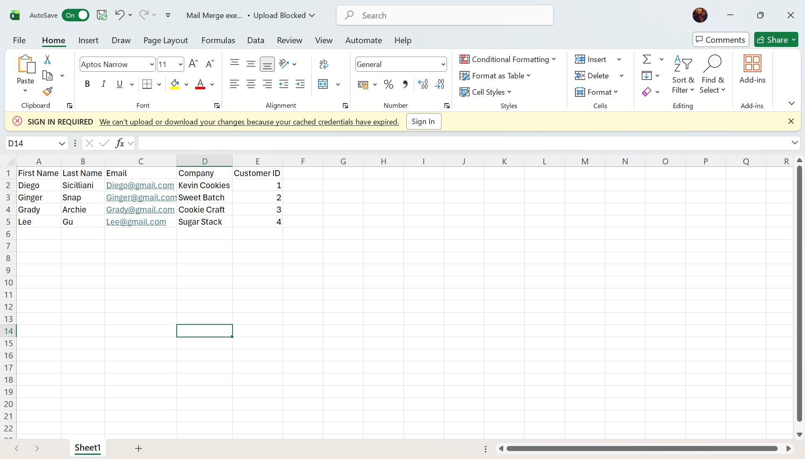
This is the Microsoft Excel document I created for this exercise
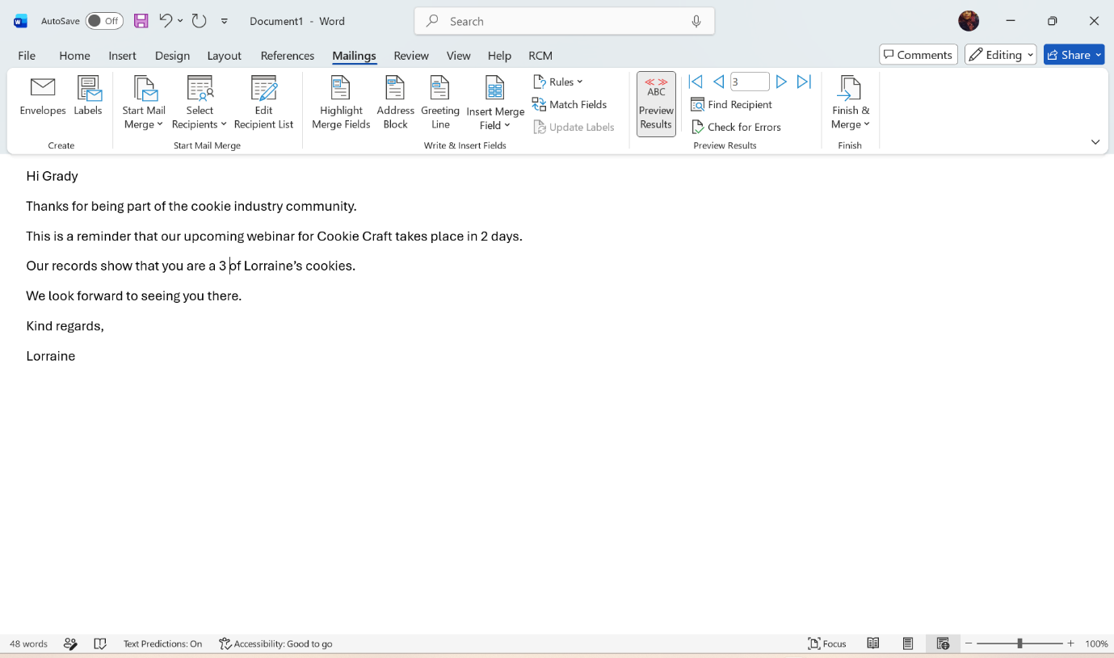
You can preview the results and edit to your liking

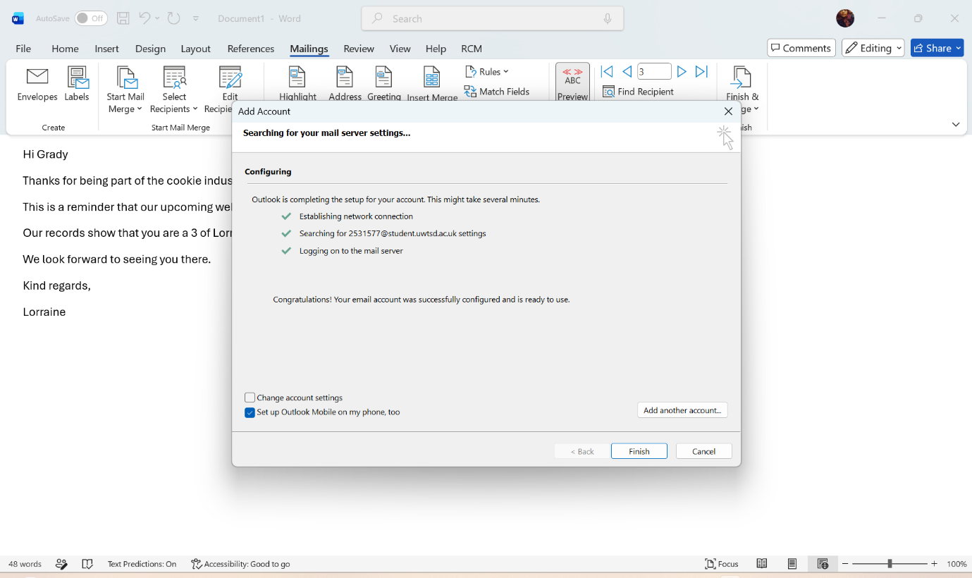
The word document is connected to my Outlook account

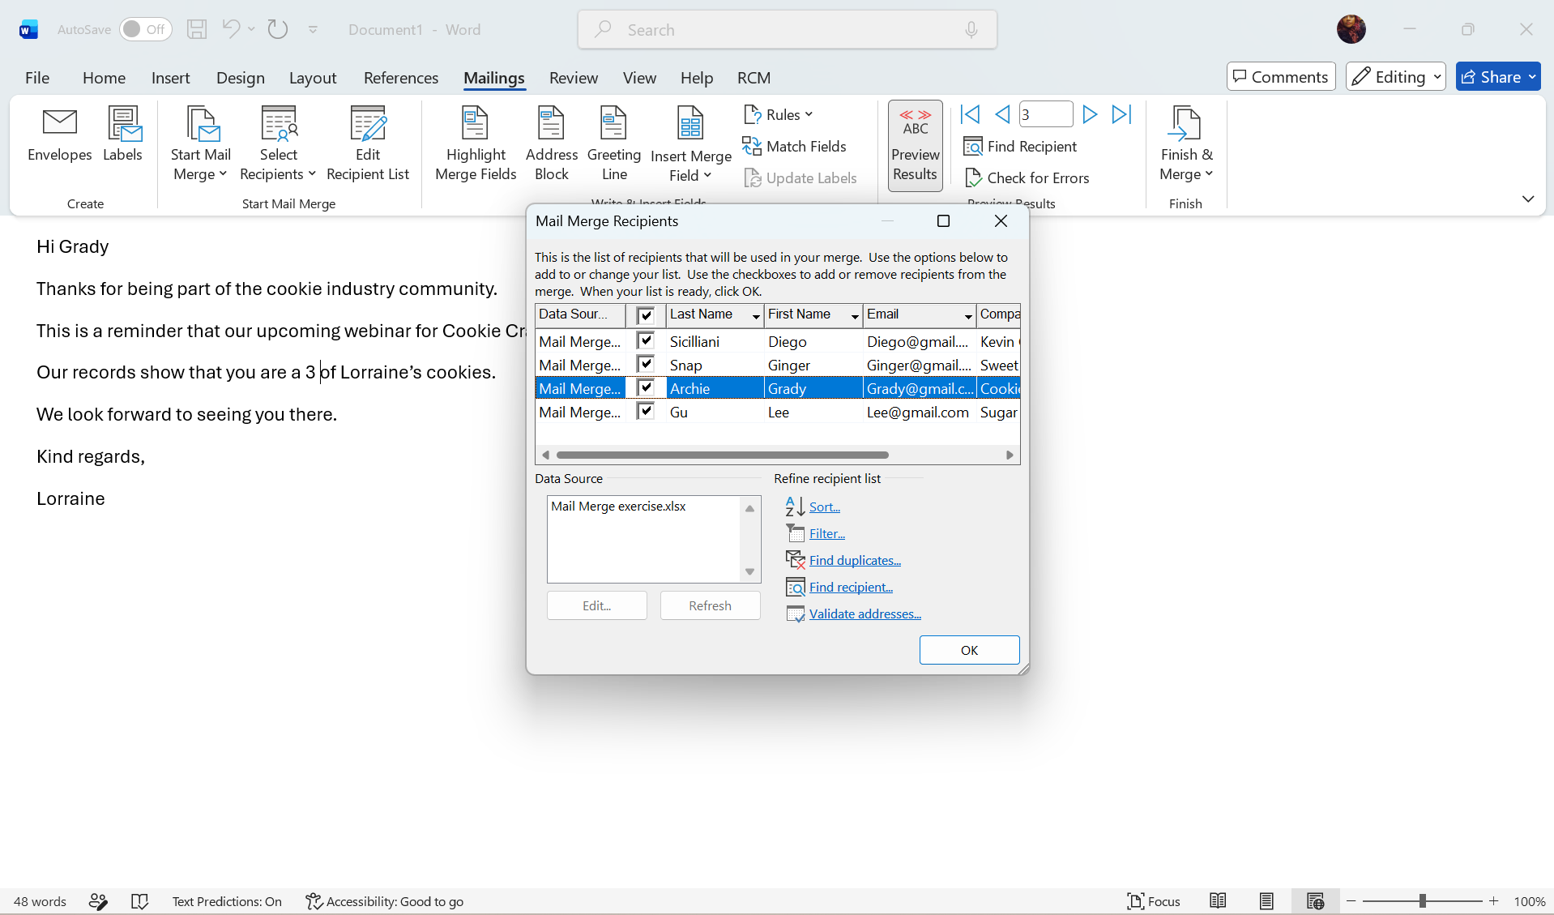
Each recipient is selected to make sure the emails reach them

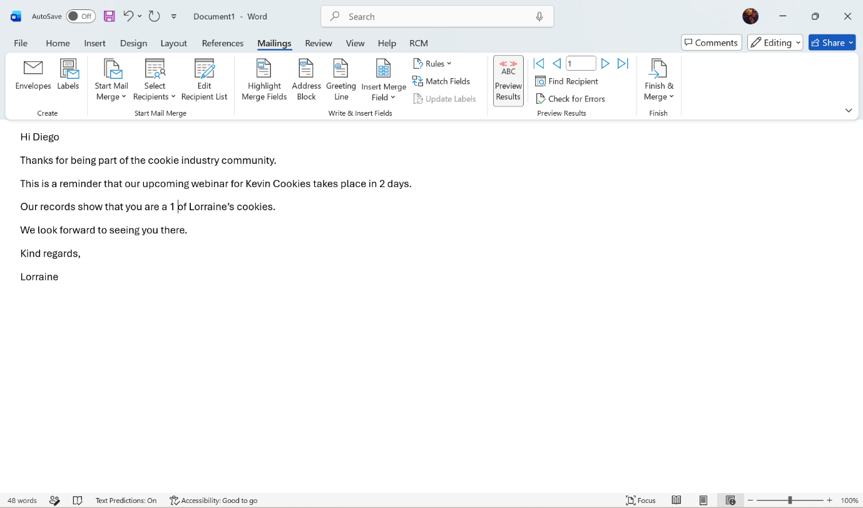
You can click the arrows to make sure that each email is sent to individual clients

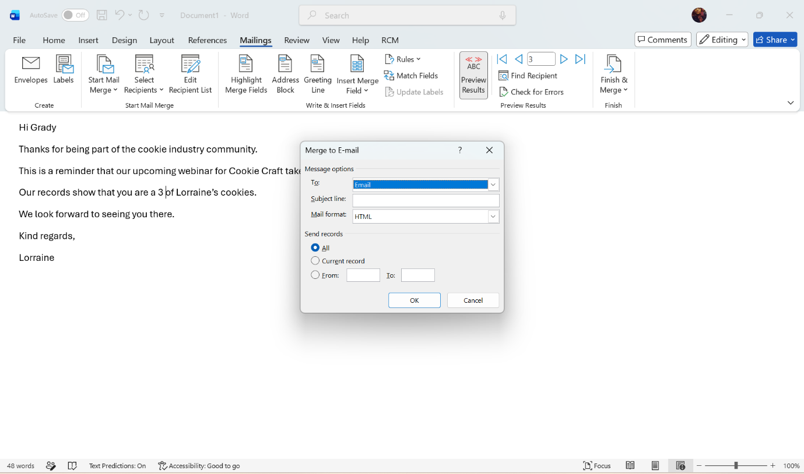
The emails are sent to each recipient customized with their individual email addresses and customer ID numbers

IF Function
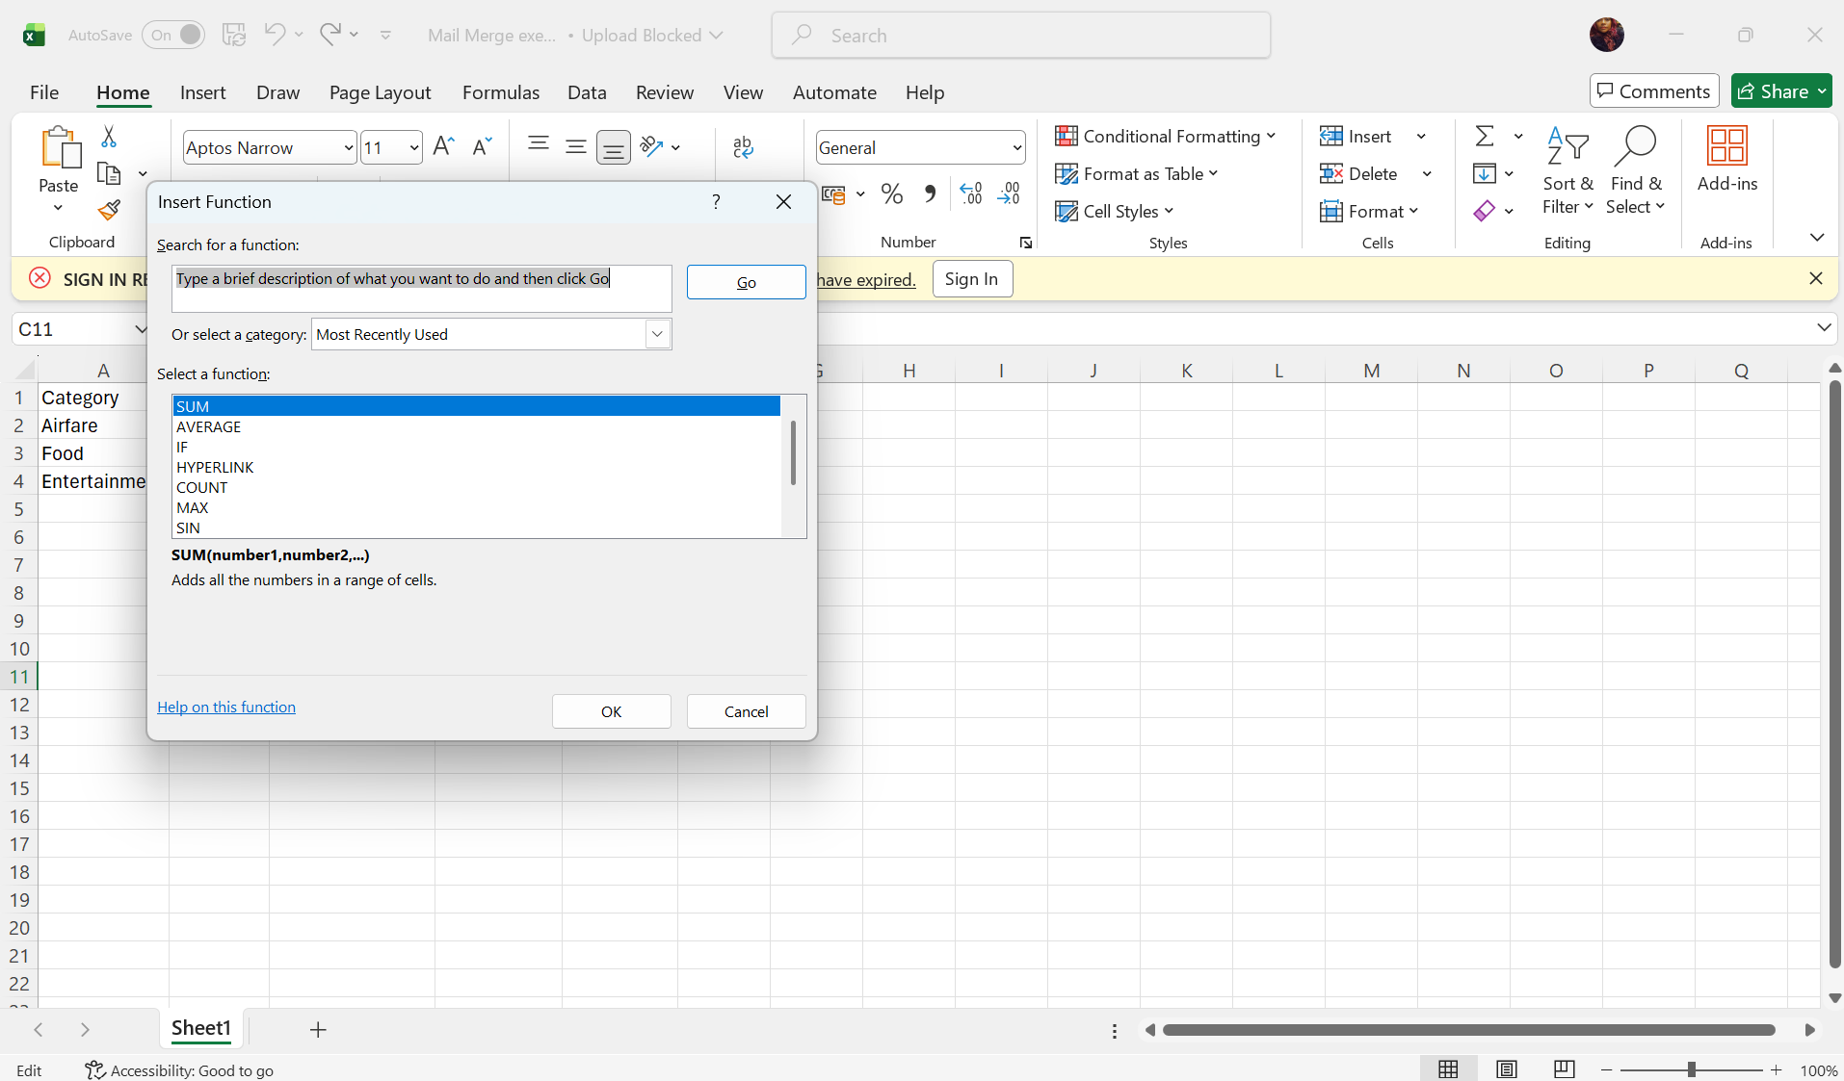
I created a simple Excel spreadsheet with figures and clicked on the insert function tab

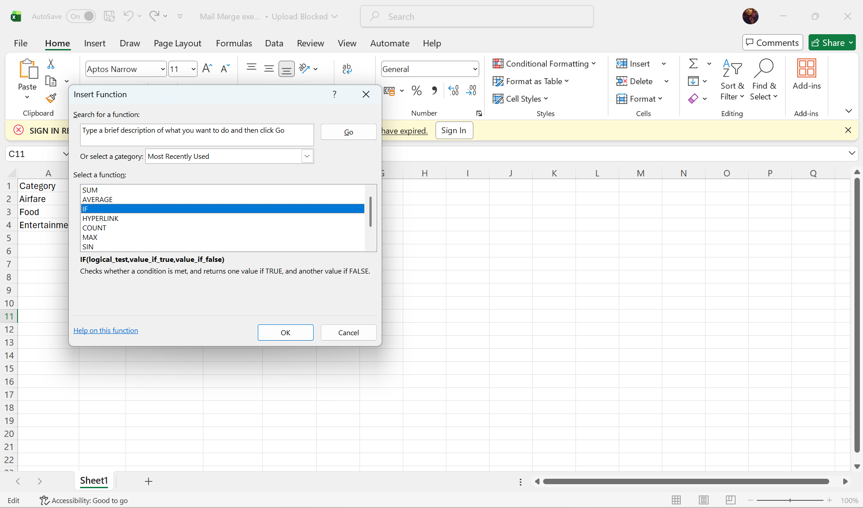
I selected the IF function the insert function tab
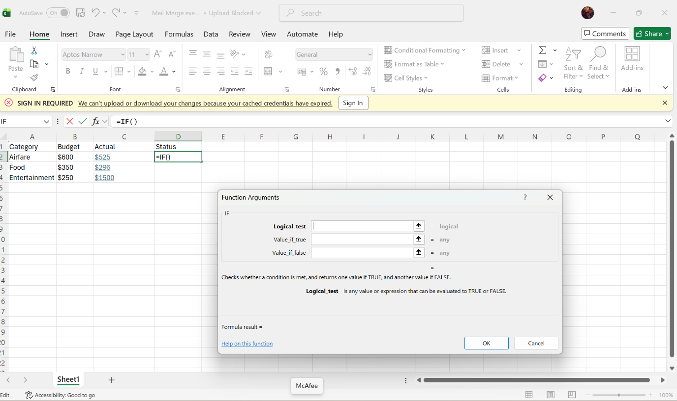
The IF function opened and I gave it instructions to insert in the brackets

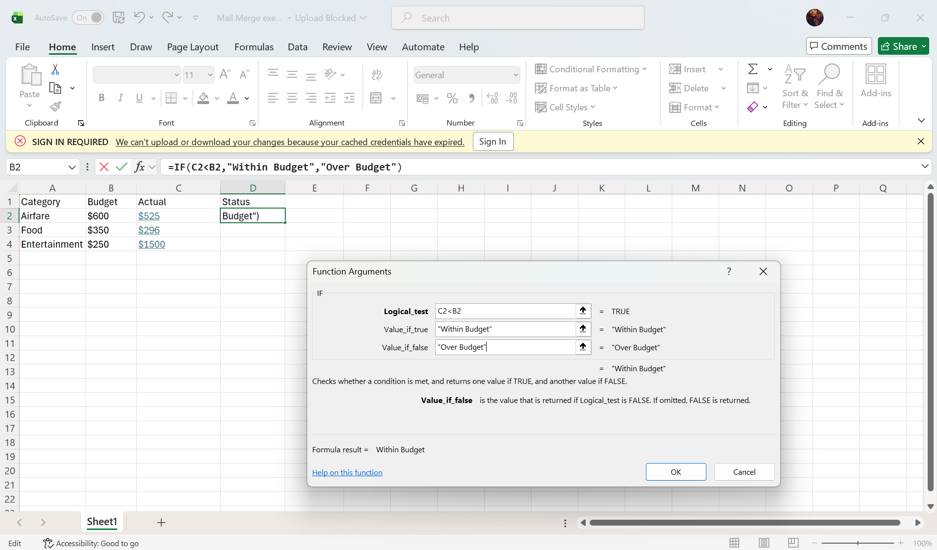
My instructions were if the actual spent is lower than the budget then the result should be within budget and if is higher than it is over budget and should be investigated
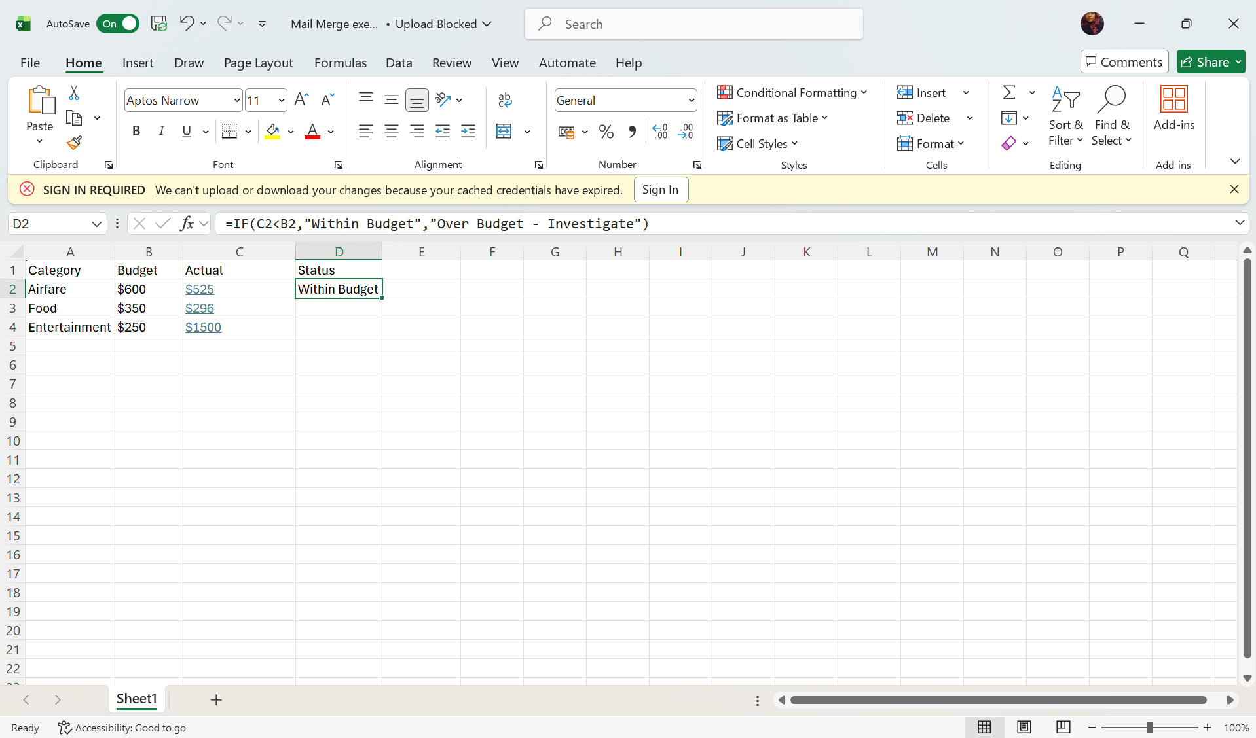
After you give the instructions the results appear automatically in collum D

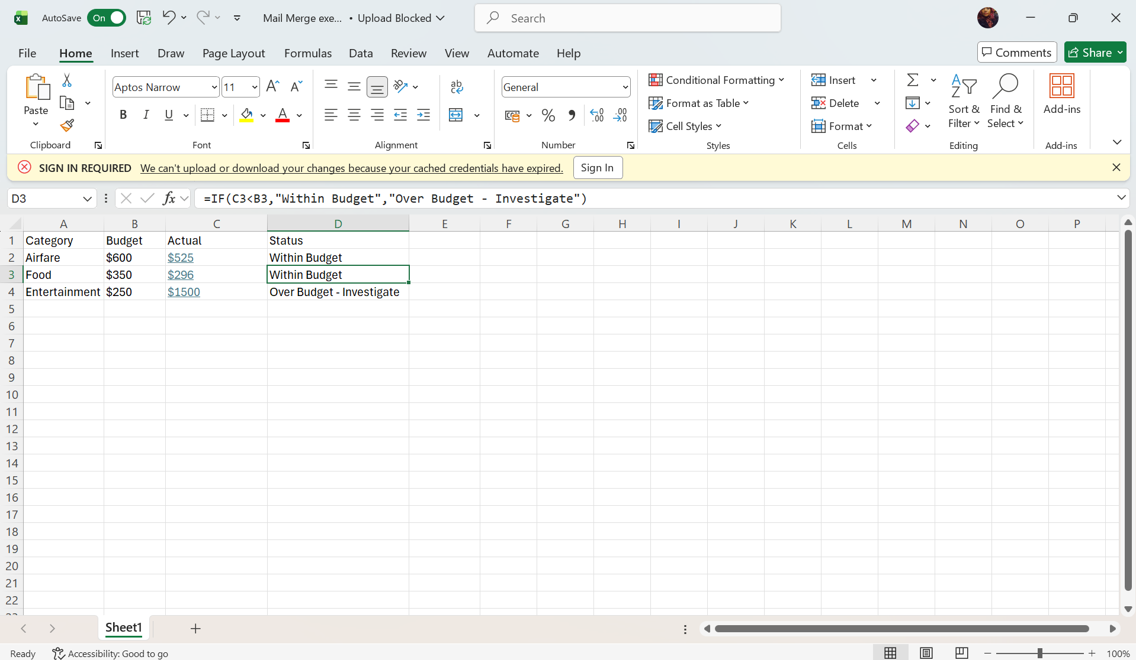
If you double click on column D row 2, the following two rows appear automatically with the IF function results. IF function is a tool used to give commands during an investigate on financial spending in an organization such as in this example.

Task 4. Communication and Collaboration applications

4.1 One contemporary Communication and one Online Collaboration

Gmail

Gmail is a free electronic communication (email) service which is owned by Google Technology. It is accessible from a web browser from your desktop computer or mobile device. You can download the application on any compatible device. It is reported to have excellent spam blocking services as well as strong cybersecurity attributes. It has a user-friendly interface and makes email management easy [12].
Google blocks almost 15 billion unwanted emails daily using artificial intelligence. This reportedly stops 99.9% of spam, phishing emails and malware. Gmail also has huge storage capabilities. Gmail’s core function is an email platform that allows users to send, receive and manage electronic messages over the internet. Gmail incorporates well with other Google products such as Google Drive, Google Calendar, Google Docs and Google Workspace [12].
Gmail was launched in 2004 and provided users with1 gigabyte of free storage. The cloud platform uses bidirectional search and email thread functions which make it easy for users to locate specific emails. All Gmail messages and attachments are stored on Google servers, which means that users can access their information from any device with internet access [12].

Figure 1: Gmail icon

Zoom

Zoom is an online audio and video conferencing platform widely used by organizations worldwide or as individuals in a personal capacity. It is used as virtual meeting space for 2 ore more people. The platform can use phone calls, chats and multi productional presentations [13].
Zoom was launched in 2012 with over 1 million users by the first year. It has become one of the most popular video conferencing solutions. The most popular feature is Zoom meetings which allows web-based audio and video calls. It accessible via the app or a web browser. It is free service and can be joined via a link even if you don’t have an account. You can upgrade from the free service to pro service for a monthly subscription [13].

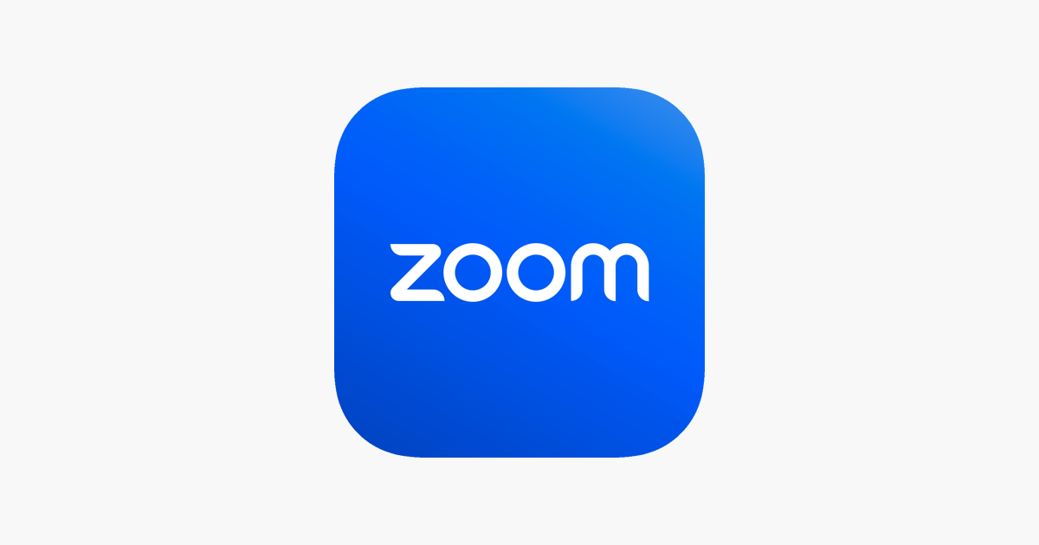
Figure 1: Zoom icon

4.2 Test a feature of a freely available Communication and Collaboration application

Gmail

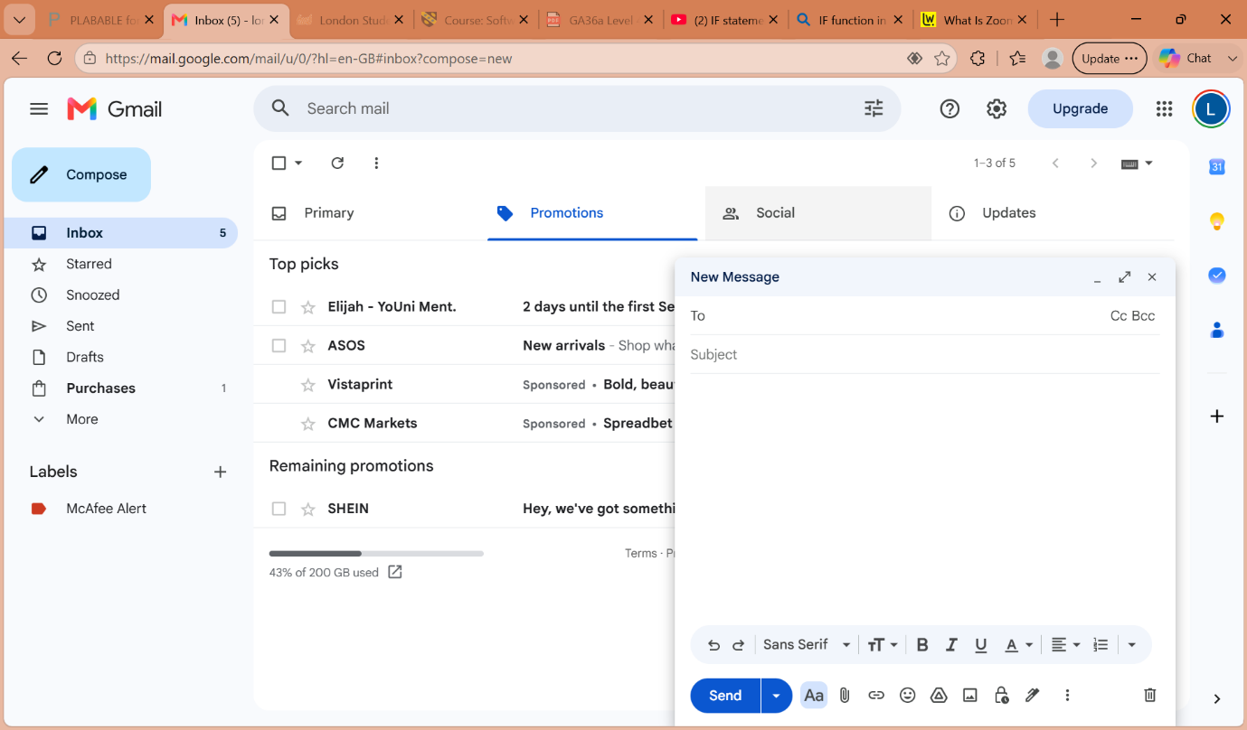
How to compose an email using Gmail

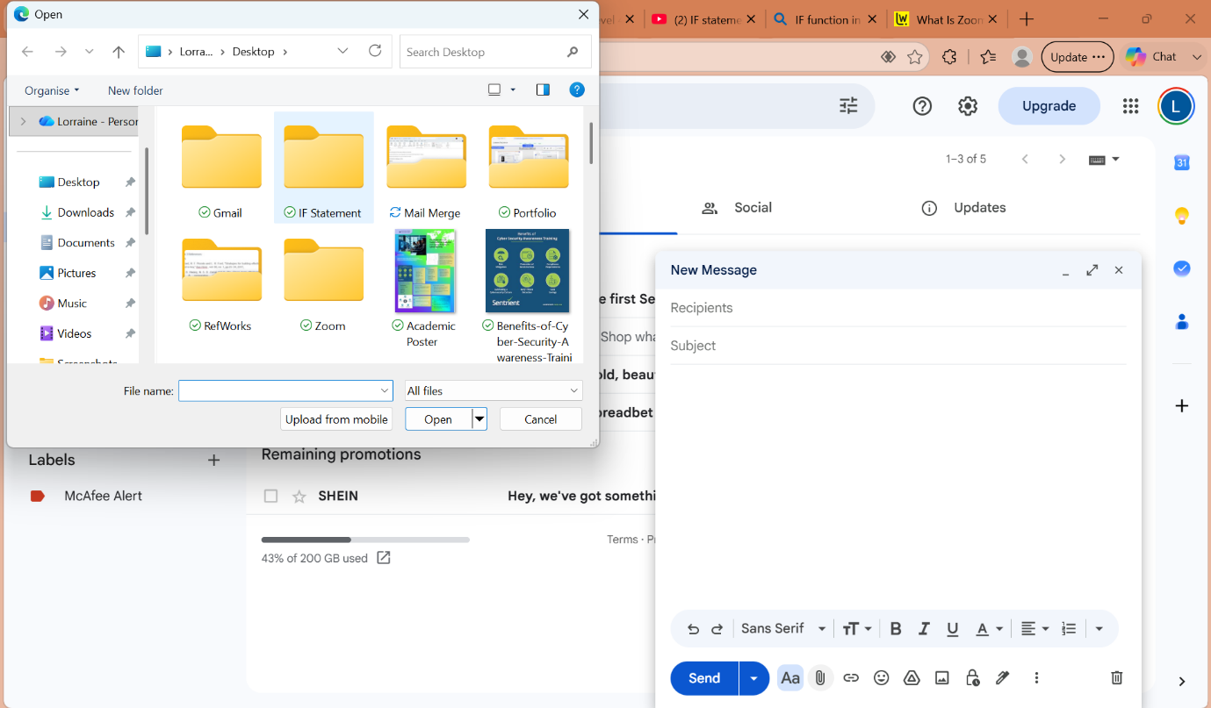
You can attach any saved documents on your email

Zoom
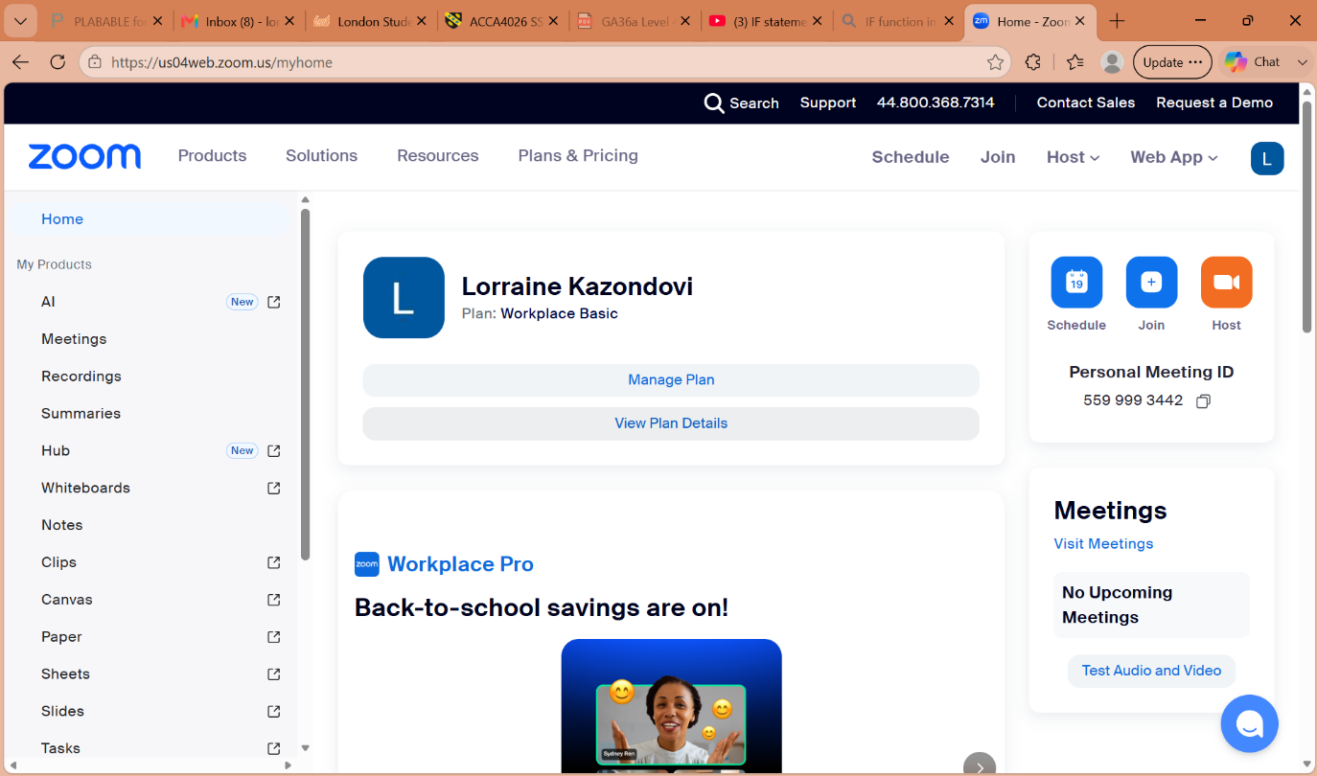
My zoom account on the home page

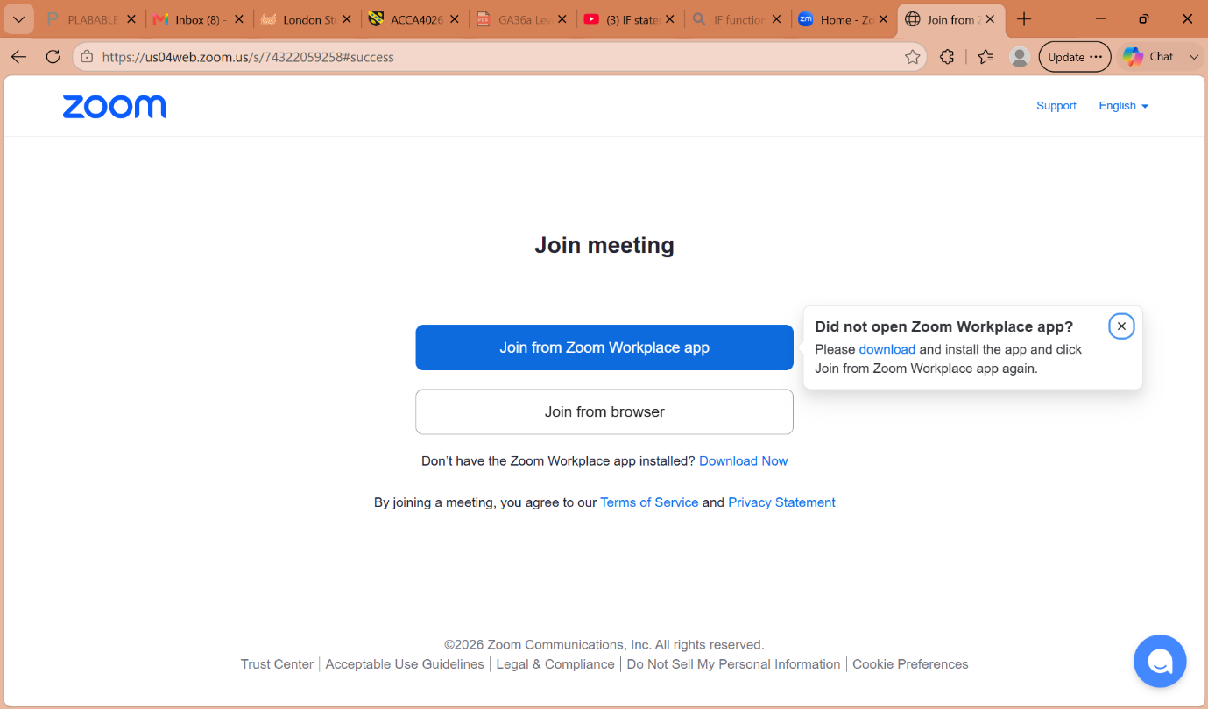
Using the join a meeting feature
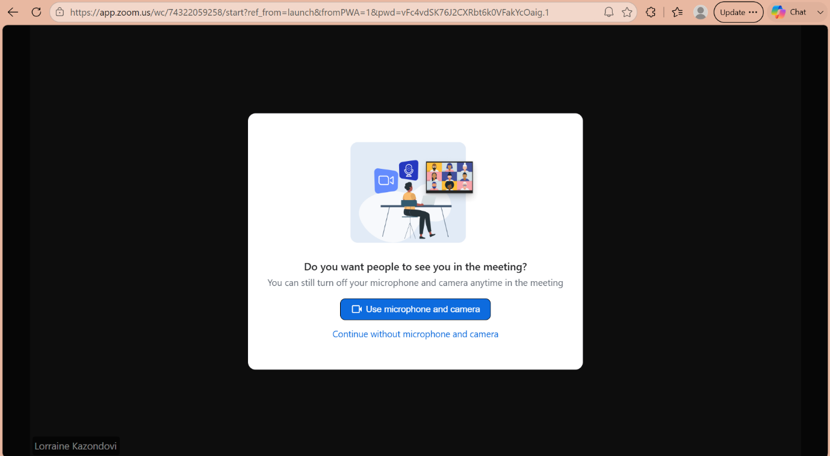
Entering the meeting and choosing to use microphone and camera. Anyone can join zoom meeting freely with or without a subscription or an account.

Conclusion
This assignment was a theoretical and practical exercise in understand various software applications that are used in day-to-day business practices as well as in personal or academic settings. The software applications have become necessary tools to enable individuals to complete tasks and have meticulous organizational skills as well as map out future objectives to be achieved.

References

[1] | N. Lindholm, “Four Tools, One Portfolio: A Practical Comparison of Canva, Wix, Figma, and Notion,” Arcada University of Applied Sciences: Bachelor of Arts, Helsinki, 2026.
[2] | J. Smith, “Shopify vs Squarespace: Best Ecommerce Platform Comparison,” Unknown, 2026.
[3] | Fabrizio Assabese Giuseppe Destefanis, “Scale, Concentration, and Entry Timing in the Shopify App Ecosystem,” IWSiB '26: Proceedings of the 9th ACM/IEEE International Workshop on Software-intensive Business, London, 2026.
[4] | T. Buzan, “Mind map mastery: The complete guide to learning and using the most powerful thinking tool in the universe,” Jaico Publishing House, Mumbai, 2024.
[5] | J. M. Guerrero, “Mind Mapping and Artificial Intelligence,” Academic Press, London, 2022.
[6] | Dipak Bhattacharya, Ramakanta Mohalik, “Digital Mind Mapping Software: A New Horizon in the Modern Teaching,” Journal of Advances in Education and Philosophy, Dubai, 2020.
[7] | Abdul Jalil Firlana Rosa Rheinald Affandi Abdul Aziz Wahyu Nurkholis Hadi Saputra Atok Ainur, “Literature Review: Exploration of Features Microsoft Word,” International Applied Science, Indonesia, 2024.
[8] | J. Ballew, “What Is Microsoft Word?,” LifeWire, New York City, 2021.
[9] | J. Schmidt, “What Is Excel? Definition and Overview,” Corporate Finance Institute, Vancouver, 2026.
[10] | M. Lynch, “What Is Microsoft PowerPoint and How Do I Use It?,” The Tech Advocate, Richmond, 2023.
[11] | J. Fisher, “What Is Microsoft Access? A Beginner’s Guide,” Addictive Tips, 2026.
[12] | M. Rouse, “What is Gmail?,” Techopedia, Edmonton, 2024.
[13] | J. Fisher, “What Is Zoom? The Essential Guide to Understanding Features, History, and Usage,” LifeWire, New York City, 2025.

