Natalie Wellbeloved
Dissertation Proposal
A critical evaluation of the relationship between effective community policing and fighting criminality in the UK.

Introduction – Background
Over the years, policing has changed significantly in order to keep up to date with the ever changing times that we live in. With that, we have seen policing go from the phrase ‘bobby’s on the beat’ where you would see a significant amount of police officers walking in their local community, to the introduction of Police Community Support Officers being sworn into police forces across the country. However, to see the introduction of the latter saw a history of concerns raised by the public. Concerns were raised that the public’s needs and expectations weren’t being met in the time taken for the Police Service to respond to emergency calls. As a result of this, the Police Service adapted and provided frontline officers with the ability to respond in vehicles. Consequently, by addressing one concern, another was raised as the public were concerned that there were insufficient frontline officers walking in the community. As a result, there were concerns on criminality in communities, which began to rise. To ensure visibility, The Police Reform Act 2002 created more staff roles, including Police Community Support Officers, and by 2008, saw the Neighbourhood Policing initiative introduced to all police services by the Labour government at the time. This helped rectify concerns and put officers back on the frontline and in the hearts of the community.
Literature Review
Blackstone’s Handbook for Policing Students sets the standard of what community policing is mainly about. It is evident that forming an effective community engagement strategy is to “develop sophisticated partnership-working arrangements to meet community needs” (Bryant and Bryant, 2018, p.133). Communication with the community is vital and through collaboration with other partner agencies, local needs and expectations surrounding crime and disorder can be highlighted and a proactive approach can be administered for the necessary action to be taken. To help combat criminality head on, the gathering of intelligence from members of the community or through the use of partner agencies will be necessary. There can and will be local issues, with reassurance essential in providing feedback on actions taken as a result of their primary information, however, such effective community policing is not immediate and requires time to build up professional relationships with the community.
Further research suggests that “‘community’ and ‘crime’ have become co-joined as a binary hierarchy, as the promotion of the former is envisioned as a strategy to reduce, or even defeat, the latter” (Hughes and Rowe, 2017, p.320). This research examines policy developments in order to explore those issues relating to both areas and that emphasis on both are centrally important. Nevertheless, this research highlights that there are clear errors, such as cultural and institutional factors which could arise if the performance targets are not met.
Effective community policing relies heavily on certain departments of policing such as neighbourhood policing teams. Bryant and Bryant emphasise that “community-orientated approaches to policing provide a crucial opportunity to engage with the public, proactively combat crime (through crime prevention strategies), and address community safety and quality of life issues” (Bryant and Bryant, 2018, p.53). I therefore intend to establish how neighbourhood policing is the core of fighting criminality. It is vital to explore how intelligence gathering of information is submitted and disseminated to the relevant departments. This will look to lead on to the discussion of specialist departments such as drug squads, criminal investigation teams, response policing, major crime and roads policing to assist with evidence led policing will help to identify patterns of crime.
To examine the relationship between effective community policing and fighting criminality will result in further research on styles of policing which overall help towards that ‘end goal’. This research will include topics such as evidence based policing, intelligence led policing, tackling anti-social behaviour, partnership programmes and partnership and communities come together meetings, otherwise known as ‘PACT’ meetings. This research will also analyse models which have been implemented into day to day policing such as the Problem-orientated Policing model, otherwise known as ‘POP’. Developed by Herman Goldstein (Bryant and Bryant, 2018, p.53), this model “is an approach to tackling crime and disorder that involves the identification of a specific problem, thorough analysis to understand the problem, the development of a tailored response and an assessment of the effects of the response” (Problem-orientated policing NEW, 2020). Furthermore the Crime Reduction Toolkit will be referenced within this research paper which “lists crime reduction interventions which span a broad range of approaches and problems” (About the Crime Reduction Toolkit | What Works Centre for Crime Reduction, 2020). When implemented, this toolkit helps those understand what interventions work and what doesn’t work in terms of “their impact on reducing crime” and “according to the best available evidence” (About the Crime Reduction Toolkit | What Works Centre for Crime Reduction, 2020). Such systematic reviews are presented on a framework guide called EMMIE (figure 1).
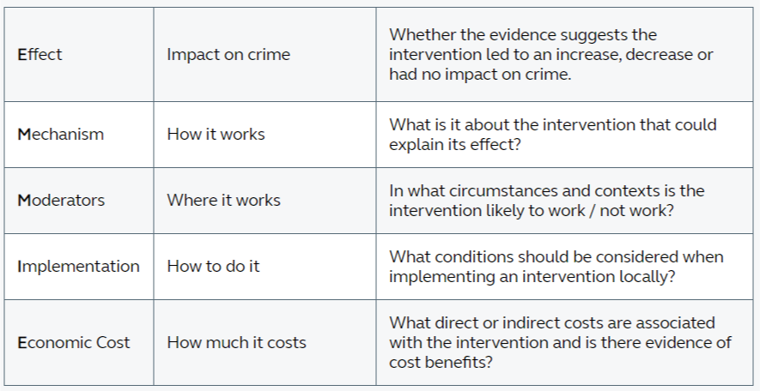
Figure 1 – EMMIE
(source About the Crime Reduction Toolkit | What Works Centre for Crime Reduction, 2020)

Within this research it is intended to highlight two major incidents including the Fiona Pilkington Case of 2007 and the Brixton Riots in 1981. It will discuss the consequences of not responding to community needs and expectations and how the police have reformed.
This research will also discuss The Home Office Consultation document named Policing in the 21st Century: Reconnecting police and the people which “proposed to ‘empower communities’ and provide ‘greater visibility and availability’” (Bryant and Bryant, 2018, p.53).
Objectives
This research will discuss the case of the relationship between effective community policing and fighting criminality in the UK. Policing history has evidenced that needs and expectations of the public have not been met and have seen a decrease in public confidence. As a result, the police service have made interventions in order to place police officers back on the front line in order to meet those needs, expectations and solve concerns to not only increase public confidence in the police but to also help combat criminality.
The objective of this research aims to discuss the importance of effective community policing today and explore the different range of views and opinions of the research topic. Therefore to discuss this topic area it is intended to highlight what community policing is. It will look to examine the legal and professional responsibilities and standards of policing which are a major part of policing in the UK today. Within this research, it will discuss policing strategies in place today which have been introduced in order to help combat criminality and how they work in modern policing and the contingencies that may arise if such policing is not present. Overall, by considering both the strengths and weaknesses this research will look to seek the relationship between both effective community policing and fighting criminality. The purpose of this research is to attempt to answer the following questions;

- How does the police service work with the public in order to obtain relevant information or intelligence to help combat criminality?
- How important is the department of neighbourhood policing?
- How do the various departments within the police service benefit from neighbourhood policing?

The justification for this research is to investigate the current impact of effective community policing in today’s society and the programmes in place which help against tackling criminality. It is essential to understand how the police, partner agencies and local communities play a strategic role through local initiatives and intelligence led policing to analyse the crime and disorder within an area. Research will analyse what methods and procedures are in place to combat such criminality to sustain a long term goal.
Research Method
It is intended to carry out the necessary research by way of secondary data. This will be sourced from web pages, journals and books and will be based on information which has been sourced in the UK. It will look to source history on policing in order to set the background for the research. The research will almost show a detailed timeline of the history of frontline policing and the introduction of relevant legislations and standards of policing such as the Peelian Principles and will show how such legitimacy is vital within policing.
Ethical issues & risks
Due to the current government guidelines and restrictions in place concerning the Covid-19 pandemic, I will be unable to carry out primary research such as questionnaires which could have been obtained from the local community.
Whilst carrying out research for this topic there may be limitations and weaknesses to my proposed research which may be affected due to the Covid-19 Pandemic. Due to social distancing and government guidelines, I will not be able to obtain primary research through members of the public of various communities.
Although there have been set dates for the course of my dissertation, my time is still limited due to work commitments and my personal life however with target dates already in place for each submission I should be able to manage my time effectively in order to achieve the deadlines.

Plan of Work
Having frontline policing experience, I will be able to draw from first-hand experience of how effective community policing is a key part of policing. Through such direct experience I will be able to reflect on what are the strengths in this area of policing but also highlight the weaknesses and contingencies that often arise. This experience will be in addition to the continued access of UWTSD online resources and web pages. An extensive literature review of both effective community policing and how such policing effects criminality rates will be essential.
References
Books;
Bryant, R. and Bryant, S. (2018) Blackstone's Handbook for Policing Students 2019. 13th Ed. New York: Oxford University Press.
Articles;
Hughes, Gordon & Rowe, Michael. (2007) ‘Neighbourhood policing and community safety’, Criminology & criminal justice, 7(4), pp.317–346. DOI: 10.1177/1748895807082059 [Accessed: 30.04.2021].
Webpages;
Whatworks.college.police.uk. 2020. About the Crime Reduction Toolkit | What Works Centre for Crime Reduction. [online] Available at: <https://whatworks.college.police.uk/toolkit/Pages/About_the_CRT.aspx#CRT> [Accessed 30 April 2021].
Whatworks.college.police.uk. 2020. Problem-orientated policing NEW. [online] Available at: <https://whatworks.college.police.uk/toolkit/Pages/Intervention.aspx?InterventionID=47> [Accessed 30 April 2021].

