University of Wales Trinity Saint David
School of Engineering



2D Transient Heat Equation Solved with the Explicit Finite Difference Method
Computational Methods
(ACMA6012)

Tia Ball
2220258
January 2026

Abstract
This report models two-dimensional transient heat conduction in a 10 m × 10 m aluminium plate using an Explicit Finite Difference Method (EFDM) with a forward-time central-space (FTCS) scheme on a uniform grid. Dirichlet boundary conditions are applied with the north edge at 60 °C, the remaining boundaries at 0 °C, and an initial interior temperature of 0 °C. Numerical results are validated against an analytical steady-state solution obtained via separation of variables and evaluated as a truncated Fourier sine series. Agreement is quantified using the maximum absolute error and RMSE. Sensitivity studies using a 12 m × 12 m aluminium plate assess the influence of grid spacing, time step, and convergence tolerance under the Fourier-number stability constraint. Results show that the stopping criterion strongly controls the reported “equilibrium” field and can dominate trends with $Δt$, producing higher validation errors for smaller time steps unless the tolerance is tightened. A parameter set is identified that balances computational cost and agreement with the analytical solution.

Contents
Abstract 2
List of Figures 6
1 Introduction 8
1.1 Context and Background 8
1.2 Aim and Objectives 8
1.2.1 Aim 8
1.2.2 Objectives 8
1.3 Methodology Overview 9
1.4 Report Structure 9
2 Governing Equation 10
2.1 Background and Importance of the Heat Equation 10
2.2 2D Heat Equation with no Heat Source Term 10
2.3 Definition of Terms and Material Properties 10
3 Explicit finite difference form of the governing equation 12
3.1 Taylor Series and Finite Difference Approximations 12
3.2 Discretisation of the Spatial and Temporal Domains 12
3.3 Formulation of the EFDM (FTCS scheme): 13
3.4 Fourier Number and Stability Criterion: 13
4 The Initial, Boundary Conditions and Analytical Solution. 14
4.1 Initial Condition 14
4.2 Boundary Conditions and Justification 14
4.3 Analytical Solution at Thermal Equilibrium 14
5 Codes’ Details and Explanations 16
5.1 Workspace Setup 16
5.2 Material Properties and Thermal Diffusivity 16
5.3 User Input and Validation for X, Y and h 16
5.4 Grid Sizing 17
5.5 Initialisation of Temperature Matrix T1 17
5.6 Apply Boundary Conditions 17
5.7 Time Step Selection and Stability Check 17
5.8 Initialise T2, Convergence Variables, and Plotting Grid 18
5.9 Live Temperature Contour Plot During Iteration 18
5.10 EFDM Update Loop and Convergence Check 18
5.11 Display Convergence Results 19
5.12 Analytical Solution Setup 19
5.13 Analytical Steady-State Solution (Series Summation) 19
5.14 Plot the Analytical Temperature Field 19
5.15 Error Map and Validation Metrics 20
5.16 Time to Thermal Equilibrium Calculation 20
6 Validation of the Code. 21
6.1 Validation Approach 21
6.2 Validation Case Selected for Presentation (CC = 0.001) 21
6.3 Comparison Validation Case (CC = 0.1) 23
6.4 Validation Conclusion 24
7 Sensitivity Analysis of the Code. 25
7.1 Purpose and Method 25
7.2 Influence of grid spacing $h$(fixed $Δt=150$s, fixed $CC=0.001$) 25
7.3 Influence of time step $Δt$(fixed $h=0.75$m, fixed $CC=0.0001$) 26
7.4 Influence of thermal equilibrium tolerance $CC$(fixed $h=1$m, fixed $Δt=500$s) 27
7.5 Sensitivity Summary 28
8 Limitations of the Numerical Model. 29
8.1 Limitations of the Numerical Method (EFDM) 29
8.2 Limitations of the Coding Implementation (Evidence Linked) 29
8.3 Limitations of the Analytical Reference Solution 30
8.4 Summary of Limitations 30
9 Suggested Improvements and Future Developments. 31
9.1 Improved Equilibrium (Steady-State) Detection 31
9.2 More Efficient Time Integration 31
9.3 Grid Convergence and Uncertainty Reporting 31
9.4 Alternatives for Complex Geometries and Unstructured Meshes 32
10 Conclusion. 33
11 References 34
12 Appendix 36
12.1 MATLAB Code 36

List of Figures
Listing 1 - Script Initialisation 16
Listing 2 - Aluminium Material Properties 16
Listing 3 - User Input Prompts & Validation 16
Listing 4 - Grid Size Calculation and Node Count Definition (NR, NC) 17
Listing 5 - Initial Temperature Field Initialisation (T1) 17
Listing 6 - Application of Dirichlet Boundary Condition on the North Edge (T0) 17
Listing 7 - Stable Time-Step Selection Enforcing Fo ≤ 1/4 17
Listing 8 - Initialise T2, Convergence Variables, and Plotting Grid 18
Listing 9 - Temperature Contour Plot 18
Listing 10 - EFDM Iteration Loop 18
Listing 11 - Convergence Check and Iteration Counter Update 19
Listing 12 - Analytical Solution Setup 19
Listing 13 - Analytical Steady-State Series Solution Assembly 19
Listing 14 - Analytical Solution Contour Plot Generation for TA 19
Listing 15 - Validation Error Field Calculation and Absolute Error Contour Plot 20
Listing 16 - Error Metrics (max error, RMSE) and Equilibrium Time Reporting 20

Table 1 - Thermal Equilibrium Time Results for the Grid Spacing Sensitivity Study on a 12 m × 12 m Plate with Δt=150s and CC=0.001. 25
Table 2 - Thermal Equilibrium Time Results for the Time Step Sensitivity Study on a 12 m × 12 m Plate with h=0.75m and CC=0.0001 26
Table 3 - Thermal Equilibrium Time Results for the Tolerance Sensitivity Study on a 12 m × 12 m Plate with h=1m and Δt=500s 27

Figure 1 - EFDM Steady-State Temperature Field 21
Figure 2 - Analytical Steady-State Temperature Field 22
Figure 3 - Absolute Error Field 22
Figure 4 - EFDM Steady-State Temperature Field 23
Figure 5 - Analytical Steady-State Temperature Field 24
Figure 6 - Thermal Equilibrium Time as a Function of Grid Spacing h for a 12 m × 12 m Plate with Δt=150s and CC=0.001 26
Figure 7 - Thermal Equilibrium Time as a Function of Time Step Δtfor a 12 m × 12 m Plate with h=0.75m and CC=0.0001 27
Figure 8 - Thermal Equilibrium Time as a Function of Equilibrium Tolerance CC for a 12 m × 12 m Plate with h=1m and Δt=500s 28

Introduction

Context and Background
Transient heat conduction in solids is a fundamental problem in engineering, underpinning thermal management in structures, manufacturing processes, and electronic systems. In many practical applications, temperature evolves over time due to imposed boundary temperatures, and spatial temperature gradients can drive thermal stresses or affect performance. While analytical solutions exist for a limited class of geometries and boundary conditions, many engineering problems require numerical methods to predict transient and steady temperature fields on spatial domains. Explicit finite difference methods are widely taught and used because they are straightforward to implement on structured grids, though they require adherence to stability constraints and careful interpretation of numerical convergence. (Morton & Mayers, 2005)

Aim and Objectives

Aim
To model two-dimensional transient heat conduction in an aluminium plate using the Explicit Finite Difference Method (EFDM) and to validate the resulting equilibrium temperature field against an analytical steady-state solution.

Objectives
- To formulate the governing 2D transient heat equation for conduction in a homogeneous plate and define thermal diffusivity from material properties (Incropera, DeWitt, Bergman, & Lavine, 2011).
- To derive and implement the EFDM (forward-time, central-space) discretisation for the 2D heat equation and identify the order of accuracy and truncation error sources (Smith, 1985).
- To apply the explicit stability condition using the Fourier number and ensure stable time-marching for all simulation runs (Morton & Mayers, 2005).
- To compute an analytical steady-state reference solution using a truncated separation-of-variables Fourier series appropriate to the prescribed boundary conditions (Carslaw & Jaeger, 1959).
- To validate the EFDM equilibrium field against the analytical solution using contour plots, the maximum absolute error and the root mean square error (RMSE) (Press, Teukolsky, Vetterling, & Flannery, 2007).
- To perform sensitivity analysis on grid spacing $h$, time step $Δt$, and convergence criterion $CC$, and to interpret trade-offs between accuracy and computational cost. (LeVeque, 2007).

Methodology Overview
The plate domain is discretised using a uniform Cartesian grid and advanced in time using an explicit FTCS finite difference scheme. A user-specified time step is restricted by the explicit stability requirement $Fo≤1/4$, where $Fo=αΔt/h^{2}$. The simulation advances until a numerical convergence criterion based on the maximum change between successive temperature fields falls below a specified tolerance. The final numerical field is then compared to an analytical steady-state solution computed using a truncated Fourier series, and quantitative error metrics are reported. (Morton & Mayers, 2005).

Report Structure
Chapter 2 introduces the governing equation and defines all parameters and units. Chapter 3 presents the EFDM formulation, including the Fourier number and stability considerations. Chapter 4 specifies the initial and boundary conditions and outlines the analytical steady-state reference solution. Chapter 5 summarises the MATLAB implementation. Chapter 6 provides validation against the analytical solution using contour plots and error metrics. Chapter 7 reports sensitivity analysis for grid spacing, time step and convergence tolerance. Chapters 8 and 9 discuss limitations and propose improvements, respectively, and Chapter 10 presents the conclusions.

Governing Equation

Background and Importance of the Heat Equation
The heat equation is a fundamental partial differential equation (PDE) describing how temperature evolves over time due to heat conduction within a material. It is widely used in engineering to model heating and cooling processes, support thermal management, and predict temperature gradients that may lead to thermal stresses or performance changes. (Incropera, DeWitt, Bergman, & Lavine, 2011). The model follows directly from energy conservation combined with Fourier’s law of conduction, making it central to heat transfer and diffusion analysis (Bergman, Lavine, Incorpera, & DeWitt, 2011).

2D Heat Equation with no Heat Source Term
The general transient heat conduction equation in two dimensions with a volumetric heat generation term $\dot{q}$(W/$m^{3}$) is:
$$ρc_{p}\frac{∂T}{∂t}=k\left(\frac{∂^{2}T}{∂x^{2}} + \frac{∂^{2}T}{∂y^{2}}\right)+\dot{q}$$
For the case considered in this report, there is no internal heat source, so $\dot{q}=0$. Dividing by $ρc_{p}$ gives the standard 2D heat equation in diffusion form:
$$\frac{∂T}{∂t}=α\left(\frac{∂^{2}T}{∂x^{2}} + \frac{∂^{2}T}{∂y^{2}}\right)$$
(Incropera, DeWitt, Bergman, & Lavine, 2011).

Definition of Terms and Material Properties
In the governing equation:
- $T(x,y,t)$ is temperature (°C).
- $t$ is time (s).
- $x$ and $y$ are spatial coordinates (m).
- $\frac{∂T}{∂t}$ is the temporal rate of change of temperature (°C/s).
- $\frac{∂^{2}T}{∂x^{2}}$ and $\frac{∂^{2}T}{∂y^{2}}$ are the spatial second derivatives representing curvature of the temperature field (°C/$m^{2}$).
- $α$ is thermal diffusivity ($m^{2}$/s), defined as:
$$α=\frac{k}{ρc_{p}}$$
where:
- $k$ is thermal conductivity (W/$m$ °C).
- $ρ$ is density (kg/$m^{3}$).
- $c_{p}$ is specific heat capacity (J/kg °C).
Thermal diffusivity characterises how rapidly temperature disturbances diffuse through a material, combining conductivity with thermal storage capacity (Bergman, Lavine, Incorpera, & DeWitt, 2011).
For aluminium, the MATLAB implementation used $k=143$W/m °C, $ρ=2800$kg/$m^{3}$, and $c_{p}=795$J/kg °C, giving $α=6.42×{10}^{-5}m^{2}$/s, consistent with the computed output from the code (Incropera, DeWitt, Bergman, & Lavine, 2011).

Explicit finite difference form of the governing equation

Taylor Series and Finite Difference Approximations
Finite difference methods approximate derivatives by expanding $T$ about a point using a Taylor series (Richtmyer & Morton, 1967). For a sufficiently smooth function, expansions about $x_{i}$ give:
$$T(x_{i+1})=T(x_{i})+hT^{'}(x_{i})+\frac{h^{2}}{2}T^{''}(x_{i})+O(h^{3}) \\ T(x_{i-1})=T(x_{i})-hT^{'}(x_{i})+\frac{h^{2}}{2}T^{''}(x_{i})+O(h^{3})$$
Adding these expansions eliminates odd derivative terms and yields the standard second-derivative central difference approximation:
$$T^{''}(x_{i})≈\frac{T_{i+1}-2T_{i}+T_{i-1}}{h^{2}}$$
with truncation error $O(h^{2})$, meaning the spatial approximation is second-order accurate (Smith, 1985). Similarly, the forward difference approximation for the time derivative:
$$\frac{∂T}{∂t}≈\frac{T^{n+1}-T^{n}}{Δt}$$
has a truncation error $O(Δt)$, making the temporal approximation first-order accurate (Morton & Mayers, 2005). The resulting FTCS EFDM is therefore first-order accurate in time and second-order accurate in space, giving a combined local truncation error of $O(Δt)+O(h^{2})$ (Smith, 1985).

Discretisation of the Spatial and Temporal Domains
The rectangular domain $0≤x≤X$, $0≤y≤Y$is divided into a uniform mesh with spacing $h$ in both directions, so $h=Δx=Δy$. Grid nodes are indexed $\left(i , j\right)$, where $i$denotes the $y$-direction (row) and $j$denotes the $x$-direction (column). Time is discretised into levels $t^{n}=nΔt$, where $n$ is the time-step index (Smith, 1985).

Formulation of the EFDM (FTCS scheme):
Applying forward difference in time and central differences in space to the 2D heat equation gives:
$$\frac{T_{i,j}^{n+1}-T_{i,j}^{n}}{Δt}=α\left(\frac{T_{i+1,j}^{n}-2T_{i,j}^{n}+T_{i-1,j}^{n}}{h^{2}} + \frac{T_{i,j+1}^{n}-2T_{i,j}^{n}+T_{i,j-1}^{n}}{h^{2}}\right)$$
Rearranging yields the explicit update:
$$T_{i,j}^{n+1}=T_{i,j}^{n}+Fo\left(T_{i+1,j}^{n}+T_{i-1,j}^{n}+T_{i,j+1}^{n}+T_{i,j-1}^{n}-4T_{i,j}^{n}\right)$$
where the Fourier number $Fo$ is defined below.

Fourier Number and Stability Criterion:
The Fourier number is introduced as:
$$Fo=\frac{αΔt}{h^{2}}$$
This nondimensional parameter controls the proportion of diffusion applied per time step relative to the mesh spacing. A larger $Fo$ generally accelerates the approach to equilibrium but can destabilise explicit schemes if it exceeds the stability limit (Morton & Mayers, 2005).
For the 2D FTCS diffusion scheme on a uniform grid, von Neumann stability analysis shows that stability requires:
$$Fo≤\frac{1}{4}$$
This criterion constrains the maximum permissible time step for a chosen $h$, linking spatial and temporal discretisation choices directly (Smith, 1985). In the MATLAB code, $Δt_{max}=h^{2}/(4α)$ is computed and user input is restricted to satisfy this requirement.

The Initial, Boundary Conditions and Analytical Solution.

Initial Condition
The plate is initialised at a uniform temperature of 0 °C throughout the domain, such that:
$$T(x,y,0)=0$$
This represents a uniform starting condition before heat diffuses into the plate from the imposed boundary temperatures.

Boundary Conditions and Justification
Dirichlet boundary conditions are applied as follows:
- North boundary: $T(x,Y,t)=T_{0}=60$°C
- South boundary: $T(x,0,t)=0$°C
- West boundary: $T(0,y,t)=0$°C
- East boundary: $T(X,y,t)=0$°C
In the MATLAB implementation, the north boundary is applied to the top row, excluding corner nodes, i.e. T1(1,2:NC-1)=T0, while the remaining boundary nodes retain the initialised value of 0 °C.
These boundary conditions were chosen because they match the analytical steady-state solution provided in the Coursework 1 brief. Since closed-form analytical solutions are only available for limited boundary-condition configurations, this choice enables direct validation by comparing the EFDM equilibrium field with the analytical reference solution.

Analytical Solution at Thermal Equilibrium
At thermal equilibrium, $∂T/∂t=0$, and the governing equation reduces to Laplace’s equation:
$$\frac{∂^{2}T}{∂x^{2}}+\frac{∂^{2}T}{∂y^{2}}=0$$
For the specified Dirichlet boundary conditions on a rectangular domain, separation of variables yields a Fourier sine-series solution for the steady-state temperature field $T_{A}\left(x,y\right)$ (Carslaw & Jaeger, 1959). In the MATLAB code, this analytical series is evaluated numerically using a finite truncation (10,000 terms) to produce the reference field used for validation.

Codes’ Details and Explanations

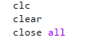
Workspace Setup
Listing 1 - Script Initialisation
Listing 1 clears the workspace and closes figures to ensure a clean run. This prevents old variables/plots from affecting results.

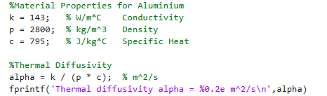
Material Properties and Thermal Diffusivity
Listing 2 - Aluminium Material Properties
Listing 2 defines aluminium properties and calculates thermal diffusivity. This is needed for $Fo$, stability, and time marching.

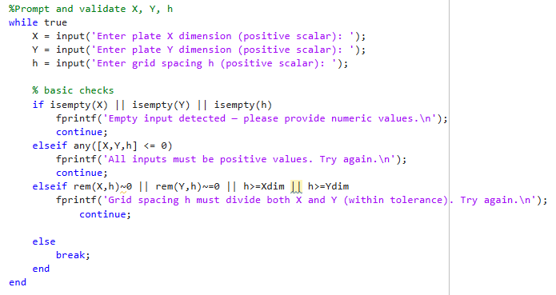
User Input and Validation for X, Y and h
Listing 3 - User Input Prompts & Validation
Listing 3 prompts the user for plate dimensions and grid spacing, then validates inputs. This ensures inputs are positive and the grid aligns with boundaries.

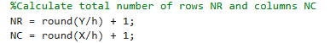
Grid Sizing
Listing 4 - Grid Size Calculation and Node Count Definition (NR, NC)
Listing 4 converts physical dimensions into grid node counts. “+1” includes both boundaries in each direction.

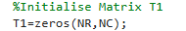
Initialisation of Temperature Matrix T1
Listing 5 - Initial Temperature Field Initialisation (T1)
Listing 5 initialises the temperature field. This implements the initial condition $T(x,y,0)=0$°C.

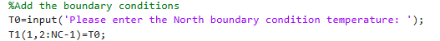
Apply Boundary Conditions
Listing 6 - Application of Dirichlet Boundary Condition on the North Edge (T0)
Listing 6 applies the north edge Dirichlet boundary condition. The above sets the top boundary to $T_{0}$while other edges remain 0 °C.

Time Step Selection and Stability Check
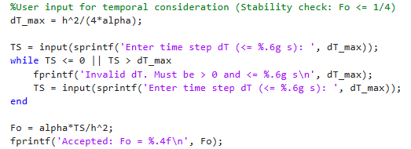
Listing 7 - Stable Time-Step Selection Enforcing Fo ≤ 1/4
Listing 7 computes the maximum stable time step and enforces $Fo≤1/4$. This prevents instability by restricting $Δt$.

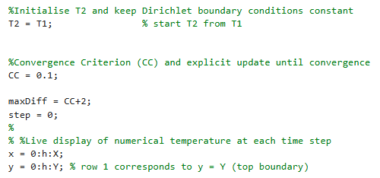
Initialise T2, Convergence Variables, and Plotting Grid
Listing 8 - Initialise T2, Convergence Variables, and Plotting Grid
Listing 8 prepares the second temperature array and convergence tracking. This sets up the solver state and grid vectors for plotting.

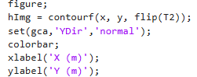
Live Temperature Contour Plot During Iteration
Listing 9 - Temperature Contour Plot
Listing 9 creates the initial contour plot for the transient solution. This visualises temperature evolution during time marching.

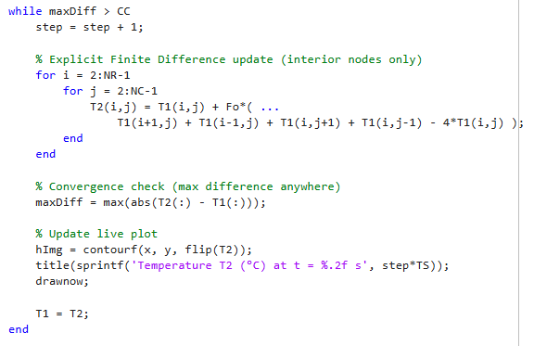
EFDM Update Loop and Convergence Check
Listing 10 - EFDM Iteration Loop
Listing 10 updates interior nodes using EFDM and checks for convergence. This applies the 5-point stencil until $max⁡∣T^{n+1}-T^{n}∣≤CC$.

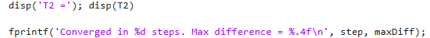
Display Convergence Results
Listing 11 - Convergence Check and Iteration Counter Update
Listing 11 prints the converged numerical field and stopping statistics. This reports the final numerical field and convergence performance.

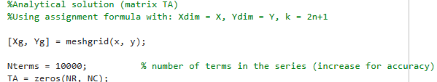
Analytical Solution Setup
Listing 12 - Analytical Solution Setup
Listing 12 creates the grid for the analytical series evaluation. This prepares arrays for the analytical reference solution.

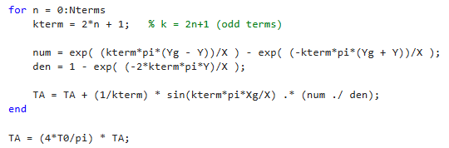
Analytical Steady-State Solution (Series Summation)
Listing 13 - Analytical Steady-State Series Solution Assembly
Listing 13 evaluates the truncated Fourier series for $T_{A}(x,y)$. This produces the analytical steady-state temperature field for validation.

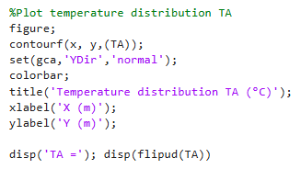
Plot the Analytical Temperature Field
Listing 14 - Analytical Solution Contour Plot Generation for TA
Listing 14 plots the analytical solution as a contour map. The above allows direct visual comparison with the numerical result.

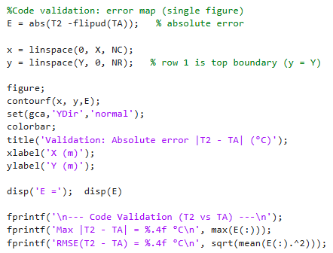
Error Map and Validation Metrics
Listing 15 - Validation Error Field Calculation and Absolute Error Contour Plot
Listing 15 computes absolute error, plots it, and reports max error and RMSE. This quantifies agreement between EFDM and analytical results.

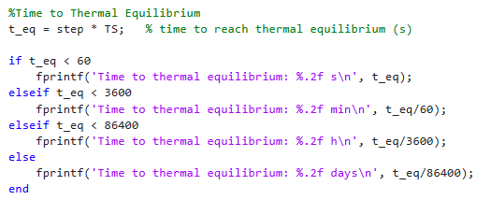
Time to Thermal Equilibrium Calculation
Listing 16 - Error Metrics (max error, RMSE) and Equilibrium Time Reporting
Listing 16 converts step count into physical time and prints it neatly. This reports the simulated time needed to satisfy the chosen convergence tolerance.

Validation of the Code.

Validation Approach
Validation compared the EFDM equilibrium field $T_{2}$with the analytical steady-state field $T_{A}$ on the same grid to quantify numerical accuracy for the specified boundary conditions (Ozisik, 1955). Agreement was assessed using $T_{2}$and $T_{A}$ contour plots, the absolute error map $E=∣T_{2}-T_{A}∣$, the maximum absolute error, and the RMSE (Press, Teukolsky, Vetterling, & Flannery, 2007).

Validation Case Selected for Presentation (CC = 0.001)
The primary validation case compares the EFDM thermal-equilibrium (steady-state) temperature field $T_{2}$ with the analytical steady-state field $T_{A}$ for $X=10$m, $Y=10$m, $h=0.5$m, $T_{0}=60$°C and $Δt=900$s, giving $Fo=0.2313$, with CC = 0.001. The run converged in 492 steps and reported a thermal equilibrium time of 5.12 days. The validation metrics were:
- $max⁡∣T_{2}-T_{A}∣=0.4360$°C.
- $RMSE(T_{2}-T_{A})=0.0732$°C.
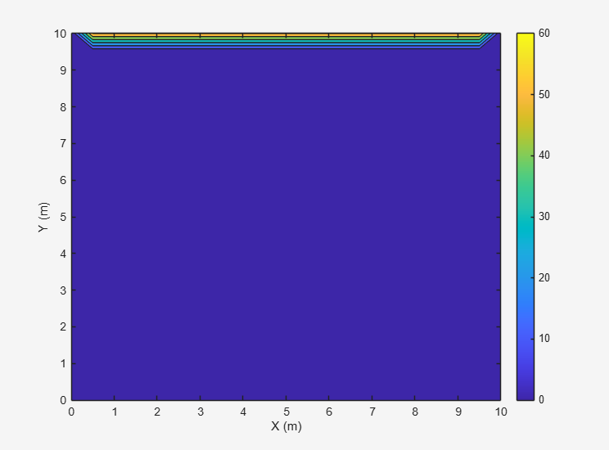
Figure 1 shows the EFDM equilibrium temperature field $T_{2}$for the CC = 0.001 case.
Figure 1 - EFDM Steady-State Temperature Field

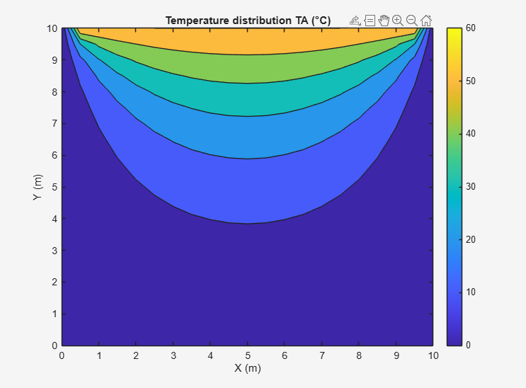
Figure 2 shows the analytical steady-state field $T_{A}$ on the same grid.
Figure 2 - Analytical Steady-State Temperature Field

Figure 3 shows the absolute error map $E=∣T_{2}-T_{A}∣$for CC = 0.001.
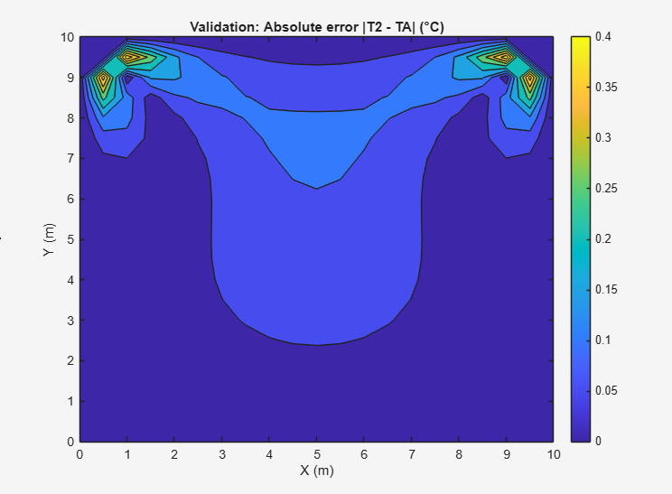
Figure 3 - Absolute Error Field

Interpretation: The numerical and analytical contours are expected to show the same diffusion-dominated structure (isotherms smoothing from the heated north boundary into the interior). The low RMSE indicates strong overall agreement across the plate, while the maximum error highlights the worst-case deviation (Smith, 1985).

Comparison Validation Case (CC = 0.1)
To demonstrate the effect of the stopping tolerance, a comparison run was performed with identical $X$, $Y$, $h$, $T_{0}$, and $Δt$, but with CC = 0.1. This run converged in 103 steps and reported a thermal equilibrium time of 1.07 days. The validation metrics were:
- $max⁡∣T_{2}-T_{A}∣=7.6524$°C.
- $RMSE(T_{2}-T_{A})=3.5779$°C.
Figure 4 shows the EFDM equilibrium temperature field $T_{2}$ for CC = 0.1.
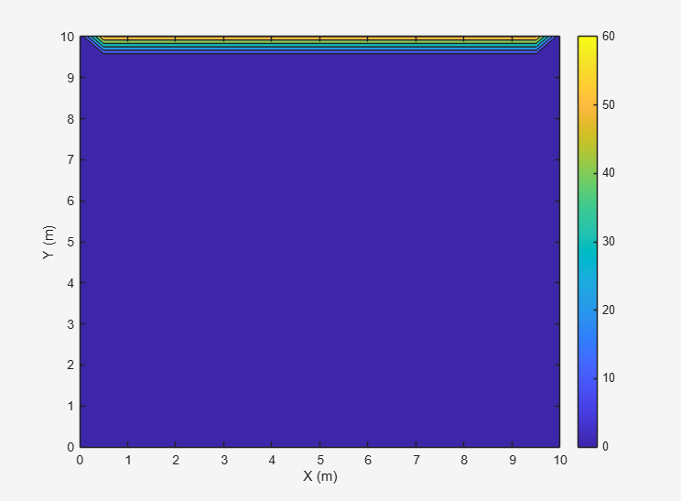
Figure 4 - EFDM Steady-State Temperature Field
Figure 5 shows the absolute error map $E=∣T_{2}-T_{A}∣$for CC = 0.1. (The analytical field is unchanged from Figure 6.2 and is therefore not repeated.)
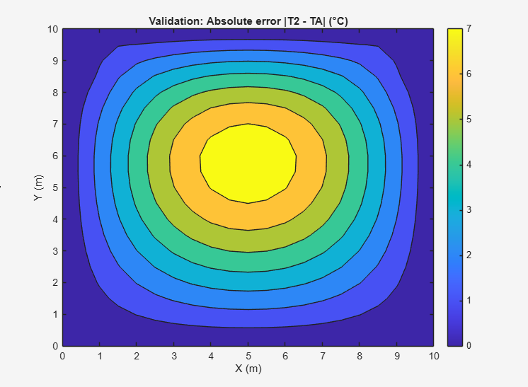
Figure 5 - Analytical Steady-State Temperature Field
Interpretation: The substantially larger errors confirm that a loose tolerance can terminate iterations while residual transient behaviour remains. This is consistent with convergence criteria based on successive iterate differences: a larger $CC$ allows the algorithm to stop earlier at a state that is less close to the steady solution (Press, Teukolsky, Vetterling, & Flannery, 2007).

Validation Conclusion
Accuracy is strongly dependent on the equilibrium tolerance $CC$: a strict tolerance ($CC=0.001$) gives close agreement with the analytical steady state, whereas a loose tolerance ($CC=0.1$) reduces computation time but produces noticeably larger errors (Morton & Mayers, 2005). For $CC=0.001$, agreement is strong, with maximum error below 0.5 °C and RMSE below 0.1 °C

Sensitivity Analysis of the Code.

Purpose and Method
This chapter assesses sensitivity to grid spacing $h$, time step $Δt$ and equilibrium tolerance $CC$ using the reported thermal equilibrium time, defined as the first time at which $max⁡∣T^{n+1}-T^{n}∣≤CC$ (Morton & Mayers, 2005). Stability is enforced using the Fourier number $Fo=αΔt/h^{2}$, and all runs satisfy the explicit stability requirement (Smith, 1985). One parameter is varied at a time while the others are held constant. All sensitivity tests used the same north boundary temperature, with T0 = 60° applied throughout.

Influence of grid spacing $h$(fixed $Δt=150$s, fixed $CC=0.001$)
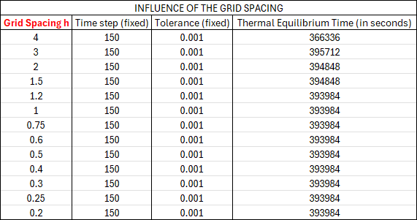
Table 1 summarises the grid spacing sensitivity study for a 12 m × 12 m plate, with $Δt=150$s and $CC=0.001$ held constant.
Table 1 - Thermal Equilibrium Time Results for the Grid Spacing Sensitivity Study on a 12 m × 12 m Plate with Δt=150s and CC=0.001.

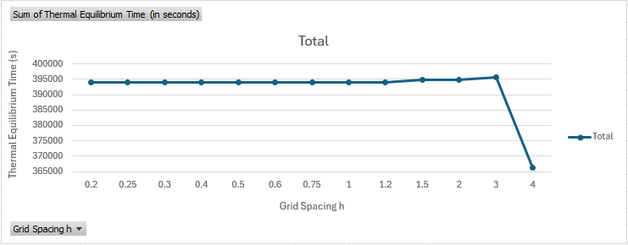
Figure 6 shows the reported thermal equilibrium time plotted against grid spacing $h$ using the results in Table 1.
Figure 6 - Thermal Equilibrium Time as a Function of Grid Spacing h for a 12 m × 12 m Plate with Δt=150s and CC=0.001

Figure 6 shows that equilibrium time changes for coarse grids but then plateaus as $h$is reduced. This indicates that, with fixed $Δt$and tolerance, the stopping criterion increasingly controls termination rather than mesh refinement (Press, Teukolsky, Vetterling, & Flannery, 2007). Once per-step updates fall below the threshold, further reductions in $h$have little effect on the reported equilibrium time (LeVeque, 2007).

Influence of time step $Δt$(fixed $h=0.75$m, fixed $CC=0.0001$)
Table 2 summarises the time-step sensitivity study for a 12 m × 12 m plate, with $h=0.75$m and $CC=0.0001$ held constant.
Table 2 - Thermal Equilibrium Time Results for the Time Step Sensitivity Study on a 12 m × 12 m Plate with h=0.75m and CC=0.0001
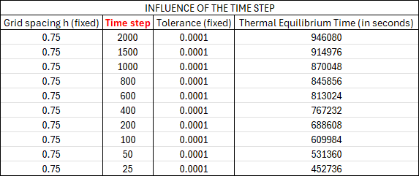
Figure 7 shows the reported thermal equilibrium time plotted against $Δt$ using the results in Table 2.
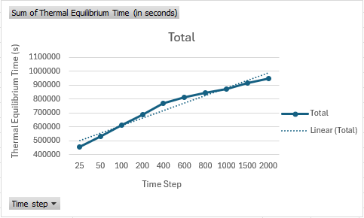
Figure 7 - Thermal Equilibrium Time as a Function of Time Step Δtfor a 12 m × 12 m Plate with h=0.75m and CC=0.0001

Figure 7 shows that the reported equilibrium time decreases as $Δt$ decreases. Because equilibrium is detected using a successive-difference criterion, smaller $Δt$ reduces the update magnitude and can cause $max⁡∣T^{n+1}-T^{n}∣$to fall below the tolerance earlier in physical time (Press, Teukolsky, Vetterling, & Flannery, 2007). Therefore, equilibrium time trends across $Δt$ reflect both diffusion behaviour and the stopping-rule definition (Morton & Mayers, 2005).

Influence of thermal equilibrium tolerance $CC$(fixed $h=1$m, fixed $Δt=500$s)
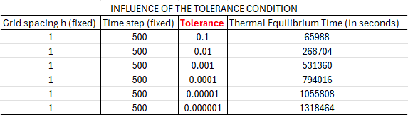
Table 3 summarises the tolerance sensitivity study for a 12 m × 12 m plate, with $h=1$m and $Δt=500$s held constant.
Table 3 - Thermal Equilibrium Time Results for the Tolerance Sensitivity Study on a 12 m × 12 m Plate with h=1m and Δt=500s

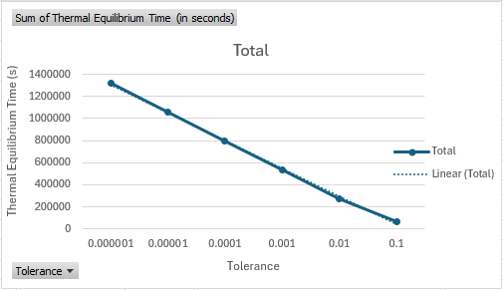
Figure 8 shows the reported thermal equilibrium time plotted against tolerance $CC$ using the results in Table 3.
Figure 8 - Thermal Equilibrium Time as a Function of Equilibrium Tolerance CC for a 12 m × 12 m Plate with h=1m and Δt=500s

Figure 8 shows that the equilibrium time increases markedly as $CC$ is tightened, because smaller tolerances require more steps for successive fields to converge (Morton & Mayers, 2005). This confirms that $CC$ strongly controls runtime and how close the final field is to steady conditions, so comparisons are only meaningful when $CC$ is consistent across runs (LeVeque, 2007).

Sensitivity Summary
Across the sensitivity studies, $CC$ has the strongest effect on reported equilibrium time, indicating that the stopping criterion dominates the measured “equilibrium” behaviour relative to changes in $h$ and $Δt$ (Press, Teukolsky, Vetterling, & Flannery, 2007). This motivates using more robust equilibrium measures (e.g., residual-based criteria) and alternative time-integration methods, as discussed in Chapters 8 and 9 (LeVeque, 2007).

Limitations of the Numerical Model.

Limitations of the Numerical Method (EFDM)
The explicit FTCS diffusion scheme is conditionally stable and requires $Fo≤1/4$ in 2D. Because $Δt_{max}∝h^{2}$, grid refinement rapidly reduces the allowable time step and increases computational cost, which constrains practical parameter selection in the sensitivity studies (Morton & Mayers, 2005).
The scheme is first-order accurate in time and second-order accurate in space, with truncation error scaling $O(Δt)+O(h^{2})$ (Smith, 1985). Although reducing $h$and $Δt$ should reduce discretisation error in principle, the trends in Tables 1–2 are not strongly monotonic, indicating that the stopping criterion can dominate the reported outcomes and mask truncation-error behaviour (Smith, 1985).
Round-off error can accumulate over many iterations, but it is expected to be secondary here because MATLAB uses double precision and the largest discrepancies are associated with changes in the stopping tolerance (Press, Teukolsky, Vetterling, & Flannery, 2007). Round-off becomes more relevant for very large grids, extremely small tolerances, or long runtimes with high iteration counts (Press, Teukolsky, Vetterling, & Flannery, 2007).
Finally, EFDM on a structured Cartesian grid is best suited to simple rectangular geometries and boundary conditions (Lach & et al, 2025); complex geometries typically require boundary approximations or alternative formulations such as FEM or FVM (LeVeque, 2007).

Limitations of the Coding Implementation (Evidence Linked)
Thermal equilibrium is defined using the successive-difference criterion $max⁡∣T^{n+1}-T^{n}∣≤CC$, which measures per-step change rather than the residual of the steady-state equation. This means termination depends on update magnitude, which scales with $Fo=αΔt/h^{2}$ (Morton & Mayers, 2005).
This limitation is supported by the sensitivity results: in the time-step study (Table 2), reducing $Δt$ (and hence $Fo$) led to earlier reported equilibrium times while not consistently improving agreement with the analytical solution, indicating that smaller updates can satisfy the tolerance sooner without reaching the same physical proximity to steady state (Press, Teukolsky, Vetterling, & Flannery, 2007). A similar effect is observed across discretisation’s, where the stopping rule can cause “equilibrium” to represent different physical states unless termination is defined consistently (Press, Teukolsky, Vetterling, & Flannery, 2007).
Therefore, results are only directly comparable when $CC$ is controlled to achieve similar proximity to steady state, as demonstrated by Table 3 where tightening $CC$ from 0.1 to 0.001 reduced RMSE from 3.5779 °C to 0.0732 °C.

Limitations of the Analytical Reference Solution
The analytical steady-state solution is evaluated using a truncated Fourier series. Truncation introduces an approximation error that decreases with increasing term count, but convergence can be slower near boundaries when the derivative is discontinuous, meaning some residual analytical approximation may remain (Ozisik, 1955). Although 10,000 terms were used to reduce truncation effects, the reference solution remains an approximation and contributes a small uncertainty floor for validation.

Summary of Limitations
The EFDM scheme is stable under the Fourier-number constraint, but efficiency is limited by conditional stability, and the reported accuracy is strongly influenced by the equilibrium tolerance. Sensitivity results show that the stopping rule can dominate trends across $h$ and $Δt$, so robustness requires a residual-based criterion or a fixed physical end time (LeVeque, 2007).

Suggested Improvements and Future Developments.

Improved Equilibrium (Steady-State) Detection
Robustness can be improved by defining equilibrium using a criterion tied to the steady-state equation rather than successive-iterate differences. A residual-based stop can be formed from the discrete Laplacian,
$$R_{i,j}=T_{i+1,j}+T_{i-1,j}+T_{i,j+1}+T_{i,j-1}-4T_{i,j},$$
with termination when $max⁡∣R∣$ falls below a chosen tolerance, directly indicating satisfaction of Laplace’s equation at interior nodes (LeVeque, 2007). Alternatively, runs can be compared at a fixed physical time to isolate the influence of $Δt$ on temporal error and avoid premature termination driven by per-step tolerances (Press, Teukolsky, Vetterling, & Flannery, 2007).

More Efficient Time Integration
The explicit method requires a small $Δt$ for stability, particularly on refined grids, whereas implicit schemes (backward Euler) and Crank–Nicolson relax this restriction for linear diffusion and allow larger stable time steps (Crank, 1975). Crank–Nicolson also provides second-order temporal accuracy, improving transient predictions (Morton & Mayers, 2005). More stable time-integration approaches are therefore commonly considered for heat-conduction simulations to reduce the practical limitations of explicit schemes (Jalghaf, Omle, & Kovacs, 2022). For structured 2D grids, ADI methods reduce computational cost by replacing a full 2D implicit solve with two 1D implicit steps (Peaceman & Rachford, 1955).

Grid Convergence and Uncertainty Reporting
A more defensible numerical study would include a grid convergence assessment where $h$ is reduced while using either:
(i) a residual-based equilibrium criterion, or
(ii) a consistent physical end time,
to ensure all cases represent a comparable physical state. With this in place, observed changes in max error and RMSE can be attributed to discretisation effects rather than termination effects (Smith, 1985).
Uncertainty reporting could also be strengthened by providing relative error metrics (e.g., normalised RMSE divided by $T_{0}$) and reporting where the maximum error occurs spatially (e.g., near corners or mid-domain) (Press, Teukolsky, Vetterling, & Flannery, 2007).

Alternatives for Complex Geometries and Unstructured Meshes
EFDM is most efficient on structured Cartesian grids and simple rectangular domains, whereas complex geometries and local refinement are typically handled using FVM or FEM. FVM enforces conservation over control volumes and is well-suited to unstructured meshes and irregular boundaries (Versteeg & Malalasekera, 2007). FEM approximates the solution using basis functions over elements and is effective for complex geometries, spatially varying properties and locally refined meshes (Zienkiewicz & Taylor, 2000). These methods improve geometric fidelity and enable targeted refinement near boundaries or high gradients without refining the entire domain (LeVeque, 2007).

Conclusion.
This report modelled 2D transient heat conduction in an aluminium plate using an explicit FTCS finite difference scheme with stability enforced by $Fo≤1/4$. Validation against a truncated Fourier-series analytical steady state showed strong dependence on the equilibrium tolerance: for $X=10$m, $Y=10$m, $h=0.5$m and $Δt=900$s, tightening $CC$from 0.1 to 0.001 reduced RMSE from 3.5779 °C to 0.0732 °C and the maximum absolute error from 7.6524 °C to 0.4360 °C. Sensitivity results indicated that the successive-difference stopping rule can dominate trends across $h$ and $Δt$, producing earlier termination and non-robust “equilibrium” times as update magnitudes decrease. Overall, the EFDM implementation was validated, and the dominant reliability controls were identified; future work should adopt residual-based equilibrium criteria and consider implicit or Crank–Nicolson time integration to improve robustness and efficiency.

References
Bergman, T., Lavine, A., Incorpera, F., & DeWitt, D. (2011). Fundamentals of Heat and Mass Transfer. Hoboken: Wiley.
Carslaw, H., & Jaeger, J. (1959). Conduction of Heat in Solids. Oxford: Clarendon Press.
Crank, J. (1975). The Mathematics of Diffusion. Oxford: Claredon Press.
Incropera, F., DeWitt, D., Bergman, T., & Lavine, A. (2011). Introduction to Heat Transfer. Hoboken: Wiley.
Jalghaf, H., Omle, I., & Kovacs, E. (2022). A Comprehensive Study of Explicit and Stable Tim Integration Schemes for Heat Conduction in an Insulated Wall. Buildings, 824. doi:10.3390
Lach, L., & et al. (2025). Advances in Numerical Modeling for Heat Transfer and Thermal Management: A Review of Computational Approaches and Environemntal Impacts. Oxford: Energies.
LeVeque, R. (2007). Finite Difference Methods for Ordinary and Partial Differential Equations: Steady-State and Time-Dependant Problems. Philadelphia: SIAM.
Morton, K., & Mayers, D. (2005). Numerical Solution of Partial Differential Equations: An Introduction. Cambridge: Cambridge University Press. Retrieved January 20, 2025
Ozisik, M. (1955). Boundary Value Problems of Heat Conduction. New York: Dover Publications.
Peaceman, D., & Rachford, H. (1955). The Numerical Solution of Parabolic and Elliptic Differential Equations. Journal of the Society for Industrial and Applied Mathematics(3), 28-41. doi:10.1137/0103003
Press, W., Teukolsky, S., Vetterling, W., & Flannery, B. (2007). Numerical Recipes: The Art of Scientific Computing. Cambridge: Cambridge University.
Richtmyer, R., & Morton, K. (1967). Difference Methods for Initial-Value Problems. New York: Interscience.
Smith, G. (1985). Numerical Solution of Partial Differential Equations: Difference Methods. Oxford: Oxford University Press. Retrieved January 20, 2025
Versteeg, H., & Malalasekera, W. (2007). An Introduction to Computational Fluid Dynamics: The Finite Volume Method. Harlow: Pearson.
Zienkiewicz, O., & Taylor, R. (2000). The Finite Element Method: Volume 1 - The Basis. Oxford: Butterworth-Heinemann.

Appendix

MATLAB Code
clc
clear
close all

%Material Properties for Aluminium
k = 143; % W/m*C Conductivity
p = 2800; % kg/m^3 Density
c = 795; % J/kg*C Specific Heat

%Thermal Diffusivity
alpha = k / (p * c); % m^2/s
fprintf('Thermal diffusivity alpha = %0.2e m^2/s\n',alpha)

%Prompt and validate X, Y, h
while true
X = input('Enter plate X dimension (positive scalar): ');
Y = input('Enter plate Y dimension (positive scalar): ');
h = input('Enter grid spacing h (positive scalar): ');

% basic checks
if isempty(X) || isempty(Y) || isempty(h)
fprintf('Empty input detected — please provide numeric values.\n');
continue;
elseif any([X,Y,h] <= 0)
fprintf('All inputs must be positive values. Try again.\n');
continue;
elseif rem(X,h)~0 || rem(Y,h)~=0 || h>=Xdim || h>=Ydim
fprintf('Grid spacing h must divide both X and Y (within tolerance). Try again.\n');
continue;

else
break;
end
end

%Calculate total number of rows NR and columns NC
NR = round(Y/h) + 1;
NC = round(X/h) + 1;

%Initialise Matrix T1
T1=zeros(NR,NC);

%Add the boundary conditions
T0=input('Please enter the North boundary condition temperature: ');
T1(1,2:NC-1)=T0;

%User input for temporal consideration (Stability check: Fo <= 1/4)
dT_max = h^2/(4*alpha);

TS = input(sprintf('Enter time step dT (<= %.6g s): ', dT_max));
while TS <= 0 || TS > dT_max
fprintf('Invalid dT. Must be > 0 and <= %.6g s\n', dT_max);
TS = input(sprintf('Enter time step dT (<= %.6g s): ', dT_max));
end

Fo = alpha*TS/h^2;
fprintf('Accepted: Fo = %.4f\n', Fo);

%Initialise T2 and keep Dirichlet boundary conditions constant
T2 = T1; % start T2 from T1

%Convergence Criterion (CC) and explicit update until convergence
CC = 0.1;

maxDiff = CC+2;
step = 0;
%
% %Live display of numerical temperature at each time step
x = 0:h:X;
y = 0:h:Y; % row 1 corresponds to y = Y (top boundary)

figure;
hImg = contourf(x, y, flip(T2));
set(gca,'YDir','normal');
colorbar;
xlabel('X (m)');
ylabel('Y (m)');

while maxDiff > CC
step = step + 1;

% Explicit Finite Difference update (interior nodes only)
for i = 2:NR-1
for j = 2:NC-1
T2(i,j) = T1(i,j) + Fo*( ...
T1(i+1,j) + T1(i-1,j) + T1(i,j+1) + T1(i,j-1) - 4*T1(i,j) );
end
end

% Convergence check (max difference anywhere)
maxDiff = max(abs(T2(:) - T1(:)));

% Update live plot
hImg = contourf(x, y, flip(T2));
title(sprintf('Temperature T2 (°C) at t = %.2f s', step*TS));
drawnow;

T1 = T2;
end

disp('T2 ='); disp(T2)

fprintf('Converged in %d steps. Max difference = %.4f\n', step, maxDiff);

%Analytical solution (matrix TA)
%Using assignment formula with: Xdim = X, Ydim = Y, k = 2n+1

[Xg, Yg] = meshgrid(x, y);

Nterms = 10000; % number of terms in the series (increase for accuracy)
TA = zeros(NR, NC);

for n = 0:Nterms
kterm = 2*n + 1; % k = 2n+1 (odd terms)

num = exp( (kterm*pi*(Yg - Y))/X ) - exp( (-kterm*pi*(Yg + Y))/X );
den = 1 - exp( (-2*kterm*pi*Y)/X );

TA = TA + (1/kterm) * sin(kterm*pi*Xg/X) .* (num ./ den);
end

TA = (4*T0/pi) * TA;

%Plot temperature distribution TA
figure;
contourf(x, y,(TA));
set(gca,'YDir','normal');
colorbar;
title('Temperature distribution TA (°C)');
xlabel('X (m)');
ylabel('Y (m)');

disp('TA ='); disp(flipud(TA))

%Code validation: error map (single figure)
E = abs(T2 -flipud(TA)); % absolute error

x = linspace(0, X, NC);
y = linspace(Y, 0, NR); % row 1 is top boundary (y = Y)

figure;
contourf(x, y,E);
set(gca,'YDir','normal');
colorbar;
title('Validation: Absolute error |T2 - TA| (°C)');
xlabel('X (m)');
ylabel('Y (m)');

disp('E ='); disp(E)

fprintf('\n--- Code Validation (T2 vs TA) ---\n');
fprintf('Max |T2 - TA| = %.4f °C\n', max(E(:)));
fprintf('RMSE(T2 - TA) = %.4f °C\n', sqrt(mean(E(:).^2)));

%Time to Thermal Equilibrium
t_eq = step * TS; % time to reach thermal equilibrium (s)

if t_eq < 60
fprintf('Time to thermal equilibrium: %.2f s\n', t_eq);
elseif t_eq < 3600
fprintf('Time to thermal equilibrium: %.2f min\n', t_eq/60);
elseif t_eq < 86400
fprintf('Time to thermal equilibrium: %.2f h\n', t_eq/3600);
else
fprintf('Time to thermal equilibrium: %.2f days\n', t_eq/86400);
end

